Exploring DDL, DML and JOIN Commands
Automating the Business Loan Approval System for a Central Bank
(Using Historical Data of Borrowers – SBA National Loan Dataset)
Submitted by: Priyanka Giri
Database: PostgreSQL (banking_db) | Table: sba_loans_raw

1. Introduction
This report documents the exploration of DDL (Data Definition Language), DML (Data Manipulation Language), and JOIN operations performed on the sba_loans_raw table in PostgreSQL, as part of the business loan approval automation project. The dataset consists of over 899,000 historical loan records used to build an understanding of how SQL commands can be used to structure, clean, and analyze borrower data for automated loan approval decisions.
For each command type, the exact SQL query executed, its output, and a short explanation of its purpose and function are provided below, along with screenshots captured directly from PostgreSQL (pgAdmin PSQL Tool).

2. DDL (Data Definition Language) Commands
DDL commands define and modify the structure of database objects (tables, columns) rather than the data stored inside them. The following ALTER TABLE and CREATE TABLE examples were used to reshape the sba_loans_raw table so that it could store cleaned, analysis-ready data.

2.1 Adding Columns — ALTER TABLE ADD COLUMN
Example A: Adding numeric columns to hold cleaned currency values.
Command:
ALTER TABLE sba_loans_raw ADD COLUMN disbursementgross_num NUMERIC, ADD COLUMN balancegross_num NUMERIC, ADD COLUMN gr_appv_num NUMERIC, ADD COLUMN sba_appv_num NUMERIC, ADD COLUMN chgoffprin_gr_num NUMERIC;
Output:
Explanation: ALTER TABLE ... ADD COLUMN modifies the table structure by adding new columns without affecting existing data. Here, five new NUMERIC columns were added to eventually hold clean, calculable versions of the currency fields (which were originally stored as TEXT with '$' and ',' symbols).
Example B: Adding date columns to hold cleaned date values.
Command:
ALTER TABLE sba_loans_raw ADD COLUMN approvaldate_d DATE, ADD COLUMN disbursementdate_d DATE, ADD COLUMN chgoffdate_d DATE;
Output:
Explanation: This second ALTER TABLE statement added three new DATE-type columns, preparing the table to hold properly typed date values instead of raw text dates, which is essential for performing date-based filtering and trend analysis on loan approvals.

2.2 Dropping Columns — ALTER TABLE DROP COLUMN
Command:
ALTER TABLE sba_loans_raw DROP COLUMN disbursementgross, DROP COLUMN balancegross, DROP COLUMN gr_appv, DROP COLUMN sba_appv, DROP COLUMN chgoffprin_gr, DROP COLUMN approvaldate, DROP COLUMN disbursementdate, DROP COLUMN chgoffdate;
Explanation: DROP COLUMN permanently removes a column and its data from the table. Once the cleaned numeric and date columns were verified to be correct, the original messy TEXT columns (containing '$', commas, and raw date strings) were dropped to keep the table structure clean and avoid duplicate/confusing fields.

2.3 Renaming Columns — ALTER TABLE RENAME COLUMN
Command:
ALTER TABLE sba_loans_raw RENAME COLUMN disbursementgross_num TO disbursementgross;
Command:
ALTER TABLE sba_loans_raw RENAME COLUMN gr_appv_num TO gr_appv;
Explanation: RENAME COLUMN changes only the name of a column, leaving its data type and values untouched. This was used to give the cleaned numeric columns their original, business-friendly names (e.g., gr_appv) after the old text versions had been removed.

2.4 Verifying Final Table Structure
Command:
SELECT column_name, data_type FROM information_schema.columns WHERE table_name = 'sba_loans_raw' ORDER BY ordinal_position;
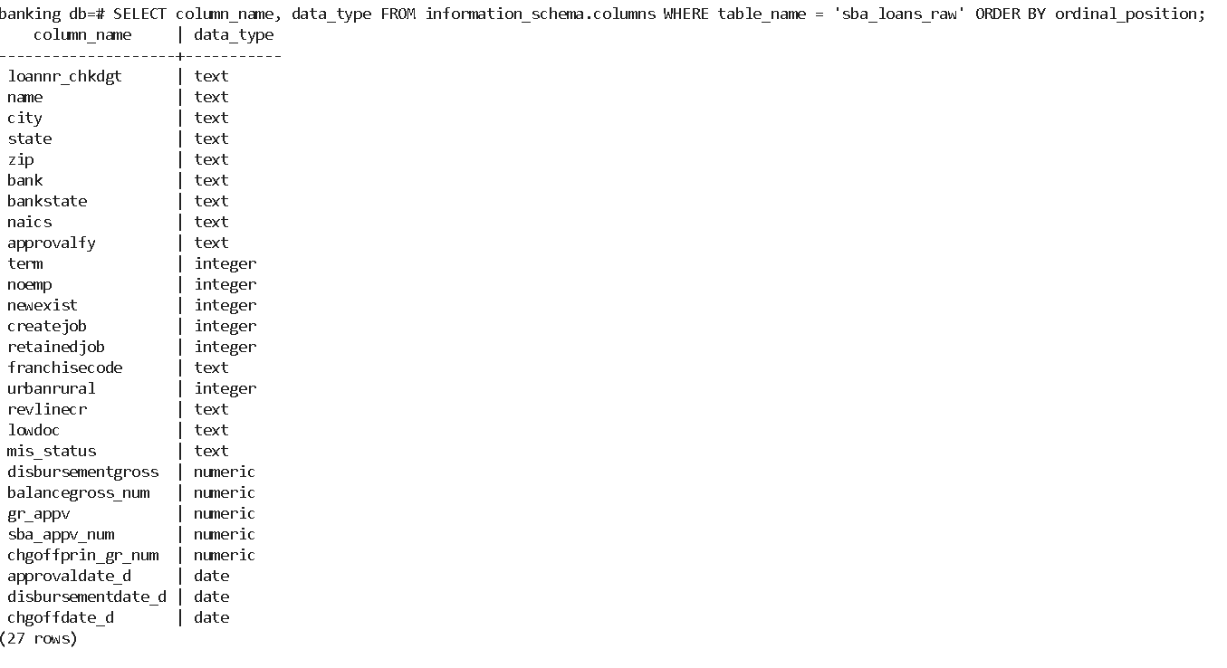
Explanation: This query (using the information_schema system view) confirms the final structure of the table after all DDL changes: text columns for descriptive fields, integer columns for counts, numeric columns for cleaned currency values, and date columns for cleaned dates.

3. DML (Data Manipulation Language) Commands
DML commands operate on the data stored inside a table (inserting, updating, deleting, or retrieving rows) without changing the table's structure. The following UPDATE and SELECT examples were used to clean and verify borrower data.

3.1 UPDATE — Cleaning Currency Data
Command:
UPDATE sba_loans_raw SET disbursementgross_num = NULLIF(REPLACE(REPLACE(TRIM(disbursementgross), '$', ''), ',', ''), '')::NUMERIC, balancegross_num = NULLIF(REPLACE(REPLACE(TRIM(balancegross), '$', ''), ',', ''), '')::NUMERIC, gr_appv_num = NULLIF(REPLACE(REPLACE(TRIM(gr_appv), '$', ''), ',', ''), '')::NUMERIC, sba_appv_num = NULLIF(REPLACE(REPLACE(TRIM(sba_appv), '$', ''), ',', ''), '')::NUMERIC, chgoffprin_gr_num = NULLIF(REPLACE(REPLACE(TRIM(chgoffprin_gr), '$', ''), ',', ''), '')::NUMERIC;
Output:
Explanation: UPDATE modifies existing rows of data. This command removed the '$' and ',' characters from the currency text fields (using REPLACE and TRIM) and cast the result to NUMERIC, storing clean, calculable loan amounts in the new columns. All 899,164 rows were successfully updated.

3.2 UPDATE — Cleaning Date Data
Command:
UPDATE sba_loans_raw SET approvaldate_d = NULLIF(TRIM(approvaldate), '')::DATE, disbursementdate_d = NULLIF(TRIM(disbursementdate), '')::DATE, chgoffdate_d = NULLIF(TRIM(chgoffdate), '')::DATE;
Output:
Explanation: This UPDATE command converted the raw text date fields (in 'DD-Mon-YY' format) into proper DATE values in the new columns, enabling date-based sorting, filtering, and comparisons across all 899,164 loan records.

3.3 SELECT — Verifying Data After DML
Verifying cleaned currency values:
Command:
SELECT name, disbursementgross, disbursementgross_num, gr_appv, gr_appv_num FROM sba_loans_raw LIMIT 10;
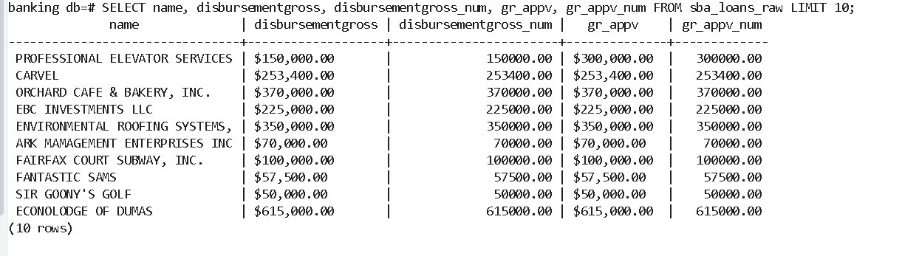
Verifying cleaned date values (checking ambiguous two-digit years, e.g. '80'):
Command:
SELECT name, approvaldate, approvaldate_d FROM sba_loans_raw WHERE approvaldate LIKE '%-80' LIMIT 5;
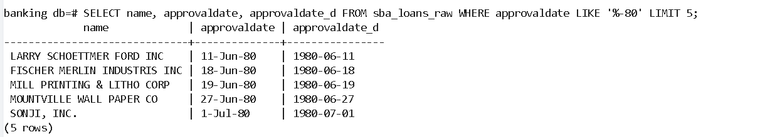
Explanation: SELECT is a DML command used to retrieve and verify data. These queries confirm that currency values were correctly stripped of symbols (e.g., $150,000.00 -> 150000.00) and that ambiguous two-digit years (e.g., '80') were correctly resolved to 1980 rather than 2080, validating the earlier UPDATE operations.

4. JOIN Operations
A JOIN combines rows from two tables (or a table and a subset of itself) based on a common column. To understand JOINs, a subset table of high-value loans was created from sba_loans_raw, and then joined back to the original table.

4.1 Creating a Subset Table — CREATE TABLE AS SELECT
Command:
CREATE TABLE high_risk_loans AS SELECT loannr_chkdgt, name, bank, gr_appv FROM sba_loans_raw WHERE gr_appv > 500000;
Explanation: CREATE TABLE ... AS SELECT is a DDL command that creates a new table populated directly from a query result. Here, it produced a smaller subset table, high_risk_loans, containing only the 87,070 loans with an approved amount greater than $500,000 — representing higher-value loans relevant to risk-based approval automation.

4.2 INNER JOIN — Joining the Subset with the Original Table
Command:
SELECT a.name, a.city, a.state, a.bank, a.gr_appv FROM sba_loans_raw a INNER JOIN high_risk_loans b ON a.loannr_chkdgt = b.loannr_chkdgt LIMIT 10;
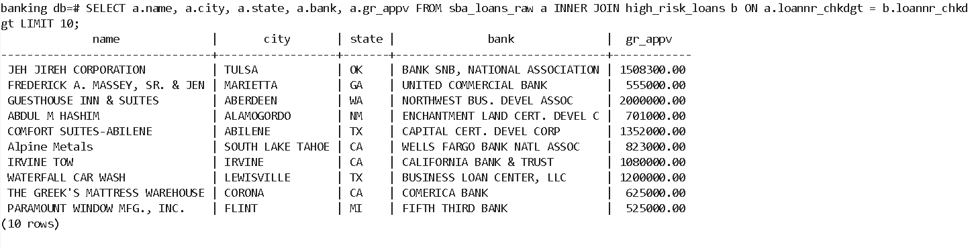
Explanation: This INNER JOIN matches rows between the full table (sba_loans_raw, aliased 'a') and its subset (high_risk_loans, aliased 'b') using the common column loannr_chkdgt. The result pulls additional detail (city, state) for only the high-value loans identified in the subset, demonstrating how JOINs let a smaller, filtered table be enriched with columns from the original, larger table.

5. Conclusion
This exercise demonstrated the practical use of DDL commands (ALTER TABLE ADD/DROP/RENAME COLUMN, CREATE TABLE AS SELECT) to shape the borrower dataset's structure, DML commands (UPDATE, SELECT) to clean and verify borrower financial and date data, and an INNER JOIN to combine a filtered subset of high-value loans with full borrower details from the original table. Together, these operations form a foundation for automating loan-risk classification and approval workflows for the central bank's historical borrower data.

