Problem:5:

Stream Processing:

Tweets on the presidential elections have been collected every day over a week and the results are plotted as below:

For a whole week, Donald Trump has been talked about the most given the number of tweets as shown below:

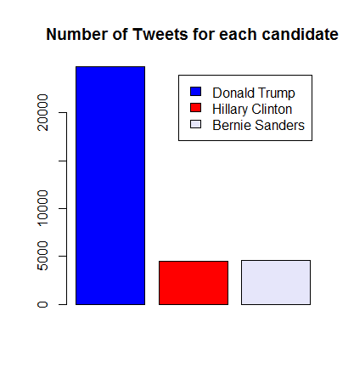

The graphs below show the trendng candidate each day and as we observe, Donald Trump has been the most talked about and therefore, the most trending .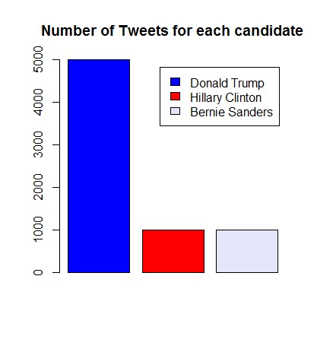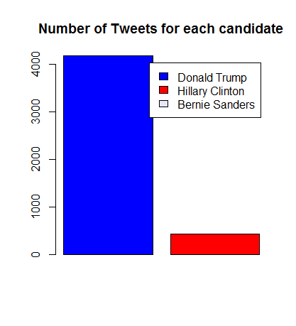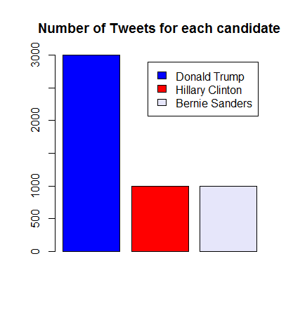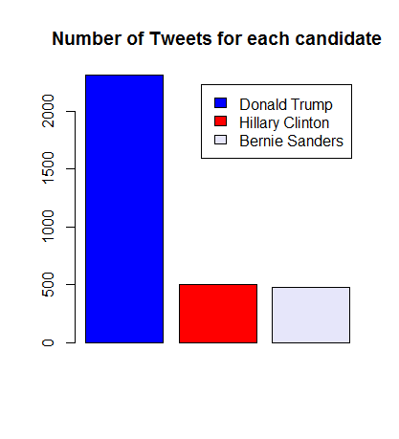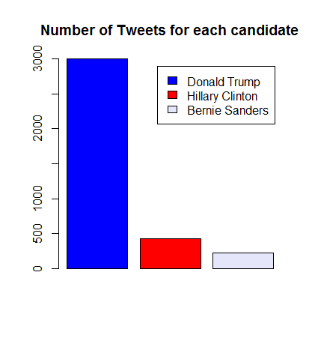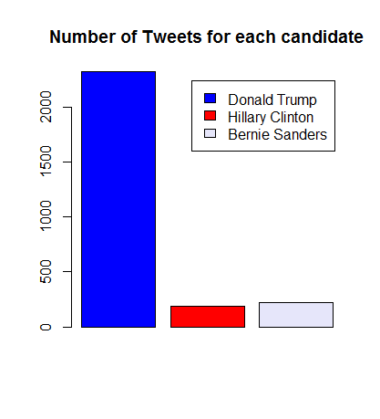 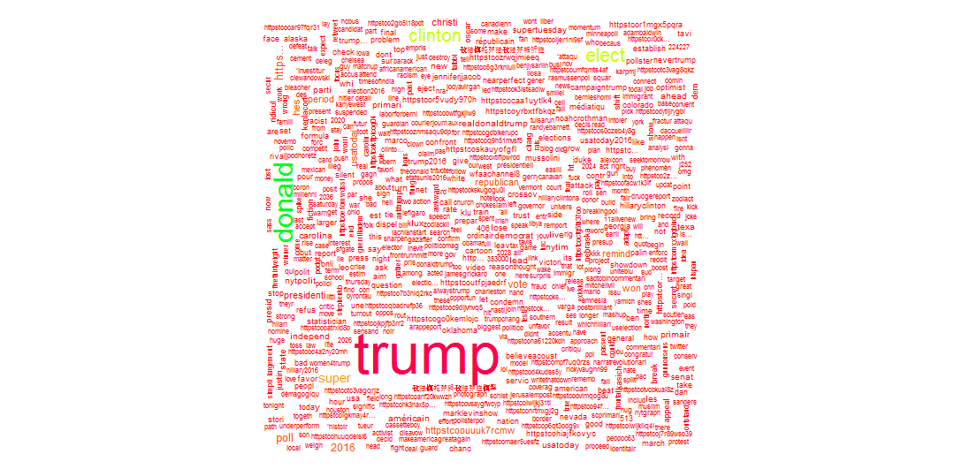

As we can see, everyday, Donald Trump beats the other candidates by a very large margin. Also, wordcloud has been developed to show the most trending words and the most trending is trump.