Activity – 5:

Suppose that a certain BST has keys that are integers between 1 and 10, and we search for 5. Which sequence below cannot be the sequence of keys examined? Why?  
a. 10, 9, 8, 7, 6, 5   
b. 4, 10, 8, 7, 3, 5  
c. 1, 10, 2, 9, 3, 8, 4, 7, 6, 5   
d. 2, 7, 3, 8, 4, 5   
e. 1, 2, 10, 4, 8, 5

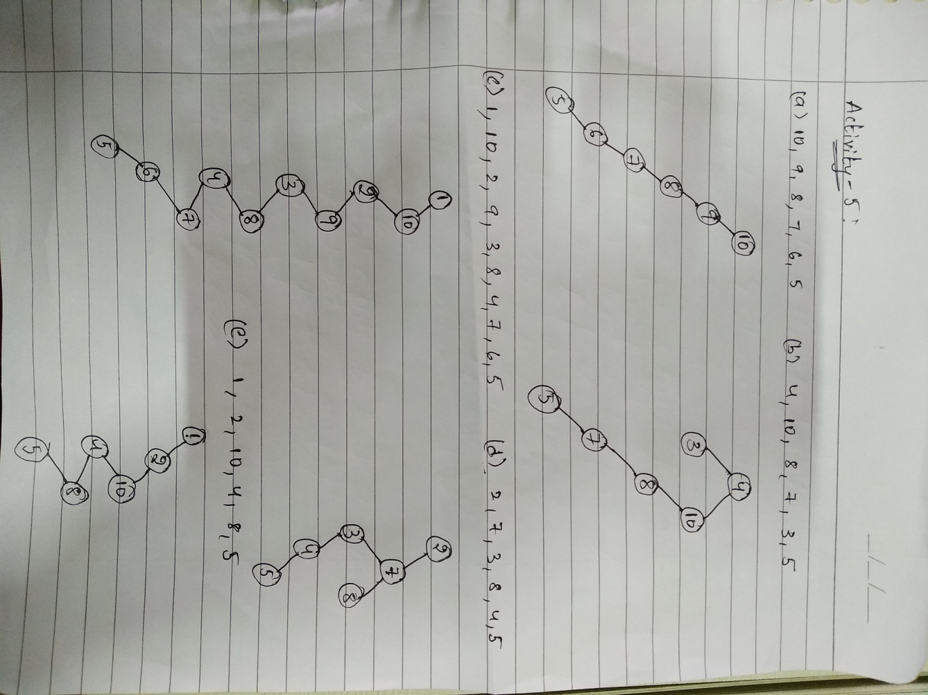

If we see in the above figure all the given sequences are possible except b, d while the sequence of keys examined.