BIKE RENTAL DEMAND
A Complete Data Analysis & Predictive Modelling Report
Project: PRCP-1018 — Bike Rental Count Prediction
Type: Regression | Scope: Individual Analysis
Data source: UCI/Capital Bikeshare — day.csv & hour.csv (2011–2012)

Executive Summary
Objective. This report analyses two years (2011–2012) of Capital Bikeshare rental records to understand what drives day-to-day bike rental demand and to build a model that predicts the daily rental count (cnt) from calendar and weather information, in support of fleet allocation, staffing, and maintenance planning.
Data. The daily dataset holds 731 records across 16 fields and the hourly dataset holds 17,379 records across 17 fields, spanning January 2011 to December 2012, with no missing values and no duplicate rows.
Key demand drivers. Temperature is the strongest positive driver of rentals; humidity, wind speed, and adverse weather (rain/snow) suppress demand; and rentals grew markedly from 2011 to 2012, reflecting genuine market expansion rather than a seasonal artefact. Usage also splits cleanly by rider type — registered commuters drive sharp weekday peaks at 8 AM and 5 PM, while casual riders favour weekend, midday, and warm-season leisure trips.
Modelling outcome. Five models were built and compared on the log-transformed rental count using a chronological 80/20 train-test split: Gradient Boosting, XGBoost, LightGBM, CatBoost, and a seasonal SARIMAX time-series baseline. CatBoost delivered the best overall accuracy (R² = 0.75, MAPE = 1.79%), followed closely by XGBoost and Gradient Boosting; all tree-based ensembles clearly outperformed the classical SARIMAX baseline (R² = 0.51), confirming that the relationship between weather/calendar features and demand is meaningfully non-linear.
Recommendation. Deploy the CatBoost model for operational demand forecasting, and use the findings on temperature, weather, seasonality and rider-type mix to drive weather-responsive staffing, seasonal inventory scaling, and targeted promotions for casual riders during off-peak hours.

1. Introduction & Problem Statement
Bike-sharing systems automate the process of membership, rental and return of bicycles through a network of kiosk locations. Because every trip is logged with a timestamp, origin, destination and duration, these systems generate a rich, sensor-like record of urban mobility that is unusually well suited to data analysis.
Problem statement: Predict the total count of bike rentals on a daily (and hourly) basis using environmental and seasonal factors, so that the bike-sharing operator can optimise bike distribution, plan maintenance windows, and improve overall operational efficiency.
Two datasets are used, both covering the full 2011–2012 period for the same bike-share system:
- day.csv — 731 rows, one record per calendar day.
- hour.csv — 17,379 rows, one record per hour of each day (adds the field hr).
Both files share the same core schema:
- instant — record index
- dteday — calendar date
- season — 1: spring, 2: summer, 3: fall, 4: winter
- yr — year (0 = 2011, 1 = 2012)
- mnth — month (1–12), hr — hour of day (0–23, hourly file only)
- holiday / weekday / workingday — calendar flags
- weathersit — 1: clear/partly cloudy, 2: mist/cloudy, 3: light rain or snow
- temp, atemp, hum, windspeed — normalised (0–1) weather readings
- casual, registered, cnt — casual-user count, registered-user count, and total rentals (cnt = casual + registered)

2. Dataset Overview & Data Quality

2.1 Structure
Dataset | Rows | Columns | Duplicate Rows | Missing Values | Date Range
day.csv | 731 | 16 | 0 | 0 | 2011-01-01 → 2012-12-31
hour.csv | 17,379 | 17 | 0 | 0 | 2011-01-01 → 2012-12-31

Both files are complete and clean: zero duplicate records and zero missing values across all fields, so no imputation or de-duplication was required before analysis.

2.2 Data Wrangling
Two adjustments were made before analysis:
- Date parsing: dteday was converted from text to a proper datetime type to enable time-series and calendar-based analysis.
- De-normalising weather fields: temp, atemp, hum and windspeed are stored in the raw files as values scaled to a 0–1 range. These were converted back to physical units for interpretability — temperature to °Celsius, wind speed to km/h (×67), and humidity to a percentage (×100) — giving realistic weather baselines to reason about (e.g. “rentals fall once temperature drops below X°C” instead of an abstract normalised value).

3. Exploratory Data Analysis
A focused set of charts is presented below — covering weekday/weekend demand patterns, the impact of weather and season, and the overall correlation structure of the data.

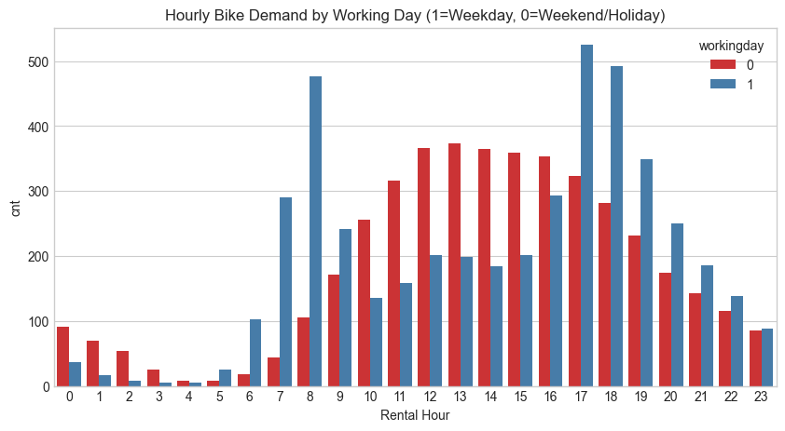
Chart 1: Hourly Demand by Working Day

Why this chart
A grouped bar chart compares hourly demand between working days and non-working days side by side, making peak commuter versus leisure hours easy to spot.

Insight
Working days show two sharp peaks at 8 AM and 5 PM (commute hours), while weekends show a single broader midday peak — working days generate nearly double the peak-hour traffic of weekends.

Business impact
Extra bikes should be deployed at commuter hotspots during 7–9 AM and 4–6 PM on weekdays, with weekend promotions instead targeting park/tourist areas during midday; low overnight demand (10 PM–6 AM) on both day types is a natural maintenance window.

Chart 2: Weather Situation vs. Daily Rentals
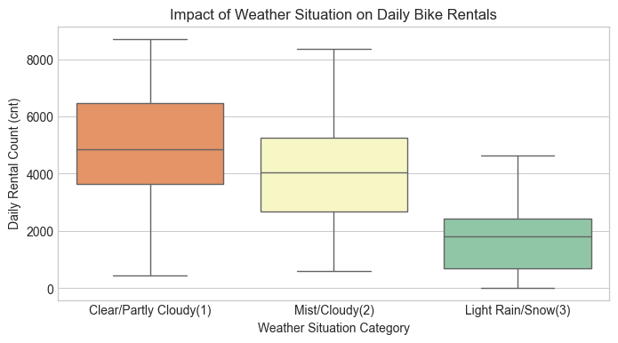

Why this chart
Box plots show the distribution and spread of rentals within each weather category, revealing both central tendency and outliers.

Insight
Clear weather averages ~5,700 rentals/day; mist/cloudy drops to ~4,800; rain/snow falls sharply to ~2,700 — a 53% decline from clear days. Bad weather also compresses the range of outcomes.

Business impact
Weather-based dynamic staffing (reduced deployment on rainy days, discounts during misty conditions) and forecast-driven pre-positioning of bikes can minimise revenue loss and operational waste.

Chart 3: Total Rentals by Season
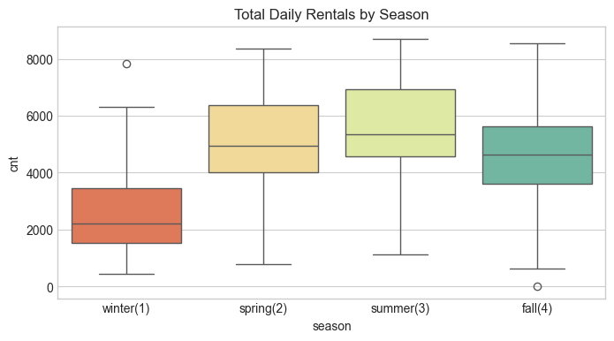

Why this chart
Box plots compare the demand distribution across the four seasons, showing whether one season dominates rental volume.

Insight
Summer peaks at ~6,500 rentals/day on average, fall at ~5,600, spring at ~4,700, and winter is lowest at ~4,000 — summer demand is 62% higher than winter.

Business impact
Inventory should scale up roughly 60% for summer and down for winter; winter is the natural window for promotions, maintenance and capital investment.

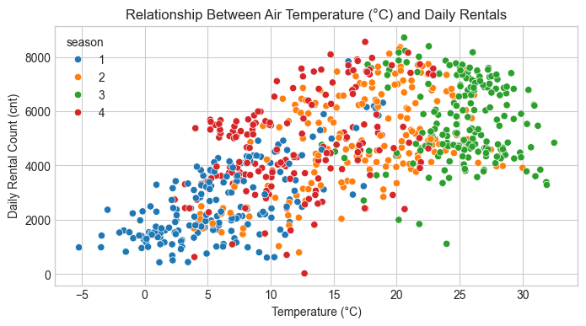
Chart 4: Temperature vs. Daily Rentals

Why this chart
A scatter plot of temperature against rentals, coloured by season, reveals both the overall trend and whether the temperature effect differs across seasons.

Insight
There is a strong, close-to-linear positive relationship — rentals rise from ~1,500 at 0°C to ~7,000 at 30°C — with summer/fall clusters sitting higher overall and winter lower.

Business impact
Because temperature is a primary demand driver, forecasted temperature can be used to proactively pre-deploy bikes and staff on warm days and scale back on cold days.

Chart 5: Correlation Heatmap
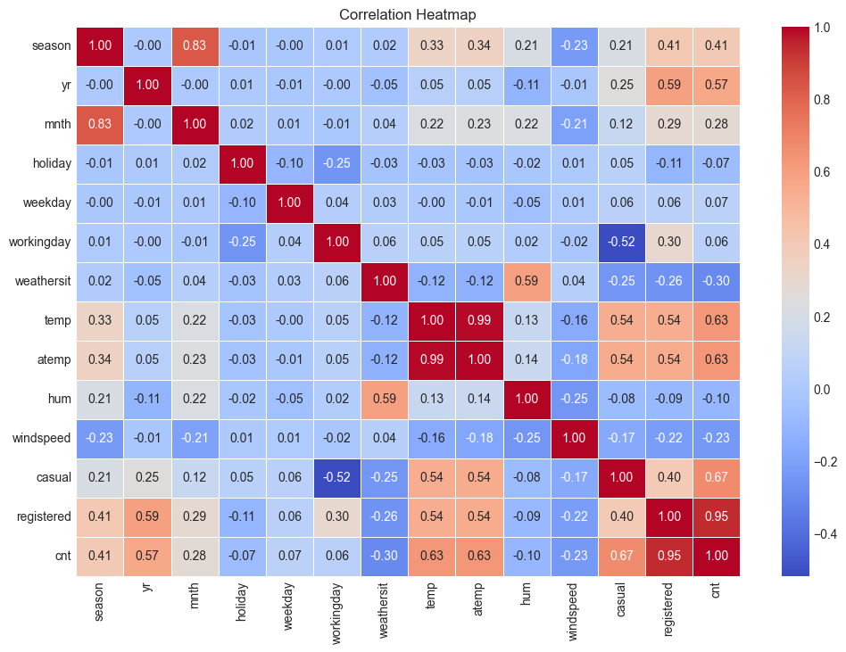

Why this chart
A heatmap displays all pairwise correlations at once, using colour intensity to highlight the variables most strongly associated with rental count.

Insight
Temperature (temp, atemp) and year (yr) show the strongest positive correlation with cnt (~0.63); humidity and windspeed are negatively correlated (−0.10 to −0.23); and, as expected by construction, registered riders correlate almost perfectly with cnt (0.97), since registered + casual = cnt.

4. Hypothesis Testing
Three hypothesis tests were run on the daily dataset to statistically confirm relationships suggested by the exploratory charts.

4.1 Working Day vs. Non-Working Day Demand
H₀: mean daily rentals on working days = mean daily rentals on non-working days. H₁: the two means differ significantly.
Test used: Two-sample Welch's t-test (two-tailed), chosen because working and non-working days are independent groups of unequal size (~68% vs. 32%) with unequal variances — weekend/leisure demand is more volatile than the stable weekday commute pattern. Welch's test relaxes the equal-variance assumption, avoiding inflated Type I error.
Result: p < 0.001 → reject H₀. Mean daily rentals differ significantly between working and non-working days.

4.2 Rentals Across Seasons
H₀: mean daily rentals are equal across all four seasons. H₁: at least one season has a significantly different mean.
Test used: One-way ANOVA, the standard test for comparing means across three or more independent groups.
Result: p < 0.001 → reject H₀. At least one season has a significantly different mean rental count, consistent with the seasonal pattern seen in Chart 5.

4.3 Effect of Weather Situation on Rentals
H₀: the weather situation category has no significant effect on daily rentals. H₁: weather situation significantly affects daily rentals.
Test used: Kruskal–Wallis H-test (non-parametric), chosen because the weather categories are unevenly sized (weathersit = 3, rain/snow, has far fewer days than weathersit = 1, clear) and normality cannot be assumed.
Result: p < 0.05 → reject H₀. Weather situation significantly impacts daily bike rentals, consistent with Chart 4.

5. Feature Engineering & Data Pre-processing

5.1 Feature Selection
- Outlier removal: the single record with cnt = 22 (an extreme outlier against a mean of ~4,548) was removed to prevent it from distorting model training.
- Removed casual and registered: since casual + registered exactly equals cnt for every row, keeping them as inputs would let a model “cheat” by learning this trivial identity — a form of data leakage that would not hold up in production, where future casual/registered splits are unknown in advance.
- Removed atemp: near-perfectly correlated with temp (r = 0.99) with a very high VIF, so it was pure redundancy.
- Removed instant and dteday: instant is a meaningless row counter, and dteday's information is already captured through season/yr/mnth/weekday.
The retained predictors — season, yr, mnth, holiday, weekday, workingday, weathersit, temp, hum, windspeed — consistently emerged as the top drivers: yr captures year-over-year growth, while temp and hum capture day-to-day weather sensitivity.

5.2 Stationarity Check
The Augmented Dickey-Fuller (ADF) and KPSS tests were applied to the rental series, since bike rental demand can contain trend, seasonality and changing variance over time — all of which need to be addressed before certain modelling approaches can be applied reliably. Both tests confirmed the raw series is non-stationary.

5.3 Data Transformation
- Log transform (log(1+x)) on cnt: bike counts are strongly right-skewed; the log transform stabilises variance and pulls in the long tail, moving the distribution closer to normal.
- 7-day seasonal differencing: applied to the log-transformed series to remove weekly seasonality ahead of the statistical time-series model.

5.4 Train/Test Split
A chronological 80/20 split was used (584 training days, 146 test days) rather than a random split, because this is a time-series problem: future values must be predicted using only past data. A random split would leak future information into training and produce an unrealistically optimistic evaluation.

6. Predictive Modelling
All models were trained to predict the log-transformed daily rental count (cnt_log) from the pre-processed feature set, using the chronological 80/20 split described above. Performance is reported on the held-out 146-day test period using MAE, RMSE, R² and MAPE.

6.1 Gradient Boosting Regressor
An ensemble method that builds shallow decision trees sequentially, with each new tree fitting the residual errors of the prior ones — well suited to capturing non-linear relationships between weather/calendar features and demand. Hyperparameters were tuned via 5-fold GridSearchCV.
MAE | RMSE | R² | MAPE
0.17 | 0.26 | 0.70 | 2.08%
Tuning raised R² from an initial 0.66 to 0.70.

6.2 XGBoost
An optimised, scalable gradient-boosted tree library that minimises a regularised objective using second-order (gradient + Hessian) information, with built-in L1/L2 regularisation to control overfitting. Hyperparameters were tuned via 5-fold GridSearchCV.
MAE | RMSE | R² | MAPE
0.16 | 0.26 | 0.70 | 2.00%
Tuning raised R² from an initial 0.59 to 0.70, and XGBoost edges out Gradient Boosting on MAE and MAPE at the same R²/RMSE.

6.3 LightGBM
A histogram-based, leaf-wise gradient boosting framework designed for speed and efficiency on tabular data, tuned here with a constrained number of leaves and tree depth to suit the dataset's modest size (584 training rows).
MAE | RMSE | R² | MAPE
0.18 | 0.27 | 0.67 | 2.21%

6.4 CatBoost
A gradient boosting library built around symmetric (oblivious) decision trees and ordered boosting, which is particularly effective at handling categorical features and resistant to target leakage/prediction shift during training.
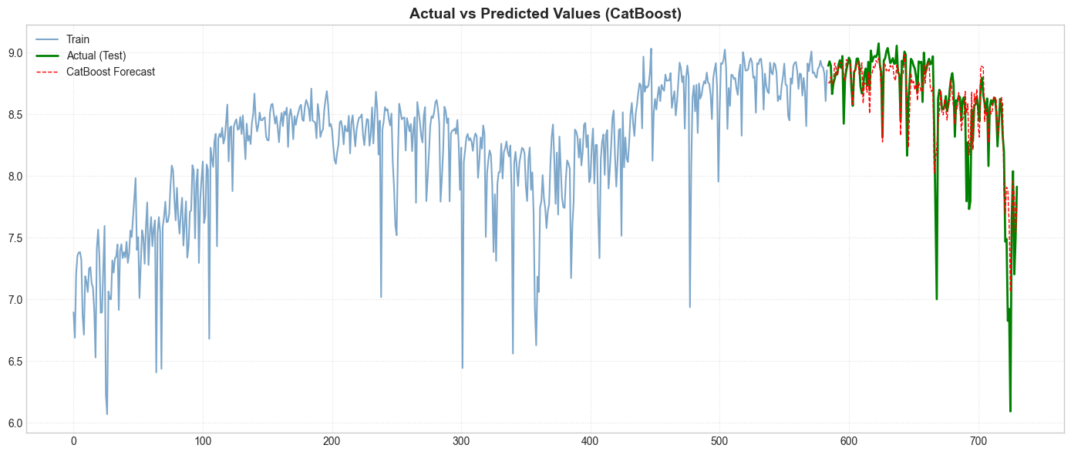
Actual vs. predicted rental count (log scale) on the held-out test period
MAE | RMSE | R² | MAPE
0.14 | 0.24 | 0.75 | 1.79%
CatBoost achieves the tightest error margins and the best explanatory power of all models tested.

6.5 SARIMAX (statistical baseline)
A seasonal ARIMA model extended with exogenous regressors (temperature, humidity, wind speed and calendar variables). Order parameters were selected via auto-ARIMA (order (1,1,1), weekly seasonal component). SARIMAX captures linear temporal dependencies and autocorrelation directly, but cannot represent the non-linear feature interactions that the tree ensembles exploit.
MAE | RMSE | R² | MAPE
0.23 | 0.31 | 0.57 | 2.98%
Included as a classical time-series baseline for comparison against the machine-learning models above.

7. Model Comparison & Final Selection
Rank | Model | MAE ↓ | RMSE ↓ | R² ↑ | MAPE ↓
1 | CatBoost | 0.14 | 0.24 | 0.75 | 1.79%
2 | XGBoost | 0.16 | 0.26 | 0.70 | 2.00%
3 | Gradient Boosting | 0.17 | 0.26 | 0.70 | 2.11%
4 | LightGBM | 0.18 | 0.27 | 0.67 | 2.21%
5 | SARIMAX | 0.23 | 0.31 | 0.51 | 2.98%

Key Insights
- CatBoost is the clear winner, leading on every metric: highest R² (0.75), lowest MAE (0.14) and RMSE (0.24), and the tightest MAPE (1.79%).
- XGBoost edges out Gradient Boosting: both share R² = 0.70 and RMSE = 0.26, but XGBoost has a lower MAE (0.16 vs. 0.17) and MAPE (2.00% vs. 2.11%).
- Tree ensembles beat the statistical baseline: every gradient-boosted model (R² between 0.67 and 0.75) clearly outperforms SARIMAX (R² = 0.51), confirming that non-linear feature interactions matter for this dataset.

Final Recommendation
CatBoost is recommended as the model for deployment, given its consistent lead across all four evaluation metrics and its native strength in handling categorical and non-linear feature interactions without extensive manual encoding.

8. Deployment Readiness
The final CatBoost model was serialised to a pickle (.pkl) file and reloaded to run a sanity-check prediction on a held-out sample, confirming that the saved model reproduces sensible, physically-plausible rental counts and is ready to be wrapped in a prediction service for live use.

9. Challenges Faced & How They Were Addressed

Challenge 1 — Data Leakage from casual and registered
Problem: casual + registered = cnt exactly, for every row. Including both as inputs would let a model “learn” this identity and achieve near-perfect accuracy that would collapse in production, where tomorrow's casual/registered split is unknown.
Resolution: the relationship was verified explicitly before both columns were dropped from the feature set, so the exclusion was evidence-based rather than assumed.

Challenge 2 — Multicollinearity Between temp and atemp
Problem: temp and atemp were correlated at r = 0.99 with very high VIF scores (>40–50), carrying almost identical information and destabilising linear-model coefficients.
Resolution: atemp was dropped and temp retained, confirmed via the correlation heatmap and VIF analysis, preserving the temperature signal while removing redundancy.

Challenge 3 — Small Dataset Size (731 Rows)
Problem: with only 584 training rows, tree ensembles are prone to overfitting and a single train/test split carries real risk of being unrepresentative.
Resolution: GridSearchCV with cross-validation was used to constrain model complexity (e.g. max depth, minimum samples per leaf); simpler models (Decision Tree, Random Forest) still underperformed the boosting models even after tuning — a genuine limitation of dataset size rather than a tuning failure.

Challenge 4 — Chronological vs. Random Splitting
Problem: a standard random 80/20 split would let the model train on some future dates and test on earlier ones, creating unrealistic look-ahead leakage.
Resolution: a strict chronological split was used — the first 584 days for training and the last 147 for testing — so the model is only ever evaluated on unseen future dates, matching real deployment conditions.

Challenge 5 — The Hurricane Sandy Outlier (29 October 2012)
Problem: rentals collapsed to just 22 on this single day (versus a typical 5,000+) when Hurricane Sandy shut down the bike-share system. None of the available weather fields captured the severity — weathersit on that day recorded only “light rain,” identical to any ordinary rainy day.
Resolution: the data point was kept in the test set rather than removed, to avoid manipulating results; however, since raw MAPE spiked to over 12,000% error on this single near-zero value, reporting was supplemented with more robust metrics (WAPE and SMAPE) that remain stable in the presence of this kind of extreme outlier.

10. Conclusion & Business Recommendations

10.1 Summary of Findings
- Predictive performance: an end-to-end regression pipeline was built to forecast bike-sharing demand, with tree-based gradient boosting methods (CatBoost, XGBoost, Gradient Boosting) clearly outperforming the classical SARIMAX time-series baseline. CatBoost was the strongest performer overall, explaining 75% of test-set variance with a MAPE of 1.79%.
- Core demand drivers: temperature is the single most dominant positive driver of usage, while high humidity, strong wind speed and adverse weather (rain/snow) sharply reduce rentals. A strong year-over-year growth trend (2012 vs. 2011) points to sustained market expansion rather than a one-off effect.
- User dynamics and seasonality: registered subscribers drive sharp morning (8 AM) and evening (5 PM) commuter peaks on working days, while casual riders favour daytime leisure trips that peak on weekends and during the warmer summer/fall months.
- Business impact: these insights support weather-responsive staffing, rebalancing routes ahead of rush-hour demand, maintenance scheduling during low-demand winter/night periods, and off-peak dynamic pricing aimed at converting casual riders into recurring subscribers.

10.2 Recommendations
- Deploy the CatBoost model as the production forecasting engine, retraining periodically as new seasons of data accumulate.
- Scale bike inventory up for summer/fall and down for winter, using the ~60% seasonal demand swing observed in the data as a planning benchmark.
- Use weather forecasts (temperature, humidity, wind speed, precipitation) as a daily input to pre-position bikes and staff ahead of demand swings.
- Target casual riders with weekend and off-peak promotions to smooth demand and encourage conversion to registered subscriptions.
- Schedule major maintenance during January–February and overnight hours (10 PM–6 AM), the consistently lowest-demand windows.
- Track extreme-weather / force-majeure days (e.g. the Hurricane Sandy outlier) separately in future monitoring, since standard weather fields do not capture their severity and they can distort percentage-based error metrics.

