Hospital Length-of-Stay Prediction
A Data Analysis & Machine Learning Report
Dataset: HealthCare_Dataset.csv | 318,438 records, 18 columns
Prepared using exploratory data analysis, statistical hypothesis testing, and supervised machine learning

Executive Summary
This report analyzes 318,438 hospital admission records to understand and predict a patient's Length of Stay (Stay) — an 11-class ordinal target ranging from 0-10 days to More than 100 Days. The objective is to help hospital administrators optimize bed allocation, staffing, and financial planning by identifying the factors that drive longer hospitalizations.
After cleaning the data, engineering features, and testing five classification models, the XGBoost model produced the strongest overall result with a weighted F1-score of 0.383 and accuracy of 0.419. Severity of Illness, Ward Type, Type of Admission, and Number of Visitors emerged as the strongest predictors of stay duration. The target variable is heavily imbalanced (about 32:1 between the largest and smallest classes), which was a central challenge addressed throughout the project.

1. Introduction & Problem Statement
Hospitals must continuously balance resource availability, patient care quality, and operational efficiency. Predicting how long a patient will need to stay in hospital is one of the most valuable forecasting problems in healthcare operations because it directly enables:
- Bed and ward capacity planning — knowing which patients need ICU/critical-care beds versus routine recovery beds.
- Staffing forecasts — scheduling specialized nursing staff ahead of time for long-stay cases.
- Financial planning — setting deposit amounts dynamically and reducing overbooking risk in surgical suites.
- Reduced readmission risk — flagging patients likely to have extended stays early enough to plan preventive interventions.

2. Dataset Overview
The dataset contains 318,438 unique hospital admission records described by 18 columns, spanning hospital infrastructure, patient demographics, admission context, and financial fields.
Aspect | Detail
Records | 318,438
Columns | 18
Duplicate rows | 0
Missing values | Bed_Grade: 113 rows (0.04%); City_Code_Patient: 4,532 rows (1.42%)
Target variable | Stay — 11 ordinal classes (0-10 days to More than 100 Days)
Class imbalance ratio | 31.9 : 1 (largest class vs. smallest class)

Feature groups include: hospital infrastructure (hospital code/type, region, extra rooms, ward type/facility, bed grade), patient demographics (age bracket, city code), admission context (type of admission, severity of illness, department), financial data (admission deposit), and social context (number of visitors).

3. Data Cleaning & Wrangling
- Identifier columns: case_id and patientid were dropped as identifiers with no predictive value; a Patient_Admission_Count feature was engineered from patientid before dropping it, to capture repeat-visit behaviour.
- Label correction: the label 'Nov-20' — an Excel auto-formatting artifact — was corrected back to '11-20' in both the Age and Stay columns.
- Missing values: Bed_Grade (113 missing, 0.04%) and City_Code_Patient (4,532 missing, 1.42%) were imputed using the modal value, avoiding row loss and preserving the class distribution.
- Outlier treatment: Admission_Deposit and Visitors_with_Patient were treated with IQR-based winsorization (capping instead of removing) to limit the influence of extreme values without discarding patient records.
- Data types: Bed_Grade and City_Code_Patient were converted from float to integer for cleaner downstream interpretation.

4. Exploratory Data Analysis & Key Insights

4.1 Length-of-Stay Distribution
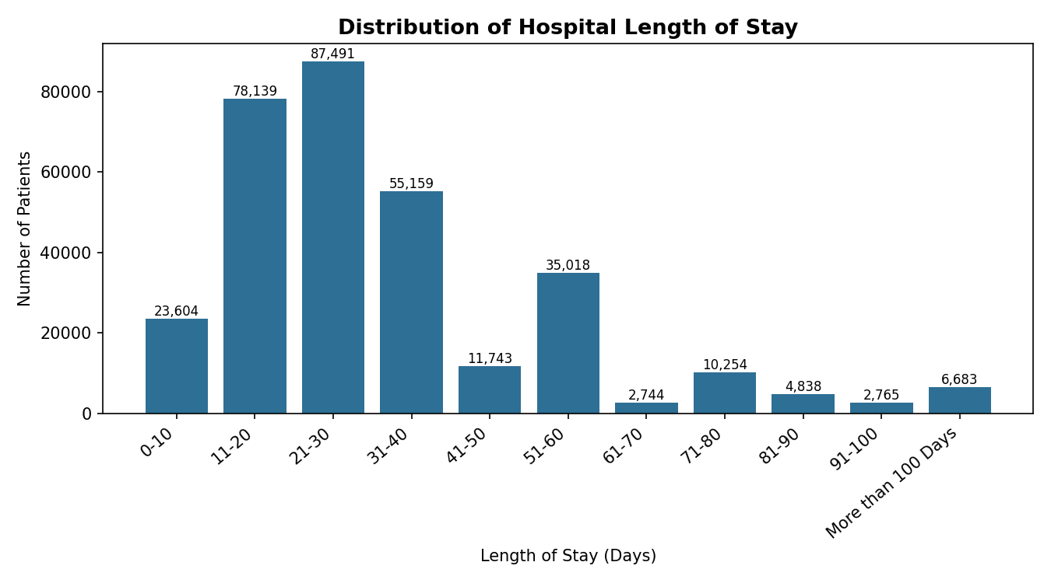
Figure 1 — Distribution of patients across the 11 length-of-stay categories.
The target distribution is strongly right-skewed. The 21-30 day (87,491 patients) and 11-20 day (78,139 patients) buckets together account for over half of all admissions, while stays beyond 60 days form a long clinical tail. Roughly 70% of patients are discharged within 40 days, giving hospitals a strong operational baseline for general ward turnover, but the small, persistent "More than 100 Days" group (6,683 patients) disproportionately consumes beds, staff time, and equipment relative to its size.

4.2 Admissions by Department
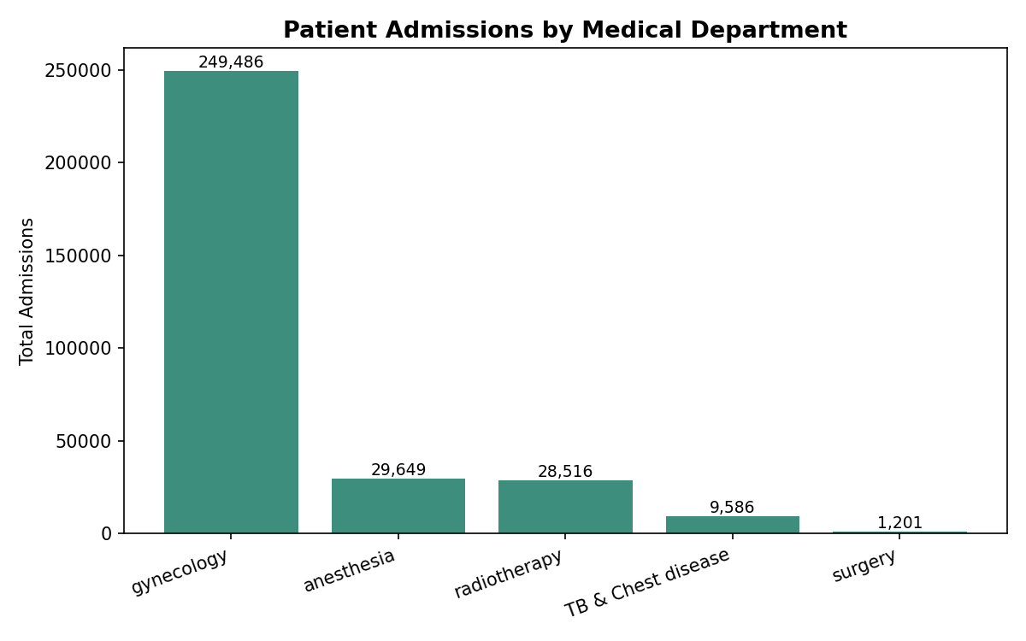
Figure 2 — Patient volume across medical departments.
Gynecology dominates patient intake by a wide margin (roughly three-quarters of all admissions), followed distantly by Anesthesia and Radiotherapy, with Surgery and TB & Chest disease seeing far fewer cases. This indicates hospital capital and specialized staff should be weighted heavily toward obstetrics/gynecology infrastructure.

4.3 Severity of Illness
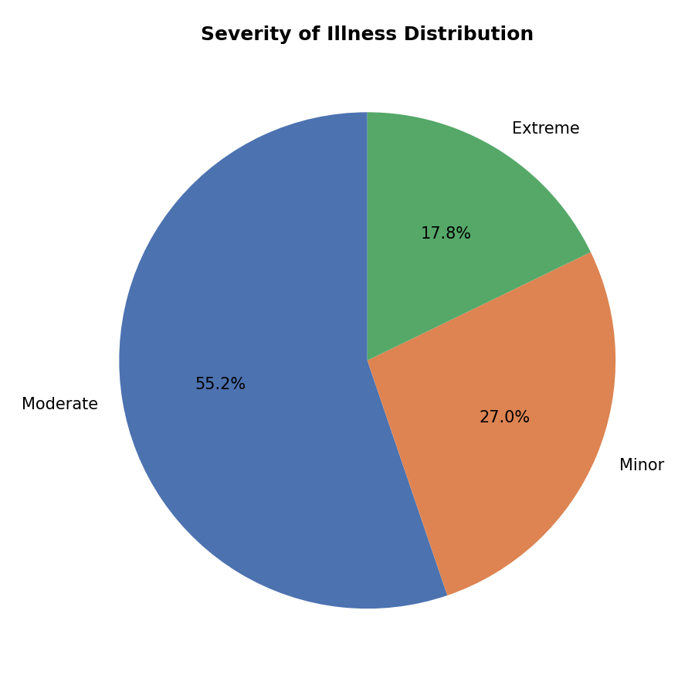
Figure 3 — Proportional breakdown of severity at triage.
Moderate severity cases make up the majority (55%) of admissions, with Minor (27%) and Extreme (18%) making up the remainder. Because Moderate is the largest group overall, it dominates the raw counts within almost every stay-duration bucket — which is why severity's true effect on stay length needed to be confirmed statistically (see Hypothesis Testing) rather than read directly off a count chart.

4.4 Visitors and Length of Stay
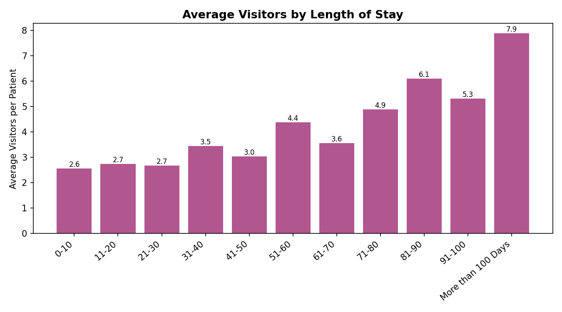
Figure 4 — Average number of visitors per patient by stay duration.
Average visitor counts climb steadily and consistently with stay length — from about 2.6 visitors for a 0-10 day stay to nearly 7.9 visitors for stays exceeding 100 days. This is one of the clearest, most monotonic relationships found in the data and later shows up as the single most important predictor in the final model.

4.5 Other Notable Patterns
- Admission type: Trauma admissions consistently skew toward longer stays (11-60+ days) compared to Emergency or Urgent admissions, reflecting more complex recovery pathways.
- Ward type: Wards R and Q handle the bulk of medium-length stays (11-30 days), while wards S and P are associated with more extended, acute cases.
- Admission deposit: The median admission deposit stays remarkably flat (roughly ₹4,300–₹4,900) regardless of eventual stay length — deposits appear to be set by department/hospital policy rather than expected duration, which is a useful negative finding for revenue-cycle teams (hospitals may be under-collecting for patients who end up staying much longer).
- Bed grade: Bed Grade shows very little consistent effect on stay length — medians stay in the 2-3 range across all four grades — suggesting stay duration is driven more by patient condition than room amenities.
- Weak / redundant features: Available_Extra_Rooms_in_Hospital, City_Code_Patient, and Ward_Facility_Code showed very weak correlation with the target and with each other, marking them as unlikely to be strong standalone predictors.

5. Statistical Hypothesis Testing
Three hypotheses were tested to confirm relationships suggested by the visual analysis, using a 0.05 significance threshold.
Hypothesis | Test | Statistic | p-value | Conclusion
Severity of Illness vs. Stay are independent | Chi-Square | χ² = 6616.5 | < 0.0001 | Rejected H0 — significant association
Ward Type vs. Stay are independent | Chi-Square | χ² = 18451.4 | < 0.0001 | Rejected H0 — significant association
Extra rooms do not differ by hospital region | One-Way ANOVA | F = 19.79 | 2.55e-9 | Rejected H0 — rooms differ by region

All three null hypotheses were rejected, statistically confirming that both Severity of Illness and Ward Type are significantly associated with length of stay, and that extra room availability is not uniformly distributed across hospital regions.

6. Feature Engineering & Pre-processing
- Ordinal encoding: Age, Stay, and Severity_of_Illness were ordinal-encoded (preserving natural order), since '31-40' is meaningfully greater than '0-10', and 'Extreme' is meaningfully more severe than 'Minor'.
- One-hot encoding: Hospital_type_code, Hospital_region_code, Department, Ward_Type, Ward_Facility_Code, and Type_of_Admission were one-hot encoded, since these are nominal categories with no inherent order.
- Correlation-based feature selection: Features with near-zero correlation to the target (|r| < 0.01), including Ward_Type_U, Hospital_type_code_e, City_Code_Hospital, Hospital_region_code_Y/Z, Ward_Type_T, and City_Code_Patient, were dropped to reduce noise and dimensionality.
- Train/test split: An 80/20 train-test split was used, giving the model sufficient data to learn from while preserving a sizeable, representative test set for evaluation.
- Scaling: StandardScaler was applied to numeric features for the scale-sensitive models (Logistic Regression, KNN) so that no single feature (e.g., Admission_Deposit) dominates purely due to its range.
- Class imbalance: the training set has an imbalance ratio of 31.9:1 between the largest and smallest class, so class_weight='balanced' was applied wherever supported, and weighted precision/recall/F1 were used for evaluation instead of relying on raw accuracy.

Top Predictive Features
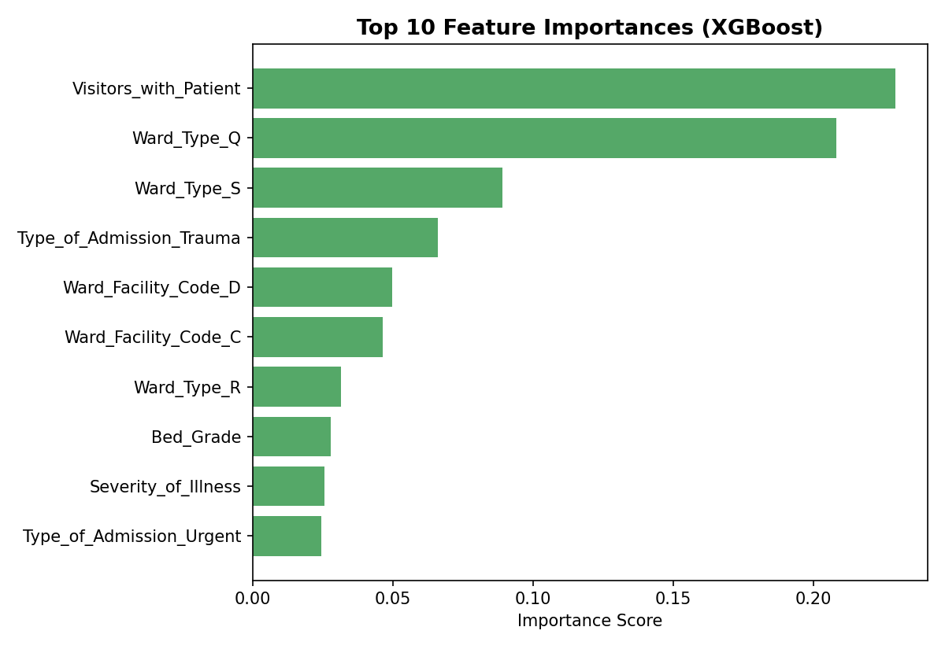
Figure 5 — Top 10 features by importance, from the trained XGBoost model.
Visitors_with_Patient and Ward_Type emerged as the dominant predictors, followed by Type_of_Admission (Trauma), Ward_Facility_Code, Bed_Grade, and Severity_of_Illness — broadly confirming the patterns surfaced during exploratory analysis and hypothesis testing.

7. Model Building & Comparison
Five classification algorithms were trained on the processed dataset and evaluated on a held-out 20% test set using Accuracy, Weighted Precision, Weighted Recall, and Weighted F1-score.
Model | Accuracy | Precision | Recall | Weighted F1
XGBoost | 0.419 | 0.394 | 0.419 | 0.383
Random Forest | 0.380 | 0.374 | 0.380 | 0.369
KNN | 0.345 | 0.321 | 0.345 | 0.324
LightGBM | 0.293 | 0.395 | 0.293 | 0.305
Logistic Regression | 0.244 | 0.340 | 0.244 | 0.260

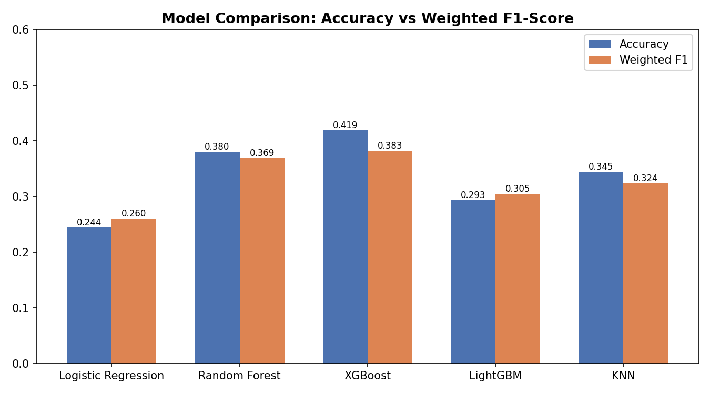
Figure 6 — Accuracy vs. weighted F1-score across all five models.

Why Weighted F1 as the Primary Metric
Given the ~32:1 class imbalance, raw accuracy is misleading — a model could score well simply by always predicting the majority class while completely failing to identify rare but clinically critical long-stay patients. Weighted F1-score balances precision (avoiding unnecessary resource allocation from false alarms) and recall (catching real long-stay cases) across all 11 classes, weighted by class support, making it the most reliable single metric for this imbalanced, multi-class problem.

Model Selection
XGBoost produced the best overall result (weighted F1 = 0.383, accuracy = 0.419), ahead of the other ensemble and linear baselines. As a gradient-boosted ensemble, it captures non-linear interactions between severity, admission type, and ward assignment far better than Logistic Regression, and it generalizes more effectively than the single-pass Random Forest on this dataset. All models still show a real ceiling on this task: with 11 ordinal classes and heavy overlap between adjacent stay buckets (e.g., 21-30 vs. 31-40 days), no model exceeded roughly 42% accuracy — a signal that the current feature set only partially explains stay duration, and that finer-grained clinical or temporal data would likely be needed to push performance materially higher.

8. Key Challenges Faced
- 1. Severe class imbalance: The target distribution is heavily right-skewed (32:1 imbalance ratio), which pushes naive models toward always predicting the majority classes (11-30 days) while missing rare, high-cost long-stay cases. This required weighted evaluation metrics and class-weighting strategies rather than raw accuracy.
- 2. Non-linear feature relationships: Severity of illness and admission type interact with stay duration in non-linear ways (e.g., Trauma admissions consistently produce longer stays regardless of severity level), which limits the ceiling for simple linear models like Logistic Regression and favors ensemble methods.
- 3. Ordinal nature of the target: Stay is an ordered categorical variable (a 41-50 day stay is 'closer' to 31-40 than to 0-10), but standard multi-class classifiers treat all misclassifications equally regardless of how far off the prediction is. Ordinal encoding was used for the target and Age, but the classifiers themselves were not ordinal-aware, which is a known limitation of the current approach.
- 4. Missing and erroneous data: Bed_Grade (113 rows) and City_Code_Patient (4,532 rows) had missing values, and the raw 'Nov-20' Excel auto-formatting artifact had to be manually identified and corrected in both the Age and Stay columns before encoding.
- 5. Feature redundancy: Several one-hot encoded columns (Ward_Type_U, Hospital_type_code_e, City_Code_Hospital, Hospital_region_code_Y/Z, Ward_Type_T, City_Code_Patient) showed almost no correlation with the target, adding noise and dimensionality without predictive benefit, and had to be identified and removed.
- 6. Dataset scale: At 318,438 rows and 18 source columns (expanding to dozens after one-hot encoding), fitting KNN and performing hyperparameter search became noticeably slower, requiring reduced cross-validation folds and search iterations to keep runtimes practical.

9. Conclusion & Recommendations
This analysis set out to predict hospital length of stay across 11 ordinal categories using 318,438 patient admission records. Despite a severe 32:1 class imbalance, ensemble methods clearly outperformed the linear baseline, with XGBoost delivering the strongest weighted F1-score (0.383). Severity of illness, ward type, admission type, and number of visitors were confirmed — both visually and statistically — as the strongest drivers of stay duration.

Business Recommendations
- Bed & ward planning: use predicted stay-duration buckets to prioritize scarce beds for likely long-stay patients and keep general wards optimized for the high-volume 11-30 day cohort.
- Visitor-based early warning: since visitor count rises sharply with stay length, monitoring visitor patterns can act as an early operational signal for cases likely to extend, and also informs infection-control and ward-traffic policies.
- Revenue cycle: because admission deposits are currently flat regardless of predicted stay length, consider tying deposit policy to a length-of-stay risk score to reduce under-collection on long-stay cases.
- Clinical pathways: route Trauma admissions and Extreme-severity cases into specialized long-stay care pathways earlier, since these groups are statistically confirmed to run longer.

Future Work
- Adopt ordinal-aware modeling techniques (e.g., ordinal regression or cost-sensitive loss functions that penalize distant misclassifications more) to better respect the natural ordering of the Stay target.
- Incorporate temporal features (admission date, seasonality, day-of-week) which were unavailable in this aggregated dataset but likely carry predictive signal.
- Deploy the selected model as a scoring microservice integrated into the hospital admission workflow, with ongoing monitoring for model and data drift.

