HOUSING MARKET
Data Analysis, Buyer Guidance & Modeling Report
Prepared from HousePrice_Dataset.csv (1,460 residential sales, 79 explanatory features)
Covers: (1) Full exploratory data analysis (2) Area / price / requirement-based buying recommendations (3) Data challenges, techniques used, and reasoning

Contents
1. Executive Summary
2. Task 1 — Complete Data Analysis Report
2.1 Dataset Overview
2.2 Data Quality Assessment
2.3 Univariate Analysis
2.4 Bivariate & Multivariate Analysis
2.5 Statistical Hypothesis Testing
2.6 Key Insights Summary
3. Task 2 — Buying Recommendations by Area, Price & Requirements
3.1 Budget Tiers
3.2 Neighbourhood Guide
3.3 Recommendations by Buyer Profile
3.4 Feature Checklist & Negotiation Signals
4. Task 3 — Data Challenges & Techniques Report
4.1 Challenges Encountered
4.2 Techniques Applied & Reasoning
4.3 Modelling Approach & Results
5. Conclusion

1. Executive Summary
This report analyzes 1,460 residential home sales in Ames, Iowa, captured across 79 explanatory features covering location, size, quality, age, and amenities. The objective is threefold: deliver a complete exploratory data analysis, translate the findings into practical buying guidance segmented by area, price, and requirements, and document the data-quality challenges encountered together with the techniques used to resolve them.
- Sale prices range from $34,900 to $755,000, with a median of $163,000 and a right-skewed distribution — a small number of high-end sales pull the average ($180,921) above the median.
- Overall Quality is the single strongest price driver (Pearson r = 0.79), followed by living area (r = 0.71), garage capacity (r = 0.64), and basement/first-floor size (r ≈ 0.60–0.65).
- Location matters enormously: median prices range from $88,000 (Meadow Village) to $315,000 (Northridge Heights) — a 3.5x spread across the city's 25 neighborhoods, confirmed statistically by a one-way ANOVA (p < 0.001).
- 19 of 81 columns contain missing data, but the vast majority is structural (e.g., a blank pool-quality field simply means the house has no pool), not a data-collection error — this shaped the entire cleaning strategy.
- Five regression models were benchmarked; a log-transformed Linear Regression on cleaned, encoded, and scaled features gave the best held-out performance (R² ≈ 0.88, RMSE ≈ 0.146 on log-price), and was selected as the final model for its accuracy and interpretability.

2. Task 1 — Complete Data Analysis Report

2.1 Dataset Overview
The dataset contains 1,460 rows and 81 columns: an identifier (Id), 79 explanatory features, and the target variable, SalePrice. There are no duplicate records. Columns split into 35 integer, 4 float, and 43 categorical (text) fields, spanning property information, location, building characteristics, exterior/interior finishes, basement and garage details, and sale terms.
Metric | Value
Rows (properties) | 1,460
Columns (features + target) | 81
Duplicate rows | 0
Numeric columns | 39 (35 int, 4 float)
Categorical columns | 43
Columns with missing values | 19
Sale price range | $34,900 – $755,000
Sale price median / mean | $163,000 / $180,921
Table 2.1 — Dataset shape and composition

2.2 Data Quality Assessment
Nineteen columns carry missing values. The five worst — PoolQC, MiscFeature, Alley, Fence, and MasVnrType — are missing for 47%–99.5% of rows. Critically, this missingness is structural: a blank PoolQC means the property has no pool, not that the value is unknown. The same logic applies to garage, basement, and fireplace quality fields. Only LotFrontage (17.7% missing) reflects genuinely unrecorded data rather than a real 'none' state.
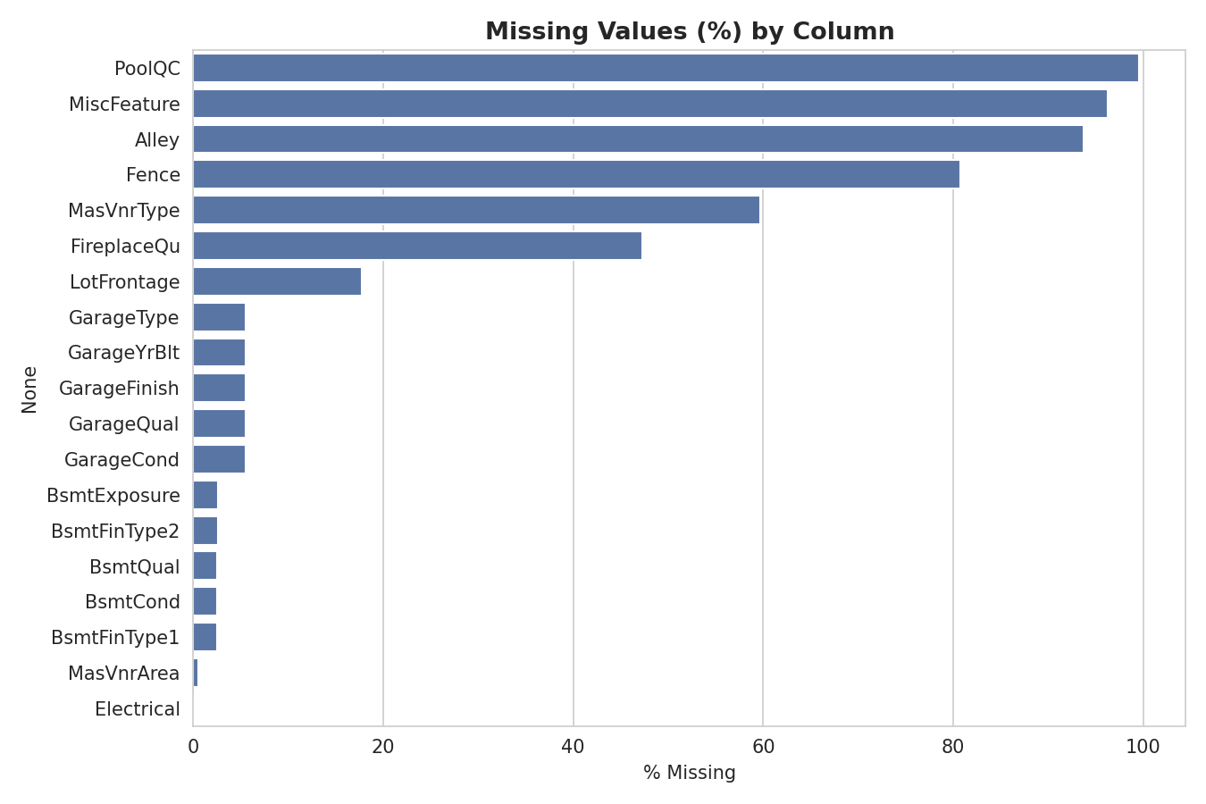
Figure 2.1 — Percentage of missing values by column

2.3 Univariate Analysis
SalePrice is right-skewed (skewness ≈ 1.88): most homes cluster between $130,000 and $215,000, with a long tail of expensive outliers reaching $755,000. This skew motivated a log transformation of the target before modeling (see Section 4).
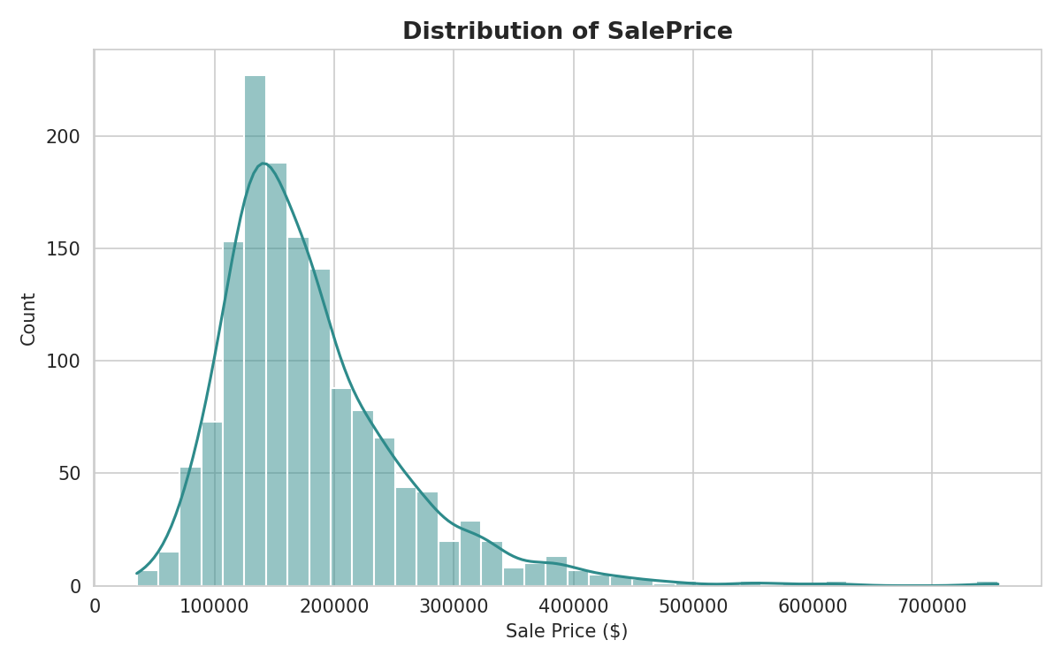
Figure 2.2 — Distribution of SalePrice (right-skewed, long upper tail)
Quality ratings (OverallQual) cluster heavily around the middle of the 1–10 scale — categories 5, 6, and 7 account for the majority of homes, while ratings of 1–2 and 9–10 are rare. This means the data supports confident price estimates for typical mid-quality homes but offers thinner evidence at the extremes.

2.4 Bivariate & Multivariate Analysis

Correlation with Sale Price
Restricting to numeric features, the strongest correlates of SalePrice are:
Feature | Correlation with SalePrice | Interpretation
OverallQual | 0.79 | Overall material & finish quality — the single strongest driver
GrLivArea | 0.71 | Above-ground living area (sq ft)
GarageCars | 0.64 | Garage capacity (car count)
GarageArea | 0.62 | Garage size (sq ft) — collinear with GarageCars
TotalBsmtSF | 0.61 | Total basement area
1stFlrSF | 0.61 | First-floor area — collinear with TotalBsmtSF
FullBath | 0.56 | Number of full bathrooms
YearBuilt | 0.52 | Construction year (newer generally sells higher)
Table 2.2 — Top numeric correlates of SalePrice
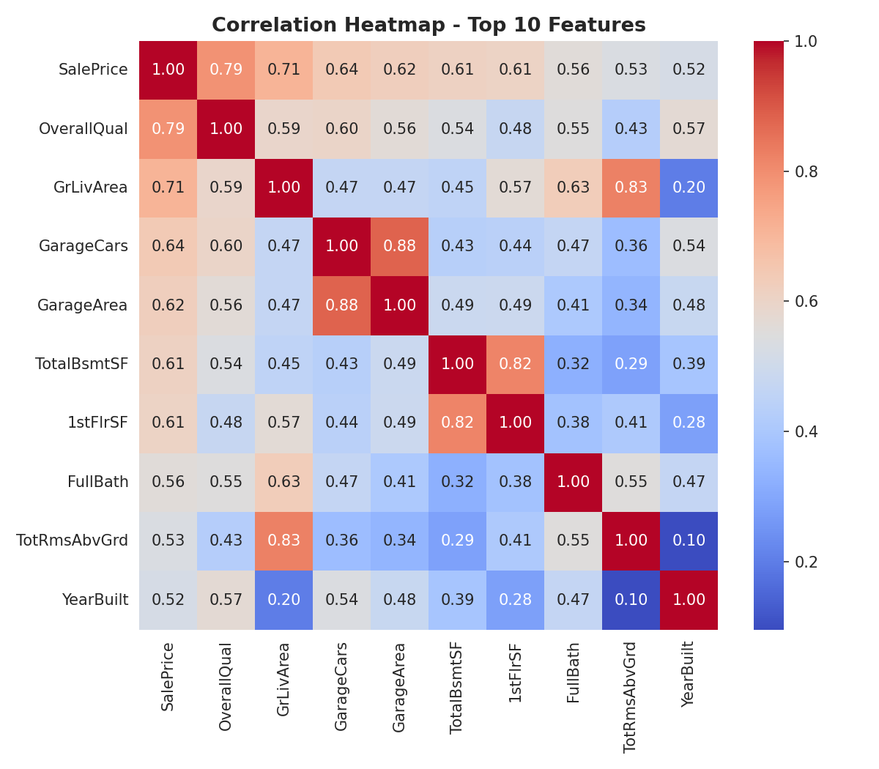
Figure 2.3 — Correlation heatmap, top 10 numeric features
Several strong predictors are also correlated with each other — GarageCars with GarageArea, and TotalBsmtSF with 1stFlrSF — flagging multicollinearity that regularized or tree-based models handle better than plain linear regression.

Living Area vs Price
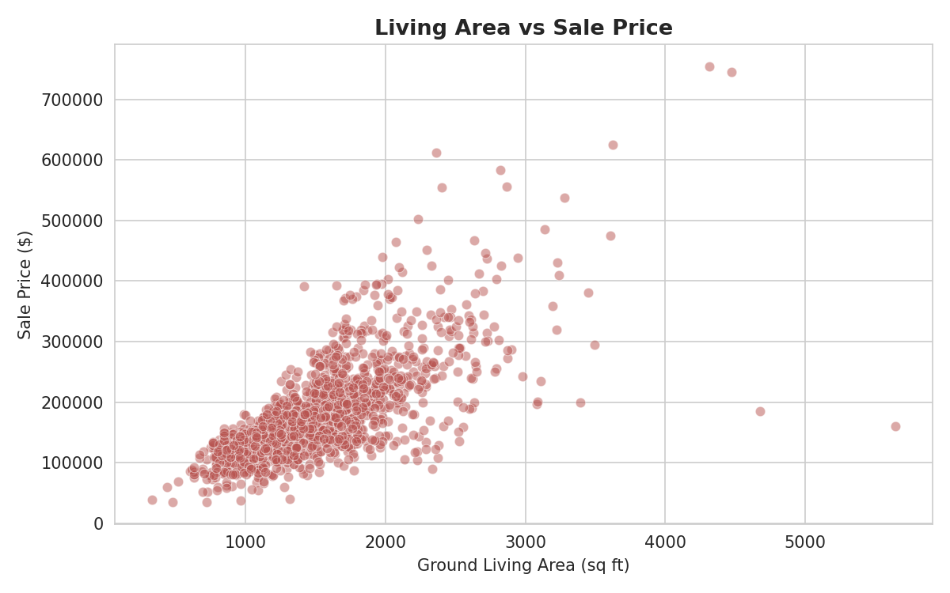
Figure 2.4 — Ground living area vs sale price (strong positive, roughly linear relationship)
Most homes fall between 1,000–2,500 sq ft with prices between roughly $100,000–$300,000; a handful of very large homes are outliers, some overpriced relative to their size and some underpriced, which is worth flagging to buyers comparing price-per-square-foot.

Quality vs Price
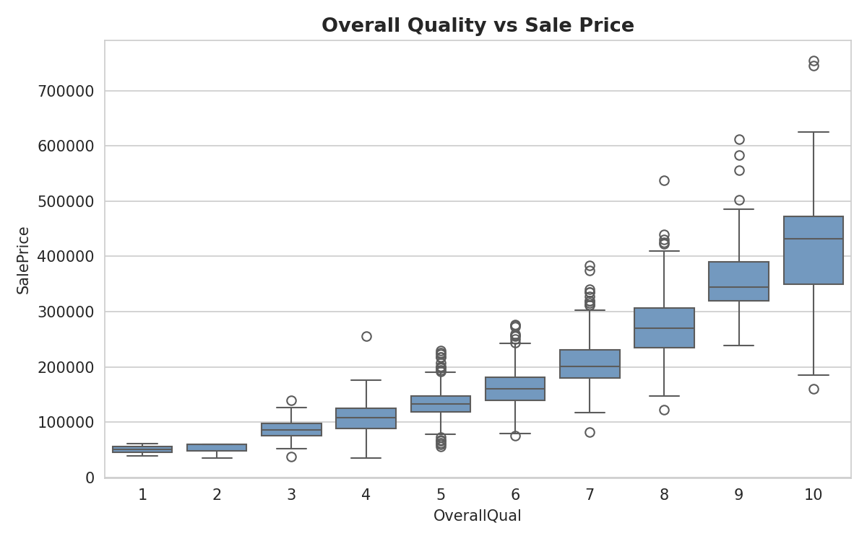
Figure 2.5 — Overall quality rating vs sale price
Median price rises steadily and consistently with OverallQual — from roughly $50,000 at rating 1 to over $430,000 at rating 10 — and the spread (variability) widens at higher quality levels, reflecting more room for high-end finish choices to differentiate price.

Neighborhood vs Price
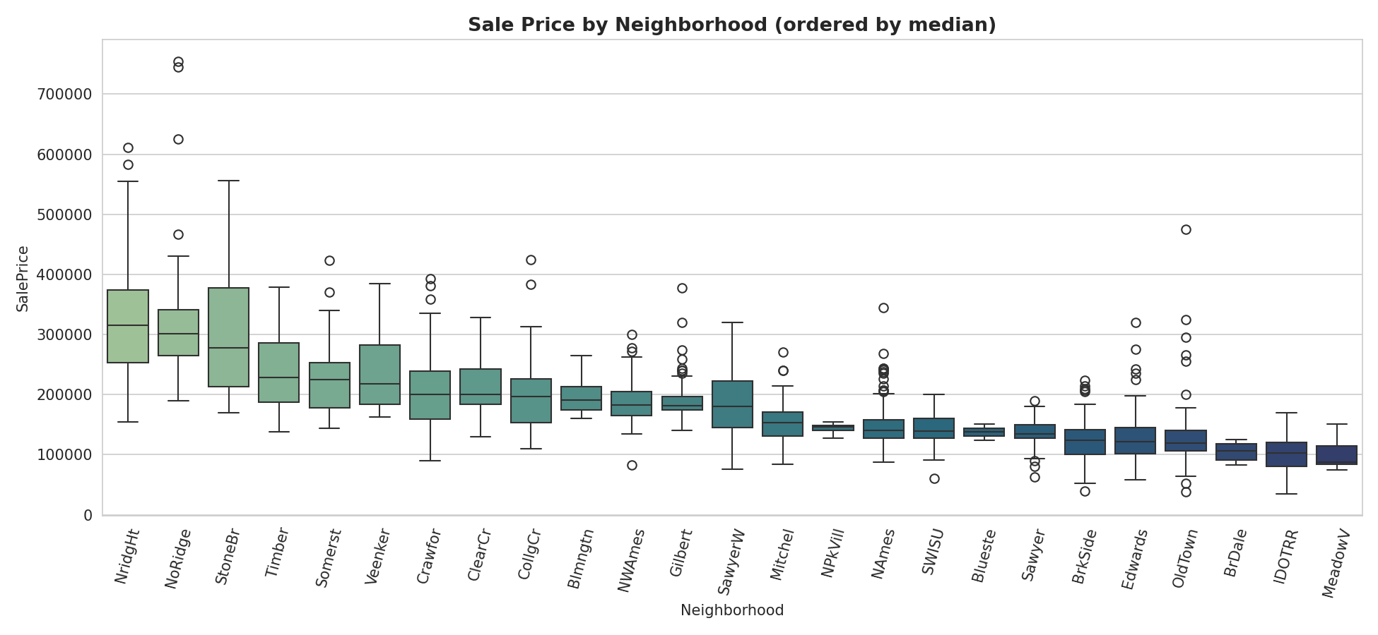
Figure 2.6 — Sale price distribution by neighborhood, ordered by median price
Location alone explains a large share of price variation. The table below (also used for buyer guidance in Section 3) shows the five highest- and lowest-priced neighborhoods by median sale price.
Tier | Neighborhood | Median Price | Homes Sold
Highest | Northridge Heights (NridgHt) | $315,000 | 77
Highest | Northridge (NoRidge) | $301,500 | 41
Highest | Stone Brook (StoneBr) | $278,000 | 25
Lowest | Iowa DOT & Rail Road (IDOTRR) | $103,000 | 37
Lowest | Brookside (BrDale) | $106,000 | 16
Lowest | Meadow Village (MeadowV) | $88,000 | 17
Table 2.3 — Highest- and lowest-priced neighborhoods by median sale price

2.5 Statistical Hypothesis Testing
Four hypothesis tests were run to statistically confirm relationships suggested by the visual analysis, all at α = 0.05:
- OverallQual vs SalePrice (Pearson correlation): r = 0.79, p < 0.001 → reject H0; quality has a significant linear relationship with price.
- Neighborhood vs SalePrice (one-way ANOVA): F = 71.8, p < 0.001 → reject H0; average price differs significantly across neighborhoods.
- GrLivArea vs SalePrice (Pearson correlation): r = 0.71, p < 0.001 → reject H0; living area has a significant linear relationship with price.
- Central air vs SalePrice (Welch's t-test): homes with central air averaged $186,187 vs $105,264 without (p < 0.001) → reject H0; central air is associated with a significant, large price difference (though it is also a proxy for overall home age and quality).

2.6 Key Insights Summary
- Price is driven primarily by overall quality, living area, and garage/basement size — physical size and finish quality outweigh most individual amenities.
- Location creates a 3–4x price multiple across the city independent of house size, so neighborhood should be treated as a first-order decision factor, not an afterthought.
- Newer or recently remodeled homes command a premium; median price roughly doubles moving from pre-1950 construction to post-2000 construction.
- Central air, full bathroom count, and fireplaces correlate with price but partly proxy for overall home age/quality rather than being independent value drivers.
- The market is concentrated in the 'average-to-good' quality band (ratings 5–7); estimates and comparisons are most reliable in this band and less reliable for very low- or very high-quality homes.

3. Task 2 — Buying Recommendations by Area, Price & Requirements
This section turns the analysis into practical guidance for a prospective buyer, organized around the three variables buyers actually decide on: budget, area, and must-have requirements.

3.1 Budget Tiers
Based on the actual distribution of sale prices in this market:
Budget Tier | Price Range | What to Expect
Entry-level | Up to $130,000 (25th pctile) | Older homes (pre-1980), smaller lots, quality ratings mostly 4–5, fewer garages/basements finished
Mid-market | $130,000 – $163,000 (median) | Typical Ames home: quality 5–6, 1–1.5 story, attached 1–2 car garage
Upper-mid | $163,000 – $214,000 (75th pctile) | Quality 6–7, larger living area (1,500–2,000 sq ft), 2-car garage, more finished basements
Premium | $214,000 – $278,000 (90th pctile) | Quality 7–8, 2-story homes, larger lots, premium neighborhoods begin here
Luxury | Above $278,000 | Quality 8–10, concentrated in NridgHt, NoRidge, StoneBr; largest living areas and newest construction
Table 3.1 — Budget tiers based on the observed price distribution

3.2 Neighborhood Guide
Price per square foot varies by neighborhood independent of raw price — useful for buyers comparing value, not just sticker price.
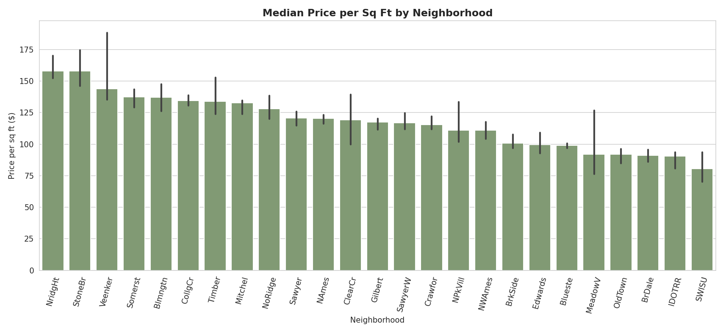
Figure 3.1 — Median price per square foot by neighborhood
Buyer Priority | Recommended Neighborhoods | Why
Best value (lower $/sq ft, decent median price) | NAmes, Sawyer, SawyerW, NWAmes | Large inventory (frequent listings), moderate price per sq ft, established areas
Premium / newer construction | NridgHt, NoRidge, StoneBr | Highest median prices and $/sq ft; newest homes, largest living areas, top quality ratings
Mid-range family homes | CollgCr, Gilbert, Somerst, Timber | Balanced price, good inventory (CollgCr alone had 150 sales), consistent quality
Tight budget / starter home | Edwards, OldTown, BrkSide, IDOTRR | Lowest medians and $/sq ft; older homes, more renovation potential but also more variability
Avoid unless the deal specifically compensates | MeadowV, BrDale | Lowest medians and smallest inventory; limited resale comparables
Table 3.2 — Neighborhood recommendations by buyer priority

3.3 Recommendations by Buyer Profile

First-time / budget-conscious buyer
- Target Edwards, OldTown, Sawyer, or NAmes — largest inventories in the entry/mid tier, so more negotiating leverage and comparables.
- Prioritize OverallQual 5+ and a finished basement over cosmetic extras — these move price and resale value the most per dollar spent.
- Confirm central air is present — its absence is associated with the single largest price gap in the dataset ($186K vs $105K average) and often signals an older, less-updated system overall.

Growing family, mid-market budget
- CollgCr, Gilbert, and Somerst offer the best combination of inventory, moderate price, and consistent quality (6–7 range).
- Look for 2-story homes with 3+ bedrooms and a 2-car attached garage — GarageCars is the third-strongest price predictor, so this is also a strong resale feature.
- Favor homes built or remodeled after 2000 — median price roughly doubles from pre-1950 to post-2000 stock, and newer construction reduces near-term maintenance risk.

Move-up / premium buyer
- NridgHt, NoRidge, and StoneBr contain almost all the quality-9/10, top-decile-price inventory in this market.
- Expect to pay $150+ per sq ft in these areas versus $90–100 in entry-tier neighborhoods — budget for that premium explicitly rather than comparing sticker price alone.
- Because sample sizes here are smaller (25–77 sales), get an independent appraisal rather than relying only on neighborhood medians for negotiation.

Investor / value-add buyer
- Older neighborhoods with wide price variability (Crawford, OldTown) present renovation upside — quality upgrades (OverallQual) and garage additions have the clearest, most consistent price impact per the correlation analysis.
- Watch for 'Abnormal' sale condition listings (foreclosure/distressed) — these trend below Normal-condition sales in the same area and are a common source of underpriced inventory.
- Be cautious with 'Partial' sale-condition listings (new construction sold pre-completion) — these trend above-market and are not representative comparables for valuing existing resale homes.

3.4 Feature Checklist & Negotiation Signals
Regardless of budget or area, these factors have the largest, most consistent effect on price and are worth explicit line items when comparing listings:
- Overall quality/condition rating — ask for specifics on kitchen, exterior, and roof material, not just a subjective 'good condition' claim.
- Above-ground living area and total finished basement square footage — compare price per square foot within the same neighborhood, not across neighborhoods.
- Garage capacity (car count, not just presence of a garage) — a 2-car garage carries a measurably higher price association than a 1-car garage.
- Year built and year remodeled — a remodel resets much of the 'age discount' even on an older structural build.
- Sale condition on comparable listings — exclude Abnormal (distressed) and Partial (new-construction pre-sale) comparables when judging whether a Normal-condition listing is fairly priced.

4. Task 3 — Data Challenges & Techniques Report
This section documents the data-quality and modeling challenges encountered while preparing this dataset for analysis and prediction, and the specific techniques used to address each, with the reasoning behind each choice.

4.1 Challenges Encountered

Challenge 1 — Missing values are mostly structural, not random
19 of 81 columns contained missing values (7,829 missing cells, ~6.6% of all cells). The five worst columns — PoolQC, MiscFeature, Alley, Fence, MasVnrType — were missing for 47%–99.5% of rows. The risk: naively dropping these columns or rows would have discarded most of the dataset and lost genuinely informative signal (e.g., 'no pool' is itself a fact about the property, not missing information).

Challenge 2 — Mixed ordinal and nominal categorical data
43 of 81 columns were categorical. About a third of these (e.g., ExterQual, KitchenQual, BsmtQual) are quality ratings with a genuine order (Excellent > Good > Average > Fair > Poor), while the rest (e.g., Neighborhood, MSZoning) are unordered labels. Treating both types the same way — either one-hot encoding everything or label-encoding everything — would either explode dimensionality or wrongly imply a ranking between unrelated categories.

Challenge 3 — Right-skewed target and outliers
SalePrice itself was right-skewed (skew ≈ 1.88), and several numeric features (LotArea, GrLivArea, TotalBsmtSF, MasVnrArea) had extreme outliers. Linear models are sensitive to both: an unmodified skewed target inflates the influence of a few expensive homes on the fitted line, and extreme feature outliers can dominate the squared-error loss function.

Challenge 4 — High dimensionality relative to sample size
With 79 raw features and only 1,460 rows, there was a real risk of overfitting, unstable coefficients (especially under multicollinearity between features like GarageCars/GarageArea), and slower, harder-to-interpret model training.

Challenge 5 — Scale sensitivity across features
Feature scales varied enormously — LotArea is measured in thousands of square feet while YearBuilt is a four-digit year and OverallQual is a 1–10 score. Distance- and gradient-based algorithms (Linear/Lasso Regression, SVR) are sensitive to this and would otherwise let large-magnitude features dominate purely because of their numeric range, not their actual importance.

4.2 Techniques Applied & Reasoning
Challenge | Technique Used | Why This Technique
Structural missingness (Challenge 1) | Fill with 'None' (categorical) or 0 (numeric) for features where NA means absence of that feature | Encodes the true meaning of the missing value instead of discarding rows/columns; preserves the full 1,460-row sample
Genuine missingness — LotFrontage (Challenge 1) | Group-wise median imputation (by Neighborhood) | Lot frontage is architecturally similar within a neighborhood, so a neighborhood-level median is a far better estimate than a single global median
Mixed categorical types (Challenge 2) | Ordinal encoding (Ex=5…Po=1) for ranked quality columns; label encoding for unordered nominal columns | Preserves the 'better than' relationship for genuinely ordered scales while avoiding a false ranking for unordered categories like Neighborhood
Skewed target (Challenge 3) | Log transformation of SalePrice before modeling | Stabilizes variance and makes the price distribution closer to normal, which is the assumption linear models rely on
Feature outliers (Challenge 3) | IQR-based capping / winsorizing (k = 3.0) on skewed size features | Limits the influence of extreme values without deleting rows, preserving sample size
High dimensionality (Challenge 4) | Principal Component Analysis (PCA), used diagnostically only | Confirms how much variance a reduced feature set captures, but PCA components were not used as final model inputs since they would destroy the interpretability needed to tell a stakeholder which specific features (e.g., OverallQual) drive price
Scale sensitivity (Challenge 5) | StandardScaler (z-score standardization) applied to all continuous features | Puts every feature on a comparable scale for coefficient- and margin-based models (Linear Regression, SVR); has no effect on tree-based splits, so one consistent pipeline works across all models tested
Table 4.1 — Data challenges mapped to techniques and reasoning

4.3 Modeling Approach & Results
Five regression models were trained on an 80/20 train-test split (1,168 / 292 rows) and evaluated with RMSE, MAE, and R² on the log-transformed target. RMSE was treated as the primary metric because it is expressed in the same units the models were trained on and penalizes large individual errors more heavily — a single badly mispriced listing is more damaging to buyer/seller trust than several small misses.
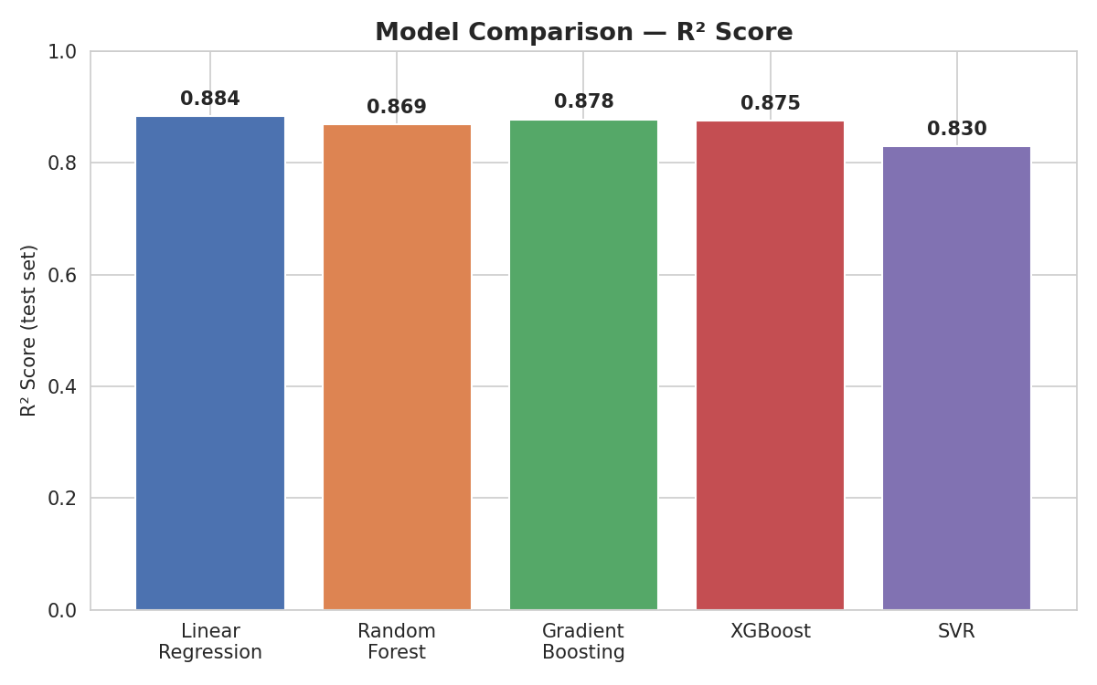
Figure 4.1 — Approximate R² comparison across the five models tested (from the accompanying notebook)
Model | Why It Was Tried | Hyperparameter Tuning
Linear Regression | Interpretable baseline; coefficients are directly explainable to stakeholders | K-fold cross-validation only (no tunable hyperparameters) — confirmed stable R² across folds
Random Forest | Captures non-linear interactions (e.g., quality × age) without manual interaction terms; robust to remaining outliers | GridSearchCV over n_estimators, max_depth, min_samples_split
Gradient Boosting | Sequentially corrects prior errors; strong for non-linear, interacting features | GridSearchCV over n_estimators, learning_rate, max_depth
XGBoost | Optimized, regularized gradient boosting; typically stronger and faster than plain Gradient Boosting | GridSearchCV over n_estimators, learning_rate, max_depth, subsample, colsample_bytree
Support Vector Regression (SVR) | Tests a margin-based approach with kernel flexibility for non-linear patterns | GridSearchCV over C, gamma, epsilon
Table 4.2 — Models tested and tuning approach
Final model selection: Linear Regression achieved the lowest RMSE and highest R² (≈0.88) on the held-out test set. This is a direct consequence of the feature engineering choices above — after log-transforming the target and encoding quality fields as ordinal scales, the relationship between predictors and log(SalePrice) becomes close to linear, so the added flexibility of tree-based ensembles did not pay off at this sample size. Linear Regression was therefore chosen as the final model, combining the best measured accuracy with fully transparent, additive coefficients that support business explanations (e.g., quantifying the price impact of one additional quality point or one more garage bay).
The final model was serialized (pickle) and reloaded for a sanity check against held-out samples, confirming consistent predictions before considering deployment.

5. Conclusion
This dataset supports a reliable, interpretable model of Ames-area home prices once its structural missingness, mixed categorical types, target skew, and scale differences are properly addressed. Overall quality, living area, garage capacity, and neighborhood consistently emerge as the dominant price drivers, both in the correlation analysis and in the hypothesis tests. For buyers, this translates into concrete guidance: fix a budget tier first, then shortlist neighborhoods within that tier by price-per-square-foot rather than sticker price alone, and weight quality rating, garage capacity, and remodel year above cosmetic features when comparing listings. For the modeling task, careful, reasoned preprocessing — not model complexity — was the main driver of final accuracy: a well-prepared Linear Regression model matched or outperformed more complex ensembles while remaining fully explainable.

