DATA CHALLENGES
& TECHNIQUES USED
A Technical Note on Data Issues Encountered and How They Were Addressed
Project: Medical Insurance Cost Prediction
Dataset: Insurance_Datasets.csv | 1,338 records · 7 features

1. Purpose of This Note
While the dataset used in this project is clean and well-structured on the surface (no missing values, consistent types), several data-quality and modeling challenges still had to be identified and handled before a reliable model could be built. This note documents each challenge, the technique used to address it, and the reasoning behind that choice — so the modeling decisions in the main report can be traced back to specific, evidence-based problems in the data.
Five challenges are covered:
- Right-skewed target variable with high-cost outliers
- Categorical variables that models cannot process directly
- Class imbalance in the smoker attribute
- Weak / low-signal features diluting the model
- Non-linear, interacting relationships between features and cost

2. Challenge 1 — Skewed Target Variable & Outliers

The problem
The charges column is strongly right-skewed (skewness ≈ 1.52). Most customers pay relatively low amounts, but a smaller group pays very high charges — up to $63,770 against a median around $9,382. Using the IQR method (upper fence ≈ $34,489), 139 of 1,338 records (about 10%) fall above the typical outlier threshold.
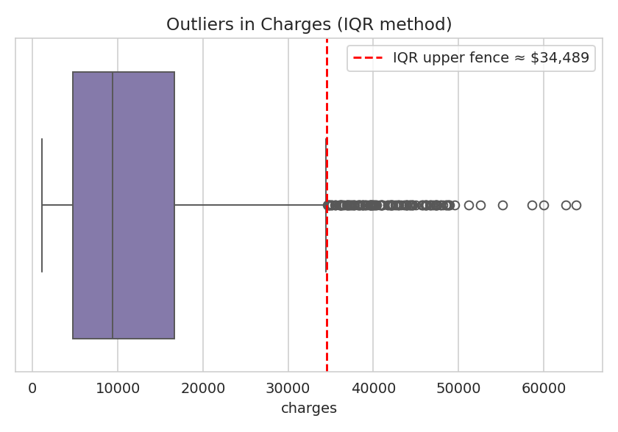
Figure 1. Boxplot of charges showing the long right tail and IQR outlier threshold.
This matters because most regression models (especially Linear Regression) assume errors are roughly normally distributed and are sensitive to large-magnitude target values — a few extreme charges can dominate the loss function and pull predictions away from the bulk of ordinary customers.

The technique used: log transformation
Rather than deleting or capping the high-cost records, a natural-log transform was applied to charges (charges_log = ln(charges)). This reduced the skewness from 1.52 to about −0.09 — i.e., close to symmetric.
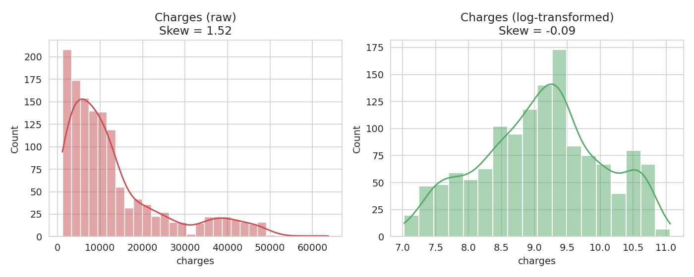
Figure 2. Distribution of charges before and after log transformation.

Reasoning
- Deleting the high-cost records was rejected: these are not data-entry errors, they are real high-cost patients (typically older smokers with high BMI) — removing them would bias the model toward underestimating the exact customers an insurer most needs to price correctly.
- Capping / winsorizing was rejected in favor of a transform because capping throws away information about how much higher those charges actually are.
- Log transform was chosen because it compresses the tail proportionally, keeps every record in the training set, and directly improves the assumptions that linear-type models rely on. Predictions are converted back with an exponential (np.exp) at inference time.

3. Challenge 2 — Categorical Variables

The problem
Three of the seven columns — sex, smoker, and region — are text categories. Scikit-learn / XGBoost models require numeric input, so these columns could not be fed into any regression model as-is.

The technique used: label encoding
Label Encoding was applied to sex, smoker, and region, converting each category to an integer code (e.g., smoker: no → 0, yes → 1).

Reasoning
- sex and smoker are binary categories, so label encoding introduces no false ordinal relationship — there are only two states, so 0/1 encoding is equivalent to one-hot encoding but more compact.
- region has four unordered categories, where label encoding does technically impose an artificial order (0,1,2,3) that doesn't exist in reality. This was accepted as a reasonable simplification here because region showed weak influence on charges in the EDA (similar charge distributions across all four regions), and tree-based models — the strongest performers in this project — are relatively insensitive to arbitrary label ordering since they split on thresholds rather than assuming linear scale.
- One-hot encoding was the safer alternative for region and would be preferable if region's effect had proven more important, since it avoids implying any order between categories.

4. Challenge 3 — Class Imbalance in Smoker Status

The problem
Only 274 of 1,338 records (20.5%) are smokers, versus 1,064 non-smokers (79.5%). Since smoking status turned out to be the single strongest predictor of charges, this imbalance is a meaningful risk: a model can achieve deceptively low average error simply by fitting the majority (non-smoker) pattern well while underfitting the minority (smoker) group — precisely the high-cost segment that matters most for accurate pricing.
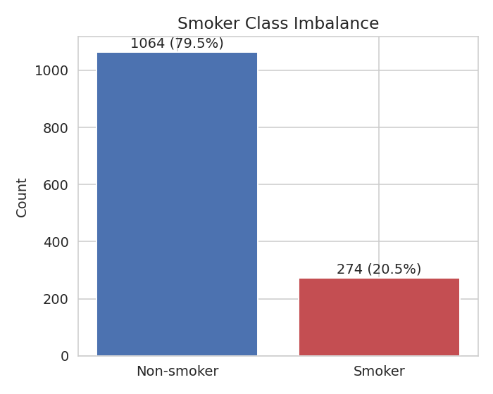
Figure 3. Class imbalance in the smoker attribute (~80% non-smoker vs. ~20% smoker).

The technique used: no resampling — relied on smoker's strong, distinct signal instead
No oversampling or class-weighting was applied. Instead, the modeling approach relied on the fact that smoker status produces a very large and consistent separation in charges (t = 46.67, p < 0.001), which is easy for tree-based ensemble models to learn even from a minority class of ~274 records.

Reasoning
- This is a regression problem, not classification — standard class-imbalance techniques are built for imbalanced classification targets, not for an imbalanced categorical feature inside a regression task, so they don't directly apply here.
- 274 minority-class records is still a reasonably sized sample, and because the smoker effect on charges is large and consistent (not subtle), models were able to learn it clearly, as confirmed by feature-importance results showing smoker as the top predictor.
- The trade-off was accepted deliberately rather than ignored: this is flagged as a limitation, and a future iteration could stratify the train/test split by smoker status to guarantee proportional representation in both sets.

5. Challenge 4 — Weak / Low-Signal Features

The problem
The correlation heatmap and pairplot showed that children has only a weak relationship with charges, and region showed largely overlapping charge distributions across all four categories. Including low-signal features risks adding noise, increasing model complexity, and diluting the influence of genuinely predictive variables like age, BMI, and smoker.

The technique used: feature selection by exclusion
The final model was trained on a reduced, deliberately narrow feature set — age, sex, bmi, and smoker — dropping children and region from the model inputs, even though they were kept and explored during EDA.

Reasoning
- EDA evidence (correlation heatmap, violin plots by region, pairplots) consistently showed children and region contributing little explanatory power relative to age, BMI, and smoker.
- Fewer, stronger features reduce the risk of overfitting on a moderately sized dataset (1,338 rows) and keep the model simpler and easier to interpret and explain to a non-technical business audience.
- This was a deliberate simplicity-vs-completeness trade-off: including all six features might marginally change performance, but the EDA justified prioritizing signal strength over exhaustiveness for this iteration of the model.

6. Challenge 5 — Non-Linear & Interacting Relationships

The problem
Charges do not depend on any single feature in a simple straight-line way. Scatter plots showed that the effect of BMI on charges is much steeper for smokers than non-smokers, and the effect of age is fairly linear but the overall cost surface is shaped by combinations of variables (e.g., high-BMI smokers vs. everyone else) rather than by any one variable alone.

The technique used: comparing linear and tree-based ensemble models
Four models were trained and compared rather than relying on a single algorithm: Linear Regression as an interpretable baseline, and Random Forest, Gradient Boosting, and XGBoost as ensemble methods capable of capturing non-linearity and feature interactions automatically.
Model | R² Score (test) | Handles non-linearity?
Linear Regression | 0.7722 | No — assumes linear/additive effects
Random Forest | 0.8062 | Yes — splits capture interactions
Gradient Boosting | 0.8344 | Yes — sequential error correction
XGBoost | 0.8247 | Yes — regularized boosting

Reasoning
- Linear Regression was kept as a baseline specifically because its lower R² (0.772) versus the ensemble models (0.81–0.83) gives direct, measurable evidence that the true relationship in the data is non-linear — this comparison is itself part of the diagnostic process, not just a performance leaderboard.
- Gradient Boosting and XGBoost were prioritized because they build trees sequentially, with each new tree correcting the residual errors of the previous ones — well suited to a target shaped by interacting factors like BMI × smoker.
- Random Forest was included as a more stable, less tuning-sensitive ensemble baseline against which the boosting methods could be judged.
- Hyperparameter tuning (GridSearchCV / RandomizedSearchCV) was applied to each model rather than relying on default settings, since ensemble methods in particular are sensitive to parameters like tree depth and learning rate, and the reasoning above about non-linearity would not be trustworthy without giving every model a fair, tuned comparison.

7. Summary Table
Challenge | Technique Used | Why
Right-skewed charges with outliers | Log transformation of target | Preserves all data while normalizing distribution and stabilizing variance
Categorical variables | Label encoding (sex, smoker, region) | Converts text to numeric form models require; acceptable given weak region effect and tree-based models used
Smoker class imbalance (20.5% smoker) | No resampling; relied on strong effect size | Regression task, not classification; smoker signal was large enough to learn from minority class
Weak features (children, region) | Excluded from final model inputs | EDA showed limited correlation; simpler model reduces overfitting risk
Non-linear, interacting effects | Compared linear vs. ensemble models; tuned each | Performance gap confirms non-linearity; boosting methods capture interactions

Taken together, these choices reflect a consistent principle: prefer techniques that preserve information (log transform over deletion, keeping minority-class records over resampling) while simplifying only where the data itself justified it (dropping low-signal features, choosing label encoding for a low-impact categorical variable).

