MEDICAL INSURANCE COST
PREDICTION — DATA ANALYSIS REPORT
Exploratory Data Analysis, Hypothesis Testing & Regression Modeling
Dataset: Insurance_Datasets.csv | 1,338 records · 7 features
Report generated: August 2026

1. Executive Summary
This report presents an end-to-end data analysis of a medical insurance dataset (1,338 records, 7 attributes) with the goal of understanding what drives individual insurance charges and building a model to predict them. The analysis follows a full workflow: data understanding, exploratory analysis, statistical hypothesis testing, feature engineering, and comparison of four regression models.
Key findings:
- Smoking status is by far the strongest driver of insurance cost — smokers pay dramatically more than non-smokers, and the difference is statistically significant (t = 46.66, p < 0.001).
- Age and BMI both show a positive relationship with charges: costs rise steadily with age and increase for higher BMI values (Pearson r = 0.198, p < 0.001 for BMI).
- Number of children and region have only a weak influence on charges compared to smoking, age, and BMI.
- Charges are strongly right-skewed (a small share of customers drive very high costs), so a log transformation was applied to the target before modeling.
- Among four models compared, Gradient Boosting performed best (R² = 0.834 on log-charges), followed by XGBoost (0.825) and Random Forest (0.806); Linear Regression was the weakest (0.772).

2. About the Dataset
The dataset contains structured medical insurance records for 1,338 individuals in the United States, with the target variable charges representing the individual medical costs billed by health insurance.
Column | Type | Description
age | Numeric | Age of primary beneficiary (18–64)
sex | Categorical | Insurance contractor gender (male / female)
bmi | Numeric | Body Mass Index — weight relative to height (kg/m²)
children | Numeric | Number of dependents covered by the policy
smoker | Categorical | Smoking status (yes / no)
region | Categorical | US residential region (NE, NW, SE, SW)
charges | Numeric | Target variable — individual medical costs billed

The dataset has no missing values across any of the 7 columns, so no imputation was required. Categorical class balance:
- sex: 676 male, 662 female — near-even split
- smoker: 1,064 non-smokers vs. 274 smokers — a clear class imbalance relevant for modeling
- region: southeast (364), southwest (325), northwest (325), northeast (324) — fairly even

3. Exploratory Data Analysis

3.1 Distribution of Numeric Features
Age is fairly evenly spread between 18 and 64. BMI is roughly bell-shaped and centered around 30–31, which falls in the obese range by clinical standards. Children is concentrated at 0–2. Charges is heavily right-skewed — most customers pay comparatively low charges, while a smaller group incurs very high costs.
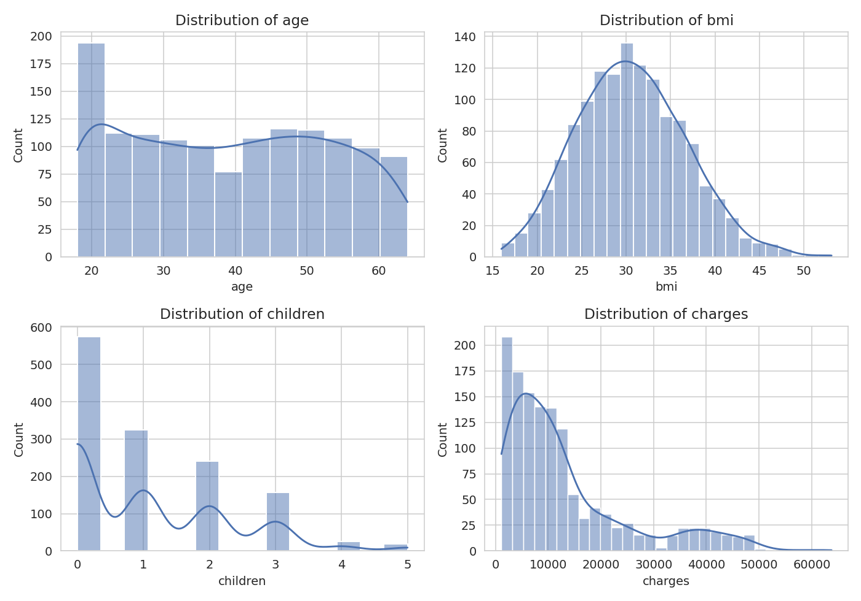
Figure 1. Distribution of age, BMI, children, and charges.

3.2 Charges by Smoker Status
Smokers show a much higher median and wider spread of charges than non-smokers, with the two groups occupying almost non-overlapping charge ranges at the upper end. This is the clearest single pattern in the dataset.
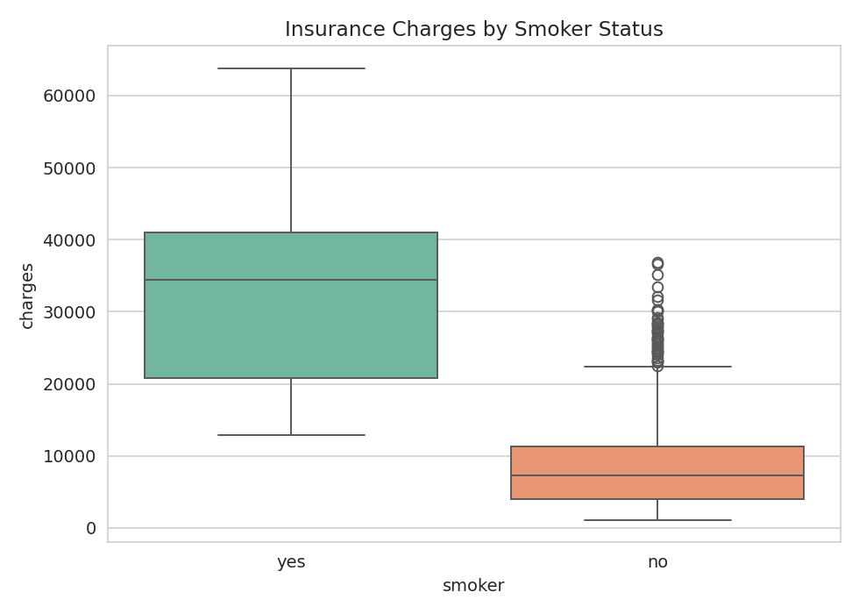
Figure 2. Insurance charges by smoker status.

3.3 Age vs. Charges (by Smoker Status and BMI)
Charges rise with age for both smokers and non-smokers, but smokers sit on a visibly higher band throughout the age range. Bubble size (BMI) shows that higher-BMI smokers tend to cluster at the very top of the cost distribution — suggesting an interaction effect between smoking and BMI.
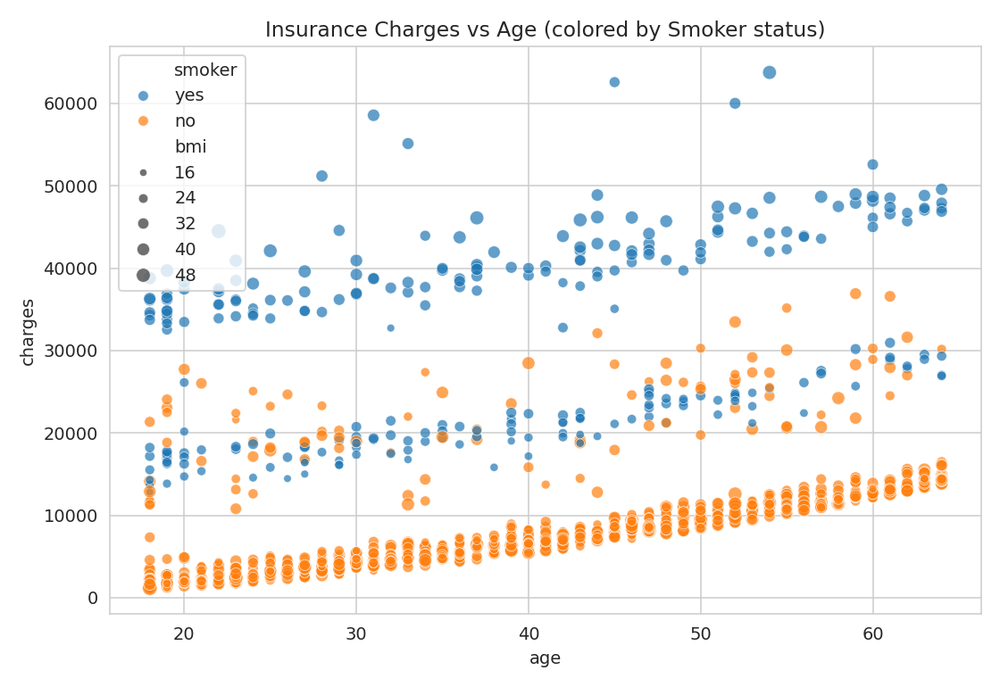
Figure 3. Charges vs. age, colored by smoker status, sized by BMI.

3.4 Correlation Between Numeric Features
Among purely numeric features, age and BMI show the strongest (positive) correlation with charges, while children is weakly correlated. Note this heatmap excludes smoker status, which — despite being categorical — is the single most influential factor, as shown by the group comparisons above.
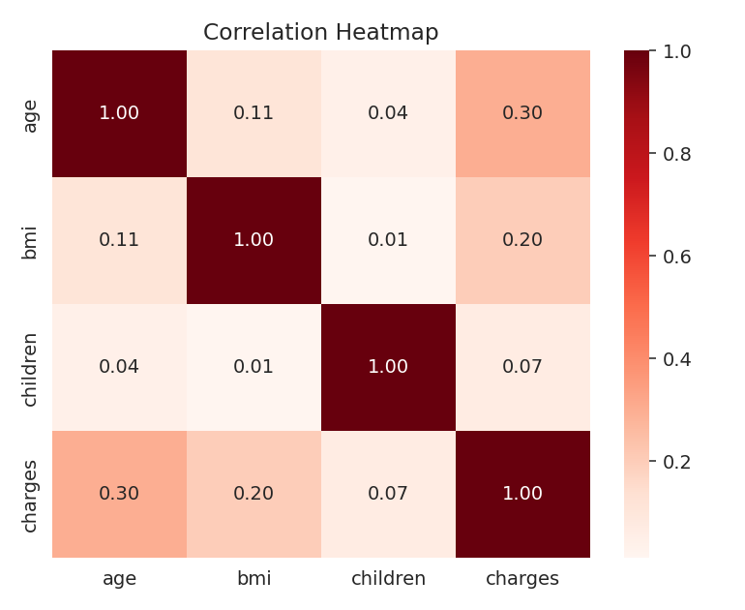
Figure 4. Correlation heatmap of numeric features.

3.5 Average Charges by Sex and Smoker Status
Male smokers have the highest average charges, followed by female smokers. Non-smokers of both sexes show much lower and more similar average charges — confirming that smoking status, not sex, is the dominant cost driver.
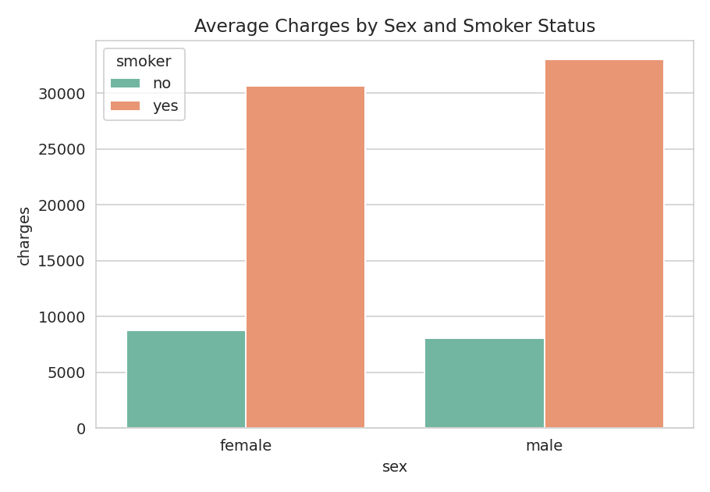
Figure 5. Average charges by sex and smoker status.

3.6 Charges by Region and Smoker Status
Charge distributions look broadly similar across all four regions. In every region, smokers cluster at higher charge levels than non-smokers, reinforcing that region has comparatively little explanatory power on its own.
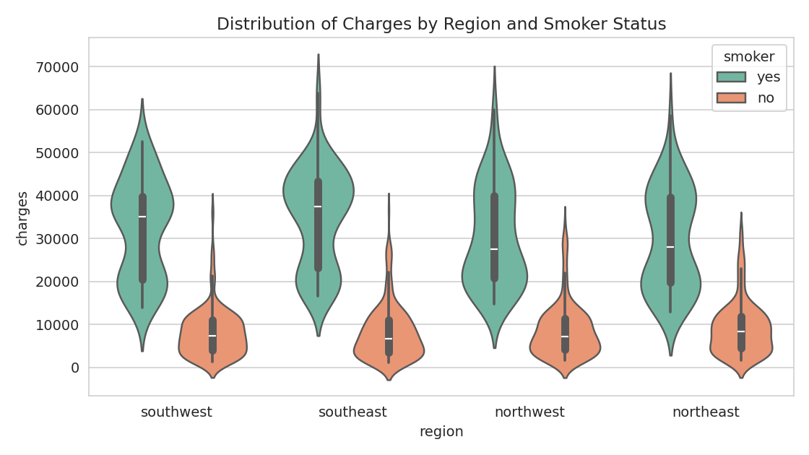
Figure 6. Distribution of charges by region and smoker status.

4. Hypothesis Testing
Two hypothesis tests were run to statistically confirm the visual patterns observed above.

4.1 Smoking Status vs. Charges
An independent-samples t-test compared mean charges between smokers and non-smokers.
Statistic | Value
t-statistic | 46.665
p-value | 4.14 × 10⁻²⁸³
Conclusion | Smokers pay significantly higher charges than non-smokers (p < 0.001)

4.2 BMI vs. Charges
BMI's relationship with charges was tested two ways: a t-test comparing high-BMI (>25) vs. low-BMI (≤25) customers, and a Pearson correlation between BMI and charges directly.
Test | Statistic | p-value | Conclusion
Independent t-test (high vs. low BMI) | t = 4.320 | 1.68 × 10⁻⁵ | Significant difference — higher BMI is associated with higher charges
Pearson correlation | r = 0.198 | 2.46 × 10⁻¹³ | Weak but statistically significant positive correlation

Both tests confirm a real, statistically significant relationship between BMI and charges, though the correlation strength is modest — BMI alone explains only a small part of the variation in cost, consistent with the scatter patterns seen earlier.

5. Feature Engineering & Preprocessing
- Log transformation: Since charges was strongly right-skewed with extreme high-cost outliers, a natural-log transform (charges_log) was applied to the target. This compresses the long right tail, stabilizes variance, and improves model fit — the outliers reflect real high-cost customers rather than data errors, so they were transformed rather than removed.
- Categorical encoding: sex, smoker, and region were label-encoded to numeric values so models could process them.
- Train/test split: An 80/20 split (random_state = 42) was used, training on age, sex, bmi, and smoker as predictors of log-charges.

6. Predictive Modeling
Four regression models were trained to predict log-transformed charges: Linear Regression (baseline), Random Forest, Gradient Boosting, and XGBoost. Each was evaluated on held-out test data using RMSE, MAE, R², and Adjusted R², then tuned with GridSearchCV / RandomizedSearchCV.

6.1 Model Performance Summary (test set, before tuning)
Model | RMSE | MAE | R² Score | Adjusted R²
Linear Regression | 0.4526 | 0.2991 | 0.7722 | 0.7687
Random Forest | 0.4174 | 0.2358 | 0.8062 | 0.8033
Gradient Boosting | 0.3858 | 0.2177 | 0.8344 | 0.8319
XGBoost | 0.3970 | 0.2245 | 0.8247 | 0.8221

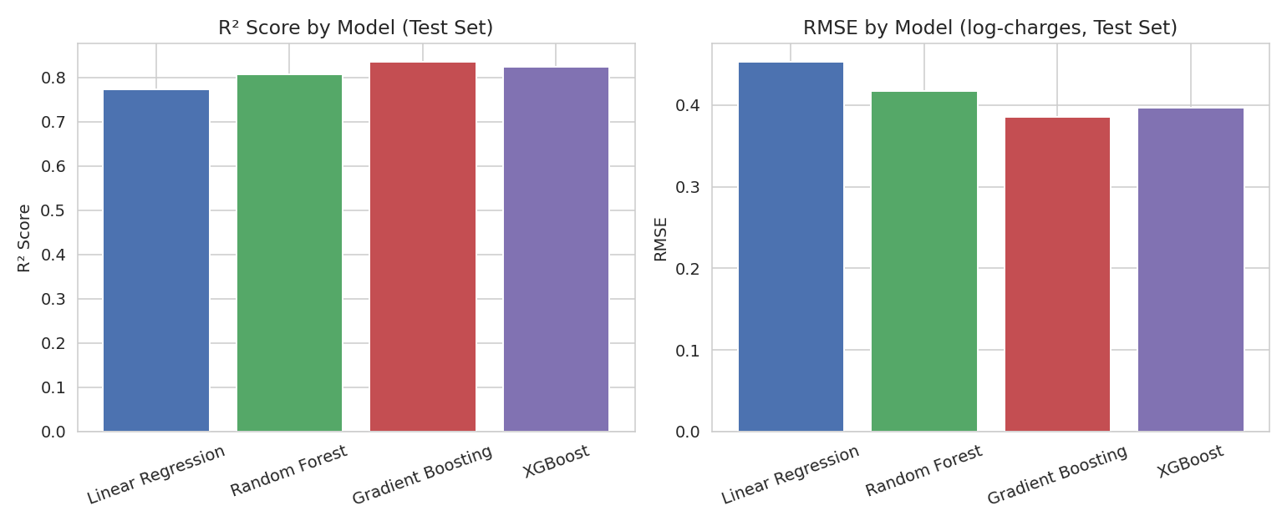
Figure 7. R² and RMSE comparison across the four models (test set, pre-tuning).

6.2 Hyperparameter Tuning Results
Model | R² Before Tuning | R² After Tuning | Change
Linear Regression | 0.7722 | 0.7722 | No change
Random Forest | 0.8062 | 0.8117 | Small improvement
Gradient Boosting | 0.8344 | 0.8313 | No improvement (slightly lower)
XGBoost | 0.8247 | 0.8318 | Improved

Gradient Boosting delivered the best out-of-the-box performance and remained the strongest model overall even after tuning, so it was selected as the final model for deployment. Its top features by importance were smoking status, age, and BMI — consistent with the EDA and hypothesis testing findings.
- Best model: Gradient Boosting Regressor (n_estimators=100, learning_rate=0.05)
- Final R² on test set: 0.834 (log-charges) — meaning the model explains roughly 83% of the variance in insurance charges
- Sanity check: the saved model correctly predicted ≈ $21,025 in charges for a 35-year-old male, BMI 28.5, smoker, southwest region

7. Conclusion & Recommendations
This analysis confirms that medical insurance charges can be predicted reasonably well from a small set of demographic and lifestyle attributes. Smoking status is overwhelmingly the strongest cost driver, followed by age and BMI; sex, number of children, and region contribute comparatively little on their own.
Business implications:
- Pricing & risk assessment: Insurers can prioritize smoking status, age, and BMI as core inputs for premium calculation and risk segmentation.
- Targeted programs: Because smoking has such an outsized effect on cost, smoking-cessation and wellness programs could meaningfully reduce long-run claim costs.
- Model choice: Gradient Boosting is recommended for deployment given its consistently strong performance across metrics; XGBoost is a close, faster-tuning alternative.
Suggested next steps: incorporate interaction terms (e.g., BMI × smoker), test additional models or stacking/ensembling, and gather more granular health data (e.g., chronic conditions) if available to further improve predictive accuracy.

