MODEL PERFORMANCE
& PRODUCTION MODEL RECOMMENDATION
Comparing Linear Regression, Random Forest, Gradient Boosting & XGBoost
Project: Medical Insurance Cost Prediction
Dataset: Insurance_Datasets.csv | 1,338 records · 4 predictors (age, sex, bmi, smoker)

1. Objective & Evaluation Setup
This report compares four regression models trained to predict medical insurance charges, and recommends which one should be deployed to production. All models were trained on the same 80/20 train-test split (random_state = 42) using age, sex, bmi, and smoker as predictors, against the log-transformed target charges_log (log transform used to correct the right-skew in raw charges).
Model | Type | Key Idea
Linear Regression | Linear baseline | Fits a single straight-line relationship between features and log-charges
Random Forest | Bagging ensemble | Averages many independent decision trees to reduce variance
Gradient Boosting | Boosting ensemble | Builds trees sequentially, each correcting the previous tree's errors
XGBoost | Regularized boosting | Optimized, regularized version of gradient boosting

Each model was evaluated using four metrics: RMSE and MAE (lower is better — average prediction error, in log-charge units), R² and Adjusted R² (higher is better — proportion of variance explained).

2. Performance Before Hyperparameter Tuning
Model | RMSE | MAE | R² Score | Adjusted R²
Linear Regression | 0.4526 | 0.2991 | 0.7722 | 0.7687
Random Forest | 0.4174 | 0.2358 | 0.8062 | 0.8033
Gradient Boosting | 0.3858 | 0.2177 | 0.8344 | 0.8319
XGBoost | 0.3970 | 0.2245 | 0.8247 | 0.8221

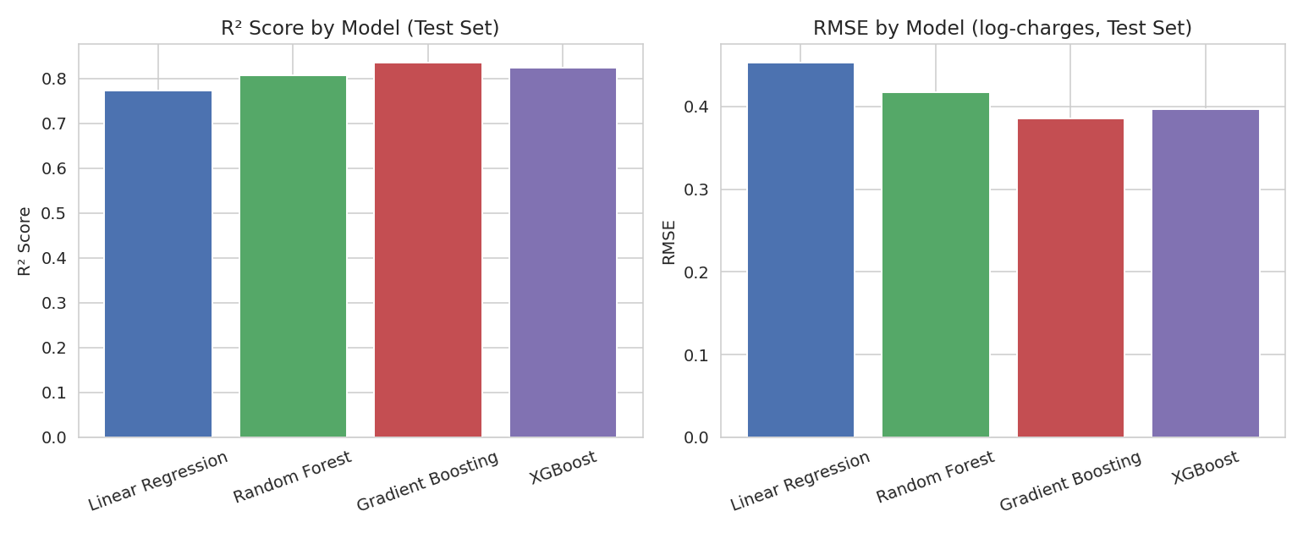
Figure 1. R² and RMSE comparison across the four models (test set, before tuning).
Gradient Boosting had the best out-of-the-box performance on every metric. Linear Regression was clearly the weakest, confirming that the relationship between the predictors and charges is non-linear (as expected, given the interaction between smoking status and BMI observed during EDA).

3. Performance After Hyperparameter Tuning
Each model was tuned using GridSearchCV and/or RandomizedSearchCV (5-fold cross-validation, scoring = R²).
Model | R² Before Tuning | R² After Tuning | Change
Linear Regression | 0.7722 | 0.7722 | No change
Random Forest | 0.8062 | 0.8117 | +0.0055 (small improvement)
Gradient Boosting | 0.8344 | 0.8313 | −0.0031 (essentially unchanged)
XGBoost | 0.8247 | 0.8318 | +0.0071 (improved)

Tuning narrowed the gap between the three ensemble models — after tuning, Gradient Boosting, XGBoost, and the tuned Random Forest all land within about 0.02 R² of each other. Gradient Boosting still edges out the others, but the margin over XGBoost specifically is now very small.

4. A Closer Look at the Leading Model — Gradient Boosting

4.1 Feature Importance
Feature importance from the trained Gradient Boosting model confirms what the exploratory analysis and hypothesis tests already suggested: smoking status dominates the prediction, with age and BMI contributing secondary but meaningful signal, and sex contributing very little.
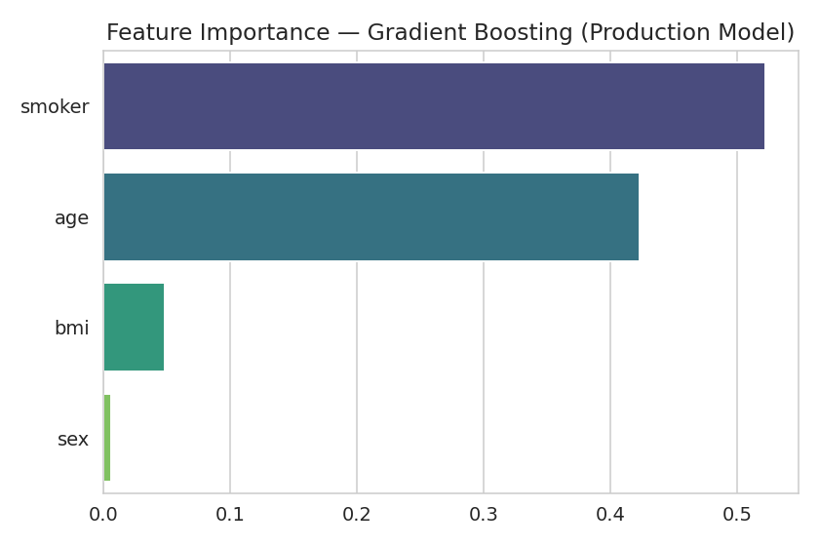
Figure 2. Feature importance — Gradient Boosting.

4.2 Predicted vs. Actual Charges
Plotting predicted charges against actual charges (converted back from log scale) shows predictions tracking the diagonal reasonably well across most of the range, with more spread at the highest charge levels — consistent with those being the hardest, most variable cases to predict precisely.
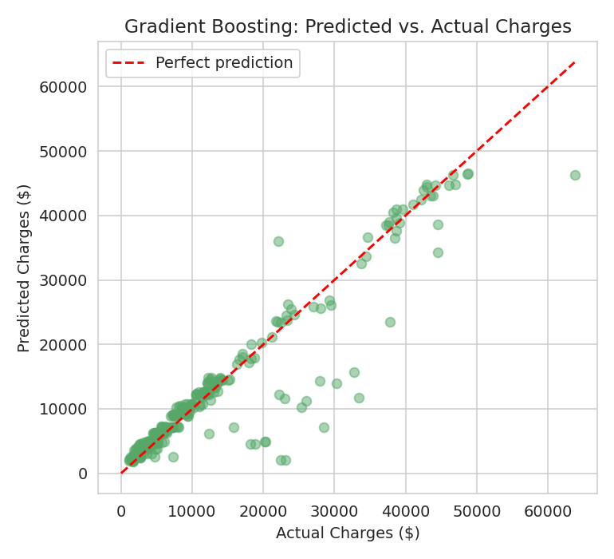
Figure 3. Gradient Boosting — predicted vs. actual charges on the test set.
A sanity check on a new, unseen record (age 35, male, BMI 28.5, smoker) returned a predicted charge of approximately $21,025, which is directionally consistent with the smoker/BMI/age patterns identified in the data.

5. Production Considerations Beyond Accuracy
Accuracy (R²/RMSE) is the primary criterion, but a production choice should also weigh training/inference cost, stability, and interpretability.
Model | Relative Train Speed | Relative Predict Speed | Interpretability | Tuning Sensitivity
Linear Regression | Fastest | Fastest | High — coefficients are directly readable | Low — few parameters to tune
Random Forest | Slower (many trees) | Slower | Medium — feature importance only | Medium
Gradient Boosting | Moderate | Fast | Medium — feature importance only | High — sensitive to learning rate/depth
XGBoost | Moderate–fast | Fast | Medium — feature importance + regularization info | High, but more tuning tools available

- Linear Regression trains and predicts fastest and is the easiest to explain to non-technical stakeholders, but its accuracy ceiling is clearly lower — not recommended as the primary production model given the ~6-point R² gap versus the ensemble methods.
- Random Forest is stable and simple to tune (fewer sensitive hyperparameters than boosting), making it a reasonable fallback if training-time resources are constrained.
- Gradient Boosting delivered the best raw accuracy both before and after tuning, at a moderate computational cost given the modest dataset size (1,338 rows).
- XGBoost performed almost identically to Gradient Boosting after tuning, with the added benefit of built-in regularization, generally faster training on larger datasets, and wider industry tooling for deployment (e.g., native support in most model-serving frameworks).

6. Recommendation
Recommended for production: Gradient Boosting Regressor
Gradient Boosting produced the best accuracy on every metric before tuning (R² = 0.8344, RMSE = 0.3858) and remained the top performer after tuning (R² = 0.8313). On a dataset of this size, its training cost is manageable, and its feature-importance output gives the business an interpretable view of what drives cost (smoking status, age, BMI) — which supports both prediction and pricing-strategy conversations. It is the model already saved via pickle and validated with a working prediction function in this project, making it the most implementation-ready choice today.

Strong alternative: XGBoost
If the production environment scales to a larger dataset, needs faster retraining cycles, or requires built-in regularization to guard against overfitting as more features are added later, XGBoost is a very close second (R² = 0.8318 after tuning — effectively tied with Gradient Boosting) and is often preferred in production ML systems for its performance and tooling ecosystem.

Final guidance: deploy Gradient Boosting now, since it is already trained, tuned, and validated in this project. Treat XGBoost as the natural upgrade path if the dataset grows, more features are added, or infrastructure standardizes on XGBoost for other models in the organization — the accuracy difference between the two is small enough that the switch would be a low-risk, low-effort change.

