**Exercise 3**

1. Open IDE

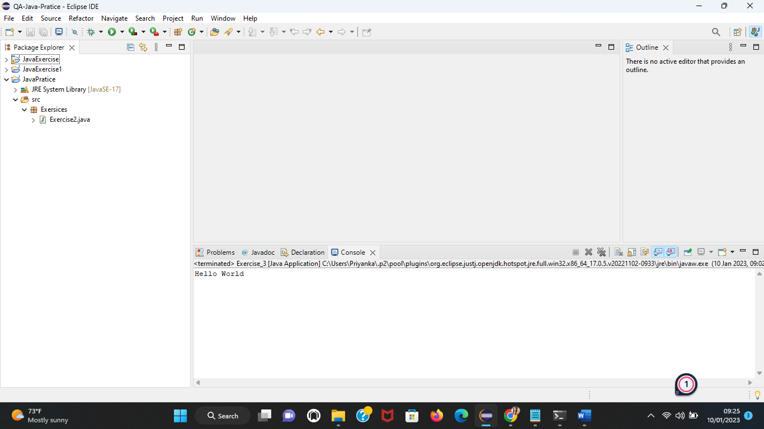

1. Create a new Java project

Here I am Creating Maven Project it is Easy to do Exercise-8

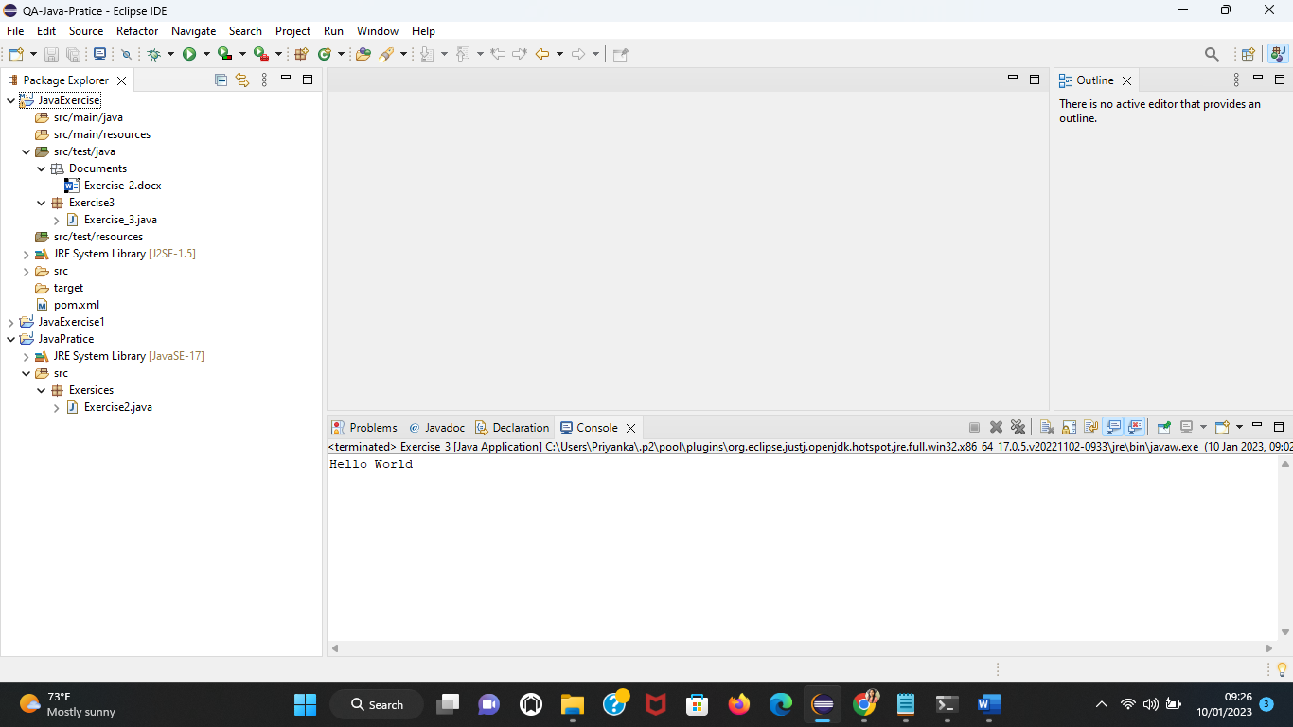

1. Type the same program you created in Exercise 2 and execute it through Eclipse/ IntelliJ IDEA

