GIT:

1. BASIC WORKFLOW

**What is version control?**

A **version control system** is a tool that manages changes made to the files and directories in a project. Many version control systems exist; this lesson focuses on one called Git, which is used by many of the data science tools covered in our other lessons. Its strengths are:

* Nothing that is saved to Git is ever lost, so you can always go back to see which results were generated by which versions of your programs.
* Git automatically notifies you when your work conflicts with someone else's, so it's harder (but not impossible) to accidentally overwrite work.
* Git can synchronize work done by different people on different machines, so it scales as your team does.

Version control isn't just for software: books, papers, parameter sets, and anything that changes over time or needs to be shared can and should be stored and shared using something like Git.

Each of your Git projects has two parts: the files and directories that you create and edit directly, and the extra information that Git records about the project's history. The combination of these two things is called a **repository**.

**Git stores all of its extra information in a directory called .git located in the root directory** of the repository. Git expects this information to be laid out in a very precise way, so you should never edit or delete anything in .git.

If repository name is dental created in root/path/dental, then root/path/dental/.git

**How can I check the state of a repository?**

When you are using Git, you will frequently want to check the **status** of your repository. To do this, run the command git status, which displays a list of the files that have been modified since the last time changes were saved.

**How can I tell what I have changed?**

Git has a **staging area** in which it stores files with changes you want to save that haven't been saved yet. Putting files in the staging area is like putting things in a box, while **committing** those changes is like putting that box in the mail: you can add more things to the box or take things out as often as you want, but once you put it in the mail, you can't make further changes.

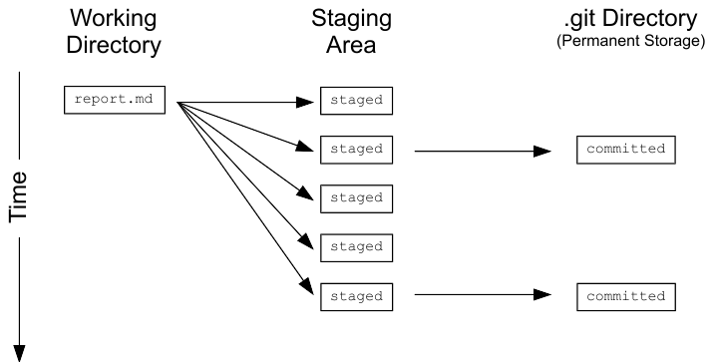

git status shows you which files are in this staging area, and which files have changes that haven't yet been put there. In order to compare the file as it currently is to what you last saved, you can use git diff filename. git diff without any filenames will show you all the changes in your repository, while git diff directory will show you the changes to the files in some directory.

**What is in a diff?**

A **diff** is a formatted display of the differences between two sets of files.

diff --git a/report.txt b/report.txt

index e713b17..4c0742a 100644

--- a/report.txt

+++ b/report.txt

@@ -1,4 +1,4 @@

-# Seasonal Dental Surgeries 2017-18

+# Seasonal Dental Surgeries (2017) 2017-18

TODO: write executive summary

This shows:

* The command used to produce the output (in this case, diff --git). In it, a and b are placeholders meaning "the first version" and "the second version".
* An index line showing keys into Git's internal database of changes. We will explore these in the next chapter.
* --- a/report.txt and +++ b/report.txt, which indicate that lines being *removed* are prefixed with -, while lines being added are prefixed with +.
* A line starting with @@ that tells where the changes are being made. The pairs of numbers are start line, number of lines changed. Here, the diff output shows that 4 lines from line 1 are being removed and replaced with new lines.
* A line-by-line listing of the changes with - showing deletions and + showing additions. (We have also configured Git to show deletions in red and additions in green.) Lines that haven't changed are sometimes shown before and after the ones that have in order to give context; when they appear, they *don't* have either + or - in front of them.

**What's the first step in saving changes?**

You commit changes to a Git repository in two steps:

1. Add one or more files to the staging area.
2. Commit everything in the staging area.

To add a file to the staging area, use git add filename.

**How can I tell what's going to be committed?**

To compare the state of your files with those in the staging area, you can use git diff -r HEAD. The -**r** flag means "compare to a particular revision", and **HEAD** is a shortcut meaning "the most recent commit".

You can restrict the results to a single file or directory using git diff -r HEAD path/to/file, where the path to the file is relative to where you are (for example, the path from the root directory of the repository).

We will explore other uses of -r and HEAD in the next chapter.

**How to edit a file?**

Unix has a bewildering variety of text editors. In this course, we will sometimes use a very simple one called Nano. If you type nano filename, it will open filename for editing (or create it if it doesn't already exist). You can then move around with the arrow keys, delete characters with the backspace key, and so on. You can also do a few other operations with control-key combinations:

* Ctrl-K: delete a line.
* Ctrl-U: un-delete a line.
* Ctrl-O: save the file ('O' stands for 'output').
* Ctrl-X: exit the editor.

Nano filename.txt

In vim, you can press i to start entering text and save by pressing esc and  :wq and enter, this will commit with the message you typed. In your current state, to just come out without committing, you can do  :q instead of the  :wq

**How do I commit changes?**

To save the changes in the staging area, you use the command git commit. It always saves everything that is in the staging area as one unit: as you will see later, when you want to undo changes to a project, you undo all of a commit or none of it.

When you commit changes, Git requires you to enter a log message. This serves the same purpose as a comment in a program: it tells the next person to examine the repository why you made a change.

By default, Git launches a text editor to let you write this message. To keep things simple, you can use -m "some message in quotes" on the command line to enter a single-line message like this:

git commit -m "Program appears to have become self-aware."

If you accidentally mistype a commit message, you can change it using the --amend flag.

git commit --amend - m "new message"

cd rename

git add filename

git status

git commit –m “msg”

**How can I view a repository's history?**

The command git log is used to view the **log** of the project's history. Log entries are shown most recent first, and look like this:

commit 0430705487381195993bac9c21512ccfb511056d

Author: Rep Loop <repl@datacamp.com>

Date: Wed Sep 20 13:42:26 2017 +0000

Added year to report title.

When you run git log, Git automatically uses a pager to show one screen of output at a time. Press the space bar to go down a page or the 'q' key to quit.

**How can I view a specific file's history?**

A project's entire log can be overwhelming, so it's often useful to inspect only the changes to particular files or directories. You can do this using git log path, where path is the path to a specific file or directory. The log for a file shows changes made to that file; the log for a directory shows when files were added or deleted in that directory, rather than when the contents of the directory's files were changed.

**How to add local files to git repo?**

1. Create new repo in git
2. From git bash(command line) got o location of local file
3. Git init
4. Git add .
5. Git commit –m “msg”
6. Git remote add origin url (url of repo in git, set new remote)
7. Git remote –v (verifies new remote url)
8. Git push origin master (pushes local files to remote repo)

<https://help.github.com/en/articles/adding-an-existing-project-to-github-using-the-command-line>

**----------------------------------------------XXXX---------------------------------------XXXX-----------------------------------**

2. REPOSITORY

How does Git store information?

You may wonder what information is stored by each commit that you make. Git uses a three-level structure for this.

1. A commit contains metadata such as the author, the commit message, and the time the commit happened. In the diagram below, the most recent commit is at the bottom (feed0098), and vertical arrows point up towards the previous ("parent") commits.
2. Each commit also has a tree, which tracks the names and locations in the repository when that commit happened. In the oldest (top) commit, there were two files tracked by the repository.
3. For each of the files listed in the tree, there is a blob. This contains a compressed snapshot of the contents of the file when the commit happened. (Blob is short for binary large object, which is a SQL database term for "may contain data of any kind".) In the middle commit, report.md and draft.md were changed, so the blobs are shown next to that commit. data/northern.csv didn't change in that commit, so the tree links to the blob from the previous commit. Reusing blobs between commits help make common operations fast and minimizes storage space.

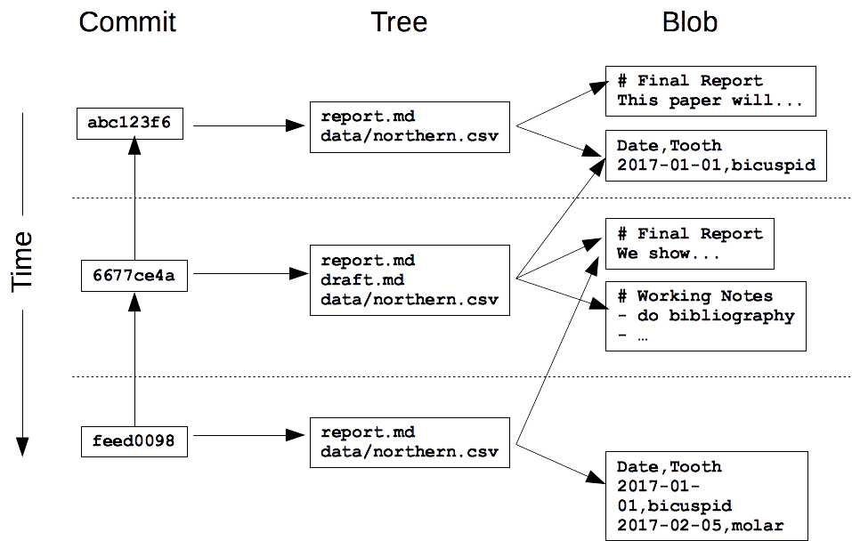

**What is a hash?**

Every commit to a repository has a unique identifier called a **hash** (since it is generated by running the changes through a pseudo-random number generator called a **hash function**). This hash is normally written as a 40-character hexadecimal string like 7c35a3ce607a14953f070f0f83b5d74c2296ef93, but most of the time, you only have to give Git the first 6 or 8 characters in order to identify the commit you mean.

Hashes are what enable Git to share data efficiently between repositories. If two files are the same, their hashes are guaranteed to be the same. Similarly, if two commits contain the same files and have the same ancestors, their hashes will be the same as well. Git can therefore tell what information needs to be saved where by comparing hashes rather than comparing entire files.

**How can I view a specific commit?**

To view the details of a specific commit, you use the command git show with the first few characters of the commit's hash.

The first part is the same as the log entry shown by git log. The second part shows the changes; as with git diff, lines that the change removed are prefixed with -, while lines that it added are prefixed with +.

**What is Git's equivalent of a relative path?**

A hash is like an absolute path: it identifies a specific commit. Another way to identify a commit is to use the equivalent of a relative path. The special label HEAD, which we saw in the previous chapter, always refers to the most recent commit. The label HEAD~1 then refers to the commit before it, while HEAD~2 refers to the commit before that, and so on.

Note that the symbol between HEAD and the number is a tilde ~, *not* a minus sign -, and that there cannot be spaces before or after the tilde

--git show HEAD~2

# How can I see who changed what in a file?

git log displays the overall history of a project or file, but Git can give even more information: the command git annotate file shows who made the last change to each line of a file and when. For example, the first three lines of output from **git annotate report.txt** look something like this:

04307054 ( Rep Loop 2017-09-20 13:42:26 +0000 1)# Seasonal Dental Surgeries (2017) 2017-18

5e6f92b6 ( Rep Loop 2017-09-20 13:42:26 +0000 2)

5e6f92b6 ( Rep Loop 2017-09-20 13:42:26 +0000 3)TODO: write executive summary.

Each line contains five things, with two to four in parentheses.

1. The first eight digits of the hash, 04307054.
2. The author, Rep Loop.
3. The time of the commit, 2017-09-20 13:42:26 +0000.
4. The line number, 1.
5. The contents of the line, # Seasonal Dental Surgeries (2017) 2017-18.

--------------------------------------------------------------------------------------------------------------------------------------

**How can I see what changed between two commits?**

git show with a commit ID shows the changes made *in* a particular commit. To see the changes *between* two commits, you can use git diff ID1..ID2, where ID1 and ID2 identify the two commits you're interested in, and the connector .. is a pair of dots.

git diff HEAD~1..HEAD~3 shows the differences between the state of the repository one commit in the past and its state three commits in the past.

**How do I add new files?**

Git does not track files by default. Instead, it waits until you have used git add at least once before it starts paying attention to a file.

In the diagram you saw at the start of the chapter, the untracked files won't have a blob, and won't be listed in a tree.

The untracked files won't benefit from version control, so to make sure you don't miss anything, git status will always tell you about files that are in your repository but aren't (yet) being tracked.

Cd reponame

Git status

Git add fnnotaddedtorepo

Git commit

**How do I tell Git to ignore certain files?**

Data analysis often produces temporary or intermediate files that you don't want to save. You can tell it to stop paying attention to files you don't care about by creating a file in the root directory of your repository called .gitignore and storing a list of **wildcard** patterns that specify the files you don't want Git to pay attention to. For example, if .gitignore contains:

build

*.mpl

then Git will ignore any file or directory called build (and, if it's a directory, anything in it), as well as any file whose name ends in .mpl.

**How can I remove unwanted files?**

Git can help you clean up files that you have told it you don't want. The command git clean –n will show you a list of files that are in the repository, but whose history Git is not currently tracking. A similar command git clean -f will then delete those files.

*Use this command carefully:* git clean only works on untracked files, so by definition, their history has not been saved. If you delete them with git clean -f, they're gone for good.

**How can I see how Git is configured?**

Like most complex pieces of software, Git allows you to change its default settings. To see what the settings are, you can use the command git config --list with one of three additional options:

* --system: settings for every user on this computer.
* --global: settings for every one of your projects.
* --local: settings for one specific project.

Each level overrides the one above it, so **local settings** (per-project) take precedence over **global settings** (per-user), which in turn take precedence over **system settings** (for all users on the computer).

Git config --global --edit :to edit the details like email id

Git config --global --user.email “djcjd@cdjc”

-------------------------------------xxx--------------------------------------------xxxx---------------------------------------

3. UNDO

# How can I commit changes selectively?

The syntax for staging a single file is git add path/to/file.

If you make a mistake and accidentally stage a file you shouldn't have, you can unstage the additions with git reset HEAD and try again.

**How do I re-stage files?**

People often save their work every few minutes when they're using a desktop text editor. Similarly, it's common to use **git add** periodically to save the most recent changes to a file to the staging area. This is particularly useful when the changes are experimental and you might want to undo them without cluttering up the repository's history.

**How can I undo changes to unstaged files?**

Suppose you have made changes to a file, then decide you want to **undo** them. Your text editor may be able to do this, but a more reliable way is to let Git do the work. The command:

git checkout -- filename

will discard the changes that have not yet been staged. (The double dash -- must be there to separate the git checkout command from the names of the file or files you want to recover.)

*Use this command carefully:* once you discard changes in this way, they are gone forever.

**How can I undo changes to staged files?**

At the start of this chapter you saw that git reset will unstage files that you previously staged using git add. By combining git reset with git checkout, you can undo changes to a file that you staged changes to. The syntax is as follows.

git reset HEAD path/to/file

git checkout -- path/to/file

**How do I restore an old version of a file?**

You previously saw how to use git checkout to undo the change that you made since the last commit. This command can also be used to go back even further into a file's history and restore versions of that file from a commit. In this way, you can think of committing as saving your work, and **checking out** as loading that saved version.

The syntax for restoring an old version takes two arguments: the hash that identifies the version you want to restore, and the name of the file.

For example, if git log shows this:

commit ab8883e8a6bfa873d44616a0f356125dbaccd9ea

Author: Author: Rep Loop <repl@datacamp.com>

Date: Thu Oct 19 09:37:48 2017 -0400

Adding graph to show latest quarterly results.

commit 2242bd761bbeafb9fc82e33aa5dad966adfe5409

Author: Author: Rep Loop <repl@datacamp.com>

Date: Thu Oct 16 09:17:37 2017 -0400

Modifying the bibliography format.

then **git checkout 2242bd report.txt** would replace the current version of report.txt with the version that was committed on October 16. Notice that this is the same syntax that you used to undo the unstaged changes, except -- has been replaced by a hash.

Restoring a file doesn't erase any of the repository's history. Instead, the act of restoring the file is saved as another commit, because you might later want to undo your undoing.

One more thing: there's another feature of git log that will come in handy here. Passing -then a number restricts the output to that many commits. For example, **git log -3 report.txt** shows you the last three commits involving report.txt.

# How can I undo all of the changes I have made?

So far, you have seen how to undo changes to a single file at a time using git reset HEAD path/to/file. You will sometimes want to undo changes to many files.

One way to do this is to give git reset a directory. For example, git reset HEAD data will unstage any files from the data directory. Even better, if you don't provide any files or directories, it will unstage everything. Even even better, HEAD is the default commit to unstage, so you can simply write git reset to unstage everything.

Similarly git checkout -- data will then restore the files in the data directory to their previous state. You can't leave the file argument completely blank, but recall from [**Introduction to Shell for Data Science**](https://www.datacamp.com/courses/introduction-to-shell-for-data-science) that you can refer to the current directory as .. So git checkout -- .will revert all files in the current directory.

------------------xxxx---------------------------------------------------------xxxxx----------------------------------------------

4. BRANCH

**What is a branch?**

If you don't use version control, a common workflow is to create different subdirectories to hold different versions of your project in different states, for example development and final. Of course, then you always end up with final-updated and final-updated-revised as well. The problem with this is that it becomes difficult to work out if you have the right version of each file in the right subdirectory, and you risk losing work.

One of the reasons Git is popular is its support for creating **branches**, which allows you to have multiple versions of your work, and lets you track each version systematically.

Each branch is like a parallel universe: changes you make in one branch do not affect other branches (until you **merge** them back together).

**How can I see what branches my repository has?**

By default, every Git repository has a branch called master (which is why you have been seeing that word in Git's output in previous lessons). To list all of the branches in a repository, you can run the command git branch. The branch you are currently in will be shown with a * beside its name.

**How can I view the differences between branches?**

Branches and revisions are closely connected, and commands that work on the latter usually work on the former. For example, just as git diff revision-1..revision-2 shows the difference between two versions of a repository, git diff branch-1..branch-2 shows the difference between two branches.

**How can I switch from one branch to another?**

You previously used git checkout with a commit hash to switch the repository state to that hash. You can also use git checkout with the name of a branch to switch to that branch.

Two notes:

1. When you run git branch, it puts a * beside the name of the branch you are currently in.
2. Git will only let you do this if all of your changes have been committed. You can get around this, but it is outside the scope of this course.

In this exercise, you'll also make use of git rm. This removes the file (just like the shell command rm) then stages the removal of that file with git add, all in one step.

**How can I create a branch?**

You might expect that you would use git branch to create a branch, and indeed this is possible. However, the most common thing you want to do is to create a branch then switch to that branch.

In the previous exercise, you used git checkout branch-name to switch to a branch. To create a branch then switch to it in one step, you add a -b flag, calling git checkout -b branch-name,

The contents of the new branch are initially identical to the contents of the original. Once you start making changes, they only affect the new branch.

**How can I merge two branches?**

Branching lets you create parallel universes; **merging** is how you bring them back together. When you merge one branch (call it the source) into another (call it the destination), Git incorporates the changes made to the source branch into the destination branch. If those changes don't overlap, the result is a new commit in the destination branch that includes everything from the source branch. (The next exercises describes what happens if there *are* conflicts.)

To merge two branches, you run  git merge source destination (without .. between the two branch names). Git automatically opens an editor so that you can write a log message for the merge; you can either keep its default message or fill in something more informative.

**What are conflicts?**

Sometimes the changes in two branches will conflict with each other: for example, bug fixes might touch the same lines of code, or analyses in two different branches may both append new (and different) records to a summary data file. In this case, Git relies on you to reconcile the conflicting changes.

**Git** can handle most merges on its own with automatic merging features. A **conflict** arises when two separate branches have made edits to the same line in a file, or when a file has been deleted in one branch but edited in the other.

# How can I merge two branches with conflicts?

When there is a conflict during a merge, Git tells you that there's a problem, and running git status after the merge reminds you which files have conflicts that you need to resolve by printing both modified: beside the files' names.

Inside the file, Git leaves markers that look like this to tell you where the conflicts occurred:

<<<<<<< destination-branch-name

...changes from the destination branch...

=======

...changes from the source branch...

>>>>>>> source-branch-name

(In many cases, the destination branch name will be HEAD, because you will be merging into the current branch.) To resolve the conflict, edit the file to remove the markers and make whatever other changes are needed to reconcile the changes, then commit those changes.

-----------------xxxxxx-------------------------------------------------------------------xxxxxx---------------------------------

1. COLLABORATING

# How can I create a brand new repository?

So far, you have been working with repositories that we created. If you want to create a repository for a new project, you can simply say git init project-name, where "project-name" is the name you want the new repository's root directory to have.

One thing you should not do is create one Git repository inside another. While Git does allow this, updating **nested repositories** becomes very complicated very quickly, since you need to tell Git which of the two .git directories the update is to be stored in. Very large projects occasionally need to do this, but most programmers and data analysts try to avoid getting into this situation.

# How can I turn an existing project into a Git repository?

Experienced Git users instinctively start new projects by creating repositories. If you are new to Git, though, or working with people who are, you will often want to convert existing projects into repositories. Doing so is simple: just run

git init

in the project's root directory, or

git init /path/to/project

from anywhere else on your computer.

# How can I create a copy of an existing repository?

Sometimes you will join a project that is already running, inherit a project from someone else, or continue working on one of your own projects on a new machine. In each case, you will **clone** an existing repository instead of creating a new one. Cloning a repository does exactly what the name suggests: it creates a copy of an existing repository (including all of its history) in a new directory.

To clone a repository, use the command git clone URL, where URL identifies the repository you want to clone. This will normally be something like

https://github.com/datacamp/project.git

but for this lesson, we will use a repository on the local file system, so you can just use a path to that directory.

When you clone a repository, Git uses the name of the existing repository as the name of the clone's root directory: for example, will create a new directory called project. If you want to call the clone something else, add the directory name you want to the command

git clone /existing/project

If you want to call the clone something else, add the directory name you want to the command

git clone /existing/project newprojectname

--------------------------------------------------------------------------------------------------------------------------------------

# How can I find out where a cloned repository originated?

When you a clone a repository, Git remembers where the original repository was. It does this by storing a **remote** in the new repository's configuration. A remote is like a browser bookmark with a name and a URL.

If you use an online git repository hosting service like GitHub or Bitbucket, a common task would be that you clone a repository from that site to work locally on your computer. Then the copy on the website is the remote.

If you are in a repository, you can list the names of its remotes using git remote.

If you want more information, you can use git remote -v (for "verbose"), which shows the remote's URLs. Note that "URLs" is plural: it's possible for a remote to have several URLs associated with it for different purposes, though in practice each remote is almost always paired with just one URL.

# How can I define remotes?

A **remote in Git** is a common repository that all team members use to exchange their changes.

When you clone a repository, Git automatically creates a remote called origin that points to the original repository. You can add more remotes using:

git remote add remote-name URL

and remove existing ones using:

git remote rm remote-name

You can connect any two Git repositories this way, but in practice, you will almost always connect repositories that share some common ancestry.

# How can I pull in changes from a remote repository?

Git keeps track of remote repositories so that you can **pull** changes from those repositories and **push** changes to them.

Recall that the remote repository is often a repository in an online hosting service like GitHub. A typical workflow is that you pull in your collaborators' work from the remote repository so you have the latest version of everything, do some work yourself, then push your work back to the remote so that your collaborators have access to it.

Pulling changes is straightforward: the command git pull remote branch gets everything in branch in the remote repository identified by remote and merges it into the current branch of your local repository. For example, if you are in the quarterly-report branch of your local repository, the command:

git pull thunk latest-analysis

would get changes from latest-analysis branch in the repository associated with the remote called thunk and merge them into your quarterly-report branch.

**What happens if I try to pull when I have unsaved changes?**

Just as Git stops you from switching branches when you have unsaved work, it also stops you from pulling in changes from a remote repository when doing so might overwrite things you have done locally. The fix is simple: either commit your local changes or revert them, and then try to pull again.

Git pull

Git checkout -- .

Git pull

# How can I push my changes to a remote repository?

The complement of git pull is git push, which pushes the changes you have made locally into a remote repository. The most common way to use it is:

git push remote-name branch-name

which pushes the contents of your branch branch-name into a branch with the same name in the remote repository associated with remote-name. It's possible to use different branch names at your end and the remote's end, but doing this quickly becomes confusing: it's almost always better to use the same names for branches across repositories.

Git push origin branch_name

**What happens if my push conflicts with someone else's work?**

Overwriting your own work by accident is bad; overwriting someone else's is worse.

To prevent this happening, Git does not allow you to push changes to a remote repository unless you have merged the contents of the remote repository into your own work.

--------------------------------------------------------------------------------------------------------------------------------------

--------------------------------------XXXXXXX---------END-----------------XXXXXXXX--------------------------------------