Tensorflow:

<http://web.stanford.edu/class/cs20si/syllabus.html>

* Tf provides libraries to build architecture in less lines of code
* “Open source software library for numerical computation using data flow graphs”
* Flexibility + Scalability
* Originally developed by Google as a single infrastructure for machine learning in both production and research
* Companies using: google, open AI, nvidia, Airbnb, airbus
* Projects: Classify skin cancer, Wavenet(text to speech), neural style translation
* Import tensorflow as tf
* Data flow graph: tf seperates definition of computation from their execution
* Tf is a computational graph approach, Any tf program has 2 phases
  + Phase1: Assemble a graph

Phase2:use a session to execute operations in a graph

* Tensor: N dimensional array
* a= tf.ad(5,4)

sess= tf.Session()

sess.run(a)

sess.close()—to get value of a create a session, assign var to sess. Within sess evaluate graph to fetch val of a

* with tf.Session() as sess:

sess.run(a)

* tf.Session():A Session object encapsulates the environment in which Operation objects are executed, and Tensor objects are evaluated. Session will allocate memory to store current values of variable
* tf.Session.run(fetches,feed_dict= None, options=None,run_metadata=None)
* fetches is a list of tensor whose value we want
* Subgraphs: Possible to break graphs into several chunks and run them parallelly across multiple CPUs, GPUs, TPUs, or other devices. Eg: Alexnet
* To put part of a graph on a specific cpu or gpu : with tf.device(‘/gpu:1’)
* Create a session with tf.sess(config= tf.configproto(Log_device_placement = true)
* g = tf.graph() to create a graph
* With g.as_default()
* Tf.get_default_graph() to use default graph
* Why graphs:?
  + Save computation. Only run subgraphs that lead to the values you want to fetch.
  + Break computation into small, differential pieces to facilitate auto-differentiation
  + Facilitate distributed computation, spread the work across multiple CPUs, GPUs, TPUs, or other devices
  + Many common machine learning models are taught and visualized as directed graphs
* In summary, we chose TensorFlow because:
  + Python API
  + Portability: deploy computation to one or more CPUs or GPUs in a desktop, server, or mobile device with a single API
  + Flexibility: from Raspberry Pi, Android, Windows, iOS, Linux to server farms
  + Visualization (TensorBoard is da bomb)
  + Save and restore models, graphs
  + Auto-differentiation autodiff (no more taking derivatives by hand. Yay)
  + Large community (~300k commits, ~85k repositories)
  + Awesome projects already using TensorFlow
* High level APIs on top of TensorFlow: There are many high level APIs built on top of TensorFlow. Some of the most popular APIs included [Keras](https://keras.io/), [TFLearn](http://tflearn.org/), and [Sonnet](https://deepmind.github.io/sonnet/). These high-level APIs allow for faster experimentation -- you can call a complex neural network models in a few lines of code.

Tenorflow ops:

import os  
  
os.environ['TF_CPP_MIN_LOG_LEVEL']='2'

* Use this to avoid warning: Tensorflow library was no complied to used XXXXX instructions
* Visualize with tensorboard: create summary writer after graph defn and before running session
* writer = tf.summary.FileWriter(‘./location_filename’, tf.get_default_graph())

with tf.Session() as sess:

# writer = tf.summary.FileWriter(‘./location_filename’, sess.graph)

Sess.run(x)

Writer.close() # close writer after done using

* tensorboard --logdir=”./location_graph” --port 6006

open browser and go <http://localhost:6006/>

* CONSTANTS: a = tf.constant(value,dtype=None,shape=None,name=’const’,verify_shape= False)
* Tf.zeros(shape, dtype=tf.float32,name= None)
* Tf.zeros_like(input-tensor,dtype= None, name= None, optimizer=True)-----creates a tensor of shape an dtype as input-tensor but all elements are zero
* Input-tensor=[[0,1][1,1]]
* Tf.zeros_like(input-tensor) ➔ [[0,0][0,0]]
* Tf.ones()
* Tf.ones_like
* Tf.fill(dimensions,value,name=None)
* Tf.fill([2,2],3)➔ [[3,3],[3,3]]
* Tf.lin_space(start,stop,num,n9ame=None)
* Tf.range(start,stop,difference)
* 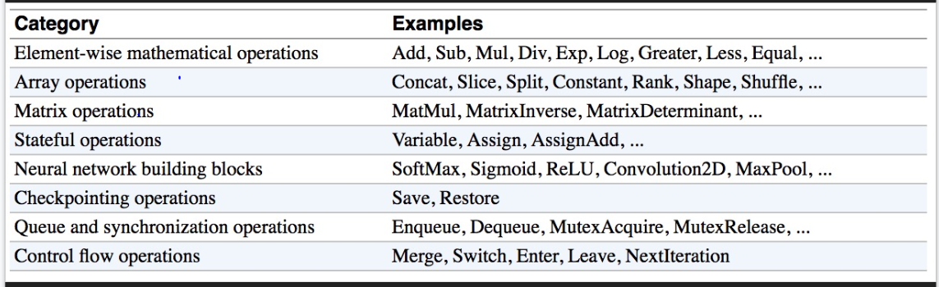
* Datatypes:
* Constants: are stored in graph definition. This makes loading graphs expensive when constants are big.
* Use variables for data that require more memory
* VARIABLE: tf.Variable(value,name=None)
* Tf.get_variable(name,shape,initializer) …we can use initializer= tf.constant(2)
* Tf.constant is op, tf.Variable is a clas with many ops
* Initialize variables:
  + We need to **initialize all variables** at once, so use “sess.run(tf.global_variable_initializer())” ➔ initializer is an op. We need to execute it within the context of a session
  + Initialize only **subset** of variables: sess.run(tf.variables_initializer([a,b])
  + Only one variable: a= tf.Variable(tf.zeros([2,3]))

With tf.Session() as sess:

Sess.run(a.initializer)

Print(a.eval()) #display values

* Tf.Variable.assign():
  + A.assign(100) needs to be executed in a session to take effect
  + Used to assign value to variable
  + Assign_add(value) to add a value to the variable
  + Assign_sub(value)
  + Var= tf.variable(10)

With tf.session() as sess:

Sess.run(var.initializer) >>10

Sess.run(var.assign_add(10))>>20

Sess.run(var.assign_sub(2))>>18

* Each session maintains its own copy of variables: like if 2 session is created the modification of variable in one session wont affect the value of other.
* Control dependencies: defines which op should run first
  + g= tf.get_default_graph() #graph g has 4 ops:a,b,c,d
  + with g.control_dependencies([a,b]):
  + #c,d will run only after a,b execution
* PLACEHOLDERS
  + A TF program often has 2 phases:
    - Assemble a graph
    - Use a session to execute operations in the graph.
  + Assemble the graph first without knowing the values needed for computation
  + Analogy:
    - Define the function f(x, y) = 2 * x + y without knowing value of x or y.
    - x, y are placeholders for the actual values.
* Why placeholders: We, or our clients, can later supply their own data when they need to execute the computation.
* Tf.placeholder(dtype,shape=None, name=None)
* Supplement the values to placeholders using a dictionary
* If a=b+c ,,then sess.run(a, feed_dict ={b:[2,3],c:[4,5]})
* Shape = None means that tensor of any shape will be accepted as value for placeholder.
* shape=None is easy to construct graphs, but nightmarish for debugging
* You can feed_dict any feedable tensor.
* Placeholder is just a way to indicate that something must be fed
* Tf.graph.is_feedable(tensor) #true if and only if tensor is feedable
* Tf.data: Instead of doing inference with placeholders and feeding in data later, do inference directly with data :
  + Tf.data.dataset
* dataset = tf.data.Dataset.from_tensor_slices((data[:,0],[:,1]))
  + Tf.data.iterator
* iterator = dataset.make_one_shot_iterator()  
  Iterates through the dataset exactly once. No need to initialization.
* iterator = dataset.make_initializable_iterator()  
  Iterates through the dataset as many times as we want. Need to initialize with each epoch.
* ------------------------------------------------------------------------------------------------------------------------

EAGER EXECUTION: "A NumPy-like library for numerical computation with support for GPU acceleration and automatic differentiation, and a flexible platform for machine learning research and experimentation."……..It's available as tf.contrib.eager, starting with version 1.50 of TensorFlow.

* Graphs are: **Optimizable**
  + automatic buffer reuse
  + constant folding
  + Inter-op parallelism
  + automatic trade-off between compute and memory
* **Deployable**
  + the Graph is an intermediate representation for models
* **Rewritable**
  + experiment with automatic device placement or quantization

TensorFlow = Operation Kernels + Execution

* Graph construction: Execute compositions of operations with Sessions
* Eager execution: Execute compositions with Python
* Motivation:
  + TensorFlow today: Construct a graph and execute it.
    - This is *declarative* programming. Its benefits include performance and easy translation to other platforms; drawbacks include that declarative programming is non-Pythonic and difficult to debug.
  + What if you could execute operations directly?
    - Eager execution offers just that: it is an *imperative* front-end to TensorFlow.
* Key advantages: Eager execution …
  + is compatible with Python debugging tools
    - pdb.set_trace() to your heart's content!
  + provides immediate error reporting
  + permits use of Python data structures
    - e.g., for structured input
  + enables you to use and differentiate through Python control flow
* Enabling eager execution requires two lines of code

import tensorflow as tf

import tensorflow.contrib.eager as tfe

tfe.enable_eager_execution() # Call this at program start-up

    and lets you write code that you can easily execute in a REPL, like this

x = [[2.]]  # No need for placeholders!

m = tf.matmul(x, x)

print(m)  # No sessions!

# tf.Tensor([[4.]], shape=(1, 1), dtype=float32)

--------------------------------------------------------------------------------------------------------------------------------------

MANAGING.

* One hot representation :
  + each word is represented by one vector with single 1 and rest is 0
  + A =[0 0 1], B=[0 1 0],C =[1 0 0]
  + Problems: Vocabulary can be large

=>  massive dimension, inefficient computation

* + Can’t represent relationship between words

=> “anxious” and “nervous” are similar but would have completely different representations

* Word embeddings:
  + Distributed representation
  + Continuous values
  + Low dimension
  + Capture the semantic relationships between words
* Representing a word by means of its neighbours. Know word by company it keeps
* PHASE1: Assemble graph
  + 1.Import data (with tf.data or placeholders)
  + 2. Define the weights
  + 3. Define the inference model
  + 4. Define loss function
  + 5. Define optimizer
* PHASE2: Compute

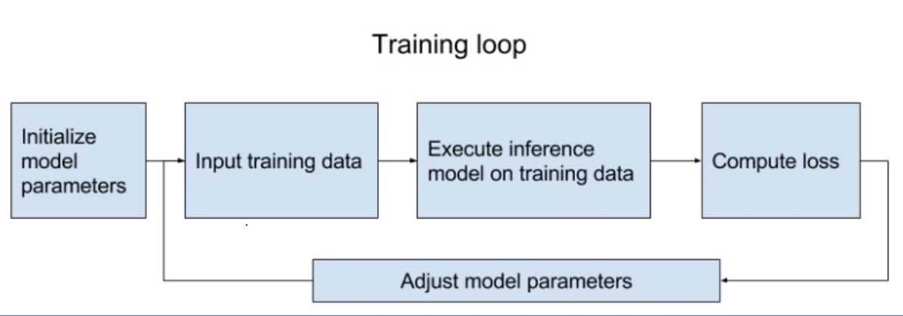

* NAMESCOPE: tf doesn’t know which nodes to group together unless we tell it
* Group nodes together with tf.name_scope(name)

with tf.name_scope(name_of_that_scope):

# declare op_1

# declare op_2

* Difference btwn namescope and variablescope: vs facilitates variable sharing
* tf.get_variable(<name>, <shape>, <initializer>)
  + If a variable with <name> already exists, reuse it
  + If not, initialize it with <shape> using <initializer>
* Put your variables within a scope and reuse all variables within that scope

**Tf.train.Saver**

* To save sessions[**checkpoints**]: (suppose if you want to save parameters after some certain number of steps)—global_step is step at which model is saved
  + tf.train.Saver.save(sess, save_path, global_step=None...)
  + Only save variables, not graph
  + Checkpoints map variable names to tensors
  + 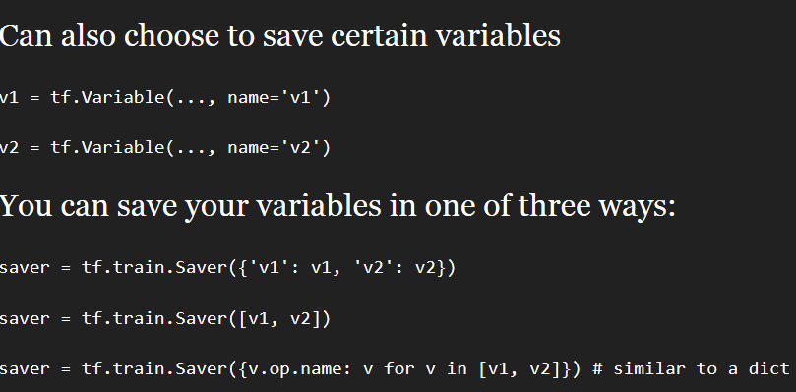

**tf.train.Saver.restore(sess, save_path)**

* + saver.restore(sess, 'checkpoints/name_of_the_checkpoint')
  + still need to first build the graph
* 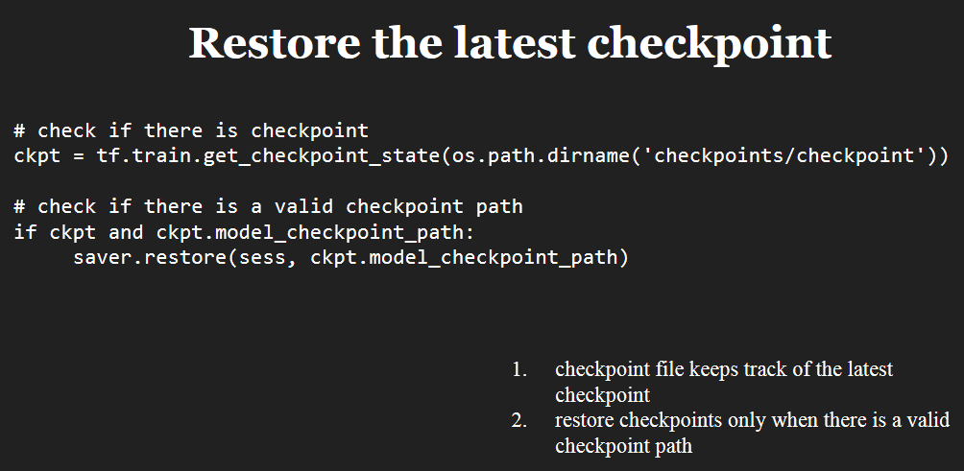

**Tf.Summary:**

* Visualize our summary statistics during our training

tf.summary.scalar

tf.summary.histogram

tf.summary.image

* Steps: create summary, run them, write summaries to file

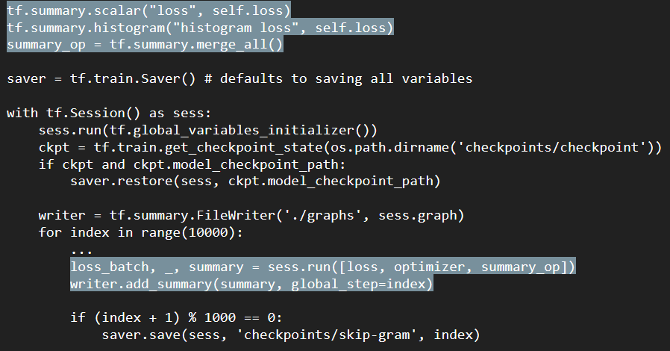

* tf.gradients(y, [xs]): Take derivative of y with respect to each tensor in the list [xs]
* **CNN**
* Features are hierarchical
  + **Composing high-complexity features out of low-complexity features** is more efficient than learning high-complexity features directly.

e.g.: having an “circle” detector is useful for detecting faces… and basketballs

* + Features are **translationally invariant:** If a feature is useful to compute at (x, y) it is useful to compute that feature at (x’, y’) as well
* 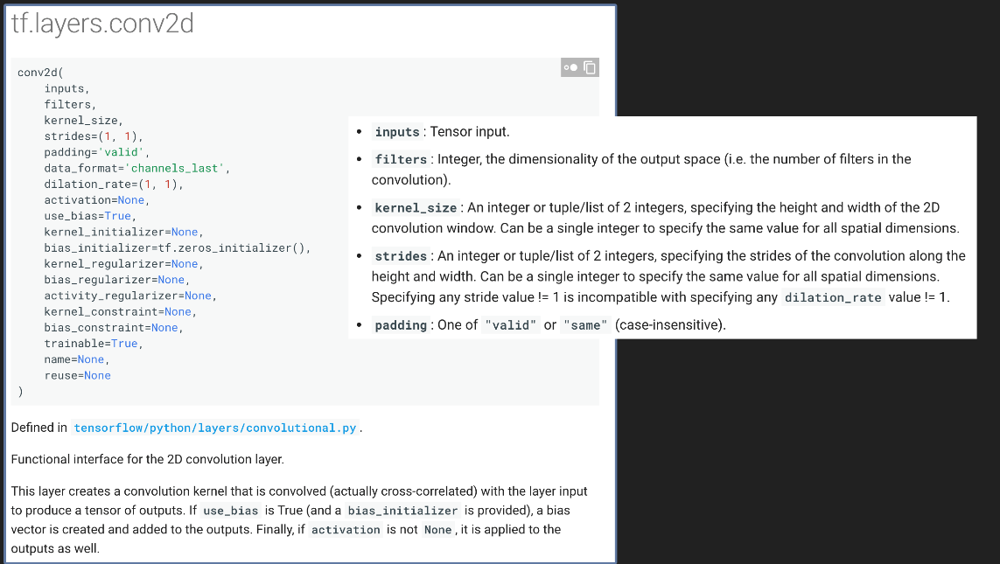
* Padding: Valid(no padding), zero (with 0 outer)
* Convolutional networks are tailor-made for computer vision tasks.They exploit:
  + Hierarchical nature of features
  + Translation invariance of features
* We can use one single convolutional layer to modify a certain image

tf.nn.conv2d(

   input,            Batch size (N) x Height (H) x Width (W) x Channels (C)

   filter,        Height x Width x Input Channels x Output Channels

   strides,        4 element 1-D tensor, strides in each direction

   padding,        'SAME' or 'VALID'

   use_cudnn_on_gpu=True,

   data_format='NHWC',

   dilations=[1, 1, 1, 1],

   name=None

)

* **Callback** can be used to control training. Well, the good news is that, the training loop does support callbacks. So in every epoch, you can callback to a code function, having checked the metrics. If they're what you want to say, then you can cancel the training at that point.
* Can be used to stop training when reached certain accuracy.
* class myCallback(tf.keras.callbacks.Callback):

def on_epoch_end(self, epoch, logs={}):

if(logs.get('acc')>0.6):

print("\nReached 60% accuracy so cancelling training!")

self.model.stop_training = True

* callbacks should be passed to run in tf/fit in keras

**tf.tile(input, multiples)**

eg: tf.tile(dig,2)---> output [a b c a b c]

if dig =[a b c]

**Eager Execution**: It is an imperative(important) programming environment where the operations are evaluated immediately without building graphs: Here the operations return concrete value instead of contsructing graph to run later.

Note: Usually without using Eager execution, tf will first contsruct a graph and then while runing the code, it takes the values and performs corresponding operations. By using eager execution, the graph wont be built, instead the operation is performed mmediately thereby it makes easy to start tf and debug models and also reduces bolierplate(boilerplate are sections of code that have to be included in many places with little or no alteration).

Eager execution is a flexible machine learning platform for research and experimentation, providing:

* An intuitive interface—Structure your code naturally and use Python data structures. Quickly iterate on small models and small data.
* Easier debugging—Call ops directly to inspect running models and test changes. Use standard Python debugging tools for immediate error reporting.
* Natural control flow—Use Python control flow instead of graph control flow, simplifying the specification of dynamic models.

**Usage**: **tf.enable_eager_execution()** at beginning of program or console session.

Cannot be added in modules that is being called by program

**RAGGED TENSORS:**

**-** Represent variably shaped sequences of data

- Tensorflow equivalent of nested variable-length lists

- Makes it easy to store and process irregular shaped data

- No need to worry about padding , Maximum size of tensor

-Can be used to store and process frames(batch of videos, each video of variable length)

-Ragged tensors supported by more than 100 tf operations(tf.add, tf.reduce_mean), array opeartions(tf.concat,tf.tile), manipulation operations(tf.substr) & etc.

* **tf.ragged.constant()** is used to construct ragged tensor

-For instance :

**digits = tf.ragged.constant([[1,2,3,4], [],[1,1,1], [6]])**

**words=tf.ragged.constant([[“so”,”good”],[“hex”]])**

print(tf.add(digits,3))—

output:<tf.RaggedTensor [[6, 4, 7, 4], [], [8, 12, 5], [9], []]>

print(tf.strings.substr(words,0,2))

print(digits[:,2]) # First two values in each row.

output: <tf.RaggedTensor [[3, 1], [], [5, 9], [6], []]>

* **To perform elementwise operation to values of ragged tensor:**

Use: **tf.ragged.map_flat_values(function, arguments)**

Example: function = lambda x: x * 2 + 1

print(tf.ragged.map_flat_values(function, digits))

Note: [] value in tensor remains [] after any type of operation

* Ragged tensors can also be constructed by pairing flat values tensors with row-partitioning tensors indicating how those values should be divided into rows, using factory classmethods such as **tf.RaggedTensor.from_value_rowids, tf.RaggedTensor.from_row_lengths, and tf.RaggedTensor.from_row_splits.**
* **Example1:**

print(tf.RaggedTensor.from_value_rowids(

values=[3, 1, 4, 1, 5, 9, 2, 6],

value_rowids=[0, 0, 0, 0, 2, 2, 2, 3]))

**output**:<tf.RaggedTensor [[3, 1, 4, 1], [], [5, 9, 2], [6]]>

* **Example2:**

print(tf.RaggedTensor.from_row_lengths(

values=[3, 1, 4, 1, 5, 9, 2, 6],

row_lengths=[4, 0, 3, 1]))

**output**:<tf.RaggedTensor [[3, 1, 4, 1], [], [5, 9, 2], [6]]>

* **Example3: row splits require the index start and end value**

print(tf.RaggedTensor.from_row_splits(

values=[3, 1, 4, 1, 5, 9, 2, 6],

row_splits=[0, 4, 4, 7, 8])) #indicates the index values like from 0 to 4, 4to 7 and 8 also if index is appeared twice then it has an empty value in between [].

**output**:<tf.RaggedTensor [[3, 1, 4, 1], [], [5, 9, 2], [6]]>

* All the value in ragged tensor must be of same type and same nesting depth.

tf.ragged.constant(["A", ["B", "C"]]) throws error saying all values must have same nesting depth.

* **tf.random.truncated_normal:** Outputs random values from a truncated normal distribution.
* Ragged tensors can be used to construct **unigram or bigram embedddings** for a batch of variable length queries, using special marker(#) at the beginning and end of each sentence(like #+first word, followed by bigrams and at end same #+lastword).

**Word embedding** is the collective name for a set of [language modeling](https://en.wikipedia.org/wiki/Language_model) and [feature learning](https://en.wikipedia.org/wiki/Feature_learning) techniques in [natural language processing](https://en.wikipedia.org/wiki/Natural_language_processing) (NLP) where words or phrases from the vocabulary are mapped to [vectors](https://en.wikipedia.org/wiki/Vector_(mathematics)) of [real numbers](https://en.wikipedia.org/wiki/Real_numbers).

* **Ragged Tensors:** It is a tensor of ragged dimensions(uneven /not uniform dimensions).

For eg. Rt =[[9,2,3,4],[1],[],[1,6]], all the column slices have different length. Col 1 2 3 4

* + - Row1| 9 3 7 5 |

Row2| 1 |

Row3| |

Row4| 1 6 |

* **Ragged Rank:** The number of ragged dimensions in a ragged tensor is called rank.

Rt =[ [9,2,3,4], [1] , [] , [1,6] ]

Here rank(dimension) of this tensor is 4.

* **tf.ragged.constant().shape** gives the dimension or rank
* **tf.ragged.constant().bounding_shape()** give sthe shape of the tensor. Here the shape of rt tensor is [4 4]
* Ragged sensor(irregular shape) is not a sparse tensor(regular shape).
* Follwing tensor is gene((rated by using tf.concat([rt1,rt2], axis=1) axis=1 is along row.

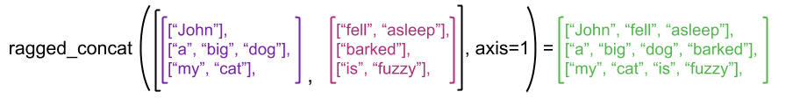

* Coverting rt to sparse tensor

sparse1 = rt1.**to_sparse()**

sparse2 = rt2.to_sparse()

sparseconcat = **tf.sparse.concat([sparse1,sparse2], axis =1)**

print(**tf.sparse.to_dense**(sparse_result, ''))

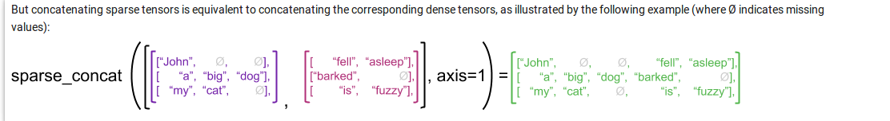

* It is possible to convert the ragged tensor to numpy array(rt.numpy), list(rt.to_list()),view all the values(rt.values), get row values(rt.row_splits—indicates how flattened values are divided into rows)

**GRAPH EXECUTION**

* In graph execution, ragged tensors can be evaluated using **session.run()**

with tf.session() a sess:

rt = tf.ragged.constant([1,2],[3],[5,9])

rt_val = sess.run(rt)