**Tech Mahindra Week 4 Task - Website Documentation**

**Movie Review Website**

**Prepared by Priyanka**

This document provides an overview of the website "Flix Fusion" as observed from the given screenshots. The purpose is to outline the structure, content, and intended functionality of the various pages of the website. This document contains screenshots of the website output along with the validations performed. Each page has been captured and documented accordingly.

**Home Page**

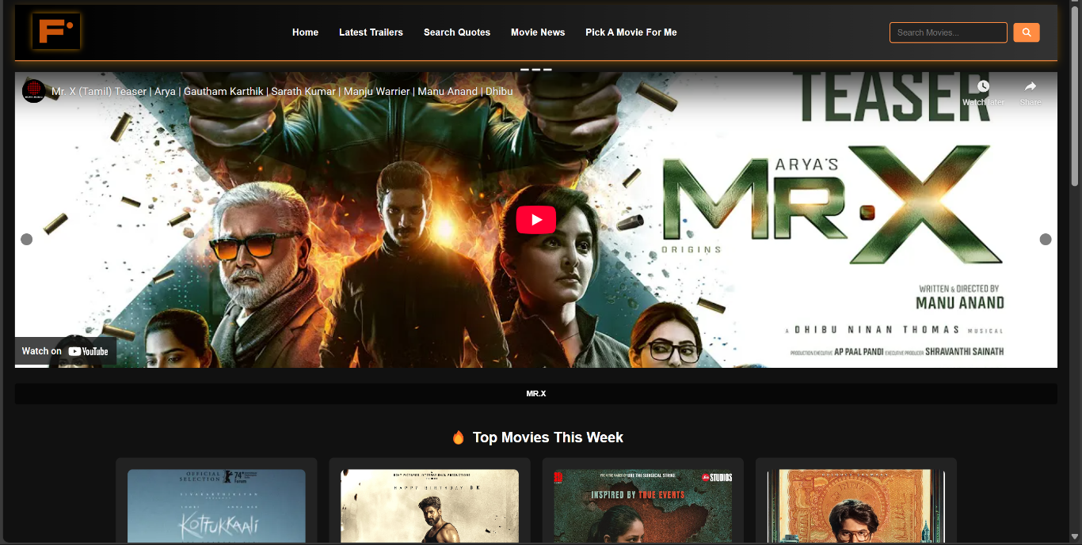

The homepage introduces "Flix Fusion" a movie review website. This page displays relevant content and has been validated successfully.

Key Features:

* Home page: A carousel slide showing latest released movie trailers.
* Call-to-Action Buttons:
  + “Home” (redirects to a home page)
  + “Latest Trailer” (redirects latest release trailer page)
  + “Search Quotes” (redirects to quotes site)
  + “Movie News” (redirects to imdb page)
  + “Pick a movie for me” (redirects to movie picker site)
  + Search bar (helps to search movies)
* Dark Theme with Gradient Accents: Enhances readability and modern UI aesthetics for friendly user interface.

**Top Rated Movies Page**

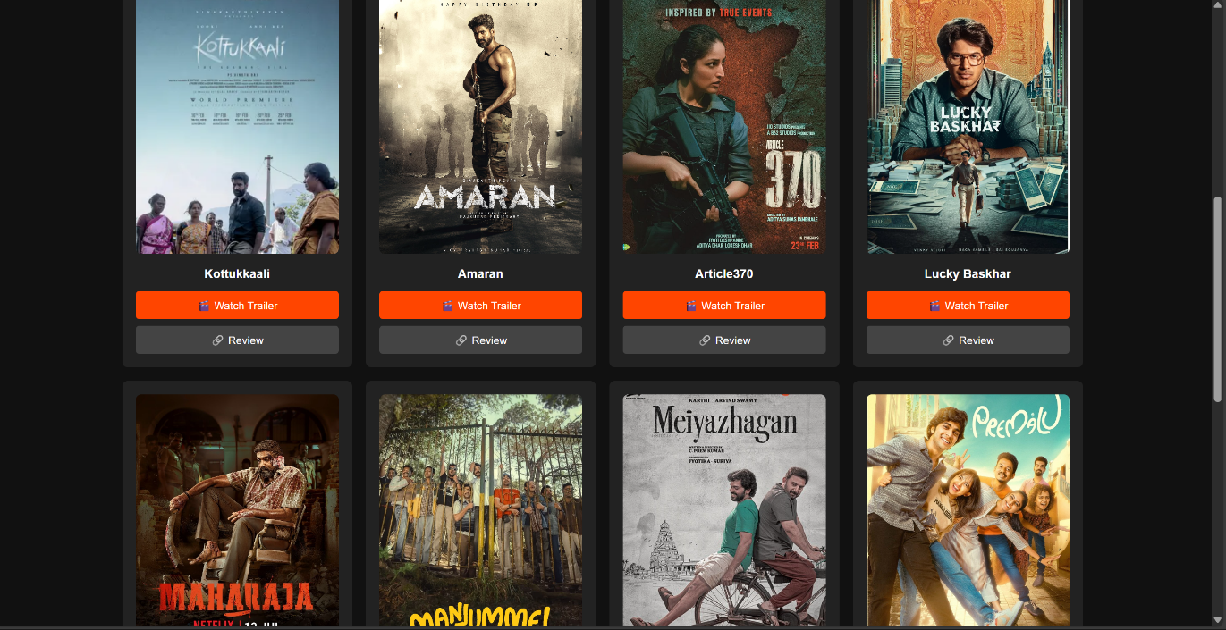

This section highlights top rated movie list from imdb. This page is used to redirect to review page of each movie given and trailer of each movie.

Key Features:

* Call-To-Action-Button:
  + “Review” (redirects to review page)
  + “Watch Trailer” (redirects to trailer in YouTube)
* Consistent Card Layout: Enhances visual appeal and readability.

**Review Page**

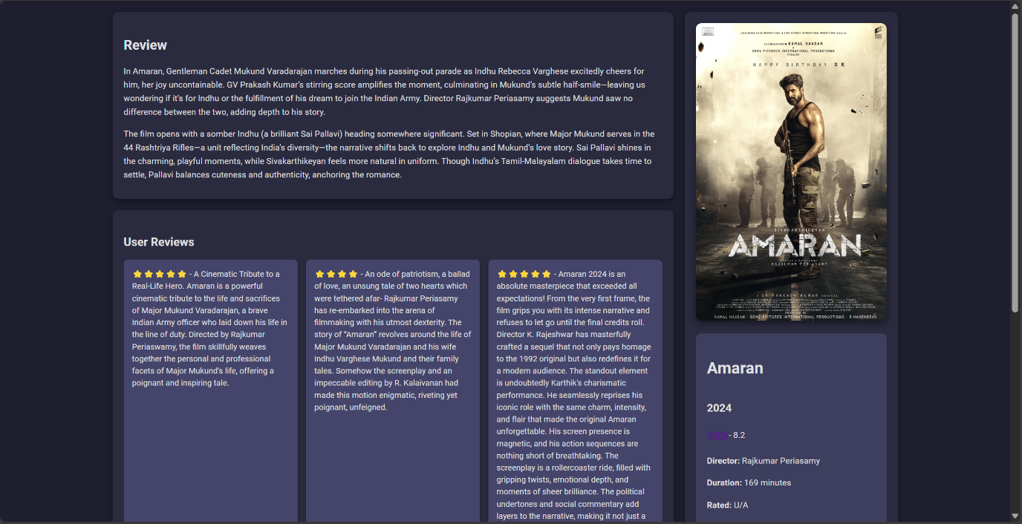

This review page provides details about the movie review with user review, review of the movie, movie details and leave review for the user review.

Key Features:

* Movie Poster: Shows the theatrical movie poster
* IMDb link button: Redirects to the imdb site of the movie.
* User Review: Displays users review of the movie.
* Movie Details: Provides the movie details like runtime, what certified movie, rating of the movie, date of release, director and cast.

**Conclusion**

The FilxFusion website presents an engaging and visually appealing interface, for the user with movie reviews and details. The homepage displays latest release trailer, the top-rated movies selection page highlights top imdb rated movies, and the review page encourages participation of the user to comment a review of the movie and also displaying the user review, movie details and review of the movie.