Product Data Cleaning and Preparation Using Excel
Data Cleaning and Insights
Project Objective:
To perform data cleaning and preparation on a retail product sales dataset using Microsoft Excel. The goal is to handle missing values, correct inconsistent text formatting, remove duplicate records, split the Product ID into Manufacturing Date and Country Code, merge Brand Name and Product Name into Product Brand, apply currency and date formatting, and use conditional formatting to highlight patterns in the dataset.

Dataset Description:
The dataset is a retail product sales dataset containing 34 records across multiple categories including Electronics, Fashion, Kitchen, Outdoor, and Accessories. Products are sold across 12 countries — US, UK, Canada, India, Australia, Germany, Italy, France, Spain, China, Russia, and Brazil. Each record includes the product name, brand, selling price, quantity sold, and category. After cleaning the dataset was reduced to 32 rows by removing 2 duplicate records.

Column Description

Column Name | Description
Product ID | Unique identifier combining manufacturing date and country code (e.g. 28-JAN-US)
Product Name | Name of the product (e.g. Laptop, Sneakers, Blender)
Brand Name | Brand of the product (e.g. Dell, Nike, Ninja)
Price ($) | Selling price of the product in US dollars — formatted as $#,##0.00 currency
Quantity | Number of units sold
Category | Product category — Electronics, Fashion, Kitchen, Outdoor, Accessories
Manufacturing Date | Date extracted from Product ID in DD-MM-YYYY format — added in Column G using TEXT formula
Country Code | Country code extracted from Product ID using RIGHT formula — added in Column H
Product Brand | Brand Name and Product Name merged into one column — added in Column I using concatenation formula

Data Cleaning and Transformation:
The dataset did not contain any missing values in the Price or Category columns. The Product Name column had one inconsistency — T-shirt in Row 7 was corrected to T-Shirt using Find and Replace (Ctrl+H). The Category column was checked for typos and all five values were correctly spelled. Two exact duplicate rows were removed using Data then Remove Duplicates — Row 24 (duplicate of Row 16) and Row 33 (duplicate of Row 11) — reducing the dataset from 34 to 32 rows. The Product ID was split into Manufacturing Date (Column G) using the TEXT DATEVALUE formula and Country Code (Column H) using RIGHT formula. A new Product Brand column (Column I) was created by merging Brand Name and Product Name. The Price column was formatted as $#,##0.00 currency and conditional formatting was applied — data bars on Price and a yellow highlight for Electronics in Category.

Visualization and Insights Arrived with Screenshot of Visualization Report/Dashboard:

Descriptive Analysis:
The cleaned dataset contains 32 products after removing 2 duplicate records. The Price column is formatted as currency with values from $30.00 to $1,000.00. Three new derived columns were added — Manufacturing Date in DD-MM-YYYY format, Country Code, and Product Brand. Products span 5 categories and 12 countries.
Diagnostic Analysis:
One text inconsistency was found and corrected in the Product Name column. Two duplicate rows were removed. The Electronics category is the most frequent and is highlighted in yellow in the Category column. Data bars on the Price column show the price distribution across all products.
Predictive Analysis:
Data bars show that Laptops ($1,000.00), Cameras ($700.00), and Smartphones ($900.00) carry the highest prices. These all belong to Electronics so maintaining good stock levels of Electronics products will keep revenue consistent.
Prescriptive Analysis:
The Manufacturing Date and Country Code columns enable analysis by region and time period. Consistent formatting and duplicate removal ensures accuracy. The Product Brand column simplifies product identification. Future data entry should follow the same formatting standards.
Reference
Fig 1 & Fig 2 — Task 1: Missing Values — Price Column | Category Column
Q1. Check for missing values in the Price column. How would you handle products with missing price information?
Answer: No missing values found in the Price column. If present, missing prices would be filled with the median price of the same category to maintain data consistency.
Q2. If there are products with missing categories, propose a strategy to impute or deal with these missing values effectively.
Answer: No missing Category values found. Strategy: infer from Product Name (e.g. Laptop → Electronics). If not inferable, assign Uncategorised as placeholder.

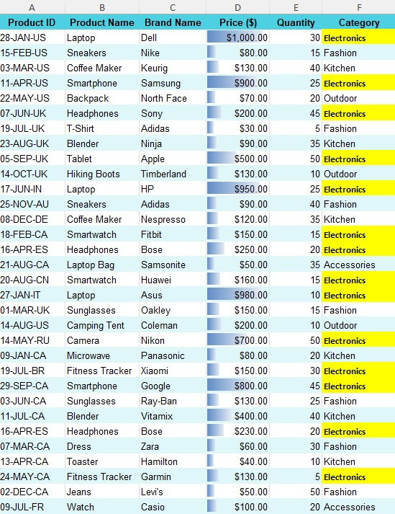
Fig 1.1 – Price column showing no missing values (all 32 rows contain data)

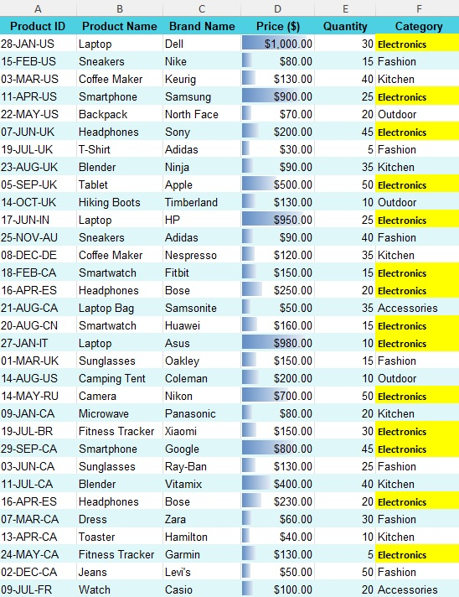
Fig 1.2 – Category column showing no missing values
Fig 3 & Fig 4 — Task 2: Inconsistent Data — Product Name Column | Category Column
Q3. Identify any inconsistent text formats present in the Product Name column.
Answer: T-shirt (Row 7, Product ID: 19-JUL-UK) used lowercase s while all other product names use Title Case. Corrected to T-Shirt using Find & Replace.
Q4. Identify any typos present in the Category column.
Answer: No typos found. All 5 category values — Electronics, Fashion, Kitchen, Outdoor, Accessories — are correctly spelled and consistent.
Q5. Use the Find and Replace function to standardize the text formats in the Product Name column and fix any typos or misspellings in the Category column.
Answer: Find & Replace (Ctrl+H): Find: T-shirt | Replace with: T-Shirt | Applied to Column B only. No replacements needed in Category column as all values were already correct.

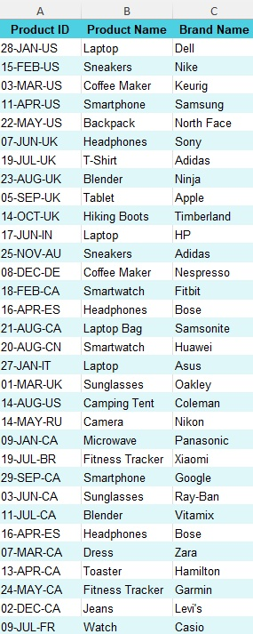
Fig 2.1 – Product Name column — T-Shirt corrected to Title Case (Row 7)

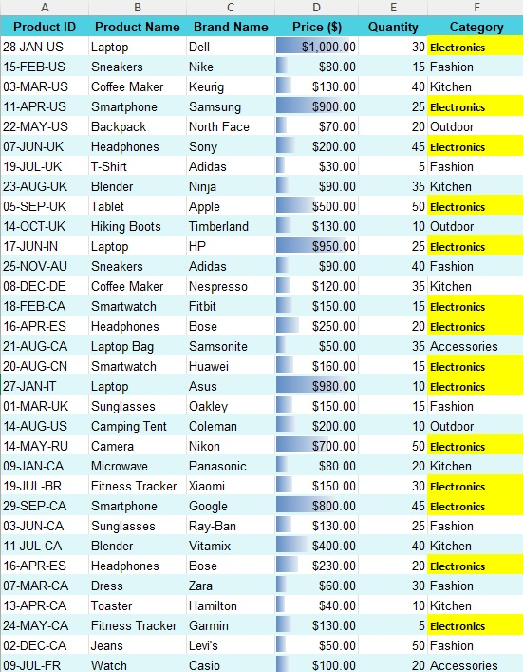
Fig 2.2 – Category column showing all values are correctly spelled
Fig 5 — Task 3: Removing Duplicate Records
Q6. Identify any duplicate rows within the dataset based on the entirety of each row, and remove them if any.
• Row 24 was a duplicate of Row 16 (21-AUG-CA | Laptop Bag | Samsonite | $50 | 35 | Accessories)
• Row 33 was a duplicate of Row 11 (17-JUN-IN | Laptop | HP | $950 | 25 | Electronics)
Answer: 2 exact duplicate rows removed using Data → Remove Duplicates (all 6 columns). Dataset: 34 rows → 32 rows.

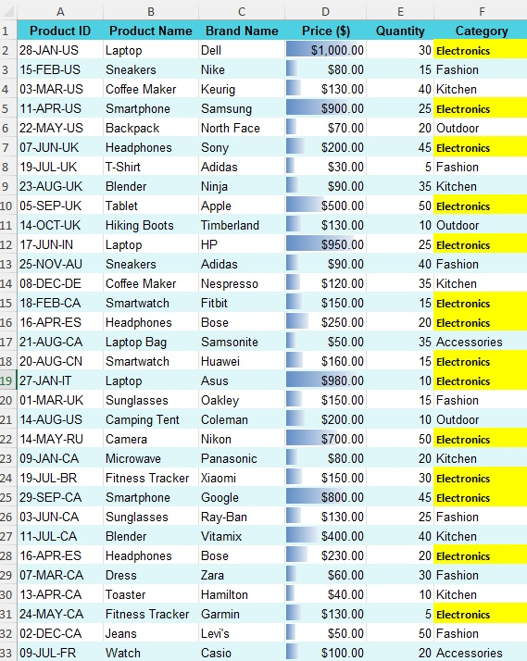
Fig 3.1 – Cleaned dataset after duplicate removal (32 rows remaining)
Fig 6 & Fig 7 — Task 4: Splitting & Merging — Manufacturing Date + Country Code | Product Brand
Q7. Split the Product ID column into two separate columns for Manufacturing Date and Country Code. Remove unnecessary characters, if any.
• Manufacturing Date (Col G): =TEXT(DATEVALUE(LEFT(A2,6)&"-2024"),"DD-MM-YYYY")
• Country Code (Col H): =RIGHT(A2,2)
Answer: Product ID (format: DD-MMM-CC) split into Manufacturing Date (e.g. 28-01-2024) and Country Code (e.g. US, UK, IN) using Excel formulas.
Q8. Merge the Brand Name and Product Name columns into one column named Product Brand.
Answer: Product Brand (Col I): =C2&" "&B2 — combines Brand Name and Product Name (e.g. Dell Laptop, Nike Sneakers)

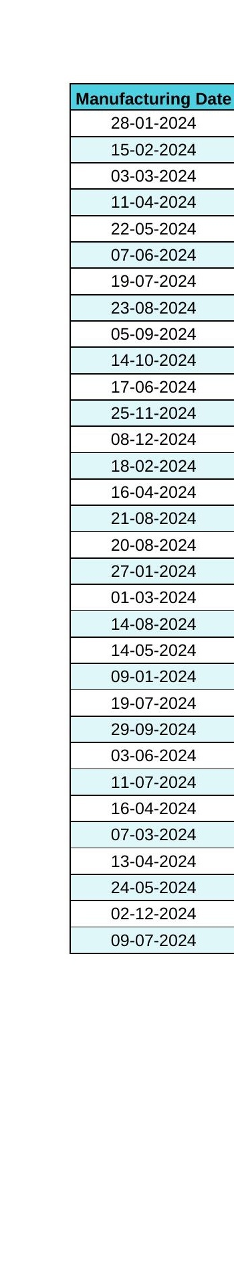
Fig 4.1 – Manufacturing Date (DD-MM-YYYY) and Country Code columns extracted from Product ID

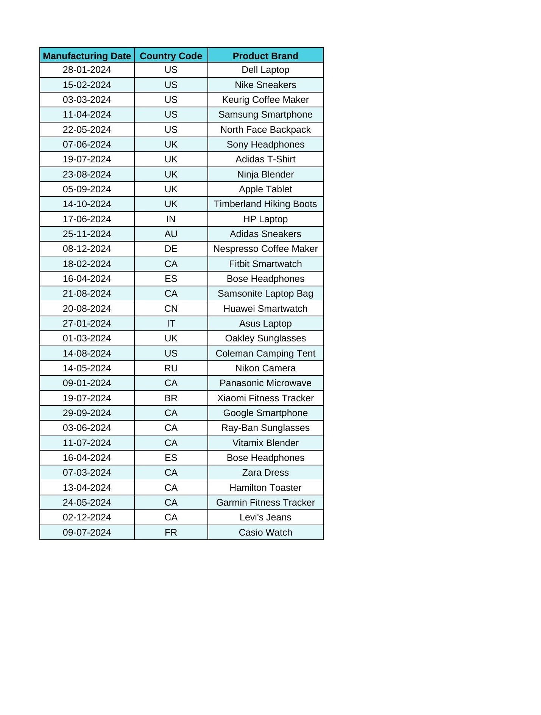
Fig 4.2 – Product Brand column showing merged Brand Name and Product Name
Fig 8 & Fig 9 — Task 5: Number Formatting — Currency Format | Date Format
Q9. Format the data type of the Price column to a currency format.
Answer: Format Cells (Ctrl+1 → Number → Currency): $#,##0.00 applied to Column D. Values display as $1,000.00, $80.00 etc.
Q10. Format the Manufacturing Date column to display dates in the DD-MM-YYYY format.
Answer: Manufacturing Date (Col G) uses formula =TEXT(DATEVALUE(LEFT(A2,6)&"-2024"),"DD-MM-YYYY") producing DD-MM-YYYY output (e.g. 28-JAN-US → 28-01-2024)

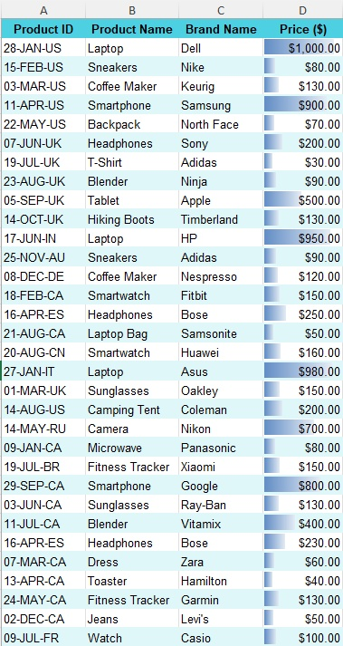
Fig 5.1 – Price column formatted as $#,##0.00 currency


Fig 5.2 – Manufacturing Date column displaying dates in DD-MM-YYYY format
Fig 10 & Fig 11 — Task 6: Conditional Formatting — Data Bars on Price | Electronics Highlight
Q11. Apply data bar or color scales conditional formatting in the Price column.
Answer: Home → Conditional Formatting → Data Bars → Blue Data Bar applied to D2:D33. Longer bars = higher price, shorter bars = lower price.
Q12. Create a custom rule for conditional formatting in the Category column to highlight cells where the category is Electronics.
Answer: Home → Conditional Formatting → New Rule → Cell Value = Electronics | Format: Yellow fill + Bold font | Applied to F2:F33

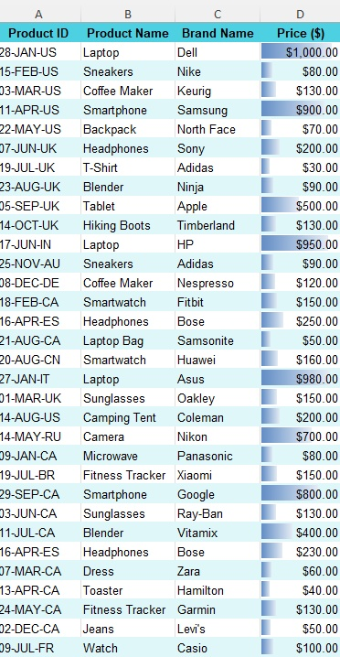
Fig 6.1 – Price column with blue data bars showing relative price values

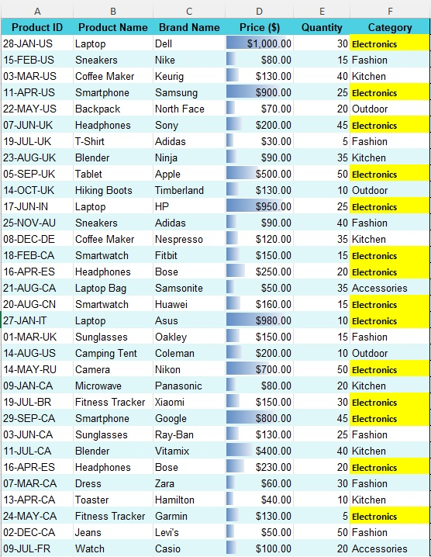
Fig 6.2 – Category column with Electronics cells highlighted in yellow bold
Conclusion:
This assignment successfully demonstrated data cleaning and preparation on a retail product sales dataset using Microsoft Excel. All six tasks were completed — missing value handling, inconsistent data correction, duplicate removal, column splitting and merging, number formatting, and conditional formatting. The dataset was reduced from 34 to 32 rows by removing 2 duplicates. One text inconsistency was corrected and three new columns were added. The final cleaned dataset is well structured, consistently formatted, and ready for further analysis.

