Smart City Bike-Sharing - Four Types of Analysis

1. Descriptive Analysis
What is happening? | Focus: Summarizes historical station and city performance
Business Problem Statement
Operations teams lack a consolidated view of how the bike-sharing network is actually performing across cities and stations. Station-level snapshot data (bike stands, available bikes, available docks, status) is captured continuously, but it sits in raw transactional form, which makes it difficult to see overall network health, top-performing cities, or underperforming stations without manual effort.
Analytical Objective
- Identify total stations, average occupancy rate, and closed-station rate across the entire network.
- Track overall network capacity, snapshot volume, and occupancy trend across the full observation period (2022 to 2025).
- Rank cities by average occupancy rate to pinpoint the highest and lowest performing markets.
Key Figures (Network Summary)
1K Total Stations | 32.8% Avg Occupancy Rate | 7.3% Closed Station Rate
Top / Bottom Cities by Avg Occupancy Rate
Rank | City | Avg Occupancy Rate
1 (Highest) | Dublin | 38.5%
2 | Toulouse | 37.7%
3 | Nantes | 37.4%
... | ... | ...
Lowest | Cergy-Pontoise | 2.6% to 3.0%

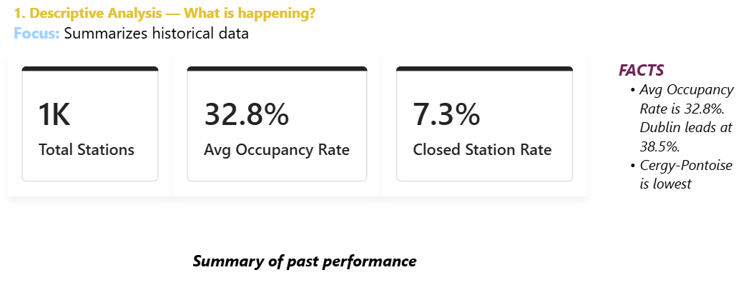

2. Diagnostic Analysis
Why is it happening? | Focus: Identifies causes behind occupancy and closure patterns
Business Problem Statement
A small number of cities (for example Cergy-Pontoise and Marseille) show disproportionately low occupancy rates alongside very high closed-station rates, while most cities cluster around a healthy 30-39% occupancy band. It isn't clear whether this reflects genuine low demand, insufficient docking capacity, or stations being taken offline for extended periods. Without this insight, the operator can't tell whether the underperformance is a demand problem or an operations/maintenance problem.
Analytical Objective
- Closure Rate Diagnosis: examine why Cergy-Pontoise (around 71% closed-station rate) and Marseille (around 34% closed-station rate) run far above the network average of 7.3%.
- Occupancy vs. Closure Correlation: cross-reference each city's Avg Occupancy Rate against its Closed Station Rate to test whether low occupancy is driven by stations being closed (a supply-side issue) rather than genuinely low ridership.
- Underperforming City Diagnosis: use the Underperforming City Flag logic (occupancy under 20% OR closed-rate over 15%) to systematically separate cities with a genuine performance issue from cities that simply have thin or incomplete data (flagged "Unknown").
Cities Flagged for Diagnostic Review
City | Avg Occupancy Rate | Closed Station Rate | Flag
Cergy-Pontoise | 2.6% to 3.0% | 71.1% | Underperforming
Marseille | 6.2% to 6.6% | 34.4% | Underperforming
Namur | 28.9% | 23.8% | Underperforming
Rouen | 29.0% | 16.8% | Underperforming
Besancon / Lillestrom / Ljubljana (thin data) | - | - | Unknown
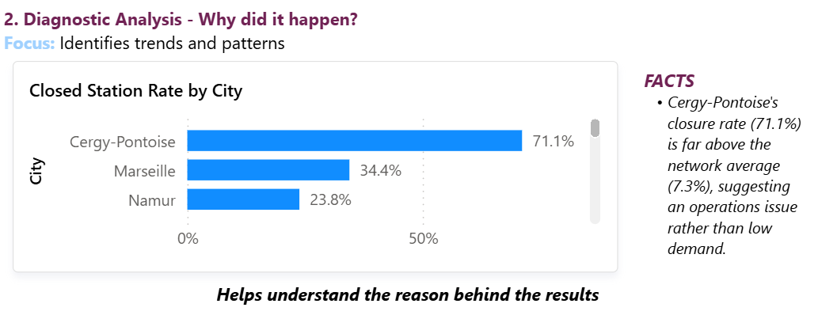

3. Predictive Analysis
What is likely to happen? | Focus: Uses historical trend to anticipate near-term occupancy
Business Problem Statement
With roughly three and a half years of station snapshot history (2022 to 2025), the operator needs a way to anticipate near-term occupancy levels and identify which cities are likely to keep trending up or down, so that bike-rebalancing and maintenance planning isn't based on guesswork.
Analytical Objective
- Use the recurring occupancy trend (the Occupancy Trend Over Time line chart, 2022 to 2025) to anticipate likely near-term occupancy levels for the network.
- Use the Year-over-Year Occupancy Change measure to identify which cities are likely to continue increasing or decreasing in occupancy if current usage patterns persist.
- Flag cities that are likely to remain Underperforming absent intervention, based on their trend direction rather than a single snapshot in time.
Note on Scope
The current dashboard surfaces the historical trend line and a Year-over-Year Occupancy Change measure, which support directional and trend-based prediction. A formal forecasting model (for example a statistical or machine-learning projection with confidence intervals) was outside the scope of this Power BI build and would be a natural next step using the same underlying occupancy data.
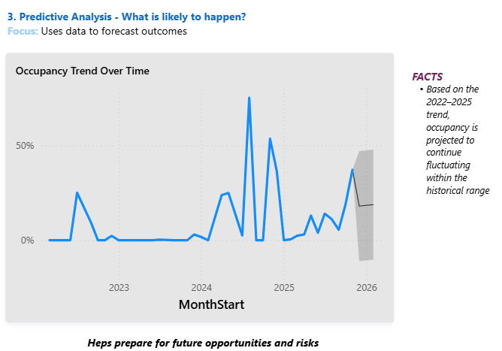

4. Prescriptive Analysis
What should we do about it? | Focus: Recommends actions to improve network performance
Business Problem Statement
Several cities are flagged as Underperforming due to low occupancy and/or high closed-station rates, but there is currently no defined action plan for station maintenance, bike rebalancing, or expansion focus, leaving clear improvement opportunities unaddressed.
Analytical Objective / Recommendations
- Prioritize maintenance and station audits in Cergy-Pontoise and Marseille first, given closed-station rates of 71.1% and 34.4% respectively, far above the 7.3% network average, since restoring these stations to active status is likely the single highest-leverage fix available.
- Rebalance bike/dock allocation in Namur and Rouen, where moderate occupancy (around 29%) combined with elevated closure rates (17-24%) suggests partial rather than total station failure, a smaller-scale operational fix rather than a full audit.
- Study and replicate practices from top-performing cities (Dublin, Toulouse, Nantes, all at 37-39% occupancy with under 1% closed-station rates) as a benchmark for station uptime and availability elsewhere in the network.
- Investigate cities flagged "Unknown" (Besancon, Lillestrom, Ljubljana, and others) to determine whether thin data reflects a genuinely small deployment or a data-collection gap, before drawing performance conclusions about them.
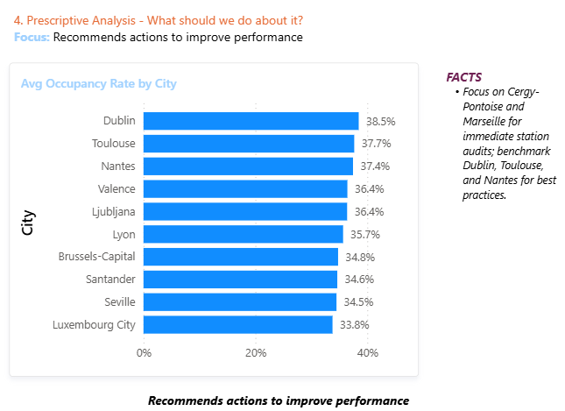
Recommended Action Summary
Priority | City / Group | Recommended Action
High | Cergy-Pontoise, Marseille | Immediate station audit and maintenance - closed-rate far above network average
Medium | Namur, Rouen | Targeted bike/dock rebalancing to lift occupancy
Benchmark | Dublin, Toulouse, Nantes | Use as best-practice reference for uptime and availability
Investigate | Besancon, Lillestrom, Ljubljana | Confirm whether "Unknown" status is a data gap or a small deployment

