Project Details

1. **Introduction:** Our Project.ai is an advanced system engineered to parse complex documents and generate structured, LLM-ready inputs with exceptional precision. It empowers businesses to extract actionable insights from a wide range of unstructured data sources, including PDFs, Excel spreadsheets, and PowerPoint presentations.

Leveraging cutting-edge natural language processing (NLP) and machine learning techniques, the system intelligently interprets content, identifies key entities, and preserves contextual meaning across diverse formats. This enables seamless integration with large language models (LLMs) for tasks such as summarization, data extraction, compliance checks, and decision support.

Designed for scalability and ease of use, Our Project.ai supports automated workflows and customizable pipelines, reducing manual effort and operational costs. Whether for financial analysis, legal review, or business intelligence, the platform transforms static documents into dynamic, structured knowledge assets.

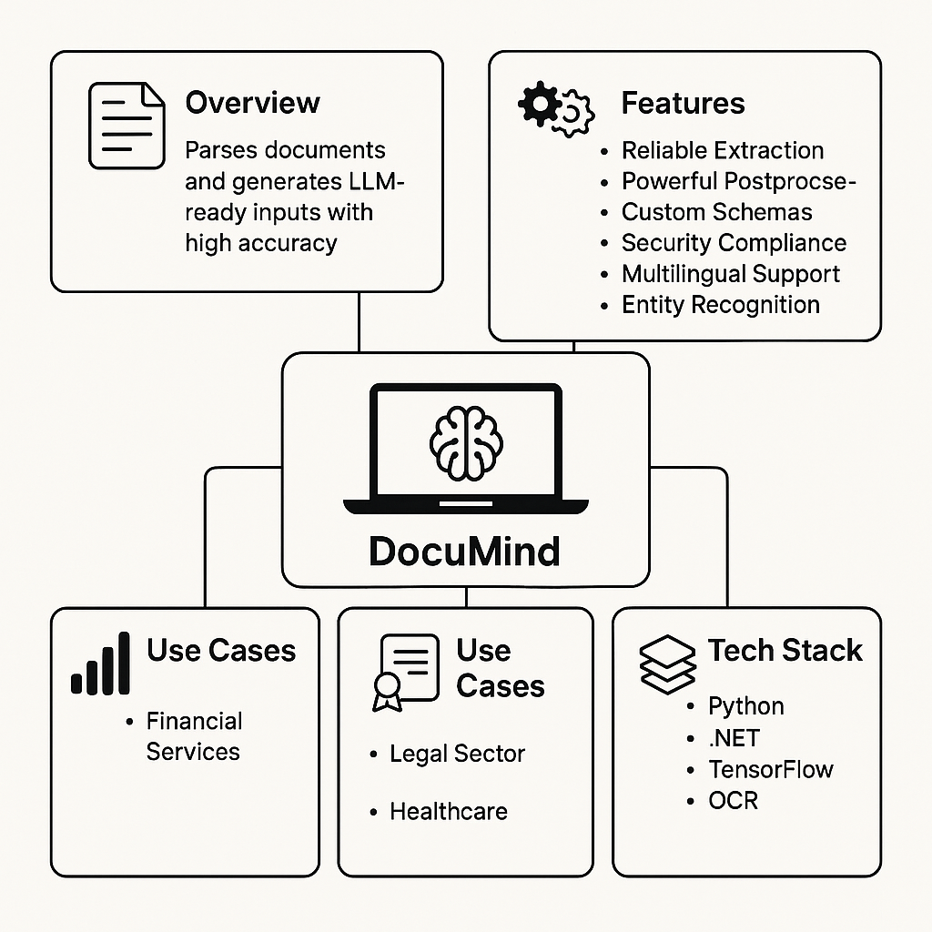

1. **Features and Functionality:**

* Reliable Extraction: Converts unstructured documents into structured outputs.
* Powerful Postprocessing: Ensures high accuracy across tables, forms, images, and graphs.
* Custom Schemas: Allows users to define extraction parameters tailored to their needs.
* Security Compliance: Provides zero data retention and supports self-hosting for enhanced security
* Multilingual Support
* Capable of processing documents in multiple languages, enabling global applications and cross-border document analysis.
* Document Type Versatility
* Supports a wide range of document types and formats, including scanned PDFs, digital documents, emails, HTML, and images with OCR integration.
* Intelligent OCR (Optical Character Recognition)
* Integrates high-performance OCR to extract data from scanned or image-based documents while preserving layout and structure.
* Entity Recognition and Classification
* Identifies and classifies key entities such as names, dates, financial figures, and more, for deeper contextual understanding.
* Real-Time Processing
* Offers fast, real-time document parsing for time-sensitive workflows, improving operational efficiency and responsiveness.
* Human-in-the-Loop Review
* Allows optional human verification at critical points, combining automation with expert oversight for maximum accuracy.
* Audit Logging and Traceability
* Maintains detailed logs of all processing activities, ensuring transparency and traceability for compliance and quality assurance.
* API and Integration Ready
* Provides robust APIs for seamless integration with enterprise tools, LLM platforms, RPA systems, CRMs, and data lakes.
* Version Control and Change Tracking
* Tracks changes in document structure and schema over time, helping teams manage document evolution and compliance.
* Adaptive Learning
* Incorporates user feedback to improve extraction accuracy over time through reinforcement learning mechanisms.

1. **UseCase:**

**1. Financial Services – Automated Financial Document Processing**

Problem:

Banks and investment firms handle vast amounts of financial documents (e.g., earnings reports, balance sheets, audit forms) that are often inconsistent in format and layout.

Solution with Our Project.ai:

Reliable Extraction and Powerful Post processing convert complex tables and statements into structured data.

Entity Recognition identifies financial figures, company names, and dates.

Custom Schemas tailor output to match reporting templates.

Audit Logging ensures traceability for compliance.

Real-Time Processing enables up-to-date market analysis.

Result: Reduces manual data entry by 90%, improves reporting accuracy, and accelerates time-to-insight.

2. **Legal Sector – Contract Review and Clause Extraction**

Problem:

Legal teams must review and extract critical clauses from large volumes of contracts, which may vary in structure and language.

Solution with Our Project.ai:

Intelligent OCR handles scanned or image-based legal documents.

Multilingual Support processes contracts in multiple jurisdictions.

Custom Schemas identify specific clauses (e.g., indemnity, termination, confidentiality).

Human-in-the-Loop Review ensures sensitive or critical clauses are verified.

Version Control helps track changes across contract iterations.

Result:

Accelerates contract review by up to 70% and reduces the risk of missing key obligations.

3. **Healthcare – Structuring Clinical and Lab Data**

Problem:

Hospitals and labs receive unstructured data from handwritten prescriptions, lab results, and discharge summaries.

Solution with Our Project.ai:

OCR and Postprocessing digitize and structure paper-based documents.

Entity Recognition identifies patient information, medications, and diagnostics.

Security Compliance ensures HIPAA-aligned zero data retention and supports on-prem deployment.

Adaptive Learning improves over time based on clinician feedback.

Result:

Delivers structured EMR-ready data, improving data accessibility and patient care quality.

4. **Insurance – Claims Automation and Document Matching**

Problem:

Insurance companies process diverse documents for claims (e.g., forms, receipts, photos), leading to slow processing and errors.

Solution with Our Project.ai:

Document Type Versatility supports forms, receipts, and images.

Entity Recognition matches policy numbers, claim dates, and incident types.

Real-Time Processing accelerates claim intake.

APIs integrate seamlessly into claims management systems.

Audit Logging maintains a verifiable trail of document activity.

Result:

Reduces claims processing time by up to 60% and enhances fraud detection accuracy.

5. **Manufacturing – Invoice and PO (Purchase Order) Reconciliation**

Problem:

Manufacturers handle thousands of invoices and purchase orders from global suppliers in different languages and formats.

Solution with Our Project.ai:

Multilingual Support handles invoices from global vendors.

Custom Schemas extract line items, vendor data, and totals.

Real-Time Processing integrates with ERP systems for immediate reconciliation.

Change Tracking monitors discrepancies or updates over time.

Result:

Streamlines AP/AR workflows and reduces invoice mismatches.

6. **Government & Policy – Regulatory Document Monitoring**

Problem:

Regulatory bodies and policy analysts must track frequent updates to laws and guidelines, often published in lengthy, complex documents.

Solution with Our Project.ai:

Reliable Extraction identifies obligations, penalties, and procedural updates.

Version Control compares new and old regulations side-by-side.

API Integration allows policy updates to flow into internal systems.

Multilingual Support helps monitor international regulations.

Result:

Improves regulatory intelligence and decision-making efficiency.

1. **Technical Architecture and Components**

**1. Programming Languages & Frameworks**

**Python**

Python is the primary language used for AI model development, data preprocessing, and orchestration of multi-agent workflows. Its rich ecosystem of libraries like NumPy, pandas, scikit-learn, TensorFlow, and PyTorch makes it ideal for handling complex machine learning and document understanding tasks.

.**NET (C#)**

.NET is used for building high-performance, enterprise-grade backend services, user interfaces, and integration layers with legacy enterprise systems (e.g., ERP, CRM). Its robust security model and compatibility with Windows-based infrastructure make it suitable for corporate environments with strict IT governance.

Common uses include: dashboard/UI development, document upload interfaces, API gateways, Active Directory authentication, and desktop client integrations.

**TensorFlow & PyTorch**

These deep learning frameworks support both training and inference of AI models:

TensorFlow powers large-scale model training and deployment in production environments.

PyTorch is favored for experimentation and NLP tasks like named entity recognition, layout parsing, and table extraction.

**FastAPI (Python)**

A high-performance, asynchronous API framework used to serve machine learning models, manage document workflows, and provide endpoints for web or desktop clients.

**ASP.NET Core (C#/.NET)**

Powers RESTful services and user interfaces that integrate with FastAPI backends and Python-based AI services. Useful for dashboard development, admin panels, role-based access control, and real-time document tracking systems.

**PostgreSQL**

An open-source relational database used for storing structured data extracted from documents. Supports complex queries, JSON fields, and integration with analytics pipelines.

**2. AI Tools & Technologies**

Vision Models

Leverage state-of-the-art models like LayoutLM, Donut, or proprietary vision transformers for understanding document layouts, extracting data from tables, forms, and mixed-content formats.

**OCR (Optical Character Recognition)**

Utilizes engines like Tesseract, Google Vision, or ABBYY to extract text from scanned documents and images. Output is integrated into vision models to preserve spatial structure and accuracy.

**Autogen & Multi-Agent Systems**

Employs modular AI agents that autonomously handle various tasks such as document classification, data extraction, postprocessing, and security enforcement.

**3. Multi-Agent System Architecture**

Each autonomous agent operates as a microservice, typically built in Python, while orchestration and integration with enterprise systems may use .NET services.

**Data Extraction Agent (Python)**

Parses documents using AI models and vision tools. Extracts structured data including entities, key-value pairs, and tables.

**Postprocessing Agent (Python)**

Refines and validates extracted data. Ensures normalization, removes duplication, and aligns outputs with user-defined schemas.

**Schema Definition Agent (.NET/Python)**

Provides a user-facing interface (built in ASP.NET Core) where business users define which fields to extract and how they should be formatted. Backend logic is implemented in Python to apply schema rules during processing.

**Security Agent (.NET)**

Enforces encryption, access control, zero data retention, and compliance policies. Integrates with enterprise security systems (e.g., Active Directory, OAuth2, or LDAP).

**Orchestration Agent (Python/.NET Hybrid)**

Coordinates task execution across all agents. May be implemented as a message broker (e.g., using RabbitMQ or Azure Service Bus) with Python handling task logic and .NET managing enterprise-level workflow triggers and UI feedback.

1. **Project Phases**

**Phase 1: Planning and Requirements Gathering**

Time Estimate: 2-4 weeks

Budget Estimate: $20,000 - $40,000

Stakeholder meetings

Documenting use cases

Finalizing feature set

Setting up project management systems

**Phase 2: System Architecture & Design**

Time Estimate: 4-6 weeks

Budget Estimate: $40,000 - $60,000

Finalizing technical architecture

Designing database schema and integrations

Designing AI model architecture

Designing user interfaces (UI/UX)

**Phase 3: Core Development – Backend and Frontend**

Time Estimate: 3-6 months

Budget Estimate: $200,000 - $300,000

Backend (Python & .NET)

API development (FastAPI, ASP.NET Core)

Integration with machine learning models (TensorFlow, PyTorch)

Database integration (PostgreSQL)

Security and compliance measures (Zero data retention, encryption)

Frontend (UI/UX, Dashboards)

Developing front-end interfaces (ASP.NET Core for web apps or desktop client)

Integration with backend for document uploading, data visualization

Multi-Agent System Development

Development of autonomous agents (Data extraction, postprocessing, schema, and security agents)

**Phase 4: AI Model Development and Training**

Time Estimate: 2-4 months

Budget Estimate: $100,000 - $150,000

Developing and fine-tuning deep learning models for document parsing

Training models on labeled datasets

Implementing OCR and vision models

Testing AI model accuracy and fine-tuning based on feedback

Infrastructure for training (cloud-based or on-prem resources)

**Phase 5: Integration & Testing**

Time Estimate: 2-3 months

Budget Estimate: $75,000 - $100,000

Integrating backend and frontend components

Ensuring seamless communication between Python-based agents and .NET services

End-to-end testing for data extraction and security compliance

Load and performance testing

User acceptance testing (UAT)

**Phase 6: Deployment & Maintenance**

Time Estimate: Ongoing

Budget Estimate: $50,000 - $75,000 (initial deployment); $15,000 - $25,000 per month for ongoing maintenance

Deploying the system on cloud or on-prem infrastructure

Continuous monitoring and troubleshooting

Bug fixing and patching

Providing technical support and updates

Training users on system operation

**Here are some suggested project names that convey the innovative and intelligent nature of your document parsing and AI-driven system:**

DocuIntelli

A blend of "Document" and "Intelligence," emphasizing smart document processing.

ParseAI

Straightforward and descriptive, focusing on AI-powered document parsing.

InsightExtract

Highlights the system’s ability to extract valuable insights from documents.

DataParseX

A modern name with a tech-forward edge, denoting data parsing with a futuristic "X" twist.

DocuMind

Suggests a "smart" system designed to understand and process documents.

ExtractIQ

A name that connects the idea of intelligent data extraction with the power of AI.

ParseFlow

Refers to the smooth, continuous flow of data extracted from complex documents.

DocuSift

Conveys the idea of "sifting" through documents to find relevant data, powered by AI.

LexiParse

A creative fusion of "Lexicon" (language) and "Parse," showing its linguistic prowess.

DataMinds

Focuses on data extraction through intelligent minds (AI), implying cognitive abilities.

InstaExtract

Emphasizes the speed of real-time document processing and extraction.

VisionParse

Highlights the system’s advanced vision-based parsing for images and documents.

ClearParse

Suggests transparency and accuracy in parsing documents and extracting useful data.

Extractra

A playful and catchy name that combines "Extract" and "Extra," highlighting the system’s ability to offer more from every document.

SmartParse

Simple but effective, emphasizing the intelligent parsing capabilities of the system.