

A
Internship Report is submitted to the
Sanjeev Agrawal Global Educational University, Bhopal, M.P.
in partial fulfillment of the requirements for the award of the Degree of BTech Specialization in
Computer Science Engineering VII Semester
By
Priyanka Sankhediya
23BTE3CSE10140
Under the guidance of
Mr. Govind Shukla
InAmigos Foundation

SCHOOL OF ENGINEERIMG & TECHNOLOGY
SANJEEV AGRAWAL GLOBAL EDUCATIONAL UNIVERSITY BHOPAL AUTUMN 2026-27


SANJEEV AGRAWAL GLOBAL EDUCATIONAL UNIVERSITY, BHOPAL

SCHOOL OF ENGINEERIMG & TECHNOLOGY

CERTIFICATE

This is to certify that the “Internship report” submitted by Priyanka Sankhediya (23BTE3CSE10140) is work done by her/him and submitted during 2026 – 2027 academic year, in partial fulfillment of the requirement for the award of BTech CSE (School of Engineering & Technology, Sanjeev Agrawal Global Educational University, Bhopal) at InAmigos Foundation

Prof. Aaradhna Soni Dr. Shruti Dixit
Asst. Professor, SOET HOD, SOET

INTERNSHIP CERIFICATE

( internship Certificate Past here )

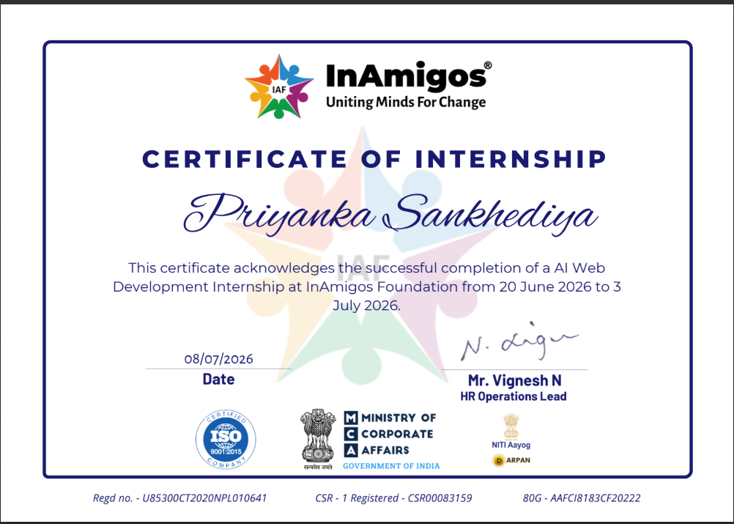

Signature of Internal Examiner
Signature of Examiner

SANJEEV AGRAWAL GLOBAL EDUCATIONAL UNIVERSITY, BHOPAL
SCHOOL OF ENGINEERIMG & TECHNOLOGY

ACKNOWLEDGEMENT

First, I would like to thank Anjali Prushty, CEO, (Company Project Leader name) Director of Internship Company Name, Place for giving me the opportunity to do an internship within the organization.

I also would like all the people that worked along with me Internship Company Name with their patience and openness they created an enjoyable working environment.

It is indeed with a great sense of pleasure and immense sense of gratitude that I acknowledge the help of these individuals.

I am highly indebted to HOS and HOD, for the facilities provided to accomplish this internship.
I would like to thank Prof. Aaradhna Soni, internship Coordinator School of Engineering & Technology, Sanjeev Agrawal Global Educational University, and Bhopal for their support and advices to get and complete internship in above said organization.

I am extremely great full to my department staff members and friends who helped me in successful completion of this internship.

Priyanka Sankhediya
23BTE3CSE10140

TABLE OF CONTENTS

S.NO | TITLE | PAGE  NO
 | ABSTRACT
CHAPTER 1: INTRODUCTION
1.1 | INTRODUCTION
1.2 | MODULES
CHAPTER 2: ANALYSIS
CHAPTER 3: TECHNOLOGY
CHAPTER 4: SOFTWARE REQUIREMENT AND SPECIFICATION
CHAPTER 5: CODING
CHAPTER 6: SCREENSHOT
CHAPTER 7: LEARNING OUTCOME
CHAPTER 8: CONCLUSION
CHAPTER 9: REFERENCE

ABSTRACT

The internship at InAmigos Foundation provided an excellent opportunity to gain practical exposure to web development, artificial intelligence, UI/UX design, and website analysis. The objective of the internship was to understand the workflow of software development while contributing to the digital transformation of a non-governmental organization (NGO).
During the internship, I completed several technical tasks, including developing an NGO awareness webpage using HTML and CSS, analyzing the official website of InAmigos Foundation to identify improvements, designing user interfaces using Figma, and generating websites using AI-based tools.
One of the major achievements of this internship was the development of an AI Resume Analyzer, an AI-powered web application capable of analyzing resumes, calculating ATS (Applicant Tracking System) scores, identifying candidate skills, detecting missing skills according to job profiles, and providing intelligent suggestions for resume improvement. The project demonstrated the practical implementation of Artificial Intelligence in the recruitment process and enhanced my understanding of AI-assisted web applications.
This internship helped me improve my technical skills in HTML, CSS, JavaScript, Python, Flask, AI tools, GitHub, and UI/UX design. It also strengthened my communication, teamwork, analytical thinking, problem-solving abilities, and project management skills. Overall, the internship served as an important step in bridging the gap between academic learning and real-world software development.

INTRODUCTION

InAmigos Foundation is a non-governmental organization (NGO) dedicated to creating positive social impact through education, community development, environmental awareness, youth empowerment, health initiatives, and skill development programs. The organization believes in leveraging technology to increase awareness and improve communication with society.
The internship program offered by InAmigos Foundation aims to provide students with practical industry exposure by assigning real-world technical tasks related to website development, UI/UX design, artificial intelligence, and digital transformation.
During my internship, I worked on various web development and AI-based projects that allowed me to apply theoretical knowledge gained during my Bachelor of Technology in Computer Science Engineering. I gained hands-on experience in developing websites, improving user interfaces, analyzing existing websites, using AI tools for website generation, and developing an AI Resume Analyzer.
The internship also taught me software development life cycle (SDLC), project planning, documentation, debugging, testing, and effective teamwork.

MODULES

Module 1: NGO Awareness Webpage Development
The first task involved designing and developing an awareness webpage for InAmigos Foundation using HTML and CSS. The webpage was developed to promote the organization's mission, vision, objectives, and ongoing activities. Responsive layouts and user-friendly navigation were implemented to ensure accessibility across multiple devices.

Module 2: Website Analysis
The second task involved analyzing the official website of InAmigos Foundation to identify usability issues, design inconsistencies, content improvements, navigation problems, responsiveness, loading performance, and accessibility. Suggestions were documented to improve the overall user experience.

Module 3: AI Website Generation
The third task focused on exploring Artificial Intelligence tools capable of generating websites automatically. Different AI website builders were studied to understand how AI simplifies website creation through automated design generation and content creation.

Module 4: UI/UX Design using Figma
A user interface prototype highlighting the key features of the NGO website was designed using Figma. The design focused on improving user experience, navigation flow, visual consistency, typography, color combinations, and mobile responsiveness.

Module 5: Website Feature Enhancement
Additional improvements were proposed to make the NGO website more user-friendly. These included donation pages, volunteer registration, event management, responsive layouts, better navigation menus, image optimization, and accessibility improvements.

Module 6: AI Resume Analyzer Project
As an AI-based internship project, I designed and developed an AI Resume Analyzer, a web application that uses Artificial Intelligence concepts to evaluate resumes.
The system allows users to upload resumes in PDF format and automatically extracts resume content using Python libraries. The application identifies technical and non-technical skills, predicts the candidate's domain, calculates ATS compatibility scores, identifies missing skills, and provides AI-generated suggestions to improve the resume according to industry requirements.
The project demonstrates the use of Artificial Intelligence, Natural Language Processing concepts, and web technologies in solving recruitment-related problems.

CHAPTER 2: ANALYSIS

Problem Statement
Recruiters often receive hundreds of resumes for a single job opening. Manual screening requires significant time and effort. Candidates also struggle to understand why their resumes are rejected by Applicant Tracking Systems (ATS).
Similarly, NGOs require efficient and attractive websites to communicate with society and increase engagement.
The internship aimed to solve these challenges by developing digital solutions using web technologies and Artificial Intelligence.

Objectives
- Develop a responsive NGO awareness webpage.
- Improve the user experience of the official NGO website.
- Learn AI-assisted website development.
- Understand website analysis techniques.
- Design attractive user interfaces.
- Build an AI Resume Analyzer.
- Learn practical software development.

Requirement Analysis
Functional Requirements
- Resume upload
- Resume parsing
- ATS score generation
- Skill extraction
- Domain prediction
- Missing skill detection
- Resume suggestions
- Website analysis
- Responsive webpage
Non-Functional Requirements
- Fast response time
- User-friendly interface
- Accuracy
- Security
- Reliability
- Maintainability

System Analysis
The internship projects followed the Software Development Life Cycle (SDLC), beginning with understanding requirements, designing interfaces, implementing features, testing functionality, identifying bugs, and documenting results.

CHAPTER 3: TECHNOLOGY

Frontend
- HTML5
- CSS3
- JavaScript
HTML - was used to develop the structure of webpages.
CSS - was used to design attractive layouts and responsive interfaces.
JavaScript - provided interactive functionality.

Backend
- Python
- Flask Framework
Python - handled resume analysis logic.
Flask - connected the frontend with backend processing.

Artificial Intelligence
- AI Resume Analysis
- Skill Extraction
- ATS Score Calculation
- Resume Recommendation
- Domain Prediction

Python Libraries
- PyMuPDF
- Pandas
- NumPy
- Scikit-learn
- JSON

Development Tools
- Visual Studio Code
- GitHub
- Google Chrome
- Figma

CHAPTER 4: SOFTWARE REQUIREMENT AND SPECIFICATION

- Visual Studio Code (VS Code): Used as the main code editor for writing, editing, and debugging HTML, CSS, JavaScript, and Python programs.
- HTML5: Used to create the basic structure and content of the web pages developed during the internship.
- CSS3: Used for designing responsive, attractive, and user-friendly web interfaces.
- JavaScript: Used to add interactivity, form validation, dynamic content, and user-friendly features to the webpages.
- Python: Used as the backend programming language for developing the AI Resume Analyzer and implementing resume analysis logic.
- Flask Framework: Used to connect the frontend and backend, process user requests, handle resume uploads, and display analysis results.
- PyMuPDF (fitz): Used to extract text from uploaded PDF resumes for further analysis.
- Pandas: Used for processing and organizing extracted resume data efficiently.
- NumPy: Used for numerical operations and data manipulation in the AI Resume Analyzer.
- Scikit-learn: Used to implement basic machine learning concepts for skill analysis and domain prediction.
- JSON: Used for exchanging data between the frontend and backend of the application.
- Figma: Used to design UI/UX wireframes and interactive prototypes for the NGO website and internship tasks.
- Git & GitHub: Used for version control, source code management, and project collaboration.
- Google Chrome: Used to test, debug, and verify the responsiveness and functionality of the web applications.
- ChatGPT: Used as an AI-assisted tool for learning programming concepts, debugging code, generating ideas, and improving project documentation.
- AI Website Builder: Used during the internship to generate AI-based website layouts and understand AI-driven web development.

CHAPTER 5: CODING

HTML-

<!DOCTYPE html>
<html>
<head>
<title>AI Resume Analyzer</title>
<link rel="stylesheet" href="style.css">
</head>
<body>

<nav>
<h2>AI Resume Analyzer</h2>
<ul>
<li><a href="index.html">Home</a></li>
<li><a href="analyzer.html">Analyzer</a></li>
<li><a href="about.html">About</a></li>
</ul>
<a href="analyzer.html" class="nav-btn">Try Now</a>
</nav>

<div class="hero">
<h1>🚀 AI-Powered Resume Analyzer</h1>

<p>
Get instant ATS score, skill detection, resume strength analysis,
and personalized AI suggestions in seconds.
</p>
<a href="analyzer.html" class="hero-btn">🚀 Analyze My Resume</a>
</div>
<div class="stats">

<div class="stat-card">
<h2>1000+</h2>
<p>Resumes Analyzed</p>
</div>

<div class="stat-card">
<h2>95%</h2>
<p>ATS Accuracy</p>
</div>

<div class="stat-card">
<h2>24/7</h2>
<p>Instant Analysis</p>
</div>

<h2 class="section-title">✨ Key Features</h2>

<div class="features">

<div class="card">
<h3>📊 ATS Score</h3>
<p>Get instant ATS analysis.</p>
</div>

<div class="card">
<h3>🤖 AI Suggestions</h3>
<p>Improve resume quality.</p>
</div>

<div class="card">
<h3>⚡ Fast Analysis</h3>
<p>Results in seconds.</p>
</div>

</div>
</div> <!-- Features section end -->

<!-- YAHAN ADD KARO -->

<div class="why-us">
<h2>🚀 Why Choose Us?</h2>

<div class="why-grid">

<div class="why-card">
<h3>Smart ATS Analysis</h3>
<p>Get instant ATS score and resume insights.</p>
</div>

<div class="why-card">
<h3>Skill Detection</h3>
<p>Automatically identifies technical skills.</p>
</div>

<div class="why-card">
<h3>AI Suggestions</h3>
<p>Improve your resume with smart recommendations.</p>
</div>

</div>
</div>
<div class="how-it-works">

<h2 class="section-title">⚙️ How It Works</h2>

<div class="steps">

<div class="step-card">
<h3>1️⃣ Upload Resume</h3>
<p>Upload your resume in PDF format.</p>
</div>

<div class="step-card">
<h3>2️⃣ AI Analysis</h3>
<p>Our AI scans skills, keywords and ATS score.</p>
</div>

<div class="step-card">
<h3>3️⃣ Get Results</h3>
<p>Receive ATS score and smart suggestions instantly.</p>
</div>

</div>

</div>
<div class="testimonials">

<h2 class="section-title">⭐ Testimonials</h2>

<div class="testimonial-grid">

<div class="testimonial-card">
<h3>Rahul Sharma</h3>
<p>"This tool helped me improve my ATS score significantly."</p>
</div>

<div class="testimonial-card">
<h3>Priya Verma</h3>
<p>"Very fast and accurate resume analysis. Highly recommended!"</p>
</div>

<div class="testimonial-card">
<h3>Aman Gupta</h3>
<p>"The AI suggestions were really useful for improving my resume."</p>
</div>

</div>

</div>
<div class="faq">
<h2 class="section-title">❓ Frequently Asked Questions</h2>

<div class="faq-card">
<h3>Is my resume secure?</h3>
<p>Yes, your resume data is processed securely.</p>
</div>

<div class="faq-card">
<h3>Which file format is supported?</h3>
<p>Currently PDF resumes are supported.</p>
</div>

<div class="faq-card">
<h3>How accurate is the ATS score?</h3>
<p>Our AI provides industry-standard ATS insights.</p>
</div>
</div>
<div class="contact">
<h2 class="section-title">📧 Contact Us</h2>

<div class="contact-card">
<p><strong>Email:</strong> priyankasankhediya07@gmail.com
<p><strong>Location:</strong> Bhopal, India</p>
</div>
</div>
<footer>
<p>© 2026 AI Resume Analyzer | Designed & Developed by Priyanka Sankhediya</p>
</footer>

</body>
</html>

CSS-

body{
margin:0;
font-family:Arial,sans-serif;
background: linear-gradient(
135deg,
#0f172a,
#1e293b,
#0f172a
);
color:white;
}

nav{
display:flex;
justify-content:space-between;
align-items:center;
padding:20px 50px;
background:#111827;
position: sticky;
top: 0;
z-index: 1000;
backdrop-filter: blur(10px);
}

nav ul{
display:flex;
list-style:none;
gap:25px;
}

nav a{
color:white;
text-decoration:none;
font-weight:bold;
}

.hero{
text-align:center;
padding:60px 20px 40px;
}

h1{
font-size:60px;
font-weight:800;
margin: left 15px;
}

p{
font-size:22px;
color:#d1d5db;
}

.features{
display:flex;
justify-content:center;
gap:30px;
flex-wrap:wrap;
margin-top:50px;
}

.card{
width:250px;
padding:25px;
border-radius:20px;
background:rgba(255,255,255,0.1);
backdrop-filter:blur(10px);
text-align:center;
transition:0.3s;
input[type="file"]{
margin-right:15px;
}

button{
margin-left:10px;
}
}

.card{
transition:0.4s;
}

.card:hover{
transform:translateY(-10px);
box-shadow:0 0 20px rgba(0,140,255,0.4);
}

button{
padding:12px 25px;
border:none;
border-radius:10px;
background:#3b82f6;
color:white;
cursor:pointer;
}
.analyzer-box{
width:700px;
margin:80px auto;
padding:40px;
text-align:center;
background:rgba(255,255,255,0.1);
border-radius:20px;
backdrop-filter:blur(10px);
box-shadow:0 0 20px rgba(0,0,0,0.3);
box-shadow: 0 0 30px rgba(33,150,243,0.25);
border:1px solid rgba(255,255,255,0.1);
}
#result,
#strength,
#skills{
margin-top:20px;
padding:15px;
border-radius:15px;
background:rgba(255,255,255,0.08);
}
button:hover{
transform:scale(1.05);
transition:0.3s;
}
#skills ul{
list-style:none;
padding:0;
}

#skills li{
margin:10px 0;
font-size:22px;
}
#result{
color:white;
font-size:20px;
font-weight:bold;
}

#strength{
color:white;
font-size:28px;
font-weight:bold;
text-align:center;
}

#skills{
color:white;
text-align:center;
}
.progress-container{
width:100%;
height:20px;
background:#555;
border-radius:10px;
overflow:hidden;
margin:20px 0;
}

#progress-bar{
width:0%;
height:100%;
background:white;
transition:width 1s ease;
}
.back-btn{
display:inline-block;
margin:15px;
color:white;
text-decoration:none;
font-weight:bold;
}
#skills{
text-align: center;
font-size: 28px;
}

#skills ul{
list-style: none;
padding: 0;
}

#skills li{
margin: 10px 0;
font-size: 22px;
}
footer{
text-align:center;
padding:20px;
margin-top:50px;
color:white;
background:rgba(0,0,0,0.2);
}
.progress-container{
width:100%;
height:20px;
background:#d9d9d9;
border-radius:20px;
overflow:hidden;
margin-top:20px;
}

#progressBar{
width:0%;
height:100%;
background:linear-gradient(to right,#00ff88,#00c853);
border-radius:20px;
transition: width 1.5s ease;
}
.dark-mode{
background:#111827;
color:white;
}
#result{
background: rgba(255,255,255,0.08);
padding:20px;
border-radius:15px;
margin-top:20px;
box-shadow:0 0 15px rgba(0,255,150,0.2);
}

.dark-mode .analyzer-box{
background:#1f2937;
}
#skills{
margin-top:20px;
padding:20px;
background:rgba(255,255,255,0.1);
border-radius:15px;
color:white;
}
#skills{
margin-top:20px;
padding:20px;
background:#2d3748;
border-radius:15px;
color:white;
}
.skill-badge{
display:inline-block;
background:#00c853;
color:white;
padding:10px 18px;
margin:8px;
border-radius:25px;
font-weight:bold;
font-size:16px;
}
/* Tumhara purana CSS */

footer{
text-align:center;
padding:20px;
}

/* Iske baad add karo */

.hero-btn{
padding:15px 35px;
background:#3b82f6;
border:none;
border-radius:12px;
color:white;
font-size:18px;
font-weight:bold;
cursor:pointer;
transition:0.3s;
}

.hero-btn:hover{
transform:scale(1.05);
}
.stats{
display:flex;
justify-content:center;
align-items:center;
gap:25px;
margin:50px auto;
flex-wrap:wrap;
}

.stat-card{
background:rgba(255,255,255,0.08);
padding:25px;
width:220px;
border-radius:15px;
text-align:center;
backdrop-filter:blur(10px);
transition:0.3s;
}

.stat-card:hover{
transform:translateY(-5px);
}

.stat-card h2{
color:#4da6ff;
font-size:32px;
margin-bottom:10px;
}

.stat-card p{
font-size:16px;
}
.stat-card{
background:rgba(255,255,255,0.08);
padding:25px;
width:220px;
border-radius:15px;
text-align:center;
backdrop-filter:blur(10px);
box-shadow:0 0 15px rgba(0,0,0,0.2);
}

.stat-card h2{
color:#4da6ff;
margin-bottom:10px;
}

.stat-card p{
margin:0;
}
.hero{
text-align:center;
padding:100px 20px;
}

.hero-btn{
display:inline-block;
margin-top:30px;
}
.section-title{
text-align:center;
font-size:40px;
margin:60px 0 30px;
}
.hero-btn{
display:inline-block;
margin-top:30px;
padding:15px 35px;
border-radius:50px;
text-decoration:none;
font-size:18px;
font-weight:bold;
color:white;
background:linear-gradient(45deg,#00c6ff,#0072ff);
box-shadow:0 0 20px rgba(0,114,255,0.5);
transition:0.3s;
}

.hero-btn:hover{
transform:translateY(-5px);
box-shadow:0 0 30px rgba(0,114,255,0.8);
}
.card:hover,
.stat-card:hover{
transform:translateY(-10px);
transition:0.4s;
box-shadow:0 10px 30px rgba(0,255,255,0.25);
}
footer{
border-top:1px solid rgba(255,255,255,0.1);
margin-top:80px;
}
.why-us{
text-align:center;
padding:80px 40px;
}

.why-us h2{
font-size:40px;
margin-bottom:40px;
}

.why-grid{
display:flex;
gap:25px;
justify-content:center;
flex-wrap:nowrap;
}

.why-card{
width:280px;
padding:25px;
border-radius:20px;
background:rgba(255,255,255,0.08);
transition:0.4s;
}

.why-card:hover{
transform:translateY(-10px);
box-shadow:0 10px 30px rgba(0,255,255,0.25);
}
.how-it-works{
text-align:center;
margin-top:80px;
}

.steps{
display:flex;
justify-content:center;
gap:25px;
flex-wrap:wrap;
margin-top:30px;
}

.step-card{
width:250px;
padding:25px;
background:rgba(255,255,255,0.08);
border-radius:20px;
backdrop-filter:blur(10px);
transition:0.3s;
}

.step-card:hover{
transform:translateY(-10px);
box-shadow:0 10px 30px rgba(0,255,255,0.25);
}
.testimonials{
text-align:center;
margin-top:80px;
}

.testimonial-grid{
display:flex;
justify-content:center;
gap:25px;
flex-wrap:wrap;
margin-top:30px;
}

.testimonial-card{
width:250px;
padding:25px;
border-radius:20px;
background:rgba(255,255,255,0.08);
backdrop-filter:blur(10px);
transition:0.3s;
}

.testimonial-card:hover{
transform:translateY(-10px);
box-shadow:0 10px 30px rgba(0,255,255,0.25);
}
.faq{
padding:80px 20px;
text-align:center;
}

.faq-card{
max-width:700px;
margin:20px auto;
padding:25px;
background:rgba(255,255,255,0.08);
border-radius:20px;
backdrop-filter:blur(10px);
}

.faq-card h3{
margin-bottom:10px;
color:#00c6ff;
}
.contact{
text-align:center;
padding:80px 20px;
}

.contact-card{
max-width:600px;
margin:auto;
padding:30px;
background:rgba(255,255,255,0.08);
border-radius:20px;
backdrop-filter:blur(10px);
}

.contact-card p{
margin:15px 0;
font-size:18px;
}
.analyzer-stats{
display:flex;
justify-content:center;
gap:20px;
margin-top:20px;
flex-wrap:wrap;
}

.analyzer-stats span{
background:rgba(255,255,255,0.08);
padding:10px 15px;
border-radius:15px;
}

.mini-features{
display:flex;
justify-content:center;
gap:25px;
margin-top:40px;
flex-wrap:wrap;
}

.mini-card{
width:180px;
padding:15px;
background:rgba(255,255,255,0.08);
border-radius:20px;
text-align:center;
}

.mini-card:hover{
transform:translateY(-8px);
}
.upload-section{
display:flex;
justify-content:center;
align-items:center;
gap:15px;
margin:20px 0;
flex-wrap:wrap;
}

.upload-section button{
background:#2196f3;
color:white;
border:none;
padding:12px 25px;
border-radius:10px;
cursor:pointer;
font-weight:bold;
}
.subtitle{
color:#bfc9d9;
font-size:18px;
margin-bottom:25px;
}
footer{
text-align:center;
padding:30px;
color:#bbb;
}
.upload-section{
display:flex;
justify-content:center;
align-items:center;
gap:15px;
margin:25px 0;
}
.upload-section{
display:flex;
justify-content:center;
align-items:center;
gap:15px;
margin:20px 0;
flex-wrap:wrap;
}

.progress-container{
width:80%;
margin:20px auto;
height:12px;
}

.hero{
padding:60px 20px;
}

.hero h1{
font-size:72px;
}

.subtitle{
font-size:20px;
color:#cfd8ff;
}
.upload-section{
display:flex;
justify-content:center;
align-items:center;
gap:15px;
margin-top:20px;
}

input[type="file"]{
color:white;
}

button{
background:#2196f3;
border:none;
padding:12px 25px;
border-radius:10px;
color:white;
cursor:pointer;
}

.progress-container{
width:70%;
margin:25px auto;
height:10px;
background:#2d3748;
border-radius:10px;
overflow:hidden;
}

#progressBar{
height:100%;
width:0%;
background:#2196f3;
}
.upload-section{
display:flex;
justify-content:center;
align-items:center;
gap:20px;
}
.progress-container{
width:85%;
height:12px;
background:#2a3550;
border-radius:20px;
overflow:hidden;
margin:25px auto;
display: none;
}

#progressBar{
width:0%;
height:100%;
background:linear-gradient(90deg,#00c6ff,#0072ff);
border-radius:20px;
}
#progressBar{width: 75;}
.upload-box{
border:2px dashed #4da3ff;
padding:30px;
border-radius:15px;
text-align:center;
cursor:pointer;
margin:40px;
.upload-box input[type="file"]{
display:none;
}
}

.mini-card:hover{
transform:translateY(-8px);
transition:0.3s;
}
.circle-score{
width:180px;
height:180px;
border-radius:50%;
background:conic-gradient(
#4da3ff 0deg 306deg,
#2c3555 306deg 360deg
);
display:flex;
justify-content:center;
align-items:center;
margin:20px auto;
}

.circle-score span{
width:140px;
height:140px;
border-radius:50%;
background:#1a2238;
display:flex;
justify-content:center;
align-items:center;
font-size:32px;
font-weight:bold;
color:white;
}
.mini-card:hover{
transform: translateY(-8px);
transition: 0.3s;
}

.score-card:hover{
transform: translateY(-8px);
transition: 0.3s;
}
button:hover{
box-shadow: 0 0 20px #4da3ff;
}
.score-card{
text-align:center;
}
.upload-box:hover{
border-color:#4da3ff;
box-shadow:0 0 15px rgba(77,163,255,0.5);
}

footer{
text-align:center;
}

.score-card{
width:220px;
height:220px;
}
.analyzer-box{
box-shadow: 0 0 30px rgba(77,163,255,0.25);
}
.score-card{
text-align:center;
display:flex;
flex-direction:column;
align-items:center;
justify-content:center;
}
.cta-section{
text-align:center;
margin-top:40px;
}
.mini-card:hover,
.score-card:hover{
transform:translateY(-8px);
box-shadow:0 0 20px rgba(77,163,255,0.4);
}
.score-card{
text-align:center;
}
button:hover{
transform:scale(1.05);
transition:0.3s;
}
.mini-card:hover{
transform: translateY(-8px);
transition: 0.3s;
}

.score-card:hover{
transform: translateY(-8px);
transition: 0.3s;
}
.circle-score{
animation: spin 2s ease;
}

@keyframes spin{
from{
transform: rotate(0deg);
}
to{
transform: rotate(360deg);
}
}
button:hover{
box-shadow: 0 0 25px #4da3ff;
}
.upload-box input{
display: none;
}
.hero-btn{
background:#4da3ff;
color:white;
border:none;
padding:12px 25px;
border-radius:10px;
cursor:pointer;
margin:15px auto;
display:block;
}
.mini-card:hover{
transform: translateY(-5px);
transition: 0.3s;
box-shadow: 0 0 15px #00d4ff;
}
#loading{
text-align:center;
font-size:22px;
font-weight:bold;
color:#4da3ff;
margin:20px 0;
animation: blink 1s infinite;
}

@keyframes blink{
0%{opacity:1;}
50%{opacity:0.4;}
100%{opacity:1;}
}
#loading{
text-align:center;
font-size:22px;
font-weight:bold;
color:#4da3ff;
margin:20px 0;
animation: blink 1s infinite;
}

@keyframes blink{
0%{opacity:1;}
50%{opacity:0.4;}
100%{opacity:1;}
}
#downloadBtn{
background:#00bfff;
color:white;
border:none;
padding:12px 25px;
font-size:16px;
border-radius:8px;
cursor:pointer;
transition:0.3s;
}

#downloadBtn:hover{
background:#0099cc;
}

Python-

from flask import Flask, request, jsonify
from reportlab.pdfgen import canvas
from flask import send_file
from flask_cors import CORS
import fitz

app = Flask(__name__)
CORS(app)
last_result= {}

@app.route("/")
def home():
return "AI Resume Analyzer Backend Running Successfully!"

@app.route("/analyze", methods=["POST"])
def analyze_resume():

file = request.files.get("resume")

if not file:
return jsonify({"error": "No resume uploaded"})

doc = fitz.open(stream=file.read(), filetype="pdf")

text = ""

for page in doc:
text += page.get_text()

text = text.lower()

# ---------------- SKILLS ----------------

skills_db = [
"python","java","c","c++","html","css","javascript",
"react","node","express","flask","django","fastapi",
"sql","mysql","postgresql","mongodb",

"machine learning","deep learning","artificial intelligence",
"data science","pandas","numpy","tensorflow","pytorch",

"aws","azure","google cloud","docker","kubernetes",
"devops","linux","git","github",

"cyber security","ethical hacking","network security",
"penetration testing",

"android","flutter","react native",

"ui/ux","figma","canva",

"power bi","tableau","excel","business analytics",

"marketing","seo","sales","branding",

"finance","accounting","investment","banking",

"recruitment","hr","talent acquisition",

"iot","arduino","raspberry pi",

"blockchain","web3",

"communication","leadership","teamwork",
"problem solving","project management"
]

detected_skills = []

for skill in skills_db:
if skill in text:
detected_skills.append(skill.title())

# ---------------- DOMAIN ----------------

domain = "General"
domain_scores = {
"Software Development": 0,
"Data Science & AI": 0,
"Cyber Security": 0,
"Cloud Computing": 0,
"DevOps": 0,
"Mobile App Development": 0,
"UI/UX Design": 0,
"Business Analytics": 0,
"Marketing": 0,
"Finance": 0,
"Human Resources": 0
}

if any(x in text for x in ["python","java","html","css","javascript","react","node","django","flask","fastapi"]):
domain_scores["Software Development"] += 1
elif any(x in text for x in ["machine learning","deep learning","artificial intelligence","data science","pandas","numpy","tensorflow","pytorch"]):
domain = "Data Science & AI"

elif any(x in text for x in ["cyber security","ethical hacking","penetration testing","network security"]):
domain = "Cyber Security"

elif any(x in text for x in ["aws","azure","google cloud","cloud computing"]):
domain = "Cloud Computing"

elif any(x in text for x in ["docker","kubernetes","devops","linux"]):
domain = "DevOps"

elif any(x in text for x in ["android","flutter","react native"]):
domain = "Mobile App Development"

elif any(x in text for x in ["ui/ux","figma","adobe xd","canva"]):
domain = "UI/UX Design"

elif any(x in text for x in ["power bi","tableau","business analytics"]):
domain = "Business Analytics"

elif any(x in text for x in ["marketing","seo","sales","branding"]):
domain = "Marketing"

elif any(x in text for x in ["finance","accounting","investment","banking"]):
domain = "Finance"

elif any(x in text for x in ["recruitment","hr","talent acquisition"]):
domain = "Human Resources"

elif any(x in text for x in ["healthcare","hospital","medical","nursing"]):
domain = "Healthcare"

elif any(x in text for x in ["iot","arduino","raspberry pi"]):
domain = "Internet of Things"

elif any(x in text for x in ["blockchain","web3"]):
domain = "Blockchain"

elif any(x in text for x in ["project management","scrum","agile"]):
domain = "Project Management"

elif any(x in text for x in ["teacher","education","training"]):
domain = "Education"

# ---------------- ATS SCORE ----------------

ats_score = 0

# Skills
ats_score += min(len(detected_skills) * 4, 40)

# Projects
if "project" in text:
ats_score += 15

# Certifications
if "certificate" in text or "certification" in text:
ats_score += 15

# Education
if "b.tech" in text or "bachelor" in text:
ats_score += 10

# Internship / Experience
if "internship" in text or "experience" in text:
ats_score += 10

# Leadership
if "leadership" in text or "team leader" in text:
ats_score += 10

ats_score = min(ats_score, 100)

# ---------------- STRENGTH ----------------

if ats_score >= 85:
strength = "Excellent"
elif ats_score >= 70:
strength = "Good"
elif ats_score >= 50:
strength = "Average"
else:
strength = "Needs Improvement"

# ---------------- MISSING SKILLS ----------------

missing_skills = []

if domain == "Software Development":
required = ["Python", "HTML", "CSS", "JavaScript", "SQL"]

elif domain == "Data Science":
required = ["Python", "Pandas", "Numpy", "SQL", "Power BI"]

elif domain == "Marketing":
required = ["SEO", "Communication", "Sales", "Branding"]

elif domain == "Finance":
required = ["Excel", "Accounting", "Finance", "Power BI"]

elif domain == "Human Resources":
required = ["Communication", "Recruitment", "Leadership"]

elif domain == "Healthcare":
required = ["Medical", "Healthcare", "Patient Care"]

else:
required = []

for skill in required:
if skill.lower() not in text:
missing_skills.append(skill)

# ---------------- RECOMMENDATIONS ----------------

recommendations = [
"Add more projects",
"Add measurable achievements",
"Improve technical keywords"
]
global last_result

last_result = {
"ats_score": ats_score,
"domain": domain,
"strength": strength,
"skills": detected_skills,
"missing_skills": missing_skills,
"recommendations": recommendations
}
return jsonify({
"filename": file.filename,
"domain": domain,
"skills": detected_skills,
"missing_skills": missing_skills,
"ats_score": ats_score,
"strength": strength,
"recommendations": recommendations
})

@app.route("/download-report")
def download_report():

pdf_file = "resume_report.pdf"

c = canvas.Canvas(pdf_file)

c.setFont("Helvetica-Bold", 20)
c.drawString(100, 800, "AI Resume Analysis Report")

c.setFont("Helvetica", 12)
c.drawString(100, 760, "Generated by AI Resume Analyzer")
c.drawString(100, 720, f"ATS Score: {last_result['ats_score']}")
c.drawString(100, 700, f"Domain: {last_result['domain']}")
c.drawString(100, 680, f"Resume Strength: {last_result['strength']}")
c.drawString(100, 650, "Detected Skills:")
c.drawString(120, 630, ",".join(last_result["skills"]))

c.drawString(100, 600, "Missing Skills:")
c.drawString(120, 580, ",".join(last_result["missing_skills"]))

c.drawString(100, 550, "Recommendations:")
y = 530
for rec in last_result["recommendations"]:
c.drawString(120, y, rec)
y -= 20
c.drawString(120, 490, "Improve technical keywords")
c.save()

return send_file(pdf_file, as_attachment=True)
if __name__ == "__main__":
app.run(debug=True)

CHAPTER 6: SCREENSHOT

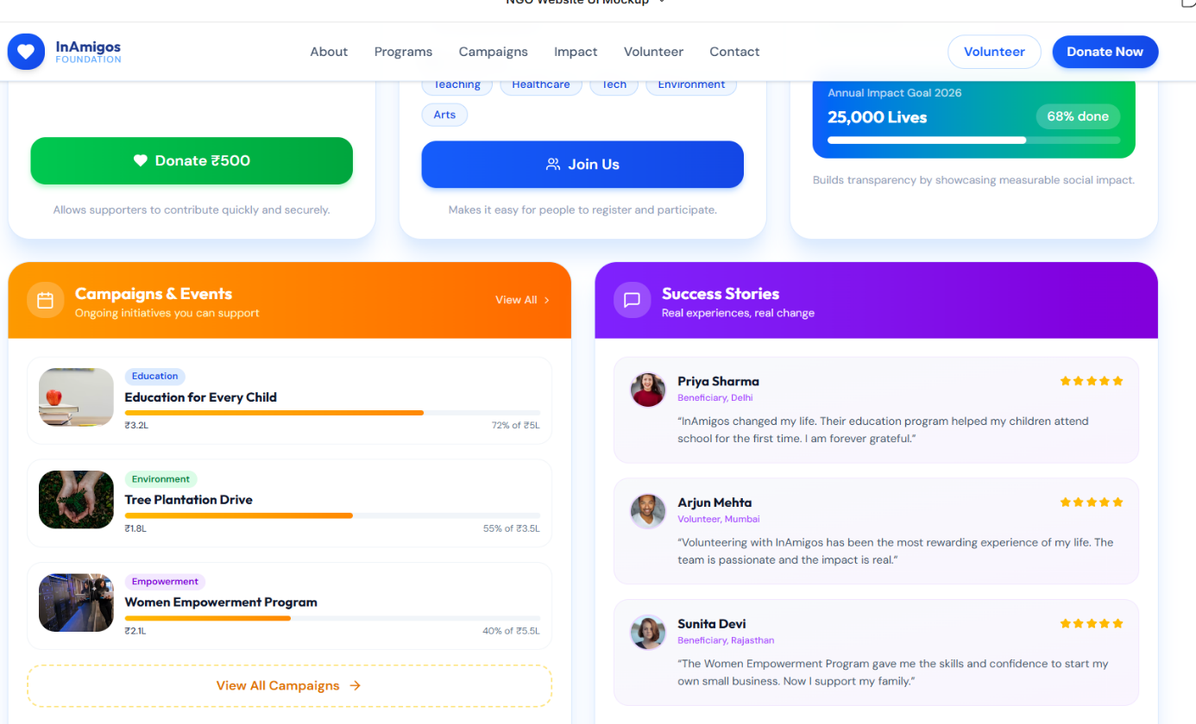

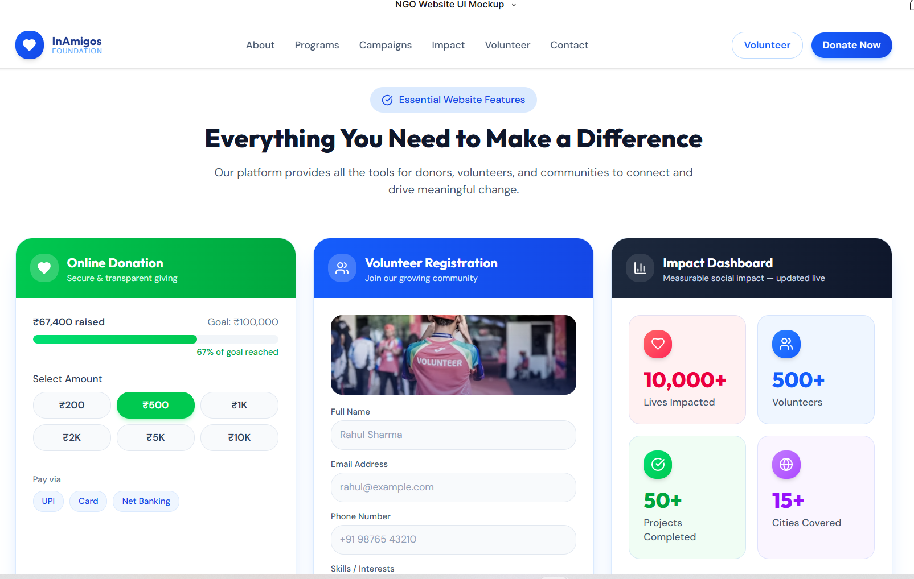

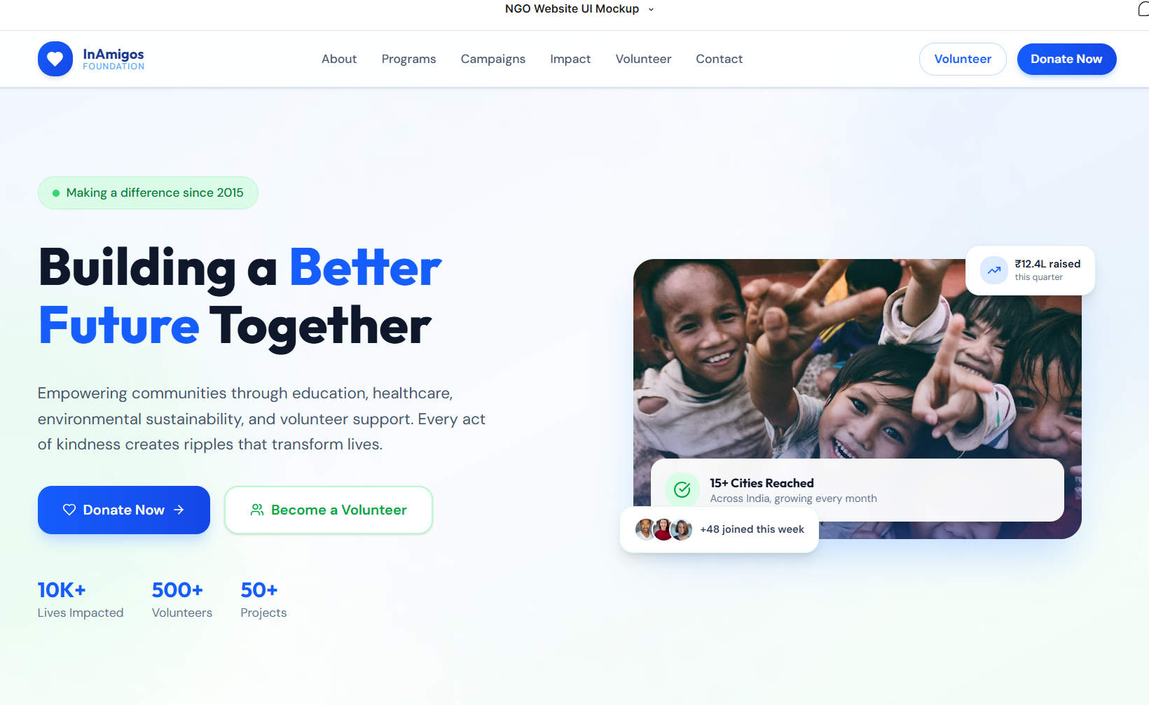

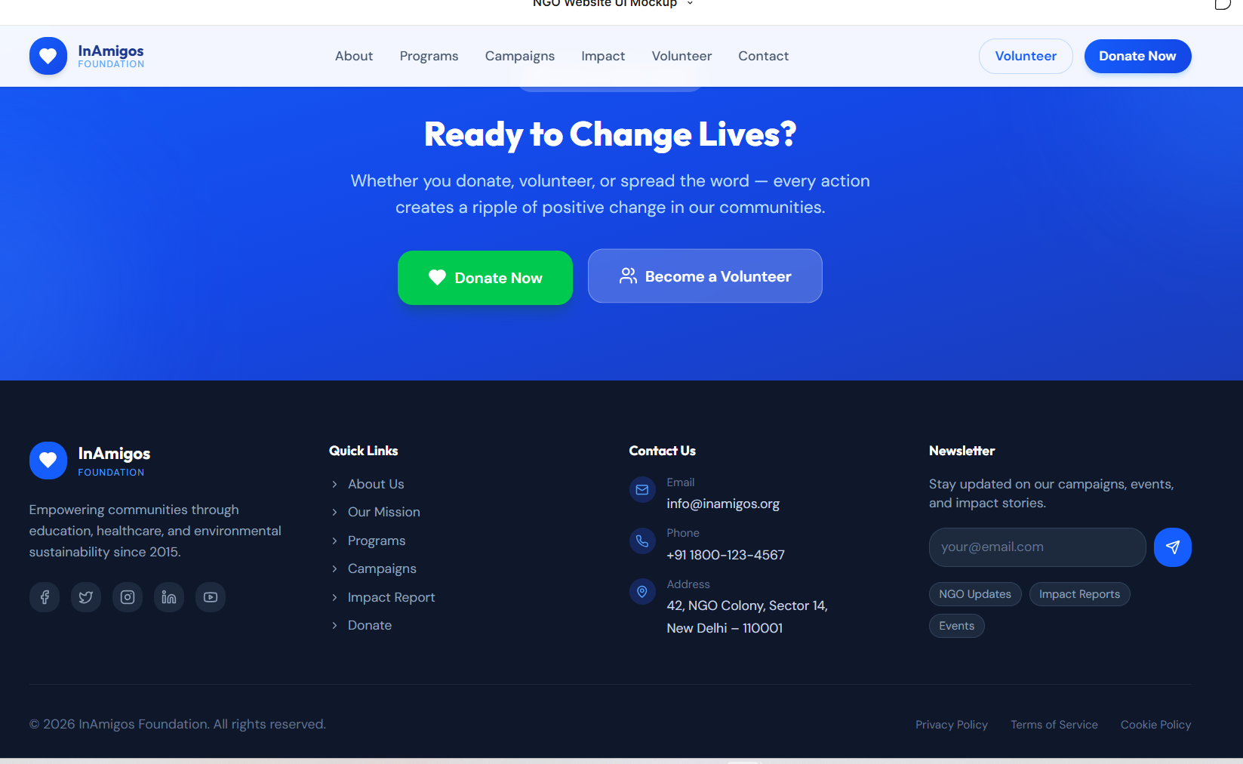InAmigos Foundation

AI Resume Analyzer:-

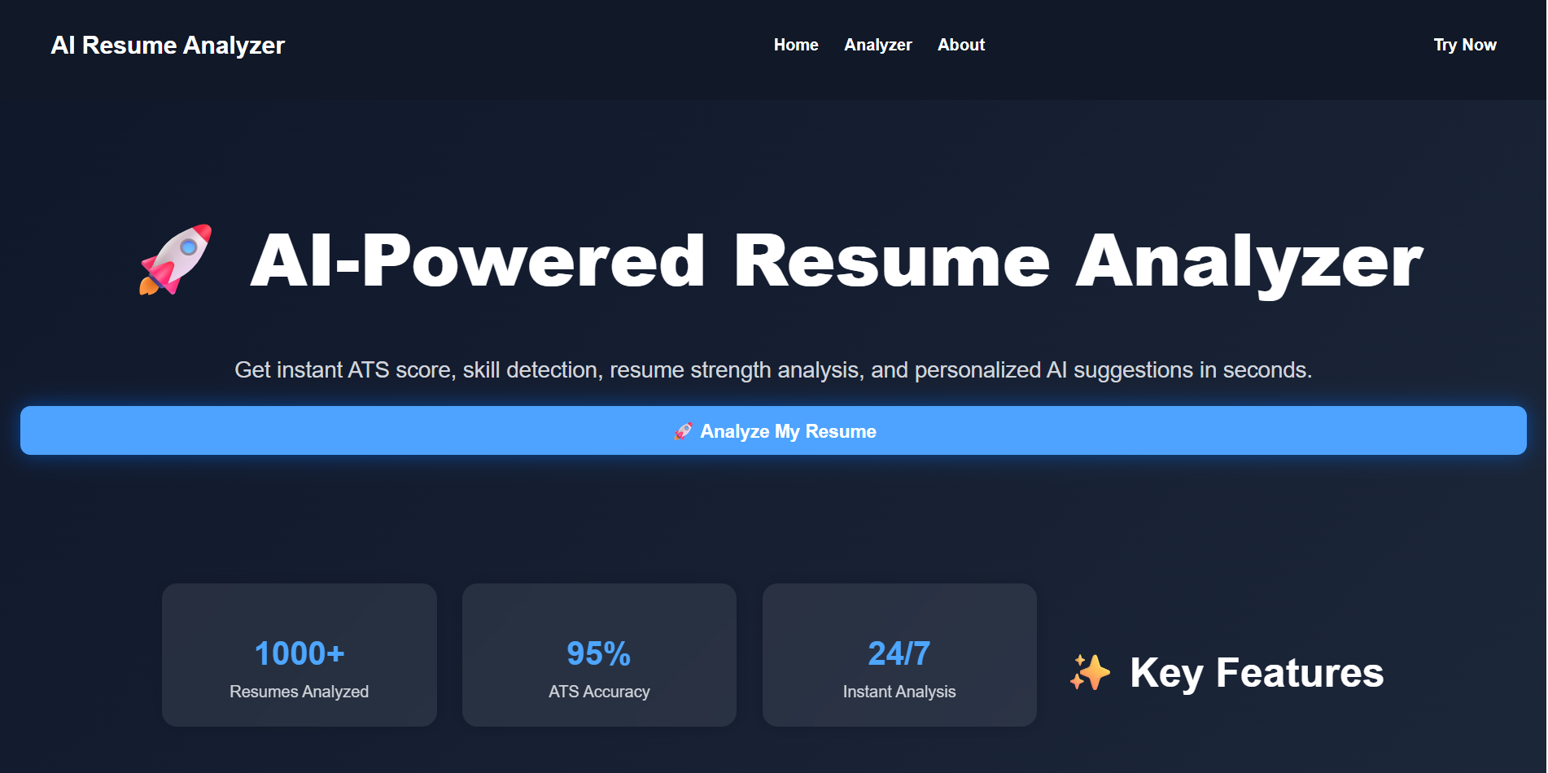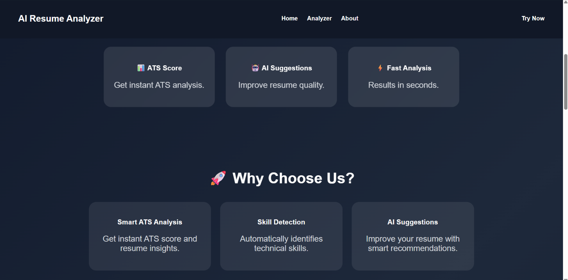

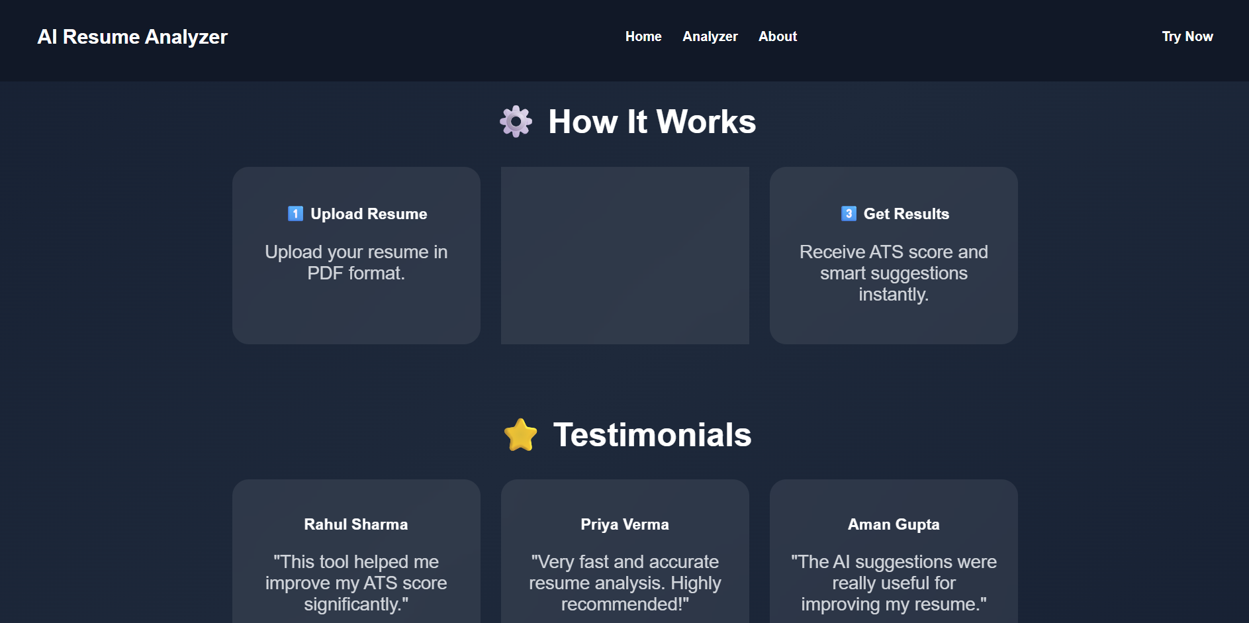

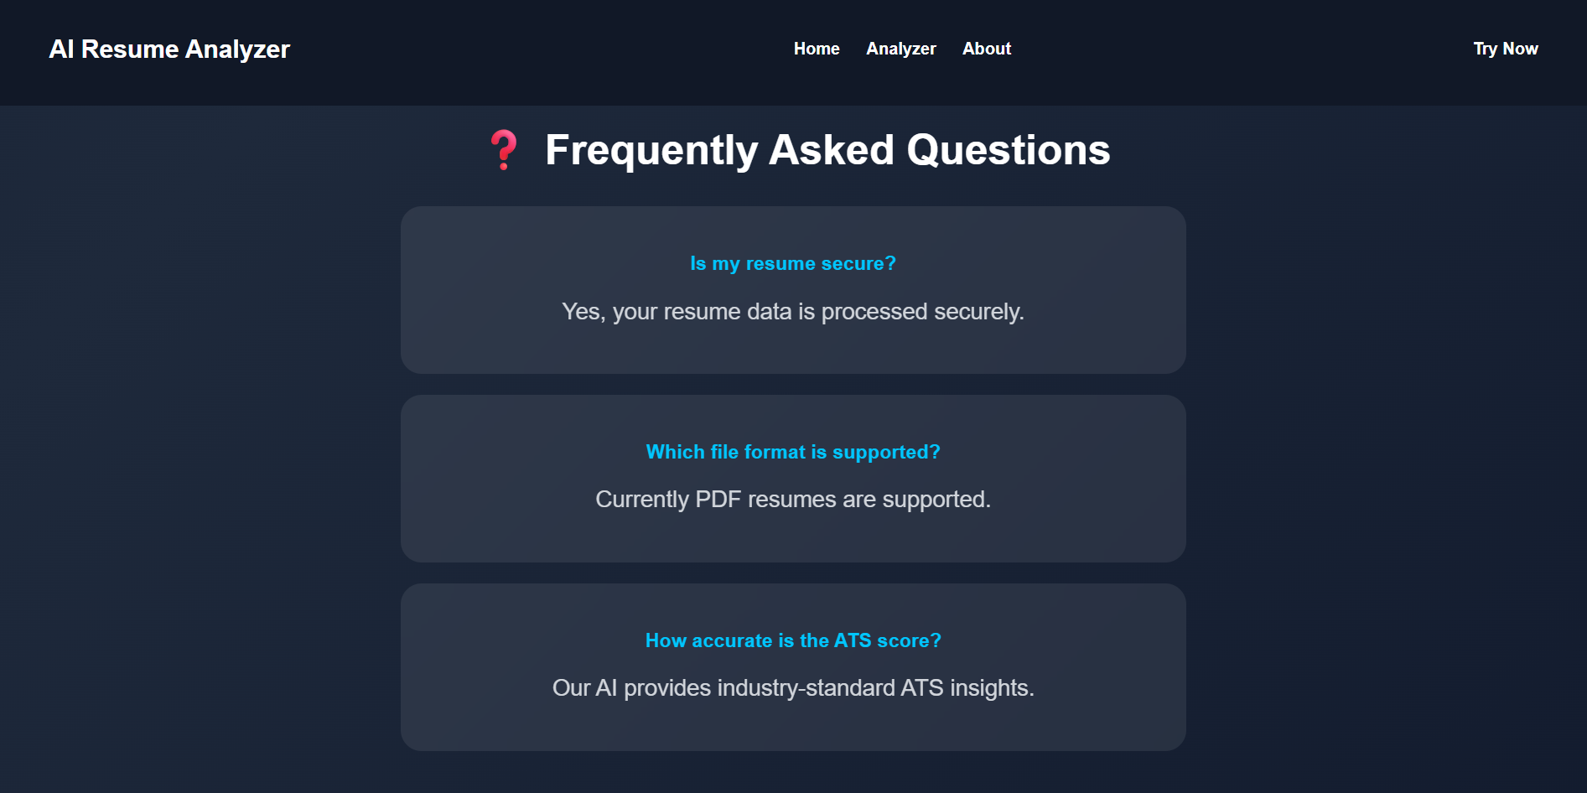

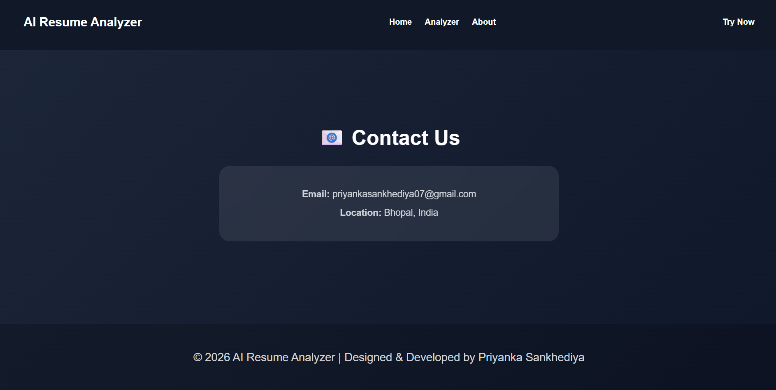

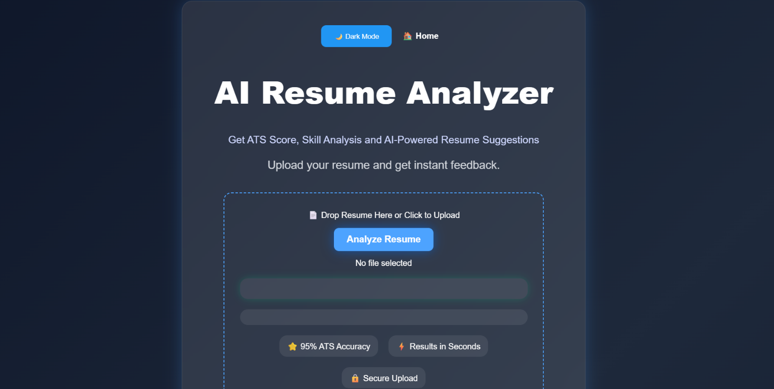
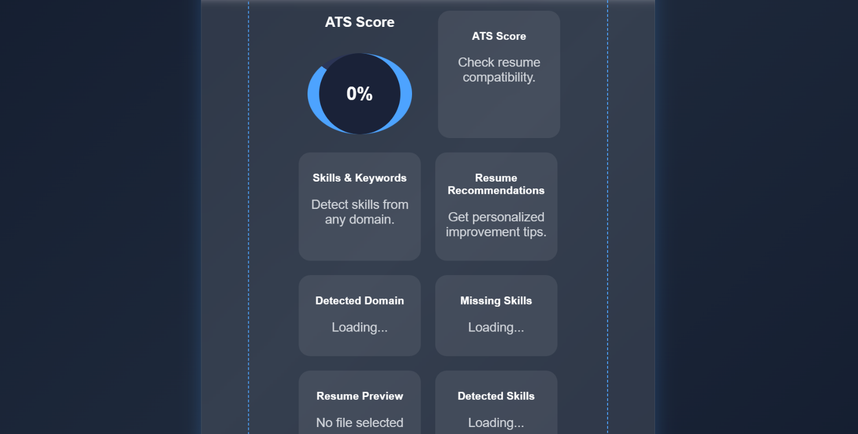

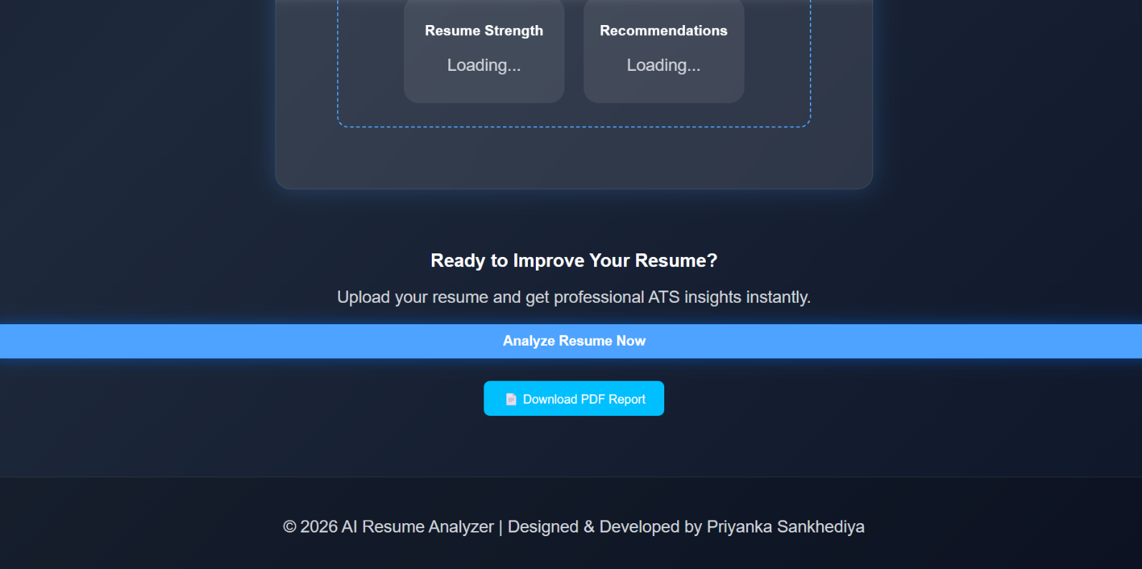

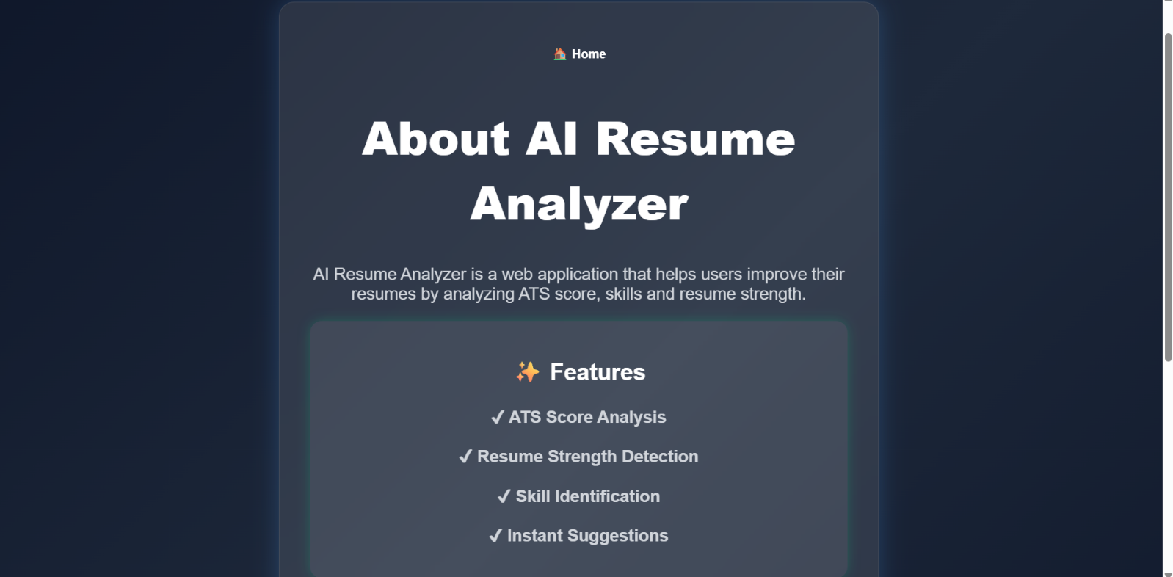

CHAPTER 7: LEARNING OUTCOME

Through this internship, I gained practical knowledge of web development, UI/UX design, website optimization, and Artificial Intelligence. I learned how to build responsive websites using HTML, CSS, and JavaScript while also understanding the importance of user experience and accessibility.
Developing the AI Resume Analyzer significantly improved my backend development skills using Python and Flask. I learned how to process PDF resumes, extract information, analyze candidate skills, calculate ATS scores, and provide intelligent recommendations.
The internship also strengthened my communication skills, teamwork, time management, debugging abilities, documentation practices, and problem-solving techniques. Working on real-world projects increased my confidence and prepared me for future software development roles.

CHAPTER 8: CONCLUSION

The internship at InAmigos Foundation was a valuable learning experience that enhanced both my technical and professional skills. Throughout the internship, I successfully completed projects involving website development, website analysis, AI-based website generation, UI/UX design, and the development of an AI Resume Analyzer.
The AI Resume Analyzer project was the highlight of my internship, allowing me to integrate Artificial Intelligence concepts with web development to solve a real-world recruitment problem. The application demonstrated resume parsing, ATS score evaluation, skill extraction, domain prediction, and intelligent recommendation generation.
Overall, this internship strengthened my understanding of modern software development practices and Artificial Intelligence applications. It also improved my confidence, creativity, teamwork, communication, and problem-solving abilities, preparing me for future career opportunities in software development and AI.

CHAPTER 9: REFERENCE

  - InAmigos Foundation Official Website
  - HTML5 Documentation
- CSS3 Documentation
  - JavaScript Documentation
  - Python Documentation
  - Flask Documentation
  - Figma Documentation
  - GitHub Documentation

