CO5-AT1-Constraint-Based
Name: S .Priyanka
Reg no:192424033

Q26. Dominating Set Problem (NP-Complete Problem)
Find a minimum set of vertices such that every vertex is either in the set or adjacent to it. Clearly define constraints related to domination. Analyze how constraints restrict feasible solutions. Develop a backtracking-based solution. Apply pruning to reduce search space. Justify correctness and discuss NP-Complete complexity.

Aim
To find a minimum dominating set of a graph using a backtracking algorithm with pruning, while analyzing the domination constraints and understanding its NP-Complete complexity.

Techniques to be Used
- Graph Representation – Represent the graph using vertices and edges/adjacency list.
- Dominating Set Concept – Select vertices so that every vertex is either selected or adjacent to a selected vertex.
- Backtracking – Try different combinations of vertices to find the minimum dominating set.
- Constraint Analysis – Ensure every vertex is dominated by at least one selected vertex.
- Pruning – Stop exploring a branch when the current solution cannot improve the best solution found.
- Branch and Bound – Compare the current number of selected vertices with the best known solution.
- Correctness Verification – Check that all vertices are dominated by the final selected set.
- Complexity Analysis – Discuss the exponential worst-case complexity and why the Dominating Set Problem is NP-Complete.
Objectives
- Understand the Dominating Set Problem.
- Represent the graph using vertices and edges.
- Identify the constraints required for domination.
- Generate possible vertex subsets using backtracking.
- Check whether each selected subset dominates all vertices.
- Use pruning to eliminate unnecessary branches.
- Find the minimum dominating set.
- Prove the correctness of the solution.
- Analyze time and space complexity.
- Explain why the problem is NP-Complete.
Algorithm

- BACKTRACK(index, count)
- If count >= bestSize, prune the branch.
- If all vertices are considered:
- Check whether all vertices are dominated.
- If yes, update best solution.
- Include the current vertex.
- Backtrack.
- Exclude the current vertex.
- Backtrack again.

C Program
#include <stdio.h>

#define MAX 20

int n, g[MAX][MAX], x[MAX], best[MAX], bestSize;

int dominate() {
for(int i=0;i<n;i++) {
if(x[i]) continue;

int ok=0;
for(int j=0;j<n;j++)
if(x[j] && g[i][j]) ok=1;

if(!ok) return 0;
}
return 1;
}

void backtrack(int i, int count) {
if(count >= bestSize) return; // Pruning

if(i == n) {
if(dominate()) {
bestSize = count;
for(int j=0;j<n;j++)
best[j] = x[j];
}
return;
}

x[i] = 1;
backtrack(i+1, count+1);

x[i] = 0;
backtrack(i+1, count);
}

int main() {
int m, u, v;

printf("Enter vertices and edges: ");
scanf("%d%d", &n, &m);

for(int i=0;i<m;i++) {
scanf("%d%d", &u, &v);
g[u-1][v-1] = g[v-1][u-1] = 1;
}

bestSize = n+1;
backtrack(0,0);

printf("Minimum Dominating Set: ");
for(int i=0;i<n;i++)
if(best[i]) printf("%d ", i+1);

printf("\nMinimum Size: %d\n", bestSize);
return 0;
}
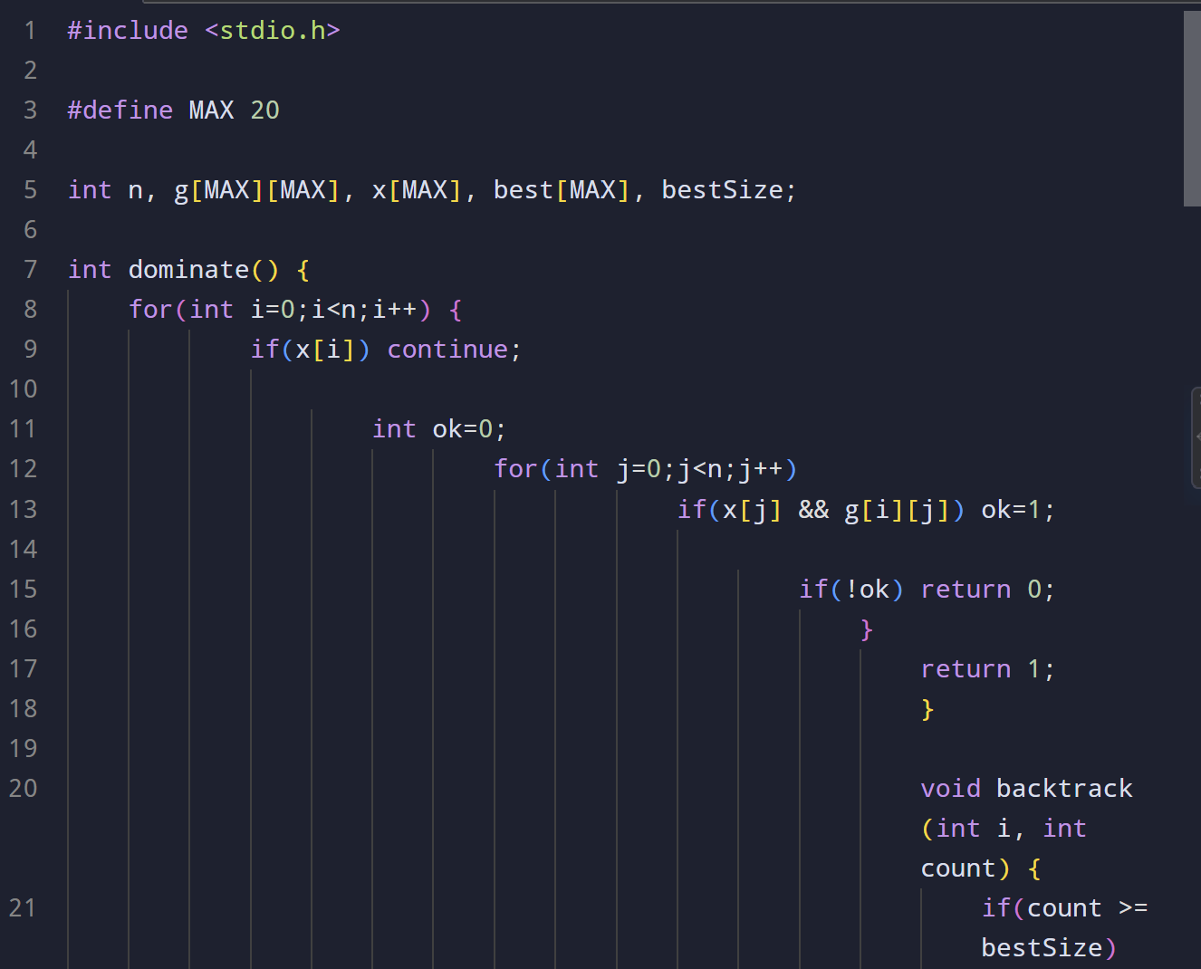

Out put
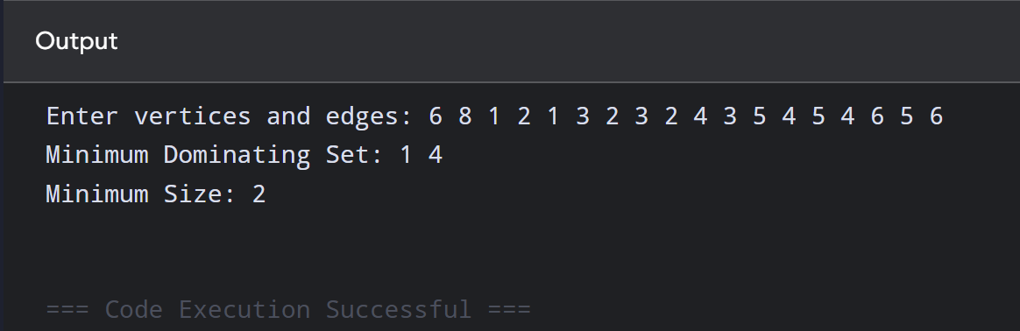
Complexity
There can be (2^n) possible subsets.
- Worst-case Time: (O(2^n n^2))
- Space: (O(n^2)) for the adjacency matrix.
Pruning reduces the practical search space, but the worst-case complexity remains exponential.

11. NP-Complete Nature
The decision version asks whether a graph has a dominating set of size at most (k). A proposed set can be verified in polynomial time, so it belongs to NP. The problem is also NP-Hard through polynomial reductions from known NP-Complete problems. Hence, the Dominating Set decision problem is NP-Complete, while the optimization version is NP-Hard.

12. Result

The minimum dominating set was successfully found using backtracking, constraint checking, and pruning. For the sample graph:
[
\boxed{D={2,5},\quad |D|=2}
]
Thus, all vertices are covered using the minimum number of selected vertices.

