# CS-513 Midterm Exam

## Question 1

## Solution:

For a function to be a proper distance function below mentioned conditions should be satisfied:

1. Distance is always positive
2. Distance follows commutative property, so distance from point ‘A’ to point ‘B’ is same as distance from ‘B’ to ‘A’

Distance (A to B) = Distance (B to A)

1. Function follows “Triangle inequality” property. So, distance from A to C must be less than or equal to distance from A to B and B to C.

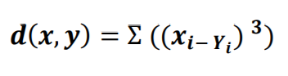

Example: Distance between points A (2,3) and B (7,8) will result in:

AB = ((2 - 7 )3 + (3 - 8 )3 ) = ( -5)3 + ( -5)3 = - 250

Since this result violates the first condition, given function is **not a proper distance function**.

The distance between x(0, 0, 0) and y(0, 1, 0)

Given distance formula: D(x,y) = ( ( 0 - 0 )3 + ( 0 – 1 )3 + ( 0 – 0 )3 ) = -1

Correct distance formula: **D(x,y) = √( ( 0 - 0 )2 + ( 0 - 1 )2 + ( 0 – 0 )2 ) = 1**