Windows Brute-Force Detection & Incident Investigation Report
1. Project Overview
This project demonstrates the detection and investigation of repeated Windows authentication failures using Splunk. Windows Security Event ID 4625 was analyzed to identify repeated failed logon attempts and develop a threshold-based detection rule for potential brute-force activity.
The project includes Splunk log analysis, dashboard creation, alert configuration, detection logic, and incident investigation.

2. Tools & Technologies
- Splunk
- Windows Security Event Logs
- Event ID 4625
- SPL (Search Processing Language)
- Windows Event Log Analysis

3. Detection Objective
The objective of this project is to detect repeated failed Windows login attempts that may indicate potential brute-force activity.
A detection threshold of 5 or more failed login attempts from the same source and account combination was configured in Splunk.

4. Splunk Dashboard
A Splunk dashboard was created to provide a visual overview of failed Windows login activity. The dashboard contains panels for:
- Total Failed Login Attempts
- Failed Login Attempts by Host
- Failed Login Activity Over Time
- Logon Types
- Potential Brute-Force Sources
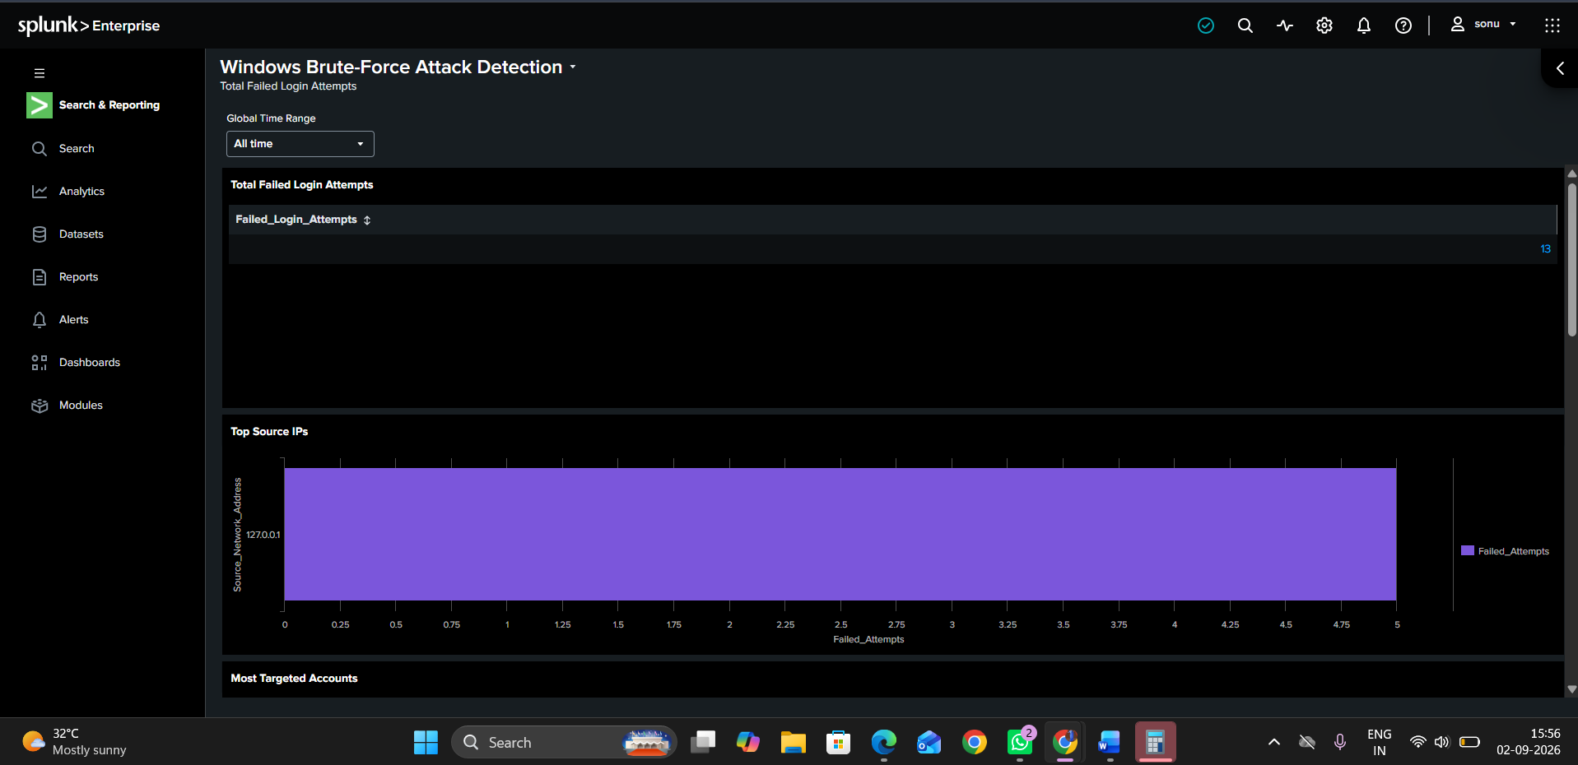
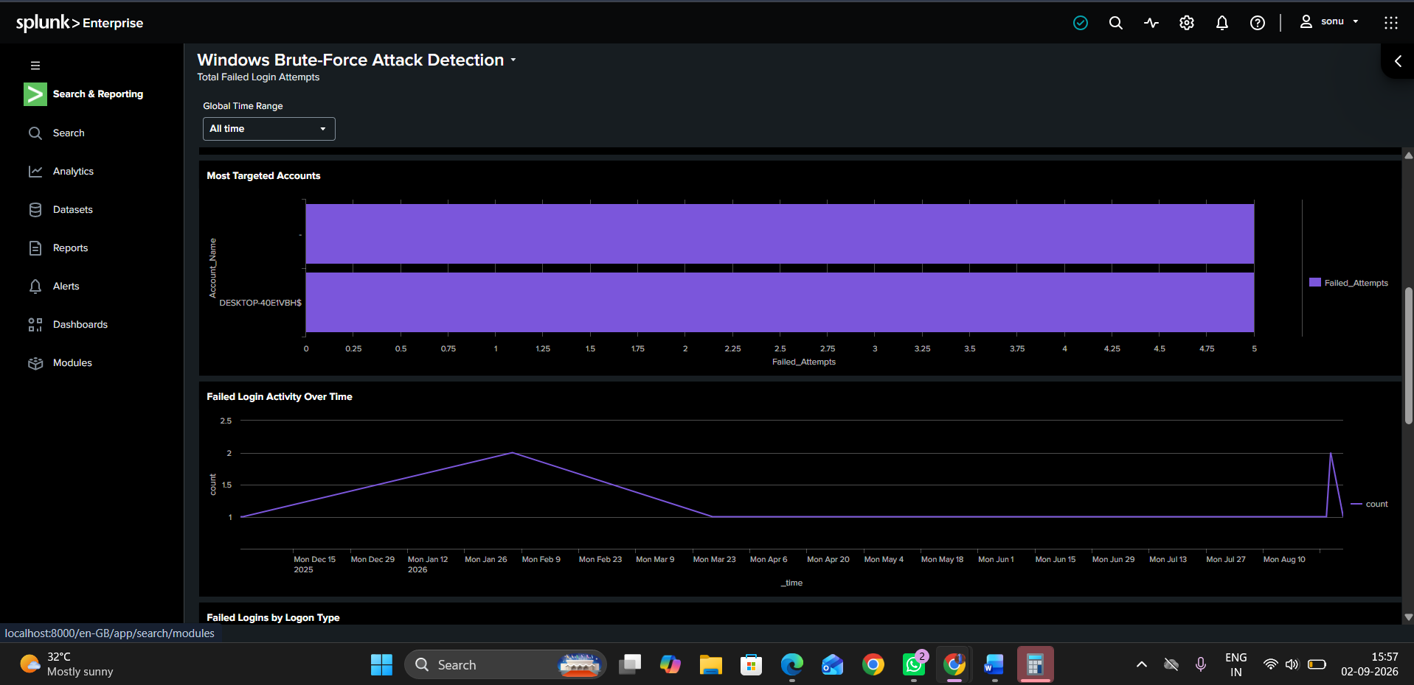
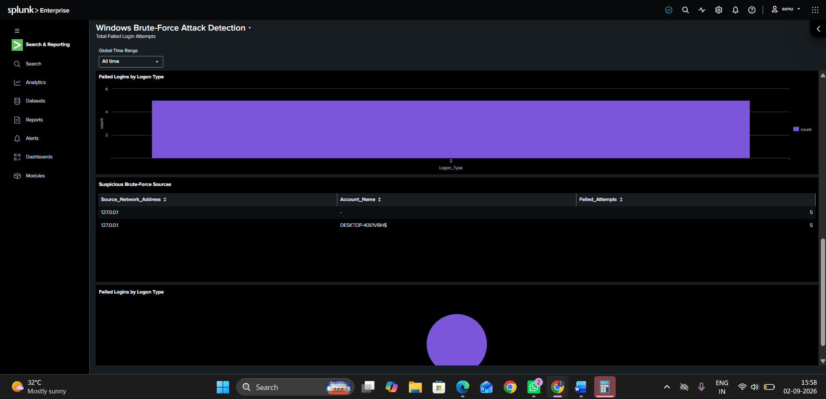
Figure 1: Splunk dashboard showing Windows failed login activity and potential brute-force sources.

5. Initial Detection
The following SPL query was used to identify Windows failed logon events:
index=main EventCode=4625
The search returned 13 Event ID 4625 events in the available dataset.
Event ID 4625 represents a failed logon attempt in Windows Security logs.
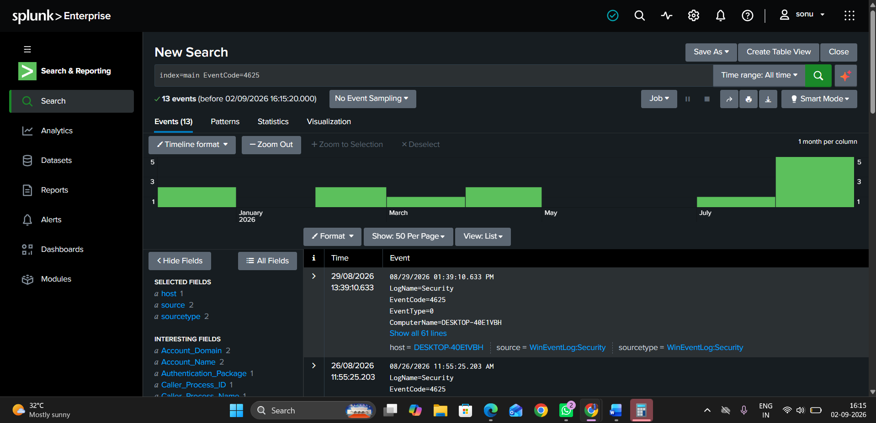Figure 2: Splunk search results showing Event ID 4625 failed logon events.

6. Brute-Force Detection Logic
A threshold-based detection query was created to identify repeated failed authentication attempts from the same source and account.
index=main EventCode=4625
| stats count as Failed_Attempts by Source_Network_Address, Account_Name
| where Failed_Attempts >= 5
| sort - Failed_Attempts
The query identified the following activity:
Source Network Address | Account Name | Failed Attempts
127.0.0.1 | - | 5
127.0.0.1 | DESKTOP-40E1VBH$ | 5
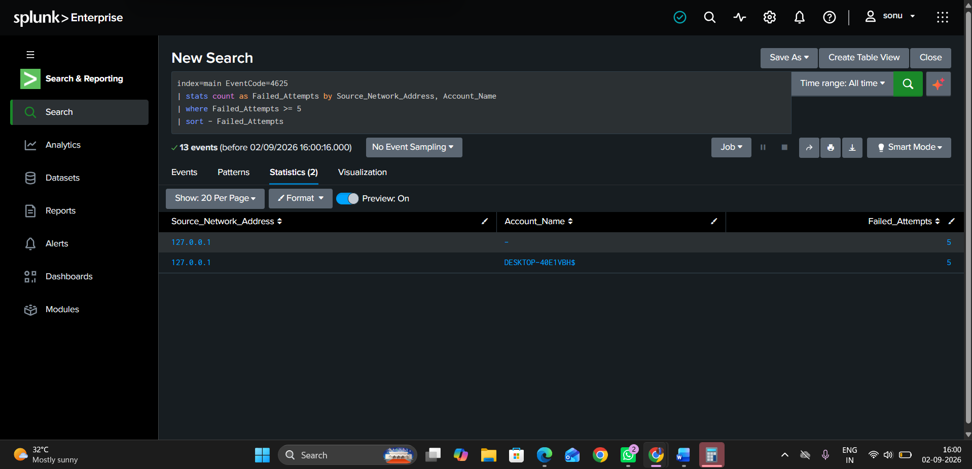 Figure 2: Threshold-based detection identifying repeated failed authentication attempts.

7. Alert Configuration
A Splunk alert named Windows Brute Force Detection was configured using the threshold-based detection query.
The alert was configured as a real-time alert and uses the detection result to identify potential repeated authentication failures.
A Log Event action was configured to record the triggered detection within Splunk.

8. Investigation
The identified source and account were investigated using the following SPL query:
index=main EventCode=4625 Source_Network_Address="127.0.0.1"
| table _time Source_Network_Address Account_Name Logon_Type EventCode
| sort _time
The investigation identified five relevant failed logon events associated with:
- Source IP: 127.0.0.1
- Account: DESKTOP-40E1VBH$
- Logon Type: 2 (Interactive)
- Event ID: 4625
- Failed Attempts: 5
Two of the failed logon events occurred approximately three seconds apart on August 26, 2026, which was considered noteworthy for further investigation.
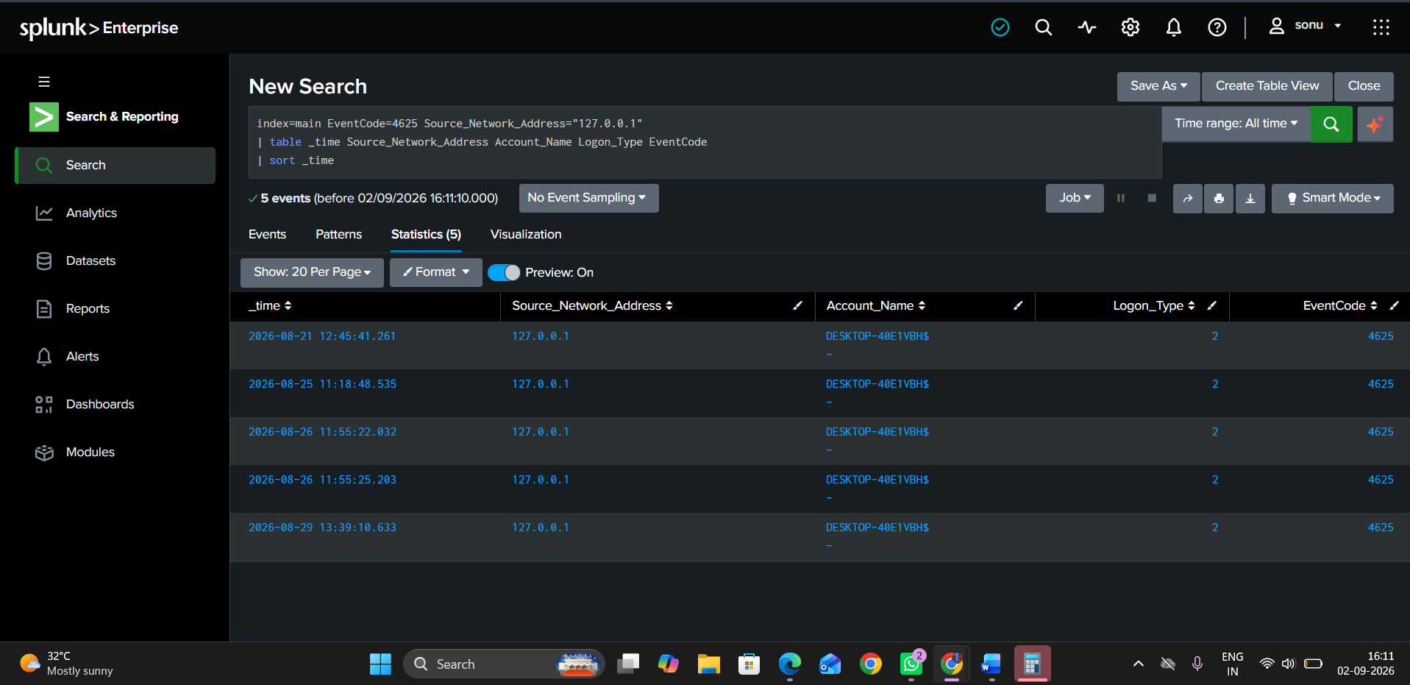Figure 3: Investigation of failed logon events associated with the identified source and account.

9. Timeline of Relevant Events
Date & Time | Event ID | Source | Account | Logon Type
2026-08-21 12:45:41 | 4625 | 127.0.0.1 | DESKTOP-40E1VBH$ | 2
2026-08-25 11:18:48 | 4625 | 127.0.0.1 | DESKTOP-40E1VBH$ | 2
2026-08-26 11:55:22 | 4625 | 127.0.0.1 | DESKTOP-40E1VBH$ | 2
2026-08-26 11:55:25 | 4625 | 127.0.0.1 | DESKTOP-40E1VBH$ | 2
2026-08-29 13:39:10 | 4625 | 127.0.0.1 | DESKTOP-40E1VBH$ | 2

10. Investigation Findings
The investigation confirmed that the detection threshold of five failed logon attempts was reached for the identified source and account combination.
However, the source address 127.0.0.1 represents localhost activity. The available logs alone do not provide enough evidence to confirm that the activity was malicious.
Therefore, the alert is classified as Potential Brute-Force Activity rather than a confirmed brute-force attack.

11. Severity and Status
Alert Classification: Potential Brute-Force Activity
Severity: Medium
Status: Requires Investigation
Detection Confidence: Moderate

12. Recommended Investigation Actions
The following actions are recommended for further investigation:
- Identify the process or service responsible for the failed authentication attempts.
- Review surrounding Windows Security events for additional suspicious activity.
- Determine whether the localhost authentication attempts are expected system behavior.
- Correlate the activity with endpoint telemetry if available.
- Investigate additional authentication and process-related events if the activity continues.
- Escalate the alert if additional indicators of compromise are identified.

13. Conclusion
This project demonstrates a practical SOC workflow using Splunk to detect and investigate repeated Windows authentication failures.
The workflow included log analysis, SPL-based detection, dashboard creation, alert configuration, and investigation of suspicious authentication activity.
The investigation identified repeated Event ID 4625 failures and generated a potential brute-force alert based on a five-attempt threshold. Because the source was localhost and the available evidence did not conclusively establish malicious intent, the activity was classified as potential brute-force activity requiring further investigation.
This project demonstrates practical skills in SIEM monitoring, SPL, Windows Event Log analysis, alert creation, dashboard development, and SOC incident investigation.

