**Priyanka Karuppuch Samy**

**729007151**

**HW4**

1. Compilation and execution

* The zip file contains a qsort_hypercube.cpp, qsort_hypercube_descending.cpp and Sorting_JOB.JOB files.
* Compilation is done using command mpiicpc -o qsort_hypercube.exe qsort_hypercube.cpp
* The output screenshots are as below.

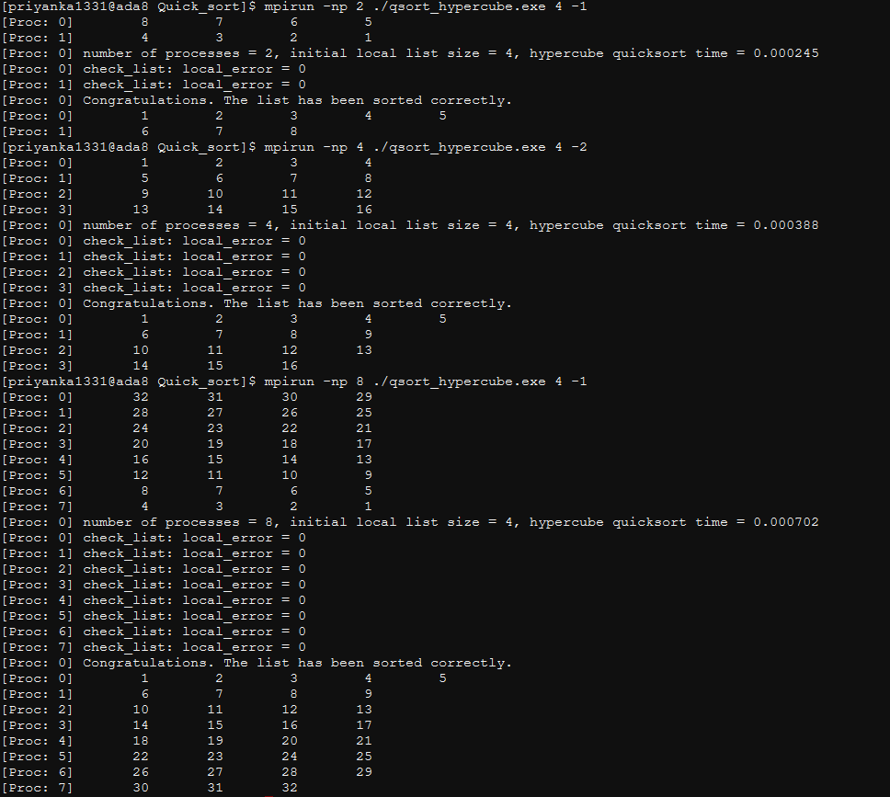

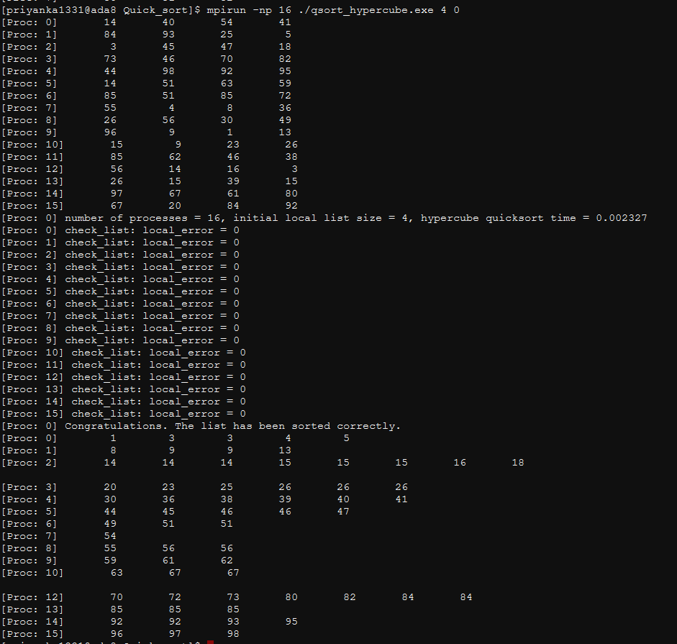

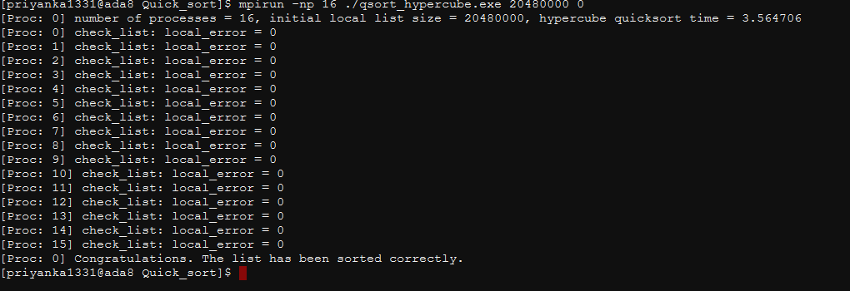

1. Weak Scalability Study:

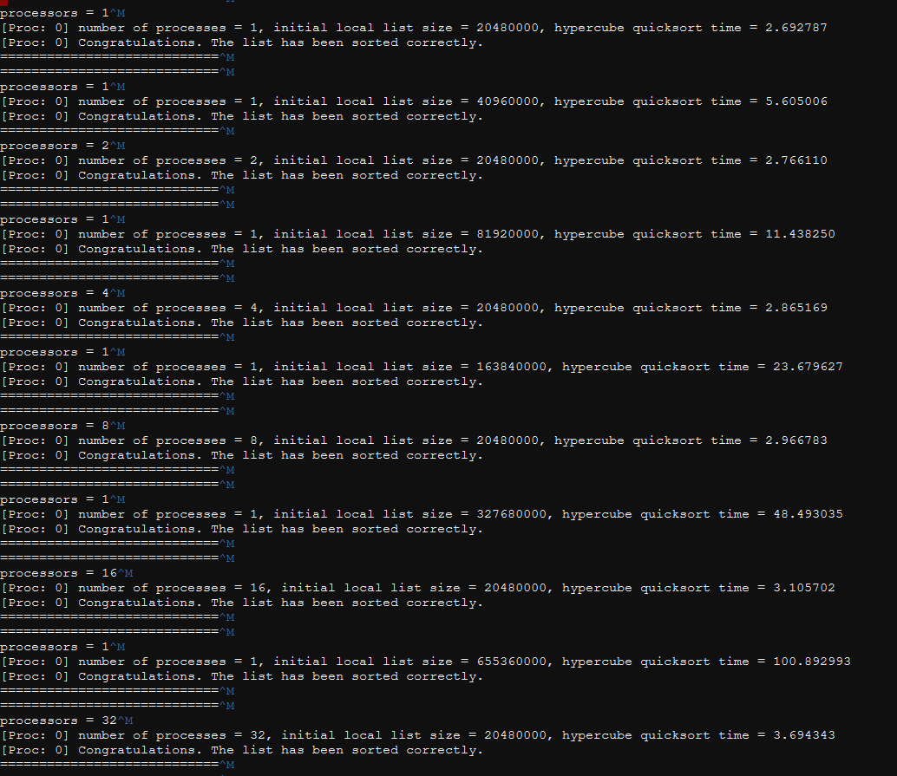

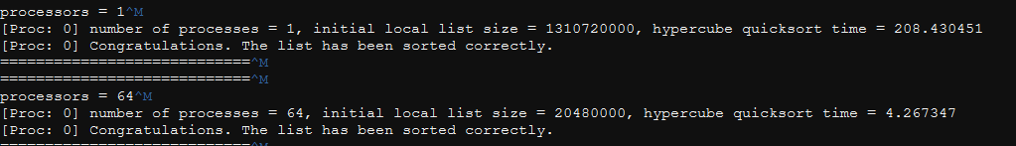



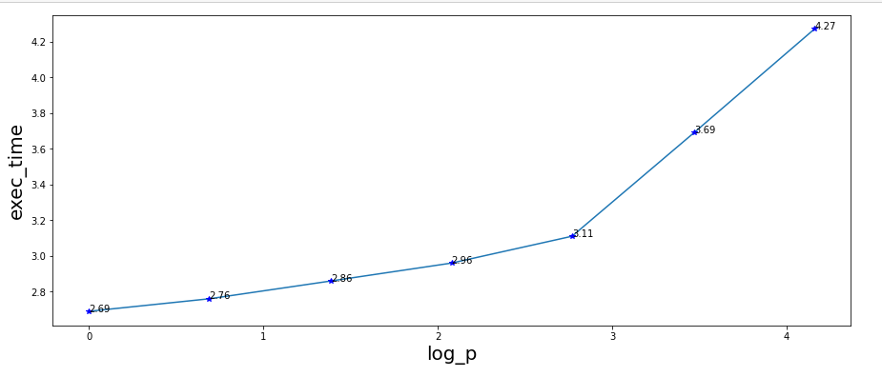

Execution time is increasing because n is doubling everytime. For plot, I have considered only p processors. If considering varying n and processors, then the plot is as below:

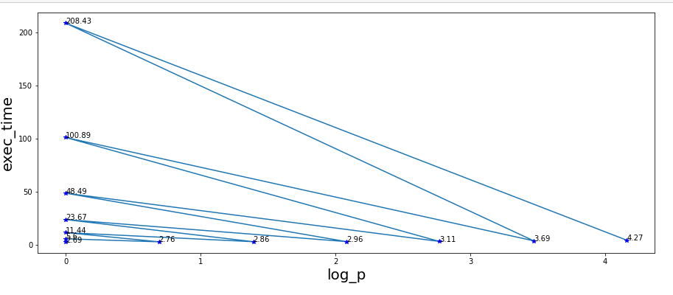

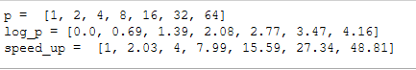

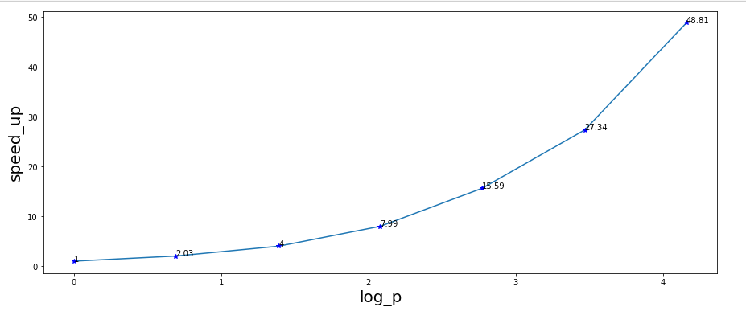



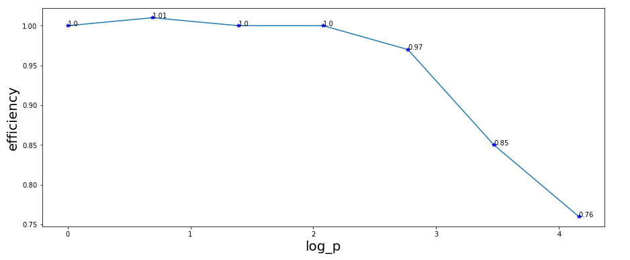

1. Strong scalability study:

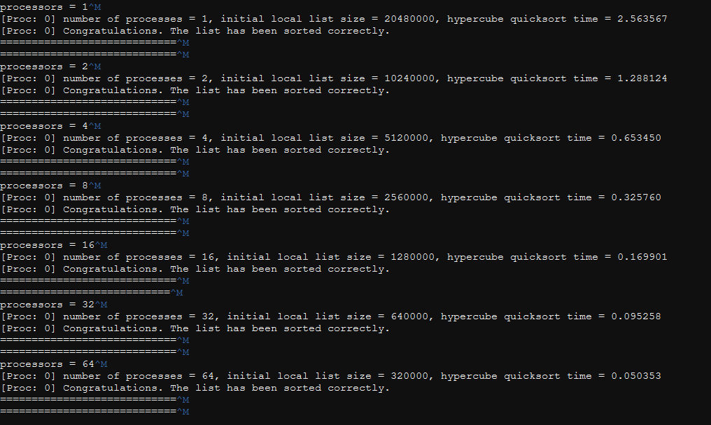

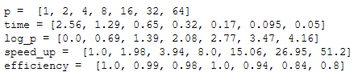

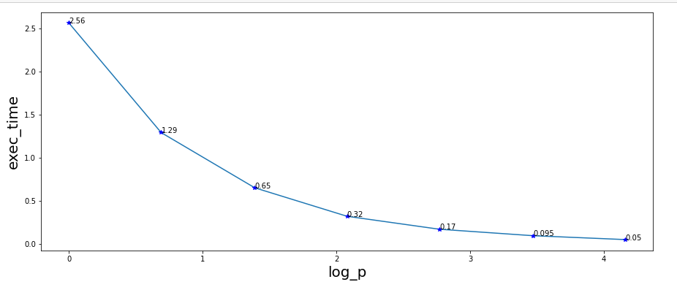

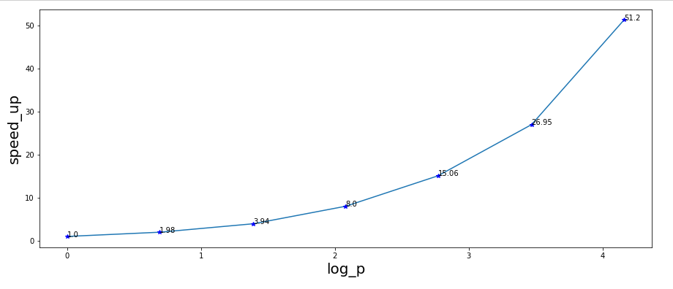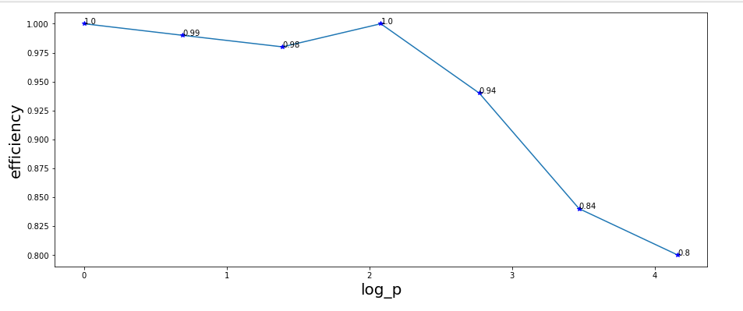

1. The modified code runs as per expectations. The outputs are attached below:

