|  |  |  |
| --- | --- | --- |
| **Author** | **Version History** | **Change** |
| Priyanka Tapkir | 1.0 | Initial draft |
|  |  |  |

Note: This document drafts the steps for Git Project checkout , Clone, Commit process on Windows machine.

**Git Repo Link:** <https://github.com/priyankatapkir/Devops_Documents.git>

**Software’s Used : Git Bash**



1. Create a Public repository in your Git Dashboard. Create ‘master’ branch with some default test file.

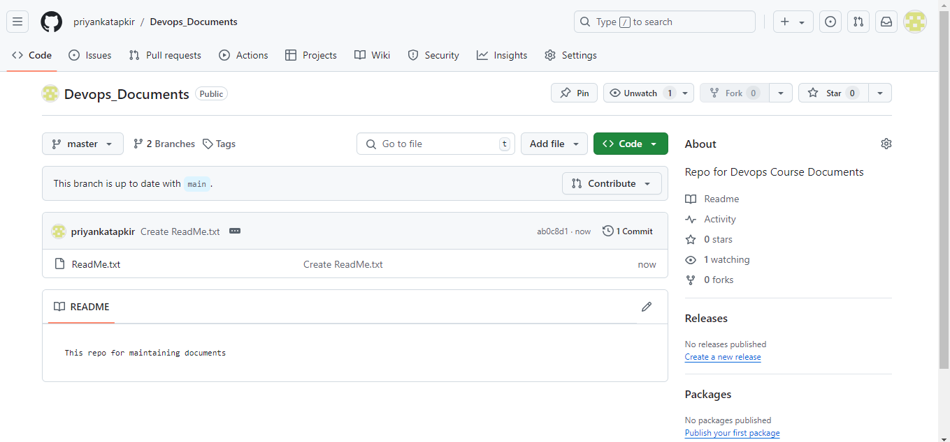

1. Using Git Bash & Git GUI, we can clone the existing repository & checkout the ‘master’ branch.

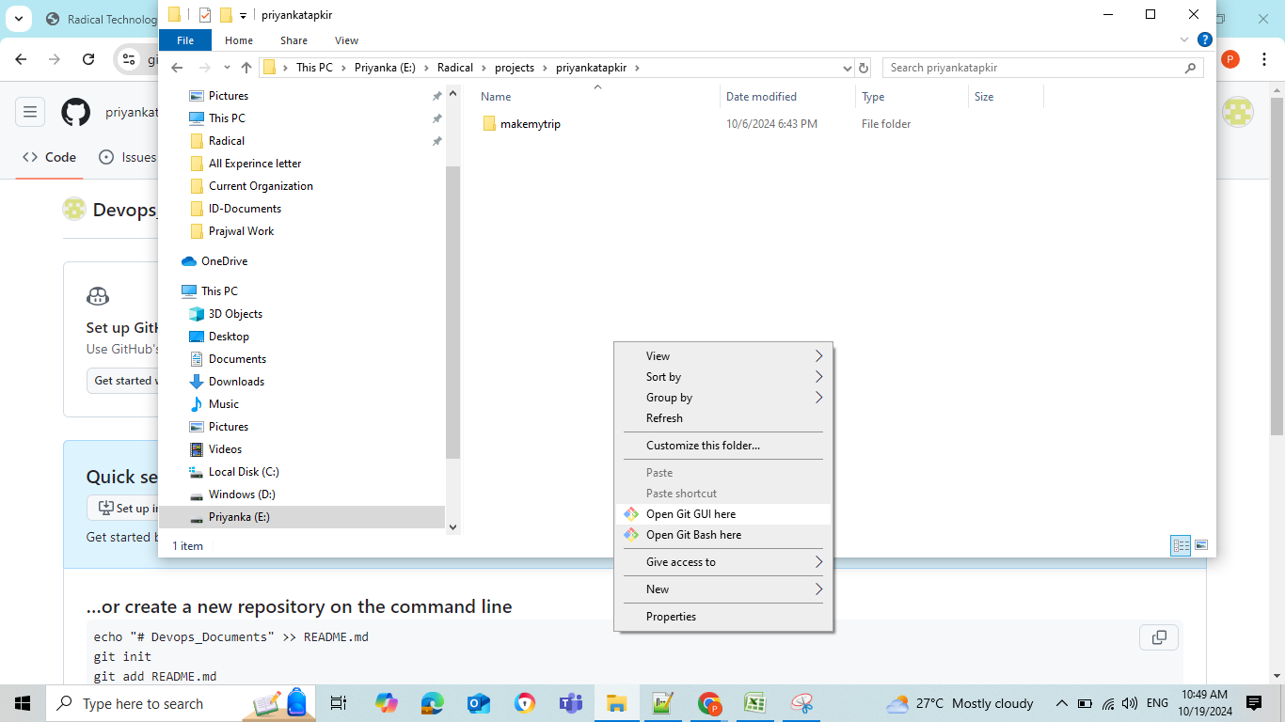

Select option ‘Clone existing Repository’

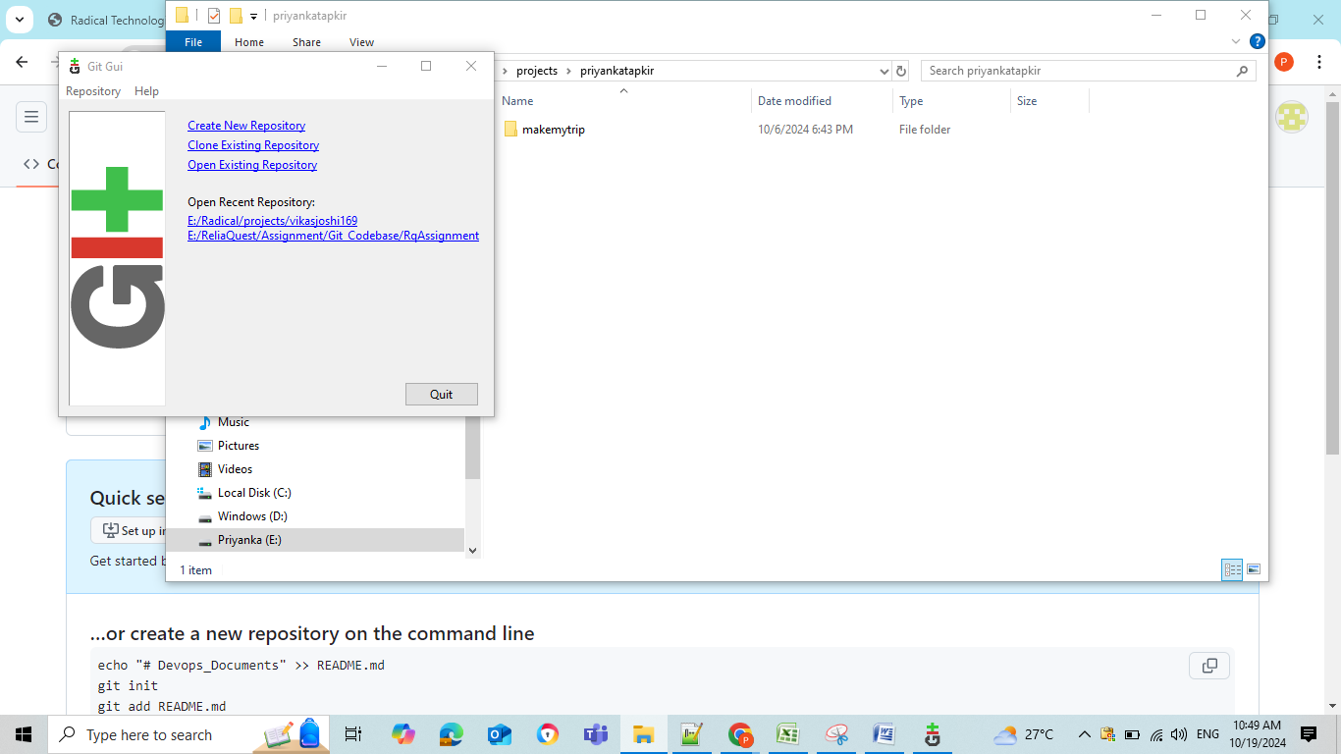

Once your remote repo cloned, you can use git checkout command to checkout ‘master’ branch.

Command: git checkout master

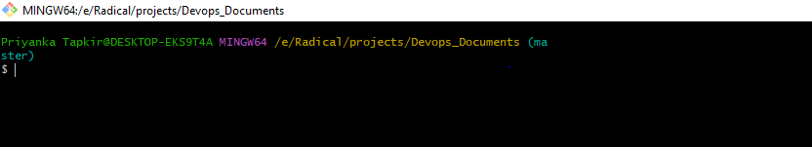

Using git Bash ,we can verify which remote branch our local pointing to (we can see ‘master’ in blue above)