# Stack & queue

## Problem Statement 1:

Implement a stack using an array.

### Description:

Write a class, which provides a stack functionality backed with array.

Stack interface:

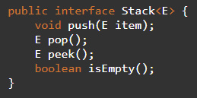

## Problem Statement 2:

Implement a queue using an array.

### Description:

Write a class, which provides a queue functionality backed with array.

Queue interface:

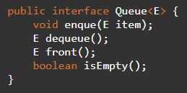

## Problem Statement 3:

Reverse a stack using recursion.

### Description:

Given a stack object, write a function that reverses its values using recursion.

## Problem Statement 4:

Reverse a queue using recursion.

### Description:

Given a queue object, write a function that reverses its values using recursion.

## Problem Statement 5:

Implement Queue using a doubly linked list.

Description:

Write a class, which provides a queue functionality backed with double linked list.