Zomato Business Insights Report
Oct 25, 2026

Executive summary
One in three orders never reaches the customer, and that is the biggest problem in the data. Over the two years from January 2023 to December 2024, the platform delivered ₹53.1 lakh of orders. Another ₹27.1 lakh was lost to cancellations and food that was never delivered.
What stood out:
- Order failure costs more than anything else. 22.3% of orders are cancelled and another 11.5% are marked "Food Not Delivered". Those failures are worth about half of delivered revenue, and every cuisine, city and payment method loses roughly the same share.
- Restaurant quality is uneven and easy to rank. The bottom-10 restaurants in each city cancel 28.5% of orders and deliver 24.5% late. For the top 10, those figures are 16.0% and 9.5%. The composite scorecard puts all 1,200 restaurants on one list for the partnerships team.
- Delivery time doesn't respond to the levers we expected. Average delivery time sits between 37 and 41 minutes in every city. Rain, traffic level and peak hours each change it by less than a minute.
- Most customers don't come back. 87% of customers who had ordered by November 2024 placed no order in the final 60 days, and 38% only ever ordered once. Retention is a bigger lever than acquisition.
- Demand peaks twice a day. Orders peak at 12–1 pm and 7–8 pm. Weekdays and weekends are almost identical, at about 2,900 orders per day of the week.
My main recommendation is to work on order failures first, starting with the bottom-10 restaurants in each city.

Scope and data
Everything in this report comes from one snapshot of 12 linked operational tables: orders, order items, customers, restaurants, menu, delivery partners, payments, promotions, feedback, cities, weather and traffic. Together they hold 159,077 raw rows.
The raw exports had the problems you'd expect. City names were spelled several ways ("Bengaluru" and "BANGALORE "), ages were negative, phone numbers were malformed, and some orders were duplicates or pointed at customers who didn't exist. I fixed all 9 issues listed in the PRD. Only 562 rows (0.35%) had to be dropped, and each one traces back to a specific rule in clean.py.
Table | Raw rows | Cleaned rows | Why rows were dropped
orders | 20,705 | 20,475 | 205 duplicate orders, 25 orders linked to unknown customers or restaurants
customers | 12,180 | 12,000 | Duplicate customer IDs
order_items, payments, feedback | 77,071 | 77,010 | Belonged to the orders removed above
weather | 18,264 | 18,173 | No city recorded
All revenue figures are in INR. They count only delivered orders ("Delivered" plus "Delivered Late"), which is the definition the SQL views and the Power BI dashboard both use.

Revenue and restaurants
Revenue is flat. Every quarter brings in between ₹6.3 lakh and ₹6.9 lakh. The low point was Q2 2023 (₹6.32 lakh) and the high point was Q1 2024 (₹6.90 lakh), with no clear growth trend in either year. The 13,544 delivered orders averaged ₹392 each.
Revenue is also spread thinly. Delhi (₹2.47 lakh), Kolkata and Surat lead the cities, but the top five sit within about 5% of each other (revenue here is grouped by the restaurant's city). Nagpur (₹1.57 lakh) and Indore (₹1.64 lakh) trail. Among cuisines, South Indian (₹3.68 lakh), Fast Food and Healthy Food earn the most, and these are also the only cuisines with more than 800 delivered orders and an average rating above 3.8. Thai is the smallest at ₹2.09 lakh.

Restaurant scorecard
Each restaurant gets a score out of 100: 40% comes from its rating, 30% from not cancelling, and 30% from delivering on time. Scores range from 55 to 95, with a median of 78. Restaurants are then ranked within their own city, so a manager in Pune isn't comparing against Delhi.
Band | Restaurants | Avg rating | Cancellation rate | Late delivery rate
Top 10 per city | 251 | 4.39 | 16.0% | 9.5%
Middle | 699 | 3.87 | 22.3% | 15.2%
Bottom 10 per city | 250 | 3.41 | 28.5% | 24.5%
The gap between the bands is large and shows up on every measure at once. A bottom-band restaurant is almost twice as likely to cancel and two and a half times as likely to deliver late. Two restaurants, The House and Tasty Treats, have the lowest rating on the platform at 2.3. Ties at a band's cutoff push the band sizes slightly above 250.

Demand patterns
Demand follows meal times. Nearly half of all orders (48%) come in two windows: 11 am to 2 pm and 6 pm to 9 pm.
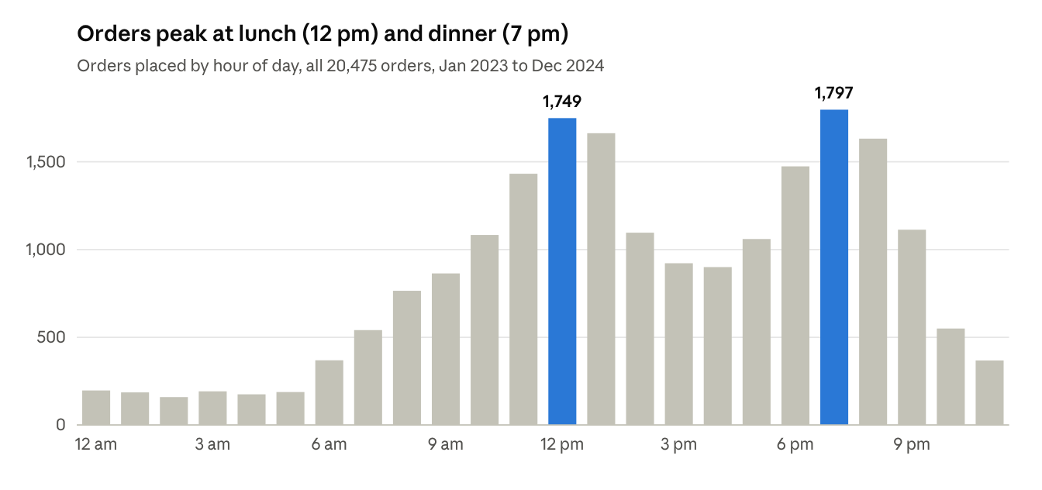
featured_orders.csv · 20,475 orders by OrderHour
The day of the week hardly matters. Each weekday averages about 2,936 orders over the two years and each weekend day about 2,897, so weekend staffing can follow the same plan as weekdays. Wednesday has the most orders (2,991) and Friday the most delivered revenue (₹7.73 lakh), but the gaps between days are small. Late-night orders (11 pm to 6 am) are about 7% of volume.

Delivery performance
A typical delivered order takes 36 minutes (median), and 15.9% of delivered orders arrive late. The spread is wide: the fastest 10% arrive within 22 minutes, while the slowest 10% take over an hour.
What surprised me is how little the obvious factors move that number:
Factor | Best case | Worst case | Gap
City | Chandigarh, 37.1 min | Ludhiana, 41.1 min | 4.0 min
Rain | Rain, 38.9 min | No rain, 39.3 min | 0.5 min
Traffic level | Level 2, 39.1 min | Level 1, 39.7 min | 0.6 min
Peak vs off-peak hour | Peak, 39.3 min | Off-peak, 39.3 min | under 0.1 min
City is the only factor with a gap worth acting on. Ludhiana and Nagpur deliver about 18% of orders late, compared with 14% in Bengaluru and Bhubaneswar.
The delivery partners look evenly matched. Cars average 30.3 minutes per delivery, and bikes, scooters and bicycles all sit around 32.5. A partner's rating has almost no relationship with their speed (correlation −0.02). Workload is fairly even too: the busiest 10% of partners handle 20% of completed deliveries, and the Gini coefficient is 0.27. In fairness, the PRD goal is largely met already.
In short, the delivery delays of these data records don't come from weather, traffic or rush hour. The data doesn't capture whatever does cause them, such as kitchen handover time or partner assignment. That is a data gap, and I come back to it in the last section.

Cancellations and order friction
Only 55.6% of orders arrive on time. Another 10.5% are delivered late, 22.3% are cancelled and 11.5% end as "Food Not Delivered". Cancelled orders were worth ₹17.9 lakh and undelivered ones ₹9.3 lakh.
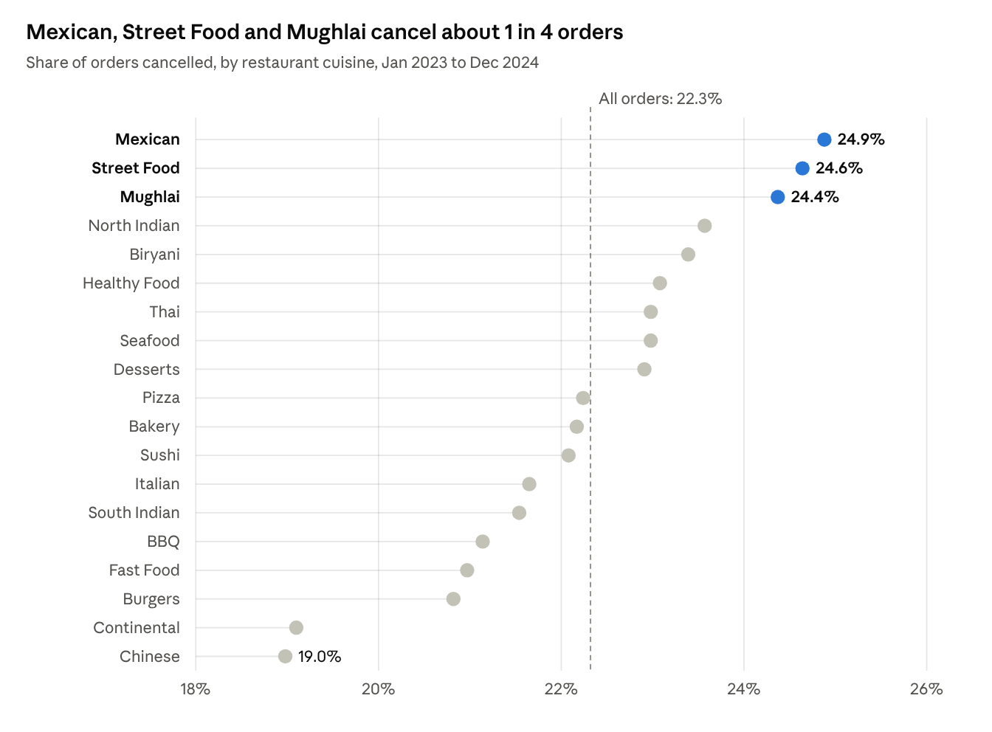
orders_cleaned.csv joined to restaurants_cleaned.csv · 20,475 orders, 19 cuisines (orders with an unknown cuisine left out)
The spread across cuisines is real but narrow, at about 6 points between Mexican (24.9%) and Chinese (19.0%). The same is true elsewhere. Failure rates by city run from 31% in Mumbai to 36% in Patna. By payment method, cancellations run from 20.9% for cash on delivery to 23.8% for net banking.
So failure isn't concentrated in one city or category. That points to something structural, either the restaurants or how orders are assigned, rather than a single local problem. The restaurant scorecard backs this up: cancellation rates differ much more between restaurants (16% vs 28.5% across bands) than between cuisines. That is why recommendation 1 targets individual restaurants rather than whole cuisines.

Customers
Most customers order once or twice and then stop. Of the 9,827 customers who placed an order, 38% ordered only once, and the average is 2.1 orders over two years. Of the 9,488 customers who had ordered by 1 November 2024, 87% placed no order in the final 60 days of the data. That is the PRD's definition of churn.
Basket size barely depends on membership. Basic members average ₹394 per delivered order, Gold ₹390 and Zomato Pro ₹389. Paid tiers aren't buying more per order, so their value has to come from ordering more often. With most customers churning, there's little sign that they do.
The RFM segmentation (recency, frequency, monetary value) gives marketing a starting list:
Segment | Customers
Loyal | 2,583
Lost | 2,321
Champions | 1,517
At Risk | 1,465
New | 959
Needs Attention | 643
The 1,465 "At Risk" and 643 "Needs Attention" customers are the ones still worth a win-back offer. The "Lost" group is probably too far gone for a cheap campaign.
Coupons don't seem to buy much. 35% of orders used one, and coupon orders failed at the same rate as orders without one (33.6% vs 34.0%). Coupon discounts on delivered orders came to ₹5.08 lakh over the two years (₹7.61 lakh if cancelled and undelivered orders are included). The single most generous code, Zomjj3Gg, accounted for ₹7,381.

Predictive models
Neither model is good enough to use in operations yet, and I'd rather say that plainly than dress it up.
Model | PRD target | Best result | Simple baseline
Delivery time (regression) | R² ≥ 0.75, RMSE ≤ 6 min | R² 0.00, RMSE 14.9 min (tuned Gradient Boosting) | R² 0.00, RMSE 14.9 min (predict the average)
Churn (classification) | F1 ≥ 0.70 | F1 0.83, ROC-AUC 0.54 (Random Forest) | F1 0.93 (predict everyone churns)
I tried six delivery-time models (linear regression, decision tree, random forest and gradient boosting, with tuned versions of the last two) and four churn models (logistic regression, decision tree, random forest and gradient boosting). None beat the naive baseline in any meaningful way. The churn F1 of 0.83 technically clears the target, but that's only because 87% of customers churn: a model that labels everyone as churned scores even higher. A ROC-AUC of 0.54 means it ranks customers barely better than a coin flip.
The models still tell us something useful:
- For delivery time, the most important inputs were partner delivery efficiency (46% of feature importance), food cost (17%), order hour (14%) and maximum prep time (13%). Weather and traffic barely registered, which matches the analysis above.
- For churn, the top signals were age, average order value and share of cash-on-delivery orders. Their importance scores are small, though, so they hint at patterns rather than prove them.
The real issue is that the inputs don't contain what actually drives these outcomes. Partner location at assignment, kitchen wait time and app engagement would all help, and none of them are in the 12 tables.

Recommendations
# | Recommendation | Owner | Why
1 | Put the bottom-10 restaurants in each city on a 30-day quality review, with a target of bringing cancellations below 20% | Restaurant Partnerships | These 250 restaurants cancel 28.5% of orders, against 16.0% for the top band
2 | Find out why 11.5% of orders end as "Food Not Delivered", starting with whether the restaurant or the partner was at fault | City Operations | This one status cost ₹9.3 lakh, more than any single city earns
3 | Pilot an extra partner pool at 12–1 pm and 7–8 pm in Ludhiana and Nagpur | City Operations | These are the two cities with the most late deliveries (about 18%), and these hours carry the most orders
4 | Send a second-order offer within 14 days of a customer's first order | Growth Marketing | 38% of customers never place a second order
5 | Aim win-back campaigns at the 2,108 "At Risk" and "Needs Attention" customers instead of discounting everyone | Growth Marketing | Coupon discounts cost ₹5.08 lakh on delivered orders, and coupon orders failed just as often
6 | Review what Gold and Zomato Pro actually give members | Growth Marketing, Finance | Members spend the same per order as Basic customers
The first two items matter most. Order failure is where the money is, and both are operational fixes that don't need a better model.

Limitations and next steps
This is one snapshot of training data, so treat the numbers as directional. A few things limit what it can tell us:
- There's no promised delivery time. "Late" comes from the order status, not from comparing actual time with a promised time. Adding the promised time would let us measure SLA breaches properly.
- Key causes aren't recorded. Partner location at assignment, kitchen wait time and cancellation reasons are all missing. That is the main reason both models come out flat.
- Weather and traffic data are thin. Each order gets the most common weather and traffic reading for its customer's city on that day, not the conditions at the time of the order. 4,954 delivered orders (37%) have no weather reading at all and are counted as dry, which weakens the rain comparison.
- Ratings needed some repair. A small number of restaurant ratings were filled in from the city median and then rounded, which slightly flattens the scorecard.
Next steps, in order:
- Add cancellation reasons and promised delivery times to the data feed.
- Retrain both models once those fields exist, and compare them against the same baselines.
- Recalculate the scorecard each month and track whether the bottom-band restaurants improve after review.

