2/7/2019 Cousera ML

**Machine Learning**

**Introduction**

* Intro
  + It originated from AI
  + Computers learn without explicitly being programmed
  + Examples:
    - Data mining, NLP, computer vision, self-customizing program
* Supervised Learning: examples given we already know how op should look like
  + House price prediction
  + 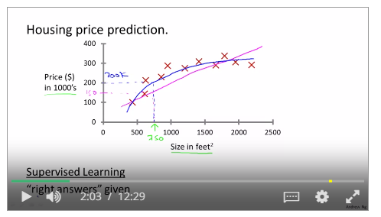
  + Regression: Predict continuous values. Map i/p variables to continuous function
  + 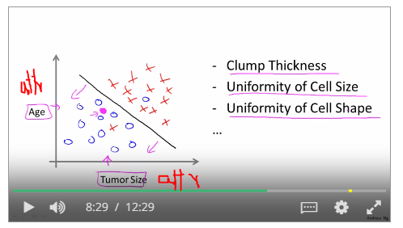
  + Classification: predict discrete valued o/p. map i/p variables to discrete categories
* Unsupervised learning: find structure in data. Eg: google news (same headline different links).
  + Clustering: Clustering data based on relationships between data.
  + Non-clustering: find structure in chaotic environment.

**Linear Regression with one variable**

* Model representation
  + By hypothesis: Maps input to output
  + 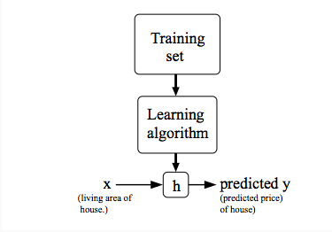
* Cost function / objective function / J
  + 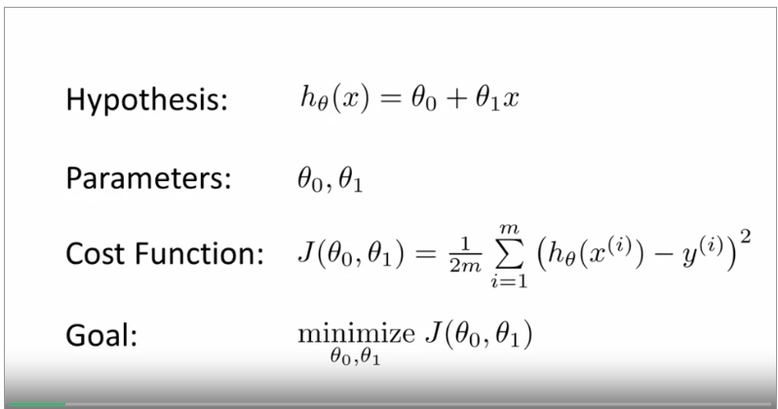
  + finds parameters of the model so that the difference between actual and predicted output (is modelled) is minimised.
  + Finds accuracy of hypothesis
  + Mean is halved for gradient computation
  + 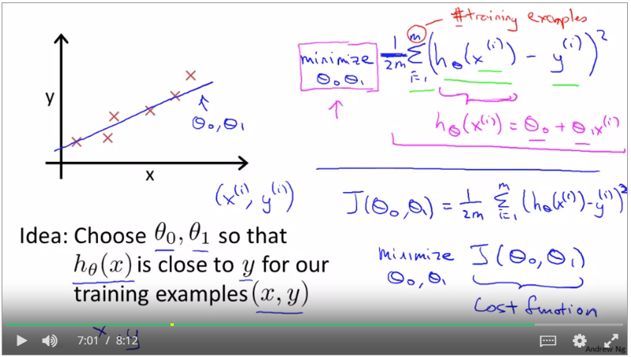
  + Here squared error loss function
* Cost function intuition
  + Plotting parameters and cost function (one parameter)
  + 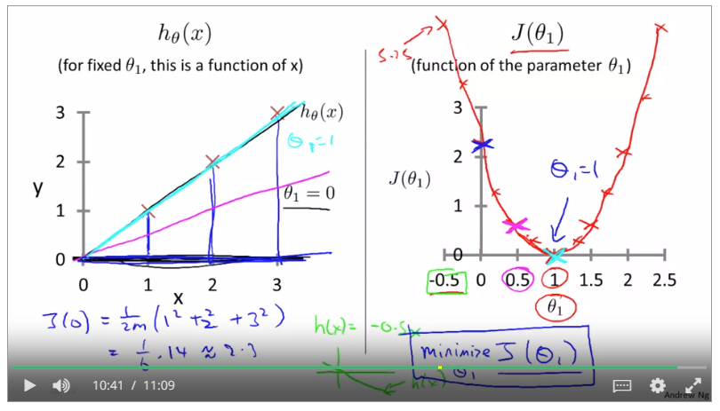
  + Two parameters
  + 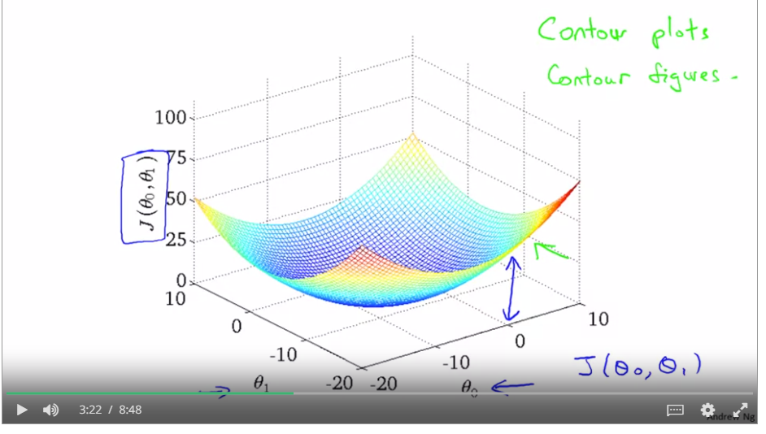
* Gradient descent
  + Iterative Method to estimate values of parameters of cost function
  + 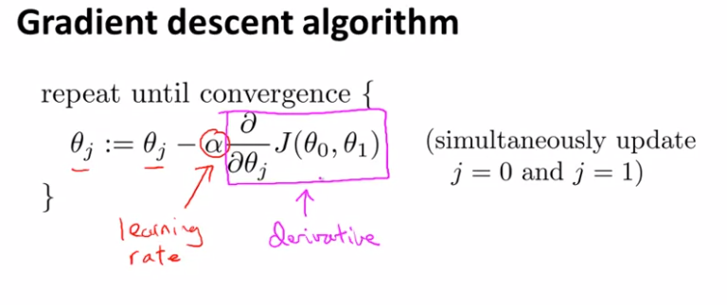
  + Gradient is slope of curve
  + 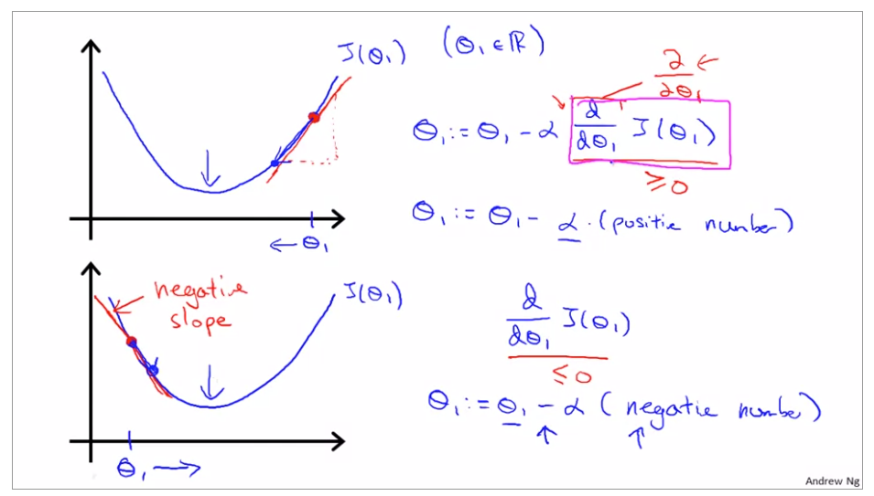
  + Effect of learning rate
  + 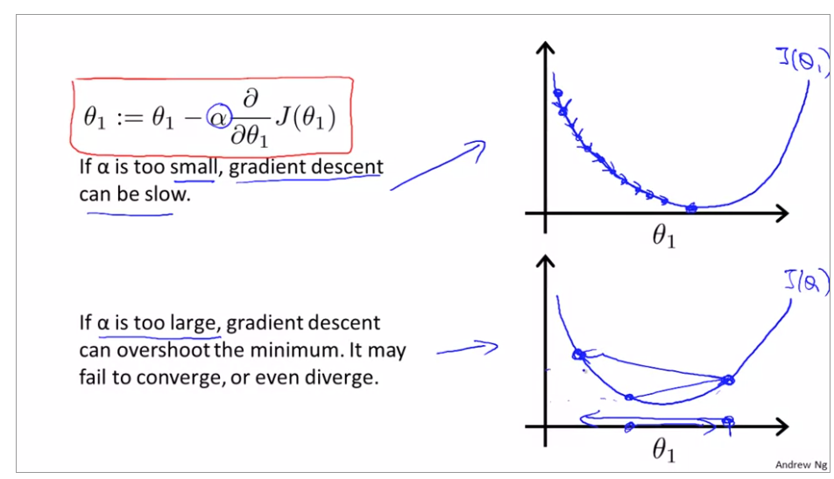
  + The value of derivative decreases as the cost function tends toward minimum.

**Multivariate linear regression**