AZ-400 - Microsoft Azure DevOps Solutions - Results

Question 1Skipped
In Azure Artifacts, how can you ensure that old versions of NuGet packages are automatically removed from a feed to maintain storage efficiency and compliance?
By manually deleting older package versions from the NuGet feed when they are no longer needed
By reaching out to Azure Support to request the removal of old package versions
Correct answer
By creating and configuring a retention policy for the NuGet feed
By enabling automatic version pruning within the Azure Artifacts settings
Overall explanation
In Azure Artifacts, you can manage the retention of package versions in NuGet feeds by creating and configuring retention policies. These policies allow you to define criteria for when old package versions should be automatically removed from the feed, ensuring storage efficiency and compliance without manual intervention.
Question 2Skipped
A team wants to ensure there are no active issues in the work item or problem management system before deploying a build to a stage.
Which feature would you use ?
Post-deployment gates
Correct answer
Pre-deployment gates
Manual Intervention
Overall explanation
https://learn.microsoft.com/en-us/azure/devops/pipelines/release/approvals/?view=azure-devops&tabs=yaml
Question 3Skipped
Your company has an application that contains a number of Azure App Service web apps and Azure functions. You would like to view recommendations with regards to the security of the web apps and functions. You plan to navigate to Compute and Apps to achieve your goal.
Which of the following should you access to make use of Compute and Apps?
Azure Advisor
Azure Log Analytics
Azure Event Hubs
Correct answer
Microsoft Defender for cloud
Overall explanation
https://learn.microsoft.com/en-us/azure/defender-for-cloud/defender-for-cloud-introduction
Question 4Skipped
Which version control systems Azure pipelines can integrate with ?
Select three supported source repositories.
CVS
Correct selection
GitHub
Correct selection
Bitbucket
Correct selection
GitHub Enterprise
Overall explanation
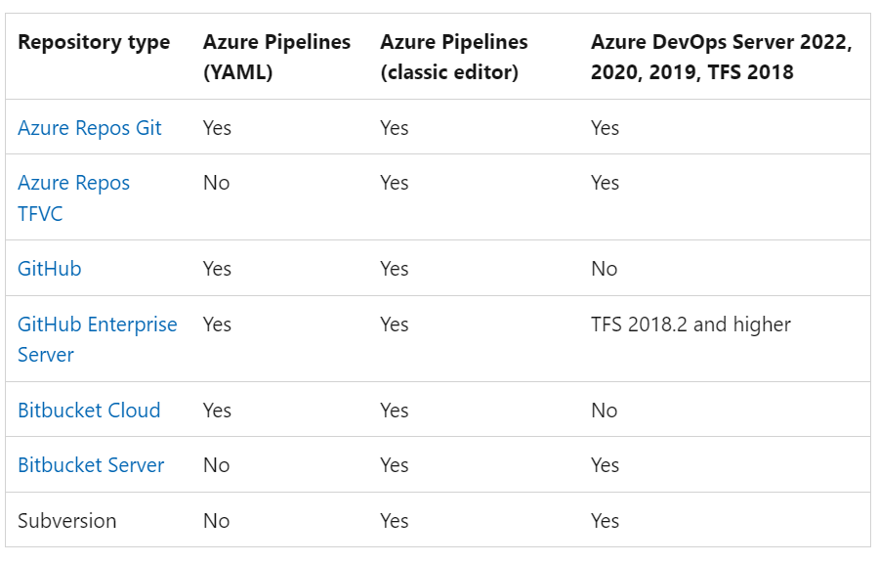

Reference:
https://learn.microsoft.com/en-us/azure/devops/pipelines/repos/?view=azure-devops
Question 5Skipped
Your team decides to use Azure DevOps for the development platform.
You need to create a build pipeline that contains a task that requires human interaction before a deployment can be approved.
What should you do?
Choose the correct answer
Create release gates that update the Kanban board when manual interaction is required.
Create build scripts that replace manual interaction with automation.
Create an Azure logic app that sends out a notification when interaction is required.
Correct answer
Create a manual intervention task inside the build pipeline.
Overall explanation
Manual intervention tasks are used when automation is not possible.
Question 6Skipped
Your company wants to release a project using the semantic versioning. Developers are not sure when to increment the major, minor, or patch version of the project.

Which version should the developers increase for the below situation ?
Statement: To release a bugfix.
Major
Correct answer
Patch
Minor
Overall explanation
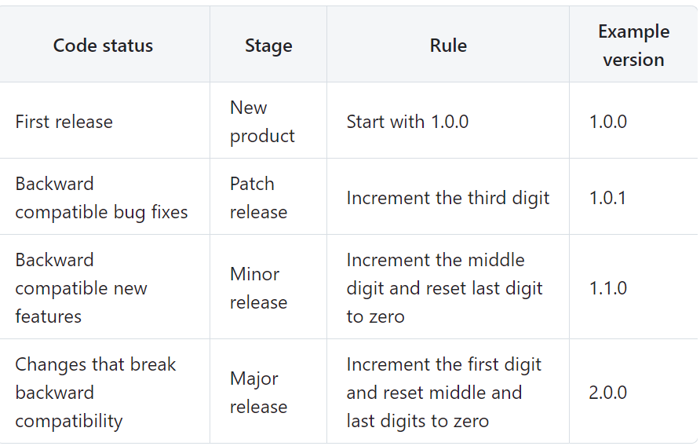
Question 7Skipped
You need to modify your Azure Pipelines release process to ensure that if the manual approval step takes more than two hours to complete, the deployments will automatically fail. This will address the issue reported by the project stakeholder where prolonged approval times do not result in deployment failures.

What should you do?

Correct answer
Set a timeout for pre-deployment approvals
Set a timeout after which gate fails
Update the pre-deployment trigger
Overall explanation
Pre-deployment approvals could be configured with a timeout of days, hours or minutes.

https://learn.microsoft.com/en-us/azure/devops/pipelines/release/approvals/approvals?view=azure-devops
Question 8Skipped
Your team is planning to host a git repository using Azure Repos. The team would be hosting the following types of files-
• ASP.Net core code files
• Images, JavaScript files linked to the projects
• Audio and video files
The team wants to follow the best practices when it comes to storing the files in a git-based repository.
Which of the following can be used for managing large files such as Audio and Video files in your project?
Git squash merge
Correct answer
Git LFS
Git locking
Git merge
Overall explanation
Git Large File Storage (LFS) replaces large files such as audio samples, videos, datasets, and graphics with text pointers inside Git, while storing the file contents on a remote server like GitHub.com or GitHub Enterprise.
https://git-lfs.com/

Question 9Skipped
You are using Azure Devops services to build and release in you company.
You need to integrate a tool with your build pipelines in order to retrieve information on open-source licenses distribution per build.

Which tool should you choose ?
OWASP ZAP
SonarQube
Correct answer
Mend Bolt ( Formerly known as WhiteSource )
Overall explanation
https://marketplace.visualstudio.com/items?itemName=whitesource.whiteSource-bolt-v2
Question 10Skipped
You need to create a list of all non-compliant resources based on existing policies using PowerShell in Azure Devops.

Which PowerShell cmdlet should you execute ?
Get-AzPolicyRemediation
Correct answer
Get-AzPolicyState
Get-AzPolicyRemediation
Overall explanation
https://learn.microsoft.com/en-us/azure/governance/policy/assign-policy-powershell
Question 11Skipped
You run the Register-AzRmAutomationDscNode command in your company's
environment.
You need to make sure that your company's test servers remain correctly configured,
regardless of configuration drift.
Solution: You set the -ConfigurationMode parameter to ApplyOnly.
Does the solution meet the goal?
Yes
Correct answer
No
Overall explanation
This parameter accepts the values Apply AndMonitor, Apply AndAutocorrect, and ApplyOnly. The Apply Only mode updates server configuration only for the first time and does not ensure that changes in the server configuration are fixed, leading to configuration drift. You should use the Apply AndAutocorrect mode to fix configuration drift over time.
Reference:

https://learn.microsoft.com/en-us/powershell/module/az.automation/register-azautomationdscnode?view=azps-10.4.1&viewFallbackFrom=azps-5.8.0
Question 12Skipped
Your orgnization has collaboration with external organization to develop an application.
Your company uses Azure Boards ro manage the tasks where as external company uses Trello.
You want to create a card on Trello (External company Board) when a work item gets created in Azure Boards. It should be as automatic as possible.

Which two actions should you perform ?
Create a query in Azure Board and export the work items as a CSV file
Import CSV cards into Trello with import2 wizard
Correct selection
Configure a service hook subscription in Azure Devops
Correct selection
Grant access to Azure Devops in the Trello Account
Overall explanation
https://learn.microsoft.com/en-us/azure/devops/service-hooks/overview?view=azure-devops
Question 13Skipped
How can you efficiently perform a URL ping test every five minutes on your globally accessed Microsoft ASP.NET Core web app hosted in Azure and set up alerts to notify you when the web app becomes unavailable from specific Azure regions, all while minimizing the time spent on development?
Create an Azure Service Health alert for the specific regions
Correct answer
Create an Azure Application Insights availability test and alert
Create an Azure Monitor Availability metric and alert
Write an Azure function and deploy the function to the specific regions.
Overall explanation
Once your web app or website is deployed, you have the option to establish recurring tests for monitoring its availability and responsiveness. Azure Application Insights conducts periodic web requests to your application from various global locations. It can notify you in case your application doesn't respond or responds sluggishly. You can configure availability tests for any publicly accessible HTTP or HTTPS endpoint, and there's no need to modify the website you're testing. In fact, the site you're testing doesn't have to be under your ownership; you can even assess the availability of a REST API that your service relies on.
Reference:
https://learn.microsoft.com/en-us/previous-versions/azure/azure-monitor/app/monitor-web-app-availability#create-a-url-ping-test
Question 14Skipped
You have windows server 2016 VM named Prod-VM-01 hosted in Azure. VM will be used as web server and SMTP server. You need to configure the VM using DSC configuration.
Complete the following the PowerShell DSC Configuration ?

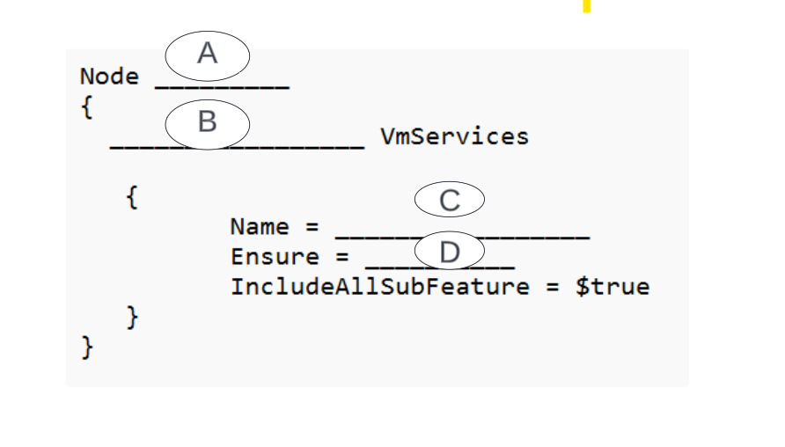
Correct answer
A: Prod-VM-01
B: WindowsFeatureSet
C: @("SMTP-Server","Web-Server")
D: "Present"
A: Localhost
B: WindowsFeature
C: @("SMTP-Server","Web-Server")
D: "Present"
A: Prod-VM-01
B: WindowsFeatureSet
C: @("SMTP-Server","Web-Server")
D: "Absent"
Overall explanation
You should complete the configuration like below:
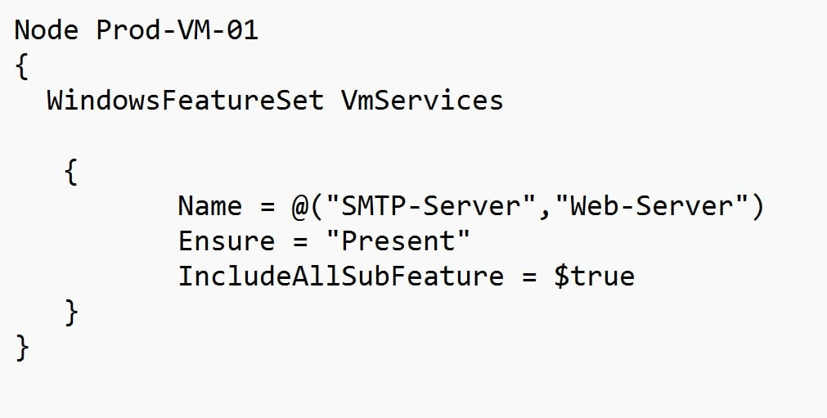

You should use Windows FeatureSet. This resource will ensure that a set of roles and features are installed on or removed from the VM node. Windows FeatureSet is a composite resource that internally calls the WindowsFeature resource for each feature in the Name property.
You should use Name = @("SMTP-Server", "Web-Server"). This will configure both the web server and the SMTP server features on the VM.
You should use Ensure = "Present". This will ensure that the features defined in the name property are installed on the VM.
You should not use Node localhost. This will configure the wrong nodes with the desired features.
You should not use Windows Feature. This resource is used to ensure that an individual feature is installed on or removed from the server, not a group of features.
Question 15Skipped
You manage an Azure Web App web application.
You need to implement a release pipeline for a blue-green deployment strategy using deployment slots. Your solution must minimize application downtime during the deployment and also minimize administrative effort.
You performed below steps

Create a new deployment slot named staging in Azure App Service.
Add a staging stage in the Release pipeline.
Create a task to deploy the application to the staging slot.
Add a production stage in the Release pipeline.
Create an App Service Manage task to swap the staging slot to production.

Is it correct ?
Correct answer
Yes
No
Overall explanation
https://learn.microsoft.com/en-us/azure/app-service/deploy-staging-slots?tabs=portal
Question 16Skipped
Some developers in your company reported that Azure build pipelines are queued for more than 30 minutes, thereby slowing down the development process. You are running the build pipelines on Microsoft-hosted agents.

What should you do ?
Correct answer
Increase the number of parallel jobs for Microsoft-Hosted agents
Decrease the number of parallel jobs for Microsoft-Hosted agents
Add an extra Self-Hosted Agent
Overall explanation
When you define a pipeline, you can define it as a collection of jobs. When a pipeline runs, you can run multiple jobs as part of that pipeline. Each running job consumes a parallel job that runs on an agent. When there aren't enough parallel jobs available for your organization, the jobs are queued up and run one after the other.

For Microsoft-hosted parallel jobs, you can get up to 10 free Microsoft-hosted parallel jobs that can run for up to 360 minutes (6 hours) each time for public projects. When you create a new Azure DevOps organization, you aren't given this free grant by default.
For private projects, you can get one free job that can run for up to 60 minutes each time. When you create a new Azure DevOps organization, you may not always be given this free grant by default.

Reference:
https://learn.microsoft.com/en-us/azure/devops/pipelines/licensing/concurrent-jobs?view=azure-devops&tabs=ms-hosted

Question 17Skipped
You manage an Azure web app that supports an e-commerce website. You need to increase the logging level when the web app exceeds normal usage patterns.
The solution must minimize administrative overhead. Which two resources should you include in the solution?
the Azure Monitor autoscale settings
an Azure Monitor alert that uses an action group that has an email action
an Azure Monitor alert that has a static threshold
Correct selection
an Azure Monitor alert that has a dynamic threshold
Correct selection
an Azure Automation runbook
Overall explanation
Metric Alert with Dynamic Thresholds detection leverages advanced machine learning (ML) to learn metrics' historical behavior, identify patterns and anomalies that indicate possible service issues. It provides support of both a simple UI and operations at scale by allowing users to configure alert rules through the Azure Resource Manager API, in a fully automated manner. A: You can use Azure Monitor to monitor base-level metrics and logs for most services in Azure. You can call Azure Automation runbooks by using action groups or by using classic alerts to automate tasks based on alerts.
Reference:
https://docs.microsoft.com/en-us/azure/azure-monitor/platform/alerts-dynamicthresholds https://docs.microsoft.com/en-us/azure/automation/automation-createalert-triggered-runbook
Question 18Skipped
Which tool offers built-in visualization and dashboarding out of the box, with support for various charts and visualizations. It has native integration with Power BI, native connectors for Grafana, Kibana etc.
Azure Storage
Azure Event grid
Correct answer
Azure Data explorer
Overall explanation
Data visualization helps you gain important insights. Azure Data Explorer offers built-in visualization and dashboarding out of the box, with support for various charts and visualizations. It has native integration with Power BI, native connectors for Grafana, Kibana and Databricks, ODBC support for Tableau, Sisense, Qlik, and more.

https://learn.microsoft.com/en-us/azure/data-explorer/data-explorer-overview
Question 19Skipped
Your organization uses Azure Devops Services teams project wikis to enhance developer communication. You need to assign default permissions to a user named John so that they can edit the teams project page.

Which security groups should you add John to as a team member ?
Correct answer
Project Administrator
Contributors
Readers
Team Administrators
Overall explanation
https://learn.microsoft.com/en-us/azure/devops/project/wiki/wiki-readme-permissions?view=azure-devops
Question 20Skipped
You are currently developing a project for a client that will be managing work items via Azure DevOps. You want to make sure that the work item process you use for the client allows for requirements, change requests, risks, and reviews to be tracked. Which of the following is the option you would choose?
Agile
Scrum
Basic
Correct answer
CMMI
Overall explanation
Choose CMMI when your team follows more formal project methods that require a framework for process improvement and an auditable record of decisions. With this process, you can track requirements, change requests, risks, and reviews. Incorrect Answers: A. Choose Basic when your team wants the simplest model that uses Issues, Tasks, and Epics to track work. B. This process works great if you want to track user stories and (optionally) bugs on the Kanban board, or track bugs and tasks on the taskboard. C. This process works great if you want to track product backlog items (PBIs) and bugs on the Kanban board, or break PBIs and bugs down into tasks on the taskboard.
Reference:
https://learn.microsoft.com/en-us/azure/devops/boards/work-items/guidance/choose-process?view=azure-devops&tabs=agile-process
Question 21Skipped
Your company has an Azure DevOps environment that can only be accessed by Azure Active Directory users. You are instructed to make sure that the Azure DevOps environment can only be accessed from devices connected to the company's on-premises network. Which of the following actions should you take?
Assign the devices to a security group
Correct answer
Configure conditional access in Azure Active Directory
Configure Security in Project Settings from Azure DevOps
Create a GPO
Overall explanation
Conditional Access is a capability of Azure Active Directory. With Conditional Access, you can implement automated access control decisions for accessing your cloud apps that are based on conditions. Conditional Access policies are enforced after the first-factor authentication has been completed.
Reference:
https://learn.microsoft.com/en-us/entra/identity/conditional-access/overview
Question 22Skipped
You are configuring project metrics for dashboards in Azure DevOps. You need to configure a chart widget that measures the elapsed time to complete work items once they become active. Which of the following is the widget you should use?
Cumulative Flow Diagram
Correct answer
Cycle time
Burnup
Burndown
Overall explanation
Cycle time measures the time it takes for your team to complete work items once they begin actively working on them.
Reference:
https://learn.microsoft.com/en-us/azure/devops/report/dashboards/cycle-time-and-lead-time?view=azure-devops&viewFallbackFrom=vsts
Question 23Skipped
You need to implement dynamic security scanning against a running web application as part of Continuous delivery pipeline.

Which tool should you integrate with your delivery pipelines ?
SonarQube
Correct answer
OWASP ZAP
Mend Bolt
Overall explanation
You should use Web Application Security Project (OWASP) Zed Attack Proxy (ZAP). OWASP ZAP is a nonprofit foundation that works to improve the security of software. OWASP ZAP is an extension that allows you to perform a dynamic security scan against a running web application. OWASP ZAP requires a continuous delivery pipeline to be in place. The extension pretends to be an attacker and it fiddles the web application with requests to try to identify vulnerabilities.

https://medium.com/codex/test-coverage-code-scan-dependency-scan-and-security-scan-in-an-azure-devops-pipeline-136fa37b6b8b
Question 24Skipped
Company is planning to use Git repository with Azure Devops. Company wants to use to Git based on Trunk-based development (Trunk-based development is a version control management practice where developers merge small, frequent updates to a core “trunk” or main branch).
Which four actions should you perform in correct order.
Generate a pull request
Merge changes to the main branch
Commit and push the changes to the feature branch
Create a feature branch
Correct answer
Create a feature branch
Commit and push the changes to the feature branch
Generate a pull request
Merge changes to the main branch
Commit and push the changes to the feature branch
Create a feature branch
Generate a pull request
Merge changes to the main branch
Overall explanation
You should perform below Actions in order:
Create a feature branch
Commit and push the changes to the feature branch
Generate a pull request
Merge changes to the main branch
Question 25Skipped
Your company is using Azure Devops, They need to implement a method that would ensure that code meets the defined quality and code review standards of the company. Which of the following would you implement for this requirement ?
Correct answer
branch policies
branch tagging
branch permissions
branch locking
Overall explanation
Branch Policies - Enforce best practices with required code reviewers.

https://learn.microsoft.com/en-us/azure/devops/repos/git/branch-policies?view=azure-devops&tabs=browser
Question 26Skipped
What components should be included in your solution for developing a mobile app for Android and iOS, managing work items and release cycles through Azure DevOps, and ensuring the collection of crash reports, distribution of beta releases to testers, and gathering user feedback on new app functionality?
Correct answer
The Microsoft Test & Feedback extension
OWASP ZAP
TFS Integration Platform
Azure Devops Board
Overall explanation
The "Exploratory Testing" extension is now "Test & Feedback" and is now Generally Available.Anyone can now test web apps and give feedback, all directly from the browser on any platform: Windows, Mac, or Linux. Available for Google Chrome and Mozilla Firefox (required version 50.0 or above) currently. Support for Microsoft Edge is in the pipeline and will be enabled once Edge moves to a Chromium- compatible web platform.
Reference:
https://marketplace.visualstudio.com/items?itemName=ms.vss-exploratorytesting-web
Question 27Skipped
You need to build a pipeline in Azure Devops. This pipeline will deploy to an Azure App Service that is in an external Azure Subscription that your credential does not have access to.
You need to configure this pipeline to deploy the application in the third-party Azure Subscription ?

What should you choose ?
A service hook subscription
Correct answer
A service connection with manual subscription pipeline
A service connection with automated subscription detection
Private endpoint
Overall explanation
Manual subscription pipeline. In this mode, you must specify the service principal you want to use to connect to Azure. The service principal specifies the resources and the access levels that are available over the connection.
Use this approach when you need to connect to an Azure account using different credentials from the credentials you're currently signed in with in Azure Pipelines.

Reference:
https://learn.microsoft.com/en-us/azure/devops/pipelines/library/service-endpoints?view=azure-devops&tabs=yaml
Question 28Skipped
A project contains a Git repository. A trigger must be in place to initiate a build from any commit changes to the repository. The trigger must not consider any changes with in the folder named /data in the repository.

How would you setup the filter ?
A branch filter to include - data/*
A branch filter to exclude - data /*
Correct answer
A path filter to exclude - data/*
A path filter to include - data/*
Overall explanation
Since branch name has not been specified in the question, it would be default i.e. master. In the Yaml file, we will specify - "/*" folder under exclude element under paths.
## YAML file using path filter

trigger:
branches:
include:
- master
paths:
include:
- docs
exclude:
- /data/*

Question 29Skipped
As you may be aware, there are advantages and disadvantages to using a Microsoft-hosted agent instead of self-hosted agent.

Which two features would you sacrifice if you choose a Microsoft-hosted agent instead of Self-hosted agent ?
Correct selection
Velocity
Correct selection
The ability to run pre-load custom software
The ability to run an agent in a virtual machine (VM)
The ability to run more than one agent simultaneously
The ability to do maintenance and upgrades
Overall explanation
Microsoft-hosted agents lack the same level of flexibility as self-hosted agents when it comes to pre-loading custom software.

Microsoft-hosted agents initiate a new virtual machine (VM) for each run, resulting in the absence of caching and the inability to save configurations. Consequently, Microsoft-hosted agents may exhibit slower performance when compared to self-hosted agents.

Opting for a Microsoft-hosted agent does not require you to sacrifice the capability of performing maintenance and upgrades, as these tasks are automated.

Microsoft-hosted agents provision a new VM for each build run, which means that you do not compromise this feature when selecting a Microsoft-hosted agent over a self-hosted agent.

Microsoft-hosted agents do not impose limitations on running multiple builds with more than one agent concurrently, preserving this feature when choosing a Microsoft-hosted agent over a self-hosted agent.
Question 30Skipped
You need to develop release pipelines for an application. You plan to use the application using progressive exposure deployments.

Which two techniques could you use ?
Blue/Green Deployment
Gradual Deployment
Correct selection
Deployment rings
Correct selection
Feature Flags
Overall explanation
You could use deployment rings. This technique, also known as canary deployment, allows you to gradually expose the new version of the application only to some users. This exposure can be controlled at the load balancing layer, using application settings or during application runtime.
You could use feature flags. Feature flags are used to turn application features on or off. They are either flags controlled via application configuration or as an opt-in feature individually by users. They are generally used to test experimental features with a limited number of users or to disable application features without a new deployment.
Question 31Skipped
The Burnup widget measures the elapsed time from creation of work items to their completion.
Select `No adjustment required` if the above statement is accurate. If it is inaccurate, select the accurate option.
Correct answer
Lead time
No adjustment required
Burndown
Test results trend
Overall explanation
Both lead time and cycle time widgets are useful to teams. They both indicate how long it takes for work to flow through their development pipeline. Lead time measures the total time elapsed from the creation of work items to their completion. Cycle time measures the time it takes for your team to complete work items once they begin actively working on them.
Reference:
https://learn.microsoft.com/en-us/azure/devops/report/dashboards/cycle-time-and-lead-time?view=azure-devops&viewFallbackFrom=vsts
Question 32Skipped
You have created an Azure DevOps project for a new application that will be deployed to a number of Windows Server 2016 Azure virtual machines. You are preparing a deployment solution that allows for the virtual machines to maintain a uniform configuration, and also keep administrative effort with regards to configuring the virtual machines to a minimum.
Which of the following should be part of your solution? (Choose two.)
Correct selection
The Custom Script Extension for Windows
Correct selection
The PowerShell Desired State Configuration (DSC) extension for Windows
Azure pipeline deployment groups
Azure pipeline stage templates
Azure Resource Manager templates
Overall explanation
The Custom Script Extension downloads and executes scripts on Azure virtual machines. This extension is useful for post deployment configuration, software installation, or any other configuration or management tasks. Scripts can be downloaded from Azure storage or GitHub, or provided to the Azure portal at extension run time. The Custom Script Extension integrates with Azure Resource Manager templates, and can be run using the Azure CLI, PowerShell, Azure portal, or the Azure Virtual Machine REST API.
Reference:
https://learn.microsoft.com/en-us/azure/virtual-machines/extensions/custom-script-windows
Question 33Skipped
You have a resource group named APP-RG-PROD that consists of several resources.
You are asked to add a storage account to the resource group. You decide to deploy the new storage account by using an Azure Resource Manager (ARM) template and the New-AzResourceGroupDeployment cmdlet. This template does not contain any linked or nested templates.
After the deployment finishes successfully, you realize that all the resources in the resource group have been deleted except for the newly created storage account.
Why did this happen?
You did not use the -mode parameter with the New-AzResourceGroupDeployment cmdlet.
The template contains the mode parameter with the value Incremental.
Correct answer
You used the -mode complete parameter with the New-AzResource Group Deployment cmdlet.
Overall explanation
Resources in the resource group were deleted except for the newly-created storage account because you used the -mode complete parameter with the New-AzResourceGroupDeployment cmdlet because the New- AzResourceGroupDeployment cmdlet has two deployment modes: incremental and complete. When you use the complete mode, all resources in the resource group that are not included in the template are deleted.
Reference:
https://learn.microsoft.com/en-us/azure/azure-resource-manager/templates/deployment-modes
Question 34Skipped
Your company decides to integrate the GitHub Enterprise Server into their Azure DevOps Server CI/CD pipeline.
You need to make sure that the connection between GitHub Enterprise Server and the Azure DevOps server is protected.
What should you use?
Choose the correct answer
Correct answer
OAuth
Windows authentication
A secured username and password
Personal access tokens (PATs)
Overall explanation
You should use OAuth to make sure that the connection between GitHub Enterprise Server and the Azure DevOps server is protected. OAuth is the preferred authentication method when connecting between GitHub Enterprise Server and Azure DevOps. OAuth allows unrelated servers and services to safely allow authenticated access to their resources.
You should not use personal access tokens (PATs). PATS are alternate passwords that you can use to authenticate into Azure DevOps.
Question 35Skipped
Your company uses ServiceNow for incident management. You develop an application that runs on Azure. The company needs to generate a ticket in ServiceNow when the application fails to authenticate.
Which Azure Log Analytics solution should you use?
Correct answer
IT Service Management Connector (ITSM)
Application Insights Connector
Automation & Control
Insight & Analytics
Overall explanation
The IT Service Management Connector (ITSMC) allows you to connect Azure and a supported IT Service Management (ITSM) product/service. ITSMC supports connections with the following ITSM tools:
ServiceNow
System Center Service Manager
Provance
Cherwell
With ITSMC, you can - Create work items in ITSM tool, based on your Azure alerts (metric alerts, Activity Log alerts and Log Analytics alerts). Optionally, you can sync your incident and change request data from your ITSM tool to an Azure Log Analytics workspace.
Reference:
https://learn.microsoft.com/en-us/azure/azure-monitor/alerts/itsmc-overview
Question 36Skipped
You have been tasked with strengthening the security of your team's development process. You need to suggest a security tool type for the Continuous Integration (CI) phase of the development process.
Which of the following is the option you would suggest?
Dynamic code analysis
Correct answer
Static code analysis
Penetration testing
Threat modeling
Overall explanation
In the CI/CD process, validation initiates prior to developers committing their code. The initial layer of defense is offered by static code analysis tools integrated into the IDE, which aids in preventing the introduction of security vulnerabilities into the CI/CD pipeline.

https://learn.microsoft.com/en-us/azure/devops/pipelines/security/overview?view=azure-devops&viewFallbackFrom=vsts
Question 37Skipped
Among your Azure DevOps responsibilities for managing build pipelines and deploy pipelines, you've been tasked with automating user and license management to accommodate the growing development team. Which of the following tasks is not suitable for automation?
Correct answer
License procurement
Group membership changes
License assignment
Assigning entitlements
Overall explanation
License procurement is not a task that can be automated in Azure DevOps. Procuring licenses requires purchasing licenses through Microsoft or a Microsoft partner, which involves a human decision-making process.
Question 38Skipped
Which feature would you use to reduce build time by allowing previous downloaded dependencies to be reused in later runs, thereby reducing the cost to avoid to recreate or redownload the same files again.
Pipeline artifacts
Parallel jobs
Correct answer
Pipeline caching
Overall explanation
Pipeline caching can help reduce build time by allowing the outputs or downloaded dependencies from one run to be reused in later runs, thereby reducing or avoiding the cost to recreate or redownload the same files again. Caching is especially useful in scenarios where the same dependencies are downloaded over and over at the start of each run. This is often a time consuming process involving hundreds or thousands of network calls.
Reference :
https://learn.microsoft.com/en-us/azure/devops/pipelines/release/caching?view=azure-devops
Question 39Skipped
Which of the widget you will use for the following statement.

Statement: Ability to provide the elapsed time to complete work items once they are marked as active.
Velocity
Lead Time
Correct answer
Cycle Time
Burndown
Overall explanation
https://learn.microsoft.com/en-us/azure/devops/report/dashboards/cycle-time-and-lead-time?view=azure-devops
Question 40Skipped
You are planning to use Azure Devops pipelines for a project to notify a third party monitoring system about successful deployments using a secret API key.
Which secret storage would you choose with minimal changes to the pipelines ?
Correct answer
Azure pipeline secret variable
GitHub Actions secret
Azure Key Vault Secret
Overall explanation
You can set variables in Azure pipelines containing secret values such as API keys that are encrypted at rest.
Reference:

https://learn.microsoft.com/en-us/azure/devops/pipelines/build/variables?view=azure-devops&tabs=yaml

