AZ-400 - Microsoft Azure DevOps Solutions - Results

Question 1Skipped
You plan to use the metrics and Key Performance Indicators (KPIs) of Azure DevOps projects to validate that your team is meeting its goals and expectations.
You need to identify the KPI that is used to measure the quality and security associated with a project in Azure DevOps.
Which KPI should you identify?
Correct answer
Mean time to recover
Lead Time
Application Performance
Server to Admin Ratio
Overall explanation
Mean time to recover is an example of a quality and security metric. Server to Admin Ratio and Application Performance are examples of efficiency metrics. Lead Time is an example of a faster outcome metric.
Question 2Skipped
A company wants to start using Azure DevOps. Three projects have been created in Azure DevOps for different departments. Each department has different requirements for their project management process.
The department-based requirements are given below

Department Requirement

DepartmentA - Ability to track product backlogs and bugs on a Kanban board. Should be able to break down the product backlog items into tasks on a task board

DepartmentB - Should be able to track user stories and bugs on a Kanban board. Should be able to track bugs and tasks on a task board.

DepartmentC Need to track requirements, change requests m risks and reviews.

You have to decide on the right process to adopt for Azure Boards for each department

Which of the following would you adopt for DepartmentB?
Scrum
Correct answer
Agile
CMMI
XP
Overall explanation
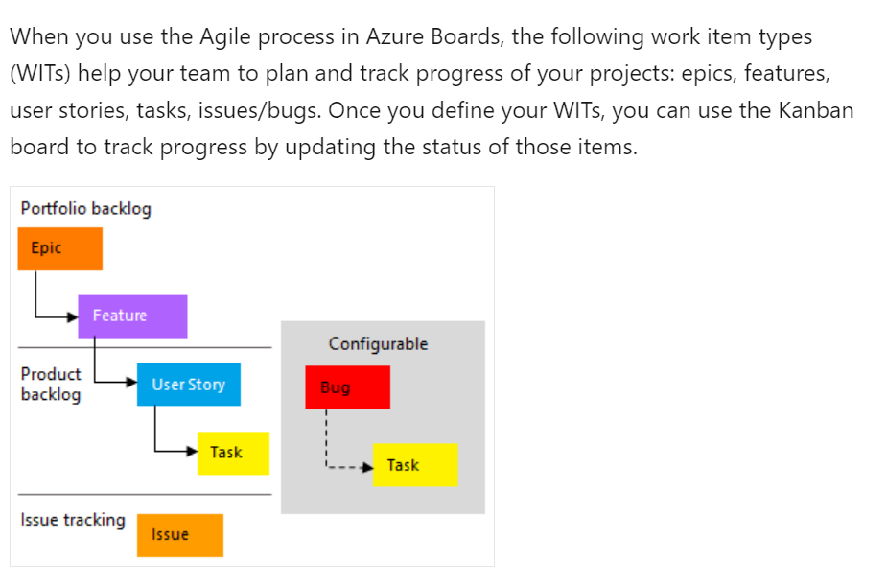
Question 3Skipped
You scan a Node.js application using WhiteSource Bolt. The scan finds numerous libraries with invalid licenses, but are only used during development. You have to make sure that only production dependencies are scanned by WhiteSource Bolt.
Which of the following is a command you should run?
npm publish
npm update
npm edit
Correct answer
npm install
Overall explanation
https://docs.npmjs.com/downloading-and-installing-node-js-and-npm
Question 4Skipped
You need to build an Azure Pipelines for a new Project. It requires a Linux Self-Hosted agent. Pipelines must run twice a day and should take about 15 mins to complete.
You need to use a compute service that runs this self-hosted agent while minimizing costs.
What should you choose ?
Correct answer
Azure Container instances (ACI)
Azure VM
Azure Kubernetes Service (AKS)
Azure Virtual Machine Scale Set
Overall explanation
You should choose Azure Container Instances (ACI). You can run a Linux self-hosted agent as a Docker container running in ACI. This is the most cost-effective solution because you will be charged only for the container execution in ACI.
You should not choose Azure Kubernetes Service (AKS). Deploying an AKS cluster requires greater administrative efforts and it is more expensive because you need to maintain worker nodes running even if the pipeline is not running, which increases the solution costs.
You should not choose Azure Virtual Machine (VM). Using an Azure VM as a self-hosted agent will incur costs during the idle periods that the pipeline is not running.
You should not choose Azure VM scale set. You could use an Azure VM scale set to scale self-hosted agents into multiple compute nodes. However, this will incur extra costs during idle time.
Question 5Skipped
A team is developing an application that would be deployed using ARM templates. The templates would also be used to create virtual machines. You need to store a secret for the virtual machine in an Azure Key vault.
You need to complete the following script for this purpose.
az SLOT_1 create –name “Contoso-Vault2” –resource-group “ContosoResourceGroup” –location eastus
az SLOT_2 SLOT_3 set –vault-name “Contoso-Vault2” –name “ExamplePassword” –value “hVFkk965BuUv”
Which of the following would go into SLOT_1?
set
Correct answer
keyvault
vault
secret
Overall explanation
https://learn.microsoft.com/en-us/azure/key-vault/secrets/quick-create-cli
Question 6Skipped
Your company is building a new solution in Java.
The company currently uses a SonarQube server to analyze the code of .NET solutions.
You need to analyze and monitor the code quality of the Java solution.
Which task types should you add to the build pipeline?
Octopus
Correct answer
Maven

Explanation
Under Choose a way to run the analysis, select Integrate with Maven or Gradle.
https://docs.sonarsource.com/sonarqube-server/latest/devops-platform-integration/azure-devops-integration/
Grunt
Gulp
Overall explanation
Under Choose a way to run the analysis, select Integrate with Maven or Gradle.
https://docs.sonarsource.com/sonarqube-server/latest/devops-platform-integration/azure-devops-integration/
Question 7Skipped
You have an Azure DevOps organization named Contoso and an Azure subscription. You use Azure DevOps to build a containerized app named App1 and deploy App1 to an Azure container instance named ACI1. You need to restart ACI1 when App1 stops responding. What should you do?
Add a readiness probe to the YAML configuration of App1.
Use IP flow verify in Azure Network Watcher.
Correct answer
Add a liveness probe to the YAML configuration of App1.
Use Connection Monitor in Azure Network Watcher.
Overall explanation
A liveness probe is a diagnostic tool used to check the health of a container and determine if it is running properly. By adding a liveness probe to the YAML configuration of App1, you can periodically check if the application is responsive. If the liveness probe fails, indicating that the application is not responding, Azure DevOps can automatically restart ACI1.
https://learn.microsoft.com/en-us/azure/container-instances/container-instances-liveness-probe
Question 8Skipped
A company is setting up Azure Artifacts. Several feeds are being created in Azure Artifacts. You need to set the permissions for the feed for the following groups

GroupA - This group should be able to list and install packages from the feed

GroupB – This group should be able to push packages to the feed

You need to ensure the least privileges are given to each group

Which of the following permission would you assign to GroupB?
Correct answer
Contributor
Owner
Collaborator
Reader
Overall explanation
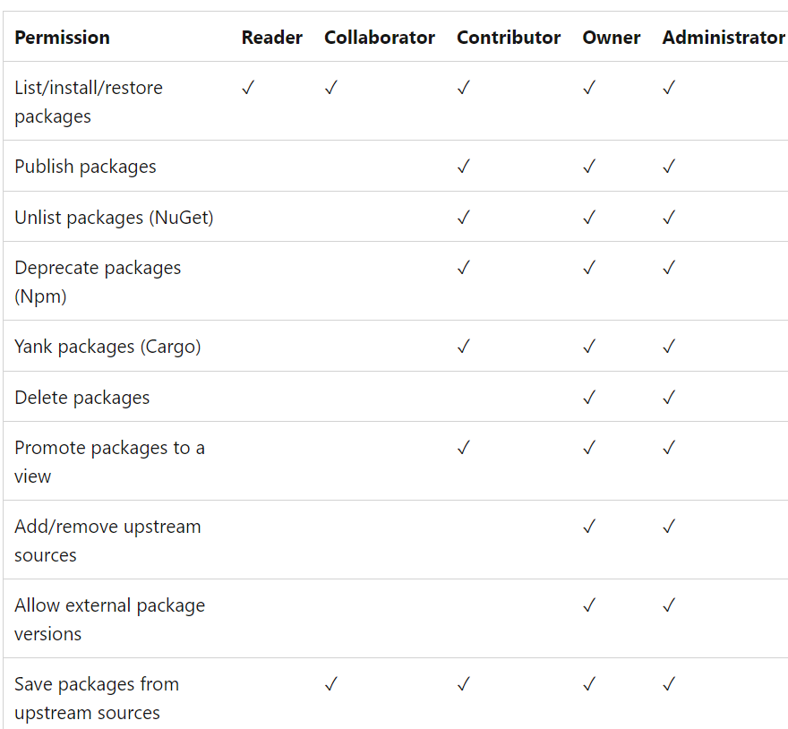
Question 9Skipped
To meet the developer's requirement of tracking diagnostics settings for troubleshooting event matching using the Azure DevOps Services REST API 6.0 Diagnostics API version 6.0, you should use which EventSubscriptionDiagnostics setting.
Choose the correct answer
deliveryResults
Correct answer
evaluationTracing
deliveryTracing
Overall explanation
In the Azure DevOps Services REST API 6.0 Service Hooks service, there are two specific Diagnostics operations: Get and Update.
For tracking event matching details defined by service hook publishers, you should utilize the "evaluation Tracing" diagnostics setting. This setting enables you to retrieve information related to the evaluation process when events are matched.
However, it's important to note that the "deliveryResults" diagnostics setting is not suitable for your purpose. This setting is primarily used to retain information about the results of delivering notifications, specifically for Service Hooks subscriptions.
Similarly, the "deliveryTracing" diagnostics setting is also not relevant for tracking event matching. It's intended for troubleshooting the delivery of notifications, rather than event matching.
Question 10Skipped
You manage a Azure Devops project - Project1. Project1 contains an Azure artifacts named feed1. feed1 does not contain any public upstream sources.

You need to connect feed1 to a public source of .NET packages.
To which upstream source should you connect in Azure Artifacts ?
Maven
npm
Correct answer
NuGet

Explanation
Connecting feed1 to NuGet as an upstream source is the correct choice for accessing public .NET packages in Azure Artifacts. NuGet is the package manager for .NET, and by connecting feed1 to NuGet, you can easily access and consume .NET packages from the public NuGet repository.
chocolatey
Overall explanation
https://learn.microsoft.com/en-us/azure/devops/artifacts/concepts/upstream-sources?view=azure-devops
Question 11Skipped
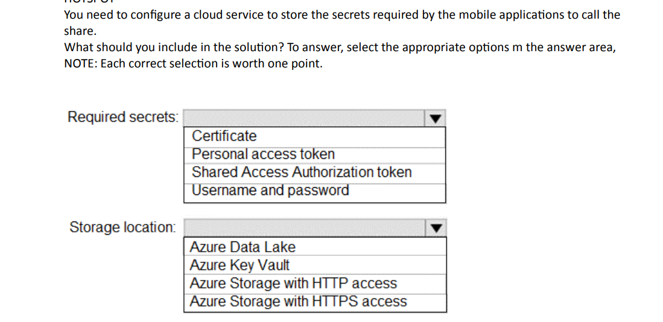
Required secrets: Personal Access token
Storage Location: Azure Storage with HTTP access
Required secrets: Personal Access token
Storage Location: Azure Storage with HTTPS access
Correct answer
Required secrets: Shared Access Authorization token
Storage Location: Azure Storage with HTTPS access
Overall explanation
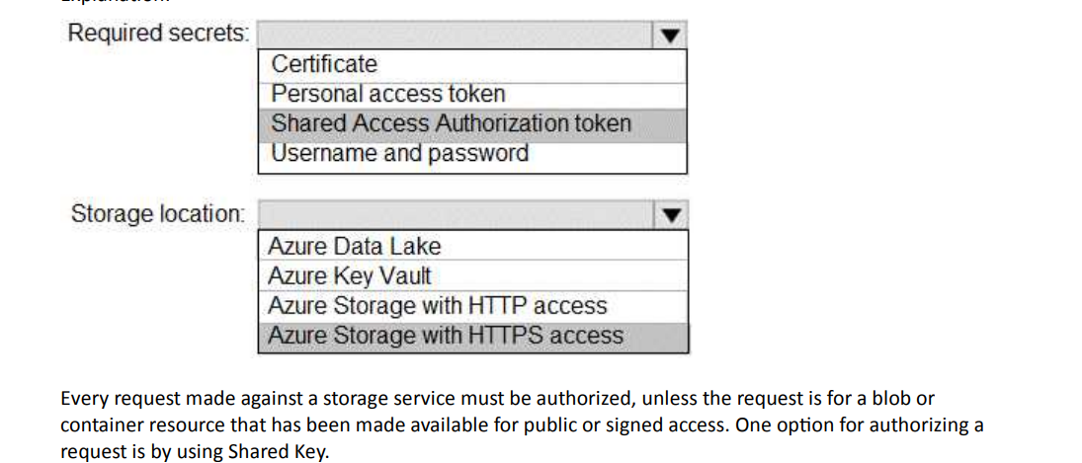
Question 12Skipped
You are developing the application using progressive exposure deployments (limit the impact on end users while gradually deploying and validating changes in production.)

Which two techniques you can use ?
Correct selection
Feature Flags
Blue/Green deployment
Correct selection
Deployment rings
Gradual deployment
Overall explanation
With deployment rings, you can gradually deploy and validate changes to your extension in production, while limiting the affect on your users.
It is not recommend deploying to all production environments at the same time, which exposes all users to the changes. A gradual rollout exposes users to the changes over time, validating the changes in production with fewer users.

With feature flags, a team can choose whether a given set of features is visible in the user experience and/or invoked within the functionality. New features can be built and deployed as part of the ordinary development process without having those features available for broad access.

https://learn.microsoft.com/en-us/azure/devops/migrate/phase-rollout-with-rings?view=azure-devops

https://learn.microsoft.com/en-us/devops/operate/progressive-experimentation-feature-flags
Question 13Skipped
Your company uses Git as the Source Code.
You need to undo the changes made by shared commit for one of the projects and ensure that the original commit is not deleted.
Which Git command should you use ?
git switch
Correct answer
git revert
git checkout
git reset
Overall explanation
https://stackoverflow.com/questions/58003030/what-is-the-git-restore-command-and-what-is-the-difference-between-git-restor
Question 14Skipped
Productivity for developers relies on the ability of tests to find real problems with the code under development or update in a timely and reliable fashion.
Which feature of Azure Devops Services provides different outcomes, such as pass or fail, even when there are no changes in the source code or execution environment
Test Impact Analysis (TIA)
Correct answer
Flaky testing
Parallel testing
UI testing
Overall explanation
https://learn.microsoft.com/en-us/azure/devops/pipelines/test/test-analytics?view=azure-devops
Question 15Skipped
A company has a project defined in Azure Devops for a new application. The application needs to be deployed onto various Windows Server 2016 virtual machines. A deployment strategy is in place which has the following requirements
– The virtual machines must always maintain a consistent configuration
– The administrative effort to deploy the virtual machines must be minimized
Which of the following solution would you use to deploy the virtual machine?
Azure Pipelines
Correct answer
ARM Templates
Azure Functions
Azure Logic Apps
Overall explanation
If you need to minimize the effort to deploy similar types of virtual machines, then the best way is to use Resource Manager templates
https://learn.microsoft.com/en-us/azure/azure-resource-manager/management/overview#template-deployment
Question 16Skipped
You need to write a KQL query to fetch about the page errors and number of users impacted. Which table would you use to run the query.
exceptions
Correct answer
requests
dependencies
Overall explanation
you can use requests table

requests | where success == 'False' | summarize sum(itemCount) by bin(timestamp, 5m) | render barchart

https://learn.microsoft.com/en-us/azure/azure-monitor/essentials/app-insights-metrics
Question 17Skipped
Which of the following choices is a Kubernetes package management?
Artifactory
Azure Artifacts
Correct answer
Helm
Overall explanation
Helm is a package manager for Kubernetes. It makes it easier to package, configure, and deploy applications and services.
Question 18Skipped
You manage a Azure Devops project - Project1. Project1 contains an Azure artifacts named feed1. feed1 does not contain any public upstream sources.

You need to connect feed1 to a public source of .NET packages.
To which upstream source should you connect in Azure Artifacts ?
npm
Correct answer
NuGet

Explanation
Connecting feed1 to the NuGet upstream source is the correct choice for accessing public .NET packages. NuGet is the package manager for .NET and is specifically designed for managing .NET packages, making it the appropriate choice for this scenario.
Maven
chocolatey
Overall explanation
https://learn.microsoft.com/en-us/azure/devops/artifacts/concepts/upstream-sources?view=azure-devops
Question 19Skipped
Which of the following choices is the most effective way to avoid direct updates from feature branches into main?
Branch Lock
Branch Security
Correct answer
Branch Policies.
Overall explanation
Policies are a great way to enforce your team's code quality and change-management standards.
Question 20Skipped
Black Duck can be used to make sure that all the open source libraries confirm to your company's licensing criteria.
Select `No adjustment required` if the above statement is accurate. If it is inaccurate, select the accurate option.
Correct answer
No adjustment required
CMAKE
Maven
Bamboo
Overall explanation
Secure and Manage Open Source Software Black Duck helps organizations identify and mitigate open source security, license compliance and code-quality risks across application and container portfolios. Black Duck Hub and its plugin for Team Foundation Server (TFS) allows you to automatically find and fix open source security vulnerabilities during the build process, so you can proactively manage risk. The integration allows you to receive alerts and fail builds when any Black Duck Hub policy violations are met.
Reference:
https://marketplace.visualstudio.com/items?itemName=black-duck-software.hub-tfs
Question 21Skipped
You manage a project in Azure DevOps Repos. The Development team requires that at least three team members (including the pull requester) review pull requests. All team members must approve the code changes on a pull request before it is merged with the master branch.
You need to create a new branch policy to meet this requirement.
Which three actions should you perform? Each correct answer presents part of the solution.
Correct selection
Enable the Allow requestors to approve their own changes option.
Correct selection
Enable the Require a minimum number of reviewers option.
Correct selection
Set the Minimum number of reviewers to three.
Set the Minimum number of reviewers to two.
Enable the Reset all code reviewer votes option when new changes are pushed.
Overall explanation
https://learn.microsoft.com/en-us/azure/devops/repos/git/branch-policies?view=azure-devops&tabs=browser
Question 22Skipped
Your team needs to deploy several Azure Resource Manager templates. These templates will reference secrets stored in the Azure Key vault service. You have to recommend the right solution for accessing the secrets in the key vault during the deployment of the Azure Resource Manager templates. You have to ensure the solution uses the principle of least privilege.

Which of the following would you use to restrict access to delete the key vault?
Correct answer
RBAC
Azure Key value access policy
A Personal Access Token
OAuth 2.0
Overall explanation
For control plane access to the key vault, you can use Role based access control

https://learn.microsoft.com/en-us/azure/key-vault/general/security-features
Question 23Skipped
Your company has setup an Azure DevOps organization and a project within the organization. Developers are currently working on application code within a particular repository.
https://dev.azure.com/wtw/project/_git/webapp

You need to ensure that notifications are sent to slack whenever pull requests are created.
Which of the following command would issue within Slack for this requirement?
/azrepos signin https://dev.azure.com/wtw/project/_git/webapp
/azrepos tag https://dev.azure.com/wtw/project/_git/webapp
/azrepos assign https://dev.azure.com/wtw/project/_git/webapp
Correct answer
/azrepos subscribe https://dev.azure.com/wtw/project/_git/webapp
Overall explanation
You should choose subscribe command.
/azrepos subscribe https://dev.azure.com/wtw/project/_git/webapp

Reference:
https://learn.microsoft.com/en-us/azure/devops/repos/integrations/repos-slack?view=azure-devops
Question 24Skipped
A company has several IT development departments. The departments are constantly working on new features.
You need to specify which branches should trigger a continuous integration pipeline when new code is pushed. The pipeline should run even if the branch does not have an open pull request.
Which action should you perform to accomplish this task?
Choose the correct answer
Create a release trigger and specify which branches should be processed.
Correct answer
Create a continuous integration (CI) trigger and specify which branches should be processed.
Create a scheduled trigger that contains only feature branches and set this trigger to run every hour.
Create a pull request (PR) trigger and specify which branches should be processed.
Overall explanation
You should create a continuous integration (CI) trigger and specify which branches should be processed. This allows you to specify which branch or branches trigger a pipeline run when new code is pushed.
You should not create a pull request (PR) trigger and specify which branches should be processed. This would allow a pipeline to run whenever a pull request is opened with one of the specified target branches, or when changes are pushed to such a pull request. This would not trigger a pipeline run from branches without a pull request open.
You should not create a scheduled trigger that contains only feature branches and set this trigger to run every hour. This would allow a pipeline to be triggered for specific branches based on a schedule. This would not trigger a pipeline when new code is pushed to a branch.
You should not create a release trigger and specify which branches should be processed. This would allow you to trigger a continuous deployment pipeline that deploys the application to production environments.
Question 25Skipped
Which of the following choices isn't a package type supported by Azure DevOps?
NPM
Python
Correct answer
PHP
Overall explanation
Azure Artifacts currently supports feeds that can store five different package types such as NuGet packages, NPM packages, Maven, Universal packages, and Python.
Question 26Skipped
You plan to provision a self-hosted Linux agent. Which authentication mechanism should you use to register the self-hosted agent?
Alternate credentials
certificate
Correct answer
personal access token (PAT)
SSH key
Overall explanation
PAT Supported only on Azure Pipelines and TFS 2017 and newer. After you choose PAT, paste the PAT token you created into the command prompt window. Use a personal access token (PAT) if your Azure DevOps Server or TFS instance and the agent machine are not in a trusted domain. PAT authentication is handled by your Azure DevOps Server or TFS instance instead of the domain controller.
Question 27Skipped
A team is using Azure Devops for Java based project. They need to use static code analysis tool for the java project ?
Which of the tools can be used along with Azure Devops for this purpose ?
Jenkins
Correct selection
PMD
Bamboo
Correct selection
FindBugs
Overall explanation
https://learn.microsoft.com/en-us/previous-versions/azure/devops/all/java/standalone-tools?view=tfs-2017&viewFallbackFrom=azure-devops
Question 28Skipped
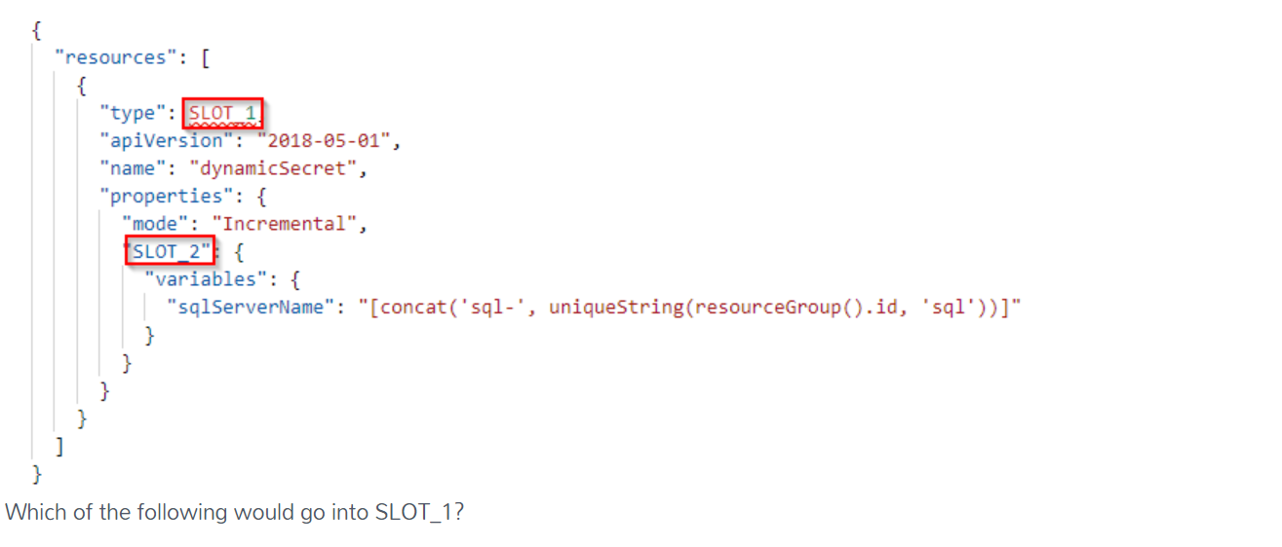
Microsoft.compute/virtualmachines
Resources/Azure.keyvault
Correct answer
Microsoft.Resources/deployments
Overall explanation
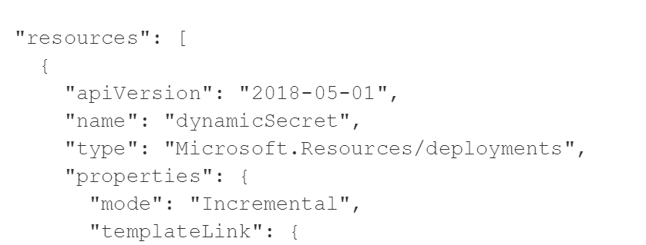

Question 29Skipped
A company is setting up Azure Artifacts. Several feeds are being created in Azure Artifacts. You need to set the permissions for the feed for the following groups
GroupA - This group should be able to list and install packages from the feed
GroupB – This group should be able to push packages to the feed
You need to ensure the least privileges are given to each group

Which of the following permission would you assign to GroupA?
Collaborator
Owner
Contributor
Correct answer
Reader
Overall explanation
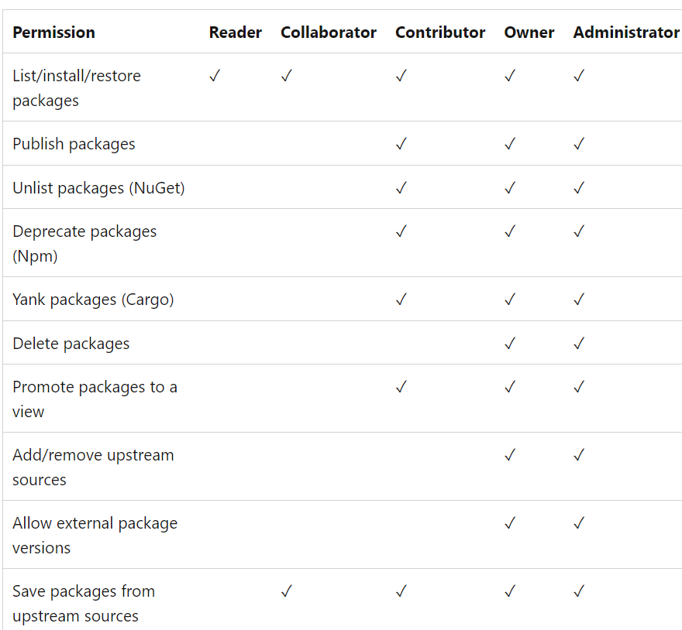
Question 30Skipped
Which Azure DevOps feature is used for tracking and visualizing work items, managing backlogs, and sprint planning?
Azure Artifacts
Azure Repos
Correct answer
Azure Boards
Azure Pipelines
Overall explanation
Azure Boards is a feature in Azure DevOps that provides tools for tracking and managing work items, such as user stories, bugs, and tasks. It is used for backlog management, sprint planning, and visualizing the progress of work items.

Question 31Skipped
You are monitoring the health and performance of an Azure web app by using Azure Application Insights. You need to ensure that an alert is sent when the web app has a sudden rise in performance issues and failures.
What should you use?
custom events
Application Insights Profiler
usage analysis
Correct answer
Smart Detection
Overall explanation
Smart Detection automatically warns you of potential performance problems and failure anomalies in your web application. It performs proactive analysis of the telemetry that your app sends to Application Insights. If there is a sudden rise in failure rates, or abnormal patterns in client or server performance, you get an alert.

Reference:
https://learn.microsoft.com/en-us/azure/azure-monitor/alerts/proactive-diagnostics
Question 32Skipped
You have an Azure subscription that contains multiple Azure services. You need to send an SMS alert when scheduled maintenance is planned for the Azure services. Which two actions should you perform? Each correct answer presents part of the solution.
Correct selection
Create and configure an action group
Correct selection
Create an Azure Service Health alert
Create and configure an Azure Monitor alert rule
Enable Microsoft Defender for cloud
Overall explanation
Creating planned maintenance alerts using Azure Service Health 1. Login into the Azure portal and select Service Health. 2. Select Health alerts followed by + Create service health alert from the top of the window on the right. 3. In the Edit Alert blade, give the alert a Name, Description, check the subscription is correct and choose a resource group. 4. The next step is to work through the Criteria section choosing which services, regions and types of event alerts should be monitored. For the purpose of this article all services and regions have been checked but only planned maintenance events. 5. Select or create an Action group. (An Action group is a group of actions to be taken, should an event be logged.) 6. Configure the actions to be taken. We are only configuring an email alert, so we first name the action, then chose Email/SMS/Push/Voice from the drop down list. Note: Azure Service Health can be used to view problems with Azure services that may impact any of your cloud services. Service Health monitors three types of health event: Service issues Azure services that are currently experiencing problems Planned maintenance Any known future maintenance that may affect the availability of your services Health advisories Changes in services, for example, deprecated features or exceeded quota usage

Question 33Skipped
Which of the following is a correct statement about a fork?
A fork is a branching strategy when working with centralized version control
Correct answer
A fork is a copy of a repository.
A fork is a branch for future development.

Overall explanation
A fork is a copy of a repository.
Question 34Skipped
You need to consider the underlined segment to establish whether it is accurate. When moving to Azure DevOps, JIRA must be replaced with the build pipelines Azure DevOps service. Select `No adjustment required` if the underlined segment is accurate. If the underlined segment is inaccurate, select the accurate option.
Correct answer
boards
repos
release pipelines
No adjustment required.
Overall explanation
https://learn.microsoft.com/en-us/azure/devops/boards/get-started/what-is-azure-boards?view=azure-devops Azure Boards is a standalone service within the Azure DevOps suite that helps teams plan, track, and discuss work across the entire software development process. It provides a flexible, customizable platform for managing work items, such as user stories, bugs, tasks, and issues, so you can track your work item's progress throughout the development lifecycle. Azure Boards supports agile methodologies, including Scrum and Kanban. It provides a range of features and integrations to help teams collaborate and stay organized with dashboards, reports, and notifications.
Question 35Skipped
Which chart widget should you select for the following requirement ?

Determine how much a work item takes from creation to completion.
Correct answer
Lead Time
Cycle Time
Deployment status
Sprint capacity
Overall explanation
https://learn.microsoft.com/en-us/azure/devops/report/dashboards/cycle-time-and-lead-time?view=azure-devops
Question 36Skipped
In order to maintain the desired state configuration of a group of Azure VMs without installing agents, which is necessary to comply with the organization's policies, which configuration management tool would you choose to use?
Terraform
Chef
Correct answer
Ansible
Puppet
Overall explanation
You can choose Ansible since it does not require any agent running on the target machine.

Chef and puppet are also configuration management tools but they require an agent to be installed on target machines.

You should not choose terraform since it is Infrastructure as Code (IaC) tool used to provision virtual machines and other resources.
Question 37Skipped
You intend to make use of Azure Artifacts to share packages that you wrote, tested, validated, and deployed. You want to use a solitary feed to release several builds of each package. You have to make sure that the release of packages that are in development is restricted. Which of the following actions should you take?
Correct answer
You should make use of views.

Explanation
Using views in Azure Artifacts allows you to control access to specific packages based on defined criteria. By creating views, you can restrict the release of packages that are still in development while allowing access to released packages. This is the correct action to take to achieve the desired restriction.
https://learn.microsoft.com/en-us/azure/devops/artifacts/concepts/views?view=azure-devops#release-packages-with-feed-views
You should make use of static code analysis.
You should make use of dynamic code analysis.
You should make use of upstream sources.
Question 38Skipped
Your team is planning on deploying an application to an Azure Kubernetes cluster. There is a requirement to ensure the cluster can interact with other Azure resources. Which of the following would you create for this purpose?
A Secret
SSH keys

Correct answer
A Service principal
Overall explanation
This can be done with the help of a service principal.

https://learn.microsoft.com/en-us/azure/aks/learn/quick-kubernetes-deploy-rm-template?tabs=azure-cli
Question 39Skipped
﻿You have a GitHub private repository for a library used by your organization. This repository is integrated with an Azure Boards project which is used to manage the project backlog. You adopt a pull request and commit guidelines to automatically generate release notes. Every two weeks you create a new git tag for this library following semantic versioning.
You need to define the best place to communicate with the library users regarding the changes in a specific version of the library.
Where should you store the release notes?
Pull requests description
Work item description
Correct answer
GitHub releases
Work item acceptance criteria
Overall explanation
You should store the release notes with GitHub releases. This makes it easy for the library users to see the changes in a specific version that is published with the git tags. In GitHub releases, alongside the release notes and the corresponding git tag, you can include links to binary files and source code packages.
You should not store the release notes with the work item acceptance criteria. The acceptance criteria field in a work item should describe what is expected in order for a work item to be considered as complete.
You should not store the release notes with the work item or pull requests description. You can use these fields to describe what a specific feature does and give more details about it. This is not the best place to store the release notes because a two-week release might include multiple features, compelling the library users to spend a lot of time to be able to understand what is new. Instead you can include a link to pull requests or work items in your release notes in order to allow the library users to understand the features in more detail.
Question 40Skipped
You have a multi-tier application that has an Azure Web Apps front end and an Azure SQL Database back end. You need to recommend a solution to capture and store telemetry data. The solution must meet the following requirements: Support using ad-hoc queries to identify baselines. Trigger alerts when metrics in the baseline are exceeded. Store application and database metrics in a central location.
What should you include in the recommendation ?
Azure Event Hubs
Azure SQL Database Intelligent Insights
Correct answer
Azure Log Analytics
Azure Application Insights
Overall explanation
Azure Platform as a Service (PaaS) resources, like Azure SQL and Web Sites (Web Apps), can emit performance metrics data natively to Log Analytics.

