Practice Test # 1 - Results

Question 1Skipped
What is the purpose of parameterizing a query?
To filter the list of countries with profit over a user-specified amount
Correct answer
To prompt the user to enter a parameter value and select its data type
To explicitly change the data type of a parameter in the query
To type the parameter as a number even if it's originally typed as text
Overall explanation
Parameterizing a query allows the user to enter a parameter value and select its data type, which can be especially useful with paginated reports in Power BI.
Domain
Data Analysis and Visualization
Question 2Skipped
What is the purpose of the DATATABLE function in Power BI?
Correct answer
To create calculated tables with data entered manually
To create anonymous tables without defining column names
To define data types for columns in a table
To list values in curly braces for use in M expressions
Overall explanation
The purpose of the DATATABLE function in Power BI is to create calculated tables with data entered manually.
Domain
Power BI
Question 3Skipped
What is the purpose of using the OPENROWSET function in SQL serverless pools?
To verify the connection to the Built-in compute
Correct answer
To query and display the top 10 rows of a dataset
To create an Azure Synapse Analytics resource
To speed up the start-up time of the Apache Spark pool
Overall explanation
The purpose of using the OPENROWSET function in SQL serverless pools is to query and display the top 10 rows of a dataset.
Domain
Azure Synapse Analytics
Question 4Skipped
What solution should you suggest to minimize the query size sent to the Azure SQL database when publishing dataset changes to the development, test, or production pipelines in order to address the issue reported by the database administrator regarding the increased number of queries from the Power BI service?
Activate the storage format for large datasets within the workspace.
Correct answer
Establish a dataset parameter to minimize the number of rows in the fact table for the development and test pipelines.
Coordinate with the authors of the deployment pipeline datasets to decrease the frequency of dataset republishing during development.
Disable the automatic refresh feature when publishing changes to the dataset in the Power BI service.
Overall explanation
To reduce the size of the queries sent to the Azure SQL database when dataset changes are published to development, test, or production pipelines, it is recommended to create a dataset parameter to reduce the fact table row count in the development and test pipelines. By implementing a dataset parameter, you can filter the data in the fact table based on specific criteria, such as a date range or a subset of rows. This reduces the amount of data that needs to be refreshed and queried, resulting in smaller and more efficient queries sent to the database. This approach helps optimize performance and minimize the impact on the Azure SQL database, especially when dealing with large datasets and tables with millions of rows.
Domain
Data Management
Question 5Skipped
What storage mode should be used to achieve optimal response time for each user group in a reporting solution with the following requirements: - External customer reports, which require support for 500 concurrent requests and access to approximately 7 GB of data stored in Azure Synapse Analytics. - Security team reports, which require local security rules applied at the database level to restrict access to 2 GB of data being reviewed.
Correct answer
Import data for external customers and use DirectQuery for the security team.
Use DirectQuery for external customers and import data for the security team.
Use DirectQuery for both external customers and the security team.
Import data for both external customers and the security team.
Overall explanation
The best storage mode for each group of users in this scenario is to use Import mode for the external customers and DirectQuery mode for the security team. Import mode is suitable for the external customers because it provides the best response time for large datasets like the 7 GB data stored in Azure Synapse Analytics. By importing the data into Power BI, the reports can be optimized for performance and handle the 500 concurrent requests efficiently. On the other hand, DirectQuery mode is ideal for the security team because it allows local security rules to be applied at the database level, ensuring restricted access to the 2 GB of data being reviewed. DirectQuery mode enables real-time access to the data source, ensuring that the security rules are enforced and providing the necessary level of control for the security team.
Domain
Data Management
Question 6Skipped
What is the purpose of Power Query in Power BI?
To identify data loading performance bottlenecks
To create and manage scalable Power BI dataflows
Correct answer
To combine data from different data sources
To write queries and functions for complex data sources
Overall explanation
Power Query is used to combine data from different data sources.
Domain
Data Analysis
Question 7Skipped
Overview - FinCorp, Ltd. is a firm that provides enhanced financial data to a diverse range of external clients. FinCorp has a primary office in Los Angeles and two branch offices in New York and Seattle. Current Environment - Data Infrastructure - FinCorp operates a 50-TB data warehouse on an instance of SQL Server on Azure Virtual Machines. This data warehouse feeds an Azure Synapse Analytics workspace accessed by external clients. Currently, all clients have access to all the data. FinCorp has one Power BI workspace named FinData, which contains a single dataset. This dataset includes global financial data and is used by 10 internal users and one external client. The dataset sources data from the data warehouse and the Synapse Analytics serverless SQL pool. Users often query the Synapse Analytics workspace using Transact-SQL. User Challenges - FinCorp has identified the following user issues: Some users report that Power BI report visuals take a long time to load when applying filters. Users report occasional query failures against the serverless SQL pool due to exceeding the size of tempdb. Users report outdated data in Power BI reports. Upon investigation, it was found that the Power BI model refresh process occasionally times out. Proposed Changes - FinCorp plans to implement the following changes: Integrate an external JSON data source accessible via the REST API into the existing Power BI dataset. Create a new dataset in the FinData workspace using data from the Synapse Analytics dedicated SQL pool. Provide each client with their own Power BI workspace for creating custom reports. Each workspace will use the new dataset in the FinData workspace. Implement subscription tiers for clients. Each subscription tier will provide access to specific rows of financial data. Deploy prebuilt datasets to Power BI to streamline the clients' query experience. Enable internal users to incorporate machine learning models loaded into the dedicated SQL pool. What two tools could be used to identify the cause of the slow report rendering? Each correct answer provides a complete solution. NOTE: Each correct selection is worth one point.
Synapse Studio
Correct selection
DAX Studio
Azure Data Studio
Correct selection
Performance analyzer in Power BI Desktop
Overall explanation
To identify the cause of slow rendering in Power BI reports, two possible tools can be used: DAX Studio and Performance Analyzer in Power BI Desktop. DAX Studio is an external tool that allows for in-depth analysis of DAX queries and performance optimization. It can be used to identify any inefficient or slow-performing DAX expressions or calculations that may be impacting report rendering. Performance Analyzer, on the other hand, is built into Power BI Desktop and provides a comprehensive view of the report's performance, including the time taken by each visual to render. It helps identify any bottlenecks or resource-intensive visuals that may be causing the slow rendering. By using both tools in combination, a complete solution can be achieved to diagnose and address the performance issues in Power BI reports.
Domain
Data Analysis
Question 8Skipped
You have a dataset named Dataset1 in Power Bi. Within Dataset1, there are currently 50 measures that utilize the same time intelligence logic. The objective is to reduce the number of measures while preserving the existing functionality. Solution: Create a hierarchy in Power BI Desktop. Does this solution achieve the desired outcome?
Yes
Correct answer
No
Overall explanation
Creating a hierarchy in Power BI Desktop does not directly address the goal of reducing the number of measures while maintaining the current functionality. A hierarchy is a way to organize and display data in a visual manner, but it does not eliminate or reduce the number of measures. To achieve the desired outcome, alternative solutions such as using calculated columns or measures, or reevaluating the necessity of certain measures, would need to be considered. Therefore, the answer is ""No.""
Domain
Cloud Computing
Question 9Skipped
Which function should be used in an Apache Spark notebook within Azure Synapse Analytics to examine statistics for a DataFrame that includes the column name, column type, number of distinct values, and presence of missing values?
displayHTML()
Correct answer
display(df, summary=true)
%%configure
display(df)
%%lsmagic
Overall explanation
To review statistics for a DataFrame in an Apache Spark notebook in Azure Synapse Analytics, the most appropriate function to use is ""display(df, summary=true)"". This function allows you to view the column name, column type, number of distinct values, and whether the column has missing values. By setting the ""summary"" parameter to true, you can obtain a summary of the statistics for the DataFrame, providing valuable insights into the data and facilitating data filtering and transformation tasks. The other options listed, such as ""displayHTML()"", ""%%configure"", ""display(df)"", and ""%%lsmagic"", are not specifically designed for reviewing statistics in a DataFrame.
Domain
Data Analysis
Question 10Skipped
What is the goal of DevOps for data analysts?
Correct answer
To increase the quality of the software product
To automate the software development process
To track code changes in a version control system
To enable continuous integration and continuous delivery
Overall explanation
The goal of DevOps for data analysts is to increase the quality of the data product.
Domain
DevOps
Question 11Skipped
What is the purpose of creating an Azure Spark pool in Azure Synapse Analytics?
Correct answer
To query and analyze data
To create a resource in Azure portal
To upload and store data in Azure Data Lake Storage Gen2
To configure the Azure Synapse Analytics resource
Overall explanation
The purpose of creating an Azure Spark pool in Azure Synapse Analytics is to query and analyze data.
Domain
Cloud Computing
Question 12Skipped
What is the purpose of query folding in Power Query?
To translate transformations into the native language of the data source
To retrieve only the columns needed from the data source
To edit the native query
Correct answer
To improve performance by performing transformations in the source
Overall explanation
Query folding in Power Query allows transformations to be performed in the source instead of after loading the whole table, which improves performance.
Domain
Data Analysis
Question 13Skipped
What are two potential reasons why the certification setting for a Power BI dataset may be inaccessible? Each correct response provides a comprehensive solution. Please note that each correct choice is worth one point.
The workspace operates under shared capacity.
Correct selection
Your account lacks the necessary permissions.
Correct selection
Dataset certification is currently disabled for the Power BI tenant.
The dataset's sensitivity level is designated as Highly Confidential.
The dataset lacks Row-level security (RLS).
Overall explanation
The unavailability of the certification setting for a Power BI dataset can be caused by two possible reasons. First, you may have insufficient permissions to configure the certification. This means that you do not have the necessary rights or roles to perform this action. Second, the dataset certification feature may be disabled for the Power BI tenant. This could be a tenant-wide policy or restriction that prevents the use of dataset certification. Both of these causes can result in the unavailability of the certification setting and should be addressed accordingly to enable the desired configuration.
Domain
Cloud Computing
Question 14Skipped
What licensing options should be recommended to minimize costs for a company migrating its current custom-built reporting solution to Power BI, considering the following scenarios: - 40 reports to be embedded in external websites, with the websites controlling their own security, and 50 monthly users consuming the reports. - 45 users requiring access to the workspaces and apps in the Power BI Admin portal, with 10 of them needing to publish and consume datasets larger than 1 GB. - 10 developers needing Text Analytics transformations and paginated reports for datasets, and an additional 15 users consuming the reports. Please select two Power BI license options that should be included in the recommendation.
70 Premium per user
Correct selection
one Premium
70 Pro
one Embedded
Correct selection
35 Pro
35 Premium per user
Overall explanation
To meet the requirements of the company's migration to Power BI while minimizing costs, the recommended licensing solution should include one Premium license and 35 Pro licenses. The Premium license is necessary to support the embedding of 40 reports in external websites, as well as to provide support for Text Analytics transformations and paginated reports for the ten developers. The 35 Pro licenses are needed for the 45 users who require access to the workspaces and apps in the Power BI Admin portal, as well as for the additional 15 users who will consume the reports. This combination of licenses ensures that all necessary features and capabilities are available to the users while keeping costs at a minimum.
Domain
Cloud Computing
Question 15Skipped
What is the purpose of installing a gateway in personal mode in Power BI?
To share data sources with others
Correct answer
To schedule a refresh in Power BI
To connect to on-premises data
To install R and Python scripts as data sources
Overall explanation
Installing a gateway in personal mode allows you to schedule a refresh in Power BI.
Domain
Data Integration
Question 16Skipped
What observations can you make based on the results obtained from the recording of the Performance Analyzer in Power BI Desktop, after refreshing the visuals on a report page that contains an imported data model?
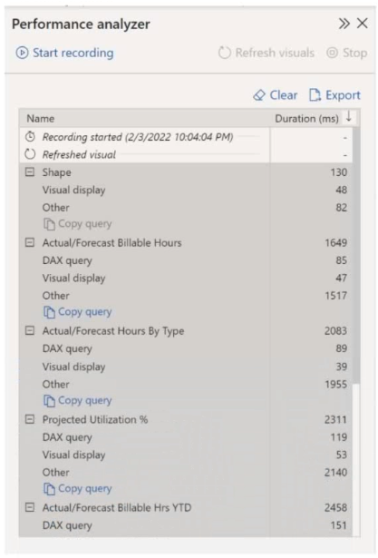

Correct answer
When all the visuals update at the same time, the visuals spend the majority of the time waiting for other processes to complete.
The Actual/Forecast Billable Hours Year-to-Date visual presents the largest amount of data.
DAX queries that are not optimized result in slow page loading.
The Actual/Forecast Hours by Type visual experiences a significant delay in rendering on the report page when the data is cross-filtered.
Overall explanation
From the results shown in the Performance Analyzer, it can be identified that when all the visuals on the report page are refreshed simultaneously, the visuals spend most of the time waiting on other processes to finish. This indicates that there may be dependencies or bottlenecks in the data model or other processes that are causing delays in the visual refresh. By identifying this issue, further investigation can be done to optimize the performance and improve the overall user experience.
Domain
Data Analysis
Question 17Skipped
What is the purpose of LOOKUPVALUE function in DAX?
To create physical relationships between tables
Correct answer
To retrieve values from another table based on one or more conditions
To insert values from one table into another table
To calculate the target excluding tax
Overall explanation
The purpose of the LOOKUPVALUE function in DAX is to retrieve values from another table based on one or more conditions.
Domain
Data Analysis Expressions (DAX)
Question 18Skipped
What function can be used in Power Query to keep calling an API until there is no data returned?
Correct answer
List.Generate
fCallApi
List.Select
List.Combine
Overall explanation
The List.Generate function in Power Query can be used to keep calling an API until there is no data returned.
Domain
Data Analysis
Question 19Skipped
What components should be included in the solution to publish five Power BI reports containing R script data sources and R visuals to the Power BI service and enable a daily dataset refresh?
Power BI Embedded capacity
a workspace that links to an Azure Data Lake Storage Gen2 account
Correct answer
an on-premises data gateway (personal mode)
an on-premises data gateway (standard mode)
Overall explanation
To successfully publish the Power BI reports containing R script data sources and R visuals and configure a daily refresh of datasets, you need to include an on-premises data gateway (personal mode) in the solution. This is because R scripts require an on-premises data gateway to connect to the data sources and perform the necessary computations. By installing the on-premises data gateway (personal mode) on the computer containing the workbook and R, you enable scheduled refresh of the R visuals or dataset. This ensures that the data in the reports is up to date and reflects any changes in the underlying data sources.
Domain
Data Management
Question 20Skipped
What can DAX variables store?
Scalar values only
Tables only
Correct answer
Both scalar values and tables
Neither scalar values nor tables
Overall explanation
DAX variables can store both scalar values and tables.
Domain
Data Analysis Expressions (DAX)
Question 21Skipped
What is the purpose of the SUMMARIZE function in Power BI?
Correct answer
To group a table by one or more columns
To add new columns to a table
To calculate the sum of a column in a table
To filter rows in a table based on certain conditions
Overall explanation
The purpose of the SUMMARIZE function in Power BI is to group a table by one or more columns.
Domain
Power BI
Question 22Skipped
What type of chart will be generated by the Python code in an Apache Spark notebook?
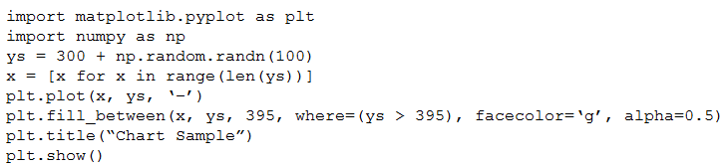

a stacked bar chart
Correct answer
an area chart
a bar chart
a pie chart
Overall explanation
The given Python code will produce an area chart. This can be determined by examining the function used in the code, which is `fill_between()`. The `fill_between()` function is commonly used to create area charts in Python, as it fills the area between two curves or lines. Additionally, the provided comment mentions that the `fill_between()` function is the key, and provides a link to a resource that explains how to create area plots using this function. Therefore, the correct answer is an area chart.
Domain
Data Visualization
Question 23Skipped
What are the three necessary steps to catalog an Azure Synapse Analytics serverless SQL pool using Azure Purview? Each correct answer contributes to the solution.
Establish an Azure Active Directory (Azure AD) managed identity.
Correct selection
Grant the Azure Purview managed service identity (MSI) associated with the Synapse Analytics workspace the Storage Blob Data Reader role for the corresponding storage account.
Correct selection
Assign the Reader role to the Azure Purview managed service identity (MSI) for the Synapse Analytics workspace.
Assign the Owner role to the Azure Purview managed service identity (MSI) for the Azure Purview resource group.
Correct selection
Register a data source.
Overall explanation
To catalog an Azure Synapse Analytics serverless SQL pool using Azure Purview, three actions need to be performed. First, the Storage Blob Data Reader role should be assigned to the Azure Purview managed service identity (MSI) for the storage account associated with the Synapse Analytics workspace. This allows the MSI to access the necessary data in the storage account. Second, the Reader role should be assigned to the Azure Purview MSI for the Synapse Analytics workspace. This grants the MSI the necessary permissions to read metadata from the Synapse Analytics workspace. Finally, a data source should be registered in Azure Purview, which enables the cataloging and discovery of the serverless SQL pool resources. By completing these actions, the Azure Purview integration with the serverless SQL pool is properly configured, ensuring effective cataloging and metadata management.
Domain
Azure Purview Integration
Question 24Skipped
What is the benefit of pushing transformations as close to the data source as possible?
To decrease data refresh times
Correct answer
To improve query performance
To simplify the data model
To enable incremental refresh
Overall explanation
Pushing transformations as close to the data source as possible improves query performance because data sources may perform data operations more efficiently than Power Query.
Domain
Data Modeling and Query Optimization
Question 25Skipped
What is the purpose of integrating Power BI with other cloud services?
To connect with on-premises IT systems
To gain maturity as an organization
Correct answer
To seamlessly integrate with core data analytics products
To identify requirements for a solution
Overall explanation
Integrating Power BI with other cloud services allows for seamless integration with core data analytics products like Azure Data Lake Storage Gen2 or Azure Synapse Analytics.
Domain
Data Analytics
Question 26Skipped
What can you do in the Capacity Usage Report section of the admin portal?
Correct answer
View the report to track usage, identify patterns, and make capacity management decisions
Get notified when you're about to exceed the available capacity
Specify the people who can add or remove workspaces in this capacity
Set various limits and options for the capacity, such as the query memory limit, query timeout, and XMLA endpoint availability
Overall explanation
In the Capacity Usage Report section of the admin portal, you can view the report to track usage, identify patterns, and make capacity management decisions.
Domain
Power BI Capacity Management
Question 27Skipped
Is using grouping sets in a query written in DAX Studio from Power BI to reduce the number of measures while preserving the existing functionality a suitable solution for the given scenario involving a Power BI dataset named Dataset1 with 50 measures that employ the same time intelligence logic?
Yes
Correct answer
No
Overall explanation
Writing a query using grouping sets in DAX Studio does not meet the goal of reducing the number of measures while maintaining the current functionality. Grouping sets are used for aggregating data and creating subtotals and grand totals, but they do not eliminate the need for individual measures. In this scenario, an alternative approach such as creating reusable calculated tables or measures, or using variables in DAX expressions, would be more appropriate for reducing the number of measures while preserving the desired functionality. Therefore, the correct answer is ""No.""
Domain
Cloud Computing
Question 28Skipped
What is the purpose of using a custom report theme in Power BI?
Correct answer
To apply formatting consistently for all new visuals and pages
To speed up the report creation process
To comply with brand guidelines
To customize the default theme provided by Power BI
Overall explanation
Using a custom report theme allows you to apply formatting consistently for all new visuals and pages, saving time and ensuring consistent branding.
Domain
Data Visualization
Question 29Skipped
What is the purpose of NATURALLEFTOUTERJOIN function?
To perform an inner join between two tables
Correct answer
To perform a left outer join between two tables
To combine all rows from the first table with extra columns from the second table
To filter rows based on common column names
Overall explanation
The purpose of NATURALLEFTOUTERJOIN function is to perform a left outer join between two tables.
Domain
Database Management
Question 30Skipped
What is the purpose of the CROSSJOIN function in Power BI?
Correct answer
To create a Cartesian product between two or more tables
To summarize data based on specific criteria
To generate all possible combinations of rows in a table
To rename columns in a table
Overall explanation
The CROSSJOIN function allows you to create a Cartesian product between two or more tables, generating all possible combinations of rows.
Domain
Power BI
Question 31Skipped
What solution should you suggest to minimize the query size sent to the Azure SQL database when publishing dataset changes to the development, test, or production pipelines in order to address the issue of increased query volume reported by the database administrator in the context of a deployment pipeline for a Power BI workspace containing two datasets using import storage mode?
Ask the deployment pipeline dataset authors to decrease the quantity of republished datasets during the development phase.
Remove the fact table from the dataset.
Correct answer
Set up the dataset to utilize a composite model with a DirectQuery connection to the fact table.
Lower the Max Intermediate Row Set Count setting in the Power Bi Admin portal's Capacity settings.
Overall explanation
To reduce the size of queries sent to the Azure SQL database when dataset changes are published to development, test, or production, it is recommended to configure the dataset to use a composite model with a DirectQuery connection to the fact table. By using a composite model, the dataset can combine both import and DirectQuery storage modes, allowing for more efficient querying. In this case, the fact table, which is larger than 1 GB and contains over 500 million rows, can be connected via DirectQuery to avoid importing the entire dataset during refreshes. This approach reduces the size of the queries sent to the database, improving performance and reducing resource consumption.
Domain
Data Management
Question 32Skipped
What action should you take to enable users to modify the visual type in a Power BI report without impacting the view for other users?
Create a new perspective using Tabular Editor.
Choose the modern visual header with updated styling options from the Visual options in Report settings.
Correct answer
Select Personalize visuals from the Report settings.
Enable Focus mode from the Bookmarks pane, and then click Add.
Overall explanation
To provide users with the ability to change the visual type without affecting the view for other users in a Power BI report, the correct option is to select ""Personalize visuals"" from the Report settings. This feature allows users to customize the visualizations according to their preferences without impacting the shared view for other users. By enabling this option, users can modify the visual type, apply filters, and make other adjustments to suit their individual needs, while maintaining the integrity of the report for other viewers. This ensures a personalized experience without compromising the overall consistency and accuracy of the data presentation.
Domain
Data Visualization
Question 33Skipped
What is the purpose of Apache Livy in Azure Spark pools?
To provide auto-scaling capabilities
To preload Anaconda libraries
To coordinate the work of a Spark application
Correct answer
To submit Spark jobs programmatically
Overall explanation
Apache Livy is a REST API for Apache Spark that is included in Azure Spark pools. It can be used to submit Spark jobs to the cluster programmatically.
Domain
Big Data Processing
Question 34Skipped
What are the limitations of Python visuals in Power BI?
They can only plot up to 150,000 rows
The timeout for plotting is 5 minutes
They can only plot to the default device
Correct answer
They cannot be used to filter other visuals
Overall explanation
Python visuals in Power BI have the limitation that they cannot be used to filter other visuals.
Domain
Data Visualization
Question 35Skipped
How can you activate an inactive relationship between two tables in DAX?
Correct answer
By using the USERELATIONSHIP function
By changing the order of the columns used as parameters
By adding a blank row to the Date table
By aggregating values in the Sale table
Overall explanation
To activate an inactive relationship between two tables in DAX, you can use the USERELATIONSHIP function.
Domain
Data Analysis Expressions (DAX)
Question 36Skipped
What is the purpose of using query options in the Web.Contents function?
To ensure the function works in Power BI Desktop
To construct a URL with parameter values
To convert the API response into JSON
Correct answer
To refresh the dataset in the Power BI service
Overall explanation
Using query options in the Web.Contents function allows the function to refresh the dataset in the Power BI service.
Domain
Data Analysis
Question 37Skipped
What is the purpose of DirectQuery connectivity mode in Power BI?
To cache data in Power BI for faster performance
To create a copy of the data that is kept static until dataset refresh
Correct answer
To query the original data source every time you interact with Power BI visuals
To import data from files and folders into Power BI
Overall explanation
DirectQuery connectivity mode allows you to query the original data source every time you interact with Power BI visuals, without caching the data in Power BI.
Domain
Data Modeling in Power BI
Question 38Skipped
What method should be called on the DataFrame in order to display the data distribution statistics in a tabular format when using a Python notebook in an Apache Spark pool within Azure Synapse Analytics?
Correct answer
summary
cov
sample
rollup
Overall explanation
To present the data distribution statistics from a DataFrame in a tabular view in an Apache Spark pool in Azure Synapse Analytics, the appropriate method to invoke on the DataFrame is ""summary"". The summary method provides a concise summary of the DataFrame, including count, mean, standard deviation, minimum, and maximum values for each column. This allows for a quick and comprehensive understanding of the data distribution without the need for complex calculations or manual aggregation.
Domain
Data Analysis
Question 39Skipped
What method should be called on the DataFrame in order to display the data distribution statistics in a tabular format when using a Python notebook in an Apache Spark pool within Azure Synapse Analytics?
freqItems
sample
corr
Correct answer
describe
Overall explanation
To present the data distribution statistics from a DataFrame in a tabular view in an Apache Spark pool in Azure Synapse Analytics, the correct method to invoke on the DataFrame is ""describe"". The describe method provides summary statistics such as count, mean, standard deviation, minimum, and maximum values for each column in the DataFrame. This allows for a comprehensive understanding of the data distribution and helps in making data-driven decisions. The other options, freqItems, sample, and corr, do not provide the same level of detailed statistics as the describe method.
Domain
Data Analysis
Question 40Skipped
What are the two settings that need to be configured in the Customize theme window to modify the default colors of the visuals in a Power BI report, in order to enhance accessibility for users with color vision deficiency?
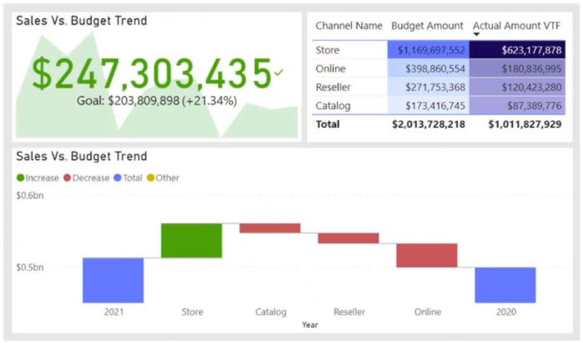

Theme colors
Correct selection
Divergent colors
Correct selection
Sentiment colors
First-level elements colors
Overall explanation
To make the Power BI report more accessible to users with color vision deficiency, you should configure two settings in the Customize theme window: Divergent colors and Sentiment colors. Divergent colors are used in conditional formatting to show where a data point falls in a range, and Sentiment colors are used in key performance indicator (KPI) visuals and waterfall charts to indicate positive, negative, or neutral results. By customizing these colors, you can ensure that users with color vision deficiency can still interpret and understand the visualizations in the report effectively.
Domain
Data Visualization
Question 41Skipped
What action should be taken to ensure that end users are able to view and utilize a limited set of 25 specific fields for customizing visuals in a Power BI dataset that currently only displays the necessary fields for report development?
Generate a new role using Tabular Editor.
Set up object-level security (OLS).
Correct answer
Establish a new perspective using Tabular Editor.
Conceal all fields within the dataset.
Overall explanation
To ensure that end users see only the 25 specific fields they can use to personalize visuals in the Power BI dataset, the most appropriate action is to create a new perspective using Tabular Editor. Perspectives allow you to define a subset of fields from the dataset that are visible to end users, providing a focused and simplified view for their analysis. This approach ensures that only the necessary fields are exposed, reducing complexity and improving user experience. Other options, such as creating a new role or configuring object-level security, may provide more granular control but are not specifically designed for limiting the visibility of fields in this scenario. Hiding all the fields in the dataset would prevent users from accessing any data, which is not the desired outcome.
Domain
Data Management
Question 42Skipped
the exhibit displays the Power BI data model.
Users have reported that the reports take a significant amount of time to load when generated from the data model. You need to propose a solution to decrease the load times of the reports. Is it recommended to denormalize the data model to achieve this objective?
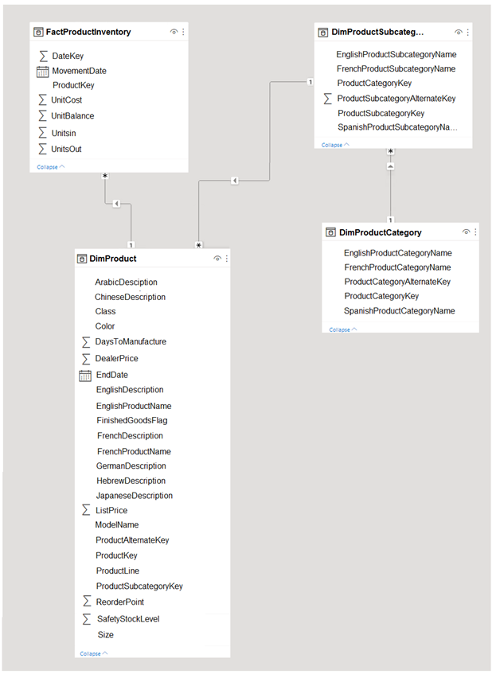

Correct answer
Yes
No
Overall explanation
To reduce the load times of the reports, it is recommended to denormalize the data model. Denormalization involves combining tables and eliminating redundant data, which can improve query performance by reducing the number of joins and simplifying the data retrieval process. By denormalizing the data model, the reports can be built more efficiently, resulting in faster load times. Therefore, the solution of denormalizing the data model meets the goal of reducing the load times of the reports.
Domain
Database Management
Question 43Skipped
What is the recommended method for managing access to a deployment pipeline in Power BI?
Grant access to individual users
Correct answer
Use security groups
Manage access separately from workspace access
Assign workspaces to stages
Overall explanation
Microsoft recommends using security groups to manage pipeline and workspace access instead of adding specific users.
Domain
Power BI
Question 44Skipped
What is the purpose of increasing the skip parameter value when calling the openFDA API?
To decrease the number of records returned by the API
Correct answer
To ensure that all records are retrieved from the API
To speed up the API response time
To limit the total number of API calls required
Overall explanation
Increasing the skip parameter value allows for retrieving all records from the API by iterating over multiple calls, ensuring that all records are retrieved.
Domain
API Integration
Question 45Skipped
How can users personalize visuals in Power BI?
Correct answer
By enabling the feature at the report level
By saving personal bookmarks
By toggling the Personalize visual option
By going to the page format settings
Overall explanation
Users can personalize visuals in Power BI by enabling the feature at the report level.
Domain
Data Visualization
Question 46Skipped
What type of authentication should be used when using Power BI to retrieve data from an API that requires passing an API key in the request headers?
organizational account
Correct answer
Basic
Web API
Anonymous
Overall explanation
To ingest data from an API that requires an API key to be passed in the headers of the request, the appropriate type of authentication to use is Basic. Basic authentication allows you to include the API key in the request headers, providing the necessary credentials to access the API. This method is commonly used when interacting with APIs that require authentication through a simple username and password or API key. Other authentication types such as organizational account, Web API, and Anonymous are not suitable for passing the required API key in the headers.
Domain
API Integration
Question 47Skipped
What is one of the skills covered in the context of industrializing a data analytics platform?
Performing impact analysis of downstream dependencies
Creating reusable assets
Implementing and managing deployment pipelines
Correct answer
Committing code and artifacts to a source control repository
Overall explanation
One of the skills covered in the context of industrializing a data analytics platform is committing code and artifacts to a source control repository in Azure Synapse Analytics.
Domain
Data Analytics
Question 48Skipped
What action should you take to enhance the accessibility of a line chart that visualizes and compares the sales data from the past six months for two departments?
Correct answer
Set up a distinctive marker for each series.
Substitute lengthy text with abbreviations and acronyms.
Transfer crucial information to a tooltip.
Configure a separate color for each series.
Overall explanation
To increase the accessibility of the line chart and ensure clear distinction between the two departments' sales data, the best option is to configure a unique marker for each series. While options A and D may both provide visual differentiation, using distinct colors alone may still pose challenges for color-blind individuals. By assigning unique markers to each series, regardless of color, the chart becomes more accessible to a wider range of users. This approach ensures that individuals with color vision deficiencies can still differentiate between the two departments' data points, promoting inclusivity and usability.
Domain
Data Visualization
Question 49Skipped
What is the purpose of the BLANK function in DAX?
To convert numeric values to text
To check if an expression is blank
Correct answer
To generate a blank value
To perform implicit type conversions
Overall explanation
The BLANK function in DAX is used to generate a blank value.
Domain
Data Modeling
Question 50Skipped
What are the recommended actions to decrease the load time of a sales report on powerbi.com while maintaining the displayed data and considering the given characteristics of the report? (Select two.)
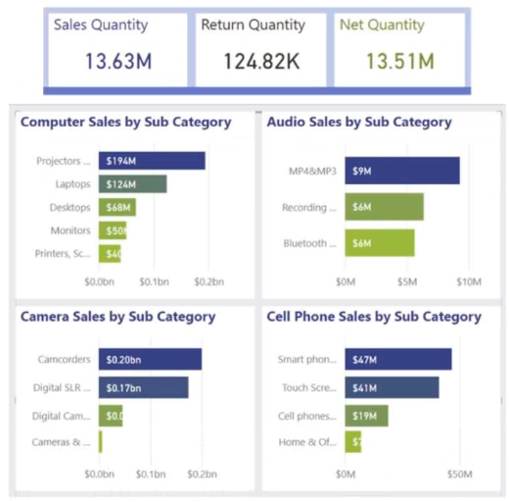

Modify the report theme to a monochromatic style.
Correct selection
Swap out the single-value cards for a multi-row card format.
Correct selection
Exchange the product category charts for a bar chart that displays sales data and includes a hierarchical structure of Category and Sub Category on the axis.
Replace the filters on the Filters pane with visual slicers directly on the report page.
Overall explanation
To reduce the load time of the sales report without affecting the data displayed, two actions should be performed. First, replacing the single-value cards with a multi-row card is recommended. Single-value cards can take up a significant amount of space on the report page and can slow down the rendering process. By using a multi-row card, multiple values can be displayed in a more compact manner, improving performance. Second, replacing the product category charts with a bar chart for sales and a hierarchy of Category and Sub Category on the axis is advised. Product category charts can be visually complex and may require more processing power to render. By using a bar chart with a hierarchy, the report can display the same information in a simpler and more efficient manner. These two actions help optimize the report's performance without compromising the data presented.
Domain
Data Visualization
Question 51Skipped
What is the purpose of Time Intelligence functions in DAX?
To calculate semi-additive measures
Correct answer
To handle calculations that span over predefined periods of time
To filter data based on custom date intervals
To calculate opening and closing balances
Overall explanation
Time Intelligence functions in DAX are used to handle calculations that span over predefined periods of time.
Domain
Data Analysis Expressions (DAX)
Question 52Skipped
What are the possible reasons why a workspace may not appear in the list of available workspaces to assign?
Correct answer
The user is not a workspace admin
The workspace is in Premium capacity
The workspace is already assigned in another deployment pipeline
The workspace is a template app workspace
Overall explanation
One of the possible reasons why a workspace may not appear in the list of available workspaces to assign is if the user is not a workspace admin.
Domain
Azure DevOps
Question 53Skipped
What is the purpose of the RangeStart and RangeEnd parameters in filtering based on dates?
To incrementally refresh the latest sales records
To convert the parameter values to the required data type
Correct answer
To filter the table based on the converted values
To allocate edge values to different partitions
Overall explanation
The RangeStart and RangeEnd parameters are used to filter the table based on the converted values, allowing for the filtering of dates in the table.
Domain
Data Analysis
Question 54Skipped
What can be done after selecting the items to import from an XML file in Power Query Editor?
Correct answer
Apply transformations to the data
Specify file encoding
Load the data to the data model
Connect to the XML file
Overall explanation
After selecting the items to import from an XML file in Power Query Editor, you can apply transformations to the data.
Domain
Data Analysis and Visualization
Question 55Skipped
What is the purpose of the Power BI API?
Correct answer
To extract activity events programmatically
To generate usage metrics reports
To monitor and audit enterprise solutions
To query the event log using PowerShell cmdlets
Overall explanation
The Power BI API allows you to programmatically extract activity events, which can then be stored in a monitoring database and used for custom alerting and monitoring.
Domain
Cloud Services
Question 56Skipped
What components should be included in the DAX expression to filter the dataset based on the current users when creating a security role named User Security for a dataset that contains a table called UserPermissions with the provided data?
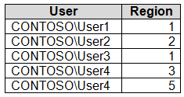

[UserPermissions] = USERPRINCIPALNAME()
[User] = USERPRINCIPALNAME()
[User] = USEROBJECTID()
[UserPermissions] = USERNAME()
Correct answer
[User] = USERNAME()
Overall explanation
To filter the dataset based on the current users, the DAX expression should include [User] = USERNAME(). This expression compares the value in the [User] column of the dataset with the current username. By using the USERNAME() function, the expression retrieves the username of the current user. Therefore, only the rows where the [User] column matches the current username will be included in the filtered dataset. This ensures that each user can only access the data that is relevant to them based on their username.
Domain
Data Management
Question 57Skipped
What are the requirements for connecting your own storage to the Power BI service?
Correct answer
Having the Owner, Storage Blob Data Owner, and Storage Blob Data Reader roles at the storage account level
Enabling Hierarchical namespace in the storage account
Being in the same Azure Active Directory and region as the Power BI service
Setting the minimum TLS version of the storage account to Version 1.2
Overall explanation
The requirements for connecting your own storage to the Power BI service include having the Owner, Storage Blob Data Owner, and Storage Blob Data Reader roles at the storage account level.
Domain
Cloud Services
Question 58Skipped
What is the default data store in Azure Synapse Analytics?
Correct answer
Azure Data Lake Storage Gen2
Microsoft Purview
Power BI
Apache Spark
Overall explanation
The default data store in Azure Synapse Analytics is the Azure Data Lake Storage Gen2.
Domain
Cloud Computing
Question 59Skipped
What is the primary purpose of the display() function in a notebook?
To create basic visualizations of data
To explore data in a raw fashion
Correct answer
To access a range of visualizations
To execute Python code in a notebook
Overall explanation
The primary purpose of the display() function is to access a range of visualizations in a notebook.
Domain
Data Visualization
Question 60Skipped
Which Python libraries should be utilized to gain access to the visual libraries when using PySpark in Azure Synapse Analytics and Apache Spark notebooks for native visual exploration?
Seaborn and TensorFlow
Seaborn only
Correct answer
Matplotlib and Seaborn
Matplotlib only
Matplotlib and TensorFlow
TensorFlow only
Overall explanation
To gain access to the visual libraries in Azure Synapse Analytics and Apache Spark notebooks using PySpark, the recommended Python libraries are Matplotlib and Seaborn. Matplotlib is a widely used plotting library that provides a flexible and comprehensive set of visualizations. Seaborn, on the other hand, is a higher-level library built on top of Matplotlib, offering additional statistical graphics and improved aesthetics. Together, these libraries provide a powerful toolkit for creating native visuals in PySpark, allowing for effective data exploration and analysis.
Domain
Data Science

