Practice Test # 3 - Results

Question 1Skipped
What is the purpose of creating the RangeStart and RangeEnd parameters in Power BI Desktop?
To filter dates in the data
Correct answer
To configure incremental refresh
To override parameter values in Power BI service
To create reserved and case-sensitive parameter names
Overall explanation
The purpose of creating the RangeStart and RangeEnd parameters is to configure incremental refresh in Power BI Desktop.
Domain
Data Analysis
Question 2Skipped
The exhibit displays the Power BI data model.
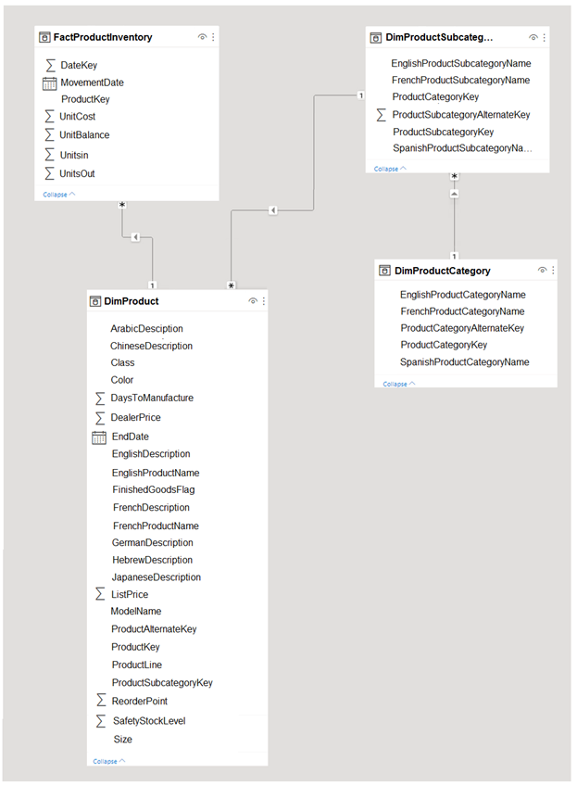
Users have reported that the reports take a significant amount of time to load when built from the data model. You need to propose a solution to decrease the report load times. Is it recommended to create a perspective that includes the commonly used fields to achieve this goal?
Yes
Correct answer
No
Overall explanation
Creating a perspective that contains commonly used fields does not meet the goal of reducing the load times of the reports. Perspectives in Power BI are used to simplify the view of a dataset by selecting specific fields and hiding others. While this can improve the user experience by reducing clutter and focusing on relevant information, it does not directly impact the performance or load times of the reports. To address the issue of slow loading, other measures such as optimizing data models, aggregating data, or using direct query mode may be more effective.
Domain
Cloud Computing
Question 3Skipped
What steps should you take to enable users to switch between viewing a Power BI report as a line chart or a column chart, while minimizing the need for development and maintenance?
Generate a mobile report featuring a column chart.
Include a column chart, bookmark, and button to allow users to select a visual.
Correct answer
Allow report readers to customize visuals.
Design a dedicated report page for users to access and view a column chart.
Overall explanation
To allow users to choose between viewing the report as a line chart or a column chart while minimizing development and maintenance effort, the best option is to enable report readers to personalize visuals. This feature allows users to customize the visualizations according to their preferences without requiring any additional development or maintenance effort. By enabling personalization of visuals, users can easily switch between a line chart and a column chart, providing them with flexibility and control over how they view the data. This approach ensures a user-friendly experience while reducing the burden on developers to create separate reports or add additional charts and buttons.
Domain
Data Visualization
Question 4Skipped
Why is Parquet recommended for analytics?
It allows for faster OLAP queries
It is compatible with Synapse Analytics
It includes ACID transactions
Correct answer
It stores data in a columnar format
Overall explanation
Parquet files store data in a columnar format, which allows for faster OLAP queries.
Domain
Data Warehousing
Question 5Skipped
What is one of the tools that can be used to connect to a Power BI dataset?
Correct answer
DAX Studio
Power BI Workspace
Tabular Server
Connect Advanced Options
Overall explanation
One of the tools that can be used to connect to a Power BI dataset is DAX Studio.
Domain
Data Analysis and Visualization
Question 6Skipped
What steps should be included in the deployment pipeline to ensure that the correct data source locations are utilized for each stage when promoting content from development to test to production in a Power BI workspace containing one dataset and four reports that connect to the dataset, with the dataset using import storage mode and consisting of a CSV file in an Azure Storage account and an Azure Database for PostgreSQL database?
Automatic binding throughout pipelines
Rules for data sources
Targeted deployment
Correct answer
Rules for parameters
Overall explanation
The correct option is D: parameter rules. According to the provided comments and the best practices for deployment in Power BI, it is recommended to use parameter rules to ensure that the appropriate data source locations are used during each stage of the deployment pipeline. Parameter rules allow you to define different values for parameters based on the stage of the pipeline, enabling you to easily switch between different data source locations. This approach provides flexibility and maintainability in managing the data sources for each stage of the deployment process. On the other hand, data source rules are supported for limited data sources and may not be applicable in this case, as the Azure Storage account used in the dataset is not listed as a supported data source for data source rules.
Domain
Cloud Computing
Question 7Skipped
When creating an external table in Azure Synapse Analytics using an Apache Spark pool, and considering that the table will have over 20 million rows partitioned by date and will be shared with SQL engines, what file format should be used to store the table data in order to optimize query execution time in a serverless SQL pool?
CSV
Delta
JSON
Correct answer
Apache Parquet
Overall explanation
To minimize query execution time for a serverless SQL pool in Azure Synapse Analytics when querying a table with more than 20 million rows partitioned by date and shared with SQL engines, it is recommended to store the table data in the Apache Parquet file format. Apache Parquet is a columnar storage file format that is highly optimized for analytical workloads. It provides efficient compression and encoding techniques, which result in faster query performance and reduced data transfer. Additionally, Apache Parquet supports predicate pushdown and column pruning, allowing the SQL engine to skip irrelevant data during query execution, further improving performance. Therefore, choosing Apache Parquet as the file format for storing the table data will help minimize the time it takes for a serverless SQL pool to execute queries against the table.
Domain
Data Management and Analytics
Question 8Skipped
What is the purpose of the ADDCOLUMNS function in Power BI?
To add new rows to a table
Correct answer
To generate row context and add new columns to a table
To perform context transition and get different values for each row
To convert multiple column values into scalar values
Overall explanation
The ADDCOLUMNS function in Power BI is used to generate row context and add new columns to a table.
Domain
Power BI
Question 9Skipped
What is the purpose of dataflows in Power BI?
To create reusable Power Query queries
Correct answer
To improve data consistency across the organization
To import a dataflow model file
To connect to data in Power BI Desktop
Overall explanation
Dataflows in Power BI are used to improve data consistency across the organization by creating reusable Power Query queries.
Domain
Business Intelligence
Question 10Skipped
What is the purpose of adding data sources to a gateway in the Power BI service?
To manage connections and gateways
To assign a name to the data source
To specify the server address for the data source
Correct answer
To enable access to shared drives and author queries
Overall explanation
Adding data sources to a gateway in the Power BI service enables access to shared drives and allows users to author queries.
Domain
Data Integration
Question 11Skipped
What function should be used in the query to score an Azure Synapse Analytics dataset containing information on jet engine performance in order to determine the probability of engine failure?
Correct answer
PREDICT
CAST
GROUPING
PIVOT
Overall explanation
To identify the likelihood of an engine failure in the Azure Synapse Analytics dataset, the appropriate function to use in the query is the PREDICT function. The PREDICT function is specifically designed for predictive analytics and machine learning tasks. It allows you to apply trained models to new data and generate predictions or scores based on the input data. In this case, the PREDICT function can be used to score the dataset and determine the likelihood of engine failure based on the available data and the trained model. The other options, CAST, GROUPING, and PIVOT, are not relevant for this specific task of predicting engine failure likelihood.
Domain
Data Analytics
Question 12Skipped
What is the purpose of defining roles in Power BI Desktop?
To manage dataset configurations
To create user-friendly names for roles
To assign users to specific roles
Correct answer
To filter table rows based on DAX expressions
Overall explanation
Defining roles in Power BI Desktop allows you to filter table rows based on DAX expressions, ensuring that only rows that meet the expression criteria are visible.
Domain
Data Analysis and Visualization
Question 13Skipped
What is the purpose of configuring the Power BI tenant to grant read rights to Microsoft Purview?
To authenticate Microsoft Purview to the Power BI tenant
Correct answer
To enable access to the read-only admin API
To register and scan the Power BI tenant
To create a new security group in Azure Active Directory
Overall explanation
Configuring the Power BI tenant to grant read rights to Microsoft Purview enables access to the read-only admin API.
Domain
Cloud Security
Question 14Skipped
Company Profile - Contoso, Ltd. is a firm that provides enhanced financial data to a diverse range of external clients. Contoso operates a primary office in Los Angeles and two branch offices in New York and Seattle. Current Environment - Data Infrastructure - Contoso operates a 50-TB data warehouse that utilizes an instance of SQL Server on Azure Virtual Machines. The data warehouse feeds an Azure Synapse Analytics workspace that is accessed by the external clients. Currently, the clients can access all the data. Contoso has one Power BI workspace named FinData that contains a single dataset. The dataset comprises financial data from across the globe. The workspace is utilized by 10 internal users and one external client. The dataset has two data sources: the data warehouse and the Synapse Analytics serverless SQL pool. Users frequently execute queries on the Synapse Analytics workspace using Transact-SQL. User Challenges - Contoso identifies the following user issues: Some users report that the visuals in Power BI reports are slow to render when making filter selections. Users report that queries against the serverless SQL pool occasionally fail due to exceeding the size of tempdb. Users report that the data in Power BI reports is outdated. You discover that the refresh process of the Power BI model occasionally times out. Proposed Changes - Contoso plans to implement the following changes: Integrate an external data source in JSON that is accessible using the REST API into the existing Power BI dataset. Construct a new dataset in the FinData workspace using data from the Synapse Analytics dedicated SQL pool. Provide all clients with their own Power BI workspace to create their own reports. Each workspace will use the new dataset in the FinData workspace. Implement subscription levels for the clients. Each subscription level will provide access to specific rows of financial data. Deploy prebuilt datasets to Power BI to simplify the query experience of the clients. Provide internal users with the ability to incorporate machine learning models loaded to the dedicated SQL pool. You need to propose a solution to resolve the query issue of the serverless SQL pool. The solution must minimize impact on the users. What should be included in the recommendation?
Correct answer
Refresh the statistics for the serverless SQL pool.
Transfer the data from the serverless SQL pool to a dedicated Apache Spark pool.
Run the sp_set_process_data_limit stored procedure for the serverless SQL pool.
Migrate the data from the serverless SQL pool to a dedicated SQL pool.
Overall explanation
To resolve the query issue of the serverless SQL pool and minimize impact on the users, the recommended solution is to update the statistics for the serverless SQL pool. Updating statistics helps the query optimizer make better decisions when generating query plans, leading to improved query performance. By updating the statistics, the serverless SQL pool will have more accurate information about the distribution of data, which can result in more efficient query execution. This solution does not require moving the data to a different pool or executing any specific stored procedures, making it a simpler and less disruptive option.
Domain
Data Management
Question 15Skipped
Is normalizing the data model a recommended solution to reduce the load times of reports, as per the given scenario and exhibit?


Yes
Correct answer
No
Overall explanation
Normalizing the data model is not the recommended solution to reduce the load times of the reports. Normalization involves breaking down data into multiple tables and establishing relationships between them. While normalization can improve data integrity and reduce redundancy, it can also increase the complexity of queries and slow down performance, especially when dealing with large datasets. In this scenario, denormalizing the data model would be a more appropriate solution. Denormalization involves combining related data into a single table or duplicating data across tables to optimize query performance. By denormalizing the data model, the reports can be built more efficiently and load times can be reduced.
Domain
Database Management
Question 16Skipped
What does the SELECTEDVALUE function return if there is more than one value in the current filter context?
Correct answer
The default value
The column value
The scalar value
The optional second parameter
Overall explanation
The SELECTEDVALUE function returns the default value if there is more than one value in the current filter context.
Domain
Data Analysis
Question 17Skipped
What are the two necessary actions to ensure that all visuals on a Power BI report page are updated every 30 minutes when using a dataset in Import storage mode? (Choose two. Each correct answer is worth one point.)
Correct selection
Set up the data sources to utilize DirectQuery.
Correct selection
Choose the Auto page refresh option.
Activate Power BI embedded functionality.
Enable the XMLA endpoint.
Include a Microsoft Power Automate visual on the report page.
Configure the data sources to utilize a streaming dataset.
Overall explanation
To ensure that the Power BI report page updates all the visuals every 30 minutes, two actions should be performed. First, the data sources should be configured to use DirectQuery. This allows the report to directly query the underlying data source, ensuring that any changes in the data are reflected in the visuals. Second, the ""Auto page refresh"" option should be selected. This option automatically refreshes the visuals on the report page at regular intervals, in this case, every 30 minutes. By combining these two actions, the report page will consistently display up-to-date information to the users.
Domain
Data Management
Question 18Skipped
What is the purpose of object-level security in Tabular Editor?
Correct answer
To hide columns or tables from certain users
To speed up the model creation process
To secure rows and objects simultaneously
To configure security settings for tables and columns
Overall explanation
Object-level security is used to hide columns or tables from certain users, ensuring that they cannot view the objects in the model.
Domain
Data Security
Question 19Skipped
What actions should be taken to enable data engineers to access the data generated from creating dataflows in three out of ten workspaces within a Power BI tenant, using Azure Data Factory? (Choose two options. Each correct answer is worth one point.)
Save and store the dataflows within the internal storage of Power BI.
Include the managed identity for Data Factory as a member of the workspaces.
Correct selection
Connect the Power BI tenant to an Azure Data Lake Storage account.
Correct selection
Save and store the dataflows within an Azure Data Lake Storage account.
Overall explanation
To ensure that data engineers can access the resulting data by using Azure Data Factory, two actions need to be performed. First, the Power BI tenant should be associated with an Azure Data Lake Storage account. This integration allows for seamless data transfer and access between Power BI and Azure Data Lake Storage. Second, the dataflows should be created and saved to the Azure Data Lake Storage account. By doing so, the resulting data will be stored in a location that can be easily accessed by Azure Data Factory and utilized by data engineers. These two actions together provide the necessary infrastructure and data storage setup to enable the desired data access and integration between Power BI and Azure Data Factory.
Domain
Data Engineering
Question 20Skipped
When using the Vertipaq Analyzer to examine tables in a dataset, you come across the Tables exhibit.
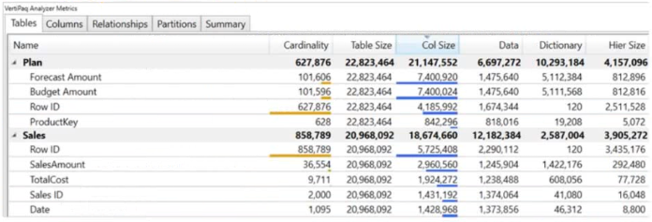
The Relationships exhibit displays the table relationships for the dataset. (Refer to the Relationships tab.)
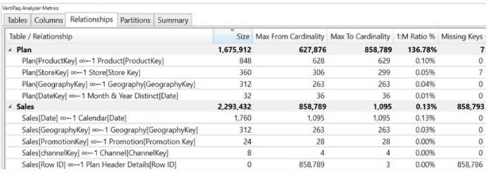
To decrease the size of the model by eliminating invalid relationships, which column should you eliminate?
Sales[Sales Amount]
Correct answer
Sales[Row ID]
Sales[Sales ID]
Plan[Row ID]
Overall explanation
To reduce the model size by eliminating invalid relationships, the column that should be removed is Sales[Row ID]. This is because, according to the provided information, the table relationships exhibit shows that there is an invalid relationship involving the Sales[Row ID] column. By removing this column, the invalid relationship will be eliminated, resulting in a smaller and more efficient model. The other columns listed as options (Sales[Sales Amount], Sales[Sales ID], and Plan[Row ID]) are not mentioned as being involved in any invalid relationships, so they should not be removed in this scenario.
Domain
Data Management
Question 21Skipped
What is the purpose of selecting 'To Table' in Power Query Editor when working with a JSON file?
To specify advanced settings for the JSON file
Correct answer
To extract data from the JSON file
To preview the data in a specific record
To specify file encoding in the File Origin drop-down list
Overall explanation
Selecting 'To Table' in Power Query Editor when working with a JSON file allows you to extract the data from the JSON file.
Domain
Data Analysis and Visualization
Question 22Skipped
What is the purpose of creating perspectives in Tabular Editor?
Correct answer
To reduce the number of fields available to a user when personalizing a visual
To speed up the process of personalizing a visual
To comply with data protection laws
To create a better user experience
Overall explanation
Creating perspectives in Tabular Editor allows you to reduce the number of fields available to a user when personalizing a visual, providing a better user experience.
Domain
Data Visualization
Question 23Skipped
What is the purpose of the artifacts impact analysis in Power BI?
To determine the popularity of reports and dashboards
To identify potentially breaking changes to the dataset
To notify contacts of affected reports and dashboards
Correct answer
To track the usage of shared content across different workspaces
Overall explanation
The artifacts impact analysis in Power BI is used to track the usage of shared content across different workspaces, allowing the owner of the shared content to see which reports and dashboards are using a specific artifact.
Domain
Data Analysis and Visualization
Question 24Skipped
What is the initial step to enable Microsoft Purview to scan an Azure Synapse Analytics dedicated SQL pool, considering that the Microsoft Purview account already has the necessary permissions?
Establish a data policy.
Explore the data catalog.
Correct answer
Enroll a data source.
Establish a data share connection.
Overall explanation
To ensure that the Azure Synapse Analytics dedicated SQL pool is scanned by Microsoft Purview, the first step is to register a data source. Registering a data source allows Microsoft Purview to establish a connection and access the data within the SQL pool. This enables Purview to scan and analyze the data for cataloging and governance purposes. Creating a data policy, searching the data catalog, or creating a data share connection are not the initial steps required to enable the scanning of the SQL pool by Microsoft Purview.
Domain
Data Management
Question 25Skipped
What can you define in the DEFINE section of a DAX query?
Correct answer
Query-level variables, measures, columns, and tables
Model-level variables, measures, columns, and tables
Query-level measures and columns only
Model-level measures and columns only
Overall explanation
In the DEFINE section of a DAX query, you can specify query-level variables, measures, columns, and tables.
Domain
Data Analysis Expressions (DAX)
Question 26Skipped
What tool should you utilize to examine the query plan and assess the duration spent in the storage engine and the formula engine when encountering a poorly performing measure in a Power BI data model?
Tabular Editor
Vertipaq Analyzer
Correct answer
DAX Studio
Performance analyzer in Power BI Desktop
Overall explanation
To review the query plan and analyze the time spent in the storage engine and the formula engine for a poorly performing measure in a Power BI data model, the most appropriate tool to use is DAX Studio. While Vertipaq Analyzer is part of DAX Studio, it only provides details about the tables and columns, not the time taken by each engine to execute the query. DAX Studio, on the other hand, offers comprehensive performance analysis capabilities, allowing you to examine the query plan and understand the time spent in both the storage engine and the formula engine. By using DAX Studio, you can identify bottlenecks and optimize the measure accordingly, improving the overall performance of the data model.
Domain
Data Analysis and Performance Optimization
Question 27Skipped
What is the main benefit of using your own storage for dataflows in Power BI?
To have access to all past versions of data for audit purposes
To integrate with Azure Data Lake Storage Gen2
Correct answer
To build solutions for more scenarios than possible with Power BI alone
To store data in the Common Data Model (CDM) model
Overall explanation
The main benefit of using your own storage for dataflows in Power BI is that you can build solutions for more scenarios than possible with Power BI alone.
Domain
Data Integration
Question 28Skipped
In an Apache Spark pool within Azure Synapse Analytics, while working with a Python notebook, what method should you call on a Data Frame to display the data distribution statistics in a tabular format?
sample
Correct answer
describe
freqItems
explain
Overall explanation
To present the data distribution statistics from a Data Frame in a tabular view in an Apache Spark pool in Azure Synapse Analytics, the appropriate method to invoke on the Data Frame is ""describe"". The ""describe"" method provides summary statistics such as count, mean, standard deviation, minimum, and maximum values for each column in the Data Frame. This allows for a comprehensive understanding of the data distribution and facilitates data analysis and decision-making processes. The other options, ""sample"", ""freqItems"", and ""explain"", do not provide the same level of detailed statistical information as the ""describe"" method.
Domain
Data Analysis
Question 29Skipped
What is the purpose of the INTERSECT function in SQL?
To combine rows from two tables based on a common column
Correct answer
To create a table that consists of rows present in both tables
To remove duplicate rows from a table
To calculate the average value of a column
Overall explanation
The purpose of the INTERSECT function is to create a table that consists of rows that are present in both tables used as arguments in INTERSECT.
Domain
SQL Functions
Question 30Skipped
What Power BI solution should you suggest to a customer who has 200 Power BI users and wants to meet the following requirements: enabling all users to generate paginated reports, allowing users to create reports with AI visuals, and providing autoscaling of CPU resources during periods of high usage, while also minimizing costs?
Correct answer
Power BI Premium per capacity
Power BI Report Server
Power BI Premium per user
Power BI Pro per user
Overall explanation
To meet the customer's requirements of enabling all users to create paginated reports, create reports containing AI visuals, and provide autoscaling of CPU resources during heavy usage spikes, the recommended Power BI solution is a Power BI Premium per capacity. Power BI Premium offers the necessary features and capabilities to fulfill these requirements while minimizing costs. With Power BI Premium, all users have access to the full range of Power BI functionalities, including the ability to create paginated reports and reports with AI visuals. Additionally, Power BI Premium allows for autoscaling of CPU resources, ensuring optimal performance during peak usage periods. This solution provides the necessary flexibility and scalability while optimizing costs for the customer.
Domain
Cloud Computing
Question 31Skipped
What is the purpose of using the FILTER function in DAX?
To create a calculated table based on specified conditions
Correct answer
To filter a table based on specified conditions
To perform calculations in a way similar to SUMIF in Excel
To trigger context transition in a calculated column
Overall explanation
The purpose of using the FILTER function in DAX is to filter a table based on specified conditions.
Domain
Data Analysis Expressions (DAX)
Question 32Skipped
What is the benefit of enabling large dataset format in Power BI Premium?
Correct answer
Datasets can grow beyond 10 GB in size
There is a default segment size of 8 million rows
Write operations are faster when using the XML for Analysis (XMLA) endpoint
You can publish datasets larger than 10 GB from Power BI Desktop to Power BI service
Overall explanation
Enabling large dataset format in Power BI Premium allows datasets to grow beyond 10 GB in size.
Domain
Business Intelligence
Question 33Skipped
What role is required to increase the number of virtual cores associated with a Power BI Premium capacity?
Power BI workspace administrator
Capacity administrator
Power Platform administrator
Correct answer
Power BI administrator
Overall explanation
To increase the number of virtual cores associated with a Power BI Premium capacity, you need to have the Power BI admin role. Power BI admins, along with global administrators, have the authority to change Power BI Premium capacity settings. The capacity admin role, on the other hand, is responsible for managing the overall capacity settings, including the number of virtual cores, memory, and other allocated resources. However, capacity admins who are not Power BI admins or global administrators do not have the option to change Power BI Premium capacity. Therefore, the correct role to increase the number of virtual cores is the Power BI admin role.
Domain
Cloud Computing
Question 34Skipped
What action should you take to enhance the performance of a measure in a Power Bi dataset, while keeping the logic and results intact?
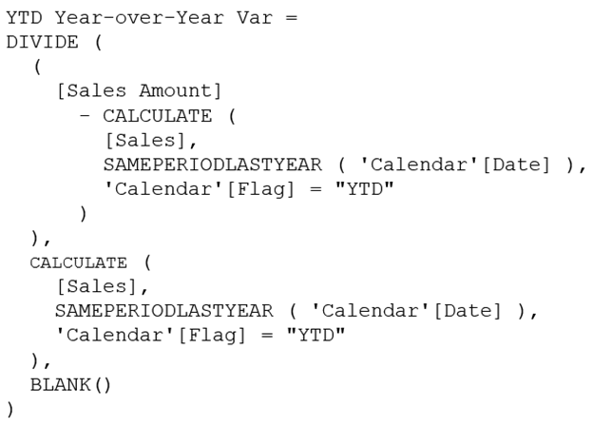

Generate a variable and substitute the values for [Sales Amount].
Correct answer
Subsitute both CALCULATE functions by utilizing a variable that encompasses the CALCULATE function.
Eliminate the alternate outcome of BLANK() from the DIVIDE function.
Exclude 'Calendar'[Flag] = ""YTD"" from the code.
Overall explanation
To improve the performance of the measure without affecting the logic or the results, the best approach is to replace both CALCULATE functions with a variable that contains the CALCULATE function. By doing so, the CALCULATE function is only executed once, and the result is stored in the variable. This eliminates the need to recalculate the same expression multiple times, resulting in improved performance. Additionally, this approach ensures that the logic and results of the measure remain unchanged, as the variable still contains the same CALCULATE function.
Domain
Data Analysis
Question 35Skipped
What is included in a Power BI template?
Data and credentials
Queries and parameters
Report pages and visuals
Correct answer
All of the above
Overall explanation
Power BI templates include queries, parameters, data model, DAX formulas, relationships, report pages, visuals, bookmarks, etc. However, they do not include the data or credentials.
Domain
Business Intelligence
Question 36Skipped
Overview - Current environment - OutdoorGoods Corp. is a retail business that offers outdoor recreational products and accessories. The company operates both online and in physical stores across six countries. Azure Resources - OutdoorGoods Corp. has the following Azure resources: An Azure Synapse Analytics workspace named synapseworkspace1 An Azure Data Lake Storage Gen2 account named datalake1 that is linked with synapseworkspace1 A Synapse Analytics dedicated SQL pool named SQLDW Dedicated SQL Pool - SQLDW houses a dimensional model that includes the following tables.
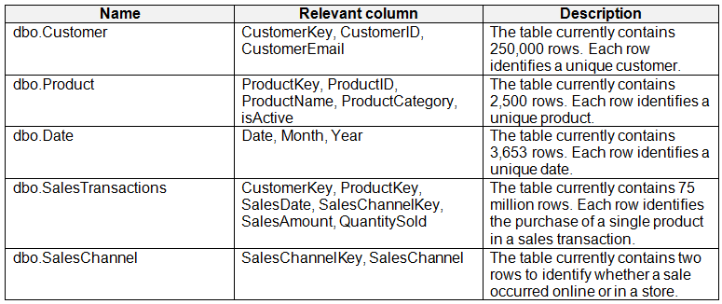
SQLDW also contains the following additional tables.
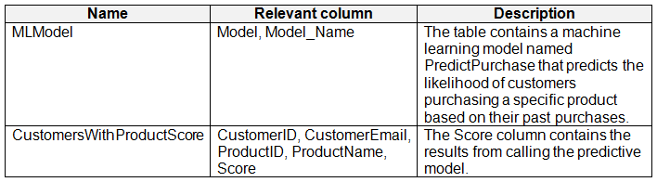
SQLDW includes a view named dbo.CustomerPurchases that generates a unique list of values from dbo.Customer [customerID], dbo.Customer [CustomerEmail], dbo.Product [ProductID] and dbo.Product [ProductName]. The sales data in SQLDW is refreshed every 30 minutes. Records in dbo.SalesTransactions are updated in SQLDW up to three days after creation. The records do NOT change after three days. Power BI - OutdoorGoods Corp. has a new Power BI tenant that includes an empty workspace named Sales Analytics. All users have Power BI Premium per user licenses. IT data analytics are workspace administrators. The IT data analysts will create datasets and reports. A single imported dataset will be created to support the company’s sales analytics goals. The dataset will be refreshed every 30 minutes. Requirements - Analytics Goals - OutdoorGoods Corp. has identified the following analytics goals: Provide historical reporting of sales by product and channel over time. Enable sales managers to perform ad hoc sales reporting with minimal effort. Conduct market basket analysis to understand which products are commonly purchased in the same transaction. Determine which customers should receive promotional emails based on their likelihood of purchasing promoted products. OutdoorGoods Corp. plans to monitor the adoption of Power BI reports over time. The company wants custom Power BI usage reporting that includes the percent change of users that view reports in the Sales Analytics workspace each month. Security Requirements - OutdoorGoods Corp. has identified the following security requirements for the analytics environment: All the users in the sales department and the marketing department must be able to see Power BI reports that contain market basket analysis and data about which customers are likely to purchase a product. Customer contact data in SQLDW and the Power BI dataset must be labeled as Sensitive. Records must be kept of any users that use the sensitive data. Sales associates must be prevented from seeing the CustomerEmail column in Power BI reports. Sales managers must be prevented from modifying reports created by other users. Development Process Requirements OutdoorGoods Corp. has identified the following development process requirements: SQLDW and datalake1 will serve as the development environment. Once feature development is complete, all entities in synapseworkspace1 will be promoted to a test workspace, and then to a production workspace. Power BI content must be deployed to test and production using deployment pipelines. All SQL scripts must be stored in Azure Repos. The IT data analysts prefer to build Power BI reports in Synapse Studio. You need to propose a solution to ensure that sensitivity labels are applied. The solution must minimize administrative effort. Which three steps should you include in the proposal? Each correct answer forms part of the solution. NOTE: Each correct selection is worth one point.
Correct selection
Enable users to apply sensitivity labels for Power BI content from the Power BI Admin portal.
Correct selection
Enable the application of sensitivity labels from data sources to their corresponding data in Power BI via the Power BI Admin portal.
Correct selection
Apply sensitivity labels to the columns in the Customer and CustomersWithProductScore tables in SQLDW.
Apply sensitivity labels to the columns in the Customer and CustomersWithProductScore tables in the Power BI datasets.
Enable the discoverability of certified content from the Power BI Admin portal.
Overall explanation
To ensure that sensitivity labels are applied with minimal administrative effort, the following actions should be included in the recommendation: 1. From the Power BI Admin portal, set ""Allow users to apply sensitivity labels for Power BI content"" to Enabled. This allows users to apply sensitivity labels to the Power BI content they create, reducing the need for manual intervention by administrators. 2. From the Power BI Admin portal, set ""Apply sensitivity labels from data sources to their data in Power BI"" to Enabled. This ensures that sensitivity labels applied to data sources, such as SQLDW, are automatically inherited by the corresponding data in Power BI. This streamlines the process of applying sensitivity labels and reduces the administrative effort. 3. In SQLDW, apply sensitivity labels to the columns in the Customer and CustomersWithProductScore tables. By labeling the sensitive columns directly in the SQLDW database, the sensitivity labels will be propagated to any downstream applications, including Power BI. This ensures consistent labeling and reduces the need for manual labeling in Power BI datasets. By implementing these actions, sensitivity labels can be effectively applied with minimal administrative effort. Users are empowered to apply labels to their own content, labels from data sources are automatically applied, and sensitive columns in SQLDW are labeled to propagate the labels to Power BI datasets.
Domain
Data Management
Question 37Skipped
What tool should you utilize to capture the query events produced by a Power BI Desktop report when optimizing a Power BI data model using DAX Studio?
the DMV list
a Server Timings trace
Correct answer
an All Queries trace
a Query Plan trace
Overall explanation
To capture the query events generated by a Power BI Desktop report, the most appropriate tool to use is an All Queries trace. This trace allows you to capture all the queries executed by the report, providing valuable insights into the performance and behavior of the data model. By analyzing the captured queries, you can identify any bottlenecks or areas for optimization in the data model. Other options, such as the DMV list, Server Timings trace, and Query Plan trace, may provide useful information but do not specifically capture all the queries generated by the report. Therefore, the All Queries trace is the correct option for this scenario.
Domain
Data Analysis
Question 38Skipped
You have a Power BI dataset that utilizes DirectQuery to connect to an Azure SQL database. Multiple reports are dependent on this dataset. A database administrator has raised concerns about the excessive number of queries being sent from Power BI to the database. You need to minimize the volume of queries sent to the database while satisfying the following conditions: DirectQuery functionality must be maintained. The current visual interactions in all reports must remain unchanged. Report consumers should only be able to apply filters from the Filter pane. Which two options should you choose? Each correct response contributes one point to the solution. NOTE: Each correct selection is worth one point.
Correct selection
Add a single Apply button to the filter pane to apply modifications simultaneously.
Incorporate Apply buttons to all fundamental filters to implement changes at your convenience.
Disable cross highlighting and filtering as the default setting.
Disregard the Privacy Levels and potentially enhance performance.
Correct selection
Integrate an Apply button to each slicer to apply modifications when desired.
Overall explanation
To reduce the number of queries sent to the Azure SQL database while still using DirectQuery and maintaining the current visual interactions in the reports, two settings should be selected. First, adding a single Apply button to the filter pane allows consumers of the reports to apply changes all at once, reducing the frequency of queries sent to the database. Second, adding an Apply button to each slicer allows users to apply changes to specific filters when they are ready, further optimizing query execution. These settings ensure that consumers can still apply filters from the Filter pane, as required, while minimizing the number of queries sent to the database. Other options, such as adding Apply buttons to all basic filters or disabling cross highlighting/filtering by default, do not meet the requirement of maintaining the current visual interactions in the reports. Additionally, enabling ""Ignore the Privacy Levels and potentially improve performance"" should be done with caution, as it may expose sensitive or confidential data.
Domain
Data Management
Question 39Skipped
What action should you take to enhance the accessibility of the visual in a Power BI report for users with color vision deficiency?
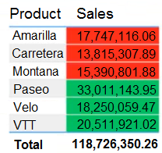

Include supplementary actions to the table values.
Modify the red background color to orange.
Correct answer
Incorporate icons to depict the sales status of each product.
Alter the font color of values in the Sales column to white.
Overall explanation
To make the visual more accessible to users with color vision deficiency, the best option is to add icons to represent the sales status of each product. This approach provides an alternative visual cue that is not reliant on color perception. Changing the background color or font color may not sufficiently address the needs of color-blind users, as they may still struggle to differentiate between different elements based on color alone. Adding icons, on the other hand, allows users to understand the sales status of each product without relying solely on color distinctions. This ensures that the visual is accessible and understandable for all users, regardless of their color vision abilities.
Domain
User Experience Design
Question 40Skipped
What is the purpose of using a data gateway in Power BI?
To publish reports created in Power BI Desktop
Correct answer
To connect to on-premises data sources from the cloud
To refresh cloud data sources in the Power BI service
To handle credentials and authentication for Power BI reports
Overall explanation
A data gateway is used to connect to on-premises data sources from the cloud in Power BI.
Domain
Data Integration
Question 41Skipped
What is the purpose of the %%sql magic command in Spark?
To create a view that can be queried with Spark SQL
To visualize data in a table format
Correct answer
To run Spark code interactively in multiple languages
To toggle the Chart option and select different chart types
Overall explanation
The %%sql magic command in Spark is used to run Spark code interactively in multiple languages.
Domain
Big Data Processing
Question 42Skipped
Does splitting the IoT DateTime column into separate Date and Time columns meet the goal of analyzing IoT events by the hour and day of the year while improving dataset performance, as shown in the provided exhibit?
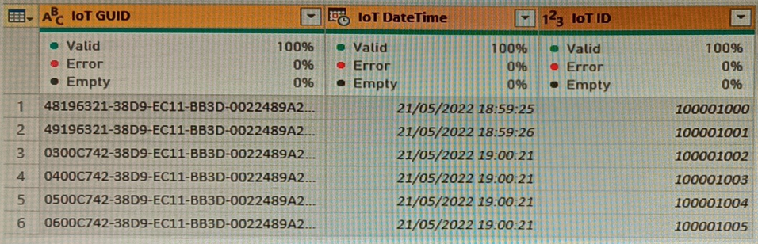

Yes
Correct answer
No
Overall explanation
Splitting the IoT DateTime column into separate Date and Time columns does not meet the goal of analyzing IoT events by the hour and day of the year. While it does separate the date and time components, it does not provide the necessary granularity to analyze events by the hour and day of the year. To achieve the desired analysis, additional transformations or calculations would be needed to extract the hour and day of the year from the DateTime column.
Domain
Data Analysis
Question 43Skipped
When using DAX Studio to analyze a report query that is running slowly, what should you examine in order to identify inefficient join operations?
the query statistics
Correct answer
the query plan
the query history
Overall explanation
To identify inefficient join operations in a slow-running report query using DAX Studio, you should review the query plan. The query plan provides a detailed breakdown of the steps and operations performed by the query, including the join operations. By analyzing the query plan, you can identify any inefficient or costly join operations that may be impacting the performance of the query. This allows you to optimize the query by making adjustments to the join operations or indexes, improving overall query performance.
Domain
Data Analysis
Question 44Skipped
Is it recommended to define a data source and view for the Parquet files and update the queries to use the view in order to reduce I/O reads and tempdb usage, as a solution to the given scenario involving the use of an Azure Synapse Analytics serverless SQL pool for querying a collection of Apache Parquet files with automatic schema inference?
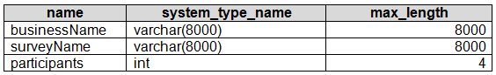

Correct answer
Yes
No
Overall explanation
Yes, recommending the use of a view to query the Parquet files meets the goal of reducing I/O reads and tempdb usage. Views in Azure Synapse Analytics provide the ability to define a logical representation of the data, allowing for more efficient querying. By defining a view for the Parquet files, the queries can be optimized to only read the necessary data, reducing the overall I/O reads. Additionally, using a view eliminates the need for repetitive OPENROWSET statements, further reducing tempdb usage. This approach aligns with best practices for improving query performance and resource utilization in Azure Synapse Analytics.
Domain
Cloud Computing
Question 45Skipped
What is the purpose of setting privacy levels when combining data from different sources?
To determine the rules for combining data
To improve query performance
To prevent the execution of certain queries
Correct answer
To ensure data is not leaked outside of Power Query
Overall explanation
Setting privacy levels helps ensure that data is not leaked outside of Power Query, even if the query performance is degraded.
Domain
Data Integration
Question 46Skipped
What is the purpose of the 'View as roles' feature in Power BI Desktop?
To assign users to roles in the Power BI service
Correct answer
To check what users with specific roles will see before publishing a report
To allocate a single user or a security group to multiple roles
To apply filters to calculated columns and calculated tables
Overall explanation
The 'View as roles' feature in Power BI Desktop allows you to check what users with specific roles will see before publishing a report to the Power BI service.
Domain
Business Intelligence
Question 47Skipped
What is the initial step to configure a Power BI workspace named Workspace1 to store its five dataflows in an Azure Data Lake Storage Gen2 account?
Correct answer
Modify the settings of the data source in the dataflow queries.
Deactivate loading for all dataflow queries.
Remove the dataflow queries.
Overall explanation
To configure Workspace1 to store the dataflows in an Azure Data Lake Storage Gen2 account, the first step is to change the Data source settings in the dataflow queries. By modifying the data source settings, you can specify the Azure Data Lake Storage Gen2 account as the destination for storing the dataflows. This ensures that the dataflows are stored in the desired location and enables seamless integration between Power BI and Azure Data Lake Storage Gen2. Disabling load for all dataflow queries or deleting the dataflow queries would not address the requirement of configuring Workspace1 to store the dataflows in the specified Azure Data Lake Storage Gen2 account.
Domain
Cloud Computing
Question 48Skipped
Overview - Current environment - OutdoorsCo, Inc. is a retail firm that specializes in outdoor recreational products and accessories. The company operates both online and in physical stores located in six countries. Azure Resources - OutdoorsCo has the following Azure resources: An Azure Synapse Analytics workspace named synapseworkspace1 An Azure Data Lake Storage Gen2 account named datalake1 that is associated with synapseworkspace1 A Synapse Analytics dedicated SQL pool named SQLDW Dedicated SQL Pool - SQLDW houses a dimensional model that includes the following tables.

SQLDW also contains the following additional tables.

SQLDW includes a view named dbo.CustomerPurchases that generates a unique list of values from dbo.Customer [customerID], dbo.Customer [CustomerEmail], dbo.Product [ProductID] and dbo.Product [ProductName]. The sales data in SQLDW is refreshed every 30 minutes. Records in dbo.SalesTransactions are updated in SQLDW up to three days after being created. The records do NOT change after three days. Power BI - OutdoorsCo has a new Power BI tenant that contains an empty workspace named Sales Analytics. All users have Power BI Premium per user licenses. IT data analytics are workspace administrators. The IT data analysts will create datasets and reports. A single imported dataset will be created to support the company’s sales analytics goals. The dataset will be refreshed every 30 minutes. Requirements - Analytics Goals - OutdoorsCo identifies the following analytics goals: Provide historical reporting of sales by product and channel over time. Allow sales managers to perform ad hoc sales reporting with minimal effort. Perform market basket analysis to understand which products are commonly purchased in the same transaction. Identify which customers should receive promotional emails based on their likelihood of purchasing promoted products. OutdoorsCo plans to monitor the adoption of Power BI reports over time. The company wants custom Power BI usage reporting that includes the percent change of users that view reports in the Sales Analytics workspace each month. Security Requirements - OutdoorsCo identifies the following security requirements for the analytics environment: All the users in the sales department and the marketing department must be able to see Power BI reports that contain market basket analysis and data about which customers are likely to purchase a product. Customer contact data in SQLDW and the Power BI dataset must be labeled as Sensitive. Records must be kept of any users that use the sensitive data. Sales associates must be prevented from seeing the CustomerEmail column in Power BI reports. Sales managers must be prevented from modifying reports created by other users. Development Process Requirements OutdoorsCo identifies the following development process requirements: SQLDW and datalake1 will act as the development environment. Once feature development is complete, all entities in synapseworkspace1 will be promoted to a test workspace, and then to a production workspace. Power BI content must be deployed to test and production by using deployment pipelines. All SQL scripts must be stored in Azure Repos. The IT data analysts prefer to build Power BI reports in Synapse Studio. You need to configure the Sales Analytics workspace to meet the ad hoc reporting requirements. What should you do?
Correct answer
Provide the sales managers with the Build authorization for the current Power BI datasets.
Provide the sales managers with administrative privileges for the existing Power BI workspace.
Establish a deployment pipeline and grant the sales managers access to it.
Generate a PBIT file and distribute it to the sales managers.
Overall explanation
To meet the ad hoc reporting requirements in the Sales Analytics workspace, the most appropriate action is to grant the sales managers the Build permission for the existing Power BI datasets. This allows the sales managers to create their own reports from the same dataset without the need to modify reports created by other users. Granting Build permission ensures that the sales managers have the necessary access and capabilities to perform ad hoc reporting with minimal effort. This approach is more secure and efficient compared to other options such as granting admin access to the workspace, creating a deployment pipeline, or distributing a PBIT file. By granting Build permission, the sales managers can leverage the existing dataset and collaborate effectively within the Sales Analytics workspace.
Domain
Data Management
Question 49Skipped
What is the purpose of the ALL function in Power Query?
Correct answer
To remove filters from a table or columns
To create calculated tables
To count the number of rows in a table
To filter out blank rows in a table
Overall explanation
The ALL function is used to remove filters that were placed on a table or columns.
Domain
Power Query
Question 50Skipped
What function can be used to count the number of non-blank values in a column?
COUNTROWS
Correct answer
COUNTA
COUNT
COUNTBLANK
Overall explanation
The COUNTA function can be used to count the number of non-blank values in a column.
Domain
Data Analysis Expressions (DAX)
Question 51Skipped
When should you enable the setting to restrict content with protected labels from being shared via link with everyone in your organization?
Correct answer
When you want to prevent people from sharing protected content by using links
When you want to apply sensitivity labels to downstream content
When you want to allow workspace admins to override automatically applied sensitivity labels
When you want to remind the dataset owner of the underlying data sensitivity
Overall explanation
You should enable the setting to restrict content with protected labels from being shared via link with everyone in your organization when you want to prevent people from sharing protected content by using links.
Domain
Data Protection and Security
Question 52Skipped
What is the purpose of using Table.Buffer or List.Buffer in Power Query?
Correct answer
To improve performance by storing data in memory and preventing multiple reads from the source
To filter the data and remove unnecessary columns
To optimize the use of table functions
To load data from a slow data source to a dataflow
Overall explanation
Using Table.Buffer or List.Buffer in Power Query improves performance by storing data in memory and ensuring that data isn't read multiple times from the source.
Domain
Data Analysis and Visualization
Question 53Skipped
When should you enable script visuals in Power BI?
Correct answer
When you want to create an R or Python visual
When you want to add fields to the Values area in the Visualization pane
When you want to launch an external IDE
When you want to copy code from an external IDE to Power BI Desktop
Overall explanation
Script visuals should be enabled when you want to create an R or Python visual in Power BI.
Domain
Data Visualization
Question 54Skipped
What is the initial step to be taken in order to switch the source control solution from GitHub to an Azure DevOps Git repository for an Azure Synapse Studio workspace?
Correct answer
Disconnect from the GitHub repository.
Create a new pull request.
Switch the workspace to live mode.
Change the active branch.
Overall explanation
To modify the source control solution in Azure Synapse Studio to use an Azure DevOps Git repository, the first step is to disconnect from the current GitHub repository. This is necessary to ensure a clean transition and avoid any conflicts or issues when connecting to the new repository. By disconnecting from the GitHub repository, you can then proceed to configure the workspace to use the Azure DevOps Git repository as the new source control solution. This ensures a seamless integration and allows for proper version control and collaboration within the Azure Synapse Studio workspace.
Domain
Cloud Computing
Question 55Skipped
What are the two recommended actions to decrease the load time of a dataflow that performs multiple joins in a Power BI Premium capacity? Each correct answer contributes to the solution.
Correct selection
Perform collapsible tasks prior to non-collapsible tasks.
Consolidate the ingestion and transformation operations into a unified dataflow.
Execute non-collapsible operations before collapsible operations.
Correct selection
Divide the ingestion and transformation operations into distinct dataflows.
Decrease the memory allocation for the dataflows.
Overall explanation
To reduce the load time of a dataflow in Power BI Premium, two actions should be performed. First, execute foldable operations before non-foldable operations. Foldable operations can be pushed down to the data source, reducing the amount of data that needs to be processed in Power BI. By executing these operations first, the dataflow can take advantage of this optimization. Second, place the ingestion operations and transformation operations in separate dataflows. This allows for parallel processing and can improve the overall performance of the dataflow. By separating these operations into different dataflows, the load time can be reduced.
Domain
Data Management
Question 56Skipped
Is it recommended to define an external table for the Parquet files and modify the query to utilize the table in order to reduce I/O reads and tempdb usage, as part of the solution to the given scenario involving the use of an Azure Synapse Analytics serverless SQL pool for querying a collection of Apache Parquet files with automatic schema inference?


Yes
Correct answer
No
Overall explanation
The recommendation to define an external table for the Parquet files and update the query to use the table does not meet the goal of reducing I/O reads and tempdb usage. While using an external table can provide benefits such as improved performance and simplified query syntax, it does not directly address the specific goal of reducing I/O reads and tempdb usage. Instead, a more appropriate solution would be to create a view that leverages the automatic schema inference feature of Azure Synapse Analytics serverless SQL pool. This allows the queries to directly access the Parquet files without the need for intermediate storage or additional I/O operations, thereby reducing both I/O reads and tempdb usage.
Domain
Cloud Computing
Question 57Skipped
What is the purpose of gathering feedback from end users in the initial stages of building a report?
To ensure consistency across pages
To make the report more user-friendly
Correct answer
To embed a feedback loop in the design process
To make the key insights immediately visible to users
Overall explanation
Gathering feedback from end users in the initial stages of building a report helps to embed a feedback loop in the design process, ensuring that the report meets the needs and expectations of the users.
Domain
Data Reporting and Visualization
Question 58Skipped
What is the advantage of using Parquet files over CSV files in Power BI?
Correct answer
Parquet files are smaller and more performant
Parquet files can be read natively by Power BI
Parquet files have predefined column headers and data types
Parquet files can be accessed using a URL or file path
Overall explanation
Parquet files are smaller and more performant than CSV files, making them a better choice for data storage in Power BI.
Domain
Data Storage and Retrieval
Question 59Skipped
What are the three recommended actions to be performed in the Power BI Admin portal to meet the new security and governance protocols for Power BI reports and datasets? Each correct answer contributes to the solution.
Correct selection
Remove all codes from Embed Codes.
Disable the Allow XMLA endpoints and Analyze in Excel with on-premises datasets options in Tenant settings.
Configure the XMLA Endpoint in Capacity settings to Read Write.
Correct selection
Set the XMLA Endpoint to Off in the Premium per user settings.
Correct selection
Disable the Publish to web option in Tenant settings.
Overall explanation
To meet the new security and governance protocols for Power BI reports and datasets, three recommended actions in the Power BI Admin portal are as follows: 1. From Embed Codes, delete all the codes: This action ensures that new reports can only be embedded in locations that require authentication. By removing all the embed codes, unauthorized access to the reports is prevented, and authentication is enforced. 2. From the Premium per user settings, set XMLA Endpoint to Off: This action restricts live connections to workspaces that use Premium capacity datasets. By disabling the XMLA Endpoint, only workspaces with Premium capacity can establish live connections, ensuring that the governance protocols are followed. 3. From Tenant settings, set Publish to web to Disable: This action disables the Publish to web feature, which prevents reports from being publicly accessible on the web. By disabling this feature, the reports can only be accessed by authorized users, aligning with the requirement of restricting access to authenticated locations. These three actions collectively enforce the new security and governance protocols, ensuring that reports are embedded only in authenticated locations, live connections are limited to Premium capacity datasets, and reports are not publicly accessible on the web.
Domain
Data Security and Governance
Question 60Skipped
What is the purpose of source control in Power BI?
To prevent work from being lost
Correct answer
To track changes and recover previous versions of Power BI assets
To store PBIX files and BIM files
To merge conflicting changes made by multiple developers
Overall explanation
Source control in Power BI is used to track changes and enable the recovery of previous versions of Power BI assets.
Domain
Data Management

