Practice Test # 4 - Results

Question 1Skipped
What type of file should be used to streamline the initial connection process to the PostgreSQL database named db1 for data analysts utilizing Power BI Desktop, considering that each analyst will be working with data from a distinct schema within db1?
PBIT
PBIX
Correct answer
PBIDS
Overall explanation
To simplify the process for the data analysts to initially connect to the PostgreSQL database named db1 when using Power BI Desktop, the recommended file type to use is PBIDS. PBIDS stands for Power BI Data Source file, which allows you to specify the connection details and credentials for the database. By providing the analysts with a PBIDS file, they can simply open it in Power BI Desktop and establish a connection to the appropriate schema in db1 without having to manually enter the connection information each time. This streamlines the process and ensures consistency in connecting to the database for all analysts.
Domain
Data Management
Question 2Skipped
What is the purpose of incremental refresh in Power BI?
To compress large datasets
To improve dataset refresh speed
To reduce resource usage during dataset refresh
Correct answer
To address issues related to dataset refresh time, resource usage, and reliability
Overall explanation
Incremental refresh in Power BI allows you to address issues related to dataset refresh time, resource usage, and reliability by refreshing only a subset of data.
Domain
Data Analysis
Question 3Skipped
What is the purpose of paging in REST APIs?
Correct answer
To divide data into pages to avoid transmitting too much data in a single call
To provide the URL for the next page in the response
To calculate the next page value
To stop calling the API when there is no data
Overall explanation
Paging in REST APIs is used to divide data into pages to avoid transmitting too much data in a single call.
Domain
Data Integration
Question 4Skipped
What is the purpose of the Record.HasFields function in Power Query?
Correct answer
To check if a record has certain fields
To create a new copy of a record with a different set of fields
To remove specific fields from a record
To add new fields to a record
Overall explanation
The Record.HasFields function is used to check if a record has certain fields.
Domain
Power Query
Question 5Skipped
What is the purpose of deployment rules in deployment pipelines?
Correct answer
To update data sources or parameter values when deploying
To compare content between adjacent stages
To selectively deploy content to different stages
To view deployment history and add notes to deployments
Overall explanation
Deployment rules allow you to update data sources or parameter values when deploying.
Domain
Data Management
Question 6Skipped
What action should be taken to ensure that individuals with color vision deficiency can access the table in a Power BI report that includes conditional formatting indicating stores that exceed, meet, or fall below the monthly returns quota?
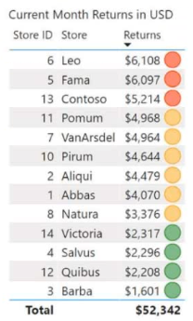

Include alternative text to clarify the meaning of each color.
Correct answer
Replace the icons with distinct shapes for each color.
Transfer the conditional formatting icons to a tooltip report.
Eliminate the icons and substitute them with red, yellow, and green background colors.
Overall explanation
To ensure accessibility for consumers of reports with color vision deficiency, the most appropriate action to take is to change the icons in the table to use a different shape for each color. This approach allows individuals with color vision deficiency to distinguish between the different categories (above, near, or below quota) based on the shape of the icons rather than relying solely on color. By using distinct shapes, the information conveyed by the conditional formatting is still effectively communicated to all users, regardless of their color vision capabilities. This ensures inclusivity and equal access to the information presented in the Power BI report.
Domain
Data Visualization
Question 7Skipped
What is the purpose of using aggregations in Power BI?
Correct answer
To optimize the performance of data sources
To create a database for DirectQuery mode
To manage aggregations in the Data pane
To determine whether to use the aggregation or the original table
Overall explanation
Using aggregations in Power BI allows you to optimize the performance of data sources, particularly those using the DirectQuery mode, by creating summary tables that can be used for reporting.
Domain
Data Analysis and Visualization
Question 8Skipped
What are the two necessary actions to enable scanning of a Power BI tenant using Azure Purview? Each correct answer contributes one point to the solution.
Create a Microsoft 365 group from the Microsoft 365 admin center.
Enable live connections from the Power BI Admin center.
Correct selection
Enable read-only Power BI admin APIs for service principals from the Power BI Admin center.
Correct selection
Create a security group from the Azure Active Directory admin center.
Enable sharing content with external users from the Power BI Admin center.
Overall explanation
To ensure that you can scan the Power BI tenant using Azure Purview, you need to perform the following actions: 1. From the Power BI Admin center, set ""Allow service principals to use read-only Power BI admin APIs"" to Enabled. This allows Azure Purview to access the necessary Power BI admin APIs for scanning the tenant. 2. From the Azure Active Directory admin center, create a security group. This security group will be used to grant the necessary permissions to Azure Purview for accessing the Power BI tenant. By enabling the service principals to use read-only Power BI admin APIs and creating a security group in Azure Active Directory, you provide the required permissions and access for Azure Purview to scan the Power BI tenant effectively. These actions ensure that Azure Purview can retrieve the necessary metadata and perform the scanning operations on the Power BI resources within the tenant.
Domain
Azure Purview
Question 9Skipped
What method should be called on the DataFrame in order to display the data distribution statistics in a tabular format when using a Python notebook in an Apache Spark pool within Azure Synapse Analytics?
explain
Correct answer
describe
corr
cov
Overall explanation
To present the data distribution statistics from a DataFrame in a tabular view in an Apache Spark pool in Azure Synapse Analytics, the correct method to invoke on the DataFrame is ""describe"". The describe method provides summary statistics of the DataFrame, including count, mean, standard deviation, minimum, and maximum values for each column. This allows for a comprehensive understanding of the data distribution and helps in identifying any outliers or anomalies. The other options, explain, corr, and cov, are not suitable for presenting data distribution statistics in a tabular view.
Domain
Data Analysis
Question 10Skipped
How can you create a table directly in the code in Power BI?
By using the Table.AddColumn function
Correct answer
By using the Table.FromRecords function
By using the Table.SelectRows function
By using the Table.Buffer function
Overall explanation
You can create a table directly in the code in Power BI by using the Table.FromRecords function.
Domain
Power BI
Question 11Skipped
What is the purpose of checking color contrast in web design?
Correct answer
To make text legible and easy to read
To create visually appealing color combinations
To ensure compatibility with color vision deficiencies
To facilitate the process of building reports
Overall explanation
Checking color contrast in web design is important to ensure that text is legible and easy to read, improving accessibility for all users.
Domain
Web Design
Question 12Skipped
What is the purpose of Power BI Desktop's Performance Analyzer?
To analyze the performance of DAX queries
To optimize report performance
Correct answer
To identify slow-performing visuals
To export DAX queries for further analysis
Overall explanation
The purpose of Power BI Desktop's Performance Analyzer is to identify slow-performing visuals by recording traces and showing the rendering duration for each visual.
Domain
Business Intelligence
Question 13Skipped
Is creating a calculation group in Tabular Editor a suitable solution for reducing the number of measures in Power BI dataset Dataset1 while preserving the existing functionality?
Correct answer
Yes
No
Overall explanation
Yes, creating a calculation group in Tabular Editor meets the goal of reducing the number of measures while maintaining the current functionality. A calculation group allows you to define a set of calculations that can be applied to multiple measures, reducing the need for duplicating the same time intelligence logic across multiple measures. By creating a calculation group, you can consolidate the common time intelligence calculations into a single place, simplifying the maintenance and management of the measures in Dataset1. This approach helps to streamline the dataset and improve efficiency without sacrificing any functionality.
Domain
Data Analysis and Business Intelligence
Question 14Skipped
What is the initial step to ensure that Azure Purview scans your dedicated SQL pool in Azure Synapse Analytics?
Establish a data policy.
Establish a data share connection.
Perform a search within the data catalog.
Correct answer
Register a data source.
Overall explanation
To ensure that the Azure Synapse Analytics dedicated SQL pool is scanned by Azure Purview, the first step is to register a data source. Registering a data source allows Azure Purview to establish a connection and access the data within the SQL pool. Once the data source is registered, Azure Purview can then scan and catalog the data, enabling data discovery and governance capabilities. Creating a data policy, creating a data share connection, or searching the data catalog are not the initial steps required to enable the scanning of the SQL pool by Azure Purview.
Domain
Data Management
Question 15Skipped
What is the purpose of using the SWITCH function in calculated columns?
To group values into categories based on business requirements
To encrypt sensitive data such as personal information or credit card numbers
To mask out part of the information in certain columns
Correct answer
To evaluate multiple conditions and return different results based on the conditions
Overall explanation
The SWITCH function is used to evaluate multiple conditions and return different results based on the conditions. It is especially useful when there are many conditions to check.
Domain
Data Analysis and Visualization
Question 16Skipped
What steps should be included in the recommendation to reduce the query execution time while preserving the existing functionality for a Power BI dataset named Dataset1 that utilizes DirectQuery against an Azure SQL database named DB1?
Eliminate the associations from Dataset1.
Standardize the tables in DB1.
Generate computed columns in Dataset1.
Correct answer
Consolidate the tables in DB1.
Overall explanation
To minimize the execution time of the query while maintaining the current functionality of the Power BI dataset that uses DirectQuery against the Azure SQL database, the recommended solution is to denormalize the tables in DB1. Denormalization involves combining tables and reducing the number of joins required in the query, which can significantly improve query performance. By denormalizing the tables, the query can access the required data more efficiently, resulting in faster execution times. Removing relationships from the dataset, normalizing the tables, or creating calculated columns would not directly address the goal of minimizing query execution time.
Domain
Database Management
Question 17Skipped
When creating a single-page report in Power BI, how can you configure the report page to ensure that users can consume content in a logical order, considering that some users will navigate the report using a keyboard and others will use a screen reader?
the X position
the bookmark order
the layer order
Correct answer
the tab order
Overall explanation
To ensure that users can consume content on a Power BI single-page report in a logical order, the tab order should be configured on the report page. This allows users to navigate through the report using the keyboard, ensuring that they can access the content in a sequential and organized manner. By setting the tab order, users can easily move between different elements on the page, such as visuals, buttons, or other interactive components, following a logical flow. This is particularly important for users who rely on screen readers, as it enables them to understand and interact with the report effectively.
Domain
User Experience Design
Question 18Skipped
The exhibit displays the Power BI data model.
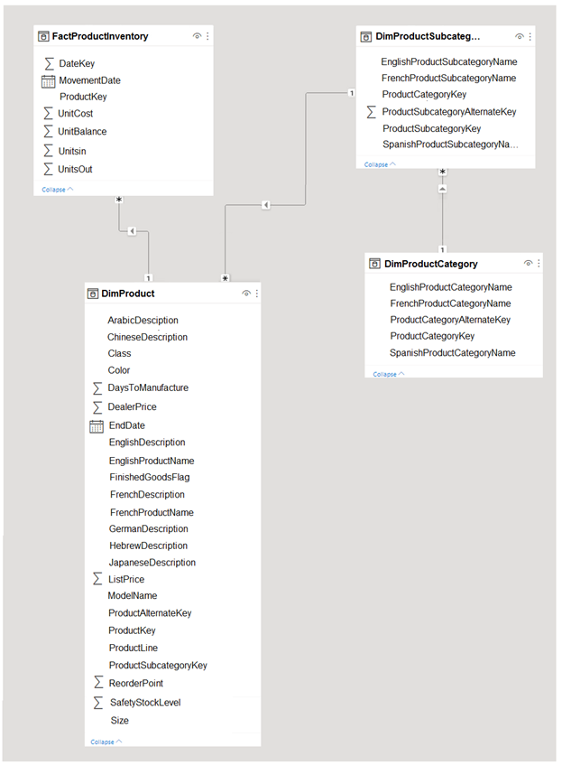
Users have reported that the reports take a significant amount of time to load when generated from the data model. You need to propose a solution to decrease the loading times of the reports. Is it recommended to move all the measures to a calculation group to achieve this goal?
Yes
Correct answer
No
Overall explanation
The recommended solution of moving all the measures to a calculation group does not meet the goal of reducing the load times of the reports. While calculation groups can help organize and manage measures, they do not directly impact the performance or load times of the reports. To improve the load times, other strategies such as optimizing the data model, aggregating data, or using query folding should be considered.
Domain
Data Management
Question 19Skipped
What is the purpose of NATURALINNERJOIN function in Power Query Editor?
Correct answer
To merge two tables based on common column names
To create a relationship between two tables
To join physical tables that have a relationship between them
To apply filters to CALCULATE or CALCULATETABLE functions
Overall explanation
The NATURALINNERJOIN function in Power Query Editor merges two tables based on common column names.
Domain
Data Analysis
Question 20Skipped
What is the purpose of a deployment strategy for Power BI assets?
To minimize the effort associated with development and deployment
To keep multiple versions of Power BI assets accessible to users
Correct answer
To manage different stages of development and testing
To avoid data duplication in shared datasets
Overall explanation
A deployment strategy for Power BI assets helps manage different stages of development and testing, ensuring that changes are properly tested and accepted before being deployed to the final production stage.
Domain
Business Intelligence
Question 21Skipped
What solution should you suggest to minimize the query size sent to the Azure SQL database when publishing dataset changes to the development, test, or production pipelines in order to address the issue reported by the database administrator regarding the increased number of queries from the Power BI service?
Activate the storage format for large datasets within the workspace.
Remove the fact table from the dataset.
Correct answer
Establish a dataset parameter to decrease the number of rows in the fact table for the development and test pipelines.
Adjust the Max Intermediate Row Set Count setting in the Power BI Admin portal under Capacity settings.
Overall explanation
To reduce the size of the queries sent to the database when dataset changes are published to development, test, or production pipelines, the recommended solution is to create a dataset parameter to reduce the fact table row count specifically in the development and test pipelines. By implementing a dataset parameter, you can dynamically control the number of rows in the fact table during the refresh process, allowing you to limit the size of the queries sent to the database. This approach provides flexibility and scalability, as you can adjust the row count parameter based on the specific needs of each pipeline. It also ensures that only the necessary data is queried, optimizing performance and reducing the strain on the Azure SQL database.
Domain
Data Management
Question 22Skipped
What is the purpose of the UNION function in Power Query Editor?
To combine tables horizontally
Correct answer
To combine tables vertically
To filter rows based on specific criteria
To create relationships between tables
Overall explanation
The UNION function in Power Query Editor is used to combine two or more tables vertically.
Domain
Data Analysis
Question 23Skipped
You possess a Power BI dataset with a capacity of 2 GB. To enable the dataset to be redeployed using Tabular Editor while minimizing the time required to apply modifications from powerbi.com, what are the two actions that should be taken? Each correct response is worth one point.
Activate service principal authentication for read-only administrative APIs.
Establish a connection between the designated workspace and an Azure Data Lake Storage Gen2 account.
Correct selection
Enable the storage format for large datasets.
Correct selection
Enable read-write access for XMLA.
Overall explanation
To ensure that you can redeploy the 2-GB Power BI dataset using Tabular Editor and minimize the time it takes to apply changes from powerbi.com, you should perform two actions. First, you should turn on the Large dataset storage format. This format optimizes the storage and processing of large datasets, allowing for faster updates and deployments. Second, you should enable XMLA read-write. This enables read and write access to the dataset using XMLA endpoints, which Tabular Editor relies on for making changes to the dataset. By enabling these two features, you can efficiently manage and update the dataset while minimizing the time required for applying changes.
Domain
Cloud Computing
Question 24Skipped
What is the purpose of the CALCULATE function in DAX?
Correct answer
To transform row context into filter context
To calculate the sum of values in a column
To apply filters to a calculation
To iterate over tables and use row context
Overall explanation
The CALCULATE function is used to transform row context into equivalent filter context in DAX.
Domain
Data Analysis Expressions (DAX)
Question 25Skipped
How can you change the tab order of visuals in the Report view?
Correct answer
By dragging and dropping the items within the list
By selecting an item and using the up and down arrows
By hiding decorative elements from the tab order
By configuring the layer order in the Selection pane
Overall explanation
You can change the tab order of visuals in the Report view by dragging and dropping the items within the list.
Domain
Data Visualization
Question 26Skipped
What is the difference between serverless and dedicated in Azure Synapse SQL?
Serverless allows ingestion of data, while dedicated only allows querying the data
Correct answer
Serverless scales automatically based on computation needs, while dedicated has a predetermined number of nodes
Serverless is used for large tables, while dedicated is used for small tables
Serverless allows for hash distribution, while dedicated allows for round-robin distribution
Overall explanation
The difference between serverless and dedicated in Azure Synapse SQL is primarily in the number of nodes available. With serverless, the number of nodes is not predetermined and will scale automatically based on the computation needs. With dedicated, the number of nodes is preallocated.
Domain
Cloud Computing
Question 27Skipped
What method should be called on the DataFrame in order to display the data distribution statistics in a tabular format when using a Python notebook in an Apache Spark pool within Azure Synapse Analytics?
Correct answer
describe
corr
freqItems
explain
Overall explanation
To present the data distribution statistics from a DataFrame in a tabular view in an Apache Spark pool in Azure Synapse Analytics, the appropriate method to invoke on the DataFrame is ""describe"". The describe method provides summary statistics such as count, mean, standard deviation, minimum, and maximum values for each column in the DataFrame. This allows for a comprehensive understanding of the data distribution and helps in identifying any outliers or anomalies. The other options, corr, freqItems, and explain, are not specifically designed to provide data distribution statistics in a tabular view.
Domain
Data Analysis
Question 28Skipped
What is the purpose of dynamic row-level security in Power BI?
To create static roles for different users
Correct answer
To filter data based on user hierarchy
To encrypt sensitive data in the data model
To speed up the data filtering process
Overall explanation
Dynamic row-level security allows you to show different data to different users within the same role based on their hierarchy. It filters the data based on the user's position in the hierarchy.
Domain
Data Security
Question 29Skipped
What type of file should you create to fulfill the requirement of providing users with a replicable approach to connect to a data source and apply an AI function to transform the data, while minimizing development effort and excluding data from the file?
Correct answer
PBIT
PBIDS
PBIX
Overall explanation
To provide users with a reproducible method to connect to a data source and transform the data using an AI function while minimizing development effort and avoiding including data in the file, the recommended file type to create is a PBIT file. A PBIT file, or Power BI template file, allows users to define the data source connection and transformations without including the actual data. This means that the file can be easily shared and reused by others, reducing the need for manual development and ensuring consistency in the data transformation process. Additionally, by not including the data in the file, it helps to keep the file size smaller and more manageable.
Domain
Data Management
Question 30Skipped
What is the initial step to configure Workspace1 in Power BI to store its five dataflows in an Azure Data Lake Storage Gen2 account?
Enable tenant-level storage through the Power BI Admin portal.
Deactivate data load for all dataflow queries.
Correct answer
Remove the dataflow queries.
Modify the data source settings in the dataflow queries.
Overall explanation
To configure Workspace1 to store the dataflows in an Azure Data Lake Storage Gen2 account, the first step is to delete the dataflow queries. This is because the dataflow queries are currently configured to store the dataflows in a different location, and deleting them will allow you to reconfigure the data source settings to point to the Azure Data Lake Storage Gen2 account. Once the dataflow queries are deleted, you can then proceed to change the data source settings in the queries to connect to the Azure Data Lake Storage Gen2 account and enable the storage of the dataflows in the desired location.
Domain
Data Management
Question 31Skipped
Company Profile - Contoso, Ltd. is a firm that provides enriched financial data to a diverse range of external clients. Contoso operates a main office in Los Angeles and two branch offices in New York and Seattle. Current Environment - Data Infrastructure - Contoso operates a 50-TB data warehouse on an instance of SQL Server on Azure Virtual Machines. This data warehouse feeds an Azure Synapse Analytics workspace accessed by external clients, who currently have access to all data. Contoso has a single Power BI workspace named FinData, which contains one dataset comprising global financial data. This workspace is utilized by 10 internal users and one external client. The dataset sources data from the data warehouse and the Synapse Analytics serverless SQL pool. Users frequently execute Transact-SQL queries on the Synapse Analytics workspace. User Challenges - Contoso has identified the following user issues: Some users report slow rendering of visuals in Power BI reports when applying filter selections. Users report occasional query failures against the serverless SQL pool due to exceeding the size of tempdb. Users report outdated data in Power BI reports, with the refresh process of the Power BI model occasionally timing out. Proposed Changes - Contoso plans to implement the following changes: Integrate an external JSON data source accessible via the REST API into the existing Power BI dataset. Construct a new dataset in the FinData workspace using data from the Synapse Analytics dedicated SQL pool. Provide each client with their own Power BI workspace for creating their own reports, each using the new dataset in the FinData workspace. Implement subscription levels for clients, with each subscription level providing access to specific rows of financial data. Deploy prebuilt datasets to Power BI to streamline the query experience for clients. Enable internal users to incorporate machine learning models loaded to the dedicated SQL pool. You are tasked with recommending a solution for the client workspace to support the planned changes. Which two configurations should be included in your recommendation? Each correct answer forms part of the solution. NOTE: Each correct selection is worth one point.
Share the financial data on the internet.
Set up the FinData workspace to utilize a Power BI Premium capacity.
Correct selection
Provide the Build authorization for the financial data to every customer.
Correct selection
Enable the Use datasets across workspaces setting.
Overall explanation
To support the planned changes and provide customers with their own Power BI workspace to create their own reports, two configurations should be included in the recommendation. First, granting the Build permission for the financial data to each customer is necessary to allow them access to the underlying dataset and create their own reports. This ensures that customers have the necessary permissions to work with the data and build their own visualizations. Second, enabling the ""Use datasets across workspaces"" setting is important to allow customers to utilize the new dataset in the FinData workspace. This configuration enables customers to access and use the dataset from their own workspaces, providing them with the necessary data for their reports. These two configurations together provide the required access and functionality for customers to create their own reports using the new dataset.
Domain
Data Management
Question 32Skipped
Company Profile - Contoso, Ltd. is a firm that provides enhanced financial data to a diverse range of external clients. Contoso's headquarters is in Los Angeles, with two branch offices in New York and Seattle. Current Environment - Data Infrastructure - Contoso operates a 50-TB data warehouse on an instance of SQL Server on Azure Virtual Machines. The data warehouse feeds an Azure Synapse Analytics workspace accessed by external clients. Currently, clients have access to all data. Contoso has a single Power BI workspace named FinData, which contains one dataset. The dataset comprises global financial data. The workspace is utilized by 10 internal users and one external client. The dataset sources data from the data warehouse and the Synapse Analytics serverless SQL pool. Users frequently execute queries on the Synapse Analytics workspace using Transact-SQL. User Challenges - Contoso identifies the following user issues: Some users report slow rendering of visuals in Power BI reports when applying filters. Users report occasional query failures against the serverless SQL pool due to exceeding the size of tempdb. Users report outdated data in Power BI reports. The Power BI model's refresh process is discovered to time out occasionally. Proposed Changes - Contoso plans to implement the following changes: Integrate an external JSON data source accessible via the REST API into the existing Power BI dataset. Construct a new dataset in the FinData workspace using data from the Synapse Analytics dedicated SQL pool. Provide each client with their own Power BI workspace for report creation. Each workspace will use the new dataset in the FinData workspace. Implement subscription tiers for clients. Each subscription tier will grant access to specific rows of financial data. Deploy prebuilt datasets to Power BI to streamline the clients' query experience. Enable internal users to incorporate machine learning models loaded to the dedicated SQL pool. You are tasked with recommending a solution to add new fields to the financial data Power BI dataset using data from the Microsoft SQL Server data warehouse. What should your recommendation include?
Azure Purview
an XMLA endpoint
Site-to-Site VPN
Correct answer
the on-premises data gateway
Overall explanation
To add new fields to the financial data Power BI dataset with data from the Microsoft SQL Server data warehouse, the recommended solution is to include the on-premises data gateway. The on-premises data gateway allows Power BI to securely connect to on-premises data sources, such as the Microsoft SQL Server data warehouse. By configuring the on-premises data gateway, Power BI can access the necessary data from the data warehouse and incorporate it into the Power BI dataset. This ensures that the financial data in the dataset is up-to-date and includes the new fields from the data warehouse. Other options, such as Azure Purview, XMLA endpoint, and Site-to-Site VPN, are not directly related to adding new fields to the Power BI dataset with data from the data warehouse.
Domain
Data Management
Question 33Skipped
Is recommending the use of OPENROWSET WITH to explicitly define the maximum length for businessName and surveyName a suitable solution to reduce I/O reads and tempdb usage in the given scenario of querying Apache Parquet files with Azure Synapse Analytics serverless SQL pool using automatic schema inference?
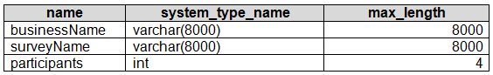

Correct answer
Yes
No
Overall explanation
Yes, recommending the use of OPENROWSET WITH to explicitly specify the maximum length for businessName and surveyName does meet the goal of reducing I/O reads and tempdb usage. By specifying the maximum length, the serverless SQL pool can allocate the appropriate amount of memory and storage for these columns, optimizing performance and minimizing unnecessary resource consumption. This approach ensures that the database does not allocate excessive resources for these columns, resulting in reduced I/O reads and tempdb usage.
Domain
Database Management
Question 34Skipped
Does removing the IoT ID column and keeping the IoT GUID column from the Power Query Editor improve dataset performance while allowing for the analysis of IoT events by the hour and day of the year?
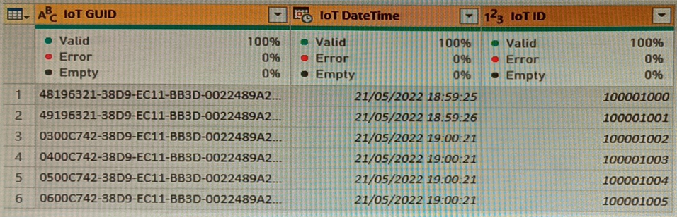

Correct answer
Yes
No
Overall explanation
Yes, removing the IoT ID column and retaining the IoT GUID column in the Power Query Editor will meet the goal of analyzing IoT events by the hour and day of the year while improving dataset performance. Since the IoT GUID column is unique to each row in the query, it can still be used as a reliable identifier for the events. By removing the IoT ID column, which is not necessary for the analysis, the dataset becomes more streamlined and efficient, resulting in improved performance.
Domain
Cloud Computing
Question 35Skipped
What is the purpose of specifying the home directory for R or Python in Power BI Desktop?
To ensure the correct installation of R or Python
To specify the location of additional packages
To launch the integrated development environment (IDE)
Correct answer
To enable the creation of R or Python visuals in Power BI Desktop
Overall explanation
Specifying the home directory for R or Python in Power BI Desktop enables the creation of R or Python visuals in Power BI Desktop.
Domain
Data Visualization
Question 36Skipped
What is the purpose of using DAX in data analysis?
To create insightful visuals without writing DAX
Correct answer
To perform calculations and query data
To filter specific columns in a data table
To mix values of different data types in the same column
Overall explanation
DAX is used to perform calculations and query data in order to derive insights from the data.
Domain
Data Analysis
Question 37Skipped
What solution should you suggest to minimize the query size sent to the Azure SQL database when publishing dataset changes to the development, test, or production pipelines in order to address the reported increase in query volume from the Power BI service?
Disable automatic refreshing when publishing modifications to the dataset in the Power BI service.
Correct answer
Convert the fact table in the dataset from an import table to a hybrid table.
Activate the large dataset storage format for the workspace.
Generate a dataset parameter to decrease the number of rows in the fact table within the development and test pipelines.
Overall explanation
The recommended solution to reduce the size of queries sent to the Azure SQL database when dataset changes are published to development, test, or production is to change the fact table from an import table to a hybrid table. By doing so, the dataset can leverage the benefits of DirectQuery storage mode, where the data remains in the Azure SQL database and Power BI sends queries directly to the database when users interact with the report. This approach significantly reduces the amount of data transferred between Power BI and the Azure SQL database, resulting in more efficient query execution and improved performance. Turning off auto refresh or enabling the large dataset storage format for the workspace would not directly address the issue of reducing query size, and creating a dataset parameter to reduce the fact table row count would not be as effective as changing the storage mode.
Domain
Data Management
Question 38Skipped
What is the purpose of the EXCEPT function in SQL?
Correct answer
To output all rows that are in the first table but not in the second table
To combine rows from two tables and remove duplicates
To output all rows that are common to both tables
To compare columns based on their positions
Overall explanation
The EXCEPT function is used to output all rows that are in the first table but not in the second table.
Domain
SQL
Question 39Skipped
What is the purpose of using the XMLA endpoint in Power BI?
To enable connections to Power BI workspaces
To visualize data in Excel
To edit datasets using third-party tools
Correct answer
To deploy and manage datasets
Overall explanation
The purpose of using the XMLA endpoint in Power BI is to deploy and manage datasets.
Domain
Business Intelligence
Question 40Skipped
What is the purpose of nesting let/in expressions in queries?
To improve query performance
Correct answer
To avoid conflicts between identifier names
To return the last expression defined in the let section
To show the steps in the Applied Steps pane
Overall explanation
Nesting let/in expressions is used to avoid conflicts between identifier names within the current scope.
Domain
Query Language

