Microsoft Certified: Power BI Data Analyst Associate | PL-300 | Practice Test 1 - Results

Question 1Skipped
You are working on a Power BI report that includes sensitive customer data. You need to configure Row-Level Security (RLS) to ensure that only certain users can view specific customer data based on their region.
The solution must restrict users from accessing data for regions they are not assigned to.
You are working with an external security team that will manage the RLS configuration but should not have access to the reports or the underlying dataset itself.
You need to set up the RLS configuration in Power BI Service. What should you do? Arrange the steps in the correct order.
I. Create security groups in Azure Active Directory for each region.
II. Add the external security team as members to the security groups.
III. Configure Row-Level Security (RLS) roles within the Power BI dataset.
IV. Assign users to the appropriate security groups based on their region.
V. Provide the external security team with access to manage the RLS roles in the Power BI workspace.
III, I, II, IV, V

Explanation
Configuring RLS roles should come after creating security groups and assigning users, not before.
IV, II, III, I, V

Explanation
Assigning users (IV) should not be the first step. Security groups need to be created first (I) before assigning users.
I, III, II, V, IV

Explanation
This order configures RLS roles before assigning users to security groups, which is not the correct sequence.
Correct answer
I, II, IV, III, V

Explanation
This is the correct order for implementing RLS:
- Create security groups in Azure Active Directory (AAD) for each region (I).
- Add the external security team as members of those groups (II).
- Assign users to the appropriate security groups based on their region (IV).
- Configure RLS roles in the Power BI dataset (III).
- Provide the external security team access to manage the RLS roles in Power BI Service (V).
Overall explanation
Row-Level Security (RLS) in Power BI Service allows organizations to control access to specific data rows based on user attributes. When working with an external security team, the best practice is to use Azure Active Directory (AAD) security groups to manage user access efficiently.
Step-by-Step Guide to Implementing RLS with an External Security Team
- Create Security Groups in Azure Active Directory (AAD) (I)
  - Define security groups based on regions to manage user access.
  - This ensures scalability and simplifies user management.
  - Learn more about Creating Security Groups in AAD.
- Add the External Security Team to the Security Groups (II)
  - Grant the external security team access to manage security settings without giving them direct report or dataset access.
- Assign Users to the Appropriate Security Groups (IV)
  - Assign each user to their respective regional security group.
  - This ensures that RLS applies correctly when users log in to Power BI Service.
- Configure RLS Roles in Power BI Dataset (III)
  - Use DAX filters to restrict data access based on region:
    - DAX
    - CopyEdit[Region] = USERPRINCIPALNAME()
  - Assign security groups (not individual users) to RLS roles.
  - Read more on Configuring RLS in Power BI.
- Provide the External Security Team with Access to Manage RLS Roles (V)
  - In Power BI Service, go to Workspace Settings → Security.
  - Assign the external security team the role of "Contributor" or "Member" with RLS management permissions.
By following this sequence, RLS is correctly implemented, ensuring that each user only sees their assigned data, while the external security team can manage role assignments without accessing the actual dataset or reports.
Domain
Deploy and maintain assets
Question 2Skipped
You are creating a Power BI report for a restaurant chain. The data model includes the following tables:
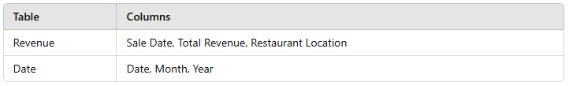

The management team wants to track the revenue for the same period last year and compare it with the current period. You already have a measure named Revenue to calculate the revenue for the current period.
Which best DAX formula should you use to calculate the revenue for the same period last year?
Correct answer
CALCULATE([Revenue], SAMEPERIODLASTYEAR(Date[Date]))

Explanation
SAMEPERIODLASTYEAR is specifically designed to calculate values for the exact same period (month, quarter, or year) in the previous year.
CALCULATE([Revenue], DATESYTD(Date[Date]))

Explanation
DATESYTD calculates the year-to-date values for the current year and does not account for the previous year, so it’s not suitable.
CALCULATE([Revenue], PARALLELPERIOD(Date[Date], -1, YEAR))

Explanation
PARALLELPERIOD shifts the time period by a specific interval, such as one year, but it doesn’t precisely match the same calendar period, making it less accurate for this scenario.
CALCULATE([Revenue], DATEADD(Date[Date], -12, MONTH))

Explanation
This formula uses DATEADD to shift the date back by 12 months. While it works, SAMEPERIODLASTYEAR is simpler and specifically designed for calculating the same period in the previous year.
Overall explanation
When analyzing year-over-year (YoY) comparisons in Power BI, it is essential to use the correct time intelligence function to ensure accuracy. Power BI offers several DAX functions designed for handling previous period calculations.
Key Time Intelligence Functions in DAX:
- SAMEPERIODLASTYEAR: This function calculates the value for the exact same period in the previous year. It is the best choice when you need a straightforward way to compare time-based metrics. Learn more about SAMEPERIODLASTYEAR in DAX.
- DATEADD: This function shifts dates by a specified interval (e.g., months, quarters, years). While it works for shifting time periods, SAMEPERIODLASTYEAR is a more direct and optimized approach. Details are available in DATEADD in DAX.
- PARALLELPERIOD: This function shifts the time period but does not ensure exact period matching across years. It is less precise when compared to SAMEPERIODLASTYEAR. Read more about PARALLELPERIOD in DAX.
- DATESYTD: This function calculates Year-To-Date (YTD) values, meaning it only considers data from the current year. It does not return prior-year comparisons, making it unsuitable for this scenario. Learn more about DATESYTD in DAX.
Using SAMEPERIODLASTYEAR ensures an accurate year-over-year revenue comparison while keeping the formula simple and efficient.
Domain
Model the data
Question 3Skipped
At SkyMetrics Corp., you want to create a date table in Power BI using DAX to support a sales report. The table needs to include columns for Year, Month, Day, and Quarter.
Which DAX formula should you use to generate the base date table?
CALENDAR(DATE(2020,1,1), DATE(2023,12,31))

Explanation
This formula generates a list of sequential dates between January 1, 2020, and December 31, 2023. However, it does not include additional columns such as Year, Month, or Quarter, making it incomplete for this requirement.
Correct answer
ADDCOLUMNS(CALENDAR(DATE(2020,1,1), DATE(2023,12,31)), "Year", YEAR([Date]), "Month"

Explanation
This formula uses CALENDAR to create a date range and ADDCOLUMNS to generate custom columns for Year, Month, and Quarter. It provides a structured date table that fully supports time-based reporting in Power BI.
DATESYTD(DATE(2020,1,1), DATE(2023,12,31))

Explanation
This function calculates Year-to-Date (YTD) values from a given start date, making it useful for trend analysis but not for creating a date table. It lacks the necessary structure for building a full date dimension table.
CALENDARAUTO()

Explanation
This function automatically creates a date table based on the earliest and latest date in the dataset. While convenient, it does not generate custom columns such as Year, Month, or Quarter, making it less flexible for manual control over date ranges.
Overall explanation
A date table is essential for enabling time intelligence calculations in Power BI, such as year-over-year comparisons, trend analysis, and dynamic filtering. The best approach for creating a custom date table in Power BI is to use the CALENDAR function along with ADDCOLUMNS, allowing the inclusion of custom attributes like Year, Month, and Quarter.
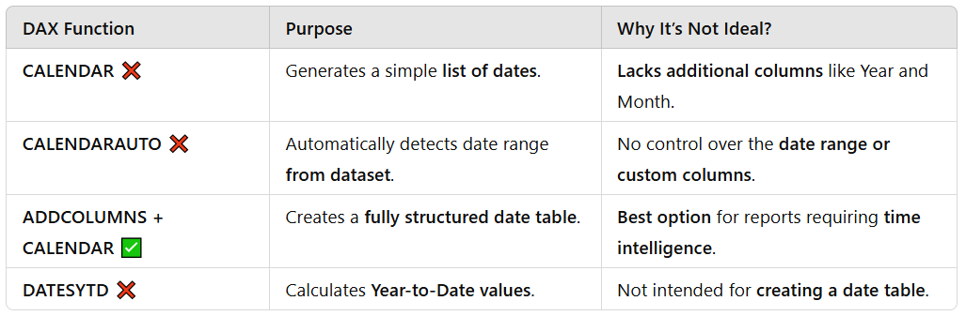
To implement a fully functional date table, use the following DAX formula:
- DateTable =
- ADDCOLUMNS(
- CALENDAR(DATE(2020,1,1), DATE(2023,12,31)),
- "Year", YEAR([Date]),
- "Month", MONTH([Date]),
- "Quarter", QUARTER([Date])
- )
For a more dynamic approach, you can use CALENDARAUTO() if the dataset already contains date fields, but ADDCOLUMNS + CALENDAR provides greater flexibility and control.
Learn more about Creating a Date Table in Power BI.
By creating a structured date table, Power BI users at SkyMetrics Corp. can enable powerful time-based analysis, trend forecasting, and dynamic filtering, ensuring more accurate sales insights.
Domain
Model the data
Question 4Skipped
You are building a sales performance report in Power BI. The report contains the following visuals:
- A pie chart showing the percentage of sales by product category.
- A line chart showing the monthly total revenue trend.
The sales manager wants to see how each product category contributes to the monthly revenue trend without filtering out other product categories.
How should you configure the interaction between the pie chart and the line chart?
Correct answer
Enable proportional highlighting to show contributions for the selected category.

Explanation
Proportional highlighting allows the line chart to display the total monthly revenue trend while emphasizing the contribution of the selected product category. This meets the requirement perfectly.
Apply filtering to display only the selected product category.

Explanation
Filtering removes the other product categories, which does not allow for a comparison of the selected category’s contribution to the total revenue trend.
Disable all interactions between the visuals.

Explanation
Disabling interactions prevents any analysis of how a product category contributes to the overall trend, making it an ineffective approach.
Show values as a tooltip when hovering over the product category.

Explanation
Using tooltips does not meet the requirement of showing the contribution of the selected category within the monthly revenue trend. Tooltips only provide additional details when hovering but do not visually emphasize the category’s contribution.
Overall explanation
In Power BI, visual interactions play a crucial role in data exploration and analysis. When multiple visuals are present, users can configure how interactions affect each other to provide better insights.
Key Visual Interaction Options in Power BI:
- Filtering: Selecting a value in one visual filters the data in another visual, showing only the relevant subset. While useful, this removes other values, which is not ideal in this scenario. Learn more about Filtering in Power BI Visuals.
- Highlighting: This keeps all data visible but emphasizes the selected value, making it easy to compare contributions within the overall dataset. Proportional highlighting is the best choice here, as it allows users to see the total monthly revenue trend while also highlighting the selected product category’s contribution. Read more about Highlighting in Power BI.
- Tooltips: Display additional details on hover, but they do not modify how data is presented in a visual. They are helpful but do not meet the requirement of emphasizing a category’s contribution within the trend. More details on Tooltips in Power BI.
- Disabling Interactions: Prevents any relationship between visuals, which is not useful in scenarios where users want to explore data dynamically.
By enabling proportional highlighting, the sales manager can effectively see how each product category contributes to the monthly revenue trend, without losing visibility into other categories, making it the best approach.
Domain
Visualize and analyze the data
Question 5Skipped
At EcoMetrics Analytics, your Power BI report contains a Sales table linked to three Date tables, each representing a different role:
✔ OrderDate
✔ ShipDate
✔ DeliveryDate
Your manager wants to filter the report by year, and the filter should apply simultaneously to all three date roles.
How should you implement this requirement?
Create three slicers: one for OrderDate, one for ShipDate, and one for DeliveryDate.

Explanation
This approach forces users to manually adjust three different slicers, increasing the risk of inconsistent selections and making the report less user-friendly.
Merge the three date columns into one in the Sales table and link it to a single Date table.

Explanation
Merging the date columns into one field would remove the ability to analyze each date role separately, making it impossible to track OrderDate, ShipDate, and DeliveryDate independently.
Correct answer
Create a master Date table, link it to the report, and use DAX measures to filter the three role-playing date tables.

Explanation
A master Date table provides a centralized date dimension, ensuring that filters applied to it automatically propagate to all role-playing date tables. DAX measures help link each date column to the master Date table dynamically, maintaining consistent filtering across the report.
Use a slicer connected to each Date table individually.

Explanation
This would require users to manually apply multiple slicers, making the report inefficient and confusing. Users may unintentionally select different years for each slicer, leading to inconsistent filtering.
Overall explanation
In Power BI, role-playing dimensions occur when multiple date columns in a fact table need to reference the same Date table. Since Power BI does not allow multiple active relationships between a fact table and a single Date table, a master Date table must be created to handle filtering across multiple date roles.
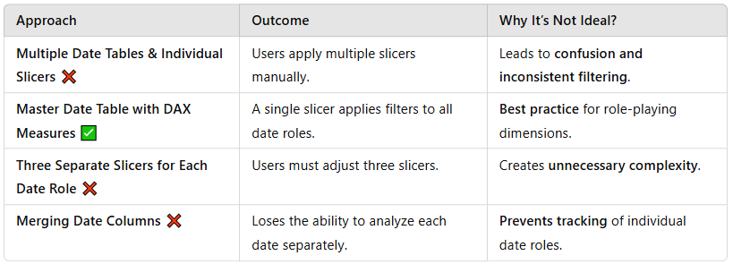
How to Implement a Master Date Table for Role-Playing Dates?
1️⃣ Create a Master Date Table
- Use CALENDAR() or CALENDARAUTO() to generate a unified Date table.
- MasterDate = CALENDARAUTO()
2️⃣ Establish Relationships
- Create inactive relationships between Sales[OrderDate], Sales[ShipDate], and Sales[DeliveryDate] with the Master Date Table.
- The relationships remain inactive to avoid ambiguity.
3️⃣ Use DAX Measures to Apply Filters Dynamically
- Create DAX measures to activate the relevant relationship dynamically when needed.
- Sales by Order Date =
- CALCULATE(SUM(Sales[Total Sales]), USERELATIONSHIP(Sales[OrderDate], MasterDate[Date]))

- Sales by Ship Date =
- CALCULATE(SUM(Sales[Total Sales]), USERELATIONSHIP(Sales[ShipDate], MasterDate[Date]))

- Sales by Delivery Date =
- CALCULATE(SUM(Sales[Total Sales]), USERELATIONSHIP(Sales[DeliveryDate], MasterDate[Date]))
4️⃣ Use a Single Slicer for Filtering
- Add a slicer from the Master Date Table, ensuring that it controls all three role-playing date fields simultaneously.
For more details, refer to Managing Role-Playing Dimensions in Power BI.
By implementing a Master Date Table with DAX measures, reports remain consistent, scalable, and easy to use, allowing users to filter by year effortlessly while maintaining the ability to analyze OrderDate, ShipDate, and DeliveryDate separately.
Domain
Model the data
Question 6Skipped
You are using the Performance Analyzer pane in Power BI Desktop to evaluate the performance of visualizations on a report page.
✔ The report contains visuals such as a map, a pie chart, a line chart, and a bar chart.
✔ The Performance Analyzer results show that the "Order Total by Shipping Fee" visual is taking significant time to process.
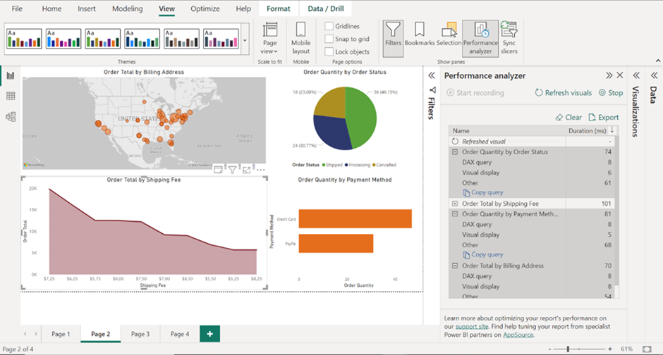
Which actions can you take to optimize the performance of this visual? (Select all that apply)
Correct selection
Replace the visual with a simpler chart type to reduce rendering time.

Explanation
Complex visuals like maps and pie charts take longer to render. Switching to bar charts or tables can improve visual rendering speed.
Correct selection
Optimize the DAX query used in the visual.

Explanation
The Performance Analyzer highlights DAX query execution as a major performance bottleneck. Optimizing DAX can reduce query execution time, improving report responsiveness.
Enable query reduction settings in Power BI Desktop.

Explanation
Reduces slicer & visual interactions, but does not improve individual visual performance. Useful for large reports with frequent user interactions, not static visual optimization.
Use a smaller dataset by applying row-level security (RLS).

Explanation
RLS controls access, not performance. Reducing dataset size before import is a more effective optimization approach.
Overall explanation
The Performance Analyzer pane in Power BI helps diagnose slow report performance by breaking down execution times into:
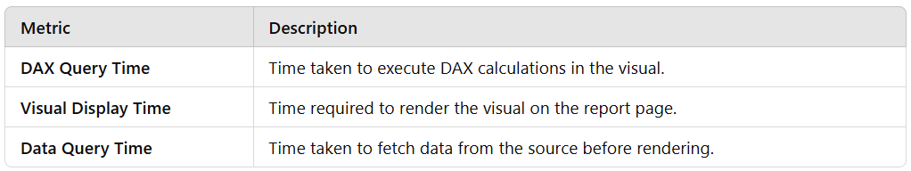
Key Strategies to Optimize Power BI Report Performance
🔹 Optimize DAX Queries
- Avoid iterators (SUMX, FILTER) when simple aggregations (SUM, AVERAGE) suffice.
- Use pre-aggregated tables where possible to reduce computation load.
- Reduce dependencies in measures to limit recursive calculations.
- More details: Optimizing DAX Queries in Power BI.
🔹 Use Simpler Visuals
- Avoid heavy visuals like maps, complex pie charts, and multi-line charts.
- Use bar charts, column charts, or tables to improve rendering speed.
- More details: Choosing the Right Power BI Visual.
🔹 Reduce Data Volume Efficiently
- Apply data transformations before import instead of relying on filters later.
- Summarize large datasets in SQL or Power Query before loading into Power BI.
🔹 When to Use Query Reduction Settings?
- Reduces slicer refreshes & cross-filtering queries, preventing excessive queries.
- Best for interactive dashboards where users frequently apply filters.
- More details: Reducing Query Interactions in Power BI.
To enhance report performance, focus on DAX optimization, reducing visual complexity, and efficient data management. Query reduction settings help in interactive scenarios, but they do not fix slow rendering issues. Power BI users should leverage Performance Analyzer to identify bottlenecks and apply the right optimizations for a smoother user experience.
Domain
Model the data
Question 7Skipped
You are a data analyst at HealthTrack Solutions, responsible for ensuring that a Power BI report displaying patient care statistics meets accessibility standards for stakeholders, including those with color blindness, screen reader reliance, and keyboard navigation needs.
What steps should you take to ensure that the report is accessible to users with color blindness? (Select all that apply)
Add descriptions to every visual in the report.

Explanation
While alt text and descriptions are essential for screen reader users, they do not specifically address color blindness. Descriptions help with navigability but do not resolve issues related to distinguishing colors.
Correct selection
Avoid using red and green together in charts.

Explanation
Red-green combinations are one of the most common challenges for color-blind users. Many people with deuteranopia (red-green color blindness) cannot easily differentiate these colors, making it essential to use alternative color pairings or non-color indicators.
Correct selection
Use patterns or textures to differentiate chart elements.

Explanation
Instead of relying solely on color variations, using patterns, textures, or distinct shapes helps ensure that all users can differentiate chart elements, even if they cannot distinguish specific colors. Striped or dotted fills in bar charts and different line styles in line charts improve clarity.
Correct selection
Use high-contrast themes in the report.

Explanation
High-contrast themes enhance text and visual clarity, making it easier for users with low vision or color vision deficiencies to interpret data. Power BI provides built-in accessibility themes that can improve visibility.
Overall explanation
Designing accessible Power BI reports ensures that all users, including those with visual impairments, can interpret data effectively. Color blindness affects a significant percentage of users, making it crucial to apply best practices to improve readability and usability.
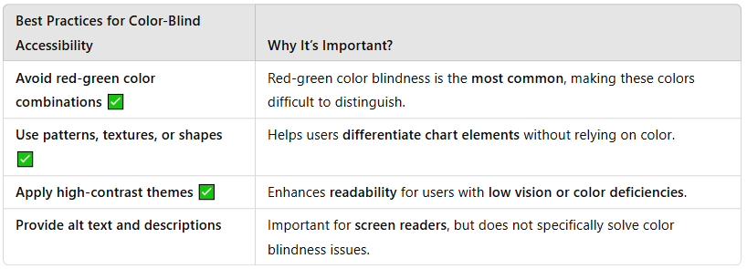
In addition to color choices, other accessibility enhancements include:
- Enabling keyboard navigation for users who cannot use a mouse.
- Using alt text for visuals to support screen readers.
- Checking accessibility in Power BI using the Accessibility Checker.
For further guidance, refer to Power BI Accessibility Guidelines.
By implementing these practices, Power BI reports become more inclusive, ensuring that stakeholders with diverse accessibility needs can fully engage with healthcare analytics.
Domain
Visualize and analyze the data
Question 8Skipped
You are building a Power BI dashboard for an e-commerce platform, which includes a card visualization displaying the average delivery time (in days) for shipped orders.
✔ Operations Team Requirement:
- If delivery time > 5 days, font must be red (indicating delay).
- If delivery time ≤ 5 days, font must be green (indicating on-time delivery).
You need to apply conditional formatting to achieve this while minimizing design complexity.
Field value

Explanation
This method requires creating a separate calculated field that dynamically returns color values (e.g., "Red" or "Green"). While this method works, it adds unnecessary complexity compared to Rules-based formatting, which can achieve the same result more efficiently.
Color scale

Explanation
This approach applies gradient-based formatting, where colors change based on a range of values. It does not allow explicit condition settings for specific font colors (red or green), making it unsuitable for this requirement.
Correct answer
Rules

Explanation
Rules-based conditional formatting allows you to set explicit conditions such as "greater than 5 days = red" and "5 days or less = green". This method is simple, effective, and minimizes complexity, making it the best approach.
Overall explanation
Conditional formatting in Power BI allows users to dynamically change visual elements based on data values. The Rules-based method is ideal for scenarios where you need explicit thresholds for formatting, like setting delivery time-based alerts.
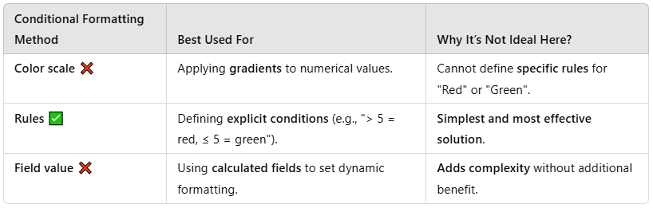
How to Apply Rules-Based Formatting in Power BI?
1️⃣ Select the Card Visual (Average Delivery Time).
2️⃣ Go to the Format Pane → Expand Data Label.
3️⃣ Click fx (Conditional Formatting Button).
4️⃣ Select Rules and define conditions:
- If value > 5, then Red.
- If value ≤ 5, then Green.
5️⃣ Click Apply to save the changes.
For more details, refer to Conditional Formatting in Power BI.
By using Rules-based conditional formatting, Power BI dashboards can effectively highlight important metrics, making insights clear and actionable for stakeholders.
Domain
Visualize and analyze the data
Question 9Skipped
CASE STUDY:
Company A, a retail and manufacturing organization, is undergoing a digital transformation to enhance data-driven decision-making. The organization has recently adopted Power BI for analytics and reporting. The analytics team is tasked with creating reports, managing datasets, and sharing insights with key business units such as Sales, Marketing, Finance, and Operations.
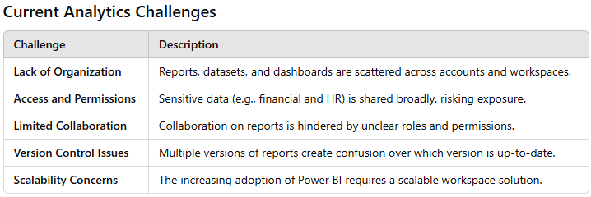

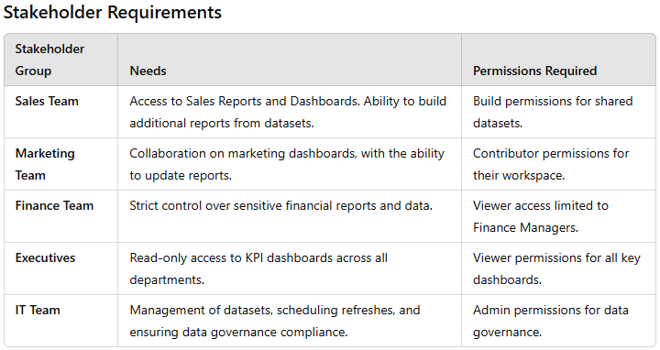

Business Challenges
You are tasked with addressing the following challenges while ensuring collaboration, security, and scalability:
- Designing Workspaces: How should workspaces be structured to meet departmental needs while ensuring data security and collaboration?
- Managing Permissions: What roles and permissions should be assigned to balance collaboration and security?
- Version Control: How can you maintain a single source of truth for reports and datasets?
- Data Governance: How can you ensure compliance with organizational policies and data privacy regulations?
- Scalability: How can you design a future-proof analytics environment for growing Power BI adoption?

Question:
You need to create a structured workspace setup that supports collaboration, security, and scalability. How would you design the workspaces?
Create a single workspace for all departments and use filters to control access.

Explanation
A single workspace does not allow for granular access control and can lead to security risks.
Create a workspace for each department and assign individual datasets to team members.

Explanation
Assigning datasets to individuals reduces collaboration and increases management overhead.
Correct answer
Create separate workspaces for each department and one for executives.

Explanation
Separate workspaces allow you to manage access and permissions by department, ensuring security and collaboration.
Use personal workspaces for all team members and share assets individually.

Explanation
Personal workspaces are not suitable for organizational collaboration.
Overall explanation
To address the challenges of collaboration, data security, version control, data governance, and scalability, it is best to structure workspaces by department while also creating a dedicated workspace for executives. This approach meets several key requirements:
- Department-Specific Workspaces:
By creating separate workspaces for each department (Sales, Marketing, Finance, and Operations), you ensure that content is organized according to functional areas. This setup provides clear boundaries, enabling each department to manage its reports and datasets according to its specific needs while also enforcing access restrictions on sensitive data. It simplifies permission management by allowing you to assign roles (Admin, Member, Contributor, Viewer) tailored to the needs of each department.
Reference: For best practices on creating and managing workspaces, see Microsoft's guidance on Create, use, and manage workspaces in Power BI
.

- Dedicated Workspace for Executives:
Executives often require a consolidated, read-only view of key performance indicators (KPIs) and dashboards from various departments. A separate workspace for executives allows you to curate content from multiple departmental workspaces while maintaining strict viewer permissions. This ensures a single source of truth for high-level reporting and reduces the risk of version control issues.
- Scalability and Governance:
Structuring workspaces in this manner helps maintain a single source of truth, simplifies version control, and supports a scalable analytics environment. As Power BI adoption grows, this approach makes it easier to manage access, enforce data governance policies, and ensure compliance with organizational data privacy regulations.
.

Why Other Options Are Not Ideal
- Creating a Workspace for Each Department with Individual Dataset Assignments:
While this might seem to offer granularity, it can lead to a fragmented environment where reports and datasets are scattered. This approach may complicate collaboration and version control, making it harder to maintain a consistent, single source of truth.
- Using a Single Workspace for All Departments with Filters:
A single workspace may simplify management initially, but it does not provide the level of granular access control required for sensitive data. Departments have distinct security and collaboration needs, and a single workspace increases the risk of unauthorized data access.
- Using Personal Workspaces for All Team Members:
Personal workspaces are designed for individual use and are not suitable for collaborative reporting. Sharing assets individually can lead to confusion over report versions and does not support centralized data governance or scalability.

The optimal design is to create separate workspaces for each department and an additional workspace dedicated to executives. This structured approach supports collaboration, enhances security by restricting access to sensitive data, simplifies version control, and scales as Power BI adoption increases across the organization.
For further reading on workspace management and governance best practices, please refer to the official Microsoft documentation:
- Create, use, and manage workspaces in Power BIlearn.microsoft.com
Domain
Case Study
Question 10Skipped
You are a data analyst at OptiMetrics Inc., and your team wants to ensure data quality before creating a report. You need to evaluate a dataset in Power BI to check for missing values, column distributions, and the minimum and maximum values in each column.
What tool or feature in Power BI should you use?
Filters in Power BI Desktop

Explanation
Filters refine the data displayed in visuals, allowing users to focus on specific subsets of information. They do not offer data profiling capabilities or allow users to view summary statistics about the dataset.
Power BI Service > Dataset Settings

Explanation
The Dataset Settings in Power BI Service are primarily used for managing refresh schedules, data source credentials, and permissions. They do not include data profiling features or allow users to examine column-level statistics.
Correct answer
Query Editor > Data Profiling View

Explanation
The Data Profiling View in Power BI Query Editor provides an in-depth analysis of column properties, including value distributions, missing values, and minimum/maximum values. This tool is essential for data quality assessment before report creation.
Slicers in Power BI Desktop

Explanation
Slicers are interactive filtering tools that enable users to filter data within reports. However, they do not provide statistical insights about the dataset, such as missing values or distributions.
Overall explanation
Before creating reports, ensuring data quality is a crucial step in the Power BI workflow. Power BI provides various tools to manage and analyze data, but the Data Profiling View in Query Editor is specifically designed for evaluating column properties, identifying missing values, and assessing distributions.
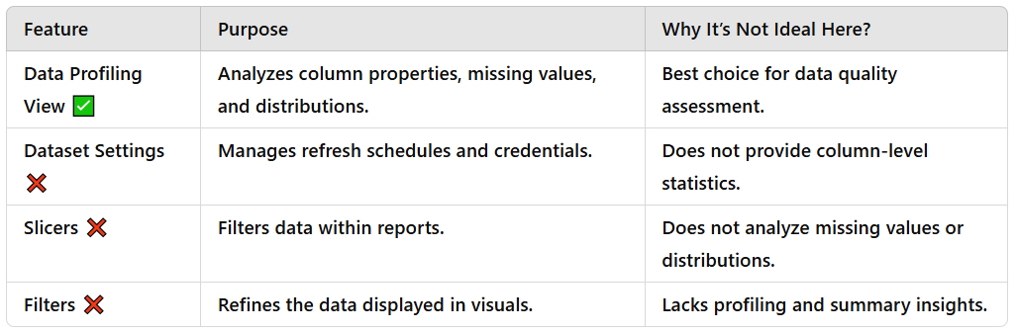
The Data Profiling View offers essential features such as Column Distribution, Column Quality, and Column Profile, which help users detect inconsistencies, missing values, and outliers before creating reports.
To enable Data Profiling View, go to Power Query Editor and turn on Column Quality, Column Distribution, and Column Profile under View > Data Profiling.
For more details, refer to Data Profiling in Power BI Query Editor.
By leveraging Data Profiling, analysts at OptiMetrics Inc. can ensure that data is clean, complete, and reliable, leading to more accurate and insightful reports.
Domain
Prepare the data
Question 11Skipped
You are analyzing a Power BI data model for an e-commerce platform. The model includes two tables:
- HighSpenders: Contains a list of customers who have spent more than $1,000 in the past year.
- RecentBuyers: Contains a list of customers who made a purchase in the last 30 days.
A calculated table is defined in the model as:
FrequentHighSpenders = INTERSECT(HighSpenders, RecentBuyers)
You need to determine the rows that will be returned in the FrequentHighSpenders table based on this DAX expression. What will the output look like?
All customers from HighSpenders and RecentBuyers.

Explanation
INTERSECT does not merge all rows; it only returns the rows that exist in both tables. To get all customers from both tables, the UNION function would be required instead.
Customers from HighSpenders who are not in RecentBuyers.

Explanation
INTERSECT does not return exclusive rows. Again, to achieve this output, the EXCEPT function would need to be used.
Correct answer
Customers who are in both HighSpenders and RecentBuyers.

Explanation
The INTERSECT function returns only the rows that are common to both tables. In this case, it will return customers who appear in both HighSpenders and RecentBuyers.
Customers from RecentBuyers who are not in HighSpenders.

Explanation
This output would require the use of the EXCEPT function, not INTERSECT, to filter out customers from RecentBuyers who are not in HighSpenders.
Overall explanation
When working with DAX functions in Power BI, it is essential to understand set operations such as INTERSECT, UNION, and EXCEPT, which help in filtering and combining tables effectively.
Key DAX Functions for Set Operations:
- INTERSECT: This function returns only the common rows present in both tables. It is useful when filtering datasets to find customers, products, or transactions that exist in multiple lists. Learn more about INTERSECT in DAX.
- UNION: This function combines all rows from both tables, including duplicates. If the goal was to return all customers from both tables, UNION would be the appropriate function. Read more about UNION in DAX.
- EXCEPT: This function returns rows that are present in the first table but not in the second table. If the goal was to find customers from RecentBuyers who are not in HighSpenders, EXCEPT would be used. Details can be found in EXCEPT in DAX.
By using INTERSECT, the FrequentHighSpenders table correctly filters only the customers who appear in both tables, making it the best choice for this scenario.
Domain
Model the data
Question 12Skipped
In the screenshot, the refresh schedule includes three times: 1:00 AM, 9:00 AM, and 5:00 PM.
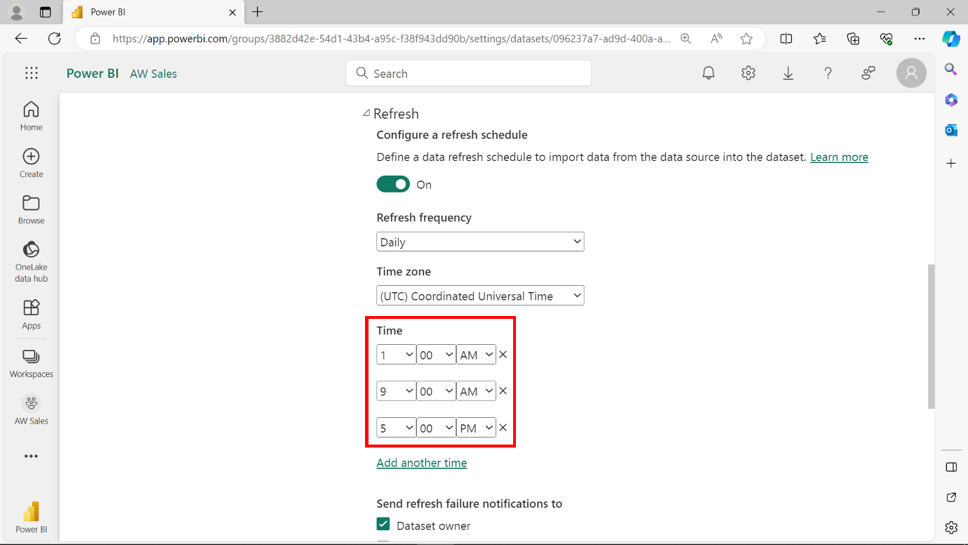
What is the maximum number of refreshes allowed per day for a dataset in the Power BI Pro license?
Correct answer
8 refreshes per day

Explanation
A Power BI Pro license allows users to schedule up to 8 automatic dataset refreshes per day. If additional refreshes are needed, a Power BI Premium capacity is required.
6 refreshes per day

Explanation
This answer is incorrect because Power BI Pro supports up to 8 scheduled refreshes per day, not 6. While fewer refreshes can be scheduled, the maximum limit is 8 per 24-hour period.
12 refreshes per day

Explanation
This is incorrect because the 12-refresh limit applies to Power BI Premium. A Pro license is capped at 8 refreshes per day, while Premium allows up to 48 refreshes per day for paginated reports and 12 for standard datasets.
Unlimited refreshes per day

Explanation
Power BI does not support unlimited refreshes, even in Premium. There are defined refresh limits based on the license type and service plan.
Overall explanation
Power BI dataset refresh limits vary based on license type. A Power BI Pro license allows a maximum of 8 scheduled refreshes per day, ensuring datasets stay reasonably up to date without overloading system resources.
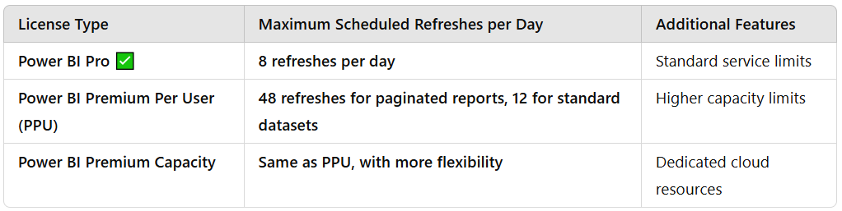
A scheduled refresh updates the dataset from its original data source, ensuring users see the latest data. If users require more than 8 refreshes per day, Power BI Premium is required.
For more details, refer to Power BI Dataset Refresh Limits.
By understanding refresh limits, SkyMetrics Corp. can ensure efficient data updates without exceeding Power BI Pro’s capabilities.
Domain
Deploy and maintain assets
Question 13Skipped
You are using Power Query to prepare a dataset for analysis. You import two tables, EmployeeData and SalaryDetails, from a SQL Database.
The image below shows the snapshots of these tables.
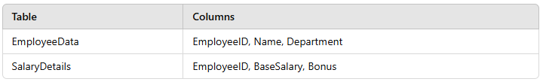

You need to combine the two tables into a single query that contains the unique columns from both tables for analysis. What should you do in Power Query Editor?
Use Transpose to reshape the data and then join the tables.

Explanation
Transpose changes the structure of the table by flipping rows and columns. This is unnecessary for joining tables and would not help in this scenario.
Use Append queries to combine the rows from both tables.

Explanation
Appending is used when you need to stack rows from two or more tables with the same schema, not when you need to combine related tables with different structures.
Correct answer
Use Merge queries and select EmployeeID as the join key.

Explanation
Merging queries is the appropriate choice when you want to combine tables by matching rows based on a common column, such as EmployeeID in this case. It keeps the unique columns from each table while maintaining a structured relationship.
Use Combine files to integrate the data from the two tables.

Explanation
Combine Files is used when importing multiple files (e.g., CSV or Excel) with the same structure, not for combining relational tables.
Overall explanation
When working with Power Query in Power BI, choosing the correct table combination method depends on the data structure and the desired output.
Key Methods to Combine Data in Power Query:
- Merging Queries:
  - Merging allows you to combine data from two tables based on a common column (e.g., EmployeeID).
  - This method is used when you need to integrate related tables while keeping all unique columns.
  - Learn more about Merging Queries in Power Query.
- Appending Queries:
  - Appending is used when you need to stack data vertically from two or more tables with the same structure (i.e., same columns but different rows).
  - It is not suitable for combining related tables.
  - More details can be found in Appending Queries in Power Query.
- Combining Files:
  - Used when importing multiple files from folders (e.g., CSV or Excel files with the same schema).
  - Not applicable for SQL tables.
  - Learn about it in Combining Files in Power Query.
- Transposing Data:
  - Transposing flips rows and columns, which is useful for reshaping data but not for joining tables.
  - See Transpose in Power Query for more details.
By merging queries using EmployeeID as the join key, Power BI combines the unique columns from EmployeeData and SalaryDetails, making it the best approach for integrating related tables in this scenario.
Domain
Prepare the data
Question 14Skipped
CASE STUDY:
Company A, a retail and manufacturing organization, is undergoing a digital transformation to enhance data-driven decision-making. The organization has recently adopted Power BI for analytics and reporting. The analytics team is tasked with creating reports, managing datasets, and sharing insights with key business units such as Sales, Marketing, Finance, and Operations.




Business Challenges
You are tasked with addressing the following challenges while ensuring collaboration, security, and scalability:
- Designing Workspaces: How should workspaces be structured to meet departmental needs while ensuring data security and collaboration?
- Managing Permissions: What roles and permissions should be assigned to balance collaboration and security?
- Version Control: How can you maintain a single source of truth for reports and datasets?
- Data Governance: How can you ensure compliance with organizational policies and data privacy regulations?
- Scalability: How can you design a future-proof analytics environment for growing Power BI adoption?
Company A’s analytics team is creating a Power BI dashboard to track Sales Representative Performance. The dataset includes the following tables:
- Sales Transactions Table: TransactionID, Date, ProductID, SalesRepID, QuantitySold, UnitPrice, Discount
- Sales Reps Table: SalesRepID, Name, Region, TargetSales
The business wants to measure how effectively each Sales Representative is meeting their monthly sales targets. The requirements are:
- Actual Sales = (QuantitySold × UnitPrice) - Discount
- Performance % = (Actual Sales ÷ Target Sales) × 100
- If a Sales Representative has no transactions for a month, their Performance % should show as 0% instead of a blank value.
Question:
Which of the following DAX measures will correctly calculate the Sales Performance % per Sales Representative, ensuring it shows 0% when there are no transactions?
- Sales Performance % =
- DIVIDE(
- CALCULATE(SUM('Sales Transactions'[UnitPrice] - 'Sales Transactions'[Discount])),
- SUM('Sales Reps'[TargetSales])
- ) * 100

Explanation
This DAX measure attempts to calculate the Sales Performance % per Sales Representative by calculating the difference between UnitPrice and Discount for all transactions. However, the logic for calculating the Performance % is incorrect, as it does not consider the QuantitySold. This measure may not ensure that the Performance % shows as 0% when there are no transactions.
- Sales Performance % =
- COALESCE(
- DIVIDE(
- SUMX('Sales Transactions', ('Sales Transactions'[QuantitySold] * 'Sales Transactions'
- [UnitPrice]) - 'Sales Transactions'[Discount]),
- SUM('Sales Reps'[TargetSales])
- ) * 100,
- 0
- )

Explanation
This DAX measure uses the COALESCE function to handle the scenario where there are no transactions for a Sales Representative. However, the calculation logic is not correctly structured, as the division by Target Sales is not handled properly. This measure may not ensure that the Performance % shows as 0% when there are no transactions.
- Sales Performance % =
- IF(
- ISBLANK(SUM('Sales Transactions'[QuantitySold])),
- 0,
- (SUMX('Sales Transactions', ('Sales Transactions'[QuantitySold] * 'Sales Transactions'
- [UnitPrice]) - 'Sales Transactions'[Discount])
- / SUM('Sales Reps'[TargetSales])) * 100
- )

Explanation
This DAX measure attempts to calculate the Sales Performance % per Sales Representative by checking if the QuantitySold is blank and assigning 0 in that case. However, the calculation logic is not correctly structured, as the division by Target Sales is not handled properly. This measure may not ensure that the Performance % shows as 0% when there are no transactions.
Correct answer
- Sales Performance % =
- DIVIDE(
- SUMX('Sales Transactions', ('Sales Transactions'[QuantitySold] * 'Sales Transactions'
- [UnitPrice]) - 'Sales Transactions'[Discount]),
- SUM('Sales Reps'[TargetSales]),
- 0
- ) * 100

Explanation
This DAX measure correctly calculates the Sales Performance % per Sales Representative by first calculating the Actual Sales using the SUMX function to iterate over each row in the 'Sales Transactions' table and then dividing it by the Target Sales. The DIVIDE function is used to handle the scenario where there are no transactions for a Sales Representative, ensuring that the Performance % shows as 0% in that case.
Overall explanation
Key Calculation:
For each Sales Representative, you need to compute:
- Actual Sales:
This is calculated as the sum over all transactions of
(QuantitySold × UnitPrice) – Discount.
- Performance %:
This is the ratio of Actual Sales to Target Sales (from the Sales Reps table) multiplied by 100.
Because you want to show 0% when there are no transactions, your measure must handle scenarios where the numerator or denominator might be blank or zero.
Measure Approaches:
- Using COALESCE with DIVIDE:
One approach is to wrap the DIVIDE function with COALESCE. The DIVIDE function already accepts an alternate result (0 in this case) if the denominator is zero or blank. Wrapping it in COALESCE ensures that even if the overall expression returns a blank, it’s replaced with 0.
Example:
  - SalesPerformance% =
  - COALESCE(
  - DIVIDE(
  - SUMX('Sales Transactions', ('Sales Transactions'[QuantitySold] * 'Sales Transactions'[UnitPrice]) - 'Sales Transactions'[Discount]),
  - SUM('Sales Reps'[TargetSales])
  - ) * 100,
  - 0
  - )
Reference: See Microsoft’s documentation on the DIVIDE function and COALESCE function.
Using DIVIDE with Alternate Result:

A more concise approach uses the alternate result parameter of the DIVIDE function directly. This function divides the sum of Actual Sales by Target Sales and returns 0 if the denominator is zero or blank.

Example:
- SalesPerformance% =
- DIVIDE(
- SUMX('Sales Transactions', ('Sales Transactions'[QuantitySold] * 'Sales Transactions'[UnitPrice]) - 'Sales Transactions'[Discount]),
- SUM('Sales Reps'[TargetSales]),
- 0
- ) * 100
- his measure meets the requirement because if there are no transactions (or the Target Sales value is missing/zero), DIVIDE returns 0.
- Using an IF Statement with ISBLANK:
Another valid approach is to explicitly check if there are no transactions by testing if the sum of QuantitySold is blank. If it is, the measure returns 0; otherwise, it performs the calculation.
Example:

  - SalesPerformance% =
  - IF(
  - ISBLANK(SUM('Sales Transactions'[QuantitySold])),
  - 0,
  - (SUMX('Sales Transactions', ('Sales Transactions'[QuantitySold] * 'Sales Transactions'[UnitPrice]) - 'Sales Transactions'[Discount])
  - / SUM('Sales Reps'[TargetSales])) * 100
  - )

Why the Alternative Option Is Not Suitable
Incorrect Calculation Ignoring QuantitySold:
One option attempted to calculate Actual Sales by summing (UnitPrice - Discount) directly, which ignores the QuantitySold. This approach does not correctly compute Actual Sales and thus fails to meet the requirement.
Conclusion
- The three approaches above all correctly calculate Sales Performance % and ensure a 0% output when there are no transactions. They use slightly different techniques:
  - One uses COALESCE with DIVIDE,
  - Another leverages DIVIDE with an alternate result,
  - The third uses an IF(ISBLANK()) check.
For further details on these functions and best practices in DAX, refer to the Microsoft documentation:
  - DIVIDE Function
  - COALESCE Function
  - SUMX Function
Domain
Case Study
Question 15Skipped
You are configuring scheduled refreshes for a dataset in Power BI.
Which of the following statements are true about dataset refreshes in Power BI? (Select all that apply)
Scheduled refreshes can use DirectQuery datasets.

Explanation
This statement is incorrect because DirectQuery does not require scheduled refreshes. In DirectQuery mode, data is retrieved in real time when users interact with the report, eliminating the need for scheduled updates. Scheduled refreshes only apply to Import mode datasets.
Correct selection
In Power BI Premium, you can schedule up to 48 refreshes per day for a dataset.

Explanation
Power BI Premium allows up to 48 scheduled refreshes per day (one every 30 minutes), compared to 8 refreshes per day for Power BI Pro. This makes Premium suitable for high-frequency data updates.
Scheduled refreshes do not support cloud-based data sources like SharePoint Online.

Explanation
Power BI fully supports scheduled refreshes for cloud-based data sources, such as SharePoint Online, OneDrive, and Azure SQL. Gateways are only required for on-premises data sources.
Correct selection
Dataset refresh history is limited to the last 30 days.

Explanation
Power BI retains dataset refresh history for the past 30 days or up to 60 refresh cycles, whichever is shorter. This allows users to track refresh performance and troubleshoot issues.
Correct selection
A refresh schedule can be paused and resumed in the Power BI service.

Explanation
In the Power BI service, users can pause and resume scheduled refreshes without deleting the configuration. This is useful when updates are temporarily unnecessary or to manage resource usage efficiently.
Correct selection
A dataset refresh will fail if the credentials for a data source are invalid or expired.

Explanation
A dataset refresh requires valid authentication credentials for each data source. If credentials are expired, changed, or revoked, the refresh will fail, and an error will appear in the dataset's refresh history. Users must update credentials in the Power BI service to resolve the issue.
Overall explanation
Power BI provides scheduled refresh functionality to keep imported datasets up to date. The number of refreshes per day depends on the license type.
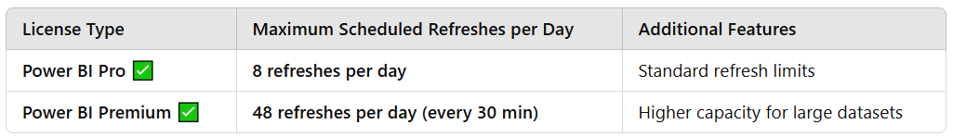
Scheduled refreshes do not apply to DirectQuery datasets, as data is always retrieved in real time when reports are accessed. Authentication credentials must be valid and up to date for refreshes to succeed. Cloud-based sources such as SharePoint Online, OneDrive, and Azure SQL support refresh scheduling, but on-premises data sources require a gateway.
Additionally, Power BI users can pause and resume refresh schedules based on business needs, ensuring efficient resource management. The refresh history is retained for 30 days or up to 60 refresh cycles, allowing users to monitor refresh performance over time.
For further details, refer to Power BI Scheduled Refresh Documentation.
By properly configuring scheduled refreshes, organizations can ensure accurate, up-to-date reports while maintaining optimal performance and resource utilization.
Domain
Deploy and maintain assets
Question 16Skipped
You are managing a sales analytics workspace in Power BI. A new team member needs to:
✔ Edit reports and dashboards
✔ Add other users to the workspace
The team follows the principle of least privilege, and the new member should not have the ability to delete the workspace or change its settings.
What steps should you take to assign the appropriate permissions to the new team member?
Assign the user the Viewer role in the workspace.
Verify the user can view reports but not add or edit content.

Explanation
The Viewer role only allows the user to view content and does not provide permissions to edit reports or manage members, making it insufficient for the user's needs.
Assign the user the Contributor role in the workspace.
Verify the user can edit content but cannot add new members.

Explanation
The Contributor role allows the user to edit reports and dashboards but does not allow them to manage members, which does not meet the requirement.
Assign the user the Admin role in the workspace.
Verify the user can add members and manage workspace settings.

Explanation
The Admin role provides unnecessary permissions, including the ability to delete the workspace or modify its settings. Assigning this role would violate the principle of least privilege.
Correct answer
Assign the user the Member role in the workspace.
Verify the user can add members and edit content without accessing advanced settings.

Explanation
The Member role allows the user to add other members and edit reports and dashboards. However, it does not grant permissions to delete the workspace or access advanced settings, making it the correct choice for this scenario.
Overall explanation
In Power BI, assigning the correct workspace role ensures that users have the necessary permissions while following the principle of least privilege.
Power BI Workspace Roles and Permissions
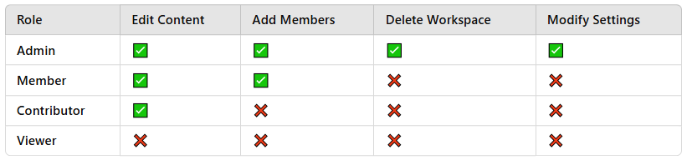
Best Role for This Scenario: "Member"
- Allows the user to edit reports and dashboards
- Grants permission to add other members
- Prevents them from deleting the workspace or modifying its settings
For more details, refer to Managing Power BI Workspace Roles.
By assigning the Member role, you ensure that the new team member can perform their tasks without unnecessary access, making it the best choice.
Domain
Deploy and maintain assets
Question 17Skipped
You are building a Power BI dashboard for an e-commerce platform. The dashboard includes a card visualization that displays the average delivery time (in days) for shipped orders.
The operations team requests that the font color of the card’s data label be formatted based on the following conditions:
- If the value is greater than 5 days, the font must be red to indicate a delay.
- If the value is 5 days or less, the font must be green to indicate on-time delivery.
You need to apply conditional formatting to achieve this while minimizing design complexity. Which format style should you use?
Color scale

Explanation
Color scale is used for gradient-based formatting and does not allow setting explicit conditions for specific font colors like red or green.
Correct answer
Rules

Explanation
Rules-based conditional formatting allows you to define explicit conditions (e.g., greater than 5 days → red, 5 days or less → green) and assign specific font colors. It is the simplest and most efficient method to meet the requirements.
Field value

Explanation
Field value formatting requires creating a separate field in the data model to determine the color. This would unnecessarily increase complexity for this scenario.
Overall explanation
In Power BI, conditional formatting enhances data visualization by dynamically adjusting visual elements based on specific criteria.
Best Format Style for This Scenario: "Rules"
- Rules-based conditional formatting allows you to:
  - Define specific thresholds for font color changes.
  - Set explicit conditions such as:
    - If "Average Delivery Time" > 5 → Red
    - If "Average Delivery Time" ≤ 5 → Green
  - Apply simple logic without modifying the data model.
  - Learn more about Rules-Based Formatting in Power BI.
Why Not Use Other Methods?
- Color Scale:
  - Works well for gradual color transitions but not for setting explicit conditions like "greater than 5 = red".
- Field Value:
  - Requires creating a separate field in the dataset to store color values, adding unnecessary complexity.
By using Rules-based formatting, you can efficiently highlight delivery performance in your card visualization, making it the best approach for this scenario.
Domain
Visualize and analyze the data
Question 18Skipped
At EcoMetrics Corp., you are tasked with creating a measure to calculate the Year-to-Date (YTD) Sales based on the Sales table, which includes the following columns:
OrderDate
SalesAmount
You already have a Date table in your data model that is marked as a date table.
Which DAX formula should you use to calculate the YTD Sales?
Correct answer
YTD Sales = CALCULATE(SUM(Sales[SalesAmount]), DATESYTD(Date[Date]))

Explanation
The DATESYTD function returns the set of dates from the start of the year to the current date, enabling the calculation of YTD Sales.
YTD Sales = CALCULATE(SUM(Sales[SalesAmount]), DATESINPERIOD(Date[Date], TODAY(), -1, YEAR))

Explanation
This calculates sales for the previous year, not YTD sales for the current year.
YTD Sales = CALCULATE(SUM(Sales[SalesAmount]), SAMEPERIODLASTYEAR(Date[Date]))

Explanation
This calculates the sales for the same period in the previous year, not the current year's YTD sales.
YTD Sales = SUM(Sales[SalesAmount])

Explanation
This calculates total sales but does not filter the results to include only Year-to-Date data.
Overall explanation
This measure calculates the Year-to-Date (YTD) Sales by summing the sales amounts within a dynamic time filter that covers the current year up to the last date in the current filter context.
- Aggregation with SUM:
The measure uses SUM(Sales[SalesAmount]) to aggregate all sales amounts from the Sales table.
- Modifying the Filter Context with CALCULATE:
Wrapping the aggregation within CALCULATE allows you to change the filter context. In this case, it applies a time filter to restrict the calculation to the dates from the beginning of the year until the current date context.
- Applying the DATESYTD Function:
DATESYTD(Date[Date]) returns a table containing dates starting from the beginning of the year up to the last date present in the current filter context. This function is specifically designed for YTD calculations, ensuring that only the relevant dates contribute to the aggregated sales total.
- Leveraging the Marked Date Table:
Since your data model already contains a Date table that is marked as a date table, Power BI’s time intelligence functions work correctly. The date table provides a continuous calendar that these functions use to compute periods like year-to-date accurately.
Documents and Further Readings
- Time Intelligence Functions in DAX:
Time Intelligence Functions in DAX
Domain
Model the data
Question 19Skipped
You are working on a Power BI report for the sales department. The report uses the following tables, as shown in the image:
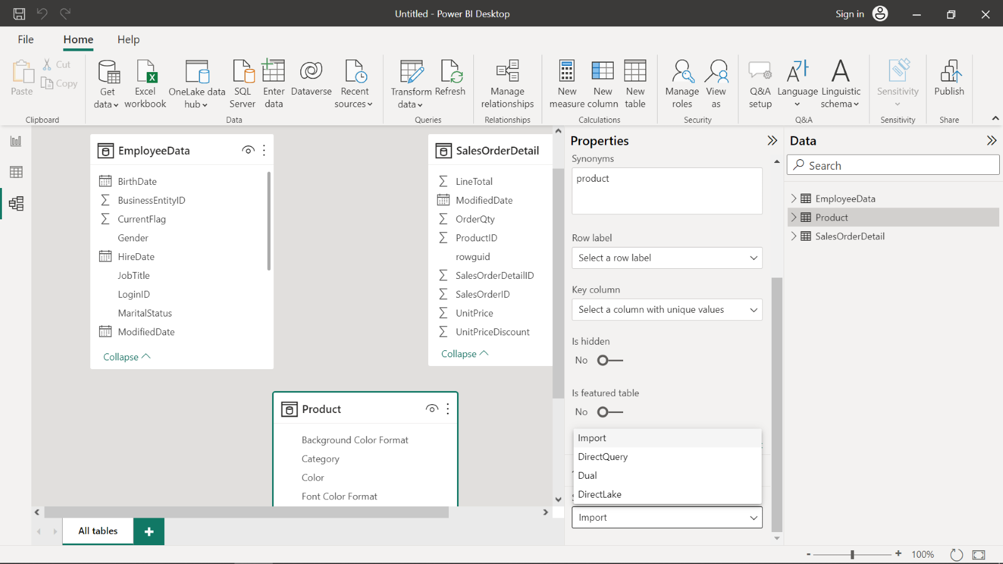

The Properties pane for the Product table is open. The storage mode is currently set to Import, but you need to analyze historical sales trends while maintaining real-time access to inventory updates.
Which storage mode configuration would best meet the requirement to balance historical analysis with real-time inventory updates?
Set the Product table to DirectQuery and the SalesOrderDetail table to Dual.

Explanation
Setting Product to DirectQuery forces all queries for that table to be live, slowing performance when analyzing large datasets. Using SalesOrderDetail in Dual mode offers flexibility, but does not compensate for the reduced performance of a DirectQuery Product table.
Keep the Product table as Import and set the SalesOrderDetail table to Dual.

Explanation
Keeping Product as Import means it cannot provide real-time inventory updates, which was the main requirement. Using SalesOrderDetail in Dual mode provides some flexibility, but does not resolve the need for real-time inventory updates.
Set the Product and SalesOrderDetail tables to Direct Query.

Explanation
While this ensures real-time data for both tables, it significantly slows down queries, especially when analyzing large amounts of historical data, leading to poor report performance.
Correct answer
Set the Product table to Dual and keep the SalesOrderDetail table as Import.

Explanation
Setting Product to Dual mode allows it to function in both Import (for faster historical queries) and DirectQuery (for real-time inventory updates). Keeping SalesOrderDetail as Import ensures efficient analysis of historical sales data.
Overall explanation
To effectively balance historical sales analysis with real-time inventory updates in Power BI, it's essential to understand the different storage modes available: Import, DirectQuery, and Dual. Each mode offers distinct advantages and considerations:

- Import Mode: This mode involves importing data into Power BI, storing it in-memory for fast query performance. It's ideal for historical data analysis but doesn't reflect real-time updates. Regular data refreshes are necessary to keep the data current. For more details, refer to Microsoft's documentation on Semantic model modes in the Power BI service.
- DirectQuery Mode: DirectQuery allows Power BI to query data directly from the source in real-time, ensuring that reports always display the most current data. However, this can impact performance, especially with large datasets, as each interaction sends a query to the underlying data source. Detailed information is available in the article DirectQuery in Power BI.
- Dual Mode: Dual mode enables a table to function as both Import and DirectQuery, allowing Power BI to choose the most efficient mode based on the query context. This flexibility is particularly useful when combining historical data analysis with the need for real-time updates. For a comprehensive understanding, see the section on Selecting a storage mode.
By configuring the Product table to Dual mode, Power BI can utilize in-memory data for historical analysis and switch to real-time queries for current inventory levels as needed. Keeping the SalesOrderDetail table in Import mode ensures efficient performance during historical sales trend analysis. This setup provides an optimal balance between up-to-date information and query performance.
For further insights and community discussions on Dual Storage Mode, you might find this thread helpful.
By leveraging these storage modes appropriately, you can design a Power BI model that meets both performance and real-time data requirements.
Domain
Prepare the data
Question 20Skipped
You are working on a Power BI report for EcoSolutions Corp. that combines data from two sources:
✔ A local Excel file
✔ A web-based API
Upon refreshing the report, you encounter a Privacy Level error due to mismatched privacy levels between the two data sources.
How should you resolve this issue?
Disable privacy levels entirely in Power BI Desktop options.

Explanation
Disabling privacy levels entirely can pose significant security risks and is not recommended.
Correct answer
Set the Privacy Level of both data sources to "Organizational" in the Privacy Level settings.

Explanation
Matching the Privacy Level to "Organizational" allows Power BI to combine the data securely while respecting privacy boundaries.
Set the Privacy Level of the Excel file to "Public."

Explanation
Setting the Excel file to "Public" reduces security for sensitive data and may not align with organizational policies.
Set both data sources to "Private" in the Privacy Level settings.

Explanation
Setting both sources to "Private" restricts data movement between sources and does not resolve the issue for combining data.
Overall explanation
In Power BI, Privacy Level settings help control data movement between sources to protect sensitive information.
Why Does This Error Occur?
- Privacy Level errors happen when Power BI combines data from different sources with conflicting privacy settings.
- The Excel file and web API have different privacy levels, preventing Power BI from merging them.
Best Solution: Set Both Data Sources to "Organizational"
✔ "Organizational" Privacy Level allows Power BI to combine the data while ensuring it remains protected within the organization.
✔ It resolves the error without compromising security.
✔ Learn more about Privacy Levels in Power BI.
Why Not Use Other Options?
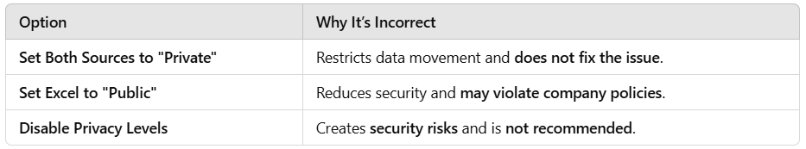
By setting both sources to "Organizational", you can securely merge data and prevent Privacy Level errors, making it the best approach.
Domain
Prepare the data
Question 21Skipped
You are on the Home tab of Power BI Desktop. The toolbar provides options for importing data, refreshing data, and transforming it.
Which of the following actions can be performed directly from the Home tab? (Select all that apply)
Correct selection
Importing data from an Excel workbook.

Explanation
The "Get Data" button on the Home tab allows users to import data from various sources, including Excel workbooks. Power BI supports multiple data sources such as SQL Server, CSV files, APIs, and cloud-based data sources.Once imported, data can be transformed using Power Query or directly used in reports. Learn more about Getting Data in Power BI.
Creating a new calculated column.

Explanation
Calculated columns are created in the Modeling tab, not the Home tab. A calculated column is a DAX-based column added to a dataset for additional computations. The Modeling tab provides options to create calculated columns, measures, and new tables. More details: Using Calculated Columns in Power BI.
Applying row-level security (RLS).

Explanation
RLS (Row-Level Security) is managed from the Modeling tab under Manage Roles. RLS restricts data access at the row level based on user roles. It is commonly used in multi-user Power BI environments where different users should see only the data relevant to them. Learn more: Configuring Row-Level Security (RLS).
Correct selection
Refreshing the dataset.

Explanation
The "Refresh" button on the Home tab allows users to update datasets by retrieving the latest data from the original sources. This is particularly useful when working with dynamic data sources that update frequently, such as SQL databases, cloud data, or web APIs. In Import Mode, the data is refreshed based on a defined schedule. In DirectQuery Mode, data is retrieved in real-time upon interaction. More details: Refreshing Data in Power BI.
Overall explanation
The Home tab in Power BI Desktop provides essential functionalities for data loading, transformation, and updating.
Key Functions of the Home Tab:
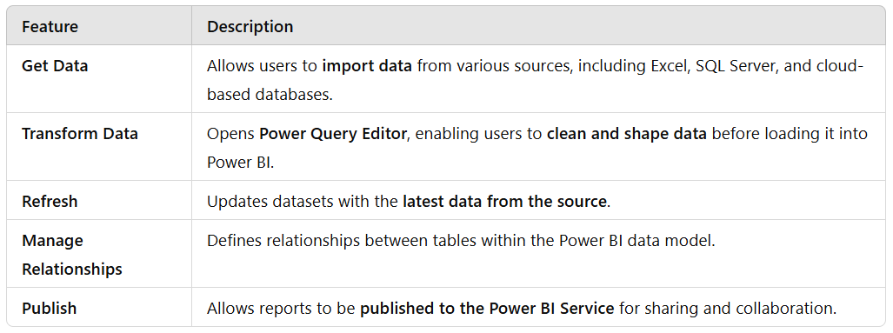
While the Home tab focuses on data acquisition and updates, tasks like creating calculated columns and configuring RLS require the Modeling tab.
By understanding which actions are available in the Home tab, users can efficiently import, transform, and refresh data, making it the first step in the Power BI data workflow.
Domain
Visualize and analyze the data
Question 22Skipped
CASE STUDY:
Company A, a retail and manufacturing organization, is undergoing a digital transformation to enhance data-driven decision-making. The organization has recently adopted Power BI for analytics and reporting. The analytics team is tasked with creating reports, managing datasets, and sharing insights with key business units such as Sales, Marketing, Finance, and Operations.




Business Challenges
You are tasked with addressing the following challenges while ensuring collaboration, security, and scalability:
- Designing Workspaces: How should workspaces be structured to meet departmental needs while ensuring data security and collaboration?
- Managing Permissions: What roles and permissions should be assigned to balance collaboration and security?
- Version Control: How can you maintain a single source of truth for reports and datasets?
- Data Governance: How can you ensure compliance with organizational policies and data privacy regulations?
- Scalability: How can you design a future-proof analytics environment for growing Power BI adoption?

Company A’s analytics team is preparing data for Power BI reports across departments like Sales, Marketing, Finance, and Operations. They receive data from multiple sources, including SQL databases, Excel files, and cloud-based services.
The Sales dataset includes the following issues:
- Duplicate records for customer transactions due to multiple data entry points.
- Inconsistent date formats (e.g., "MM/DD/YYYY" and "DD-MM-YYYY") across sources.
- Missing values in critical columns such as "Transaction Amount" and "Customer ID".
- A Product Code column where some codes contain leading/trailing spaces, causing join errors when merging with the Product Master table.
The team must ensure the data is clean, consistent, and optimized for report performance.
Question:
You are preparing the Sales dataset in Power Query for Power BI. Which of the following steps should you implement to ensure data quality and consistency before loading it into the data model?
Correct answer
Remove duplicates based on a combination of "Transaction ID" and "Customer ID" to ensure transaction uniqueness.
Use the "Detect Data Type" feature to automatically correct inconsistent date formats.
Replace null values in "Transaction Amount" with the average transaction amount for accurate reporting.
Trim leading/trailing spaces in "Product Code" to fix join errors with the Product Master table.

Explanation
Removing duplicates based on a combination of "Transaction ID" and "Customer ID" ensures transaction uniqueness and data accuracy. Using the "Detect Data Type" feature automatically corrects inconsistent date formats, saving time and ensuring data consistency. Replacing null values in "Transaction Amount" with the average transaction amount improves reporting accuracy. Trimming leading/trailing spaces in "Product Code" resolves join errors and ensures data integrity.
Remove duplicate rows based on the "Transaction ID" column.
Use the "Replace Values" function to manually fix date format issues.
Replace missing "Transaction Amount" values with zero.
Keep leading/trailing spaces in "Product Code" to maintain data integrity.

Explanation
Removing duplicate rows based on the "Transaction ID" column may not ensure transaction uniqueness if there are multiple data entry points. Manually fixing date format issues with the "Replace Values" function can be time-consuming and error-prone. Replacing missing "Transaction Amount" values with zero may skew the data and affect reporting accuracy. Keeping leading/trailing spaces in "Product Code" can lead to join errors when merging with other tables.
Remove duplicate rows without specifying any columns.
Ignore inconsistent date formats since Power BI automatically handles date data types.
Delete all rows with null values in any critical column.
Use the "Merge Queries" option without trimming the "Product Code" column to maintain original data.

Explanation
Removing duplicate rows without specifying any columns may not address the issue of duplicate transactions. Ignoring inconsistent date formats can lead to data inconsistency and affect date-based calculations. Deleting all rows with null values in critical columns may result in data loss. Using the "Merge Queries" option without trimming the "Product Code" column can cause join errors and impact data integration with other tables.
Remove duplicates based on the "Customer ID" only to ensure customer-level data accuracy.
Convert all date columns to text format to avoid format issues.
Replace missing "Transaction Amount" with "N/A" to highlight missing data.
Apply the "Remove Errors" option to clean all invalid data entries.

Explanation
Removing duplicates based on the "Customer ID" only may not ensure transaction uniqueness if there are multiple entries for the same customer. Converting all date columns to text format can lead to data format issues and hinder date-based calculations. Replacing missing "Transaction Amount" with "N/A" may not be suitable for numerical analysis. Applying the "Remove Errors" option may remove valid data entries along with invalid ones.
Overall explanation
To ensure data quality and consistency before loading the Sales dataset into Power BI, you should apply the following transformations in Power Query:
- Remove Duplicate Rows Based on a Composite Key:
Instead of removing duplicates by a single column, use a combination of fields such as “Transaction ID” and “Customer ID” to uniquely identify each record. This ensures that duplicate customer transactions are eliminated without losing unique transaction details.
- Standardize Date Formats Automatically:
Use Power Query’s ability to detect and convert data types. By ensuring that date columns are converted to a proper date type, inconsistent formats (e.g., "MM/DD/YYYY" vs. "DD-MM-YYYY") are automatically standardized.
- Replace Null Values in Critical Numeric Columns:
For missing values in the “Transaction Amount” column, you can replace nulls with the average transaction amount (or another statistically valid imputation) rather than simply replacing them with zero. This approach reduces the risk of distorting analysis results.
- Trim Leading and Trailing Spaces in Text Fields:
Removing extra spaces from text fields, such as the “Product Code” column, ensures that joins with other tables (e.g., the Product Master table) are accurate.
Why Other Options Are Not Ideal
- Manual Replacement for Date Formats and Keeping Extra Spaces:
Manually fixing date formats and retaining extra spaces can lead to inconsistent data and join errors. Relying on automated data type conversion and text trimming is more reliable and efficient.
- Removing Duplicates Based on a Single Column:
Removing duplicates using only “Transaction ID” or “Customer ID” may not capture all duplicate entries caused by multiple data entry points. Using a composite key (combining “Transaction ID” and “Customer ID”) ensures a more precise cleaning process.
- Deleting All Rows with Nulls:
Deleting rows with missing values in critical columns might result in loss of valuable data. Replacing nulls with a statistically appropriate value (like the average) preserves data integrity for analysis.
Domain
Case Study
Question 23Skipped
At BrightLens Analytics, your team is evaluating when to use paginated reports versus interactive Power BI reports. Which scenarios are best suited for paginated reports? (Select all that apply.)
Correct selection
Exporting large, detailed datasets to PDF or Excel for stakeholders.

Explanation
Paginated reports excel at handling large datasets and exporting them in multiple formats.
Correct selection
Financial reporting with detailed balance sheets and profit/loss statements.

Explanation
Paginated reports are ideal for financial reports that require precise formatting and detailed data.
Visualizing trends in sales performance over time using line charts and bar charts.

Explanation
Interactive reports are better for trend analysis and visual exploration.
Interactive dashboards for monitoring key performance indicators (KPIs).

Explanation
Dashboards and interactive reports are better suited for monitoring KPIs.
Correct selection
Generating invoices or purchase orders for a specific customer.

Explanation
Paginated reports can handle customized, printable documents like invoices or purchase orders.
Overall explanation
When to Use Paginated Reports
Paginated reports are designed for highly formatted, pixel-perfect reporting. They are ideal when you need fixed-layout reports that can be printed or exported to formats such as PDF or Excel. In particular, scenarios that require detailed, page-oriented output are best handled by paginated reports. These include:
- Generating Invoices or Purchase Orders:
Creating documents like invoices or purchase orders typically requires a precise, fixed layout to meet business or regulatory standards. Paginated reports are engineered for this purpose because they allow you to design a report that looks exactly the same every time it’s printed or exported.
.

- Exporting Large, Detailed Datasets:
When you need to export or print large amounts of detailed data, paginated reports excel due to their ability to handle large volumes of data and maintain a consistent layout. This ensures that stakeholders receive a comprehensive report in a standard format.
- Financial Reporting (e.g., Detailed Balance Sheets and Profit/Loss Statements):
Financial reports often require a high level of detail and must adhere to strict formatting standards. Paginated reports provide the fixed structure needed to accurately display balance sheets and profit/loss statements. The precision and layout control offered by paginated reports make them the preferred option for financial reporting.
Why Other Scenarios Are Not Ideal for Paginated Reports
- Interactive Dashboards for Monitoring KPIs:
These are better suited to interactive Power BI reports, which allow users to drill down, filter, and explore data in real time. The dynamic nature of interactive reports is more aligned with monitoring and analysis rather than static, formatted output.
- Visualizing Trends in Sales Performance Over Time:
While visualizing trends with line charts and bar charts is excellent for interactive analysis, these visuals are typically integrated into interactive dashboards where users can interact with the data. Paginated reports, by contrast, are static and are not designed for dynamic data exploration.
Summary
The scenarios best suited for paginated reports are those that require:
- Generation of fixed-layout documents (like invoices or purchase orders),
- Exporting large, detailed datasets to PDF or Excel,
- High-detail financial reporting such as balance sheets and profit/loss statements.
In contrast, scenarios that require interactive, dynamic exploration—such as monitoring KPIs or visualizing sales trends—are more appropriate for interactive Power BI reports.
Domain
Visualize and analyze the data
Question 24Skipped
You are working at EcoMetrics Analytics, and your team needs to build a Power BI report using a large dataset stored in a cloud-based SQL database.
✔ The dataset contains millions of rows.
✔ The data is updated every 15 minutes.
✔ Users require near real-time data for their analysis.
Which connection mode should you choose, and why?
Live Connection

Explanation
Live Connection is used for Analysis Services models, not for direct connections to SQL databases.
Correct answer
DirectQuery

Explanation
- DirectQuery allows Power BI to retrieve data directly from the SQL database for each user interaction, making it suitable for near real-time data requirements.
- However, performance may be impacted when working with large datasets.
- Learn more about DirectQuery in Power BI.
Import

Explanation
- Import mode loads data into Power BI’s in-memory engine, which offers better performance but does not support real-time updates.
- It requires manual or scheduled refreshes, making it unsuitable for near real-time needs.
Hybrid Mode

Explanation
Hybrid mode (combining Import and DirectQuery) is not directly supported for a single SQL dataset in Power BI.
Overall explanation
Power BI offers different connection modes, but the best option depends on data size, refresh frequency, and performance needs.
Why Choose DirectQuery for Near Real-Time Data?
✔ Connects directly to the SQL database without storing data in Power BI.
✔ Fetches updated data on every interaction, ensuring real-time insights.
✔ Supports large datasets without loading them into memory.
When to Use Other Modes?
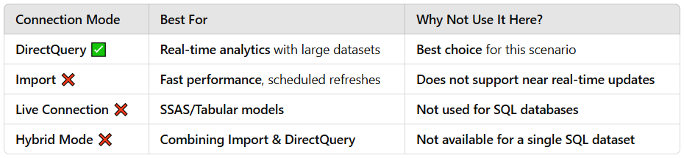
By choosing DirectQuery, your team can ensure users always get up-to-date data, making it the best approach for this scenario.
Domain
Prepare the data
Question 25Skipped
You are creating a Power BI report for a university to manage access to student grades. The data model includes the following tables:
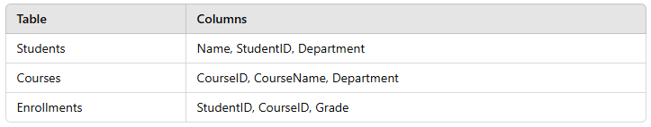
You have implemented two Row-Level Security (RLS) roles:
- Role1: Filters the Students table to only include students from the "Engineering" department.
- Role2: Filters the Courses table to only include courses offered in the "Mathematics" department.
A user is assigned to both Role1 and Role2.
What data will the user see in the report?
Correct answer
Only grades for students in the "Engineering" department who are enrolled in courses in the "Mathematics" department.

Explanation
Explanation:
- Power BI applies multiple RLS roles using the logical AND operator.
- Role1: Filters data to include only students from the "Engineering" department.
- Role2: Filters data to include only courses offered in the "Mathematics" department.
- Result: The user will only see grades for students in "Engineering" who are enrolled in "Mathematics" courses.
All grades for courses in the "Mathematics" department, regardless of the students enrolled.

Explanation
This would only apply if Role1 did not exist. Since both roles are applied, students must also be from the Engineering department.
No data, as the filters from the roles do not overlap and result in conflicting filters.

Explanation
The filters do not conflict; they overlap where Engineering students are enrolled in Mathematics courses.
All grades for students in the "Engineering" department, regardless of the courses they are enrolled in.

Explanation
This would only apply if Role2 did not exist. However, both roles are applied together using the AND logic, so this is incorrect.
Overall explanation
How Does Power BI Handle Multiple RLS Roles?
- In Power BI, when a user is assigned to multiple RLS roles, the security filters from all assigned roles are applied using AND logic (i.e., both filters must be satisfied for data to be visible).
- Power BI does not use OR logic for multiple roles unless explicitly configured.
- For more details on RLS in Power BI, refer to Configuring RLS in Power BI.
Key Takeaways for This Scenario:
- Role1 filters "Students" → Only Engineering students remain.
- Role2 filters "Courses" → Only Mathematics courses remain.
- Both filters are applied together → The user only sees grades where:
  - The student is from "Engineering".
  - The course is from "Mathematics".
By following AND logic, the correct answer is that the user will only see grades for Engineering students enrolled in Mathematics courses, making this the best approach for secure data access control in Power BI.
Domain
Deploy and maintain assets
Question 26Skipped
You want to create a measure in the Sales table that calculates the total sales for each region.
This requires using the relationship between the Sales and Region tables.
Which DAX function should you use to leverage the relationship between Sales and Region?
SUMMARIZE

Explanation
The SUMMARIZE function in DAX is used to group data based on specified columns and calculate summary statistics. While it can be used for aggregating data, it is not the function you would use to leverage the relationship between the Sales and Region tables to calculate total sales for each region.
Correct answer
CALCULATE

Explanation
CALCULATE modifies context and can use the existing relationship between Sales and Region to aggregate total sales per region.
A proper measure would look like:
- TotalSalesByRegion = CALCULATE(SUM(Sales[TotalSales]), RELATEDTABLE(Region))
RELATED is only used for retrieving a column value, not for performing aggregations across relationships.
LOOKUPVALUE

Explanation
The LOOKUPVALUE function in DAX is used to retrieve a single value from a table based on a search condition. While it can be helpful for looking up specific values, it is not the function you would use to calculate the total sales for each region by leveraging the relationship between the Sales and Region tables.
RELATED

Explanation
RELATED is used to retrieve a single column value from a related table, but it is not the correct function for aggregating total sales by region. To calculate total sales for each region, the correct function should be CALCULATE with an appropriate filter applied.
Overall explanation
When working with related tables in Power BI, it’s important to use the appropriate DAX function to retrieve or aggregate data across relationships effectively. Choosing the right function depends on whether you need to fetch a single related value or perform aggregations using relationships.
Best Function for Accessing Related Data:
✅ RELATED (For Retrieving a Single Column Value)
The RELATED function is used to fetch a single column value from a related table based on an existing relationship.
- When to Use RELATED:
  - When you need to pull data from a lookup table (one-to-many relationship).
  - Works when filtering a single row from the related table.
- Example: Retrieving Region Name for Each Sales Record
  - SalesRegion = RELATED(Region[RegionName])
  - This returns the RegionName for each sale in the Sales table.
Best Function for Aggregating Data by Relationships:
✅ CALCULATE (For Aggregating Data Based on Relationships)
If you want to calculate total sales for each region, you must aggregate the data correctly, and CALCULATE is the best function to do this.
- When to Use CALCULATE:
  - When aggregating values across related tables.
  - When modifying filter context in measures.
- Example: Correct Measure to Calculate Total Sales by Region
  - Total Sales by Region = CALCULATE(SUM(Sales[TotalSales]), ALLEXCEPT(Sales, Sales[RegionID]))
  - This ensures the total sales are grouped by Region, leveraging the existing relationship.
  - RELATED cannot be used for this type of aggregation.
Domain
Model the data
Question 27Skipped
CASE STUDY:
Company A, a retail and manufacturing organization, is undergoing a digital transformation to enhance data-driven decision-making. The organization has recently adopted Power BI for analytics and reporting. The analytics team is tasked with creating reports, managing datasets, and sharing insights with key business units such as Sales, Marketing, Finance, and Operations.




Business Challenges
You are tasked with addressing the following challenges while ensuring collaboration, security, and scalability:
- Designing Workspaces: How should workspaces be structured to meet departmental needs while ensuring data security and collaboration?
- Managing Permissions: What roles and permissions should be assigned to balance collaboration and security?
- Version Control: How can you maintain a single source of truth for reports and datasets?
- Data Governance: How can you ensure compliance with organizational policies and data privacy regulations?
- Scalability: How can you design a future-proof analytics environment for growing Power BI adoption?

Question:
How can you implement data governance policies to ensure compliance with security and privacy regulations?
Create a Power BI workspace solely for sensitive reports and restrict access to it.

Explanation
A single workspace for sensitive reports can be helpful but does not address governance at the dataset level.
Correct answer
Use sensitivity labels to classify and protect sensitive data in reports and datasets.

Explanation
Sensitivity labels ensure that sensitive data is classified and protected according to organizational policies.
Limit access to Power BI to managers and executives only.

Explanation
Restricting Power BI to managers and executives limits the potential for data-driven decision-making.
Require all users to have "Build" permissions to ensure transparency.

Explanation
Giving all users Build permissions increases the risk of unauthorized access and changes.
Overall explanation
To ensure compliance with security and privacy regulations, a best practice is to use sensitivity labels to classify and protect sensitive data in reports and datasets. Sensitivity labels allow you to:
- Classify Data:
Apply labels to content based on its sensitivity (e.g., confidential, highly confidential) to clearly mark which data requires additional protection.
- Enforce Protection Policies:
Sensitivity labels can trigger automatic encryption and access controls. This helps ensure that sensitive information is only visible to authorized users and is handled in accordance with organizational policies and regulatory requirements.
- Maintain Compliance:
By consistently applying these labels across reports and datasets, you create a unified, organization-wide approach to data governance. This minimizes the risk of unintentional data exposure and supports regulatory compliance.

Why Other Options Are Not Ideal
- Limiting Access Only to Managers and Executives:
This option is overly restrictive and does not support collaboration. It could prevent necessary users from accessing data needed for decision-making, undermining the purpose of a digital transformation.
- Creating a Separate Workspace Solely for Sensitive Reports:
While isolating sensitive content in a dedicated workspace can add a layer of security, it does not provide a comprehensive governance framework. This method lacks the systematic control offered by sensitivity labels, as it doesn’t classify or protect the data within reports and datasets themselves.
- Requiring All Users to Have “Build” Permissions:
This approach is counterproductive for data governance. It increases the risk of unauthorized modifications and exposure, since every user would have the ability to alter or build on reports, regardless of their need or clearance.
Domain
Case Study
Question 28Skipped
You are working on a company-wide financial dashboard in Power BI. The dashboard contains several tiles showcasing KPIs from multiple reports.
The company branding team has provided a custom JSON theme file to align the dashboard’s design with the company colors and fonts.
You need to apply the provided custom theme to the dashboard. What should you do?
Correct answer
Upload the JSON theme file directly to the dashboard in Power BI Service.

Explanation
Power BI allows you to upload a JSON theme file directly to a dashboard in Power BI Service, ensuring that the custom colors and formatting are applied without additional steps.
Export the custom theme from the report and apply it to the dashboard.

Explanation
Exporting a custom theme from a report is not needed here. The custom theme has already been provided as a JSON file by the branding team.
Create a new dashboard from scratch and manually replicate the design.

Explanation
Creating a new dashboard from scratch unnecessarily increases development effort and does not apply the custom theme efficiently.
Apply the custom theme by uploading the JSON file to Power BI Desktop and publishing a new dashboard.

Explanation
Applying the theme in Power BI Desktop and republishing does not apply the custom theme to a Applying the theme in Power BI Desktop and republishing does not apply the custom theme to a dashboard directly; it applies the theme to the report instead.
Overall explanation
Custom themes in Power BI allow organizations to maintain consistent branding across reports and dashboards by defining colors, fonts, and visual styles in a JSON theme file.
How to Apply a Custom Theme in Power BI?
- For Reports in Power BI Desktop: You can import a custom theme in Power BI Desktop by navigating to View → Themes → Browse for themes and selecting the JSON file. Learn more about Applying Themes in Power BI Desktop.
- For Dashboards in Power BI Service: Unlike reports, dashboards in Power BI Service allow users to directly upload a JSON theme file to apply branding. This ensures that KPI tiles and visuals in the dashboard reflect the company’s custom colors and fonts. Learn more about Applying Custom Themes to Dashboards.
- For Individual Visuals: If you need custom branding for individual visuals, you can modify them using the Format pane.
By uploading the JSON theme file directly to the dashboard in Power BI Service, you can efficiently apply the company branding without additional steps, making it the best approach.
Domain
Visualize and analyze the data
Question 29Skipped
At DataLens Analytics, you are tasked with creating a measure to calculate the Year-over-Year (YoY) Sales Growth. The Sales table contains SalesAmount and OrderDate.
Which DAX formula should you use?
Correct answer
YoY Growth = DIVIDE(SUM(Sales[SalesAmount]) - CALCULATE(SUM(Sales[SalesAmount]), SAMEPERIODLASTYEAR(Date[Date])), CALCULATE(SUM(Sales[SalesAmount]), SAMEPERIODLASTYEAR(Date[Date])))

Explanation
This DAX formula correctly calculates the Year-over-Year Sales Growth by subtracting the sum of SalesAmount for the current period from the sum of SalesAmount for the same period last year, then dividing the result by the sum of SalesAmount for the same period last year. This calculation provides the percentage growth in sales from one year to the next.
YoY Growth = CALCULATE(SUM(Sales[SalesAmount]), SAMEPERIODLASTYEAR(Date[Date]))

Explanation
The DAX formula provided calculates the sum of SalesAmount for the current period and the sum of SalesAmount for the same period last year using the SAMEPERIODLASTYEAR function. However, it does not calculate the Year-over-Year growth as it only provides the sales amount for the two periods without calculating the growth percentage.
YoY Growth = CALCULATE(AVERAGE(Sales[SalesAmount]), SAMEPERIODLASTYEAR(Date[Date]))

Explanation
The DAX formula presented calculates the average SalesAmount for the current period using the AVERAGE function and the SalesAmount for the same period last year using the SAMEPERIODLASTYEAR function. However, it does not accurately calculate the Year-over-Year Sales Growth as it calculates the average instead of the growth percentage.
YoY Growth = CALCULATE(SUM(Sales[SalesAmount]), DATEADD(Date[Date], -12, MONTH))

Explanation
The DAX formula provided uses the DATEADD function to subtract 12 months from the Date column, which does not accurately calculate the Year-over-Year Sales Growth. This formula does not compare the sales amount for the current period with the sales amount for the same period last year to determine the growth percentage.
Overall explanation
The objective is to calculate the percentage change in sales between the current period and the same period in the previous year. In a YoY calculation, you need to:
- Compute current year sales.
- Compute last year’s sales for the same period.
- Calculate the difference (growth) and express it as a percentage.
- YoY Growth = DIVIDE(
- SUM(Sales[SalesAmount]) - CALCULATE(SUM(Sales[SalesAmount]), SAMEPERIODLASTYEAR(Date[Date])),
- CALCULATE(SUM(Sales[SalesAmount]), SAMEPERIODLASTYEAR(Date[Date]))
- )
Let’s break it down step by step:
- Current Sales Calculation
  - Expression: SUM(Sales[SalesAmount])
  - Purpose: This calculates the total sales for the current filter context (e.g., the current year or a specific period).
- Previous Year’s Sales Calculation
  - Expression: CALCULATE(SUM(Sales[SalesAmount]), SAMEPERIODLASTYEAR(Date[Date]))
  - Purpose:
    - CALCULATE: Changes the context in which the sales sum is evaluated.
    - SAMEPERIODLASTYEAR(Date[Date]): Shifts the date context back one year to compute the total sales for the corresponding period in the previous year.
  - Reference: For more details on how this function shifts the date context, see the Microsoft documentation on SAMEPERIODLASTYEARlearn.microsoft.com.
- Calculating the Growth Percentage
  - Difference: The measure subtracts the previous year’s sales from the current year’s sales:

    - SUM(Sales[SalesAmount]) - CALCULATE(SUM(Sales[SalesAmount]), SAMEPERIODLASTYEAR(Date[Date]))
  - Division:
    - The result of the subtraction is divided by the previous year’s sales.
    - DIVIDE Function:
      - This function safely performs division and handles any division-by-zero scenarios by returning a blank (or an alternate result if specified).
      - Reference: For more details on safe division, see the Microsoft documentation on DIVIDE
Why This Formula Is Correct
- Accurate Time Intelligence:
The use of SAMEPERIODLASTYEAR ensures that the calculation dynamically adjusts to the current filter context. It automatically shifts the dates one year back, allowing for a like-for-like comparison between the current period and the corresponding period from the previous year.
- Safe Calculation:
Using the DIVIDE function instead of a simple division operator ensures that if the previous year’s sales value is zero, the measure will return a blank (or an alternative value), avoiding errors in your report.
- Logical Calculation Flow:
The measure computes:
  - Current sales.
  - Previous year’s sales.
  - The difference (i.e., growth in sales).
  - Finally, it divides the difference by the previous year’s sales to yield a percentage growth rate.
Other options in the provided list either use an average (which does not make sense in the context of total sales) or do not compute the percentage growth but simply return a shifted sum.
Domain
Model the data
Question 30Skipped
CASE STUDY:
Company A, a retail and manufacturing organization, is undergoing a digital transformation to enhance data-driven decision-making. The organization has recently adopted Power BI for analytics and reporting. The analytics team is tasked with creating reports, managing datasets, and sharing insights with key business units such as Sales, Marketing, Finance, and Operations.




Business Challenges
You are tasked with addressing the following challenges while ensuring collaboration, security, and scalability:
- Designing Workspaces: How should workspaces be structured to meet departmental needs while ensuring data security and collaboration?
- Managing Permissions: What roles and permissions should be assigned to balance collaboration and security?
- Version Control: How can you maintain a single source of truth for reports and datasets?
- Data Governance: How can you ensure compliance with organizational policies and data privacy regulations?
- Scalability: How can you design a future-proof analytics environment for growing Power BI adoption?

Company A’s Sales Analytics Team is tasked with identifying unusual sales patterns to support data-driven decisions. They’ve created a line chart in Power BI that shows Monthly Sales Revenue over the past three years. The dataset includes seasonal trends and occasional sales spikes due to promotional events.
The team wants to:
- Automatically detect anomalies in the sales data.
- Highlight outliers without manually adjusting thresholds.
- Provide contextual explanations for the anomalies when possible.
Question:
Which of the following steps should you take to detect outliers and anomalies effectively in Power BI?
Add a Trend Line to the line chart, set custom thresholds using DAX measures, and apply conditional formatting to highlight deviations.

Explanation
Adding a Trend Line to the line chart and setting custom thresholds using DAX measures can help identify deviations in the sales data. Applying conditional formatting to highlight these deviations visually can make it easier for the Sales Analytics Team to spot outliers. However, this method may require manual adjustment of thresholds and does not provide automatic anomaly detection.
Use the Decomposition Tree visual, break down the sales data by category, and manually identify outliers through drill-down analysis.

Explanation
Using the Decomposition Tree visual to break down sales data by category and manually identifying outliers through drill-down analysis is a valid approach to analyzing data. However, this method may be time-consuming and may not effectively detect anomalies automatically without the need for manual intervention.
Correct answer
Enable the Anomaly Detection feature in the line chart, configure the Sensitivity setting, and review the automatically generated explanations.

Explanation
Enabling the Anomaly Detection feature in the line chart allows Power BI to automatically detect outliers in the sales data. By configuring the Sensitivity setting, you can adjust the threshold for what is considered an anomaly. The feature also generates explanations for the detected anomalies, providing contextual information for the sales team.
Create a Clustered Bar Chart, apply dynamic reference lines, and visually inspect bars that exceed the average sales value.

Explanation
Creating a Clustered Bar Chart and applying dynamic reference lines to visually inspect bars that exceed the average sales value can help identify potential outliers. However, this method relies on visual inspection and does not provide automated anomaly detection capabilities like the Anomaly Detection feature in Power BI.
Overall explanation
1. Enable the Anomaly Detection Feature in Power BI
Power BI provides a built-in Anomaly Detection feature for line charts, which uses machine learning to automatically identify outliers in time-series data. This feature is particularly useful for detecting unusual patterns in sales data, such as unexpected spikes or drops, without requiring manual intervention.
- How it works: The Anomaly Detection feature analyzes historical data, identifies trends and seasonality, and flags data points that deviate significantly from the expected pattern. It also provides contextual explanations for the anomalies, such as whether the anomaly is due to a sudden increase or decrease in sales.
- Configuration: You can adjust the Sensitivity setting to control how aggressively the model detects anomalies. A higher sensitivity will flag more data points as anomalies, while a lower sensitivity will only flag the most significant deviations.
- Explanation: The feature automatically generates explanations for detected anomalies, which can help the Sales Analytics Team understand the root cause of unusual sales patterns.

2. Why Other Options Are Less Suitable
- Clustered Bar Chart with Dynamic Reference Lines: While this approach allows for visual inspection of outliers, it requires manual effort to set thresholds and identify anomalies. It does not leverage Power BI's automated capabilities, making it less efficient for detecting subtle or complex anomalies.
- Decomposition Tree: The Decomposition Tree is useful for breaking down data by categories (e.g., product, region) but is not designed specifically for anomaly detection. It requires manual drill-down analysis, which is time-consuming and less effective for identifying outliers in time-series data.
- Trend Line with DAX Measures and Conditional Formatting: While this approach allows for custom thresholds and conditional formatting, it relies heavily on manual configuration and does not provide automated explanations for anomalies. It is also less scalable for large datasets.
3. Benefits of Using Anomaly Detection
- Automation: The Anomaly Detection feature automates the process of identifying outliers, reducing the need for manual analysis.
- Contextual Insights: It provides explanations for anomalies, helping the team understand the underlying causes of unusual sales patterns.
- Scalability: This feature is scalable and can handle large datasets, making it suitable for Company A's growing Power BI adoption.
- Compliance: By using built-in Power BI features, the organization can ensure compliance with data governance policies and privacy regulations.
4. Implementation Steps
- Enable Anomaly Detection:
  - Open the line chart visualization in Power BI.
  - Go to the Analytics Pane and enable the Anomaly Detection option.
  - Configure the Sensitivity setting based on the desired level of anomaly detection.
- Review Anomalies:
  - Power BI will automatically highlight anomalies in the line chart.
  - Hover over the anomalies to view contextual explanations.
- Share Insights:
  - Use Power BI workspaces to share the report with relevant stakeholders, ensuring proper role-based permissions are applied for data security.

The Anomaly Detection feature in Power BI is the most effective solution for Company A's Sales Analytics Team. It automates the detection of outliers, provides contextual explanations, and ensures scalability and compliance with organizational policies. By leveraging this feature, the team can focus on data-driven decision-making without the need for manual intervention.
Domain
Case Study
Question 31Skipped
At EcoMetrics Corp., you are tasked with creating a common date table to be used across multiple fact tables, including Sales and Inventory. The table must include date-related columns for filtering and analysis.
Which of the following is a key requirement for a common date table in Power BI?
The table must include all possible dates and times for a given range.

Explanation
A date table typically contains only dates, not time values, unless the model specifically requires time-based filtering. A datetime column may be useful in some cases, but it is not a strict requirement for a functional date table.
The table must be imported from an external database to ensure consistency.

Explanation
A date table does not need to be imported. It can be created in Power BI using DAX functions like CALENDAR() or CALENDARAUTO(), ensuring flexibility and consistency within the Power BI model.
The table must have relationships defined with both fact tables before any columns are added.

Explanation
Relationships between the date table and fact tables can be established at any point in the modeling process. Columns can be added before or after relationships are defined. The key requirement is that the date column is unique and contiguous to function correctly in relationships.
Correct answer
The table must have a column with unique and contiguous dates.

Explanation
A date table requires a column containing unique and contiguous dates to serve as the primary key. This ensures that filters and relationships work correctly. Contiguous dates prevent missing values that could disrupt time intelligence functions like SAMEPERIODLASTYEAR or TOTALYTD.
Overall explanation
A common date table in Power BI is crucial for enabling consistent filtering across multiple fact tables (such as Sales and Inventory) and allowing the use of time intelligence functions.
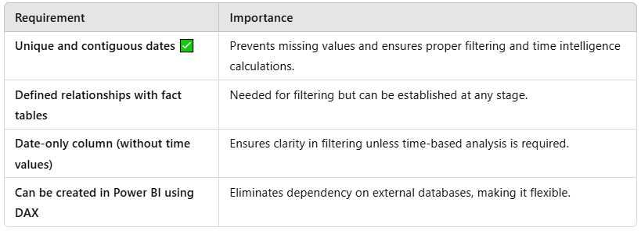
How to Create a Date Table in Power BI?
A common date table can be generated using DAX as follows:
- DateTable =
- ADDCOLUMNS(
- CALENDAR(DATE(2020,1,1), DATE(2025,12,31)),
- "Year", YEAR([Date]),
- "Month", FORMAT([Date], "MMMM"),
- "Month Number", MONTH([Date]),
- "Quarter", "Q" & FORMAT([Date], "Q"),
- "Weekday", FORMAT([Date], "dddd")
- )
Best Practices for Using a Date Table
- Mark the Date Table as a Date Table in Power BI to enable time intelligence calculations.
- Use a continuous date range to avoid missing periods in reports.
- Link all fact tables (e.g., Sales, Inventory) to a single date table to ensure consistent filtering.
For more details, refer to Power BI Date Tables.
By implementing a well-structured date table, users can perform accurate time-based analysis, ensuring reliable insights and effective trend tracking.
Domain
Prepare the data
Question 32Skipped
At BrightLens Analytics, you are working with a data model that includes a Sales table and a Products table. Your manager asks for the following enhancements:

- Add a new column to the Sales table that calculates Profit as SalesAmount - Cost.
- Create a table showing total sales by Category (from the Products table) for reporting purposes.
Which options should you choose to fulfill these requirements? (Select all that apply.)
Use a DAX measure to calculate total sales by Category.

Explanation
While a DAX measure can calculate total sales, it does not create a new table for reporting.
Use a calculated column in the Products table for the sales summary by Category.

Explanation
Calculated columns in the Products table cannot summarize data from the Sales table.
Correct selection
Use a calculated column to add the Profit column to the Sales table.

Explanation
A calculated column is the appropriate choice for row-by-row calculations like Profit = SalesAmount - Cost.
Correct selection
Use a calculated table to create the sales summary by Category.

Explanation
Calculated tables can create new summary tables using DAX, such as SummaryTable = SUMMARIZE(Products, Products[Category], "TotalSales", SUM(Sales[SalesAmount])).
Overall explanation
Enhancement 1 – Adding a Profit Column to the Sales Table
- Requirement:
Create a new column in the Sales table that calculates Profit as SalesAmount – Cost.
- Solution:
A calculated column is appropriate here because the calculation is performed on a row-by-row basis and becomes part of the table.
  - Key Point: Calculated columns are used to extend data with new values that depend on values in the same row.
  - Reference: See the Microsoft documentation on calculated columns
  - Choice:
Use a calculated column to add the Profit column to the Sales table.
Enhancement 2 – Creating a Table Showing Total Sales by Category
- Requirement:
Build a table for reporting that shows total sales aggregated by Category from the Products table.
- Solution:
A DAX measure is ideal for this purpose because measures are dynamic and aggregate values based on the filter context in your visuals.
  - Key Point: Measures are preferred for aggregations such as summing sales by category, as they update automatically when slicers or other filters change.

- Choice:
Use a DAX measure to calculate total sales by Category.
Domain
Model the data
Question 33Skipped
You are preparing a Power BI report for a retail company. The company wants to monitor historical sales for each product category over the past two years and predict sales trends for the next 12 months.
Which visual is most appropriate for displaying both historical and forecasted sales data?
Waterfall chart

Explanation
Waterfall charts display how individual components contribute to a total over a static set of categories, but they do not handle trends or predictions.
Correct answer
Line chart with forecasting enabled

Explanation
Line charts are designed for visualizing trends over time. The forecasting feature in Power BI allows you to predict future data points, making it the best choice for this requirement.
Decomposition tree

Explanation
Decomposition trees analyze how individual variables contribute to a metric but are not suitable for showing historical trends or predictions.
Clustered bar chart

Explanation
Clustered bar charts are used for category comparisons but are not suitable for showing time-based trends or forecasting.
Overall explanation
In Power BI, the best visual for time-based trends and forecasting is a Line Chart with Forecasting Enabled.
Why Use a Line Chart with Forecasting?
✔ Tracks historical trends over time.
✔ Uses built-in forecasting to predict future values.
✔ Dynamically updates predictions based on new data.
How to Enable Forecasting in Power BI?
- Add a Line Chart to your Power BI report.
- Drag "Date" to the X-axis and "Sales" to the Y-axis.
- Go to the Analytics Pane (visual formatting options).
- Expand the "Forecast" option and click "Add".
- Set the forecast length (e.g., 12 months) and adjust settings.
For more details, refer to Power BI Forecasting Guide.
Why Not Use Other Visuals?
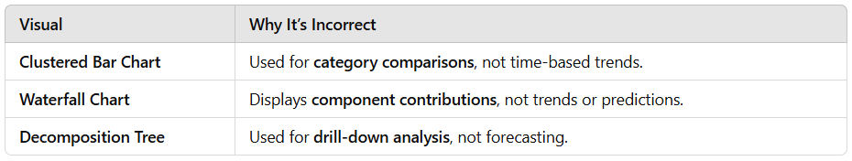
By using a Line Chart with Forecasting, the company can monitor past sales trends and predict future sales, making it the best choice for this scenario.
Domain
Visualize and analyze the data
Question 34Skipped
CASE STUDY:
Company A, a retail and manufacturing organization, is undergoing a digital transformation to enhance data-driven decision-making. The organization has recently adopted Power BI for analytics and reporting. The analytics team is tasked with creating reports, managing datasets, and sharing insights with key business units such as Sales, Marketing, Finance, and Operations.




Business Challenges
You are tasked with addressing the following challenges while ensuring collaboration, security, and scalability:
- Designing Workspaces: How should workspaces be structured to meet departmental needs while ensuring data security and collaboration?
- Managing Permissions: What roles and permissions should be assigned to balance collaboration and security?
- Version Control: How can you maintain a single source of truth for reports and datasets?
- Data Governance: How can you ensure compliance with organizational policies and data privacy regulations?
- Scalability: How can you design a future-proof analytics environment for growing Power BI adoption?

Company A’s analytics team has created a Power BI dashboard to track Sales Performance across regions. The dashboard includes the following visuals:
- Bar Chart showing Total Sales per Region
- Pie Chart displaying Sales by Product Category
- Table listing detailed Transaction Data
The business requires the following interaction behavior:
- When a user clicks on a region in the Bar Chart, the Pie Chart should filter to show only the product categories sold in that region.
- The Table should remain unchanged regardless of any selections in the Bar Chart.
- All visuals must still respond to filters applied via slicers (e.g., Date, Sales Rep).
Question:
How should you configure the visual interactions to meet these requirements in Power BI?
Apply a Cross-filter relationship between the Bar Chart and Pie Chart, and disable all interactions with the Table using the Manage Relationships pane.

Explanation
Applying a Cross-filter relationship between the Bar Chart and the Pie Chart will establish a filter relationship between the two visuals, but it will not provide the desired behavior of filtering the Pie Chart based on the selected region. Disabling all interactions with the Table using the Manage Relationships pane will prevent any interaction with the Table, which is not the intended outcome.
Use the Sync Slicers feature to link the Bar Chart to the Pie Chart and disable the slicer sync with the Table.

Explanation
Using the Sync Slicers feature to link the Bar Chart to the Pie Chart will synchronize slicer selections between the two visuals, but it will not achieve the specific requirement of filtering the Pie Chart based on the selected region in the Bar Chart. Disabling the slicer sync with the Table will prevent any interaction with the Table, which is not the desired behavior in this case.
Correct answer
Go to Format → Edit Interactions, click the Bar Chart, and set the interaction with the Pie Chart to "Filter" and the interaction with the Table to "None".

Explanation
Configuring the Bar Chart to interact with the Pie Chart by setting it to "Filter" will ensure that when a user clicks on a region in the Bar Chart, the Pie Chart will filter to show only the product categories sold in that region. Setting the interaction with the Table to "None" will keep the Table unchanged, meeting the specified requirements.
Go to Format → Edit Interactions, click the Bar Chart, and set the interaction with the Pie Chart to "Highlight" and the interaction with the Table to "None".

Explanation
Setting the interaction between the Bar Chart and the Pie Chart to "Highlight" will not filter the Pie Chart based on the selected region. Additionally, setting the interaction with the Table to "None" will prevent any interaction between the Bar Chart and the Table, which is not the desired behavior in this scenario.
Overall explanation
To achieve the desired behavior in Power BI, you need to leverage the "Edit Interactions" feature, which allows you to specify how one visual affects another. Here’s a detailed breakdown of the steps and the rationale behind each:
- Activate Edit Interactions:
In Power BI Desktop (or the Power BI service in editing mode), select the visual that will drive the interactions—in this case, the Bar Chart. Then go to the Format tab and click Edit Interactions. This action will overlay icons on every other visual on the page.
Reference: Change how visuals interact in a Power BI report​

- Configure the Pie Chart:
For the Pie Chart, choose the Filter icon. This configuration means that when a user clicks on a region in the Bar Chart, the Pie Chart will filter its data to display only the product categories relevant to that selected region. This behavior is in line with cross-filtering, where selections narrow down the dataset to a subset that meets the filtering criteria.
Reference: How visuals cross-filter each other in a Power BI report​

- Configure the Table:
For the Table visual, select the None icon. By doing this, you ensure that any selection made on the Bar Chart does not affect the Table. This setting is crucial when you want the Table to always display the complete set of transaction data, regardless of any filtering applied by the Bar Chart.
Reference: Change how visuals interact in a Power BI report​

- Maintain Slicer Effects:
It’s important to note that these interaction settings are independent of slicer controls. Slicers will continue to filter all visuals on the report page uniformly. Therefore, while the Bar Chart’s selection affects the Pie Chart (via filtering) and leaves the Table untouched, any slicers (like Date or Sales Rep) will still apply across all visuals, preserving overall report consistency.
This method provides a controlled environment where you can tailor how visuals interact—balancing user engagement with data integrity and clarity. By setting these interactions, you ensure that the key insights are presented accurately, with only the necessary visuals reacting to user selections, which is particularly important in a complex reporting scenario.
Domain
Case Study
Question 35Skipped
You are building a Power BI report for a logistics company. The company stores its delivery data in a custom-built NoSQL database system.
While working in Power BI Desktop, you find that there is no specific Get Data connector for this database.
To establish a connection, the IT team provides you with a REST API endpoint to fetch data from the database.
How should you configure Power BI to connect to this database?
Use the OData feed connector and configure the REST API URL.

Explanation
OData is a specific protocol for web-based data sources. While it supports APIs, the question states that the IT team provided a generic REST API endpoint, not an OData feed.
Use the Blank Query option and write a custom SQL query.

Explanation
NoSQL databases do not use SQL as a query language, and the REST API endpoint does not support SQL queries.
Use the JSON file connector to import data from the API.

Explanation
While REST APIs often return data in JSON format, the JSON file connector is specifically for importing local JSON files. It cannot directly connect to a REST API endpoint.
Correct answer
Use the Web connector to pull data from the API.

Explanation
The Web connector allows Power BI to retrieve data directly from a REST API endpoint, which is the recommended approach for connecting to custom NoSQL databases via APIs.
Overall explanation
When connecting Power BI to a NoSQL database via a REST API, the best approach is to use the Web connector.
Steps to Connect Power BI to a REST API
- Open Power BI Desktop
- Go to Home → Get Data → Web
- Enter the REST API URL provided by IT
- If authentication is required, provide API keys or credentials
- Transform and structure the data using Power Query
For more details, refer to Connecting to REST APIs in Power BI.
Why Not Use Other Connectors?
- OData Connector: Only works with OData-compliant APIs, which is not the case here.
- Blank Query with SQL: NoSQL databases do not support SQL queries, making this approach incorrect.
- JSON Connector: Imports local JSON files but cannot call REST APIs directly.
By using the Web connector, Power BI can successfully pull data from a REST API, making it the best approach for connecting to a custom NoSQL database.
Domain
Prepare the data
Question 36Skipped
At Skyline Technologies, your Power BI report requires data from a cloud-based CRM system.
✔ The dataset is moderately sized.
✔ Data is updated every two hours.
✔ Users prioritize performance but can tolerate a slight delay in data freshness.
Which connection mode should you choose?
DirectQuery

Explanation
Provides real-time data, but impacts performance due to constant database queries. Less suitable for a moderate dataset with scheduled updates.
Correct answer
Import

Explanation
Import mode loads data into Power BI's in-memory engine, ensuring fast performance. Scheduled refreshes every two hours allow for relatively fresh data without constant querying.
Live Connection

Explanation
Used for Analysis Services (SSAS), not cloud-based CRM systems. Not applicable to this scenario.
Dual Mode

Explanation
Designed for composite models combining Import & DirectQuery. Unnecessary if the dataset fits well in memory and refreshes efficiently.
Overall explanation
Power BI provides multiple connection modes, each optimized for different use cases. Selecting the right mode depends on data size, refresh frequency, and user expectations regarding performance vs. real-time access.
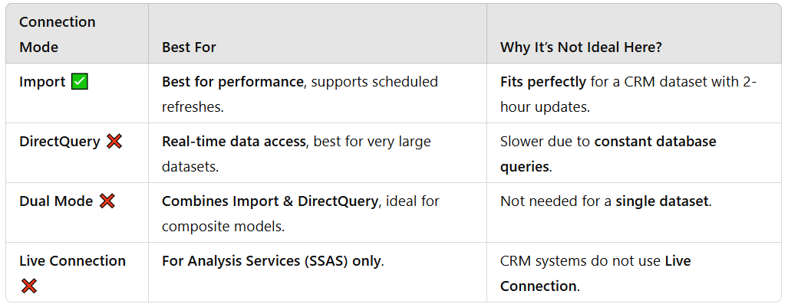
Import mode is the best choice for this scenario, as it delivers high performance while still allowing scheduled refreshes to keep data relatively fresh.
Why Import Mode is Recommended?
- Performance: Stores data in-memory, making queries and visuals load much faster.
- Scheduled Refresh: Can refresh every two hours to match the CRM update frequency.
- Optimized for CRM Data: CRM systems often store structured, relational data that fits well into Import mode.
For more details, refer to Power BI Data Connection Modes.
By using Import mode, the report remains fast and efficient, meeting both the performance and data freshness requirements of Skyline Technologies.
Domain
Model the data
Question 37Skipped
You are working on a Power BI report for the sales department. The report uses the following tables, as shown in the image:


The Properties pane for the Product table is open. The storage mode is currently set to Import, but you notice that the Is Featured Table property for the Product table is currently set to No.
You want the Product table to appear as a featured table in Excel for users accessing it via the Analyze in Excel feature.
Which action should you take to set the Product table as a featured table for external use?
Configure row-level security (RLS) for the Product table.

Explanation
RLS restricts access to data within the table but does not affect whether the table appears as a featured table in external tools.
Enable relationships between the Product and SalesOrderDetail tables.

Explanation
Relationships allow data linking between tables but are unrelated to the "Is Featured Table" property.
Set the storage mode for the Product table to DirectQuery.

Explanation
Storage mode affects how the data is queried (e.g., Import vs. DirectQuery) but does not determine whether the table is featured in Excel.
Correct answer
Enable the "Is Featured Table" option in the Properties pane for the Product table.

Explanation
Setting the Is Featured Table option to "Yes" ensures that the Product table appears as a featured table when accessed in Excel or other external tools using the Analyze in Excel feature.
Overall explanation
Power BI allows users to designate tables as Featured Tables so that they can be easily accessed in Excel via the Analyze in Excel feature.
How to Enable a Featured Table in Power BI?
- Open Power BI Desktop.
- Go to Model View and select the Product table.
- Open the Properties pane and locate the Is Featured Table option.
- Set the option to "Yes" to enable the table as a Featured Table.
- Save and publish the report to Power BI Service for use in Analyze in Excel.
For more details, refer to Using Featured Tables in Power BI.
By enabling the "Is Featured Table" option, you ensure that the Product table appears in Excel, making it the best approach for integrating Power BI data with external tools.
Domain
Prepare the data
Question 38Skipped
You are developing a Power BI report for a global sales team. The dataset includes a Regions table, and you need to implement Row-Level Security so that each user only sees data for their assigned region.
Which steps should you follow to implement RLS in Power BI?
Correct answer
Create a role with a DAX filter on the Regions table that restricts data based on the user’s email address.

Explanation
Creating a role with a DAX filter on the Regions table that restricts data based on the user's email address is the correct approach to implementing Row-Level Security (RLS) in Power BI. This method ensures that each user only sees data for their assigned region by filtering the data at the row level based on the user's email address.
Use Power Query to remove rows for non-relevant regions before loading the data into the model.

Explanation
Power Query row removal: Permanently strips out data at refresh time, so you’d need separate datasets per region—and you lose flexibility.
Apply a filter directly on each visual in the report using the user’s email address.

Explanation
Visual-level filters: Tedious to maintain and can be bypassed if users copy the report.
Create a calculated column in the Sales table that assigns a region, then filter the report based on that column.

Explanation
Calculated column + report filter: Calculated columns are static once loaded, and filtering at report level isn’t secure—it can be overridden by savvy users.
Overall explanation
Solution Steps
- Define a Role in Power BI Desktop
  - In Modeling → Manage roles, click Create.
  - Select the Regions table.
- Add a DAX Filter
  - In the filter box for Regions, write something like:

    - [Region] = LOOKUPVALUE(
    - UserRegions[Region],
    - UserRegions[Email],
    - USERPRINCIPALNAME()
    - )
  - or, if you have the email directly on the Regions table:
  - [Email] = USERPRINCIPALNAME()
This ensures that when a user (identified by USERPRINCIPALNAME()) views the report, they only see the rows where their email matches.

- Test the Role
  - Back in Modeling → View as, select the new role and enter a test email.
  - Verify that only the appropriate regional data is visible.
- Publish and Assign
  - Publish your PBIX to the Power BI service.
  - In the service, go to the dataset’s Security settings and add each user (or Azure AD group) to the role you created.
Row-level security (RLS) with Power BI
Row-level security (RLS) guidance in Power BI Desktop
Domain
Visualize and analyze the data
Question 39Skipped
You are designing a Power BI report for a university performance dashboard. The report includes a clustered bar chart that displays:
✔ Student GPA as the value (numerical, on a scale from 0 to 4).
✔ Student Name on the categorical axis.
The university administration requests a reference line to show students performing above the average GPA for the class.
What action should you take to implement the reference line correctly?
Create a tooltip to display the average GPA when hovering over the chart.

Explanation
Creating a tooltip does not add a reference line. A tooltip provides additional information but does not visually indicate students above the average GPA.
Correct answer
Use the Analytics pane to add an average line.

Explanation
Using the Analytics pane allows you to add an average line that dynamically calculates the average GPA for the dataset. This line will automatically adjust if the data changes, making it the best solution.
Add a custom DAX measure to calculate the median GPA and use it as a constant line.

Explanation
While calculating the median GPA with DAX could be useful, the requirement is for an average GPA, not the median. Also, the Analytics pane already provides a direct way to add an average line.
Add a constant line and set its value to 3.0.

Explanation
Setting a constant line to 3.0 assumes the average GPA without dynamically calculating it. This approach is static and not suitable for changing data.
Overall explanation
In Power BI, the best way to add a dynamic reference line for average GPA is through the Analytics pane.
How to Add an Average Line Using the Analytics Pane
- Select the Clustered Bar Chart in Power BI.
- Go to the Analytics Pane (on the right-side panel).
- Expand the "Average Line" option and click Add.
- Choose the GPA field as the measure to calculate the average.
- Customize the formatting (color, label, and style).
For more details, refer to Adding Reference Lines in Power BI.
Why Not Use Other Methods?
- Constant Line: A fixed value (e.g., 3.0) does not adjust dynamically when data updates.
- DAX Measure: Creating a DAX measure for average GPA is unnecessary, as the Analytics pane provides this feature directly.
- Tooltip: Provides contextual information but does not create a visible reference line.
By using the Analytics pane to add an average line, the reference line updates dynamically based on real-time data, making it the best approach for this scenario.
Domain
Visualize and analyze the data
Question 40Skipped
You are a data analyst at DataWorks Solutions. Your team works with sales data stored in a SQL Server database. To generate reports in Power BI, you need to connect to the database, extract the necessary data using SQL queries, and ensure the connection configuration aligns with the organization's data requirements.
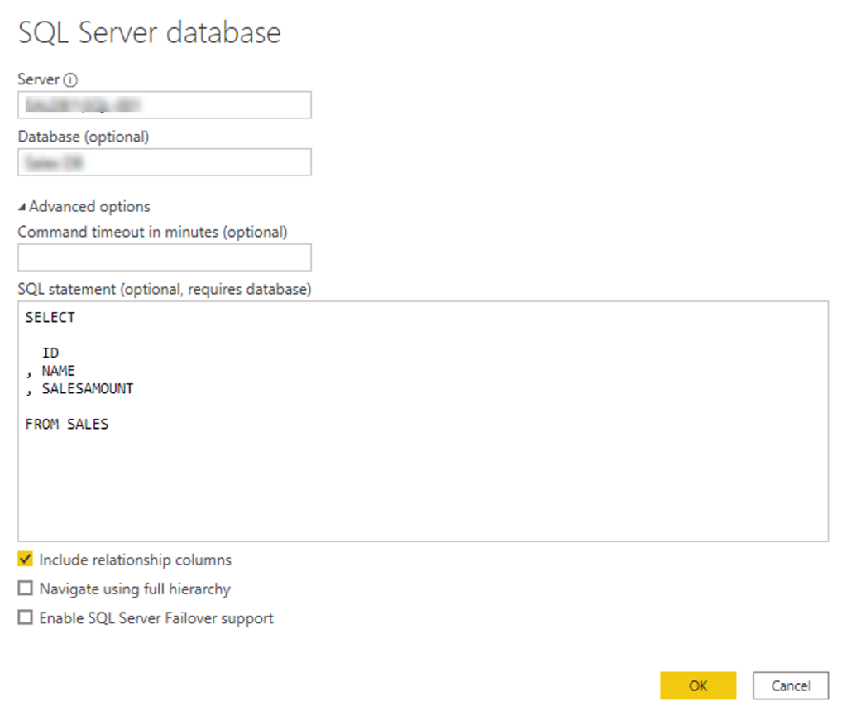
The screenshot shows the SQL Server database connection dialog in Power BI, where a query is written to extract ID, NAME, and SALESAMOUNT columns from the SALES table.
To configure the relationship between the tables in Power BI.

Explanation
Relationships are configured within Power BI, not through SQL statements.
To allow Power BI to enable SQL Server Failover support.

Explanation
Failover support is configured separately and is unrelated to writing a SQL query.
Correct answer
To apply filters and transformations directly in the database before loading data into Power BI.

Explanation
Writing a SQL statement ensures only the required data is retrieved from the database, improving performance and reducing unnecessary data load.
To establish a secure connection to the database.

Explanation
The secure connection is established using server credentials, not the SQL query.
Overall explanation
When connecting to a SQL Server database from Power BI, you are presented with a connection dialog where you can enter a custom SQL query. This serves two main purposes:
- Filtering and Transforming Data at the Source:
By writing a SQL query (for example, selecting only the ID, NAME, and SALESAMOUNT columns from the SALES table), you limit the data retrieved from the database. This offloads processing to the database engine and ensures that only the necessary data is imported into Power BI. This approach is essential when you need to optimize performance and meet data governance requirements.

- Establishing a Secure Connection:
The SQL Server connection dialog is also the place where you configure connection parameters such as server name, database name, and authentication mode. This ensures that the connection adheres to your organization's security and data access policies. A secure connection is fundamental to protect sensitive data during transmission between the database and Power BI.
Why the Other Options Are Not Appropriate
- Enabling SQL Server Failover Support:
While SQL Server Failover support is an important feature for high availability, it is not the primary function of the connection dialog where you write your query. The focus here is on data extraction and secure connectivity rather than on configuring failover mechanisms.
- Configuring Relationships Between Tables:
Relationships between tables in Power BI are managed within the data model after data has been imported. The connection dialog is solely responsible for establishing the connection to the database and retrieving the data based on the provided query.
Domain
Prepare the data
Question 41Skipped
What additional assurance does a Certified report provide compared to a Promoted report?
Certified reports are automatically refreshed without manual intervention.

Explanation
Certification is unrelated to the data refresh process. Reports still require scheduled refreshes or manual updates based on the dataset configuration.
Certified reports are automatically included in dashboards.

Explanation
Certification does not affect whether a report is included in a dashboard. Users must manually pin visuals from a report to a dashboard.
Certified reports are accessible to users without permission checks.

Explanation
Access permissions in Power BI remain unchanged regardless of whether a report is Certified or Promoted. Users still need appropriate permissions to view the report.
Correct answer
Certified reports meet specific organizational criteria for trust and quality.

Explanation
A Certified report has undergone a formal review process to ensure it meets high-quality standards set by the organization. Certification provides greater reliability and trustworthiness compared to Promoted reports, which are simply marked as useful by report creators.
Overall explanation
In Power BI, Certified reports provide a higher level of assurance than Promoted reports because they are validated against specific organizational criteria. Certification ensures that a report:
- Has been reviewed and approved by data governance teams or IT administrators.
- Meets organizational quality, security, and reliability standards.
- Is more trustworthy than a standard or Promoted report.

Certification does not change a report’s permissions, dashboard inclusion, or refresh settings, but it provides assurance that the report follows best practices and meets company guidelines.
For more details, refer to Power BI Report Certification Guidelines.
By leveraging Certified reports, organizations can ensure data integrity, consistency, and reliability across business reporting.
Domain
Deploy and maintain assets
Question 42Skipped
Your manager asks you to ensure that the query execution and data load are optimized. What is the best practice to follow in this case?
Correct answer
Filter and transform the data directly in the SQL query to reduce data load in Power BI.

Explanation
Performing filters and transformations in the SQL query minimizes the data size and improves performance during loading.
Include all columns in the SALES table in the query to have flexibility in the report.

Explanation
Loading unnecessary columns increases the dataset size and slows down performance.
Use a SELECT * statement to simplify the query.

Explanation
A SELECT * statement retrieves all columns, which is inefficient when only specific columns are needed.
Load the entire SALES table into Power BI and apply filters in Power Query.

Explanation
Filtering in Power Query requires loading all the data first, which is inefficient.
Overall explanation
Best Practice: Filter and Transform Data in the SQL Query
When preparing data for Power BI, it is highly recommended to reduce the volume of data that needs to be loaded. By filtering and transforming data directly in the SQL query, you ensure that only the necessary data is retrieved from the source. This approach has several benefits:
- Efficiency in Query Execution:
By applying filters and transformations at the source, you minimize the amount of data transferred over the network, reducing load times and resource consumption. This can lead to faster query execution and improved performance of your Power BI reports.
- Optimized Data Load:
Loading only the relevant subset of data means that Power BI's data model remains lean and efficient, which is especially important when dealing with large tables like the SALES table. This practice ensures that your reports are responsive and that system resources are used effectively..

Why Other Options Are Not Ideal
- Loading the Entire Table and Filtering in Power Query:
This approach unnecessarily increases the data load. Importing all columns and rows before applying filters results in longer load times and more memory usage, which can degrade performance.
- Using a SELECT * Statement:
Using SELECT * retrieves all columns, which is not optimal when only a subset of columns is needed. It reduces flexibility for optimization because it forces the report to handle extra data that is not used in the analysis.
- Including All Columns for Flexibility:
While having more columns may seem to provide flexibility, it comes at the cost of performance. Including unnecessary columns bloats the data model and may slow down report performance.
Domain
Prepare the data
Question 43Skipped
CASE STUDY:
Company A, a retail and manufacturing organization, is undergoing a digital transformation to enhance data-driven decision-making. The organization has recently adopted Power BI for analytics and reporting. The analytics team is tasked with creating reports, managing datasets, and sharing insights with key business units such as Sales, Marketing, Finance, and Operations.




Business Challenges
You are tasked with addressing the following challenges while ensuring collaboration, security, and scalability:
- Designing Workspaces: How should workspaces be structured to meet departmental needs while ensuring data security and collaboration?
- Managing Permissions: What roles and permissions should be assigned to balance collaboration and security?
- Version Control: How can you maintain a single source of truth for reports and datasets?
- Data Governance: How can you ensure compliance with organizational policies and data privacy regulations?
- Scalability: How can you design a future-proof analytics environment for growing Power BI adoption?

Question:
You need to assign appropriate roles to users in each workspace. Which roles should you assign to balance collaboration and security?
Correct answer
Assign "Contributor" roles to department heads and "Viewer" roles to other team members.

Explanation
Department heads can manage content creation, while other team members can view reports, ensuring proper control.
Assign "Member" roles to all users for collaboration, and use row-level security (RLS) for sensitive data.

Explanation
Using "Member" roles for all users can lead to unauthorized changes. RLS is not sufficient to address all security concerns.
Assign all users as Admins in their respective workspaces.

Explanation
Giving all users Admin access increases the risk of accidental changes and security breaches.
Assign the Sales Team as "Contributors" and the Finance Team as "Viewers."

Explanation
Sales may need build permissions to create reports, while Finance may require stricter access controls.
Overall explanation
When balancing collaboration and security within Power BI workspaces, it is essential to align workspace roles with the specific needs of each department:
- For the Sales Team:
The Sales Team needs not only to view reports but also to build additional reports from shared datasets. In this case, granting them a role that allows them to create and modify content (typically a Contributor role) meets their need for collaboration and content creation.
- For the Finance Team:
The Finance Team deals with sensitive financial data and requires strict control. They should have read-only access to ensure that no unauthorized changes can be made to financial reports. Assigning them a Viewer role ensures that they can access the reports they need without the risk of inadvertently modifying critical information.
This approach—granting collaborative roles (Contributor) to teams that need to actively work on reports and restrictive roles (Viewer) to teams handling sensitive data—helps balance the dual requirements of enabling collaboration while protecting sensitive data.
Why Other Options Are Not Ideal
- Uniform Member Roles with Row-Level Security:
While using Member roles for all users may facilitate collaboration, it doesn’t address the need for differing levels of access across departments. Relying solely on row-level security to control access to sensitive data may not be sufficient for overall workspace management, especially when departmental boundaries and permissions are a priority.
- Assigning All Users as Admins:
This approach is overly permissive and poses significant security risks. Admin roles allow for full control over the workspace, which is inappropriate for users who only need to view or contribute content. Overexposure of permissions can lead to accidental changes or unauthorized access.
- Assigning Contributor Roles Only to Department Heads:
Although empowering department heads as Contributors may seem reasonable, it does not provide the necessary flexibility for team members who need to actively participate in building reports. Additionally, other departments like Finance require even more restrictive access, making a blanket assignment of Contributor and Viewer roles based on hierarchy less effective.
Conclusion
The best practice is to assign roles based on the specific needs of each department—granting a collaborative, content-building role (Contributor) to teams like Sales, while providing a more restrictive, read-only role (Viewer) to teams handling sensitive data like Finance. This approach aligns with Microsoft’s recommendations for managing access in Power BI workspaces, as outlined in the documentation on creating and managing workspaces in Power BI
Domain
Case Study
Question 44Skipped
You have a dataset containing the number of new subscribers and cancellations per month for a subscription-based service.
You want to create a visualization to compare the number of new subscribers and cancellations on a monthly basis (showing trends over time).
Which type of visualization would be most effective?
Clustered bar chart

Explanation
A clustered bar chart is not the most effective choice for comparing the number of new subscribers and cancellations on a monthly basis. This type of chart is more suitable for comparing multiple categories within each month rather than tracking changes over time.
Correct answer
Line chart

Explanation
A line chart is the most effective visualization for comparing the number of new subscribers and cancellations on a monthly basis. It allows for a clear representation of trends and patterns over time, making it easy to see the relationship between the two variables.
Stacked bar chart

Explanation
A stacked bar chart is not the most effective choice for comparing the number of new subscribers and cancellations on a monthly basis. This type of chart is more suitable for showing the total quantity and the composition of each month's data, rather than comparing two separate variables over time.
Area chart

Explanation
An area chart is not the most effective choice for comparing the number of new subscribers and cancellations on a monthly basis. While it can show the overall trend of the data, it may not provide a clear comparison between the two variables on a monthly basis as effectively as a line chart would.
Overall explanation
When selecting a visualization in Power BI, it is essential to choose a chart type that clearly communicates the insights and allows for an easy comparison between data points.
Best Visualization for This Scenario: Line Chart
- A line chart is the most effective visualization for comparing the number of new subscribers and cancellations on a monthly basis. It allows for a clear representation of trends and patterns over time, making it easy to see the relationship between the two variables.
- Learn more about Clustered Bar Charts in Power BI.Line Charts in Power BI.
Alternative Visuals and Why They Are Less Effective
- Clustered Bar Charts: A clustered bar chart is not the most effective choice for comparing the number of new subscribers and cancellations on a monthly basis. This type of chart is more suitable for comparing multiple categories within each month rather than tracking changes over time. See Clustered Bar Charts in Power BI.
- Stacked Bar Charts: Useful for total comparisons, but not effective for comparing individual components. Read about Stacked Charts in Power BI.
- Area Charts: Suitable for cumulative data visualization, but not great for side-by-side metric comparisons. Explore Area Charts in Power BI.
By using a Clustered Bar Chart, you can effectively compare the number of new subscribers and cancellations per month, making it the best choice for this analysis.
Domain
Visualize and analyze the data
Question 45Skipped
You are a data analyst for Global Retail Inc., building a Power BI report that integrates Sales and Date tables.
✔ The Sales table contains transactional data.
✔ The Date table serves as a calendar table.
✔ Relationships exist between OrderDate and ShipDate in the Sales table and the Date column in the Date table.
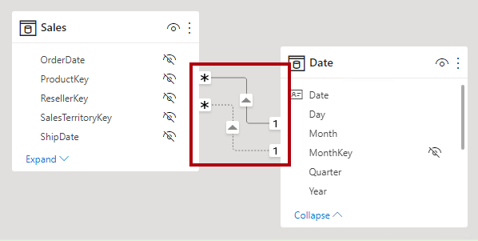
Your manager requests confirmation that these relationships are correctly configured for time-based analysis.
Why would you set the cross-filter direction to Both in the relationship between the Sales and Date tables?
To ensure that the relationship remains active in the model.

Explanation
Active relationships are set during model configuration and are independent of cross-filter direction. A relationship remains active as long as no other conflicting active relationships exist between the same tables.
To enable time intelligence functions in DAX calculations.

Explanation
Time intelligence functions such as TOTALYTD, SAMEPERIODLASTYEAR, and DATESYTD require a properly configured date table, but do not rely on bidirectional filtering. These functions work as long as the Date table is marked as a Date Table, regardless of cross-filtering settings.
Correct answer
To allow filters applied to either table to propagate to the other table.

Explanation
Setting cross-filter direction to "Both" allows filters applied to either the Sales table or the Date table to flow in both directions. This ensures that filtering based on dates impacts sales transactions, and vice versa. It is particularly useful when working with complex relationships where multiple tables need to interact dynamically.
To avoid creating circular references in the data model.

Explanation
Circular references occur due to incorrect table relationships or loops in the model, not due to cross-filter direction. Power BI prevents circular dependencies automatically by restricting relationship setups that would create a cycle.
Overall explanation
Cross-filter direction in Power BI determines how filters propagate between related tables. By default, relationships are set to Single direction, meaning that filters flow from the lookup table (Date) to the fact table (Sales). This standard one-way filtering works well in most star schema models.
However, in some cases, enabling Both (bidirectional) filtering can be beneficial. This setting allows filters to flow in both directions, meaning that filtering the Sales table also affects the Date table, and vice versa. This approach is particularly useful when working with multiple fact tables, interconnected dimensions, or many-to-many relationships, where one-way filtering may limit analytical capabilities.
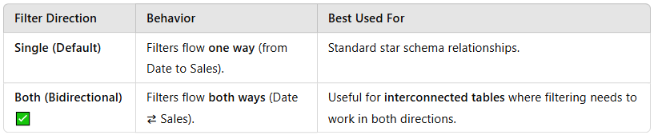
Although bidirectional filtering provides flexibility, it should be used with caution because it can increase model complexity and potentially cause performance issues, especially with large datasets. Improper use of Both filtering can also create ambiguous relationships and lead to unexpected results.
To ensure optimal time-based analysis in Power BI:
- Mark the Date table as a Date Table to enable time intelligence functions.
- Use bidirectional filtering only when necessary to avoid unnecessary complexity.
- Check for potential circular references before enabling Both cross-filter direction.
For more details, refer to Managing Relationships in Power BI.
By applying the correct cross-filtering settings, users can enhance data interactions, enable better filtering capabilities, and ensure accurate report analysis.
Domain
Model the data
Question 46Skipped
You are designing a Power BI sales report for a retail company. The report includes a line chart that displays monthly sales over time.
The sales team wants to see the total number of items sold when hovering over any data point in the line chart.
To achieve this, you must add the total items sold field to the:
Legend

Explanation
Adding the field to the legend creates additional series or categories in the chart but does not display the field in the hover-over tooltips.
Y-Axis

Explanation
Adding the field to the Y-Axis changes the chart's visual representation but does not display the total items sold when hovering over data points.
Slicers.

Explanation
Slicers allow filtering the data but do not provide hover-over information on the chart.
Correct answer
Tooltip

Explanation
Adding the total items sold field to the tooltip ensures it is displayed when hovering over a data point in the line chart.
Overall explanation
Power BI Tooltips allow users to view additional data when hovering over a visual.
How to Add a Field to Tooltips in a Line Chart
- Select the Line Chart in Power BI.
- Go to the "Format Pane" and expand the Tooltips section.
- Drag the "Total Items Sold" field into the Tooltip area in the Fields section.
- Customize the tooltip format if needed.
For more details, refer to Using Tooltips in Power BI.
Why Not Use Other Methods?
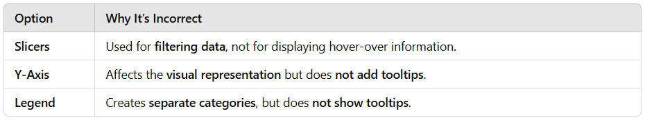
By adding the total items sold field to the tooltip, the sales team can see the total items sold when hovering over data points, making it the best approach for this scenario.
Domain
Visualize and analyze the data
Question 47Skipped
You are working on a Power BI report for SkyMetrics Solutions, and you notice that the OrderDate column in your dataset contains null values, which affects your ability to analyze sales trends.
How should you address this issue?
Remove all rows with null values in the OrderDate column.

Explanation
Removing rows with null OrderDate values may lead to loss of critical data, which could still be useful for other analyses such as customer segmentation or sales attribution.
Use a DAX measure to exclude null values during calculations.

Explanation
Using DAX measures to handle null values is a reactive approach that does not address the issue at the data preparation stage. Handling missing values in Power Query ensures a clean dataset for all calculations and reports.
Correct answer
Replace null values with a default date, such as 01/01/1900.

Explanation
Replacing null values with a default date ensures that the dataset remains complete while still allowing for filtering or highlighting of these values later. This approach prevents disruptions in time-based calculations and visualizations.
Leave the null values as they are to maintain data integrity.

Explanation
Null values can disrupt trend analysis, time-based calculations, and relationships between tables. While data integrity is important, handling null values appropriately improves analytical accuracy.
Overall explanation
Null values in date columns can significantly impact sales trend analysis, time intelligence functions, and report accuracy in Power BI. When working with datasets containing null OrderDate values, it's important to address them properly to ensure accurate reporting and consistent calculations.
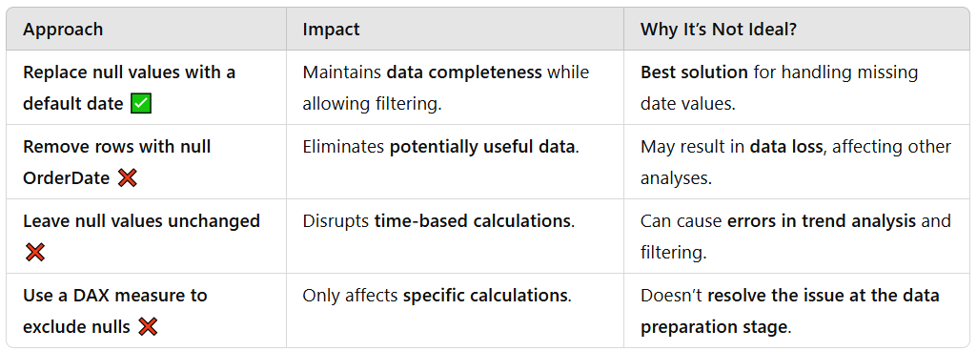
The best approach is to replace null values with a default date, such as 01/01/1900 or another business-defined placeholder. This keeps the dataset intact while ensuring time-based analyses remain functional. Analysts can later filter out or highlight these default values to differentiate them from actual dates.
For further best practices on handling null values in Power BI, refer to Handling Missing Data in Power Query.
By proactively addressing missing OrderDate values, Power BI reports at SkyMetrics Solutions can provide accurate sales trends, better forecasting, and improved decision-making.
Domain
Prepare the data
Question 48Skipped
You are creating a Power BI dashboard for a hospital management system. A report page includes the following visuals:
✔ A line chart showing patient admissions over time.
✔ A bar chart showing patient admissions by department.
✔ A map showing admissions by location.
The hospital administrators want these visuals on the dashboard, and they need the interactivity between the visuals to remain intact.
What should you do?
Correct answer
Pin the report page as a live tile on the dashboard.

Explanation
Pinning the report page as a live tile ensures that all interactivity between the visuals is preserved and accessible from the dashboard.
Publish the report to the Power BI service and share a link to the report.

Explanation
While sharing the report link allows interactivity, it does not add the visuals to the dashboard as requested.
Export the visuals as images and upload them to the dashboard.

Explanation
Exporting visuals as images creates static representations, and no interactivity is maintained.
Export the report as a PDF and upload it to the dashboard.

Explanation
Exporting the report as a PDF creates a static file that does not retain interactivity between visuals.
Overall explanation
In Power BI, dashboards provide a high-level overview using visuals from reports. However, if interactivity is required, you need to pin the report page as a live tile.
Best Approach: "Pin the Report Page as a Live Tile"
- A Live Page Tile keeps all interactivity between visuals intact.
- Users can filter, drill down, and interact with the data directly on the dashboard.
- Steps to Pin a Live Page Tile:
  - Open the report in Power BI Service.
  - Click "Pin a Live Page" in the top menu.
  - Select the destination dashboard.
  - Confirm pinning the live report.
  - Learn more about Pinning Live Pages in Power BI.
Why Not Use Other Methods?
- PDF Export: Creates a static file, losing all interactivity.
- Sharing a Report Link: Allows interaction but does not place visuals on the dashboard.
- Exporting as Images: Results in static visuals with no drill-through or filtering.
By pinning the report page as a live tile, you meet the hospital administrators' request while ensuring all visuals remain interactive, making it the best approach.
Domain
Visualize and analyze the data
Question 49Skipped
At SkyMetrics Corp., your report includes a Global Sales Summary page and two drillthrough pages:

- Product Details: Filters by Product Category.
- Customer Details: Filters by Customer Name.
Your manager requests that when selecting a product category in the summary page, users can drill through to the Product Details page. Similarly, selecting a customer name should drill through to the Customer Details page.
How should you configure the drillthrough navigation?
Add both Product Category and Customer Name to the "Drillthrough" section of a single drillthrough page.

Explanation
Drillthrough navigation works best when each page is dedicated to a specific filter field.
Use a slicer to switch between Product Category and Customer Name on the drillthrough page.

Explanation
Slicers allow manual filtering but do not enable dynamic drillthrough functionality.
Correct answer
Create separate drillthrough pages for Product Category and Customer Name and configure each with the appropriate field in the "Drillthrough" section.

Explanation
This ensures each drillthrough page is tailored to its specific filter field, improving clarity and usability.
Enable "Cross-Highlight" between visuals to allow drillthrough based on the selected field.

Explanation
Cross-highlighting highlights data points but does not enable drillthrough navigation.
Overall explanation
The requirement is to have two separate drillthrough paths:
- When a user selects a product category on the Global Sales Summary page, they should be taken to a drillthrough page that shows Product Details filtered by that product category.
- When a user selects a customer name, they should be taken to a separate drillthrough page that shows Customer Details filtered by that customer name.
To achieve this, you need to create two separate drillthrough pages—each configured with the appropriate filter field in the drillthrough section:
- Product Details Drillthrough Page:
Configure this page by adding the Product Category field to its drillthrough filters. This ensures that when a product category is selected on the summary page, the page will filter its content to show only the related product details.
- Customer Details Drillthrough Page:
Similarly, configure this page by adding the Customer Name field to its drillthrough filters. This way, when a customer name is selected, the drillthrough will navigate to the page showing detailed information specific to that customer.
This approach isolates the two navigation contexts so that each drillthrough page only receives and uses the relevant filter from the summary page.
Why Other Options Are Not Appropriate
- Using a Slicer to Switch Between Fields on a Drillthrough Page:
A slicer is used for interactive filtering within a page, but it doesn’t provide the context-specific navigation needed for drillthrough. It would not automatically filter the drillthrough page based on the selection made on the summary page.
- Enabling Cross-Highlighting Between Visuals:
Cross-highlighting is designed for interactivity within a page and is not a substitute for drillthrough navigation. It does not enable users to navigate to a different page with a specific filter context.
- Adding Both Fields to a Single Drillthrough Page:
Including both Product Category and Customer Name in one drillthrough page would require both fields to be present in the filter context. This is problematic because a selection on the summary page might only provide one of the two values. It could lead to confusing or unintended filtering on the drillthrough page.
Conclusion
The best approach is to create separate drillthrough pages for the Product Details and Customer Details. Each page should have its corresponding field—Product Category for the Product Details page and Customer Name for the Customer Details page—added to the drillthrough filter. This configuration ensures that users drilling through from the Global Sales Summary receive a context-specific view that accurately reflects their selection.
For further details and best practices on setting up drillthrough in Power BI, please refer to the official Microsoft documentation on Drillthrough in Power BI
Domain
Visualize and analyze the data
Question 50Skipped
You are building a Power BI report for a human resources (HR) department. The HR team wants to analyze employee attrition to identify the factors driving employee resignations.
The dataset includes the following columns:
- Employee ID
- Resignation (Yes/No)
- Job Role
- Years at Company
- Salary Band
- Performance Rating
- Department
The HR team requests a visualization that can automatically determine and rank the most significant factors influencing employee resignations. Which visualization should you use?
Clustered column chart

Explanation
A clustered column chart is useful for comparing data across categories but does not analyze or rank factors driving a specific outcome like resignations.
Decomposition tree

Explanation
The Decomposition Tree allows users to manually break down a metric into contributing factors step by step but does not automatically rank the significance of factors.
Correct answer
Key influencers

Explanation
The Key Influencers visualization uses statistical methods to analyze the dataset and automatically identifies the most significant factors driving the outcome (Resignation = Yes). It is the ideal choice for identifying and ranking the factors influencing employee resignations.
Histogram

Explanation
A histogram visualizes the frequency distribution of a single variable but does not identify or rank factors influencing a specific outcome like resignations.
Overall explanation
When analyzing employee attrition in Power BI, it is important to use a visualization that can:
✔ Identify key drivers of resignations
✔ Rank the most influential factors automatically
✔ Provide insights into correlations and patterns
Key Power BI Visuals for Data Analysis
- Key Influencers:
  - This visualization uses machine learning-based statistical analysis to determine which factors have the strongest correlation with a selected outcome (e.g., employee resignation).
  - It ranks the most influential factors, making it perfect for HR analytics.
  - More details can be found in Key Influencers in Power BI.
- Decomposition Tree:
  - Allows users to drill down into contributing factors, but ranking is not automatic.
  - Useful for exploratory analysis but less effective for identifying key influencers. Learn more about it in Decomposition Tree in Power BI.
- Histograms & Clustered Column Charts:
  - These are best for distribution analysis and category comparisons but do not rank influencing factors.
By using the Key Influencers visualization, the HR team can effectively identify, rank, and understand the top factors contributing to employee resignations, making it the best choice for this scenario.
Domain
Visualize and analyze the data
Question 51Skipped
You are building a university enrollment report in Power BI Desktop. The data model includes two tables:
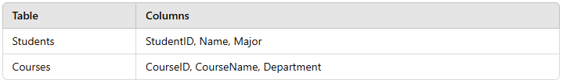

Both tables have Row-Level Security (RLS) configured and are filtered by Department.
You need to create a relationship between the Students and Courses tables. The solution must ensure that security filters are respected when users view data for both tables. What steps should you take?
Create an active relationship and enable "Enforce Referential Integrity" between the tables.

Explanation
"Enforce Referential Integrity" optimizes query performance but does not control how RLS is applied between tables or ensure security filters are respected.
Create an inactive relationship and enable "Apply security filter in both directions" for the relationship.

Explanation
An inactive relationship does not allow for any filtering to occur unless it is manually activated via DAX, making it unsuitable for this scenario.
Create an active relationship and enable "Cross-filter direction: Both" for the relationship.

Explanation
Enabling "Cross-filter direction: Both" enables bidirectional filtering but does not enforce row-level security filters between the tables.
Correct answer
Create an active relationship and enable "Apply security filter in both directions" for the relationship.

Explanation
An active relationship ensures that the two tables are connected and filters can flow between them. By enabling "Apply security filter in both directions", row-level security filters will apply to both tables in the relationship, ensuring that security settings are respected across the model.
Overall explanation
When working with Row-Level Security (RLS) in Power BI, it’s crucial to ensure that security filters apply correctly across related tables. In this scenario, both the Students and Courses tables are filtered by Department, and the goal is to maintain security restrictions while enabling a relationship between them.
Understanding Relationship Settings for RLS
Active Relationship
An active relationship between two tables ensures that filters automatically flow from one table to another. This is essential for proper filtering but does not inherently enforce security settings. More details can be found in Managing Relationships in Power BI.
Bidirectional Filtering
Enabling Cross-filter direction: Both allows filters to flow in both directions between related tables. However, this alone does not enforce RLS. While it improves data interactions, security filters will not automatically propagate across tables unless explicitly enabled. More information is available in Bidirectional Cross-Filtering in Power BI.
Enforcing Security Filters
To ensure that RLS settings are applied across tables, the Apply security filter in both directions option must be enabled in the relationship settings. This setting ensures that RLS-defined filters propagate between the Students and Courses tables, restricting data based on the assigned permissions. You can learn more about this in Row-Level Security (RLS) in Power BI.
Best Approach for RLS Compliance
To maintain proper security enforcement, the most effective solution is to:
✔ Create an active relationship between the Students and Courses tables
✔ Enable "Apply security filter in both directions"
This ensures that RLS rules restrict access across both tables while still allowing necessary filtering for report functionality.
Domain
Model the data
Question 52Skipped
You are working on a Power BI dashboard for a retail company. The data model contains Sales and Product tables.
You need to create a measure to calculate the number of unique products sold across all orders.
Which steps should you follow to create this measure in Power BI?
Use COUNT(Sales[ProductID]) to create a measure in the Sales table.
Filter the results to exclude duplicate products.

Explanation
The COUNT function counts all rows without considering duplicates, which does not meet the requirement of counting unique products.
Create a calculated column in the Sales table to count distinct ProductID.
Add a calculated measure in the Products table to count ProductID.

Explanation
Calculated columns are not necessary here, as they increase the model size and don’t provide flexibility for filtering or summarization in visuals.
Correct answer
Add a measure in the Sales table using DISTINCTCOUNT(Sales[ProductID]).
Use the measure in a visualization.

Explanation
To count the unique products sold, the correct DAX function is DISTINCTCOUNT, which counts the distinct values of ProductID in the Sales table. This ensures that each product is counted only once, regardless of how many times it appears in different orders.
Create a measure in the Products table using COUNTROWS(Products).
Filter the table to only include products sold.

Explanation
While COUNTROWS can count rows, it cannot be used to count distinct values from a related table without additional filtering logic.
Overall explanation
When calculating distinct values in Power BI, the best approach is to use DAX measures rather than calculated columns for flexibility and optimized performance.
Best DAX Function for Counting Unique Products Sold
- DISTINCTCOUNT(Sales[ProductID])
  - This function counts the unique occurrences of ProductID in the Sales table.
  - Ensures that each product is counted only once, regardless of the number of orders it appears in.
  - Learn more about DISTINCTCOUNT in Power BI.
Why Not Use Other Methods?
- Calculated Columns
  - Increase model size and reduce performance.
  - Do not allow dynamic filtering when used in visuals.
  - See Why Measures Are Better Than Calculated Columns.
- COUNT vs. DISTINCTCOUNT
  - COUNT() includes duplicate values, which does not meet the requirement.
  - DISTINCTCOUNT() ensures that each unique ProductID is counted once, making it the correct choice.
By using DISTINCTCOUNT in a measure, you can effectively track the number of unique products sold, making it the best approach for this scenario.
Domain
Model the data
Question 53Skipped
You are managing a Power BI tenant for a retail organization. The organization uses Power BI to analyze and share sensitive customer and sales data.
To comply with regulatory requirements, you need to ensure that:
✔ All reports, datasets, and dashboards are labeled according to their sensitivity level.
✔ Exported files (e.g., Excel, PDF) are protected.
What should you do?
Prevent users from exporting data from a report.

Explanation
Sensitivity labels do not control export permissions. Export restrictions are managed through tenant settings or individual user roles in the Power BI admin portal.
Certify datasets to ensure quality.

Explanation
Dataset certification is a feature for validating dataset quality but is unrelated to sensitivity labels or data protection.
Correct answer
Encrypt exported files such as Excel and PDF.

Explanation
Sensitivity labels in Power BI integrate with Microsoft Information Protection (MIP) to ensure that files exported from Power BI (such as Excel, PDF) are encrypted and labeled appropriately to prevent unauthorized access.
Automatically restrict access to Power BI reports.

Explanation
Sensitivity labels do not manage access control; report access is controlled by user permissions, workspace roles, and row-level security (RLS).
Overall explanation
Power BI Sensitivity Labels (powered by Microsoft Information Protection - MIP) help organizations classify, protect, and govern sensitive data.
How Sensitivity Labels Work in Power BI:
✔ Labels classify reports, dashboards, and datasets based on sensitivity (e.g., "Confidential", "Highly Confidential").
✔ When exporting to Excel, PDF, or PowerPoint, labels and encryption persist to prevent unauthorized sharing.
✔ Admins can enforce protection policies to control how sensitive data is handled.
How to Enable Sensitivity Labels in Power BI
- Enable Microsoft Information Protection (MIP) in Power BI Admin Settings.
- Apply Sensitivity Labels in the Power BI Service to datasets, reports, and dashboards.
- Ensure labels apply to exported files (Excel, PDF, PowerPoint).
For more details, refer to Sensitivity Labels in Power BI.
Why Not Use Other Methods?
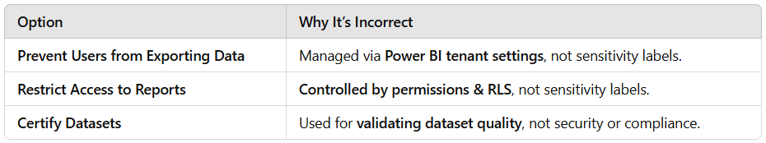
By encrypting exported files, the organization ensures that sensitive data remains protected, making it the best approach for compliance and security.
Domain
Deploy and maintain assets
Question 54Skipped
You are developing a Power BI report for a multinational company. The imported dataset contains a Date column stored as text with inconsistent formats (e.g., “dd/mm/yyyy” and “mm/dd/yyyy”). You need to standardize these values in Power Query so that time-based analyses work correctly.
Which steps should you follow to convert and standardize the date column?
Correct answer
Use the Change Type Using Locale option in the Transform tab, selecting a locale that matches the source data format.

Explanation
Using the Change Type Using Locale option in Power Query allows you to specify a locale that matches the source data format. This ensures that the date column is standardized correctly, taking into account different date formats used in the dataset.
Split the Date column by delimiter into separate day, month, and year columns, and then recombine them using custom formulas.

Explanation
Overly manual, error-prone, and unnecessary given Power Query’s built-in locale feature.
Create a new calculated column in the data model using DAX’s DATEVALUE() function to convert the text to date.

Explanation
DAX works on loaded data and can’t handle transformation errors as cleanly; you lose the benefits of Power Query’s step-by-step preview and error handling.
Use the Change Type transformation directly to Date; then manually replace any error values with null.

Explanation
Will throw errors or mis-interpret half the values without giving you locale control.
Overall explanation
Why “Change Type Using Locale” is the right approach
- Inconsistent formats: Your source has dates in both dd/mm/yyyy and mm/dd/yyyy forms. A simple “Change Type → Date” will apply your Power BI desktop’s locale setting uniformly and will mis-interpret half of the values (e.g. treat “03/04/2023” as March 4th instead of April 3rd).
- Locale awareness: “Change Type Using Locale” lets you explicitly tell Power Query which locale to assume when converting text to dates. For example, you can first convert all dd/mm/yyyy entries by choosing English (United Kingdom), then apply another conversion step for the US format if needed.
Steps to standardize your Date column
- Open Power Query Editor
In Power BI Desktop, go to Home → Transform data.
- Select the Date column
Click the header of your text-based Date column.
- Invoke Change Type Using Locale
  - On the Transform tab, click the drop-down under Data Type, and choose Using Locale…
  - In the dialog:
    - Set Data Type to Date
    - Set Locale to match the format in your text (e.g. English (United Kingdom) for dd/mm/yyyy).
- Handle remaining formats
  - If you have mixed formats in the same column, you may need to:
    - Duplicate the column.
    - Apply Change Type Using Locale with one locale on one copy, and a different locale on the other.
    - Merge the two using a conditional (e.g. if try [UKConverted] is date then [UKConverted] else [USConverted]).
- Close & Apply
Once all text values are successfully converted to true Date types, click Close & Apply to load back into your model.
Official Documentation
- Add or change data types (Power Query)
Add or change data types (Power Query)
Domain
Model the data
Question 55Skipped
You are using the Group By feature in Power Query to summarize sales data. The image shows an advanced grouping operation where:
✔ Rows are grouped by the OrderDate column.
✔ A new column named "Count" is created to count the number of rows for each date.
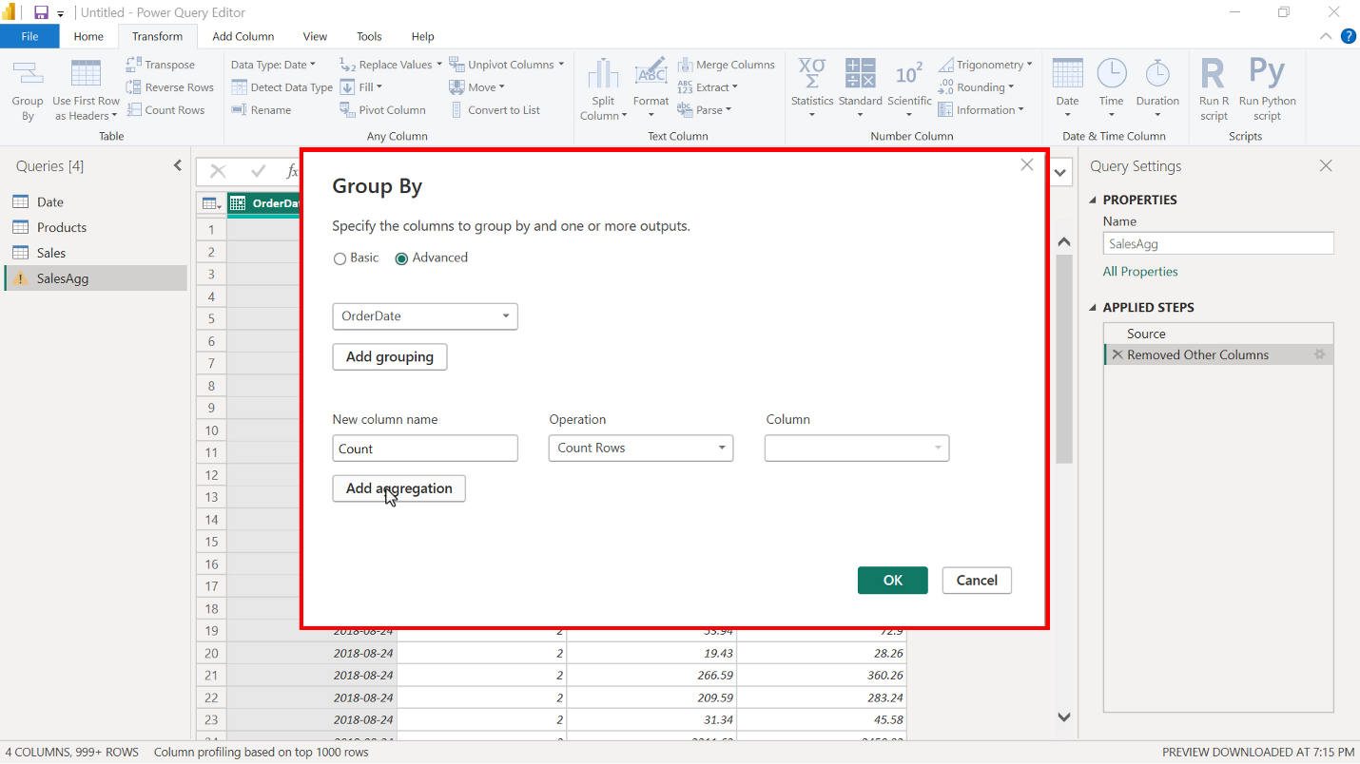
Now, you decide to add another aggregation to calculate the total sales for each OrderDate, using the SalesAmount column.
What steps should you take?
Click Add Grouping, select SalesAmount, and set the operation to Sum.

Explanation
Grouping is used to define how rows are grouped, not for performing calculations. Aggregations should be used instead.
Filter the SalesAmount column to show only rows with non-null values before applying the Group By operation.

Explanation
Filtering rows is not required unless you need to exclude specific data from the aggregation.
Add a calculated column to the table using the formula = SUM(Sales[SalesAmount]).

Explanation
Calculated columns are created outside the Group By feature and do not summarize grouped data.
Correct answer
Click Add Aggregation, select Sum as the operation, and choose SalesAmount as the column.

Explanation
The "Add Aggregation" option allows you to add another summarized column in Power Query.
Selecting "Sum" as the operation and choosing "SalesAmount" ensures that total sales for each group (OrderDate) are calculated correctly.
Overall explanation
In Power Query, the Group By feature helps summarize data based on a specific column. To add another aggregation while keeping the existing Count column, you should:
Steps to Add a Sum Aggregation for SalesAmount
- Open Power Query Editor.
- Select the table you want to summarize.
- Click "Transform" → "Group By".
- Ensure OrderDate is set as the grouping column.
- Click "Add Aggregation".
- Select "Sum" as the operation and choose "SalesAmount" as the column.
- Click OK to apply the changes.
For more details, refer to Using the Group By Feature in Power Query.
Why Not Use Other Methods?
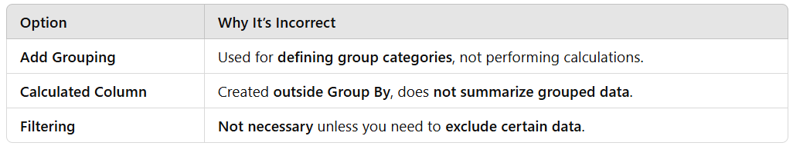
By adding an aggregation with Sum, you can successfully calculate the total sales per OrderDate, making it the best approach for this scenario.
Domain
Prepare the data
Question 56Skipped
You are working with Microsoft Power BI to model sales data. Your dataset includes a SQL Server table named TransactionDetails containing over 150 million records.
To optimize performance during development, you need to import a sample of the data for testing purposes while ensuring that your dataset remains representative of the full table.
Which of the following actions should you take? (Select all that apply)
Write a DAX expression using the FILTER function to limit the data imported.

Explanation
This option is incorrect because DAX operates on the data already imported into the model and does not affect the import process.
Correct selection
Use the TOP clause in a native SQL query to limit the number of records retrieved.

Explanation
Writing a native SQL query with a TOP clause or a WHERE filter limits the data at the source, which is a more efficient approach when dealing with large datasets.
Load the full dataset into Power BI and filter the visuals on the report page.

Explanation
This approach does not reduce the dataset size during import and can lead to performance issues due to the large volume of data.
Correct selection
Apply row filters in Power Query to import only a subset of the data.

Explanation
Power Query allows you to filter rows during the data preparation stage, ensuring that only the relevant subset of data is imported into the model. This is an effective method for sampling large datasets.
Overall explanation
When dealing with large datasets in Power BI, optimizing data import is crucial to ensure efficient performance without slowing down development.
Best Practices for Sampling Large Datasets in Power BI
- Applying Row Filters in Power Query
  - Power Query enables row-level filtering before data is loaded into the model, allowing you to work with a manageable subset of data.
  - Learn more about Filtering Data in Power Query.
- Using a TOP Clause in a SQL Query
  - Writing a SQL query using TOP or WHERE filters limits the number of rows retrieved from the database, which reduces the data load and improves performance.
  - More details can be found in Writing Efficient SQL Queries for Power BI.
What to Avoid?
- Using DAX for Filtering Data Before Import
  - DAX expressions operate on imported data and do not reduce the number of records before loading. Learn why in DAX vs. Power Query.
- Loading the Entire Dataset and Filtering in Reports
  - This increases memory usage and processing time, making it inefficient for handling large datasets.
By filtering data in Power Query or using a SQL query with a TOP clause, you can efficiently sample data, ensuring better performance while still working with a representative dataset.
Domain
Prepare the data
Question 57Skipped
CASE STUDY:
Company A, a retail and manufacturing organization, is undergoing a digital transformation to enhance data-driven decision-making. The organization has recently adopted Power BI for analytics and reporting. The analytics team is tasked with creating reports, managing datasets, and sharing insights with key business units such as Sales, Marketing, Finance, and Operations.




Business Challenges
You are tasked with addressing the following challenges while ensuring collaboration, security, and scalability:
- Designing Workspaces: How should workspaces be structured to meet departmental needs while ensuring data security and collaboration?
- Managing Permissions: What roles and permissions should be assigned to balance collaboration and security?
- Version Control: How can you maintain a single source of truth for reports and datasets?
- Data Governance: How can you ensure compliance with organizational policies and data privacy regulations?
- Scalability: How can you design a future-proof analytics environment for growing Power BI adoption?

Question:
How can you ensure that only the latest version of reports is used and shared?
Use email notifications to alert users about updates to reports.

Explanation
Email notifications are not a scalable or reliable method for version control.
Save all report versions in a shared OneDrive folder.

Explanation
Saving versions in OneDrive is not integrated with Power BI and can lead to confusion.
Correct answer
Use the "Promote" or "Certify" feature for key datasets and reports.

Explanation
Promoting or certifying reports ensures users can easily identify and use the official, up-to-date version.
Require users to download the latest version of reports from the Power BI service.

Explanation
Relying on users to download reports manually is prone to errors and inefficiencies.
Overall explanation
The recommended approach is to use the "Promote" or "Certify" feature for key datasets and reports. This feature allows the organization to designate certain reports and datasets as the single source of truth. By certifying or promoting content, you:
- Establish Trust and Authority:
Certifying content signals to all users that the report or dataset has been reviewed, meets quality standards, and is the most up-to-date version. It serves as an official endorsement from the analytics or IT team.
- Improve Governance and Version Control:
When content is certified, users are encouraged to use only the promoted or certified version. This minimizes the risk of working with outdated or multiple versions of reports, ensuring consistency across the organization.
- Streamline Collaboration:
With a certified version available, teams across departments (such as Sales, Marketing, Finance, and Operations) can confidently build additional reports and dashboards on top of a single trusted dataset.

Why Other Options Are Not Ideal
- Requiring Users to Download the Latest Version:
This approach places the burden on individual users to ensure they have the most recent report. It does not enforce version control and can easily lead to inconsistencies, as different users might operate with different versions.
- Using Email Notifications to Alert Users About Updates:
While notifications can help inform users of updates, they do not prevent users from accessing or sharing outdated versions. This method is more of an informational tool rather than a governance mechanism.
- Saving All Report Versions in a Shared OneDrive Folder:
Maintaining multiple versions in a shared folder can actually exacerbate version control issues. Users may inadvertently use or share older versions, leading to confusion and data inconsistencies.
Domain
Case Study
Question 58Skipped
You are a data analyst at BlueSky Electronics, and your manager has asked you to extract sales data from the company’s SQL Server database to build a sales performance report in Power BI.
Which language should you use to retrieve the data from the database?
Correct answer
T-SQL

Explanation
- T-SQL (Transact-SQL) is the standard language for querying and managing data in SQL Server databases.
- When connecting Power BI to SQL Server, you use T-SQL to write queries that extract data for analysis and reporting.
- Learn more about T-SQL in SQL Server.
MDX

Explanation
- MDX is a query language used for querying OLAP cubes in SQL Server Analysis Services (SSAS).
- It is not used for querying relational SQL Server databases.
- More details: MDX in Analysis Services.
DAX

Explanation
- DAX is used within Power BI for creating calculated columns, measures, and aggregations.
- It is not designed to extract data from external databases like SQL Server.
- More details: DAX in Power BI.
Overall explanation
When extracting sales data from a SQL Server database for use in Power BI, the correct query language is T-SQL (Transact-SQL).
How to Extract Data Using T-SQL in Power BI?
- Open Power BI Desktop
- Go to "Get Data" → Select "SQL Server"
- Enter the Server Name and Database Name
- Choose "DirectQuery" or "Import Mode"
- Write a T-SQL Query (if using Advanced Options)
  - ELECT ProductName, SUM(SalesAmount) AS TotalSales
  - FROM SalesTable
  - WHERE OrderDate >= '2023-01-01'
  - GROUP BY ProductName
- Load Data and Build Visuals
Why Not Use Other Languages?
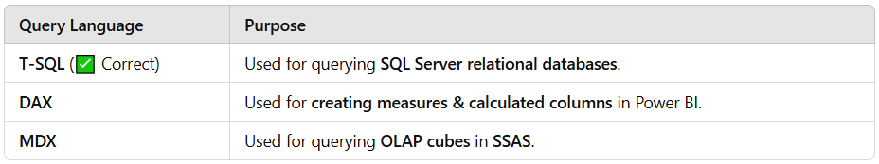
By using T-SQL, you can retrieve, filter, and aggregate the required sales data efficiently, making it the best approach for this scenario.
Domain
Prepare the data
Question 59Skipped
You are managing a Power BI environment for a financial organization. The organization has a large semantic model hosted in Analysis Services, which is connected to several Power BI reports.
A new analyst needs to use this semantic model for creating reports in Power BI Desktop.
What steps must you take to configure access for the analyst?
Grant the analyst the Viewer role in the Power BI workspace containing the reports.

Explanation
The Viewer role allows users to view reports but does not grant access to connect to or use semantic models in Power BI Desktop.
Assign the analyst to the Reader role for the Analysis Services database.

Explanation
The Reader role allows the user to query the database but does not provide the necessary permissions to connect to the semantic model in Power BI Desktop.
Enable the "Allow XMLA endpoint connections" option for the Power BI tenant.

Explanation
- Enabling XMLA endpoint connections is necessary for accessing Power BI Premium datasets as semantic models.
- However, the user still needs Build permissions or database access credentials to connect.
Correct answer
Provide the analyst with the server name and ensure they have Build permissions on the dataset.

Explanation
- To connect to an Analysis Services semantic model, the analyst needs the server name for Analysis Services (SSAS).
- If using Power BI Service datasets, the analyst must have Build permissions on the dataset in Power BI.
- Build permissions allow users to create their own reports using the semantic model.
- Learn more about Build permissions in Power BI.
Overall explanation
When connecting a Power BI Desktop report to a semantic model in Analysis Services (SSAS) or Power BI Service, the user must have:
✔ The server name (for SSAS models) OR
✔ Build permissions (for Power BI datasets)
How to Grant Access to a Semantic Model?
- For Analysis Services (SSAS) Models:
  - Provide the server name and database name.
  - Ensure the user has Reader access to query the model.
  - Guide the user to connect via Get Data → Analysis Services in Power BI Desktop.
- For Power BI Service Datasets:
  - Grant the Build permission in Power BI Service.
  - The user can then connect via Power BI Desktop → Get Data → Power BI Datasets.
  - More details on Connecting to Power BI Datasets.
Why Not Use Other Methods?
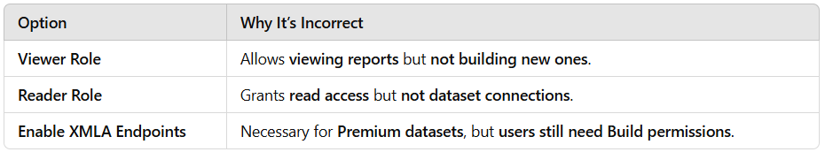
By providing the analyst with the server name (for SSAS) and Build permissions (for Power BI datasets), they can successfully connect and create reports, making this the best approach for this scenario.
Domain
Deploy and maintain assets
Question 60Skipped
You are a Power BI developer implementing dynamic row-level security (RLS) in a financial dashboard. The dashboard contains a table named Orders.
You configured the RLS filter on the CustomerEmail column as follows:
CustomerEmail = USERPRINCIPALNAME()
After publishing the report to the Power BI Service, customers report that they can still see all order records instead of only their own.
What is the most likely cause of this issue?
Correct answer
The email addresses in the CustomerEmail column do not match the format returned by USERPRINCIPALNAME().

Explanation
Dynamic RLS filters in Power BI depend on exact matches between the column being filtered and the value returned by USERPRINCIPALNAME(). If there is a format mismatch (e.g., CustomerEmail stores values like "john.doe" instead of "john.doe@example.com"), the filter will not work as expected, and users may see all rows.
You used USERNAME() instead of USERPRINCIPALNAME() in the DAX filter expression.

Explanation
The question clearly states that the filter uses USERPRINCIPALNAME(), so this is not the issue.
The RLS filter was not applied to the dataset when publishing the report to the Power BI service.

Explanation
RLS filters are automatically applied when publishing the report to the Power BI Service, as long as they are properly configured in Power BI Desktop.
The CustomerEmail column is not properly linked to the Orders table in the data model.

Explanation
RLS operates on the dataset directly and does not depend on relationships between tables unless specific conditions require it (which is not the case here).
Overall explanation
Row-Level Security (RLS) in Power BI allows developers to restrict data access based on user identity.
Key Aspects of Dynamic RLS using USERPRINCIPALNAME()
- USERPRINCIPALNAME() retrieves the logged-in user's email address as stored in Power BI Service (e.g., "john.doe@example.com").
- The CustomerEmail column must contain values in the same format as USERPRINCIPALNAME() for the filter to work correctly.
- If the CustomerEmail column stores only usernames (e.g., "john.doe" instead of "john.doe@example.com"), the filter will not match and will not restrict data properly.
- To fix this, ensure the CustomerEmail column is formatted correctly by either:
  - Updating the source data to store full email addresses.
  - Modifying the RLS filter to append the domain dynamically:
    - DAX
    - CopyEditCustomerEmail & "@example.com" = USERPRINCIPALNAME()
Common Issues with RLS in Power BI
- Mismatch in Email Formatting: If USERPRINCIPALNAME() returns "john.doe@example.com" but the table only stores "john.doe", the filter will not match.
- Publishing and RLS Settings: RLS must be defined in Power BI Desktop and then tested in Power BI Service. Learn more about Configuring RLS in Power BI.
- DirectQuery vs. Import Mode: RLS works in both modes, but queries in DirectQuery mode may require optimization. See RLS with DirectQuery.
By ensuring an exact match between USERPRINCIPALNAME() and CustomerEmail, you can properly implement dynamic row-level security, restricting users to only their relevant records.
Domain
Deploy and maintain assets

