Table of Contents

Memorandum 2

Introduction 2

Field of the Project 2

Impact on Area of Study 3

Project Goals 3

Objective 4

Milestones and Timeline 5

Methodology 6

Technologies or Service 6

Architecture 7

Data Management Plan 7

Design and Implementation plan 7

Conclusion 8

References 9

# Memorandum

DATE: September 27, 2024

TO: Rahim

FROM: AIDA Student, Saskatchewan Polytechnic

TOPIC: Forecasting food delivery demand using weather & time

## Introduction

Food delivery through online services has been a necessity for quite a few years. Demand highly depends on exogenous variables, such as weather conditions and time of day. The fast-growing number of deliveries enables predictions of customer demand to be made in order to optimize delivery operations toward higher customer satisfaction and overall efficiency. The paper is focused on the development of a machine-learning model in the context of forecasting food delivery services demand, including weather and time-of-the-day information to guarantee that historical data provide valuable insights.

## Field of the Project

The project deals with Data Science, Machine Learning, and Operations Management by proposing analytics of data and predictive modeling of the problems which naturally arise in real-world logistical challenges related to food delivery services.

## Impact on Area of Study

From the possible contributions of this project to the field of logistics and operations management, it will be clear that delivery functions will be enhanced to meet business needs. They can be used by the food delivery platforms to understand how to staff up, allocate resources and where to provide services to efficiently. Further, finally, to the body of knowledge in Predictive Analytics, this study established enviro temporal factors that assist in predicting demand through machine learning. (Rabaa'i, 2022)

## Project Goals

The purpose of this project is to create a model to predict the number of food delivery orders for any day based on the weather conditions such as, temperature, raining, wind speed and time of the day like morning; afternoon; evening, or night. The model shall give the delivery platforms information regarding when customers demand delivery services most, which shall enhance planning how best to meet those needs.

## Objective

**Develop a Comprehensive Dataset:** Compile a dataset combining historical food delivery data with corresponding weather conditions and time-of-day information for accurate modeling.

**Preprocess the Collected Data**: Clean, encode, and normalize the data to ensure it is in a suitable format for machine learning, eliminating inconsistencies and enhancing model performance.

**Train a Machine-Learning Model:** Use a suitable algorithm to train the model on the preprocessed data, enabling accurate prediction of delivery demand.

**Evaluate Model Performance:** Assess the model’s effectiveness using statistical metrics like Mean Squared Error (MSE) and R-squared to ensure reliable predictions.

**Visualize Predicted Demand:** Create visual representations, such as bar graphs and line charts, to help users understand and compare predicted demand patterns.

**Create an Interactive User Interface:** Develop a simple interface that allows users to input variables and receive real-time demand predictions, enhancing usability. (Food Delivery Time Prediction with LSTM Neural Network, n.d.)

## Milestones and Timeline

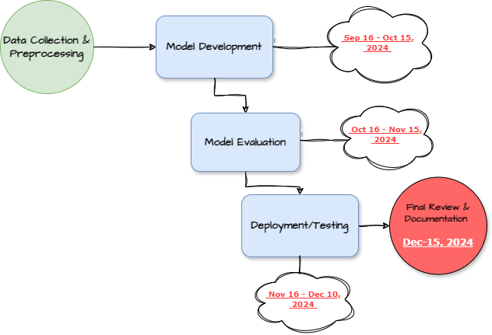

Figure 1 : Overview of Schedule

## Methodology

1. **Data Collection:** Gather historical data, including food delivery counts, weather data (temperature, precipitation, wind speed), and time of day.
2. **Preprocessing:** Clean the dataset, handle missing values, encode categorical data (e.g., weather condition and time of day), and normalize numerical values.
3. **Model Training**: Train a machine-learning model, such as a Random Forest Regressor, on the cleaned data to predict delivery demand.
4. **Evaluation:** Use metrics like Mean Squared Error (MSE) and R-squared to evaluate model performance on test data. (Food-Delivery-Time-Prediction-Model, n.d.)
5. **Visualization:** Create graphical representations (e.g., bar graphs) to compare predicted deliveries for different dates and times.
6. **Deployment:** Create an easy-to-use application for businesses to input weather and time parameters and receive predicted delivery demand.

## Technologies or Service

* **Programming Language:** Python
* **Libraries:** Pandas, NumPy, Scikit-learn, Matplotlib, Seaborn for data visualization
* **Tools**: Google Colab
* **Dataset:** Kaggle or other publicly available datasets (Food Delivery Dataset, n.d.)

## Architecture

1. **Input Layer:** Data (weather conditions, time of day)  
2. **Processing Layer:** Data preprocessing, feature engineering, model training  
3. **Output Layer:** Predicted number of deliveries for given weather and time of day  
4. **Interface:** A user-friendly web interface to input variables and display predictions

## Data Management Plan

The collected data will be handled and safeguarded securely all through project implementation. The preprocessed data will be kept exactly in structured forms to maintain consistent records. Measures of ensuring back up of data in case of loss will be put in place.

## Design and Implementation plan

* **Design Phase:** Understand the relationships between weather conditions, time of day, and delivery patterns. Develop data pipelines for processing and storing the data.
* **Implementation Phase:** Develop machine learning models and test their accuracy. Implement an intuitive user interface for users to interact with the model.
* **Testing Phase:** Test the model’s accuracy and efficiency with different data inputs. Validate the interface with potential end-users for feedback and improvements.

## Conclusion

This project aims to build a predictive model to forecast food delivery demand based on weather the goal of this work is to use the weather and the hour of the day as inputs to the model, which is to predict demand for food delivery in the future. Furthermore, given accurate estimation of demand, an optimized operation is achieved eventually improving the delivery of services and hence meeting customer expectations. Having machine learning incorporated with real-time weather information, this project has high potential in helping the logistics and food delivery sectors.

# References

1. *Food Delivery Dataset*. (n.d.). Retrieved from https://www.kaggle.com/datasets/gauravmalik26/food-delivery-dataset/data
2. *Food Delivery Time Prediction with LSTM Neural Network*. (n.d.). Retrieved from Analytics Vidhya: https://www.analyticsvidhya.com/blog/2023/04/food-delivery-time-prediction-with-lstm-neural-network/
3. *Food-Delivery-Time-Prediction-Model*. (n.d.). Retrieved from https://github.com/SaloniJhalani/Food-Delivery-Time-Prediction-Model/tree/main/code
4. Rabaa'i, A. (2022). *Model Assisted Statistics and Applications -1.* Newark.