**Assignment Day 6**

**Question 1**

**1. Install Google chrome on a windows system.**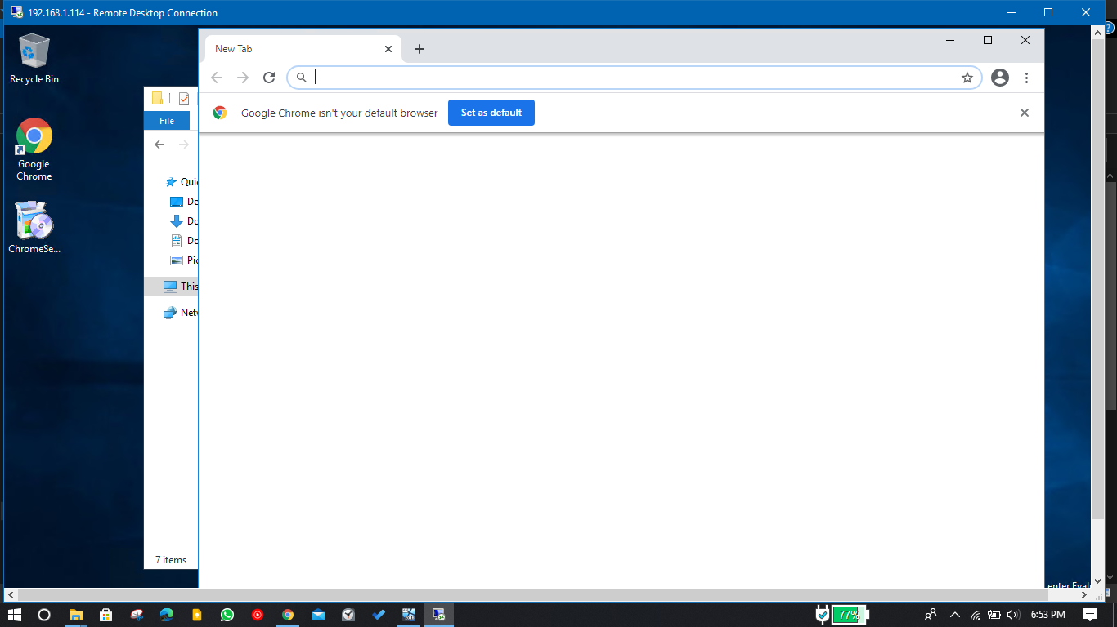

**2. Block the usage of google chrome to all users**

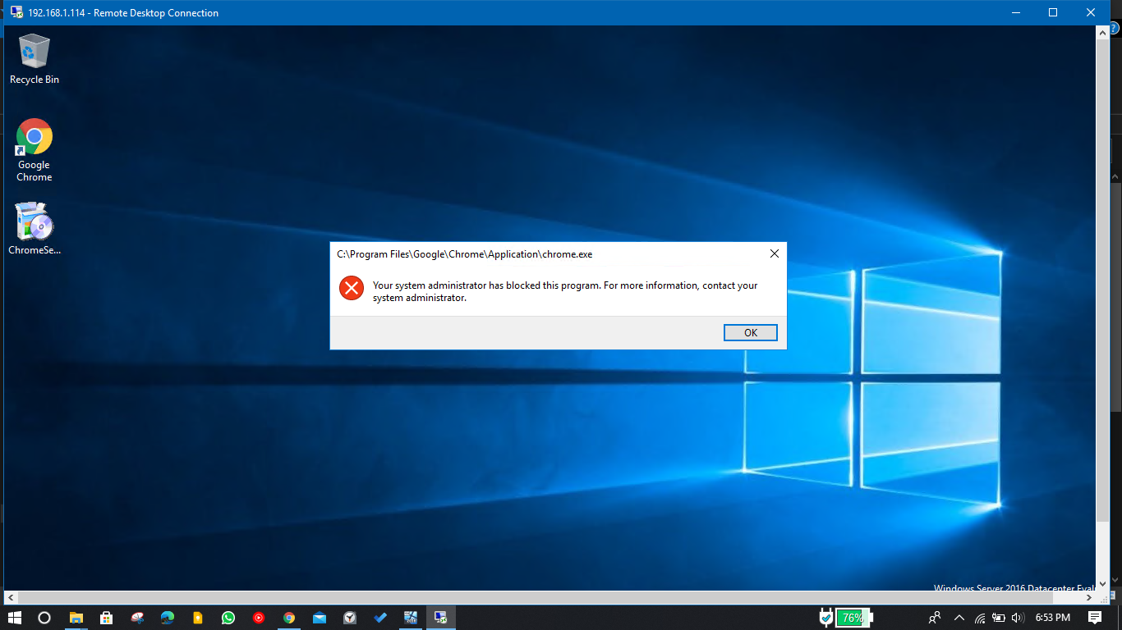

**3. Block the access of control panel to all the users in windows system**

