SCREEN SHOTS:
- Local Worker:
- Throughput Experiment
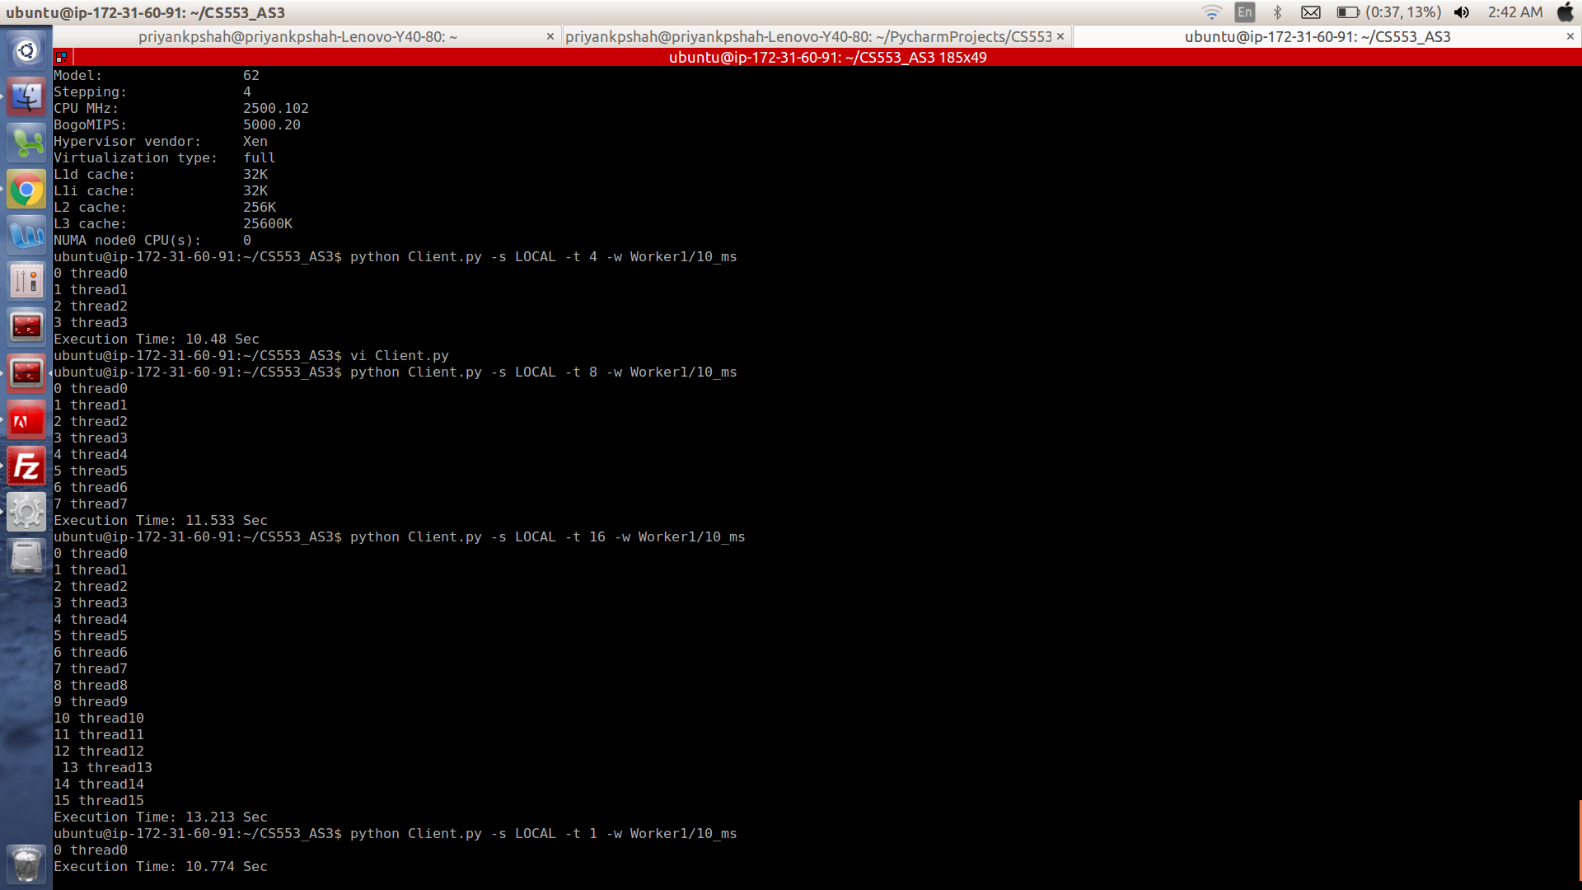
- 10 ms Experiment
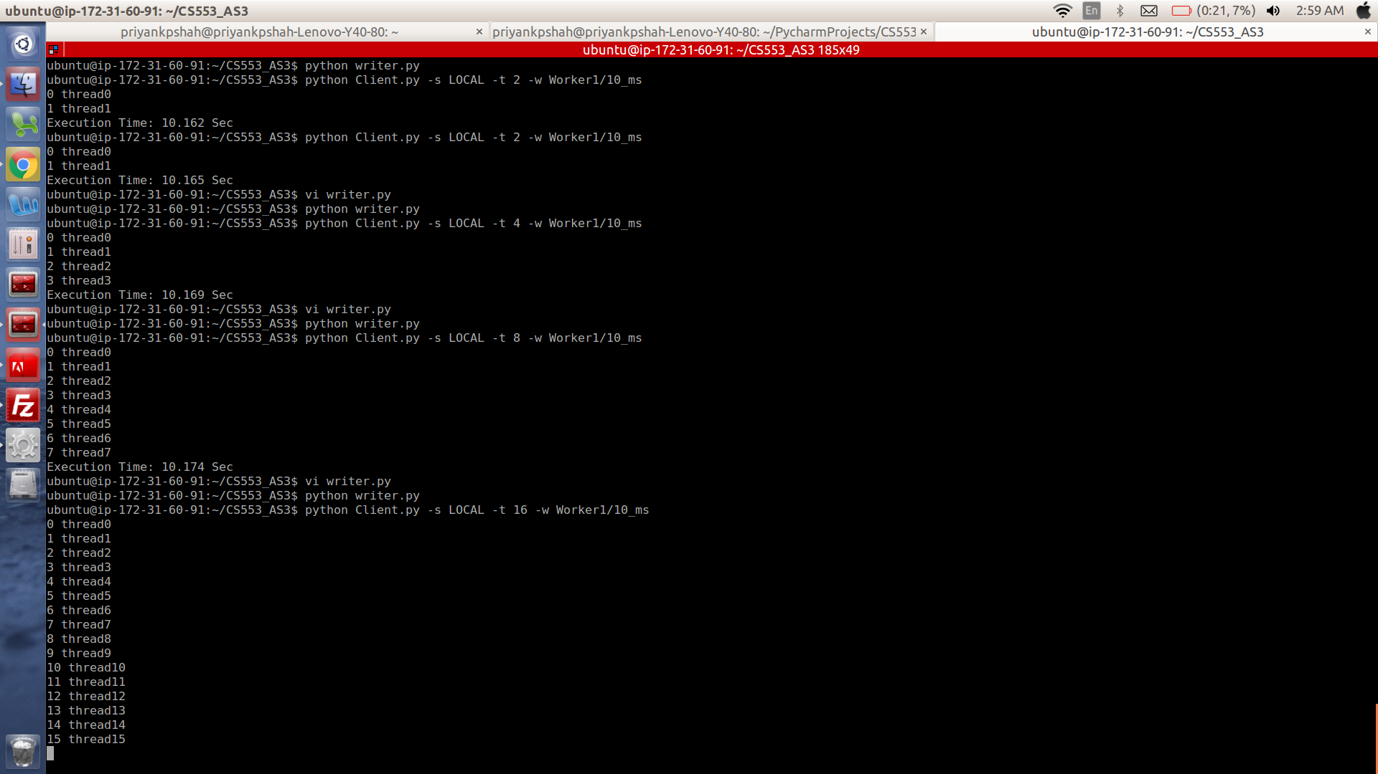

3. 1 Second Experiment:
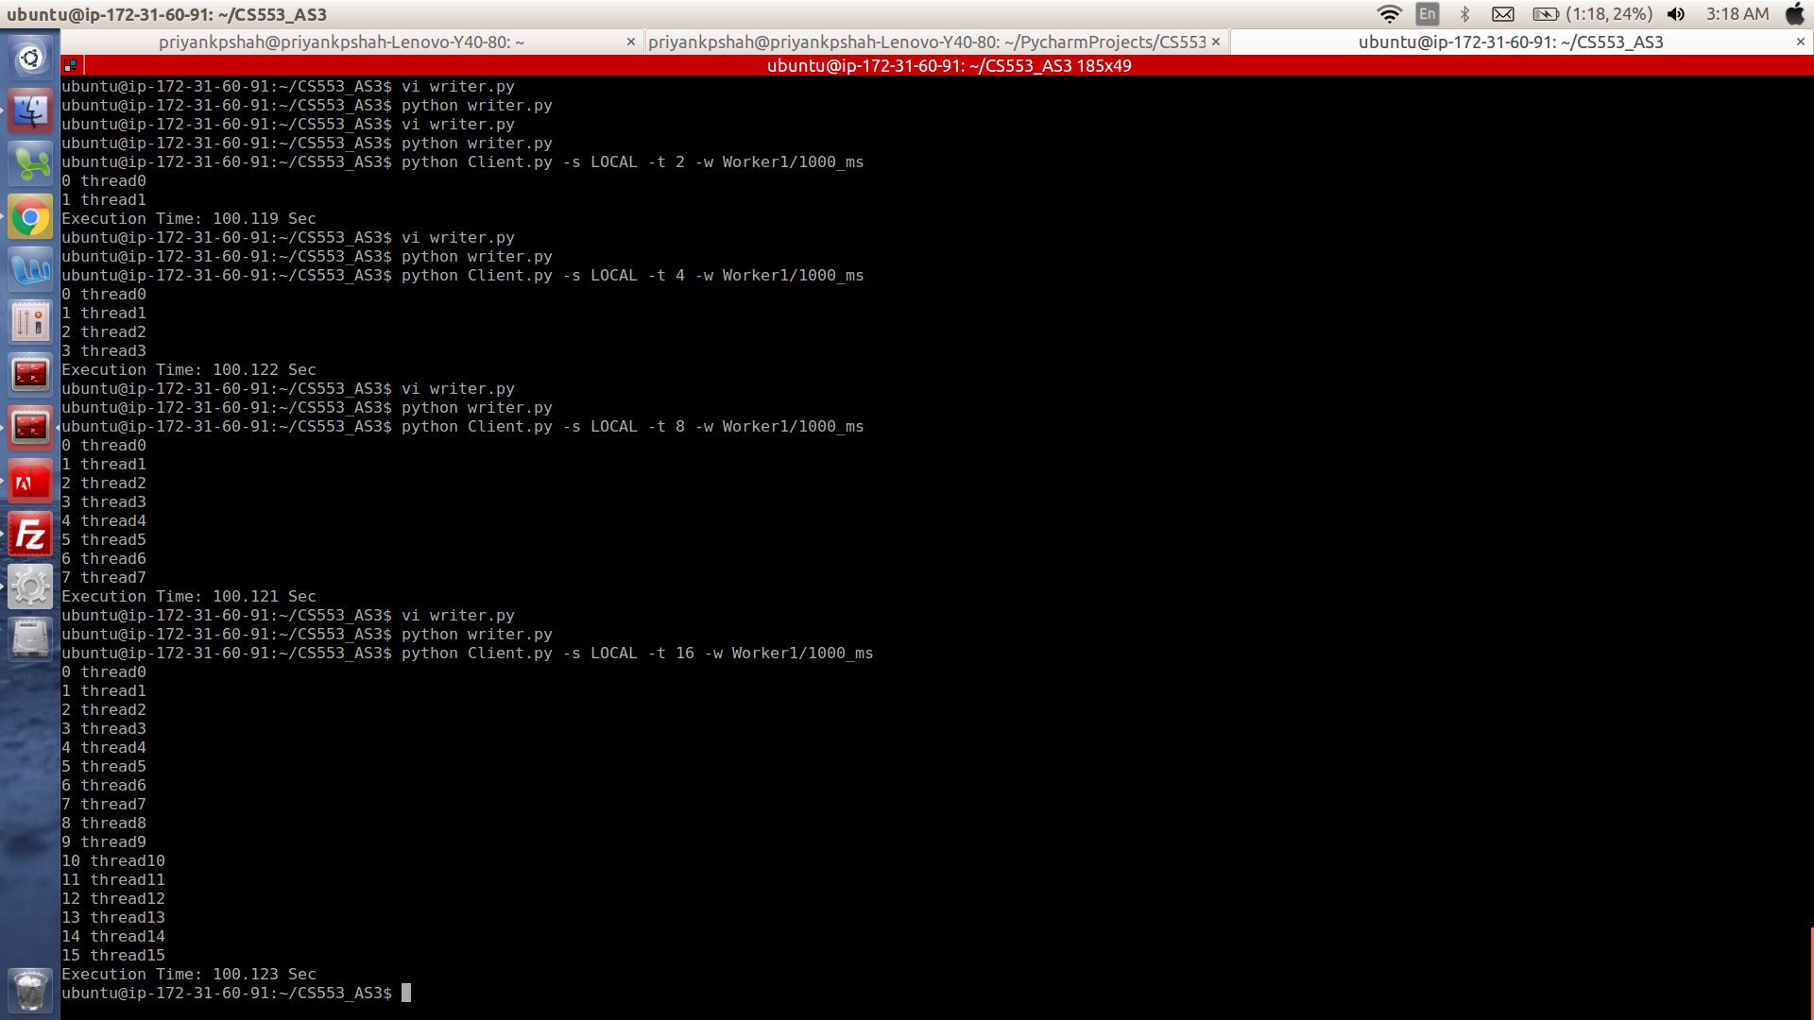
4. 10 Second Experiment:

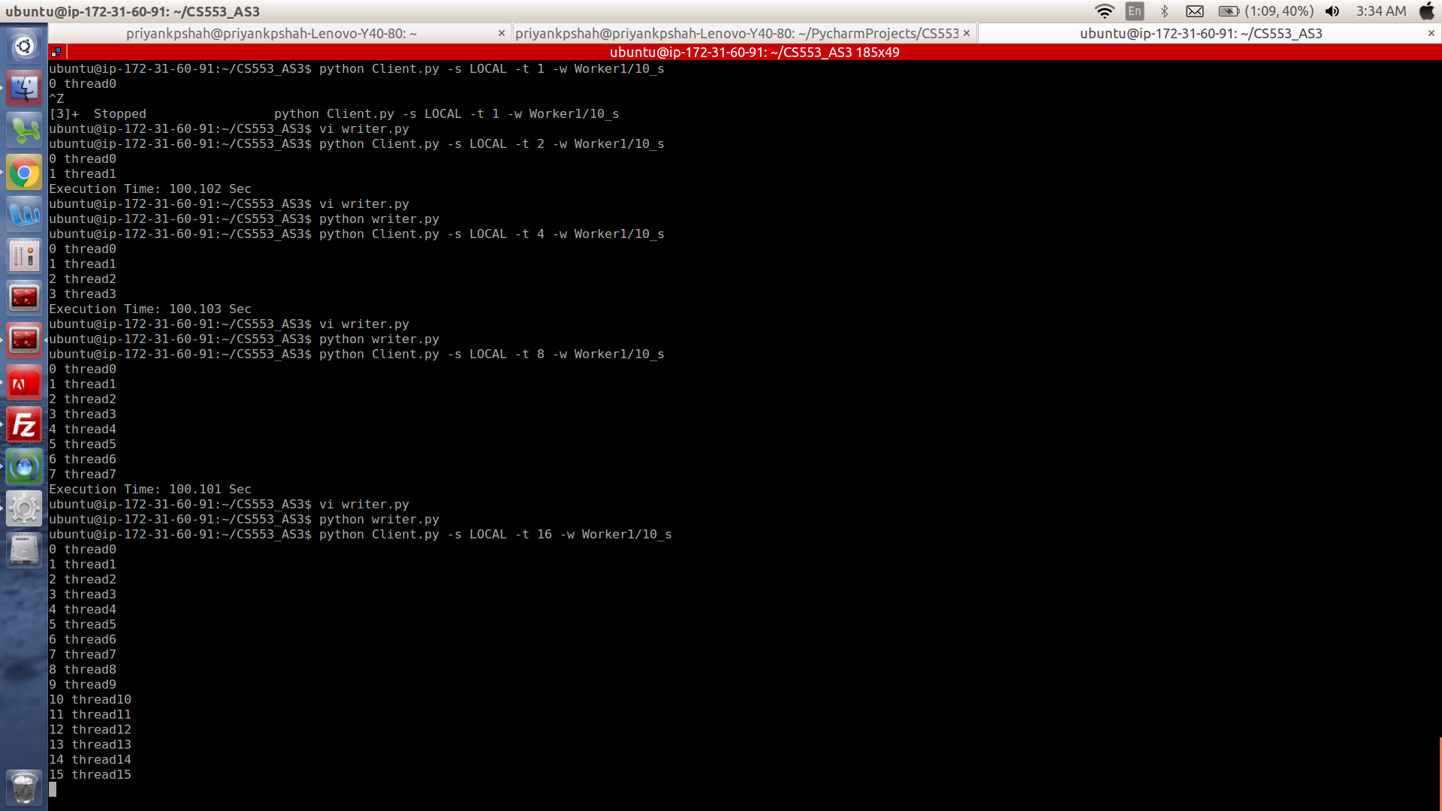

- Remote Experiment:
- SQS Screen shot:

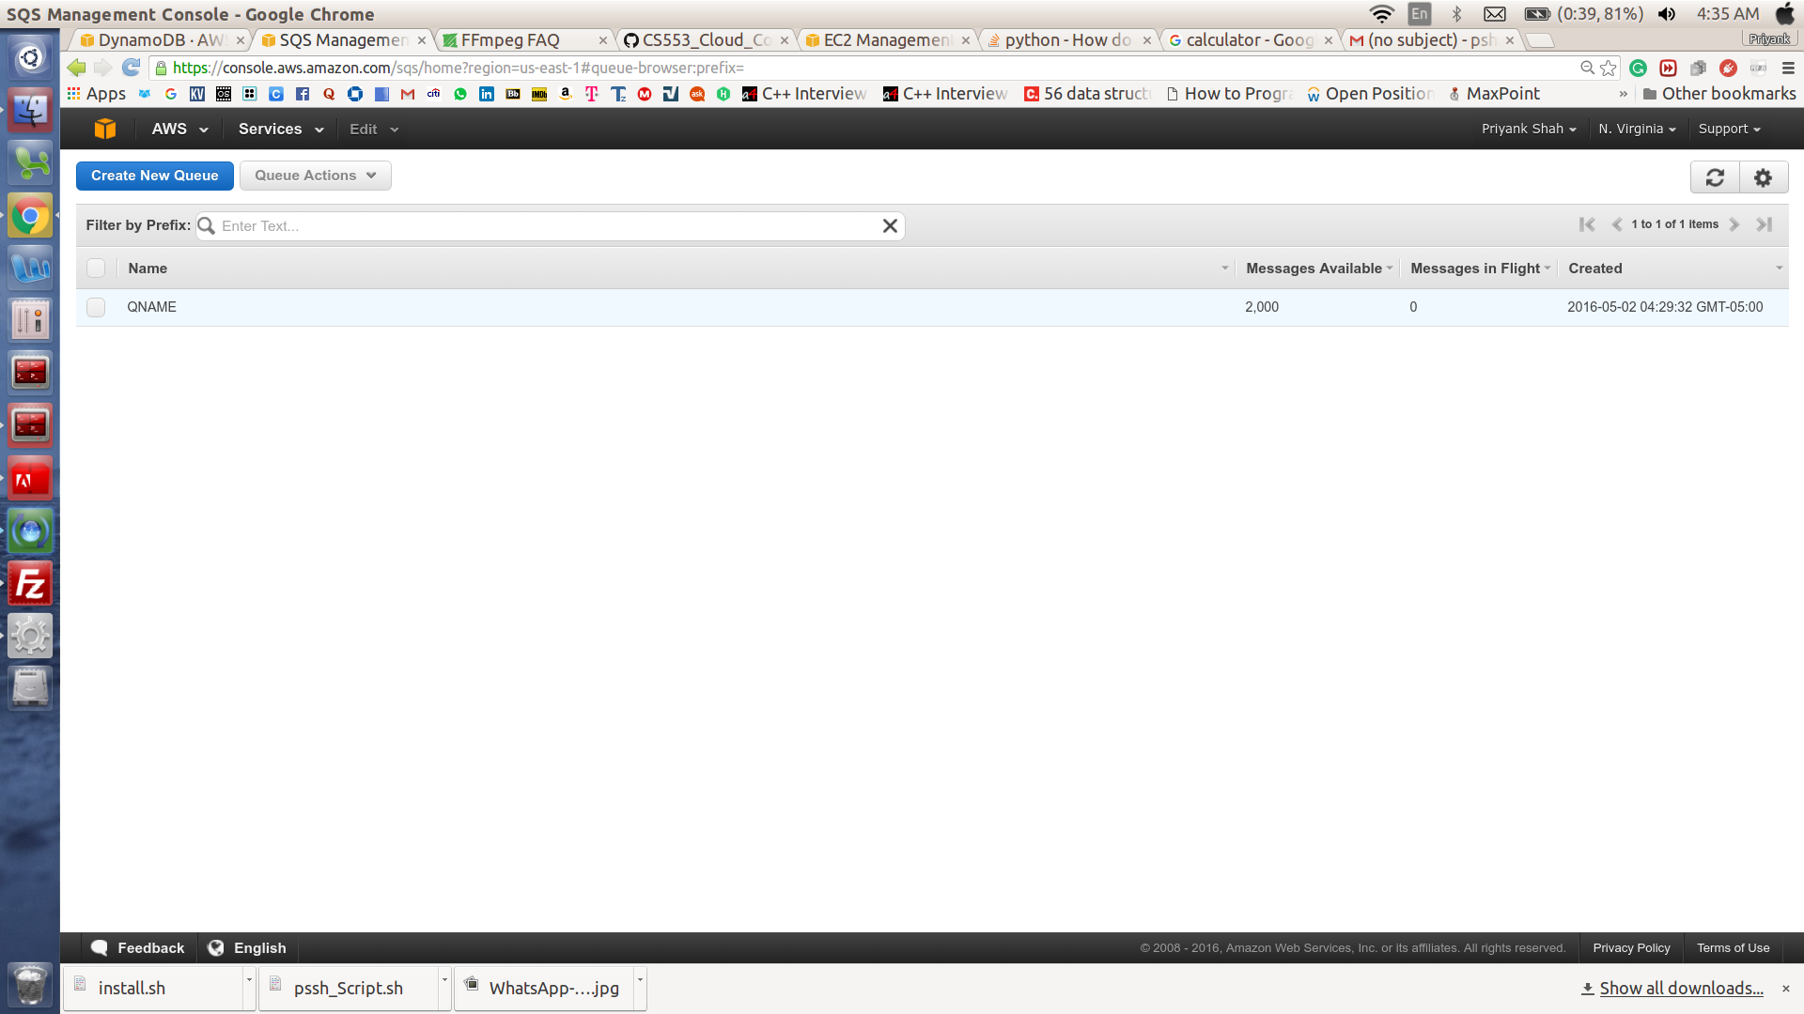
- DynamoDB Screen Shot:

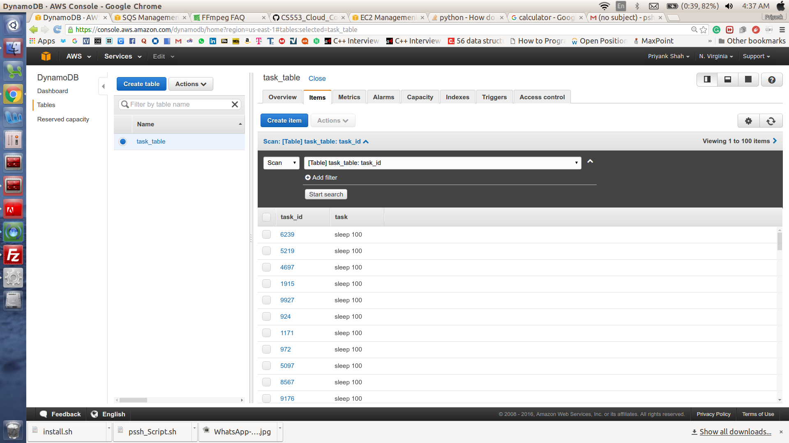

- EC2- Instance Screen Shot:
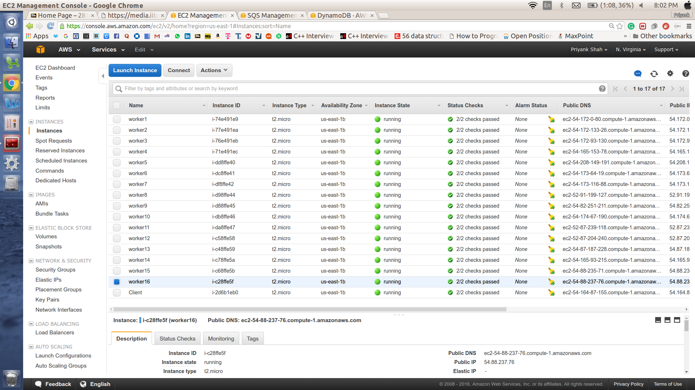
4. 1 Worker Experiment:
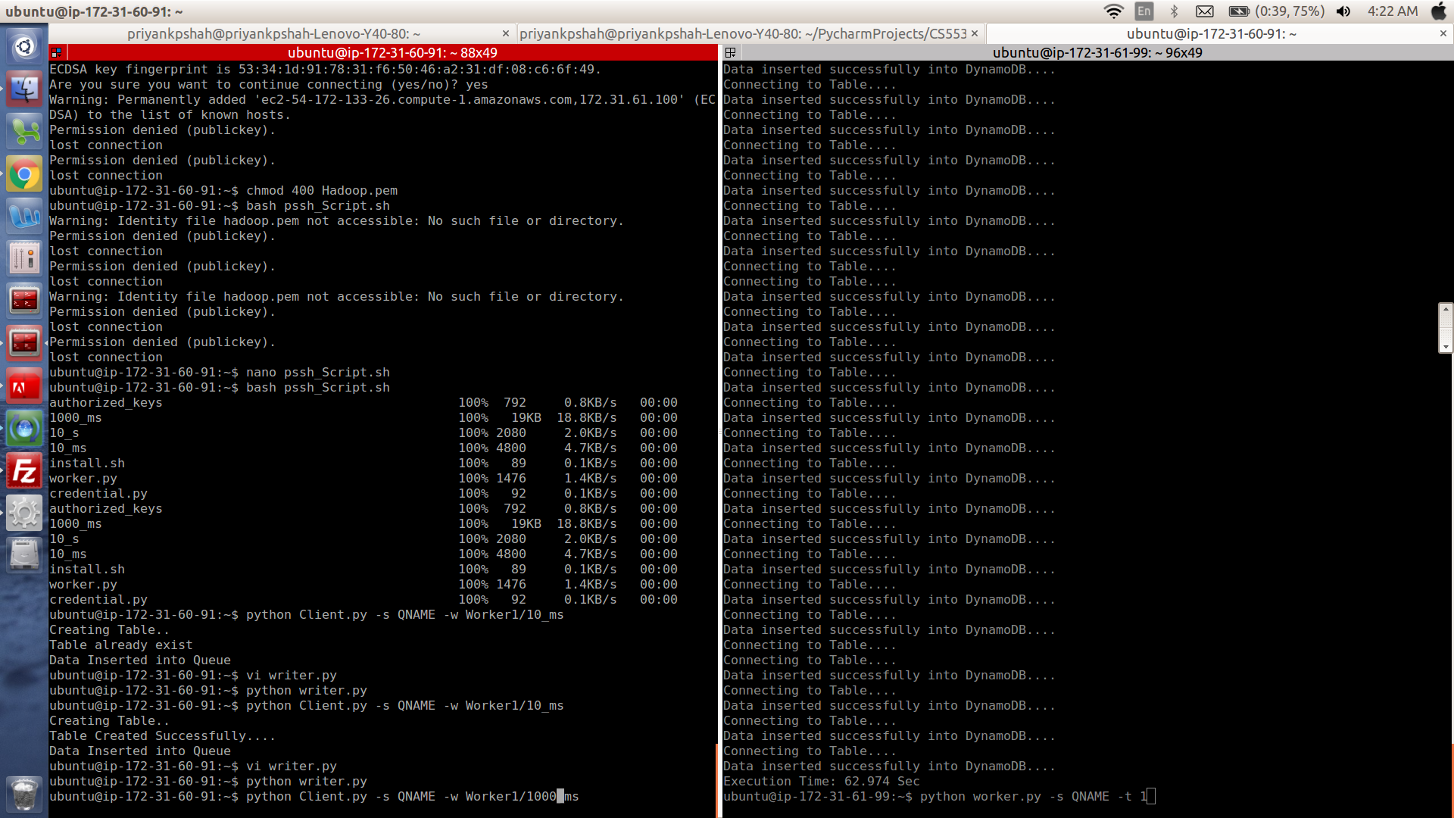

5. Efficiency Experiment 2 Workers:
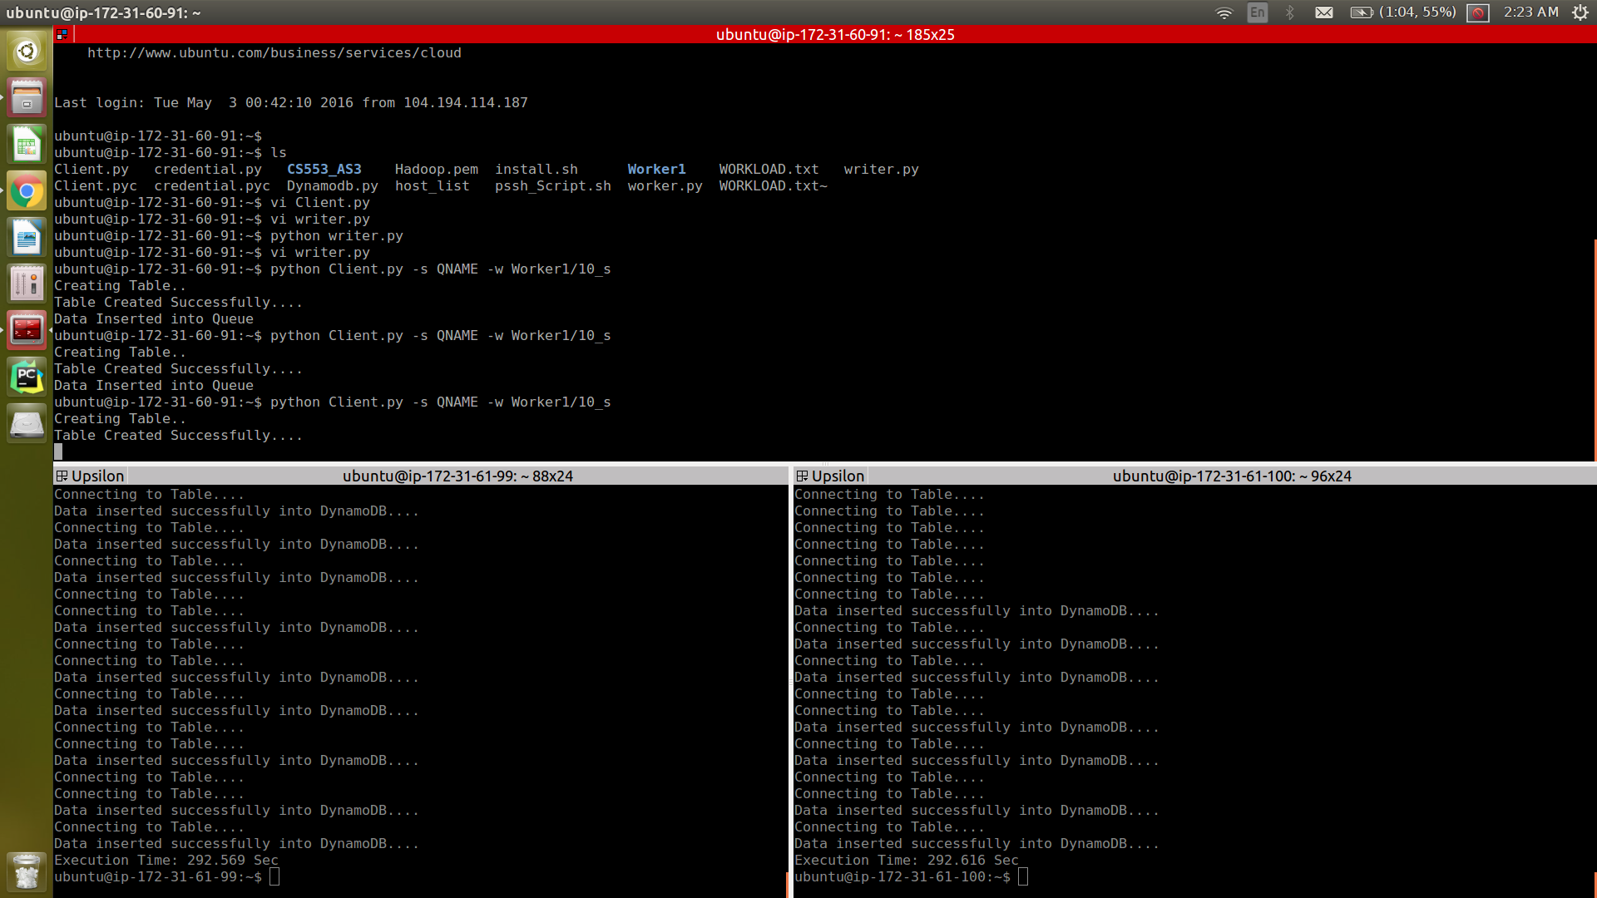
6. Efficiency Experiment 4 Workers:
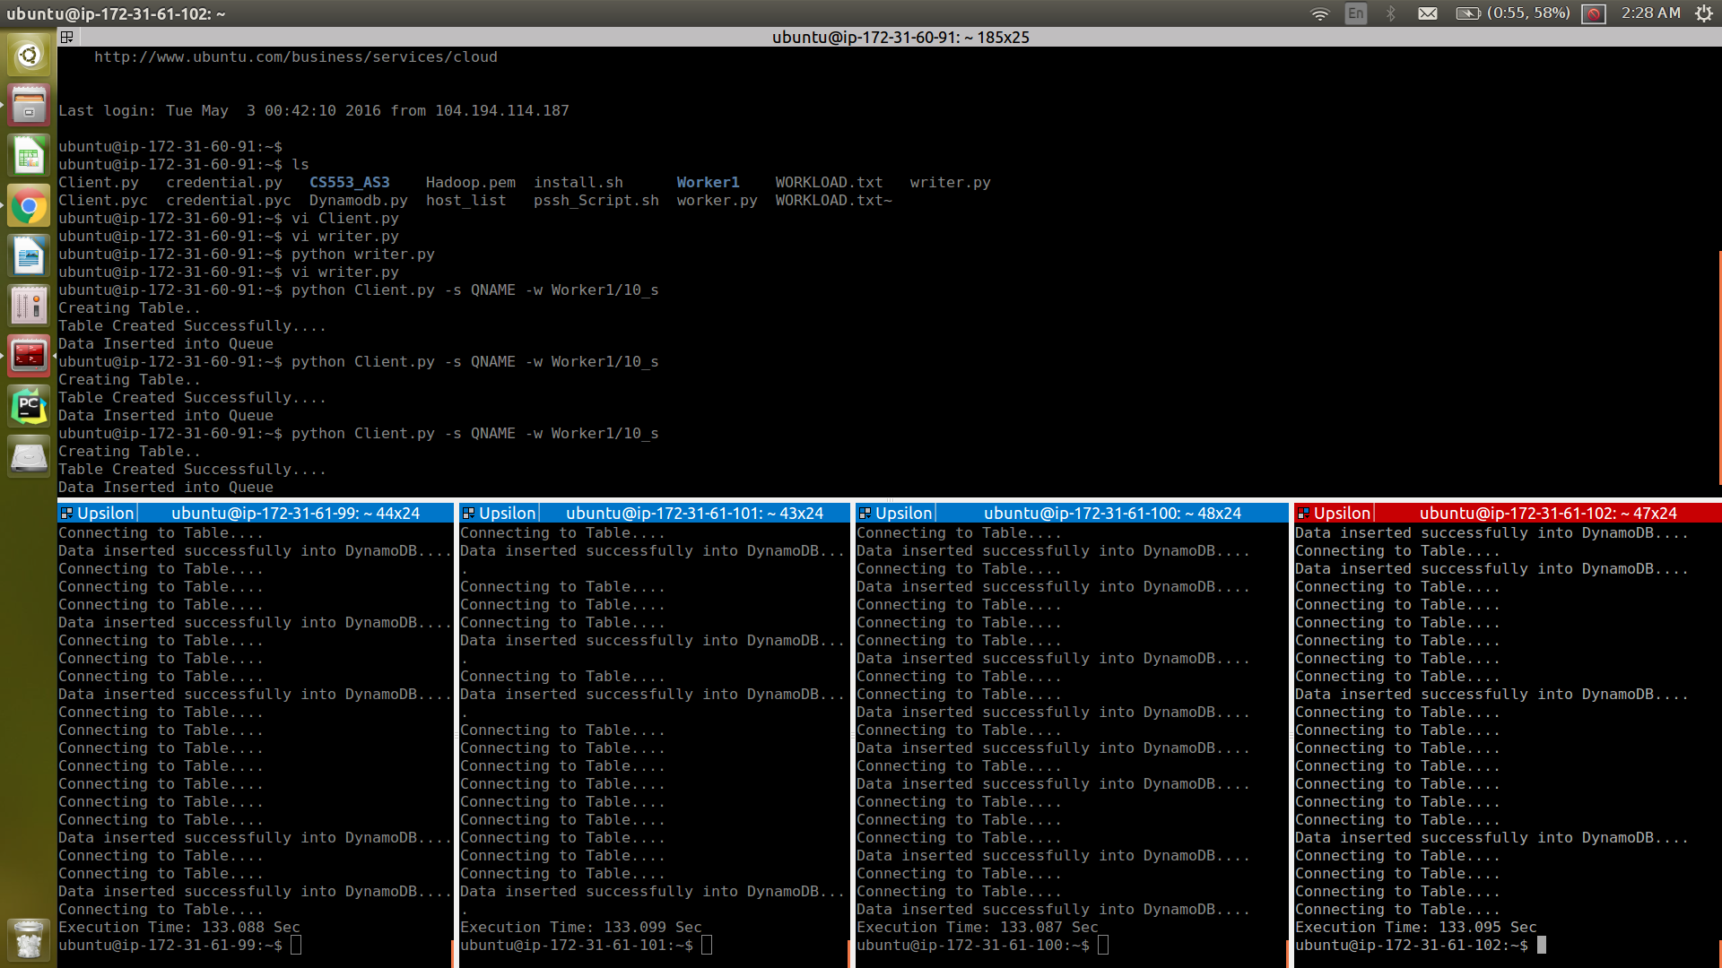

7. 4 Worker Throughput Experiment:
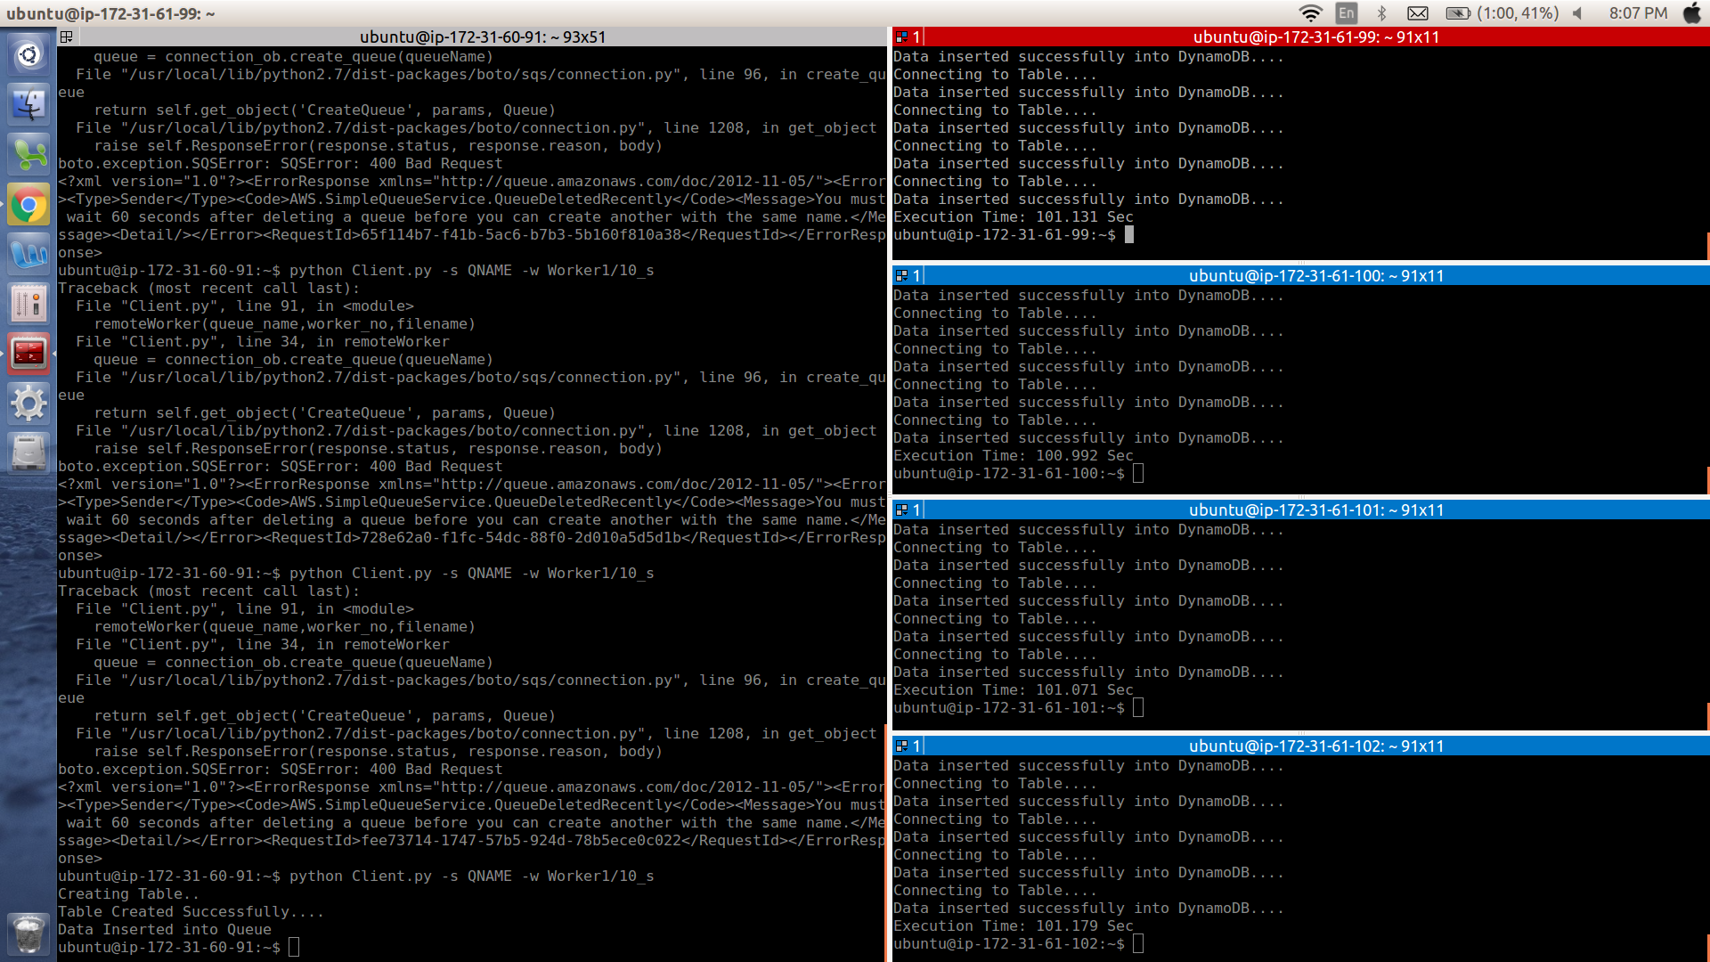
8. 8 Worker Throughput Experiment Initiation:
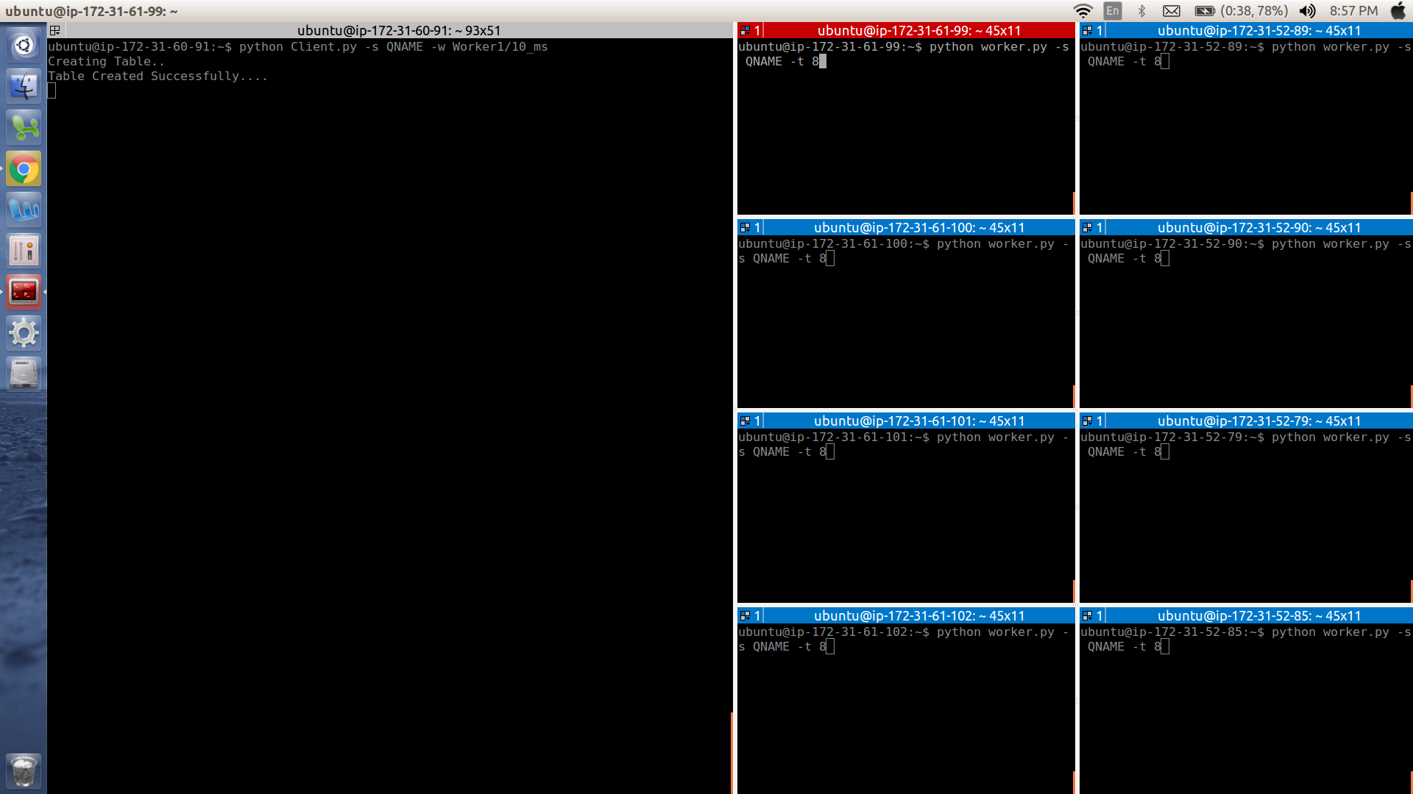

9. 8 Worker Throughput Experiment (1 Sec):
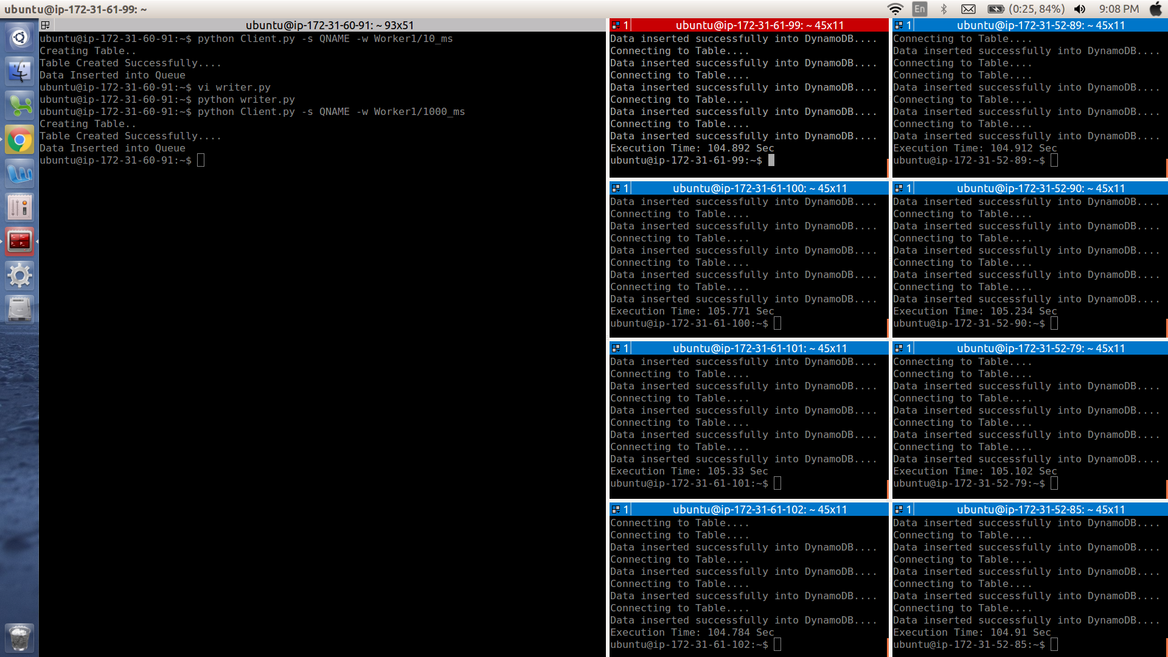
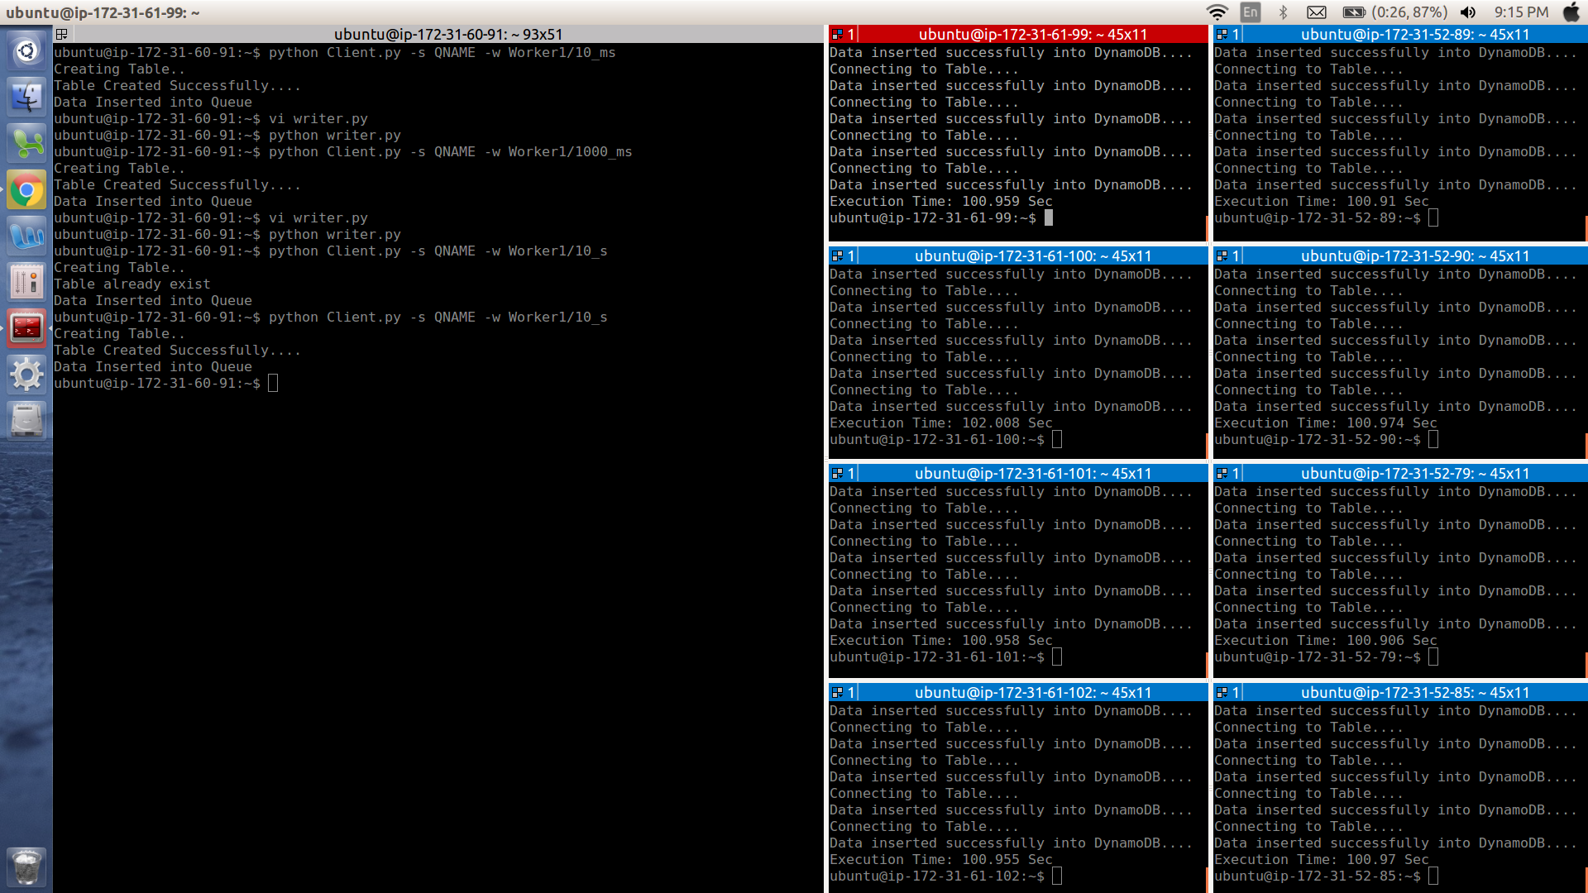
10. 8 Worker Throughput Experiment (10 Sec):

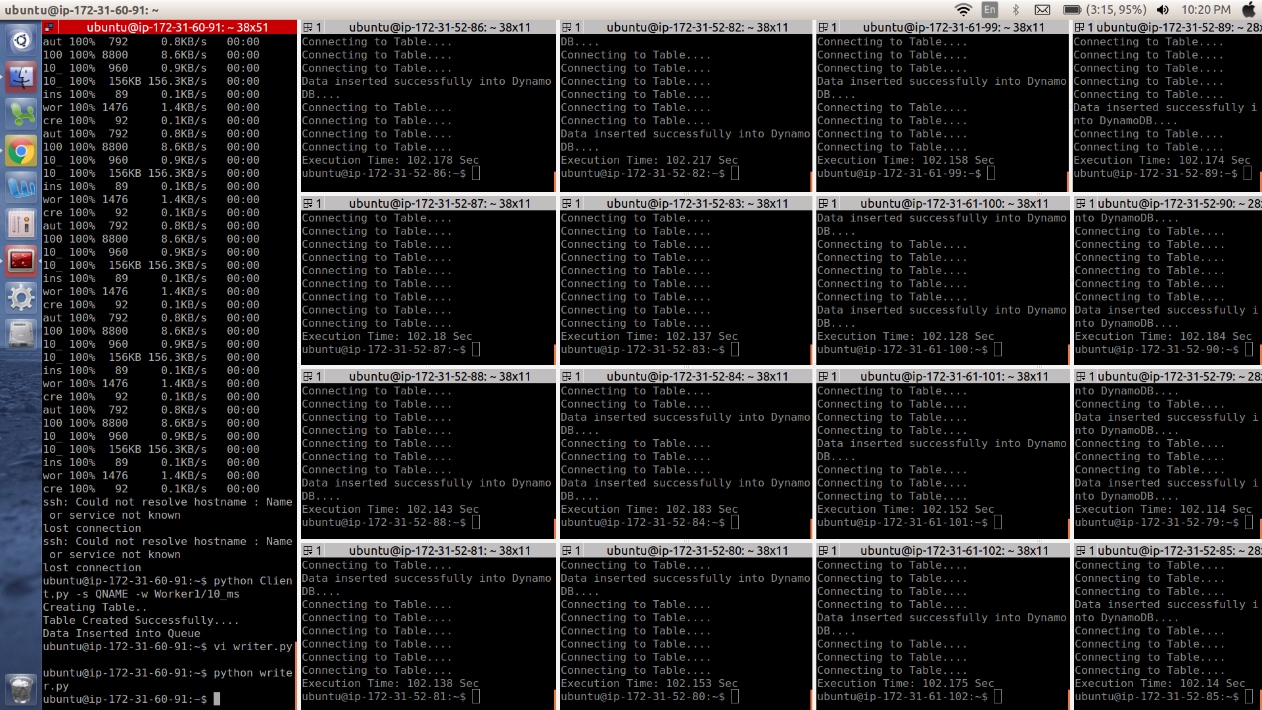
11. 16 Worker Throughput Experiment (10 ms):

12. 16 Worker Throughput Experiment(10 Sec):


