I. Sequential VP Tree Build Process
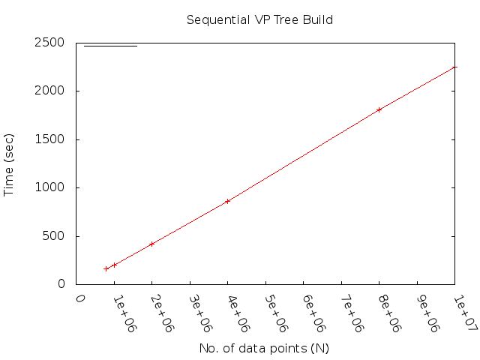Graph 1: VP Tree Build Process
The Graph 1 shows time taken for the sequential build process for Vantage Point Tree on CGM7.

II. Sequential Nearest Neighbour Search Queries
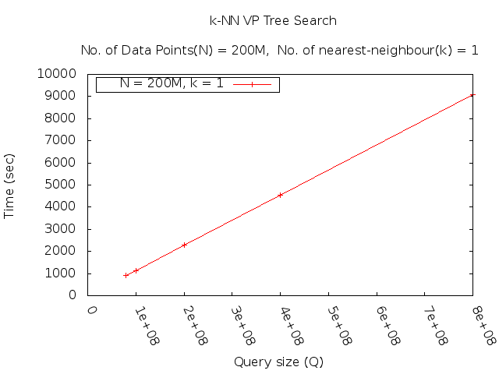Graph 2

Graph 2 shows Varying querying size vs time taken to query “1” nearest neighbour on a tree size of 200M points. Data points following uniform distribution.

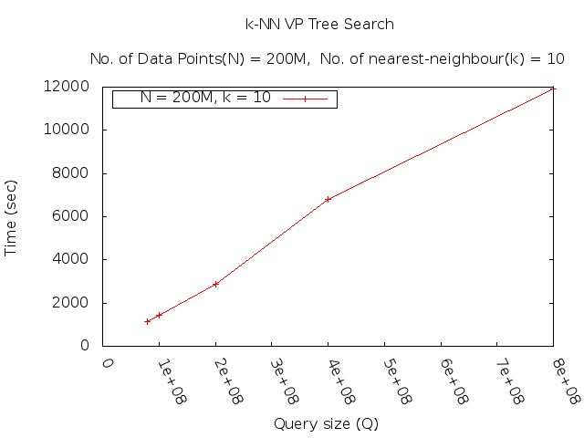Graph 3: k-Nearest Neighbour Search, k = 10
Graph 2 shows Varying querying size vs time taken to query “1” nearest neighbour on a tree size of 200M points. Data points following uniform distribution.

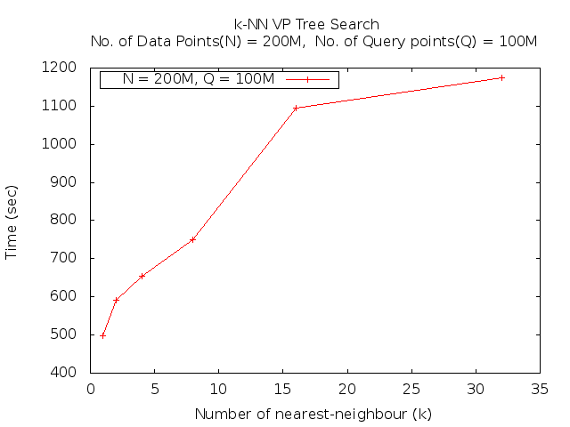Graph 4

Graph 4 shows the time taken in querying k-NN on a VP Tree with 200M points and Query Set(Q) size being 100M points. K k varies from 1 , 2, 4, 8,16, 32

The following set of graphs show the path length(x-axis) for a particular value of k vs frequency

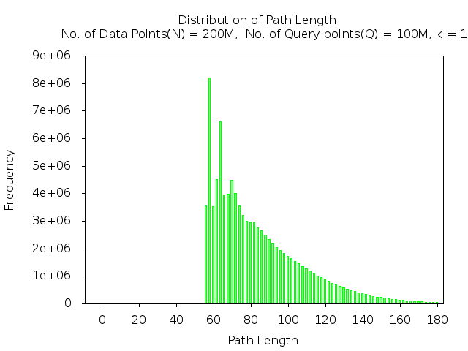
k = 1 , 2, 4, 8, 16, 32

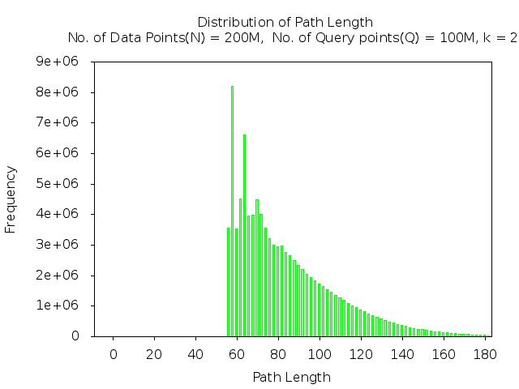

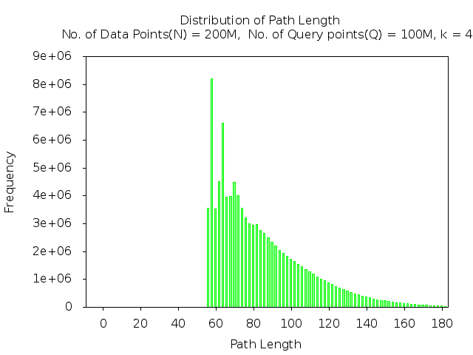

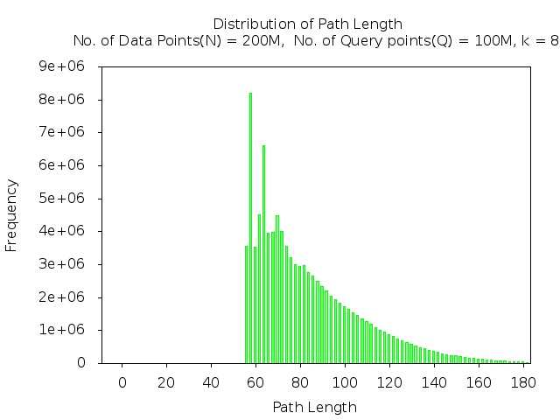

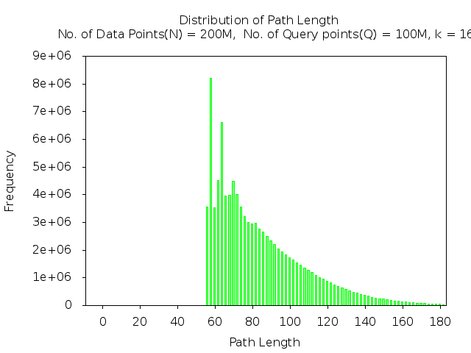

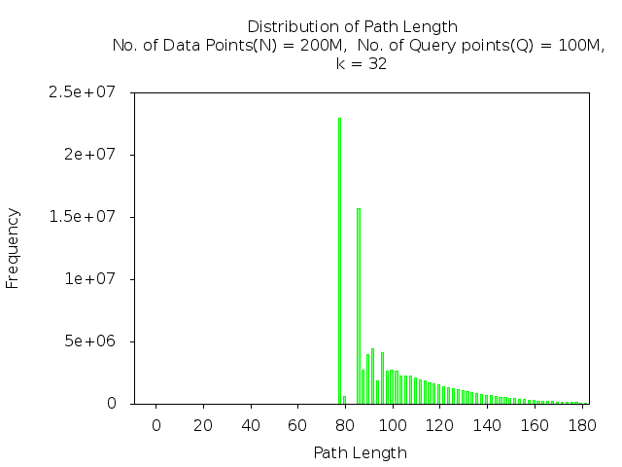

            - Point Searches in VP Tree (exact query match)

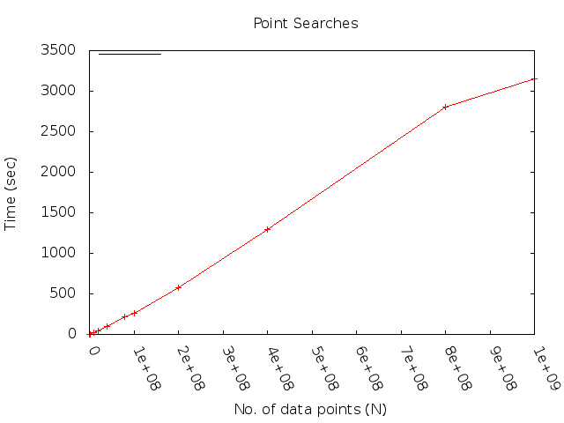

Following histogram depict the distribution of path length for data size varying from 10000 to 100M.

- 10k
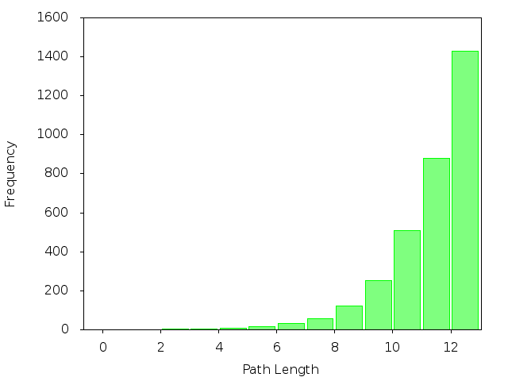

- 80k
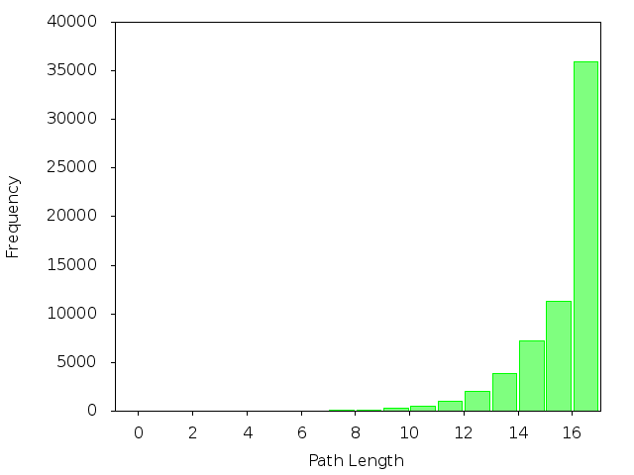
- 100k
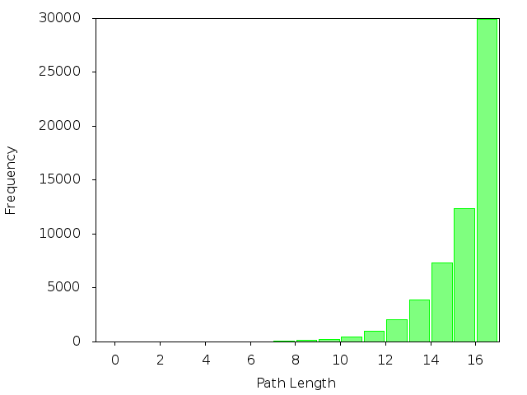
- 1M
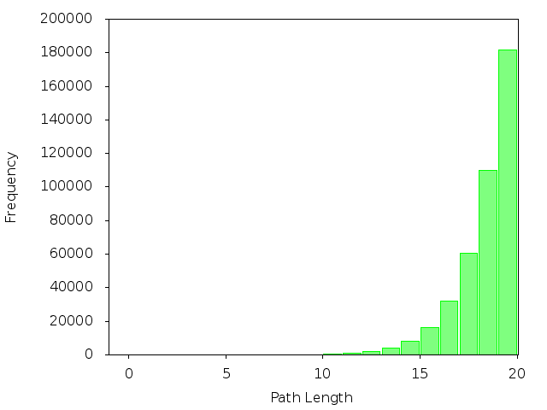

- 10M
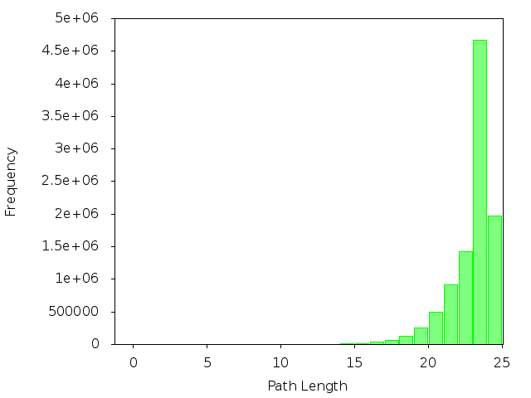
- 20M
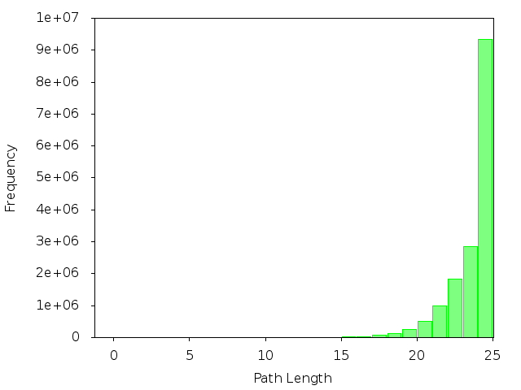

- 40M
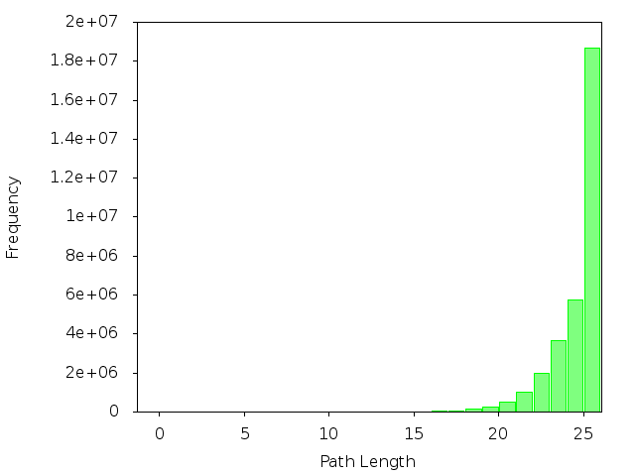

- 80M
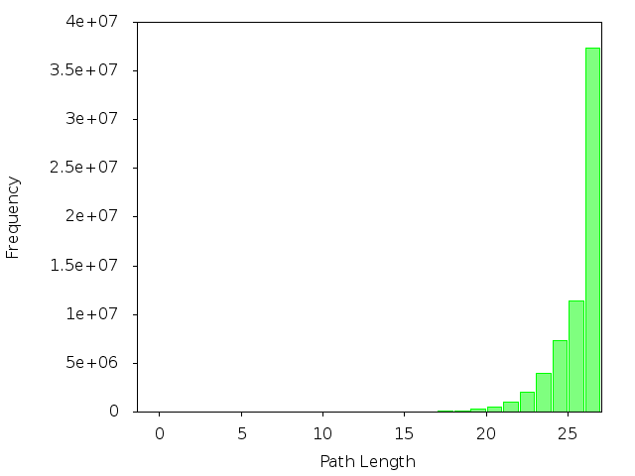

- 100M
