Index.php:
<!DOCTYPE html>
<html>
<head>
<title>Employee List</title>
<style>
body {
font-family: 'Segoe UI', Tahoma, Geneva, Verdana, sans-serif;
background-color: #f4f7f6;
color: #333;
margin: 0;
padding: 20px;
display: flex;
justify-content: center;
}
.container {
background: #ffffff;
padding: 30px;
border-radius: 10px;
box-shadow: 0 4px 15px rgba(0, 0, 0, 0.05);
width: 100%;
max-width: 900px;
}
h2 {
margin-top: 0;
color: #2c3e50;
border-bottom: 2px solid #eaeaea;
padding-bottom: 10px;
}
table {
width: 100%;
border-collapse: collapse;
margin-top: 15px;
}
th, td {
padding: 12px;
text-align: left;
border-bottom: 1px solid #ddd;
font-size: 14px;
}
th {
background-color: #2c3e50;
color: white;
}
tr:hover {
background-color: #f9f9f9;
}
</style>
</head>
<body>
<div class="container">
<h2>Employee Details List</h2>
<?php
// Load the XML file
$xml = simplexml_load_file("employees.xml") or die("Error: Cannot load XML file.");
echo "<table>";
echo "<tr><th>Emp ID</th><th>Name</th><th>Department</th><th>Designation</th><th>Salary</th></tr>";
// Loop through each <employee> element and display its details
foreach ($xml->employee as $emp) {
echo "<tr>";
echo "<td>" . $emp->id . "</td>";
echo "<td>" . $emp->name . "</td>";
echo "<td>" . $emp->department . "</td>";
echo "<td>" . $emp->designation . "</td>";
echo "<td>$" . $emp->salary . "</td>";
echo "</tr>";
}
echo "</table>";
?>
</div>
</body>
</html>

dbconnect.php:
<?php
$servername = "localhost";
$username = "root";
$password = "mysql";
$dbname = "shopping_db";
$conn = new mysqli($servername, $username, $password, $dbname);
if ($conn->connect_error) {
die("Connection failed: " . $conn->connect_error);
}
?>

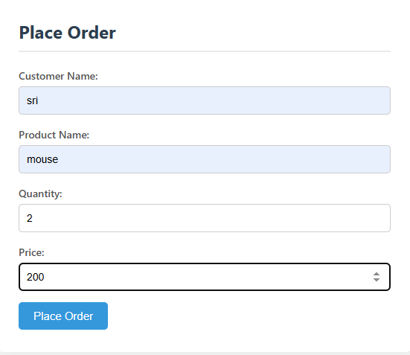

Database storage:

