Team Pebbles
Technex 2016, IIT BHU

App Name

Look Around

A quick way to get hold of your vicinity

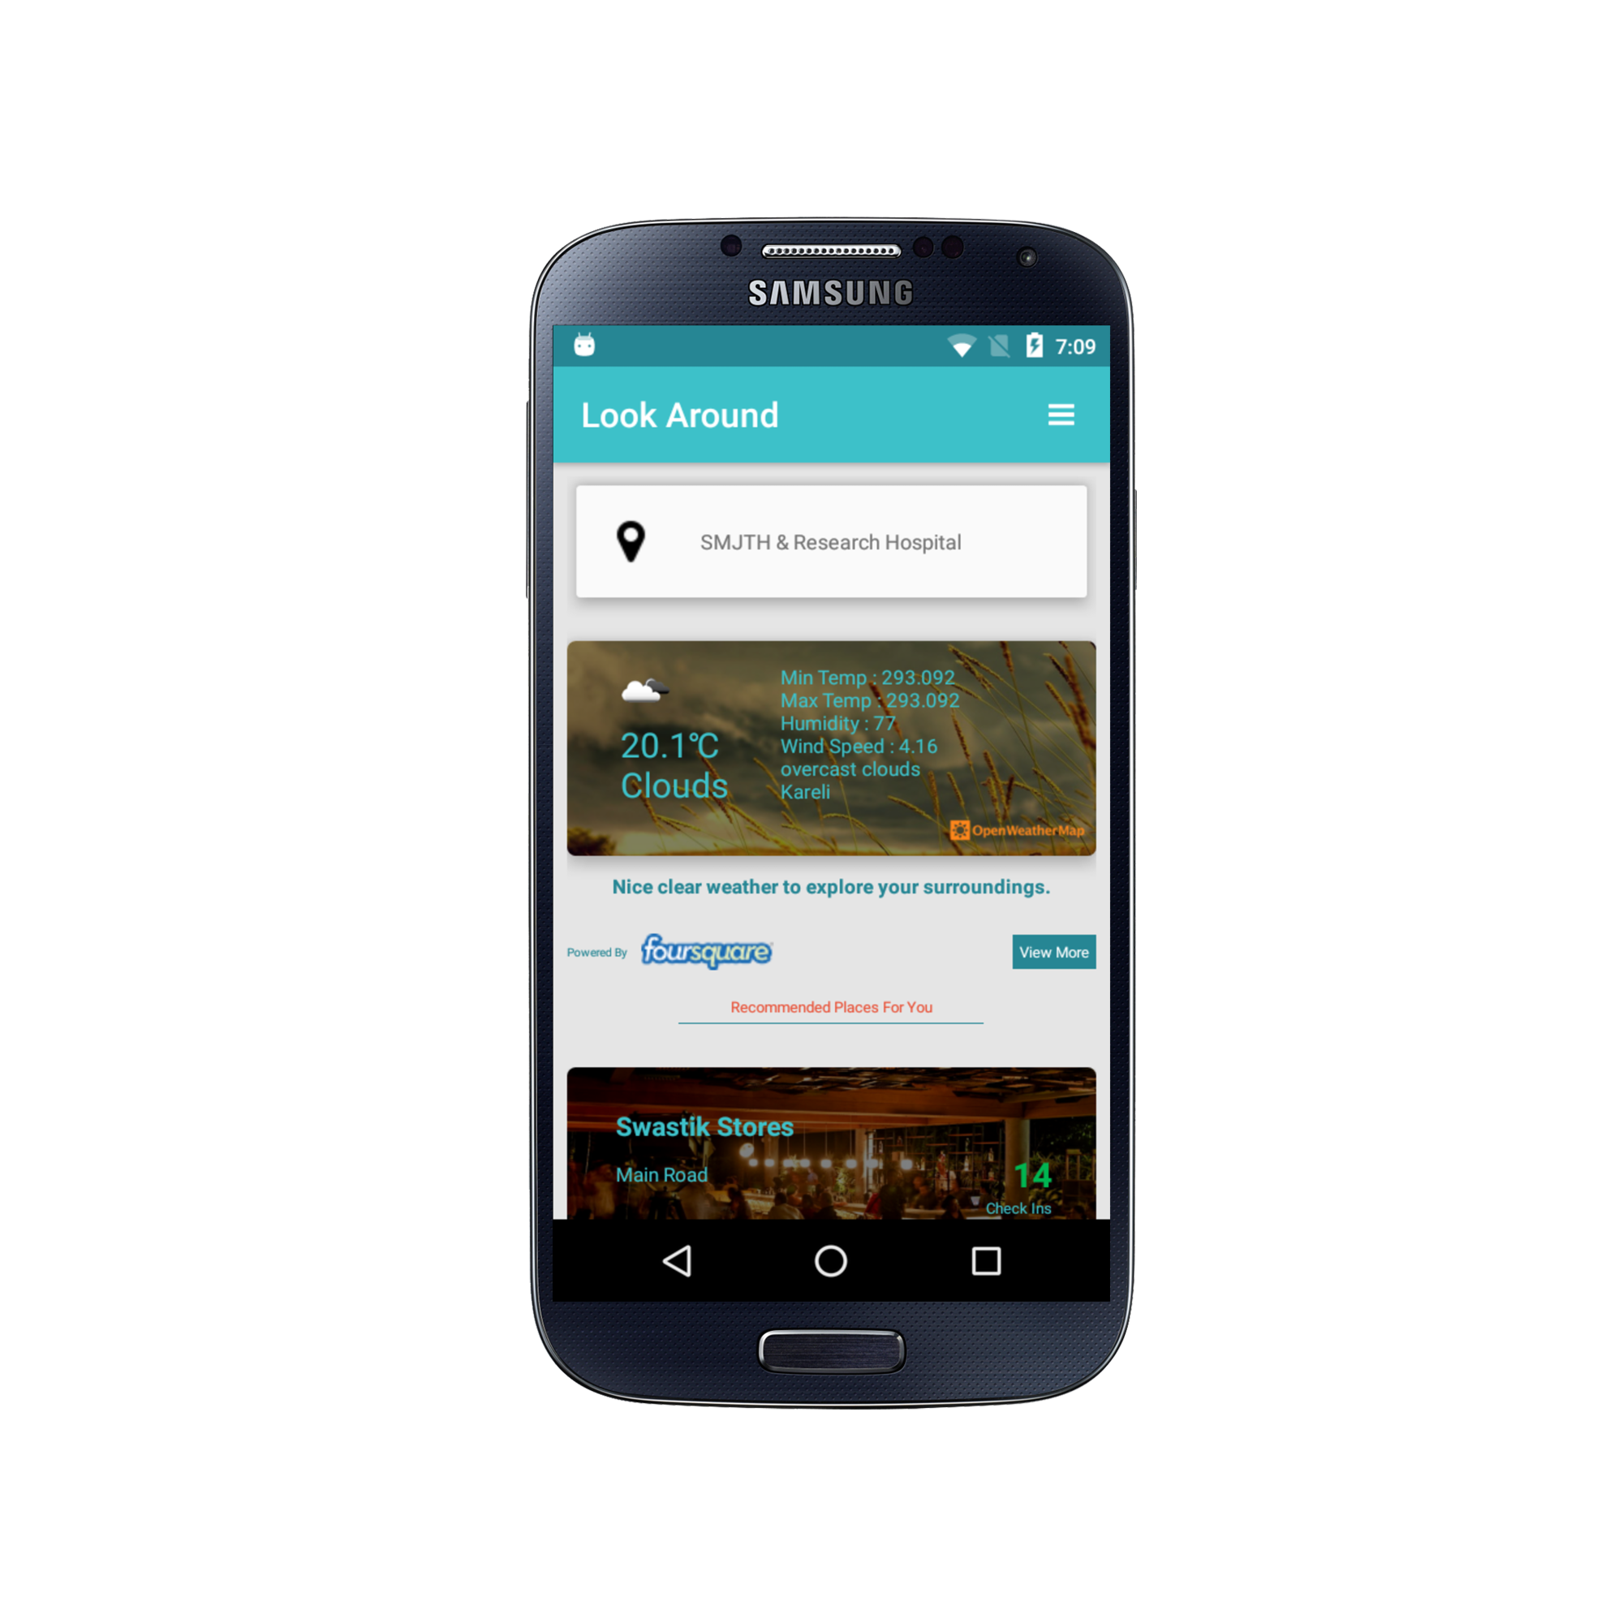

AIM

The aim of the app “Look Around” is to get the data about weather and near by places and display it to the user.
With any place, two major ascpects associated are weather and near by places that are worth visiting. All outings and plans revolve around above two things.
With the use of this app exact weather report of the location is provided.
Along with weather data user can browse near by places that the local community of people recommends visitong.

Perfect weather, Perfect place. You have to find perfect partners on your own.

Features

1. Choose precise location :
With the location picker of the app, user can pick his/her pricise location. Let it be co-ordinates or by name, everything will work.

2. Detailed weather report :
App is powered by very powerful weather Api and thus provides detailed weather information to user.

3. Top places to visit :
Using extensive database of venues, app provides best and most recommended spots to visit near by.

4. Custom location search :
User can search for top places around other locations too.

5. Offline support :
Last displayed information to the user is persisted, so that user can come back to look at it, even when he/she is not connected to the internet.

6. Share venues :
Users can quickly share venue info woth their friends and contacts.

APIs USED

1. Google Places API :

App uses Google Places API to allow user to search and pick locations.
Using Places API widgets, picking up places is provided in the app.

2. Open Weather Map :

Open weather map API is used to get the current weather report for the give latitude and longitude.

3. Foursquare API :

App uses Foursquare explore API to get the results of suggested place near by.

SCREENSHOTS

Screenshots are under screenshots folder in root directory.

FLOW OF THE APP

Flow of the app is pretty simple.
App start with home screen. Home screen is having the button to connect to Foursquare if user is not already connected.
Once the user is connected features to brwose top near by places becomes active.
Weather updates don't need any user level authentication and thus are directly displayed in the home screen.

FUTURE POSSIBLE ENHANCEMENTS

In future to develop the idea of this app furthur, even more location centric APIs can be connected to the app.
User can browse near by events using services like explara, can check traffic and updates.
App can be carved into a prodcuct that delivers the best of all location based services to the user.

