**BestBuy:**

When I run the test with different browsers, fields are getting changed and getting the error as request failed because of internet connection.

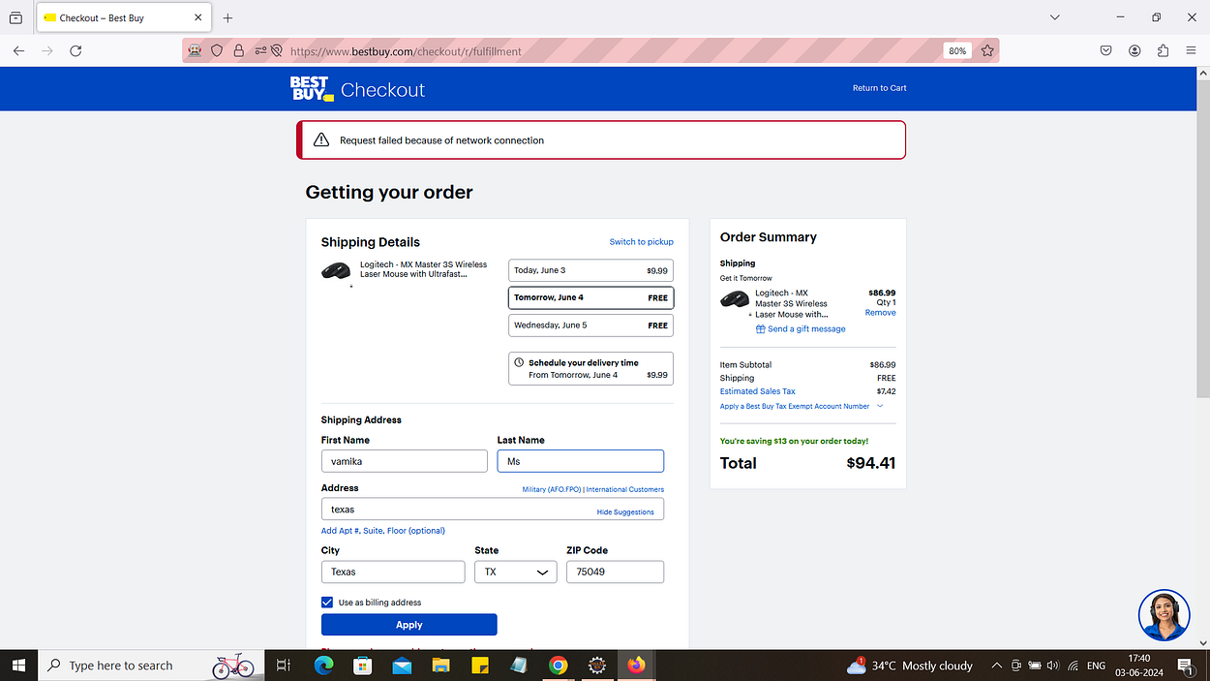

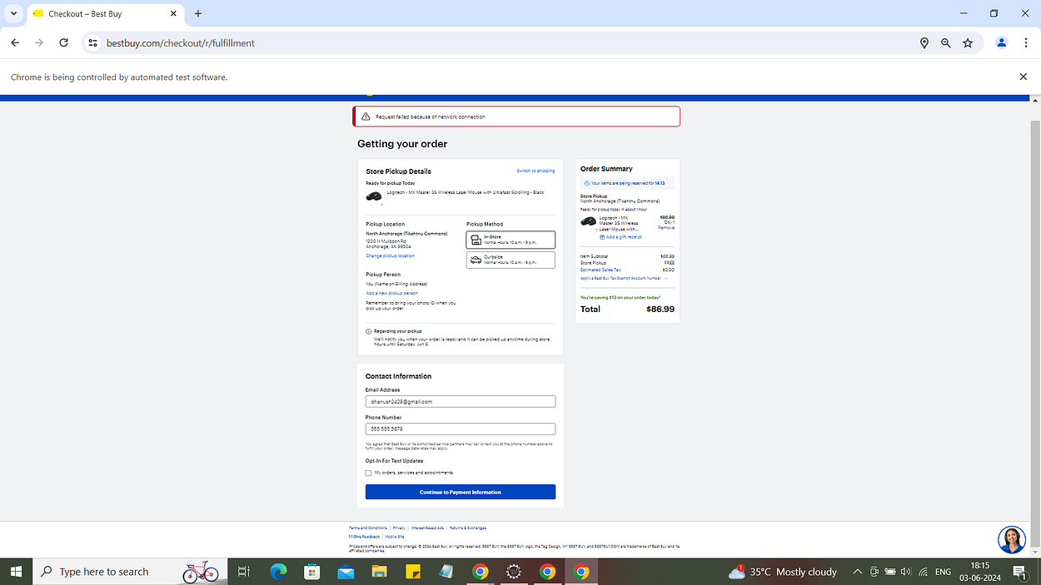

**Output ss:**

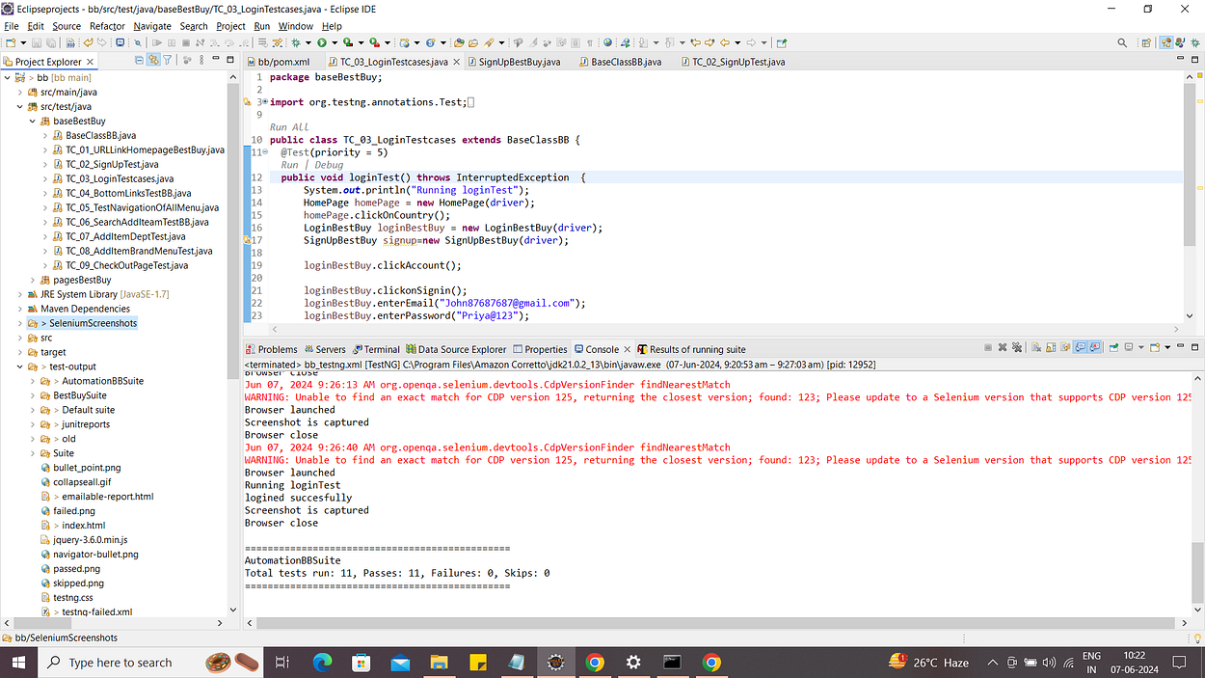

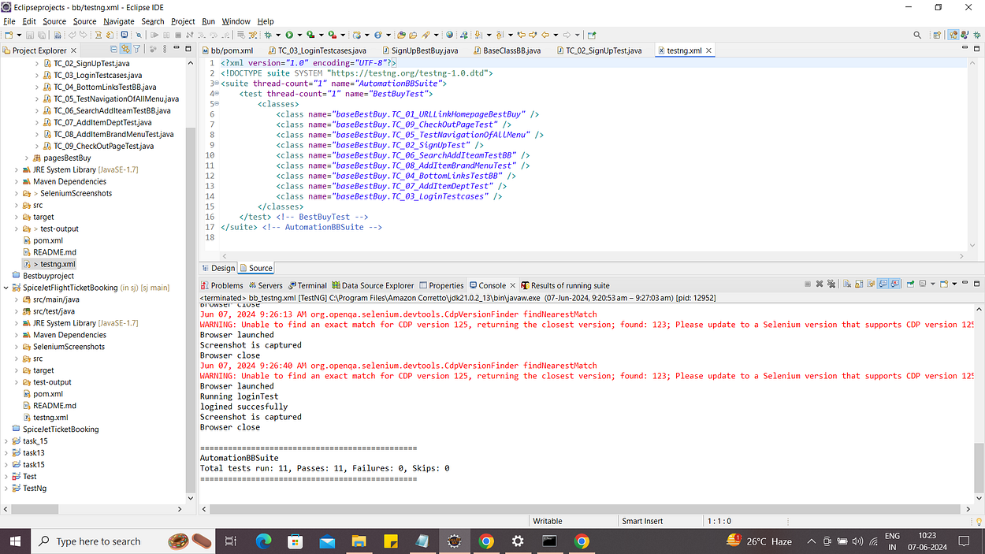

**For login and sign up:**

**When i run the tests for best buy sign up and login facing issues because of website issues.**

**When used headless chrome test cases are failing and it's taking more time to execute.**

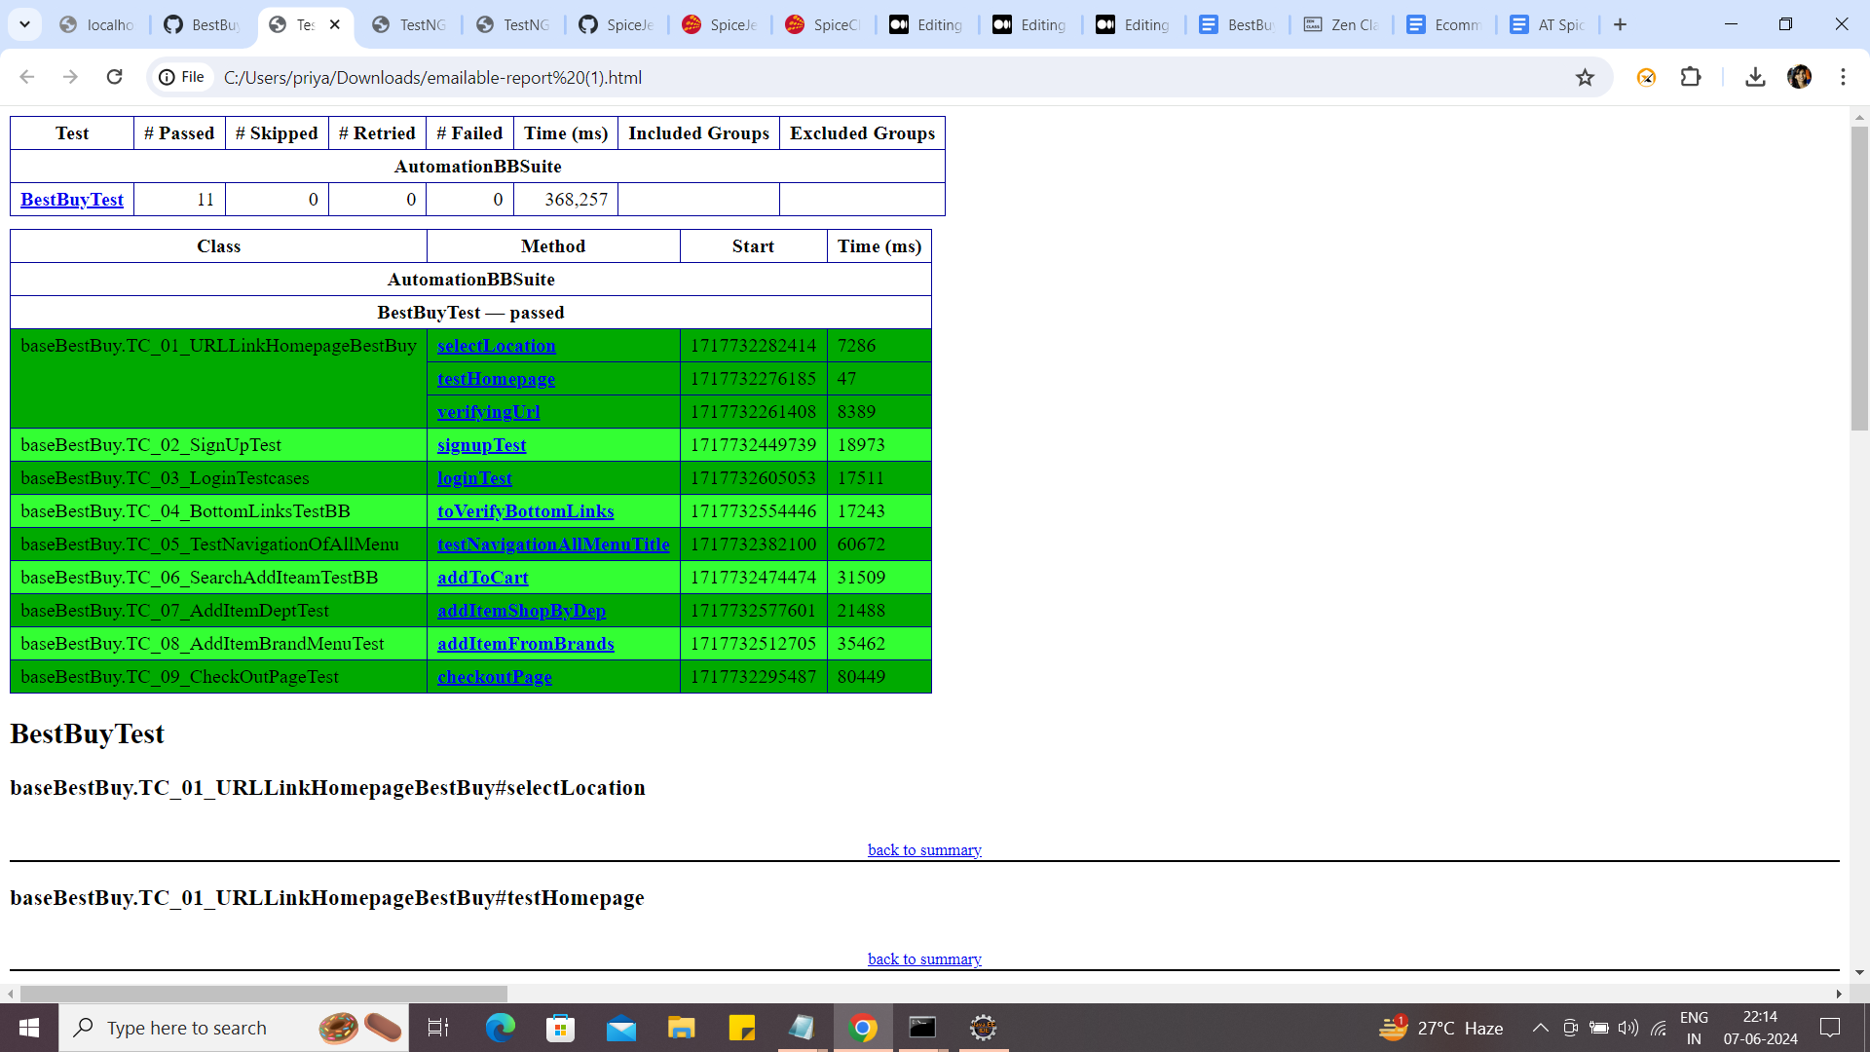

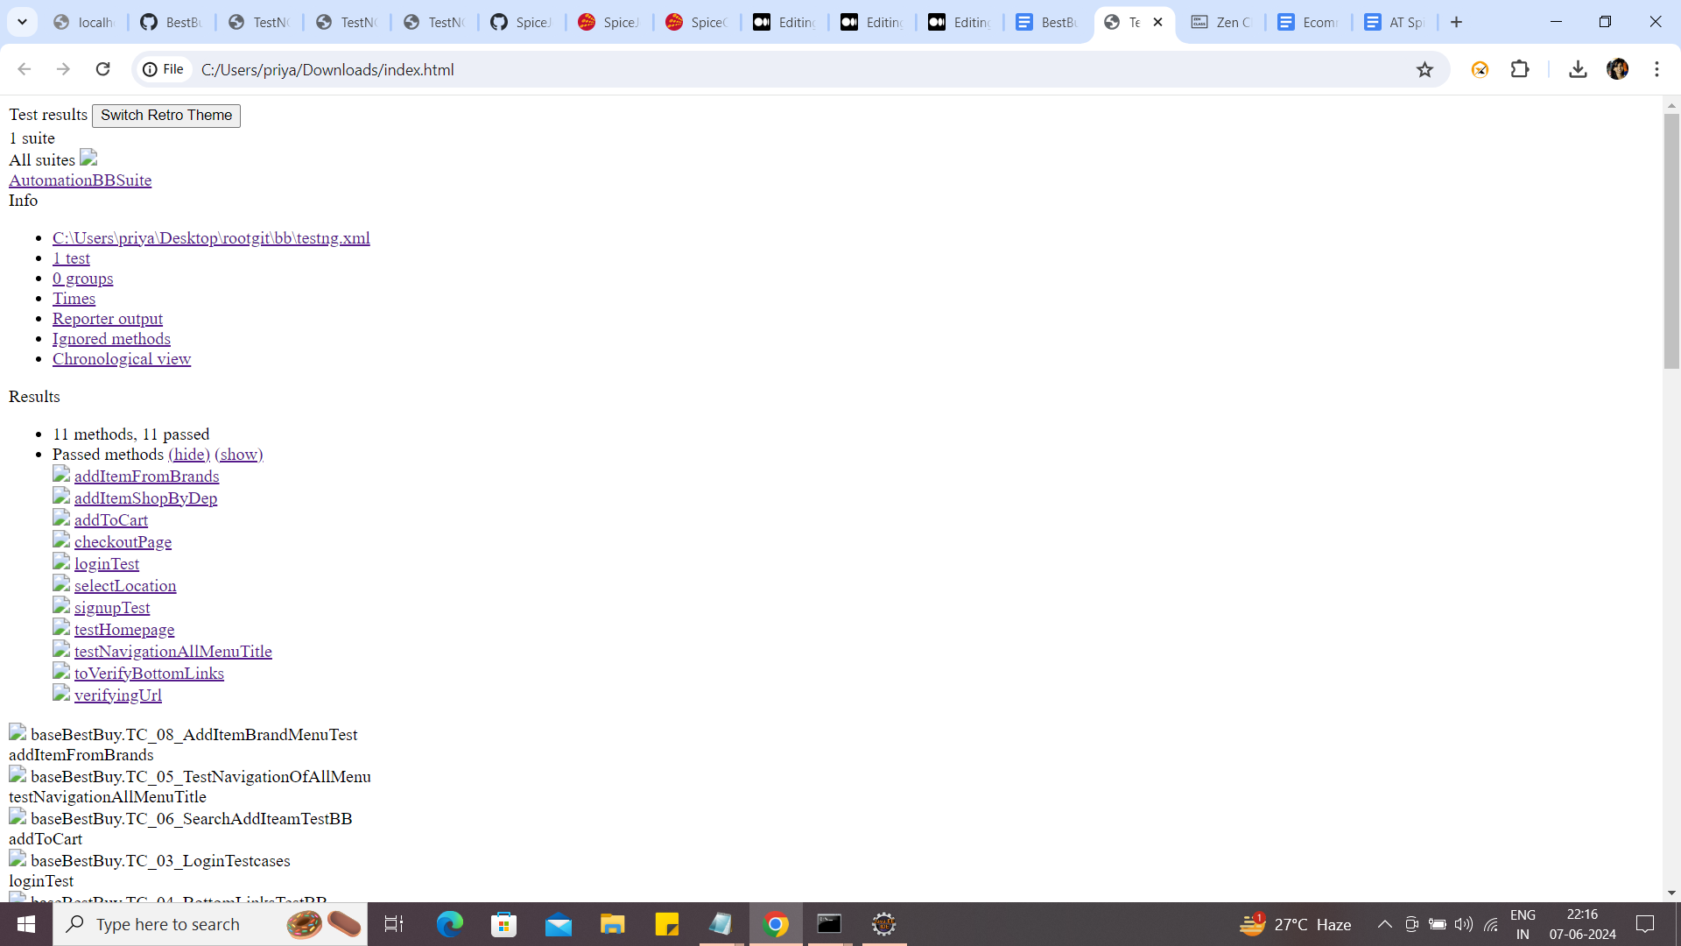

**Jenkins:**

After setting up Jenkins create freestyle project go to configure fill up the required fields

Provide the GitHub URL and set build triggers

If we want run the suite automatically when a new code is pushed into the repository go to manage Jenkins select hook URL and go to GitHub settings

In web hooks we have to add as it is local host we cannot do that so i used **Poll** **SCM**.

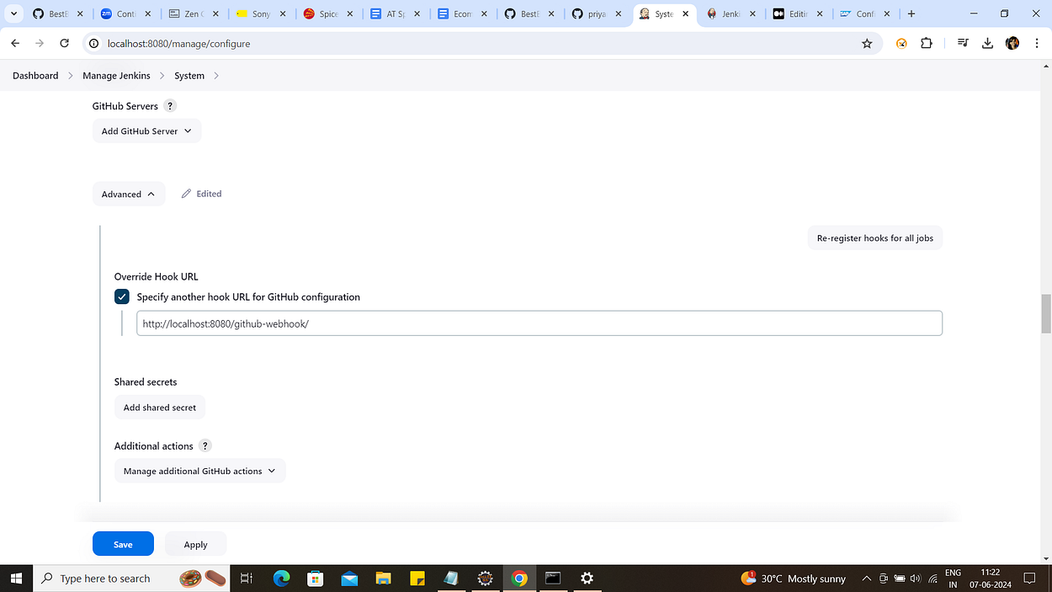

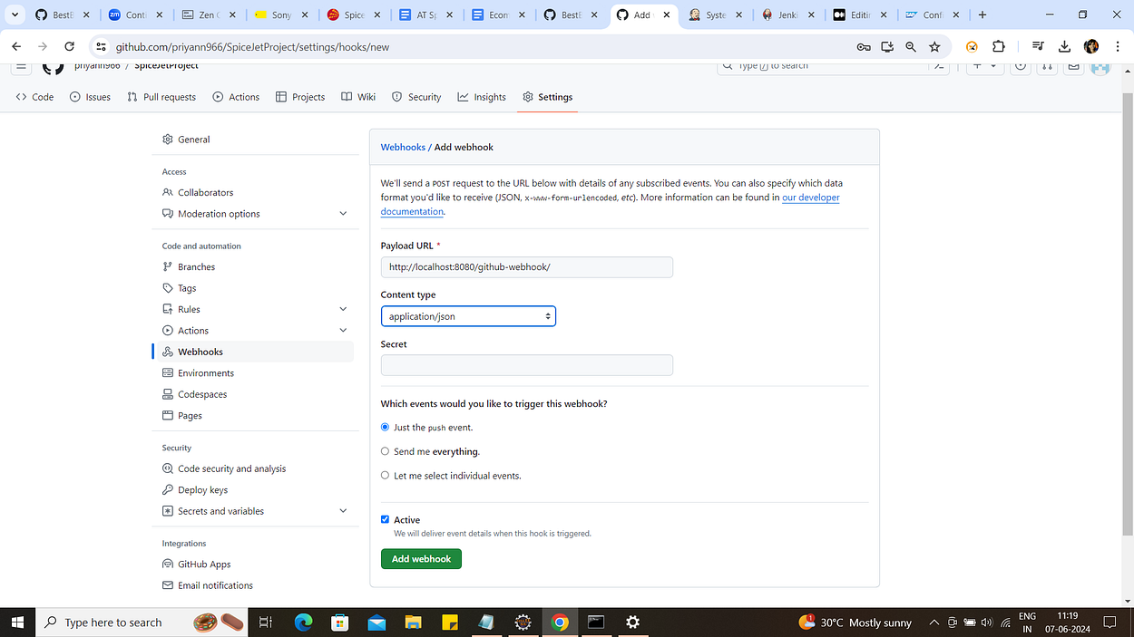

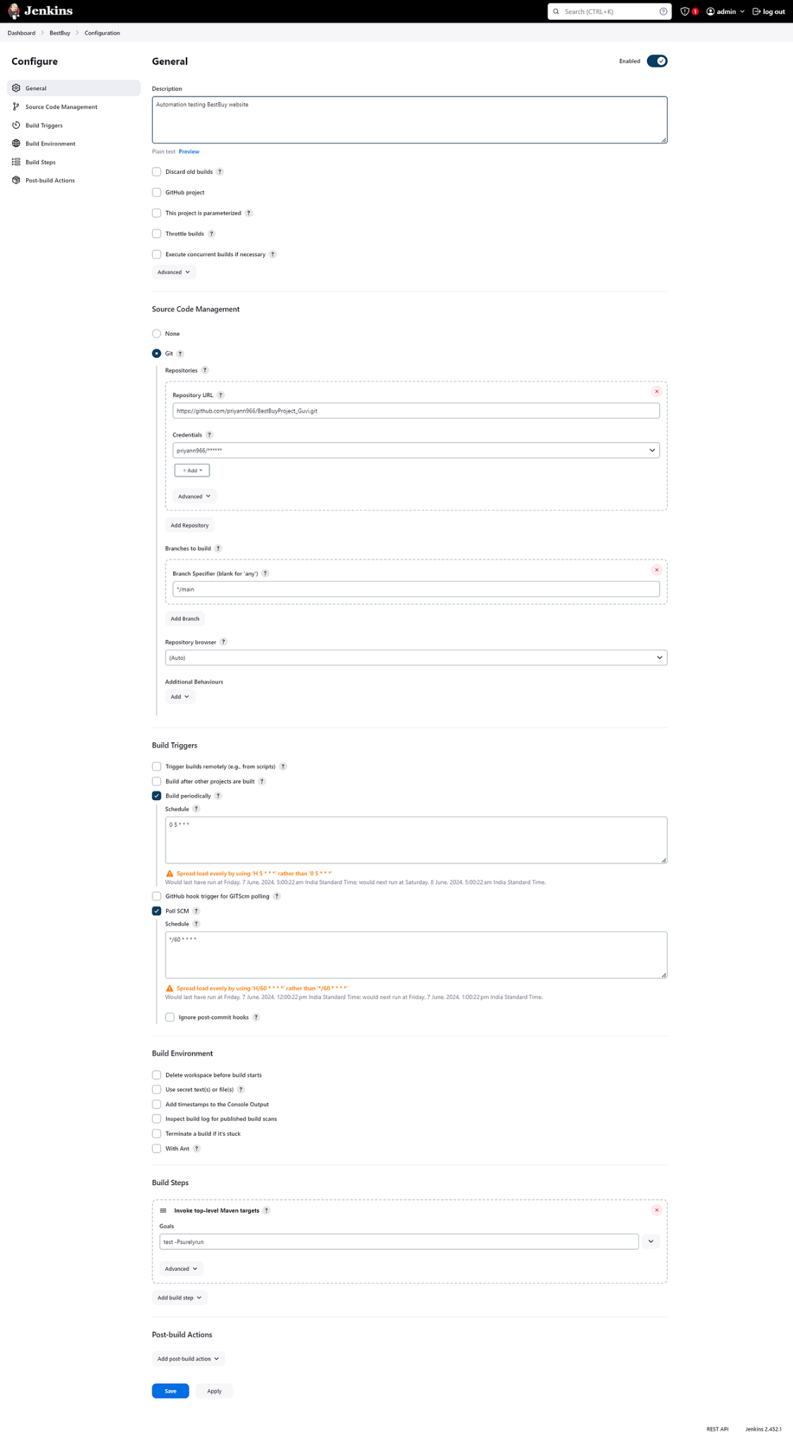

**In build triggers we can run test suite automatically like once per day by setting the Cron expressions**

**Here I have set Poll SCM as there are no changes in my repository it will not build.**

