**SpiceJetProject:**

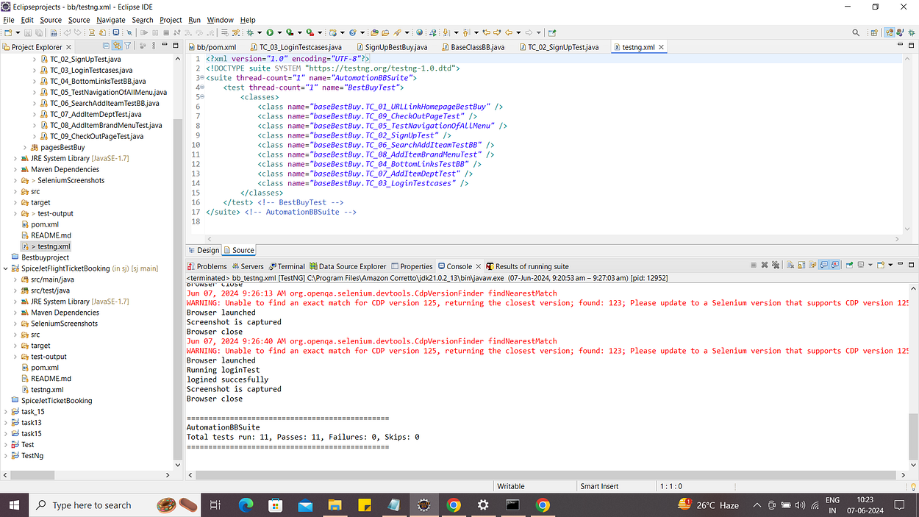

**In sign up, facing issues with the website after running the test case any one of the fields is not accepted but there is no error appearing,issue with the website.**

**With headless chrome test cases are failing and it is taking more time to execute.**

**Output ss:**

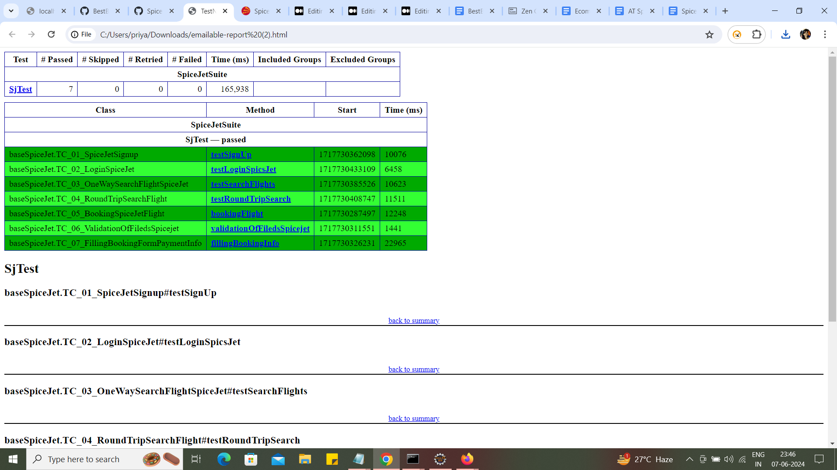

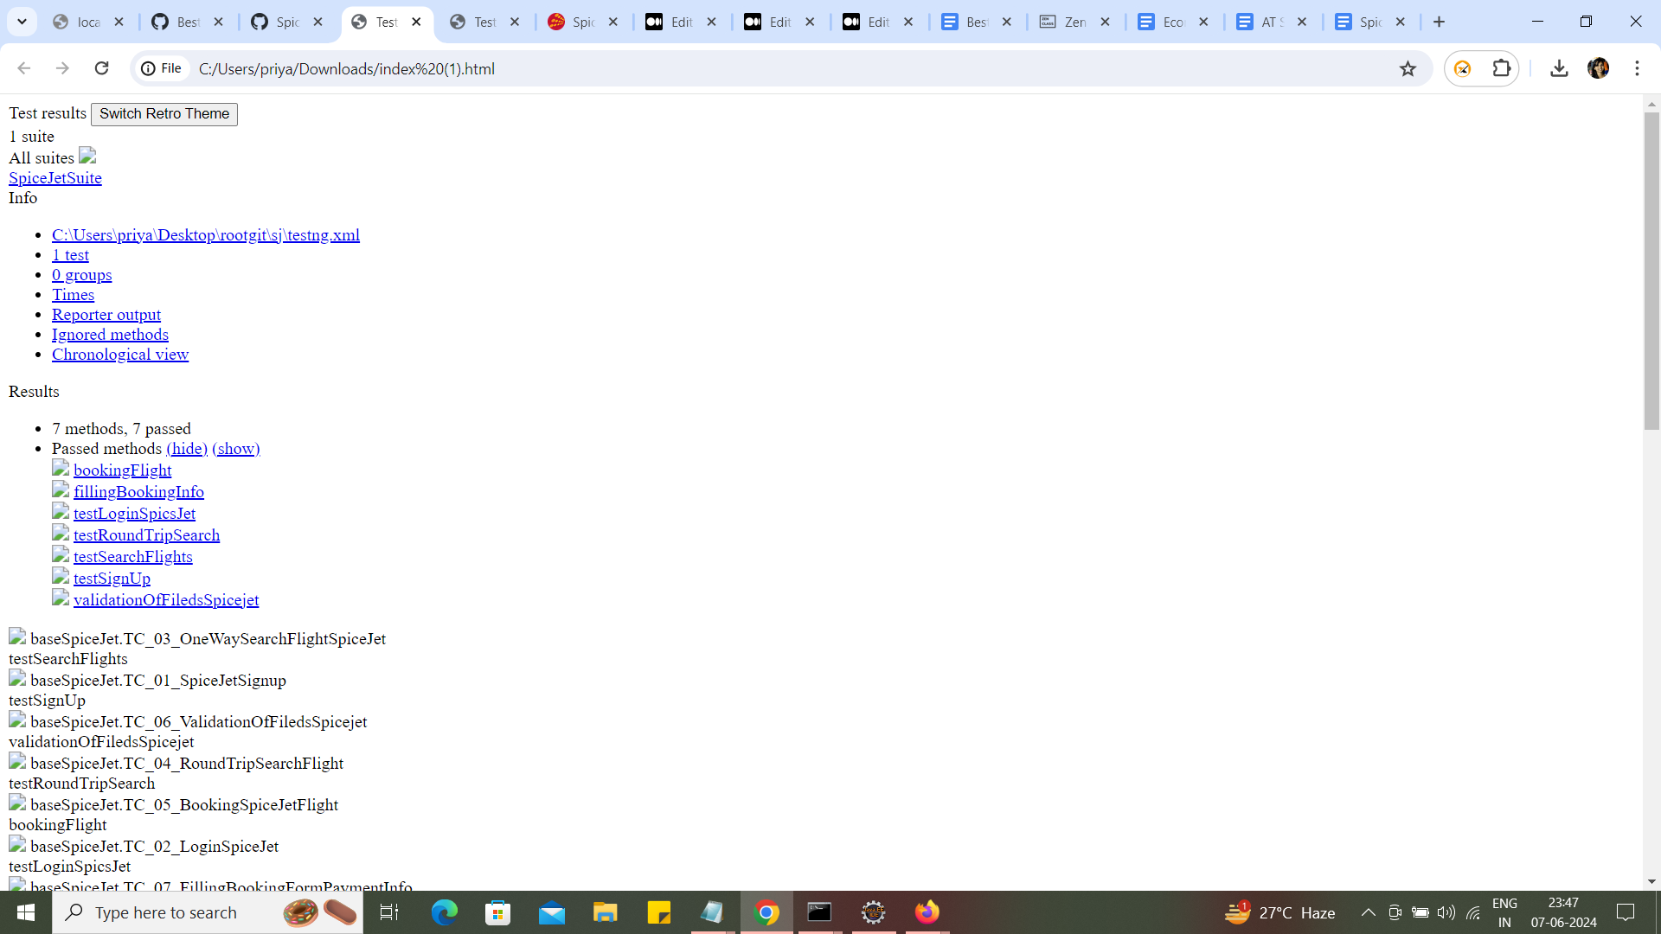

**Jenkins:**

After setting up jenkins create freestyle project go to configure fill up the required fields

Provide the github URL and set build triggers

If we want run the suite automatically when a new code is pushed into the repository go to manage jenkins select hook URL and goto github settings

In webhooks we have to add as it is localhost we cannot do that so i used **Poll** **SCM.**

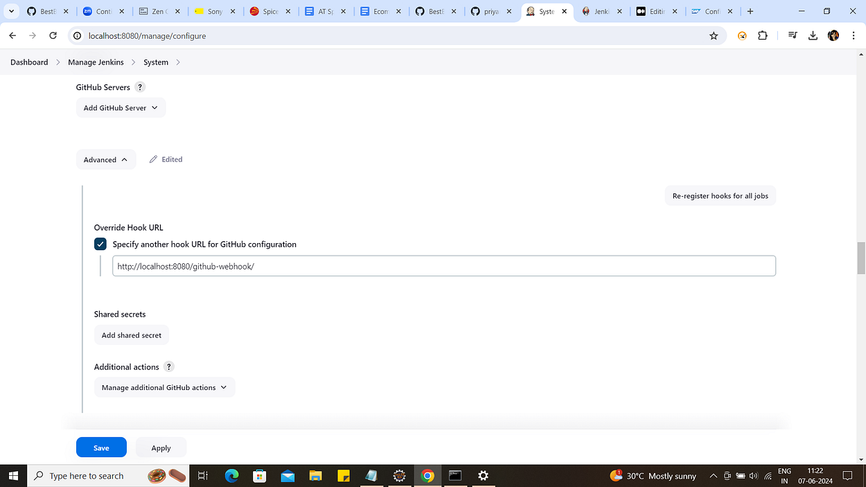

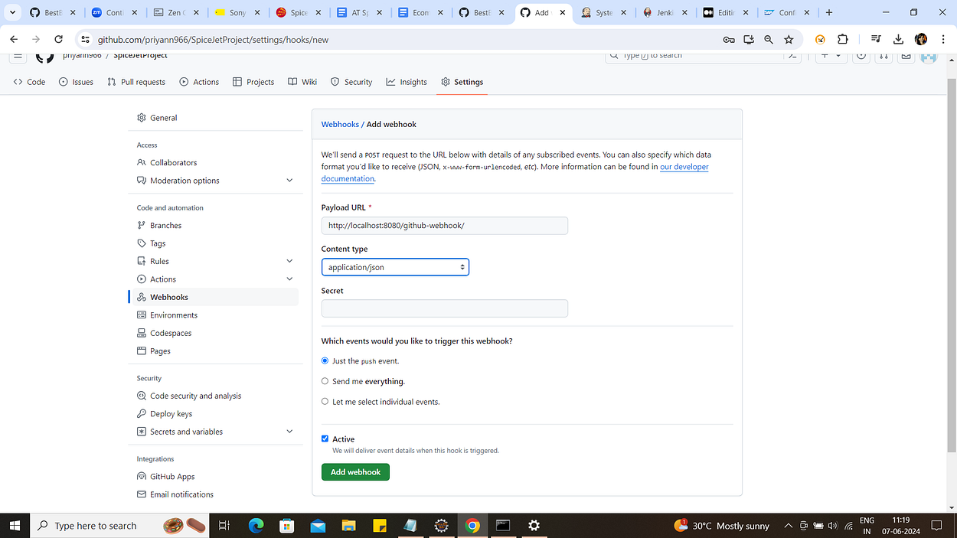

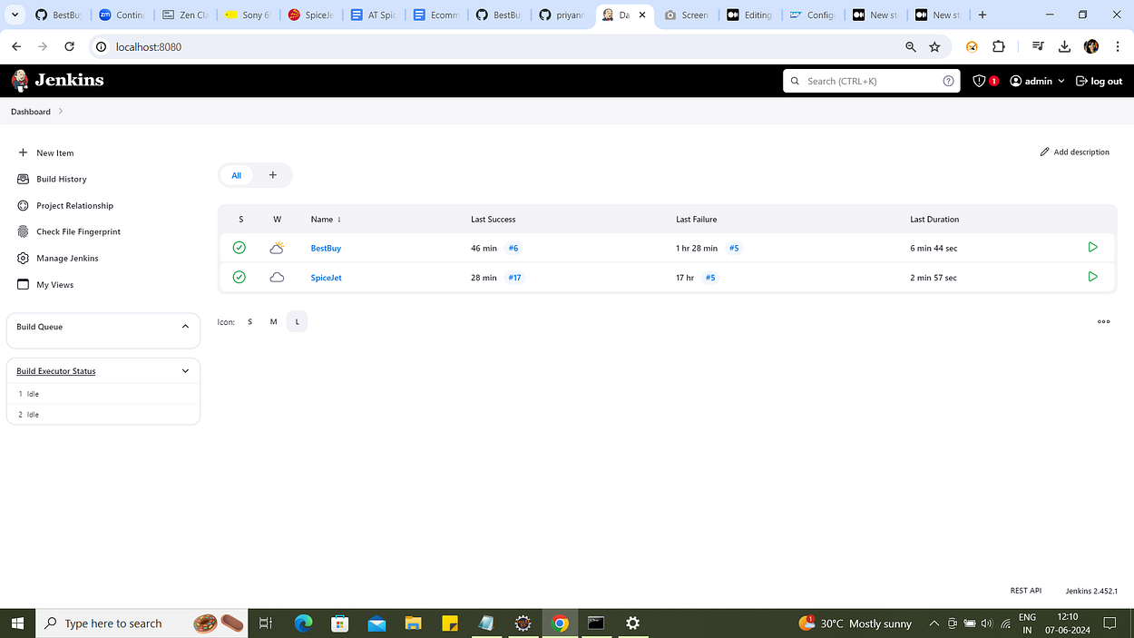

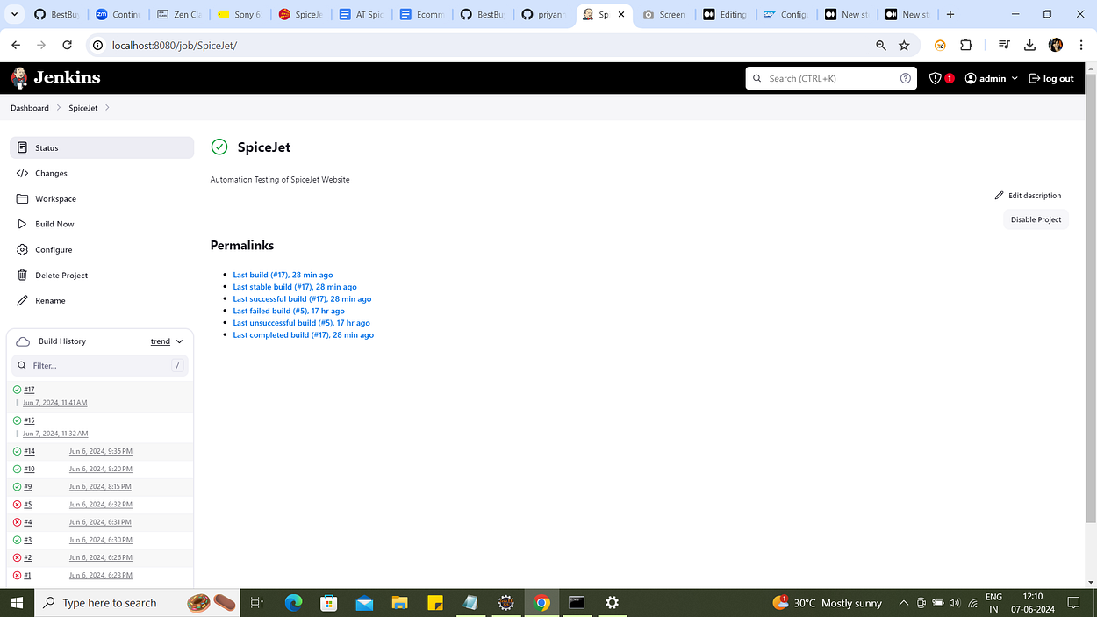

Here in build triggers we can run test suite automatically like once per day by setting the cron expressions

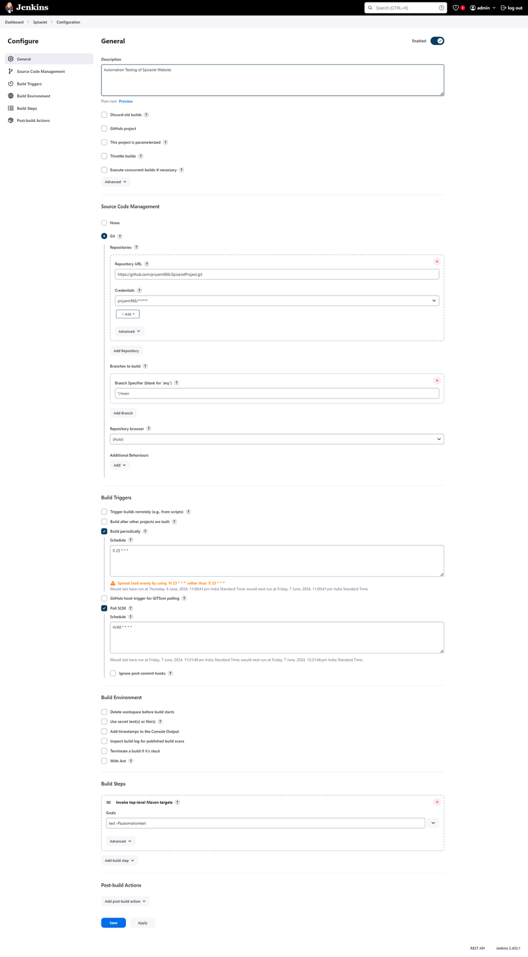

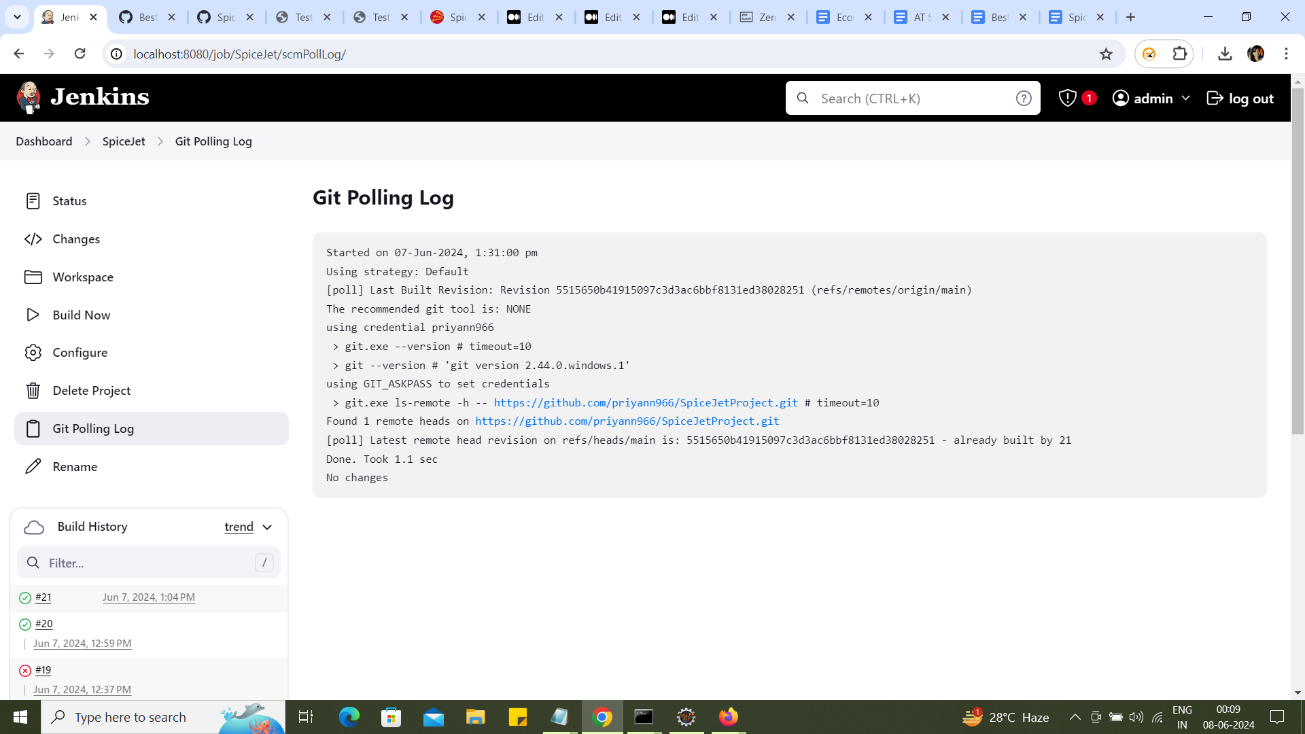

Here I have set poll SCM as there are no changes in my repository. It is reflecting as there are no changes. If there are any changes then it will automatically build at that point of time what we have set.

