CHAPTER 3
Mahābhārata: What's and What Nots
Strategic Lessons from Mahābhārata | Exam-Ready Revision Notes | Book pages 35 to 39
Chapter at a glance
- Core idea: Why Mahābhārata is the fifth Veda: it turns the Veda's abstract truths into lived 'technology' for people who are eligible for mokṣa but not competent for rigorous Vedic study, and its essence of Dharma is Niṣkāma Karma.
- Itihāsa conveys universal truths through stories of humans and non-humans; the truths come from Ṛṣis' experience (mantra-draṣṭā).
- Kṛṣṇa Dvaipāyana compiled and classified the Vedic aphorisms, hence Veda Vyāsa.
- Three kinds of Vedic statements: Praśasti, Vidhi, Jñāna Vākya (statement of truth).
- Hierarchy: Vedas/Upaniṣads = sourcebooks; Brahma Sūtra = text; Bhagavadgītā = technology.
- Eligibility vs competence explains the need for the fifth Veda; Niṣkāma Karma = essence of Dharma.

1. Complete Summary
An Itihāsa conveys universal truth as stories about humans and non-humans. Mahābhārata, one of the greatest Itihāsas, expresses eternal truths about human nature, including how truth can be experienced, communicated, understood and verified. These truths come from thousands of years of observation, study and analysis by Ṛṣis, who are called mantra-draṣṭās: those who have experienced the truth. They did not create the aphorisms; they verbalised what they experienced in meditation. All of these expressions were combined, classified and edited by Kṛṣṇa Dvaipāyana, so he became known as Veda Vyāsa, the editor of the Vedas.
Each Veda is classified into four texts: Saṃhitā, Āraṇyaka, Brāhmaṇa and Upaniṣad. Across them there are three types of statements. Praśasti Vākyas are decorative statements praising or blaming a deity, event, person or experience. Because they involve fame and infamy, they rest on the speaker's likes and dislikes, which affects veracity; the book therefore says the Saṃhitā statements are Praśasti Vākyas and not statements of truth. Vidhi Vākyas are the dos and don'ts, which change with context: what is expected in one situation may not be in another. These two kinds are compiled in the Brāhmaṇas and Āraṇyakas. The third kind, the statement of truth, is like an equation: changing the word order does not change the meaning, as 2+2=4 equals 4=2+2, and as 'Aham Brahmāsmi' equals 'Brahma aham asmi', and 'tat tvam asi' equals 'asi tat tvam'. The Upaniṣads mainly consist of such statements.
Brahma Sūtra is a text on the Vedānta system, derived from the Vedas by taking statements of truth and arranging them systematically. The Gītā shows how ancient lessons are applied practically. So the Vedas and Upaniṣads are the sourcebooks, Brahma Sūtra is the text, and the Bhagavadgītā is the technology by which the lessons are enacted. Mahābhārata contains this technology of Vedānta, which is why Vyāsa called it the fifth Veda.
Why a fifth Veda? Learning the Veda needs two things: eligibility and competence. For example, passing a degree makes one eligible for civil service, but not everyone is competent. Likewise, in Indian thought all beings, human and non-human, are eligible for mokṣa, the ultimate aim. Heaven is not the final destination because it is impermanent: when merit is exhausted, one returns to earth. But not all humans are competent to learn the Vedas, which demands strict rules, vratas and systematic training. Mahābhārata expresses lofty ideas in simple language and offers those who are eligible but not competent a distinctive means to mokṣa: the multifaceted life experiences of its characters. Its principal purpose is to show how Dharma operates in countless contexts.
Vyāsa says the essence of Dharma is Niṣkāma Karma, the central theme of every anecdote. It means performing karma without the touch of karmic elements: serving others while controlling the sense organs and mind. The 'presumed intelligentsia' wrongly confine it to the Bhagavadgītā; in fact it is found everywhere in the universe. The human body is dynamic, so action and reaction are unavoidable and complete inaction is inconceivable. One should act with the benefit of all in mind. As social beings, everyone must at some point commit to Niṣkāma Karma. One is responsible for one's action or inaction and cannot blame external forces; one must think about pros and cons and control the senses and manas. Mahābhārata teaches this through its characters' life stories.

2. Section-wise Detailed Notes

A. What an Itihāsa conveys
- Universal truth as stories of humans and non-humans.
- Themes: how truth is experienced, communicated, understood and verified.
- Truths = fruit of thousands of years of observation by Ṛṣis.
- Ṛṣis are mantra-draṣṭā ('one who has experienced it'), not creators of aphorisms.
- Kṛṣṇa Dvaipāyana combined, classified and edited them: Veda Vyāsa.

B. Structure of the Veda and types of statements
- Each Veda has 4 texts: Saṃhitā, Āraṇyaka, Brāhmaṇa, Upaniṣad.
- Praśasti Vākya: decorative statements of fame/infamy; based on likes/dislikes; Saṃhitā statements are of this type.
- Vidhi Vākya: dos and don'ts; context-dependent and variable.
- Praśasti + Vidhi compiled in Brāhmaṇas and Āraṇyakas.
- Jñāna Vākya (statement of truth): like an equation, order-independent: 2+2=4 / 4=2+2; Aham Brahmāsmi / Brahma aham asmi; tat tvam asi / asi tat tvam.
- Upaniṣads mainly hold statements of truth.

C. From Veda to Gītā
- Brahma Sūtra: Vedānta text built by arranging statements of truth in order.
- Gītā: practical application of ancient lessons in real life circumstances.
- Vedas/Upaniṣads = sourcebooks; Brahma Sūtra = text; Bhagavadgītā = technology.
- Mahābhārata holds the technology of Vedānta: hence fifth Veda.

D. Eligibility vs competence
- Analogy: a degree makes one eligible for civil service, not necessarily competent.
- All beings are eligible for mokṣa; heaven is not final (impermanent; one returns).
- Vedic study demands rigorous vratas and training; many humans fall short.
- Mahābhārata: lofty ideas in simple words; teaches through life experiences.
- Principal purpose: show how Dharma operates in numerous contexts.

E. Niṣkāma Karma: the essence of Dharma
- Vyāsa: essence of Dharma = Niṣkāma Karma, the theme of every anecdote.
- Meaning: karma without the touch of karmic elements; service to others with controlled senses and mind.
- Misconception: that it belongs only to the Bhagavadgītā.
- Logic: body is dynamic; inaction is inconceivable; act for everyone's benefit.
- Humans are social; everyone must commit to it at some time.
- Take responsibility for action or inaction; do not blame external forces; weigh pros and cons; control senses and manas.

3. Key Terms and Keywords
Term | Meaning / Why it matters
Mantra-draṣṭā (Dṛṣṭakāl in the book) | Ṛṣi who has experienced the truth; not an author of aphorisms.
Veda Vyāsa | Kṛṣṇa Dvaipāyana, called so because he compiled, classified and edited the Vedas.
Saṃhitā, Āraṇyaka, Brāhmaṇa, Upaniṣad | The four texts into which each Veda is classified.
Praśasti Vākya | Decorative statement of fame or infamy, reflecting likes and dislikes; not a statement of truth.
Vidhi Vākya | Statement of dos and don'ts; depends on context.
Jñāna Vākya (statement of truth) | Order-independent, equation-like statement, as in the Upaniṣads.
Brahma Sūtra | Systematic Vedānta text derived from statements of truth.
Bhagavadgītā as 'technology' | The practical method by which Vedic lessons are applied in life.
Eligibility vs competence | Everyone is eligible for mokṣa; not everyone is competent for rigorous Vedic learning.
Mokṣa | Ultimate purpose of every living being; heaven is not the final goal.
Niṣkāma Karma | Selfless action without karmic attachment; essence of Dharma.
Manas | Mind, to be controlled along with the sense organs.

4. Numbers, Facts and Figures
Fact | Detail
Texts per Veda | 4 (Saṃhitā, Āraṇyaka, Brāhmaṇa, Upaniṣad)
Types of Vedic statements | 3 (Praśasti, Vidhi, Jñāna/truth)
Tiers of knowledge | 3: sourcebooks (Vedas/Upaniṣads), text (Brahma Sūtra), technology (Gītā)
Equation example | 2+2=4 equals 4=2+2
Truth sentences | Aham Brahmāsmi / Brahma aham asmi; tat tvam asi / asi tat tvam

5. People, Places and Texts
Name | Role / Significance in this chapter
Kṛṣṇa Dvaipāyana (Veda Vyāsa) | Editor of the Vedas, composer of the fifth Veda.
Ṛṣis | Experiencers of truth through meditation.
Bhagavadgītā | Practical application of Vedic teaching within Mahābhārata.
Brahma Sūtra | Systematic text of Vedānta.

6. Ślokas, Sayings and Sources
Śloka / Source | Meaning and use
Aham Brahmāsmi / Brahma aham asmi | Examples of statements of truth: meaning does not change when words are reordered.
Tat tvam asi / asi tat tvam | Same: order-independent statement of truth.

7. Comparisons and Frameworks

Three kinds of Vedic statements
Type | Nature | Where compiled
Praśasti Vākya | Praise/blame, based on likes and dislikes; not a pure truth statement | Brāhmaṇas and Āraṇyakas
Vidhi Vākya | Dos and don'ts; vary with context | Brāhmaṇas and Āraṇyakas
Jñāna Vākya (truth) | Equation-like; meaning fixed whatever the order | Upaniṣads

Source, text and technology
Level | Work | Role
Sourcebooks | Vedas and Upaniṣads | Origin of truths
Text | Brahma Sūtra | Systematic arrangement of truths
Technology | Bhagavadgītā (in Mahābhārata) | Applies the lessons in real situations

Eligibility vs competence
Aspect | Eligibility | Competence
For mokṣa | All beings, human and non-human | Needs suitable means
For Vedic study | Humans are eligible | Requires rigorous vratas and training
Role of MB | Offers a path through life-experiences to the eligible but incompetent

8. Mind Map
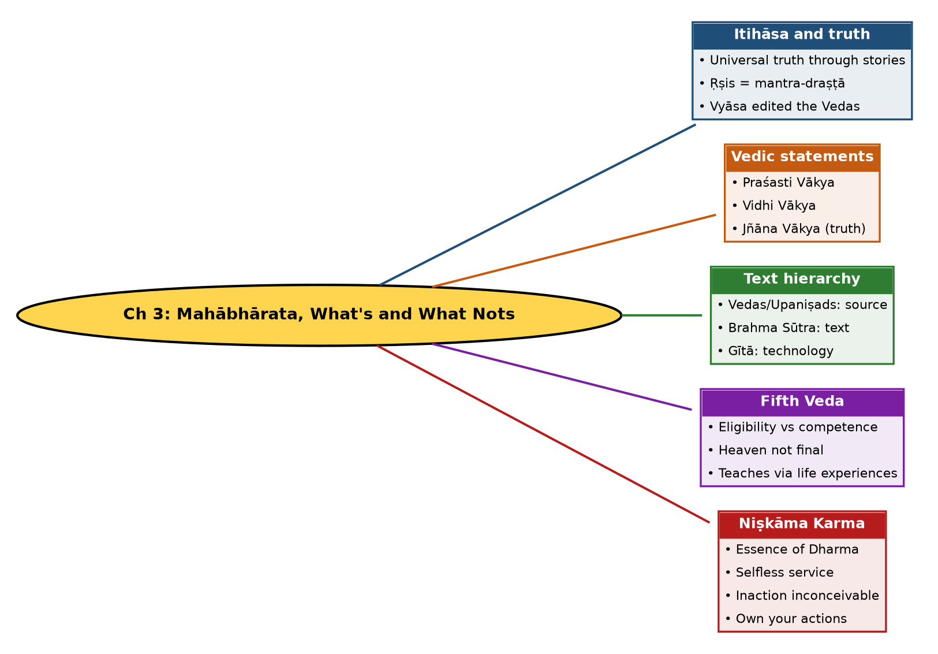

Tree view (text version for quick revision)
Ch 3: Mahābhārata, What's and What Nots
- Itihāsa and truth
  - Universal truth through stories
  - Ṛṣis = mantra-draṣṭā
  - Vyāsa edited the Vedas
- Vedic statements
  - Praśasti Vākya
  - Vidhi Vākya
  - Jñāna Vākya (truth)
- Text hierarchy
  - Vedas/Upaniṣads: source
  - Brahma Sūtra: text
  - Gītā: technology
- Fifth Veda
  - Eligibility vs competence
  - Heaven not final
  - Teaches via life experiences
- Niṣkāma Karma
  - Essence of Dharma
  - Selfless service
  - Inaction inconceivable
  - Own your actions

9. Highlights Marked in Your Book
These phrases are the yellow-highlighted portions detected on the book pages (read by OCR, so a few spellings may be unaccented). Treat them as your own priority list.
- Mantra drstakkal’, Drstakkal’ means
- one who has experienced
- Krsna Dvaipayana
- Aranyaka, Brahmana, and Upanisads
- Prasasti Vakya, the Vidhj
- Vakya, and the Jana
- fame or infamy
- Prasasti Vakya
- commission and omission
- all the Samhita statements are Prasasti Vakyas
- not the statements of the
- dos and don’ts
- Brahmanasand Aranyakas
- Aham Brahma
- Brahma Sutra
- Vedanta system
- Vedic aphorisms
- the Upanisads are the sourcebooks, Brahma Siitra
- the text and Bhagavadgita is the technology
- rigorous vratas
- essence of Dharma is Niskima Karma
- every anecdote
- controlling his sense
- and mind

10. Quick Revision: Memory Aids
- P-V-J = Praśasti, Vidhi, Jñāna: the 3 statements.
- S-A-B-U = Saṃhitā, Āraṇyaka, Brāhmaṇa, Upaniṣad.
- Source, Text, Technology = Vedas/Upaniṣads, Brahma Sūtra, Gītā.
- E vs C: Everyone is Eligible, but not everyone is Competent.
- Truth is like an equation: reorder the words, the meaning stays.
- Niṣkāma Karma is not only a Gītā idea; it is in every anecdote.

11. Exam Practice: Questions and Model Answers
Q1. What is an Itihāsa trying to convey, according to this chapter?
Ans: Universal truths about human nature, narrated as stories of humans and non-humans, including how truth is experienced, communicated, understood and verified.
Q2. Who are the mantra-draṣṭās and what is their role?
Ans: Ṛṣis who experienced truths in meditation. They did not create the aphorisms but expressed what they experienced. Kṛṣṇa Dvaipāyana compiled, classified and edited them and so became Veda Vyāsa.
Q3. Name and explain the three types of statements in the Vedas.
Ans: Praśasti Vākya: decorative statements of fame or infamy, based on likes and dislikes. Vidhi Vākya: dos and don'ts that vary with context. Jñāna Vākya: statements of truth, like equations where word order does not change meaning.
Q4. Why are Saṃhitā statements called Praśasti Vākyas and not statements of truth?
Ans: Because they narrate fame or infamy, which involves acts of commission and omission based on likes and dislikes, reducing veracity.
Q5. Give examples of order-independent truth statements.
Ans: 2+2=4 and 4=2+2; Aham Brahmāsmi / Brahma aham asmi; tat tvam asi / asi tat tvam.
Q6. Explain how Vedas, Brahma Sūtra and the Gītā relate.
Ans: Vedas and Upaniṣads are sourcebooks, Brahma Sūtra is the systematic text, and the Bhagavadgītā is the technology to apply them. Mahābhārata holds this technology, so it is the fifth Veda.
Q7. Explain eligibility and competence with the book's example.
Ans: A degree makes one eligible for civil service, but not all graduates are competent. Similarly all beings are eligible for mokṣa, yet not all humans are competent to follow the rigorous training for Vedic study.
Q8. Why is heaven not the final goal in Indian thought?
Ans: It is not permanent; once the time is over a being may return to earth. Mokṣa is the ultimate purpose.
Q9. How does Mahābhārata help those who are eligible but not competent?
Ans: It presents lofty ideas in simple words and offers a distinctive means through the many life experiences it illustrates, showing how Dharma operates in varied contexts.
Q10. What is Niṣkāma Karma and why is it the essence of Dharma?
Ans: Performing karma without karmic attachment, serving others while controlling the senses and mind. Vyāsa says it is the central topic of every anecdote of Mahābhārata.
Q11. Why does the chapter say inaction is inconceivable?
Ans: The human body is dynamic; whatever is dynamic acts and reacts, so one is always engaged in some action and must keep it beneficial to all.
Q12. What personal responsibility does Niṣkāma Karma imply?
Ans: One is responsible for one's actions or inaction, cannot blame external forces, must weigh pros and cons and control the sense organs and manas.

Self-test: one-line recall
- Fourfold Vedic texts = ? Saṃhitā, Āraṇyaka, Brāhmaṇa, Upaniṣad.
- Gītā's role = ? Technology of Vedānta.
- Essence of Dharma = ? Niṣkāma Karma.
- Is heaven final? No, it is impermanent.

