CHAPTER 4
Dharmic Insights of a Butcher
Strategic Lessons from Mahābhārata | Exam-Ready Revision Notes | Book pages 43 to 47
Chapter at a glance
- Core idea: The Vyādha Gītā (Vana Parva): a butcher and a housewife teach a proud ascetic that real spirituality is doing one's duty without attachment, and that work done as worship is Karma Yoga.
- Three Gītās: Bhagavadgītā (Kṛṣṇa to Arjuna), Uddhava Gītā (Kṛṣṇa to Uddhava), Vyādha Gītā (by a butcher).
- The story is in Vana Parva, while the Pāṇḍavas are in the forest.
- The ascetic's fury burned a crane; the housewife says: 'I am not a crane'.
- 'No duty is ugly, no duty is impure': do your duty well, unattached.
- Spirituality is not running away from duty; serve parents and family; work = worship.

1. Complete Summary
The chapter begins by calling the Bhagavadgītā the crest jewel of Mahābhārata, the pendant of a long string of pearls. There are two other Gītās: the Uddhava Gītā, taught by Kṛṣṇa to his friend and disciple Uddhava, and the Vyādha Gītā, a profound philosophical account explaining Advaita, delivered by a vyādha (butcher). The Vyādha Gītā is rooted in a story that holds the essence of Karma Yoga and the definition of work and worship.
A young Brāhmaṇa boy decided to renounce the world, leaving his old parents who begged him to stay and look after them, and did tapas in the forest to attain God and truth. This happened before Buddha, in the time when the Pāṇḍavas were in exile. After years of tapas his concentration grew and he gained unusual powers. One day a crane sat on the tree above him and its droppings fell on his head. Furious, he looked at the bird and it burned to ashes. He became proud of his power. Going to a village for bhikṣā with the call 'bhavati bhikṣāṃ dehi', he met a woman serving her tired husband, who asked him to wait. He raged at her for making a great man wait. She smiled and said, 'Do you think I am a crane that you can burn me up?' She explained that she put her duty to her husband first, said he knew nothing yet of yoga and spirituality, and sent him to the next village to a man called Dharmavyādha.
Humbled and shocked that she knew about the crane, he found Dharmavyādha's place, which looked like an ordinary slaughterhouse. The butcher greeted him: 'Did the lady send you? Come in', surprising him again. He saw the butcher attending to his parents. When the ascetic asked why such a wise man did this gruesome work, the butcher said that running to a forest and gaining powers does not make one accomplished, that he had incurred sin by killing the crane out of anger without control of mind and action, and that this is not spirituality. He added, 'No duty is ugly, no duty is impure. Birth placed me in these circumstances. I learned this trade as a boy; I am unattached and try to do my duty well. I do all I can to make my father and mother happy.'
The Vyādha Gītā shows how to worship one's work, whatever it is; disinterest in the fruit shows up as excellence in duty. In Mahābhārata, Kṛṣṇa says that by treating work as worship one can attain the highest; Janaka and others attained supremacy through Karma Yoga. The woman served her husband and the butcher served his aged parents with devotion, without expecting reward, offering it to the Absolute, and so attained their goal. The butcher told the Brahmacārī to go home and care for his parents first.
Swami Vivekananda says the Vyādha Gītā contains the heights of Advaita, which preaches renunciation; but when the all-pervading Self is within, renunciation is not leaving home for the forest. One can be a householder and still follow a spiritual path. Ramana Maharṣi says one can pass from householder to ascetic, but the point is to find who the 'I' is and go beyond it. Amma, asked by a woman for enlightenment, told her to continue doing what she was doing and she would reach there one day, and contrasted Dakṣa's yajña, which became a battlefield through his audacity, with Arjuna who, through faith in Kṛṣṇa, turned Kurukṣetra into a place of worship. The Brāhmaṇa's austerities, done with ego, pushed him into ignorance. Spirituality is not escaping actions or basic duties; the woman and the butcher are models of Karma Yoga through devoted, duty-bound, reward-free service of family.

2. Section-wise Detailed Notes

A. The three Gītās
- Bhagavadgītā: crest jewel / pendant of the string of pearls that is Mahābhārata; Kṛṣṇa to Arjuna.
- Uddhava Gītā: Kṛṣṇa to Uddhava, long-standing friend and disciple.
- Vyādha Gītā: delivered by a butcher (vyādha); philosophical; explains Advaita; essence of Karma Yoga, work and worship.

B. The ascetic and the crane
- Young Brāhmaṇa leaves old parents (who needed him) for tapas in the forest; time of Pāṇḍavas' exile.
- Gains powers; crane's droppings fall on him; anger burns the crane; pride grows.
- Common belief he followed: spirituality = leaving everything and doing tapas in a forest.

C. The housewife
- He begs: 'bhavati bhikṣāṃ dehi'; she asks him to wait while serving her husband.
- He shouts at her; she: 'Do you think I am a crane?'
- She chose duty first (feeding her tired husband); sends him to Dharmavyādha.
- Her knowledge came from duty-bound life, not from reading the Vedas.

D. Dharmavyādha the butcher
- Place looks like a slaughterhouse; he already knows about the lady.
- Is serving his parents when the ascetic arrives.
- Tells him: killing the crane was sin (anger, no control of mind).
- 'No duty is ugly, no duty is impure.' Born into his work; unattached; makes parents happy.
- Teaches: worship your work; disinterest in fruits shows in good performance.
- Final instruction: go home and look after your parents.

E. Teaching and voices of authority
- Story is in Vana Parva.
- Kṛṣṇa (MB): work as worship leads to supremacy; King Janaka attained it by Karma Yoga.
- Vivekananda: Vyādha Gītā = heights of Advaita; renunciation is not about leaving home.
- Ramana Maharṣi: find who the 'I' is and go beyond it.
- Amma: 'Continue doing what you are doing.' Dakṣa's yajña became a battlefield; Arjuna made Kurukṣetra a place of worship.
- Conclusion: spirituality is not escape from duty; the lady and the butcher are models of Karma Yoga.

3. Key Terms and Keywords
Term | Meaning / Why it matters
Vyādha Gītā | Gītā taught by a butcher in Vana Parva; philosophical, Advaitic, centred on Karma Yoga.
Uddhava Gītā | Kṛṣṇa's teaching to Uddhava.
Vyādha / Dharmavyādha | Butcher; the butcher of the story, known for dharma.
Tapas | Austerity/meditation practised by the ascetic.
Bhikṣā | Alms; 'bhavati bhikṣāṃ dehi' is the call for alms.
Brahmacārī | Young celibate student/ascetic, here the proud Brāhmaṇa boy.
Karma Yoga | Doing duty as worship, without attachment to reward.
Advaita | Non-dual philosophy; Vyādha Gītā explains it.
Svadharma duty | Duty by birth and circumstance; 'no duty is ugly'.
Renunciation | Per the chapter, inner detachment, not merely leaving home.

4. Numbers, Facts and Figures
Fact | Detail
Gītās named | 3: Bhagavadgītā, Uddhava Gītā, Vyādha Gītā
Parva | Vana (Āraṇya) Parva
Time | Before Buddha; when the Pāṇḍavas were in the forest
Number of teachers of the ascetic | 2 (the housewife, the butcher)
Persons mentioned as Karma Yogis | The housewife, the butcher, King Janaka

5. People, Places and Texts
Name | Role / Significance in this chapter
The young Brāhmaṇa (Brahmacārī) | Left old parents for tapas; proud, learns humility.
The housewife | Duty to her husband; says 'I am not a crane'.
Dharmavyādha | Butcher who serves parents and teaches Karma Yoga.
Uddhava | Friend and disciple of Kṛṣṇa.
King Janaka | Attained supremacy through Karma Yoga.
Swami Vivekananda, Ramana Maharṣi, Amma | Voices quoted on renunciation, the 'I', and continuing one's duties.
Dakṣa and Arjuna | Contrast: yajña became a battlefield vs battlefield became worship.

6. Ślokas, Sayings and Sources
Śloka / Source | Meaning and use
bhavati bhikṣāṃ dehi | Call for alms used by the Brahmacārī.
'My son, no duty is ugly, no duty is impure.' (Dharmavyādha) | Core teaching: dignity in every duty done without attachment.
'Do you think I am a crane?' (the housewife) | Rebuke to anger and ego; duty comes before the ascetic's demand.

7. Comparisons and Frameworks

Ascetic vs housewife vs butcher
 | Ascetic | Housewife / Butcher
Conduct | Left parents; tapas in forest | Served husband / parents with devotion
Attitude | Pride, anger, expects respect | Humility, detachment, no reward expected
Result | Burned a crane; sin and ego | Attained the goal through Karma Yoga
Lesson | Powers without control are not spirituality | Duty done as worship is spirituality

8. Mind Map
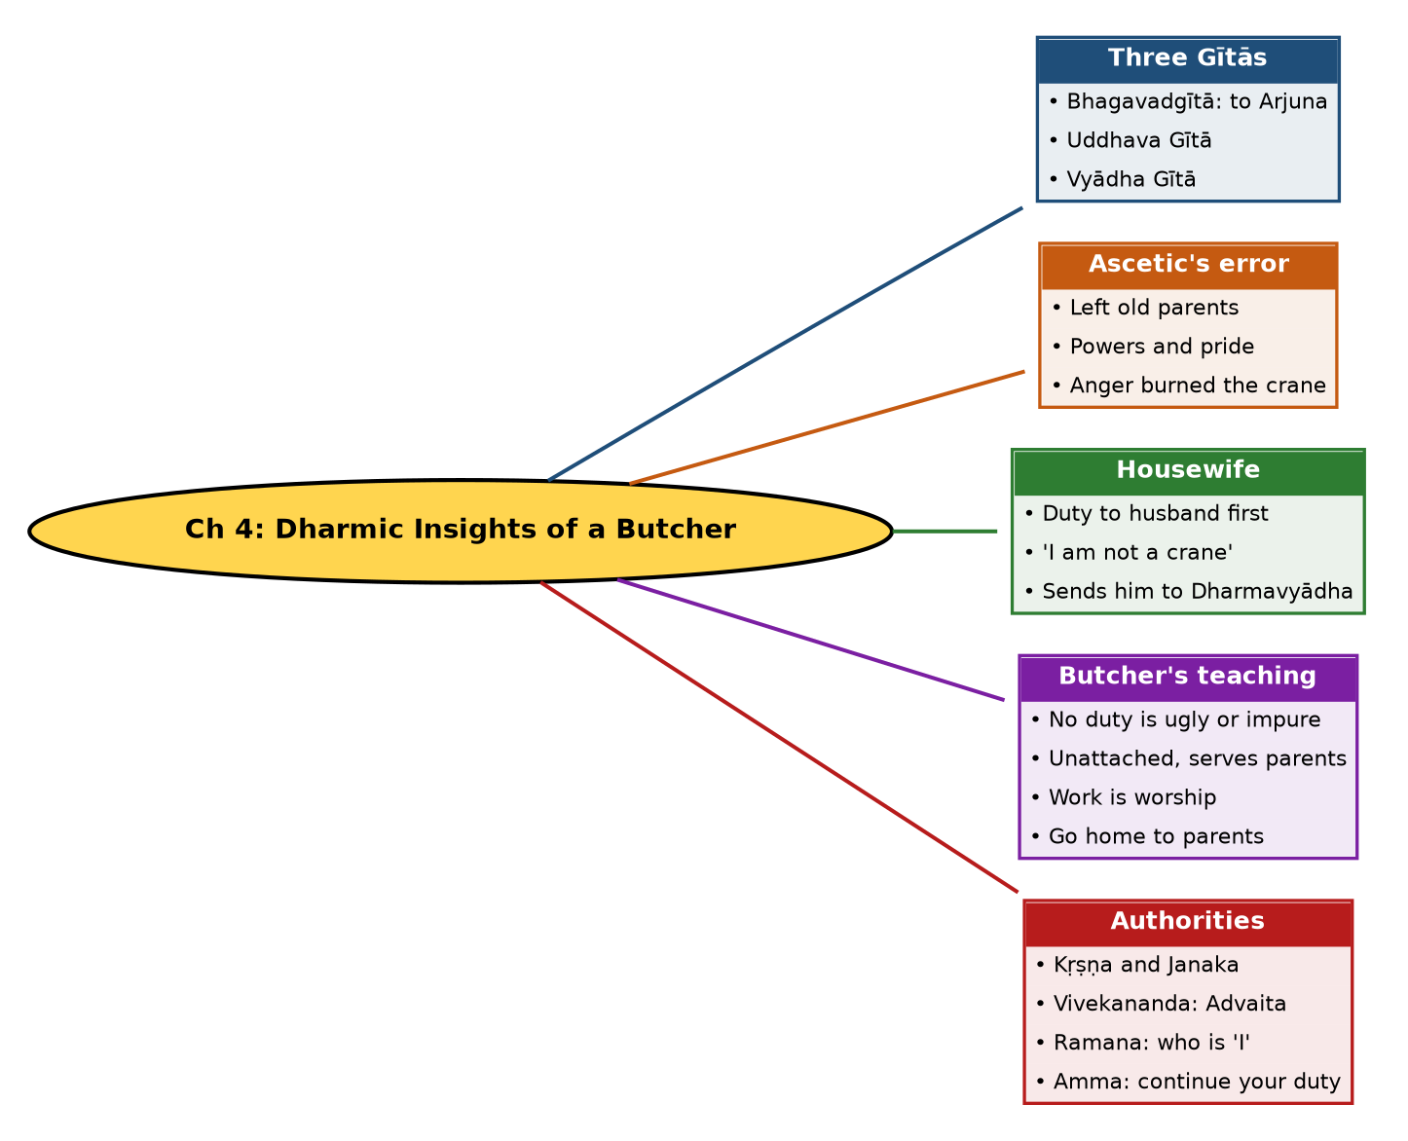

Tree view (text version for quick revision)
Ch 4: Dharmic Insights of a Butcher
- Three Gītās
  - Bhagavadgītā: to Arjuna
  - Uddhava Gītā
  - Vyādha Gītā
- Ascetic's error
  - Left old parents
  - Powers and pride
  - Anger burned the crane
- Housewife
  - Duty to husband first
  - 'I am not a crane'
  - Sends him to Dharmavyādha
- Butcher's teaching
  - No duty is ugly or impure
  - Unattached, serves parents
  - Work is worship
  - Go home to parents
- Authorities
  - Kṛṣṇa and Janaka
  - Vivekananda: Advaita
  - Ramana: who is 'I'
  - Amma: continue your duty

9. Highlights Marked in Your Book
These phrases are the yellow-highlighted portions detected on the book pages (read by OCR, so a few spellings may be unaccented). Treat them as your own priority list.
- crest jewel
- pendant of the long
- Uddhava Gita and Vyadha Gita
- Bhagavan Sri Krsnato
- friend and
- Advaita philosophy
- work and worship
- tapas (austerities)
- Pandavas are in the
- bhavati bhiksam
- Vyadha Gita
- worship one’s work
- Vana Parva
- Swami Vivekananda
- King Daksa

10. Quick Revision: Memory Aids
- Crane test: anger turned power into sin; the lady said 'I am not a crane'.
- Quote to remember: 'No duty is ugly, no duty is impure.'
- Order of teachers: Housewife (duty) then Butcher (worship of work) then home to parents.
- Spiritual = not escape: Dakṣa's yajña (ego) vs Arjuna's Kurukṣetra (faith).
- Trio of Gītās: Bhagavad, Uddhava, Vyādha.

11. Exam Practice: Questions and Model Answers
Q1. Name the three Gītās mentioned in the chapter.
Ans: Bhagavadgītā (Kṛṣṇa to Arjuna), Uddhava Gītā (Kṛṣṇa to Uddhava) and Vyādha Gītā (taught by a butcher).
Q2. Narrate the story of the young Brāhmaṇa and the crane.
Ans: He left his old parents for tapas in the forest, gained powers, and burned a crane in anger when its droppings fell on his head. He became proud, then was humbled by a housewife and a butcher.
Q3. What did the housewife teach him?
Ans: She said she was not a crane he could burn, that her duty to her tired husband came first, and that he did not yet understand yoga; she sent him to Dharmavyādha.
Q4. Why was the Brahmacārī shocked in the butcher's house?
Ans: The butcher knew about the lady and about his killing of the crane, and was serving his parents despite his gruesome trade.
Q5. What does 'no duty is ugly, no duty is impure' mean?
Ans: Any duty fixed by one's birth and circumstance can be dignified if done well, without attachment, and as service.
Q6. What is the Vyādha Gītā's central message?
Ans: Treat work as worship; detachment from reward improves performance of duty; spirituality means doing duty, such as serving parents or family, not running away.
Q7. Where does the Vyādha Gītā occur?
Ans: In Vana Parva, when the Pāṇḍavas were in the forest.
Q8. What does Vivekananda say about the Vyādha Gītā?
Ans: It contains the heights of Advaita, which preaches renunciation; but renunciation does not require leaving home, since the Self is within.
Q9. Compare Dakṣa's yajña and Arjuna's battlefield (Amma).
Ans: Dakṣa's yajña became a battleground because of his audacity, whereas Arjuna, with dedication to Kṛṣṇa, turned the battleground of Kurukṣetra into a place of worship.
Q10. Why were the housewife and butcher exemplars of Karma Yoga?
Ans: They served family with devotion, sense of duty and complete detachment from reward, offering it as worship.

Self-test: one-line recall
- Who is the butcher? Dharmavyādha.
- Where is the story? Vana Parva.
- What burned? A crane.
- Final advice? Go home and serve your parents.

