CHAPTER 5
The Unbroken Legacy
Strategic Lessons from Mahābhārata | Exam-Ready Revision Notes | Book pages 51 to 66
Chapter at a glance
- Core idea: Mahābhārata lives on in regional retellings, classical Sanskrit literature, festivals, temples, folk and classical performing arts, painting, sculpture and even in the list of 363 peoples it records: an unbroken legacy across India.
- Regional versions in Malayalam, Tamil, Odia, Bengali, Hindi and Assamese keep the story familiar to everyone.
- Sanskrit literature: Kālidāsa's Abhijñānaśākuntalam, Bhāsa's 7 plays, Bhāravi's Kirātārjunīya, Śrīharṣa's Naiṣadha Carita.
- Festivals: Karaga, Kuvakam (Koovagam), Dhungri Melā, Bhīṣma Ekādaśī, Chhath Pūjā.
- Art forms: Pāṇḍav Līlā, Terukkūttu, Kathakali, Kūṭiyāṭṭam, Chākyār Kūthu, Bhaona, Chhau, Velakali.
- MB lists 363 janas/jātis; carvings at Hoysaleśvara, Mahabalipuram, Ellora and more. MB is a Kalpavṛkṣa for artists.

1. Complete Summary
Mahābhārata portrays life's complexities like a grand canvas and has played a major role in preserving the culture of India, shaping its philosophy and ethos. This chapter explores the traditions linked with it across India: rituals, storytelling, theatre, songs, folk performances, literature and textual traditions. Its story is familiar to everyone from scholar to illiterate, and daily life draws examples from its characters and stories naturally. A reason is the many regional retellings and inspired literary works.
Regional versions: Malayalam: Kilippāṭṭu Mahābhāratam by Thuñcattu Ezhuthachan, Cherusseri Bhāratam by Cherusseri, Bhāratamālā by Niraṇam Śaṅkara Paṇikkar. Tamil: Mahābhāratam by Peruntevanār and Villibhāratam by Villiputtūrār. Odia: Sarala Dās. Bengali: Kabi Sañjay. Hindi: Sabal Singh Chauhan. Assamese: Rāma Sarasvatī. Three of the five great Sanskrit poems (Pañcamahākāvyas) are rooted in the Itihāsa. Kālidāsa's Abhijñānaśākuntalam dramatises the Śakuntalā-Duṣyanta story from Ādi Parva. Before Kālidāsa, Bhāsa wrote seven plays based on it: Bālacarita, Karṇabhāra, Ūrubhaṅga, Madhyamavyāyoga, Pañcarātra, Dūtaghaṭotkaca and Dūtavākya. In Vana Parva, Arjuna worships Śiva for the Pāśupatāstra; Śiva tests him as a Kirāta, and the poet Bhāravi (6th century CE) wrote the Mahākāvya Kirātārjunīya on it. Also in Vana Parva, Muni Bṛhadaśva tells the story of King Nala to console the exiled Pāṇḍavas, and Śrīharṣa (12th century CE) wrote Naiṣadha Caritam from it. Almost all characters struggle with inner conflicts and face the inevitable consequences of their own karma, making the work a moral guide across generations.
Festivals: Karaga in Karnataka (Caitra, March/April) is celebrated chiefly by the Tigala community, who see themselves as Draupadī's descendants; the Dharmarāya Swāmi Temple in Bengaluru is the main centre; spread over eleven days, it celebrates nature and water (Gaṅgā Pūjā). Kuvakam (Koovagam) in Tamil Nadu, at the Kattāntavar Temple, Villupuram district, comes from a regional version: Iravān (Aravan), Arjuna's son, was granted three boons by Kṛṣṇa for self-sacrifice; he wished to marry before death, so Kṛṣṇa became Mohinī and married him; next day Aravan gave his life and Mohinī mourned as a widow. Dhungri Melā (Hiḍimbā Devī Melā) marks Hiḍimbā's birthday at the cave shrine in Manali, Himachal Pradesh, apparently the only place she is worshipped as a goddess. Bhīṣma Ekādaśī, in Māgha (Jan/Feb), honours Bhīṣma Pitāmaha. Chhath Pūjā in Bihar honours Sūrya; folklore says Draupadī performed it during exile.
Temples: the five Pañca Pāṇḍava temples around Chengannur, Kerala, each said to be built by one Pāṇḍava: Tṛcchittāṭ (Yudhiṣṭhira), Tṛppuliyūr (Bhīma), Aranmula Pārthasārathi (Arjuna), Thiruvanvandoor (Nakula) and Tṛkoḍitthānam (Sahadeva); the pilgrimage starts at Tṛcchittāṭ. Others include Pañcāli Amman (Palakkad), Parṇatrayīśa (Tṛppuṇittura; idol believed given to Arjuna by Viṣṇu), Malanada Duryodhana (Kollam), Gāndhārī Amman (Thiruvananthapuram), Pañca Pāṇḍava (Ganeswarpur, Odisha; Khammam, Telangana), Karṇa (Naitwar, Uttarakhand), Bhīṣma (Narkatari, Haryana), Draupadī Amman (Velachery, Tamil Nadu), Dharmarāya Swāmi (Bengaluru) and Hiḍimbā Devī (Manali). Tamil Nadu has hundreds of Draupadī temples and hundreds of folk versions of the epic (survey by A. A. Manavalan). Kalamkari painting, centred on Srikalahasti (Chittoor) and Machilipatnam (Krishna district), Andhra Pradesh, depicts Itihāsa scenes; a belief says the Hanumān flag on Arjuna's chariot was in Kalamkari style.
Art forms: Pāṇḍav Līlā (Garhwal, Uttarakhand), a ritual performance staged not annually but to ward off bad omens and gain the Pāṇḍavas' blessings. Terukkūttu, Tamil Nadu rural folk theatre, based on Villiputtūrār's text. Kathakali, a centuries-old classical theatre of Kerala using gestures, facial expressions, dance and music. Kūṭiyāṭṭam, ancient Kerala temple theatre with episodes entirely from the epic. Chākyār Kūthu, with satire and social criticism (the Chākyār could even criticise the king). Bhaona in Assam. Chhau in Bengal, Bihar and Odisha, danced by male dancers at night in the open to mohuri and shehnai. Velakali, a martial dance with sword and shield depicting the Pāṇḍava-Kaurava fight, in temple festivals. The epic is a Kalpavṛkṣa for artists; it says Itihāsa is a livelihood for them. Films and dramas, from Peter Brook's Mahabharata to the Telugu film Virāṭa Parvam, keep drawing on it.
Anthropology: Mahābhārata is a mine of anthropological information and lists 363 janas or jātis. Jana usually means a people forming a state; jāti a community or segment of a jana (both from 'ja', born). North: Trigartas, Khasas; South: Colas, Pāṇḍyas, Draviḍas, Keralas, Andhras; West: Yādavas, Surāṣṭras, Vāhlikas; Northwest: Yavanas, Kāmbojas, Śakas; East: Aṅgas, Kirātas, Vaṅgas, Cīnas, Puṇḍras. Kirātas correspond to the Indo-Mongoloids of the Northeast; one tradition identifies Ghaṭotkaca with the Kachari kingdom of Assam. Some tribals in the north worship the Pāṇḍavas and Draupadī as their iṣṭa devatā.
Architecture: wall carvings made the epic a bridge between scripture and ordinary people. Examples: Hoysaleśvara Temple (Karnataka), Arjuna's Penance at Mahabalipuram (Tamil Nadu), Daśāvatāra Temple at Deogarh (as the book says, Rajasthan), Kailāsa Temple at Ellora, Amṛteśvara Temple (Karnataka), Mallikārjuna Temple at Pattadakal, Ambatīrtha (Karnataka), Narasimha Temple (Mysore) and Keśava Temple at Somnathpur. Amma chose Arjuna in a chariot with Kṛṣṇa as charioteer, in charging mode, as the main sculpture of the Kālī temple at Amṛtapurī, perhaps symbolising 'the rejuvenated Arjuna who fights to re-establish Dharma'. Conclusion: all this is only the tip of the iceberg; the epic has seeped into names of people and places, language and ethics, and the more we learn the more we bow to Vyāsa's genius.

2. Section-wise Detailed Notes

A. Literature
- Familiar to everyone, from intellectual to illiterate; examples in daily life.
- Regional retellings make it popular (see table).
- 3 of the 5 Pañcamahākāvyas are rooted in MB.
- Kālidāsa: Abhijñānaśākuntalam (Ādi Parva).
- Bhāsa: 7 plays before Kālidāsa.
- Bhāravi (6th c. CE): Kirātārjunīya, Arjuna and Śiva as Kirāta (Vana Parva) for Pāśupatāstra.
- Śrīharṣa (12th c. CE): Naiṣadha Caritam from Nala's story, told by Bṛhadaśva to console Pāṇḍavas.
- Characters face inner conflicts and consequences of own karma; MB = moral guide.

B. Festivals
- Karaga (Karnataka, Caitra, 11 days, Tigala community, Draupadī, Gaṅgā Pūjā).
- Kuvakam / Koovagam (Tamil Nadu, Kattāntavar Temple, Villupuram): Iravān/Aravan, Kṛṣṇa as Mohinī.
- Dhungri Melā (Manali): Hiḍimbā Devī's birthday; cave shrine with footprints.
- Bhīṣma Ekādaśī (Māgha, Jan/Feb).
- Chhath Pūjā (Bihar): Sūrya Deva; Draupadī in exile.

C. Temples
- Pañca Pāṇḍava temples, Chengannur, Kerala: Yudhiṣṭhira, Bhīma, Arjuna, Nakula, Sahadeva.
- Also temples for Duryodhana, Gāndhārī, Karṇa, Bhīṣma, Draupadī, Dharmarāya, Hiḍimbā.
- Hundreds of Draupadī temples in south (esp. Tamil Nadu); hundreds of folk versions in TN.

D. Painting and performing arts
- Kalamkari: Srikalahasti and Machilipatnam; Hanumān flag legend.
- Pāṇḍav Līlā, Terukkūttu, Kathakali, Kūṭiyāṭṭam, Chākyār Kūthu, Bhaona, Chhau, Velakali.
- MB = Kalpavṛkṣa; Itihāsa is a livelihood for artists.
- Modern: Peter Brook's Mahabharata, Telugu film Virāṭa Parvam.

E. Anthropology
- 363 janas/jātis recorded.
- Jana = people forming a state; jāti = community or segment of a jana.
- Regions: north, south, west, northwest, east (see table).
- Kirātas = Indo-Mongoloids of the Northeast; Ghaṭotkaca linked with Kachari kingdom.
- Some northern tribals worship Pāṇḍavas and Draupadī as iṣṭa devatā.

F. Architecture and conclusion
- Wall carvings = bridge between scriptures and innocent minds.
- Sites: Hoysaleśvara, Mahabalipuram, Deogarh, Ellora, Pattadakal, Somnathpur and more.
- Amma's Kālī temple, Amṛtapurī: Arjuna and Kṛṣṇa's chariot in charging mode = 'rejuvenated Arjuna who fights to re-establish Dharma'.
- Conclusion: tip of the iceberg; MB has seeped into the psyche of the subcontinent.

3. Key Terms and Keywords
Term | Meaning / Why it matters
Unbroken legacy | Continuity of Mahābhārata's impact through literature, rituals, arts and daily life.
Pañcamahākāvyas | Five great Sanskrit poems; three are rooted in Mahābhārata.
Mahākāvya | Great poem, e.g. Kirātārjunīya, Naiṣadha Caritam.
Kirāta | Hunter/gatherer form in which Śiva tested Arjuna.
Pāśupatāstra | Powerful weapon given by Śiva to Arjuna.
Jana / Jāti | People forming a state / community or segment of a jana.
Kalpavṛkṣa | Wish-fulfilling divine tree; the epic as source of stories for artists.
Devālaya | Temple, abode of a deity.
Iṣṭa devatā | Favourite deity, e.g. Pāṇḍavas and Draupadī for some tribals.
Kalamkari | Painted/block-printed cloth of Andhra Pradesh and Tamil Nadu depicting Itihāsa scenes.
Kūṭiyāṭṭam / Kathakali / Terukkūttu / Bhaona / Chhau / Velakali / Pāṇḍav Līlā | Folk and classical performance forms rooted in the epic.

4. Numbers, Facts and Figures
Fact | Detail
Janas/jātis listed in MB | 363
Bhāsa's plays | 7
Pañcamahākāvyas rooted in MB | 3 of 5
Karaga duration | 11 days; month of Caitra (March/April)
Bhīṣma Ekādaśī month | Māgha (Jan/Feb)
Pañca Pāṇḍava temples (Kerala) | 5, one per Pāṇḍava
Bhāravi / Śrīharṣa | 6th century CE / 12th century CE
Iravān's boons | 3 boons from Kṛṣṇa
Regional retellings listed | Malayalam, Tamil, Odia, Bengali, Hindi, Assamese

5. People, Places and Texts
Name | Role / Significance in this chapter
Thuñcattu Ezhuthachan | Malayalam Kilippāṭṭu Mahābhāratam.
Cherusseri / Niraṇam Śaṅkara Paṇikkar | Cherusseri Bhāratam / Bhāratamālā.
Peruntevanār / Villiputtūrār | Tamil Mahābhāratam / Villibhāratam.
Sarala Dās; Kabi Sañjay; Sabal Singh Chauhan; Rāma Sarasvatī | Odia; Bengali; Hindi; Assamese versions.
Kālidāsa, Bhāsa, Bhāravi, Śrīharṣa | Sanskrit authors inspired by the epic.
Iravān (Aravan) | Arjuna's son; sacrifice; Kuvakam festival.
Hiḍimbā Devī | Rākṣasī wife of Bhīma; goddess of Manali.
Brhadaśva | Narrated Nala's story to the Pāṇḍavas.
Amma (Mata Amritanandamayi) | Chose the Arjuna-Kṛṣṇa chariot as the Kālī temple sculpture.

6. Ślokas, Sayings and Sources
Śloka / Source | Meaning and use
Mahābhārata as Kalpavṛkṣa | The Itihāsa is an endless source of stories and sub-stories for artists and writers.
Itihāsa as livelihood | MB itself says the Itihāsa is a livelihood for artists.
'Rejuvenated Arjuna who fights to re-establish Dharma' | Amma's sculpture: a call to act for Dharma.

7. Comparisons and Frameworks

Regional retellings
Language | Work | Author
Malayalam | Kilippāṭṭu Mahābhāratam | Thuñcattu Ezhuthachan
Malayalam | Cherusseri Bhāratam | Cherusseri
Malayalam | Bhāratamālā | Niraṇam Śaṅkara Paṇikkar
Tamil | Mahābhāratam | Peruntevanār
Tamil | Villibhāratam | Villiputtūrār
Odia | Odia Mahābhārata | Sarala Dās
Bengali | Bengali Mahābhārata | Kabi Sañjay
Hindi | Hindi Mahābhārata | Sabal Singh Chauhan
Assamese | Assamese Mahābhārata | Rāma Sarasvatī

Classical works inspired by MB
Work | Author | Source in MB
Abhijñānaśākuntalam | Kālidāsa | Śakuntalā and Duṣyanta, Ādi Parva
Bhāsa's 7 plays (Bālacarita, Karṇabhāra, Ūrubhaṅga, Madhyamavyāyoga, Pañcarātra, Dūtaghaṭotkaca, Dūtavākya) | Bhāsa | Various episodes
Kirātārjunīya | Bhāravi (6th c. CE) | Arjuna and Śiva as Kirāta, Vana Parva
Naiṣadha Caritam | Śrīharṣa (12th c. CE) | Nala's story told by Bṛhadaśva, Vana Parva

Festivals
Festival | Place / Time | Link to MB
Karaga | Karnataka; Caitra; 11 days | Tigala community, descendants of Draupadī; Dharmarāya temple
Kuvakam (Koovagam) | Villupuram, Tamil Nadu | Iravān's sacrifice; Kṛṣṇa as Mohinī
Dhungri Melā | Manali, Himachal | Hiḍimbā Devī's birthday
Bhīṣma Ekādaśī | Māgha (Jan/Feb) | Honours Bhīṣma Pitāmaha
Chhath Pūjā | Bihar | Sūrya worship; Draupadī in exile

Performing arts
Art form | Region | Key feature
Pāṇḍav Līlā | Garhwal, Uttarakhand | Ritual re-enactment to offset bad omens; not annual
Terukkūttu | Tamil Nadu | Rural folk theatre; Villiputtūrār's text
Kathakali | Kerala | Classical; gestures, facial expressions, dance, music
Kūṭiyāṭṭam | Kerala | Ancient temple theatre; episodes from MB
Chākyār Kūthu | Kerala | Satire and social criticism; narrator could criticise king
Bhaona | Upper and central Assam | Traditional theatre
Chhau | Bengal, Bihar, Odisha | Male dancers; night, open space; mohuri and shehnai
Velakali | Kerala (temples) | Martial dance; sword and shield; Pāṇḍava vs Kaurava fight

Janas by region
Region | Janas named
North (Himalayan) | Trigartas, Khasas
South | Colas, Pāṇḍyas, Draviḍas, Keralas, Andhras
West | Yādavas, Surāṣṭras, Vāhlikas
Northwest | Yavanas, Kāmbojas, Śakas
East | Aṅgas, Kirātas, Vaṅgas, Cīnas, Puṇḍras

Pañca Pāṇḍava temples, Kerala (order of pilgrimage)
Order | Temple | Built by
1 | Tṛcchittāṭ Mahāviṣṇu | Yudhiṣṭhira
2 | Tṛppuliyūr Mahāviṣṇu | Bhīma
3 | Aranmula Pārthasārathi | Arjuna
4 | Thiruvanvandoor Mahāviṣṇu | Nakula
5 | Tṛkoḍitthānam Mahāviṣṇu | Sahadeva

8. Mind Map
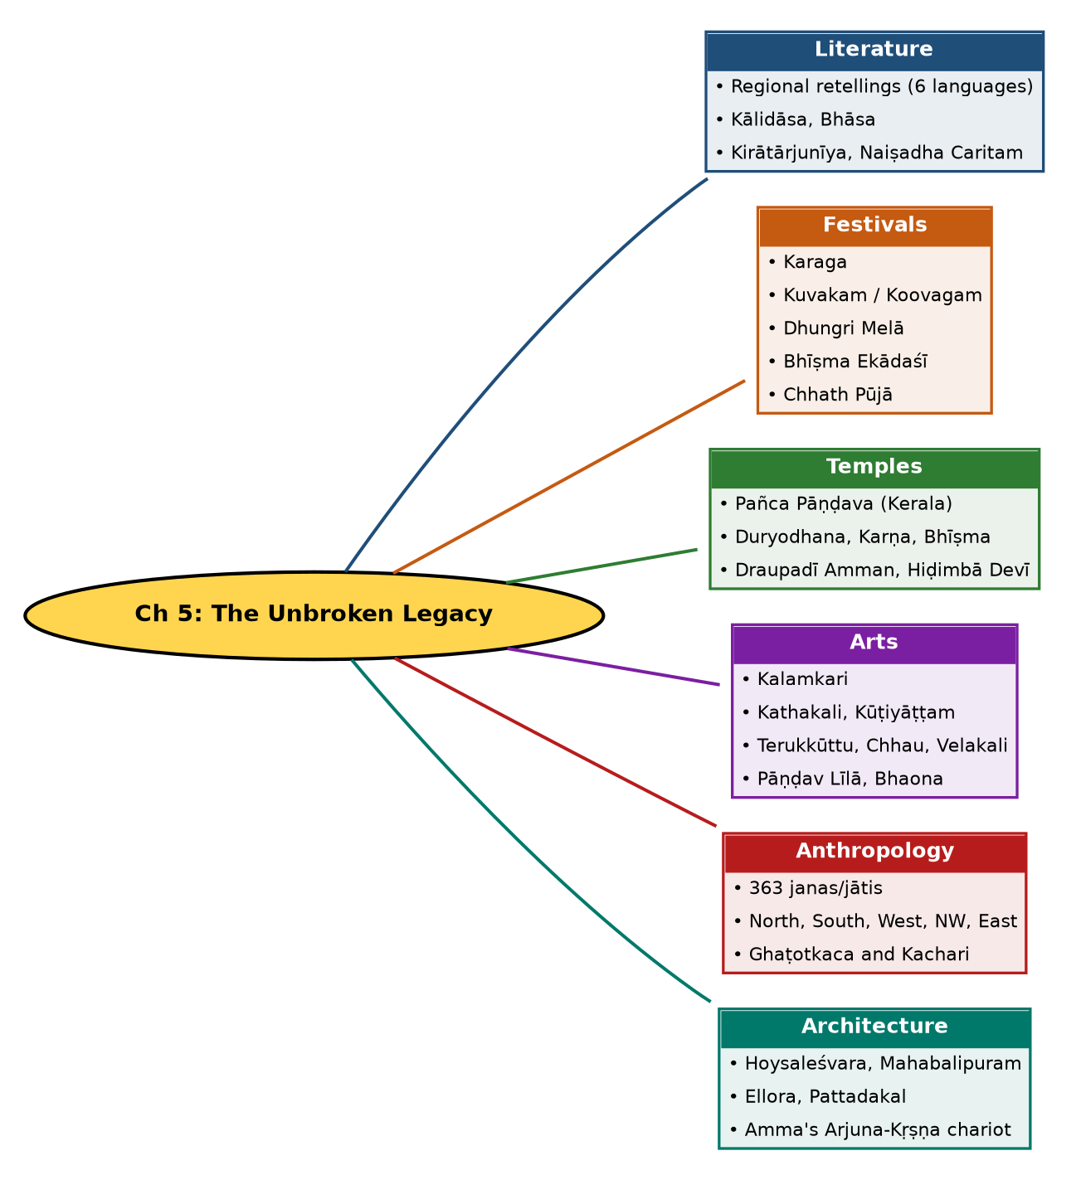

Tree view (text version for quick revision)
Ch 5: The Unbroken Legacy
- Literature
  - Regional retellings (6 languages)
  - Kālidāsa, Bhāsa
  - Kirātārjunīya, Naiṣadha Caritam
- Festivals
  - Karaga
  - Kuvakam / Koovagam
  - Dhungri Melā
  - Bhīṣma Ekādaśī
  - Chhath Pūjā
- Temples
  - Pañca Pāṇḍava (Kerala)
  - Duryodhana, Karṇa, Bhīṣma
  - Draupadī Amman, Hiḍimbā Devī
- Arts
  - Kalamkari
  - Kathakali, Kūṭiyāṭṭam
  - Terukkūttu, Chhau, Velakali
  - Pāṇḍav Līlā, Bhaona
- Anthropology
  - 363 janas/jātis
  - North, South, West, NW, East
  - Ghaṭotkaca and Kachari
- Architecture
  - Hoysaleśvara, Mahabalipuram
  - Ellora, Pattadakal
  - Amma's Arjuna-Kṛṣṇa chariot

10. Quick Revision: Memory Aids
- L-F-T-A-A-A = Literature, Festivals, Temples, Arts, Anthropology, Architecture: the six areas of legacy.
- Karaga = Kar-Ag-a: Draupadī's descendants (Tigalas), Bengaluru, 11 days.
- Chhath = Chhath for Sun; Bhīṣma Ekādaśī = Māgha; Karaga = Caitra.
- Order of Pañca Pāṇḍava temples follows birth order: Yudhiṣṭhira, Bhīma, Arjuna, Nakula, Sahadeva.
- Bhāravi (6th) before Śrīharṣa (12th); Bhāsa before Kālidāsa.
- 363 janas. Remember '3-6-3'.
- Kuvakam: Iravān + Mohinī (Kṛṣṇa).

11. Exam Practice: Questions and Model Answers
Q1. How have regional retellings kept Mahābhārata alive? Name six.
Ans: They make the story familiar to all. Examples: Malayalam (Thuñcattu Ezhuthachan, Cherusseri, Niraṇam Śaṅkara Paṇikkar), Tamil (Peruntevanār, Villiputtūrār), Odia (Sarala Dās), Bengali (Kabi Sañjay), Hindi (Sabal Singh Chauhan), Assamese (Rāma Sarasvatī).
Q2. Which Sanskrit works are based on Mahābhārata?
Ans: Kālidāsa's Abhijñānaśākuntalam, Bhāsa's seven plays, Bhāravi's Kirātārjunīya (6th c. CE), Śrīharṣa's Naiṣadha Caritam (12th c. CE); three of the Pañcamahākāvyas are rooted in it.
Q3. Explain the story behind Kirātārjunīya.
Ans: In Vana Parva Arjuna worships Śiva for the Pāśupatāstra; Śiva appears as a Kirāta to test him and, pleased, gives it. Bhāravi wrote the Mahākāvya on this.
Q4. Describe the Karaga festival.
Ans: Celebrated in Karnataka in Caitra by the Tigala community, who consider themselves Draupadī's descendants; centred on the Dharmarāya Swāmi Temple, Bengaluru; eleven days celebrating nature and water including Gaṅgā Pūjā.
Q5. What is the Kuvakam festival?
Ans: In Tamil Nadu at the Kattāntavar Temple, Villupuram. Arjuna's son Iravān wished to marry before sacrificing himself; Kṛṣṇa as Mohinī married him; next day he sacrificed his life and Mohinī mourned as a widow.
Q6. Why is Manali's Hiḍimbā Devī temple notable?
Ans: It is perhaps the only place where the Rākṣasī Hiḍimbā, Bhīma's wife, is worshipped as a goddess; the sanctum is a cave with footprints; Dhungri Melā marks her birthday.
Q7. List the Pañca Pāṇḍava temples of Kerala.
Ans: Tṛcchittāṭ (Yudhiṣṭhira), Tṛppuliyūr (Bhīma), Aranmula Pārthasārathi (Arjuna), Thiruvanvandoor (Nakula), Tṛkoḍitthānam (Sahadeva).
Q8. Name five performing arts inspired by Mahābhārata with a feature each.
Ans: Kathakali (gestures and expressions), Kūṭiyāṭṭam (temple theatre), Chākyār Kūthu (satire), Chhau (male dance with mohuri and shehnai), Velakali (martial dance with sword and shield); also Terukkūttu, Bhaona, Pāṇḍav Līlā.
Q9. What does 'Kalpavṛkṣa' signify for Mahābhārata?
Ans: It is a wish-fulfilling tree that supplies endless stories and sub-stories to artists and writers; MB itself calls Itihāsa a livelihood for them.
Q10. What anthropological information does Mahābhārata contain?
Ans: Names of 363 janas/jātis across regions: north, south, west, northwest and east; it also links Ghaṭotkaca with the Kachari kingdom of Assam, and some tribals worship the Pāṇḍavas and Draupadī.
Q11. How is MB reflected in temple architecture?
Ans: Carvings at Hoysaleśvara, Mahabalipuram (Arjuna's Penance), Deogarh, Ellora, Pattadakal, Somnathpur etc. Wall visuals bridged scripture and the masses.
Q12. What does Amma's sculpture at Amṛtapurī symbolise?
Ans: Arjuna on Kṛṣṇa's chariot in charging mode: the rejuvenated Arjuna who fights to re-establish Dharma, and an appeal to do the same.

Self-test: one-line recall
- Kalamkari centres = ? Srikalahasti and Machilipatnam.
- Sūrya festival in Bihar = ? Chhath Pūjā.
- Kuvakam hero = ? Iravān (Aravan).
- Number of janas = ? 363.

