CHAPTER 6
A Timeless Itihāsa for Timely Needs
Strategic Lessons from Mahābhārata | Exam-Ready Revision Notes | Book pages 69 to 80
Chapter at a glance
- Core idea: Study the core of Mahābhārata by diving deep, not by dipping a tail at the periphery; once you dive, it offers timely answers on untouchability, womanhood, good versus evil and unity in diversity, while remaining a Mokṣa Śāstra.
- Itihāsa = organic body of literature with a historical core and a spiritual nucleus, not just an 'epic'.
- Periphery vs core: Shakespeare scholar vs scholar of Shakespeare's ink; fox that 'measured' the ocean.
- Gītā 16.18: five traits (ahaṅkāra, bala, darpa, kāma, krodha) cause hatred; untouchability is a disease of the mind.
- Gītā 10.34: six feminine qualities (kīrti, śrī, vāk, smṛti, medhā, dhṛti, kṣamā).
- Gītā 13.31: unity in diversity; Mahābhārata is ultimately a Mokṣa Śāstra.

1. Complete Summary
Mahābhārata is called a national epic of India, but an Itihāsa differs from an epic: it is a huge, organic body of literature with a historical core and a spiritual nucleus. For about two hundred years it has been studied through a westernised academic framework, so the essence has been lost: people wander in the periphery and take it for the core. The book compares a scholar of Shakespeare, who internalises his value system, with someone who studies the chemical nature of Shakespeare's ink. Both study Shakespeare, but only one is entitled to speak on his values. Likewise, Indian epics were studied by periphery scholars who judged as if they were core scholars, while the long line of Indian scholars, sages and seers who lived the core was ignored, and flimsy frameworks (subaltern, ethnological and so on) were accepted.
The fable of the fox illustrates the problem. A fox wanted to measure the ocean's depth, got frightened by the waves, dipped only its tail at the shore, touched the ground and announced that the ocean was three-fourths of its tail's length. Scholars who apply Freudian, subaltern or postmodern frameworks to Mahābhārata are in the same position. They are also like students before a great sculpture who scribble their name on it. Using one framework (say, environmentalism) is not wrong, but insisting it is the only one is. We should dive deep and pick pearls. Mahābhārata is timeless and Sanātana, and gives answers to the timely, pressing problems of the day.
Untouchability is a disease of the mind. Gītā 16.18 names five asuric traits: ahaṅkāra (egoism), bala (power without moral value, for its own sake), darpa (showing off that power), kāma (lust for resources and control of others) and krodha (anger). They reinforce each other, and the person with them hates the Ātman in his own body and in others. So whoever treats another as untouchable harms his own realisation of the Ātman. Applied to a village conflict between the weak and dominant, anyone who exploits or uses violence, whatever his community, will show all five. The Gītā does not exist to provide this framework, but it can.
For an Indic view of woman, Gītā 10.34 lists divine emanations seen as feminine qualities: kīrti (fame: in patriarchal societies a woman is thought to stand in her husband's shadow, but Kṛṣṇa lists fame as her quality), śrī (auspicious wealth: like shopkeepers who write 'Śubh-Lābh', with Śubham, collective good, before Lābham, profit), vāk (truthful speech, sweet and harmless, benefiting all; Tiruvalluvar: speak so that no other word can counter it), smṛti (memory), medhā (insightful genius: example of Jane Goodall, who saw chimpanzees as personalities and used 'he/she', and who gave the Gandhi King Award to Amma), dhṛti (steadfastness: Sāvitrī stood by her decision and won Satyavān back from Yama, whereas Ruru gave half his life to Yama for Priyamvadā; Sri Aurobindo wrote a long poem on Ruru-Priyamvadā but a full epic on Savitri), and kṣamā (forgiveness: humanity survives through motherly patience despite wars and nuclear weapons).
Mahābhārata is not a property dispute between two clans; it is a fight between good and evil. An adharmic period may give a semblance of order, but remains adharmic, and a dharmic period usually follows conflict. On pluralism: most cultures manage diversity by subjugating it to a majority or monoculture. India has no majoritarian culture but one grand cultural matrix with many strands, and it resists any strand trying to dominate, because of theo-diversity and resistance to monocultural expansionism. Gītā 13.31 says one who sees the One become the many and the many rest in the One realises Brahman. This unity in diversity is the civilisational cornerstone. The book links it to Schrödinger's 'What is Life?', which looked for a mechanism that keeps itself while producing diversity and led toward DNA; a scientist or even a carpenter who grasps this Gītā insight can do better work.
Finally, Mahābhārata is a timely and timeless sacred text aimed at Mokṣa, a Mokṣa Śāstra. If we concentrate only on social, political or ethnological aspects, we are discussing the chemical composition of Shakespeare's ink and not the play. We must immerse ourselves in it and let it fill us with its fundamental values.

2. Section-wise Detailed Notes

A. Itihāsa versus 'epic': core and periphery
- Itihāsa = organic body of literature, historical core (sanctum), spiritual nucleus.
- Westernised academic framework (last ~200 years) made us lose the essence.
- Shakespeare analogy: scholar of the bard (core) vs scholar of his ink (periphery).
- Periphery scholars were treated as authorities; Indian sages/scholars who lived the core were ignored.
- Flimsy frameworks: subaltern, ethnological, etc.

B. The fox and the ocean
- Fox measured the ocean by dipping its tail at the shore: 'depth = three-fourths of my tail'.
- Scholars using Freudian, subaltern, postmodern frameworks do the same.
- Also like students who scribble their names on a great sculpture.
- A single lens (e.g. environmentalist) is fine; insisting it is the only lens is wrong.
- Remedy: dive deep and pick pearls.

C. Untouchability: Gītā 16.18
- Untouchability = disease of the mind.
- Five traits: ahaṅkāra (egoism), bala (power for power's sake), darpa (flaunting), kāma (lust for resources/control), krodha (anger).
- They reinforce each other; the person hates the Ātman in self and others.
- Hating another = harming oneself; blocks Ātma realisation.
- Applies to any exploiter or abuser, whatever his community.

D. Feminine qualities: Gītā 10.34
- Kīrti (fame): women also have fame in their own right.
- Śrī (auspicious wealth): Śubh before Lābh, collective good before profit.
- Vāk (truthful, sweet, harmless speech); Tiruvalluvar.
- Smṛti (memory).
- Medhā (insightful genius): Jane Goodall, chimpanzees as 'he/she'; she presented the Gandhi King Award to Amma.
- Dhṛti (steadfastness): Sāvitrī vs Ruru-Priyamvadā; Aurobindo's *Savitri*.
- Kṣamā (forgiveness): humanity survives due to motherly patience.

E. Good vs evil, and pluralism
- MB is not a property dispute; it is good vs evil.
- Adharmic rule gives a semblance of order; the dharmic period follows conflict.
- India: no majoritarian culture; one cultural matrix with many strands; resists monocultural expansionism.
- Gītā 13.31: One becomes many, many rest in One: unity in diversity.
- Schrödinger's *What is Life?* → path to DNA; unity-in-diversity as a science principle.
- Scientist or carpenter applying Gītā principles does better work.

F. Closing: Mokṣa Śāstra
- MB is timely and timeless; aims at Mokṣa.
- Only social/ethnological study = analysing Shakespeare's ink, not the play.
- Immerse and let it fill you with its fundamental values.

3. Key Terms and Keywords
Term | Meaning / Why it matters
Itihāsa (here) | Organic literature with a historical core and spiritual nucleus; not merely an epic.
Periphery vs core | Surface-level (external/academic frameworks) vs the essence (value system, spiritual message).
Sanātana | Eternal; Mahābhārata is timeless and gives solutions to timely needs.
Ahaṅkāra | Egoism.
Bala | Power without moral value; power for its own sake.
Darpa | Flaunting or showing off power.
Kāma (Gītā 16.18) | Lust for resources and control of others.
Krodha | Anger/hatred towards others.
Kīrti, Śrī, Vāk, Smṛti, Medhā, Dhṛti, Kṣamā | Fame, auspicious wealth, truthful speech, memory, insightful genius, steadfastness, forgiveness: qualities Kṛṣṇa calls feminine.
Śubh-Lābh | 'Auspiciousness-Profit': collective good comes before profit.
Unity in diversity | The One appearing as many (Gītā 13.31), the civilisational cornerstone of India.
Mokṣa Śāstra | A scripture whose ultimate aim is liberation.

4. Numbers, Facts and Figures
Fact | Detail
Academic framework influence | About the last 200 years
Fox's claim | Ocean depth = three-fourths of its tail
Traits in Gītā 16.18 | 5 (ahaṅkāra, bala, darpa, kāma, krodha)
Feminine qualities in Gītā 10.34 | 7 named: kīrti, śrī, vāk, smṛti, medhā, dhṛti, kṣamā
Gītā verse references | 16.18, 10.34, 13.31
Ruru gave Yama | Half of his own life for Priyamvadā

5. People, Places and Texts
Name | Role / Significance in this chapter
Shakespeare (analogy) | Used to separate core scholars from periphery scholars.
Jane Goodall | Primatologist; saw chimpanzees as personalities; example of medhā; gave Gandhi King Award to Amma.
Tiruvalluvar | Quoted to define vāk.
Sāvitrī and Satyavān | Dhṛti example; she won him back from Yama.
Ruru and Priyamvadā | Ruru gave half his life to Yama to revive Priyamvadā.
Sri Aurobindo | Wrote a poem on Ruru-Priyamvadā and an epic on Savitri.
Schrödinger | Author of 'What is Life?' cited for unity in diversity.
Amma | Honoured with the Gandhi King Award.

6. Ślokas, Sayings and Sources
Śloka / Source | Meaning and use
ahaṅkāraṃ balaṃ darpaṃ kāmaṃ krodhaṃ ca saṃśritāḥ; mām ātma-para-deheṣu pradviṣanto 'bhyasūyakāḥ (Gītā 16.18) | Those clinging to ego, power, pride, lust and anger hate the Ātman in themselves and others; a framework to understand untouchability and exploitation.
kīrtiḥ śrīr vāk ca nārīṇāṃ smṛtir medhā dhṛtiḥ kṣamā (Gītā 10.34) | Seven divine qualities that Kṛṣṇa identifies as feminine.
yadā bhūta-pṛthag-bhāvam eka-sthām anupaśyati; tata eva ca vistāraṃ brahma saṃpadyate tadā (Gītā 13.31) | One who sees the many resting in the One, and the One spreading as many, realises Brahman: unity in diversity.

7. Comparisons and Frameworks

Periphery vs core scholar
 | Core scholar | Periphery scholar
Shakespeare analogy | Studies plays, internalises values | Studies chemistry of the ink
In India | Sages, seers and scholars who lived the Itihāsa | Academics using subaltern/Freudian/postmodern/ethnological lenses
Result | Authority on values | Stands on the shore; 'measures' ocean with a tail

Seven feminine qualities (Gītā 10.34)
Quality | Meaning in the lecture
Kīrti | Fame, not only reflected from husband or father
Śrī | Auspicious wealth; Śubh before Lābh
Vāk | True, sweet, harmless, beneficial speech
Smṛti | Memory
Medhā | Insightful genius (Jane Goodall)
Dhṛti | Steadfastness (Sāvitrī)
Kṣamā | Forgiveness, motherly patience

8. Mind Map
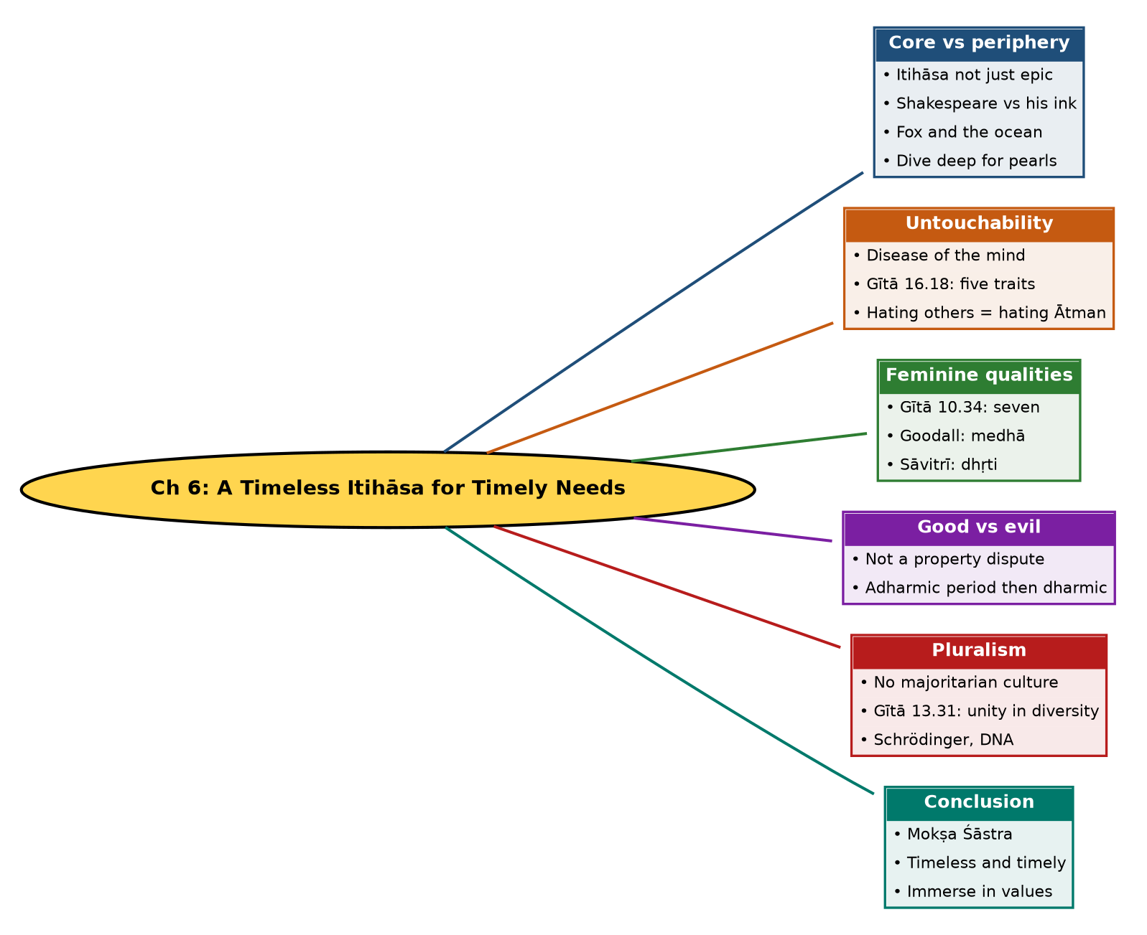

Tree view (text version for quick revision)
Ch 6: A Timeless Itihāsa for Timely Needs
- Core vs periphery
  - Itihāsa not just epic
  - Shakespeare vs his ink
  - Fox and the ocean
  - Dive deep for pearls
- Untouchability
  - Disease of the mind
  - Gītā 16.18: five traits
  - Hating others = hating Ātman
- Feminine qualities
  - Gītā 10.34: seven
  - Goodall: medhā
  - Sāvitrī: dhṛti
- Good vs evil
  - Not a property dispute
  - Adharmic period then dharmic
- Pluralism
  - No majoritarian culture
  - Gītā 13.31: unity in diversity
  - Schrödinger, DNA
- Conclusion
  - Mokṣa Śāstra
  - Timeless and timely
  - Immerse in values

10. Quick Revision: Memory Aids
- A-B-D-K-K for Gītā 16.18: Ahaṅkāra, Bala, Darpa, Kāma, Krodha.
- K-S-V-S-M-D-K for Gītā 10.34: Kīrti, Śrī, Vāk, Smṛti, Medhā, Dhṛti, Kṣamā.
- Fox = 3/4 of tail; Shakespeare = ink: periphery images.
- Śubh before Lābh (good before profit).
- Ruru gave half his life; Sāvitrī fought Yama: contrast of two women/men stories.
- Verse numbers: 16.18 (hatred), 10.34 (feminine), 13.31 (unity in diversity).

11. Exam Practice: Questions and Model Answers
Q1. What is the difference between core and periphery scholars of Mahābhārata?
Ans: Core scholars internalise the value system and spiritual message, like a scholar of Shakespeare; periphery scholars study external aspects, like the chemistry of Shakespeare's ink, and should not be treated as authorities on its values.
Q2. Explain the fable of the fox and the ocean and its relevance.
Ans: The fox dipped its tail at the shore and declared the ocean's depth to be three-fourths of its tail. Scholars applying narrow frameworks (Freudian, subaltern, postmodern) to Mahābhārata similarly stand at the periphery and claim to know the depth.
Q3. How should one study Mahābhārata, according to this chapter?
Ans: By diving deep to pick pearls: using frameworks without insisting they are the only one, and immersing in its fundamental values as a Mokṣa Śāstra.
Q4. Why is untouchability called a disease of the mind?
Ans: It arises from ego, power, flaunting, lust and anger (Gītā 16.18), which produce hatred of others and, ultimately, of the Ātman in oneself.
Q5. List the five traits in Gītā 16.18 with meanings.
Ans: Ahaṅkāra (egoism), bala (power for power's sake), darpa (flaunting power), kāma (lust for resources and control), krodha (anger/hatred).
Q6. What are the qualities of women in Gītā 10.34? Explain any three.
Ans: Kīrti, śrī, vāk, smṛti, medhā, dhṛti, kṣamā. E.g., śrī is auspicious wealth where Śubham precedes Lābham; vāk is truthful, sweet, harmless speech; dhṛti is steadfastness as in Sāvitrī.
Q7. How does the lecture explain medhā with Jane Goodall?
Ans: She saw chimpanzees making tools and treated them as individuals, using 'he' and 'she' against scientific convention; this insight is described as feminine insightful genius.
Q8. Contrast Ruru-Priyamvadā and Sāvitrī-Satyavān.
Ans: Ruru got Priyamvadā back by giving half his life to Yama; Sāvitrī stood steadfast, followed Yama and won Satyavān back. Sri Aurobindo wrote a poem on the first and an epic on the second.
Q9. What is the book's view on the war's nature?
Ans: It is a fight between good and evil, not a property dispute. Adharmic rule may seem orderly but is still adharmic; a dharmic period follows conflict.
Q10. How does the chapter explain India's approach to diversity (Gītā 13.31)?
Ans: India has no majoritarian monoculture but one cultural matrix of many strands, resisting domination by any one strand. Gītā 13.31 expresses unity in diversity: seeing the One in the many and the many in the One.
Q11. Why does the chapter mention Schrödinger?
Ans: His 'What is Life?' sought a process that persists as unity while producing diversity, leading toward the discovery of DNA; the Gītā states this principle clearly, and scientists or carpenters who grasp it can work better.
Q12. Why is Mahābhārata a Mokṣa Śāstra?
Ans: Its ultimate aim is liberation; focusing only on social or ethnological aspects ignores its main purpose, like studying ink and not the play.

Self-test: one-line recall
- Itihāsa core = ? Historical core and spiritual nucleus.
- Gītā verse on feminine qualities = ? 10.34.
- Verse on unity in diversity = ? 13.31.
- Śubh-Lābh means? Good before profit.

