CHAPTER 8
Karṇa: The Maestro Who Went Wide of the Mark
Strategic Lessons from Mahābhārata | Exam-Ready Revision Notes | Book pages 97 to 105
Chapter at a glance
- Core idea: Karṇa had skill and strength but let jealousy of Arjuna, loyalty to adharma and refusal to forgive decide his course; the chapter corrects popular sympathetic readings of his friendship with Duryodhana and of his death.
- Born to Kuntī (Pṛthā) and Sūrya via Durvāsā's mantra; raised by Adhiratha and Rādhā; names: Vasusena, Karṇa, Rādheya, Vaikartana.
- His life was a perpetual attempt to outshine Arjuna: jealousy and inferiority complex.
- Friendship with Duryodhana was mutual benefit, not pure loyalty; he fled several times and planned evil acts (Draupadī's disrobing, Abhimanyu's killing).
- Kṛṣṇa offered him a chance to join Dharma; he refused.
- His death was the result of his own karma: Brāhmaṇa's curse, Paraśurāma's curse, wheel stuck; he sought Dharma he had denied others.

1. Complete Summary
Karṇa is one of the most debated characters, with different versions that make an overall understanding vague. Works such as Bhāsa's Karṇabhāra and Śivaji Sawant's Mṛtyuñjaya make him the main character. Sympathisers claim he was superior to Arjuna because Arjuna failed to resist the Nāgāstra on the seventeenth day (Kṛṣṇa saved him). The book answers that even the mightiest warrior has moments of failure; many warriors (Bhagadatta, for instance, killed by Bhīma, Sātyaki and others) also had such moments, and Karṇa himself fled in the incident with the Gandharva Citrasena. So he cannot be called superior on that basis.
Birth: King Śūrasena of the Vṛṣṇi dynasty had a daughter Pṛthā (Kuntī). She served the sage Durvāsā so well during his long stay that he gave her a mantra to invoke any deity for a child. Curious, she invoked Sūrya next morning; he came with golden glow and a breastplate and gave a son. Worried about an unwed birth, she set the baby afloat in a basket on the Aśvanadī, which reached the Carmaṇvatī, then the Gaṅgā, and the kingdom of Aṅga, where Rādhā, wife of the charioteer Adhiratha, found him. They named him Vasusena. He also got the names Karṇa, Rādheya and Vaikartana. In the twelfth year of the Pāṇḍavas' exile, Indra came to Vasusena to ask for the kavaca-kuṇḍala (armour and earrings born with him); he cut them off, hence Karṇa and Vaikartana (from karṇa and kṛti, 'cutting').
Karṇa's life was invested in vexation: a perpetual attempt to outshine and defeat Arjuna, blinded by jealousy and inferiority. He sought auspicious weapons and rare skills. The story that Droṇa 'refused him as a student' is misconstrued; Droṇa refused only the Brahmāstra because it had been given to Arjuna and Aśvatthāmā. Karṇa went to Paraśurāma (Droṇa's guru), disguised as a Brāhmaṇa since Paraśurāma had vowed not to teach Kṣatriyas. He deceived him at first; Paraśurāma discovered the truth and cursed that Karṇa would be unable to use the knowledge to save himself in war. At the tournament in Hastināpura, he came uninvited, surpassed Arjuna's displays and wanted to provoke a duel, a tendency that remained. Only Duryodhana was impressed and crowned him King of Aṅga, sealing the alliance against the Pāṇḍavas.
Karṇa and Duryodhana: the bond brought out viciousness in each. Karṇa was indebted for being raised from a charioteer's son to king, but the friendship served individual goals. He told Kṛṣṇa that it was his own will to destroy Arjuna and keep his power, not moral obligation, that kept him with the Kauravas (he had enjoyed sovereignty for thirteen years 'without a thorn', and was chosen as Arjuna's great antagonist). He drew up the roadmap for every crime against the Pāṇḍavas, including the murder attempt, was responsible for the course of events at the dice game, instructed Duḥśāsana to disrobe Draupadī, and in the war proposed that Abhimanyu be attacked together inside the Cakravyūha. He also betrayed Duryodhana: when Gandharva Citrasena attacked, Karṇa fled and Yudhiṣṭhira rescued Duryodhana; in Virāṭa Parva, after vowing over his sword to kill Arjuna, he was defeated by Arjuna (as Bṛhannalā) and deserted the battle again, and Duryodhana, humiliated, decided to end his life on darbha grass. Duryodhana could handle Bhīma but needed an archer against Arjuna, so Karṇa was useful. Praise for his commitment to friendship is thus unsubstantial.
Death: dharma or adharma? Popular accounts present him as a tragic hero killed while unarmed. The chapter says it was the result of his evil karma. Kṛṣṇa, seeing Dharma failing in his actions, approached him: 'You are Kuntī's eldest son, you should fight on the side of Dharma, do not stick with the side for the benefits you get... Please come.' Karṇa refused, so Kṛṣṇa felt no remorse. Earlier Karṇa killed a Brāhmaṇa's calf for eating flowers, and the Brāhmaṇa cursed that his chariot wheels would sink in soil in a crucial battle. In the war the wheel stuck in the sand and he appealed to Arjuna for Dharma, the same Karṇa who had denied Dharma to Draupadī and to Abhimanyu. Kṛṣṇa reminded him he could not seek Dharma's protection, which also reminded Arjuna of his past adharma; Arjuna killed him. Amma: Dharma is the root principle of life; conscience should be like a balanced needle on the scale.
Conclusion: lack of rational thinking led to adharma; refusing to forgive or compromise caused his downfall. His attitude to elders (Droṇa, Bhīṣma, Śalya) shows that might bears fruit only with elders' blessings and God's grace. He felt betrayed by mother, teacher and society, failed to use his hard-won knowledge at the right moment, and could not control envy and hatred of Arjuna; he worked to surpass someone else, not to improve himself for his own happiness. He embodies a mix of right and wrong; as Hiltebeitel notes, he inspires admiration, affection and a wish that things had gone otherwise, expressed by Kuntī and Yudhiṣṭhira.

2. Section-wise Detailed Notes

A. Debates on Karṇa
- Versions vary: Bhāsa's Karṇabhāra, Mṛtyuñjaya (Śivaji Sawant).
- Claim of superiority over Arjuna: Nāgāstra on day 17 (Kṛṣṇa saved Arjuna). Answer: even the mightiest fail at times; Karṇa fled (e.g. from Citrasena).

B. Birth and names
- Śūrasena's daughter Pṛthā/Kuntī; Durvāsā's mantra; invoked Sūrya; baby set afloat.
- River route: Aśvanadī → Carmaṇvatī → Gaṅgā → Aṅga; found by Rādhā, wife of charioteer Adhiratha.
- Names: Vasusena, Karṇa, Rādheya, Vaikartana.
- Indra took kavaca-kuṇḍala in the Pāṇḍavas' 12th year of exile; karṇa + kṛti = cutting.

C. Life of vexation (Arjuna-obsession)
- Jealousy and inferiority complex.
- Droṇa refused only the Brahmāstra (already given to Arjuna and Aśvatthāmā).
- Paraśurāma: Karṇa posed as Brāhmaṇa; cursed he could not use the knowledge to save himself in war.
- Tournament: uninvited, surpassed Arjuna, sought a duel; Duryodhana made him King of Aṅga.

D. Karṇa and Duryodhana
- Friendship = mutual benefit; Karṇa told Kṛṣṇa it was his own will to destroy Arjuna.
- Karṇa's role in crimes: murder attempt (wax palace), dice game, Draupadī's disrobing, killing of Abhimanyu in Cakravyūha.
- Betrayals: fled from Citrasena (Yudhiṣṭhira rescued Duryodhana); Virāṭa Parva: defeated by Arjuna as Bṛhannalā, deserted; Duryodhana planned to end life on darbha.
- Duryodhana needed an archer against Arjuna.

E. Death of Karṇa
- Myth of an unarmed tragic hero; book: result of his own karma.
- Kṛṣṇa's appeal: 'You are Kuntī's eldest son... come'; Karṇa refused.
- Brāhmaṇa's curse (calf killed): chariot wheel sinks; wheel stuck in sand.
- Asked Arjuna for Dharma; Kṛṣṇa: you denied Dharma to Draupadī and Abhimanyu.
- Amma: Dharma is the root principle; conscience like a balanced needle.

F. Conclusion
- No rational thinking; unwilling to forgive or compromise.
- Needs elders' blessings and God's grace; disrespected Droṇa, Bhīṣma, Śalya.
- Felt betrayed by mother, teacher, society; envy and hatred of Arjuna.
- Worked to surpass others, not to improve himself.
- Still appealing for his inherent goodness (Hiltebeitel).

3. Key Terms and Keywords
Term | Meaning / Why it matters
Kavaca-kuṇḍala | Natural armour and earrings Karṇa was born with; given to Indra.
Vaikartana / Karṇa | Names from cutting off (karṇa, kṛti) the armour and earrings.
Rādheya | Son of Rādhā, his foster mother.
Brahmāstra | Great weapon given to Arjuna and Aśvatthāmā by Droṇa.
Nāgāstra | Serpent weapon Karṇa used on day 17.
Aṅga | Kingdom (ancient Bengal) over which Duryodhana crowned Karṇa.
Ajñātavāsa | Year of living incognito, spent at Virāṭa's court.
Bṛhannalā | Arjuna's disguise during the incognito year.
Darbha | Sacred grass; Duryodhana sat on it to end his life.
Karma (his death) | Consequence of his own actions, curses and refusal of Kṛṣṇa's offer.
Tragic hero | Popular framing the chapter disputes.

4. Numbers, Facts and Figures
Fact | Detail
Day of Nāgāstra incident | 17th day of the war
Years of sovereignty Karṇa mentions | 13
Names of Karṇa | 4: Vasusena, Karṇa, Rādheya, Vaikartana
Rivers on the basket's route | Aśvanadī, Carmaṇvatī, Gaṅgā
Persons whose blessings Karṇa lacked | Droṇa, Bhīṣma, Śalya (elders)
Pāṇḍava exile year of Indra's visit | 12th year
Karṇa's father | Sūrya Deva

5. People, Places and Texts
Name | Role / Significance in this chapter
Kuntī (Pṛthā) | Karṇa's birth mother; daughter of Śūrasena.
Sūrya | Karṇa's divine father.
Durvāsā | Sage who gave the mantra.
Adhiratha and Rādhā | Charioteer couple who raised him.
Paraśurāma, Droṇa | Teachers: Paraśurāma cursed him; Droṇa refused only the Brahmāstra.
Duryodhana | Crowned him King of Aṅga; mutual-benefit friend.
Citrasena (Gandharva) | Attacked the Kauravas; Karṇa fled.
Kṛṣṇa | Offered him a chance to join Dharma.
Hiltebeitel | Scholar quoted in the conclusion.

6. Ślokas, Sayings and Sources
Śloka / Source | Meaning and use
Karṇa to Kṛṣṇa (Ganguli): '...I have enjoyed sovereignty for thirteen years without a thorn... chosen as the great antagonist of Arjuna...' | Shows motive: power and rivalry, not duty.
Kṛṣṇa to Karṇa: 'You are the eldest son of Kuntī... Dharma should become victorious... Please come.' | Offer of a chance to change fate.
Amma: 'Dharma is the root principle of Life... conscience like a well-balanced needle on the measuring scale.' | Karṇa lacked this balance.

7. Comparisons and Frameworks

Popular view vs the chapter's view
Claim | Chapter's response
Karṇa was superior to Arjuna (Nāgāstra, day 17) | Every warrior has failures; Karṇa himself fled from Citrasena and Arjuna (as Bṛhannalā)
Droṇa refused him out of bias | Droṇa refused only the Brahmāstra, already given to Arjuna and Aśvatthāmā
Karṇa was a loyal friend | Friendship was mutual benefit; he deserted Duryodhana twice
Karṇa was killed unarmed, a tragic hero | Death was the result of his own karma, curses and refusal of Kṛṣṇa's offer

Curses that shaped Karṇa's end
Curse by | Reason | Effect
Paraśurāma | Karṇa deceived him by posing as a Brāhmaṇa | Could not use acquired knowledge to save himself in war
A Brāhmaṇa | Karṇa killed his calf for eating flowers | Chariot wheel would sink in soil in a crucial battle

8. Mind Map
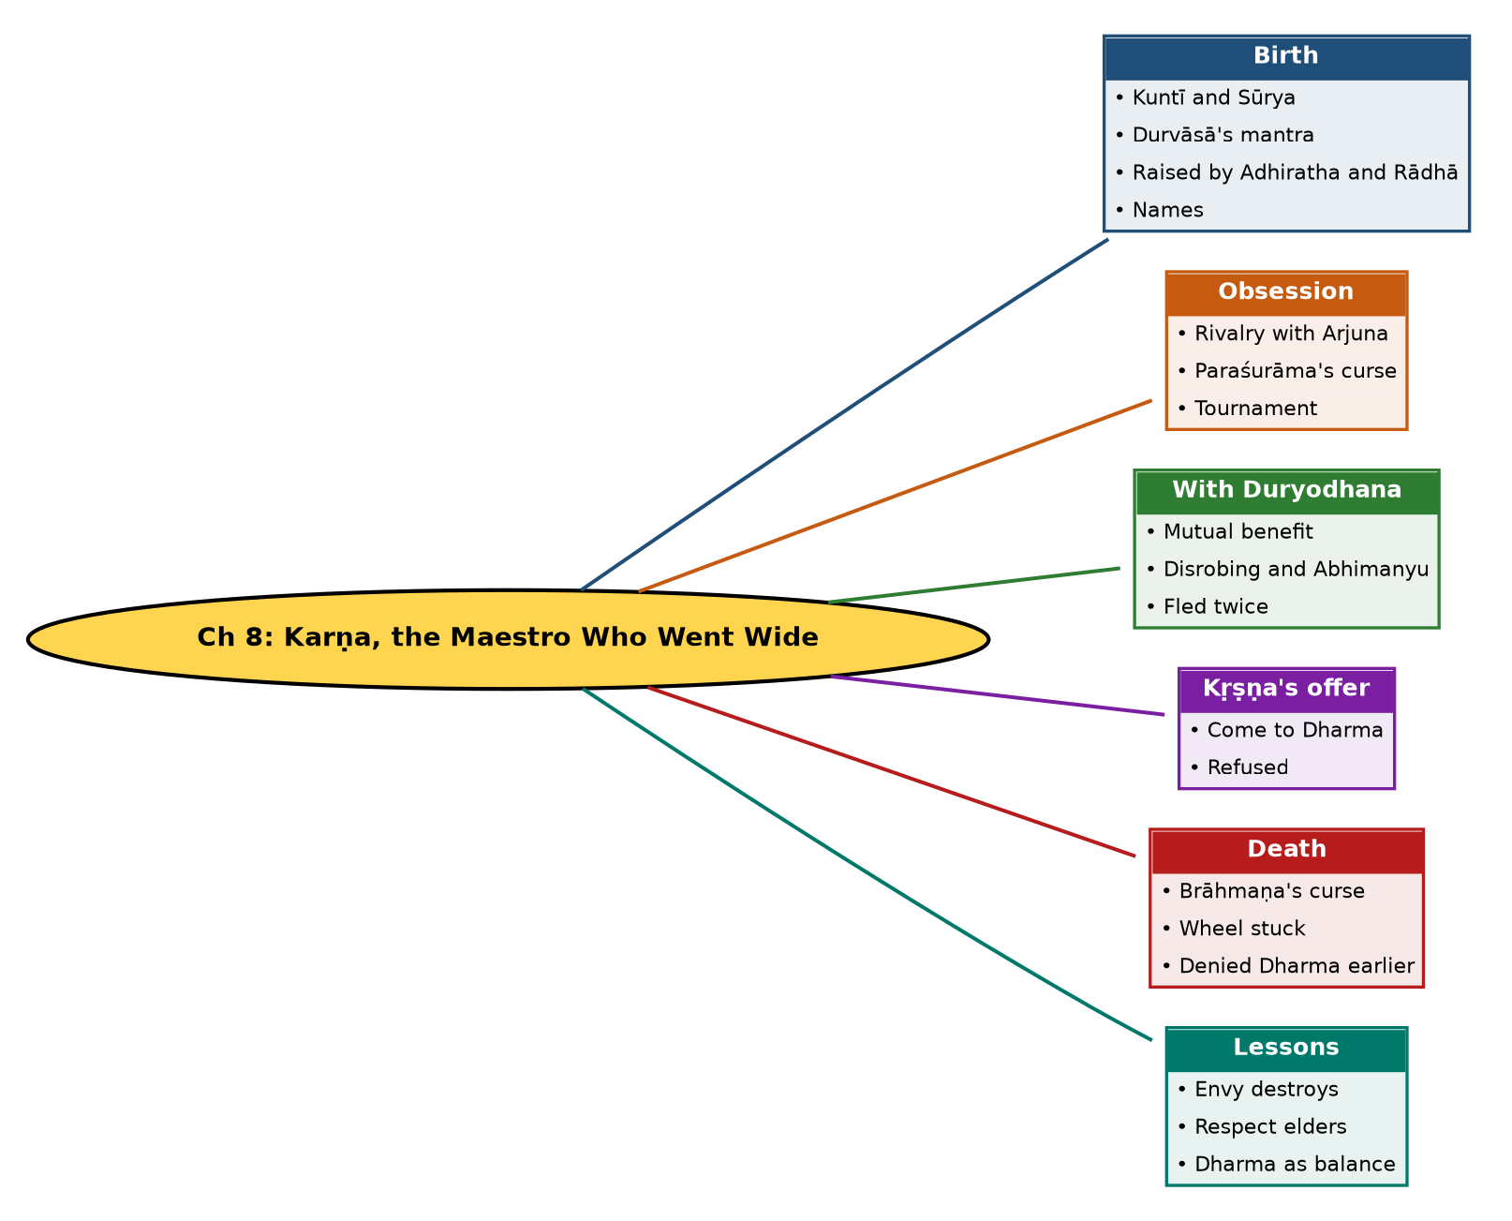

Tree view (text version for quick revision)
Ch 8: Karṇa, the Maestro Who Went Wide
- Birth
  - Kuntī and Sūrya
  - Durvāsā's mantra
  - Raised by Adhiratha and Rādhā
  - Names
- Obsession
  - Rivalry with Arjuna
  - Paraśurāma's curse
  - Tournament
- With Duryodhana
  - Mutual benefit
  - Disrobing and Abhimanyu
  - Fled twice
- Kṛṣṇa's offer
  - Come to Dharma
  - Refused
- Death
  - Brāhmaṇa's curse
  - Wheel stuck
  - Denied Dharma earlier
- Lessons
  - Envy destroys
  - Respect elders
  - Dharma as balance

10. Quick Revision: Memory Aids
- 4 names: Vasusena, Karṇa, Rādheya, Vaikartana.
- Two curses: Paraśurāma (knowledge fails), Brāhmaṇa (wheel sinks).
- Two desertions: Citrasena and Virāṭa (Bṛhannalā).
- 3 crimes: wax-palace plot, Draupadī's disrobing, Abhimanyu's killing.
- Elders disrespected: Droṇa, Bhīṣma, Śalya.
- Hiltebeitel: admiration, affection and a wish it were otherwise.

11. Exam Practice: Questions and Model Answers
Q1. Describe Karṇa's birth and how he got his names.
Ans: Kuntī (Pṛthā) used Durvāsā's mantra to invoke Sūrya and bore Karṇa with armour and earrings; she set him afloat in a basket, and Adhiratha and Rādhā raised him as Vasusena. He was called Karṇa/Vaikartana after cutting off his kavaca-kuṇḍala for Indra, and Rādheya after Rādhā.
Q2. Why does the chapter say Karṇa's life was invested in vexation?
Ans: He was driven by jealousy and inferiority to outshine Arjuna, collecting weapons, deceiving Paraśurāma and provoking a duel at the tournament.
Q3. Was Droṇa unfair to Karṇa? Explain.
Ans: No. Droṇa refused only the Brahmāstra, which was already given to Arjuna and Aśvatthāmā.
Q4. What was Paraśurāma's curse and why?
Ans: Karṇa learned archery from him by posing as a Brāhmaṇa; Paraśurāma, learning the truth, cursed that he would be unable to use the knowledge to save himself in war.
Q5. Was Karṇa a truly loyal friend to Duryodhana?
Ans: The chapter says the friendship was for mutual benefit. Karṇa told Kṛṣṇa it was his own will to destroy Arjuna; he fled from Citrasena and from Arjuna (as Bṛhannalā), leaving Duryodhana exposed.
Q6. List the adharmic acts attributed to Karṇa.
Ans: Planning against the Pāṇḍavas including the murder attempt, instructing Duḥśāsana to disrobe Draupadī, and suggesting the combined attack on Abhimanyu in the Cakravyūha.
Q7. What chance did Kṛṣṇa give Karṇa?
Ans: He asked Karṇa, as Kuntī's eldest son, to join the side of Dharma. Karṇa refused, so Kṛṣṇa felt no remorse at his death.
Q8. How did the Brāhmaṇa's curse fulfil itself?
Ans: Karṇa killed a Brāhmaṇa's calf; the Brāhmaṇa cursed that his chariot wheel would sink in soil in a critical battle; it happened with Arjuna.
Q9. Why was Karṇa's plea for Dharma rejected?
Ans: He had denied Dharma to Draupadī and Abhimanyu, so he could not claim its protection at the end.
Q10. State the lessons from Karṇa's character.
Ans: Envy, refusal to forgive and disrespect for elders destroy even great skill; work to improve oneself, not to defeat others; keep conscience balanced like a needle, as Amma says.

Self-test: one-line recall
- Karṇa's foster father = ? Adhiratha.
- Who cut his armour for Indra? Karṇa (Vasusena).
- Who defeated Karṇa in Virāṭa? Arjuna as Bṛhannalā.
- Kingdom given by Duryodhana = ? Aṅga.

