CHAPTER 9
Kingship and Polity Acumen
Strategic Lessons from Mahābhārata | Exam-Ready Revision Notes | Book pages 109 to 119
Chapter at a glance
- Core idea: Bhīṣma's and Nārada's advice to Yudhiṣṭhira (Śānti and Sabhā Parvas) on dharma-based governance, administration, spies, taxation and justice, plus the author's argument on 'misplaced compassion' and Janaka's ideal of kingship as a path to salvation.
- Ideal republic (MB 12.59.14): no king, no punishment, people protect each other through Dharma.
- Dharma from root dhṛ = to uphold (MB 12.110.11).
- Administration: heads for 1, 10, 20, 100, 1000 villages; spies in threes, 18 tīrthas (opposing) + 15 (own).
- Economy and justice: yoga-kṣema, commensurate taxes, milk like a bee / cow with calf, no begging except in disaster.
- Misplaced compassion (author's argument) and Janaka-Brāhmaṇa saṃvāda (MB 14.32.25): governance as a medium to Brahma Pada; 'king makes Time' (MB 12.70.06).

1. Complete Summary
The chapter opens with two 2021 incidents, the 6 January US Capitol riot and the 26 January Red Fort breach during India's Republic Day tractor parade, which the book calls attitudes of adharma and disregard for law, then asks what governments can do. Since anything about the four puruṣārthas is in Mahābhārata (MB 1.56.33), it looks there for governance ideas worth taking up today.
Ideal republic: Bhīṣma tells Yudhiṣṭhira (Śānti Parva 59.14) that in the ideal state there is no kingdom, king, lawbreaker or magistrate; people protect each other by Dharma. Dharma is defined (12.110.11) as that which upholds the people, from the root dhṛ, 'to uphold'. If all inhabitants follow Dharma, society is healthy. On protecting the kingdom, Bhīṣma recommends a head for every village, one for ten villages, then twenty, hundred and thousand, each reporting upward, with faithful supervisors implementing the head of state's instructions. He also advises spies travelling the land to learn whether policy is sound and the king's conduct praised. In Sabhā Parva Nārada asks Yudhiṣṭhira whether he uses groups of three spies unknown to each other to learn about the eighteen tīrthas (ministry-like categories such as minister, chief priest, head of judiciary, treasury head, city head) on the other side and fifteen on his own.
Economy: Bhīṣma says each town should have a supervisor who checks sales, purchases, expenses, shops and traders' routes, imposes taxes and ensures traders' yoga-kṣema (prosperity); also artisans' production and expenses so they live well and the craft flourishes; taxes must be commensurate. The author argues this links Indian economic thought with the Itihāsas and that we can quote MB instead of Milton Friedman or Simon Kuznets. Nārada also asks whether wealth is spent properly, whether soldiers are paid in advance, enemy spoils shared according to merit, and whether work is examined and its creator praised.
Justice and welfare: a king who desires Dharma should work for subjects' welfare considering time, place and strength, and should 'milk the kingdom' like a bee taking honey without harming the flower, or like milking a cow mindful of the calf. Bhīṣma warns that taverns, prostitutes, pimps, gamblers and similar must be controlled since they can injure the kingdom; the author relates this to paid or misled mob violence. He also says no one should beg unless there is a disaster, and compassionate people may give then; in general there should be no beggars. (The Macaulay 'no beggars' speech is mentioned as possibly never delivered.) India's tradition has sages advising rulers, from Cāṇakya, Rāmakṛṣṇa Paramahaṃsa, Samartha Rāmadāsa, Thathachariar and Vidyāraṇya to Amma; Dr. A. P. J. Abdul Kalam summarised Amma's message as 'Give, go on giving'.
Misplaced compassion: the author argues that in the name of compassion governments have pardoned where strictness was required, and cites Kṛṣṇa's attitude toward adharmic or asuric forces. When Karṇa's wheel stuck and he invoked Dharma, Kṛṣṇa said 'Now you remember Dharma!' and reminded him of his deeds to Draupadī and Abhimanyu, so Arjuna resumed. In the mace duel Kṛṣṇa signalled the thigh strike, and when Balarāma and others protested, he explained that Duryodhana embodied adharma and extended this to the earlier killings of Bhīṣma, Droṇa and Bhūriśravas. The point: Kṛṣṇa does not advocate adharmic means in all battles but as a last resort against enemies who themselves used adharma. The author relates this to Prithviraj Chauhan and Muhammad Ghori, the 1962 episode with China, and, in his view, the border policy until the Balakot strikes and Galwan incident, calling for this policy with more vigour. (These are the author's political interpretations, stated in the book.)
Janaka and the Brāhmaṇa (Anugītā Parva, Aśvamedhika Parva): Kṛṣṇa tells Arjuna that King Janaka exiled a Brāhmaṇa for a crime, who asked which kingdom is under his rule so he could live in another's. Janaka reflected and realised the land belonged neither to him nor his forefathers; he had conquered his five senses and mind, given up mamatā and acted only for others' benefit. The Brāhmaṇa was Dharmarāja in disguise, who said such a king, free from mamatā and working for others, is fit to turn the dharma-cakra whose spokes are sattva guṇas and whose goal is Brahma-prāpti (MB 14.32.25). Governance can be a medium of salvation, which the author says would make India a Viśvaguru. Finally Bhīṣma tells Yudhiṣṭhira (12.70.06) not to doubt whether Time makes the king or the king makes Time: the king makes the age. In a democracy, people create the leaders and are responsible for the nation.

2. Section-wise Detailed Notes

A. Why governance from MB?
- Examples: 6 Jan 2021 US Capitol, 26 Jan 2021 Red Fort: cited as adharma/failure of policy.
- MB 1.56.33: everything on Dharma-Artha-Kāma-Mokṣa is here.

B. Ideal republic and Dharma
- MB 12.59.14: no king/kingdom/punisher; people protect each other by Dharma.
- MB 12.110.11: Dharma from dhṛ (dhāraṇe) = to uphold.
- Healthy society if all follow Dharma; relevant today.

C. Administration and spies
- Heads for 1 village, 10, 20, 100, 1000; reports upward; supervisors implement the head's orders.
- Spies across the land to test policy and reputation; report directly to head.
- Nārada (Sabhā Parva): 3 spies unknown to each other; 18 tīrthas (enemy) and 15 (own): minister, chief priest, judiciary head, treasury head, city head.

D. Economic thought
- Town supervisor checks sales, purchases, expenses, shops, routes; taxes; ensures yoga-kṣema of traders.
- Artisans must live well and craft flourish; taxes commensurate.
- Nārada: wealth spent properly? Soldiers paid in advance? Spoils shared by merit? Praise the creator of good work, honour the good.

E. Justice and welfare
- King considers time, place, strength; bee and flower / cow and calf metaphors.
- Control taverns, prostitutes, pimps, gamblers.
- No begging except in disaster; then compassionate people give.
- Sages as advisers: Cāṇakya, Rāmakṛṣṇa, Samartha Rāmadāsa, Thathachariar, Vidyāraṇya, Amma; Kalam: 'Give, go on giving'.

F. Misplaced compassion (author's thesis)
- Karṇa's wheel: 'Now you remember Dharma!'
- Thigh strike and Kṛṣṇa's defence: Duryodhana = embodiment of adharma; also earlier killings of Bhīṣma, Droṇa, Bhūriśravas.
- Adharmic means are last resort against those who used them first.
- Author links to Prithviraj–Ghori, 1962, Balakot, Galwan (his interpretation).

G. Janaka-Brāhmaṇa saṃvāda and conclusion
- From Anugītā/Aśvamedhika Parva, told by Kṛṣṇa to Arjuna.
- Janaka: land belongs neither to him nor forefathers; conquered five senses and mind; renounced mamatā.
- Brāhmaṇa = Dharmarāja; MB 14.32.25: dharma-cakra with sattva spokes, goal Brahma-prāpti.
- MB 12.70.06: 'king creates the age'; in democracy people create kings.

3. Key Terms and Keywords
Term | Meaning / Why it matters
Dharma (dhṛ) | That which upholds; derived from dhṛ-dhāraṇe.
Ideal republic | State where Dharma alone makes people protect each other, with no need for punishment.
Tīrtha (here) | A ministry-like category/bureau headed by a minister (18 on the other side, 15 on one's own).
Yoga-kṣema | Prosperity/welfare, here of traders.
Misplaced compassion | Author's term for leniency to adharmic forces where firmness was needed.
Gadāyuddha | Mace duel (Bhīma vs Duryodhana).
Janaka-Brāhmaṇa saṃvāda | Dialogue in Anugītā Parva teaching detached kingship.
Mamatā | Possessive attachment, renounced by Janaka.
Dharma-cakra | Wheel of Dharma controlled by the ideal king, with sattva guṇa spokes.
Brahma-prāpti / Brahma Pada | Attainment of Brahman; goal of governance.
Viśvaguru | World teacher; the status the author hopes for India.

4. Numbers, Facts and Figures
Fact | Detail
Village hierarchy | Heads for 1, 10, 20, 100, 1000 villages
Nārada's spy groups | Groups of 3, unknown to each other
Tīrthas | 18 (other side) + 15 (own side)
Verses | MB 12.59.14; 12.110.11; 14.32.25; 12.70.06; 1.56.33
Modern incidents cited | 6 Jan 2021 (US Capitol); 26 Jan 2021 (Red Fort)
Senses conquered by Janaka | 5 senses + mind

5. People, Places and Texts
Name | Role / Significance in this chapter
Bhīṣma | Main teacher of rājadharma to Yudhiṣṭhira (Śānti Parva).
Yudhiṣṭhira | Receives the instruction.
Nārada | Asks probing questions of Yudhiṣṭhira (Sabhā Parva).
Kṛṣṇa | Defends last-resort adharma against adharmic enemies; narrates Janaka story.
Janaka | Ideal detached king.
Dharmarāja | Appears as a disguised Brāhmaṇa to test Janaka.
Amma and Abdul Kalam | Amma's message 'Give'; Kalam quoted.
Sage-advisers | Cāṇakya, Rāmakṛṣṇa, Samartha Rāmadāsa, Thathachariar, Vidyāraṇya.

6. Ślokas, Sayings and Sources
Śloka / Source | Meaning and use
naiva rājyaṃ na rājāsīn na daṇḍo na ca daṇḍikaḥ; dharmeṇaiva prajāḥ sarvā rakṣanti ca parasparam (MB 12.59.14) | Ideal state: people protect each other through Dharma.
dhāraṇād dharmam ity āhur dharmeṇa vidhṛtāḥ prajāḥ (MB 12.110.11) | Dharma upholds the people.
hetuḥ kālasya vā rājño rājā vā kālakāraṇam iti te saṃśayo mā bhūd rājā kālasya kāraṇam (MB 12.70.06) | The king is the cause of the age.
MB 14.32.25 (Dharmarāja to Janaka) | A king free from mamatā who works for others controls the dharma-cakra and can attain Brahman.
MB 1.56.33 | What is here on the puruṣārthas may be found elsewhere; what is not here is nowhere.

7. Comparisons and Frameworks

Administration advice
Theme | Advice (speaker)
Village hierarchy | Head for each village, 10, 20, 100, 1000 villages; reports upward (Bhīṣma)
Intelligence | Spies to learn reputation and soundness of policy (Bhīṣma); 3 unknown spies on 18+15 tīrthas (Nārada)
Economy | Supervisor over traders and artisans; commensurate taxes; yoga-kṣema (Bhīṣma)
Finance and reward | Wealth spent properly, pay soldiers in advance, share spoils by merit, praise workers (Nārada)
Law and order | Control taverns, prostitutes, pimps, gamblers; no begging except in disaster (Bhīṣma)
Revenue ethic | Milk the kingdom like a bee or a cow with its calf (Bhīṣma)

Examples used for 'misplaced compassion' (author's argument)
Episode | Kṛṣṇa's reasoning
Karṇa's wheel stuck | He denied Dharma to Draupadī and Abhimanyu, so cannot claim it now
Thigh strike on Duryodhana | Duryodhana embodied adharma; adharma may be used as last resort against such an enemy
Earlier killings (Bhīṣma, Droṇa, Bhūriśravas) | Defended on the same principle

8. Mind Map
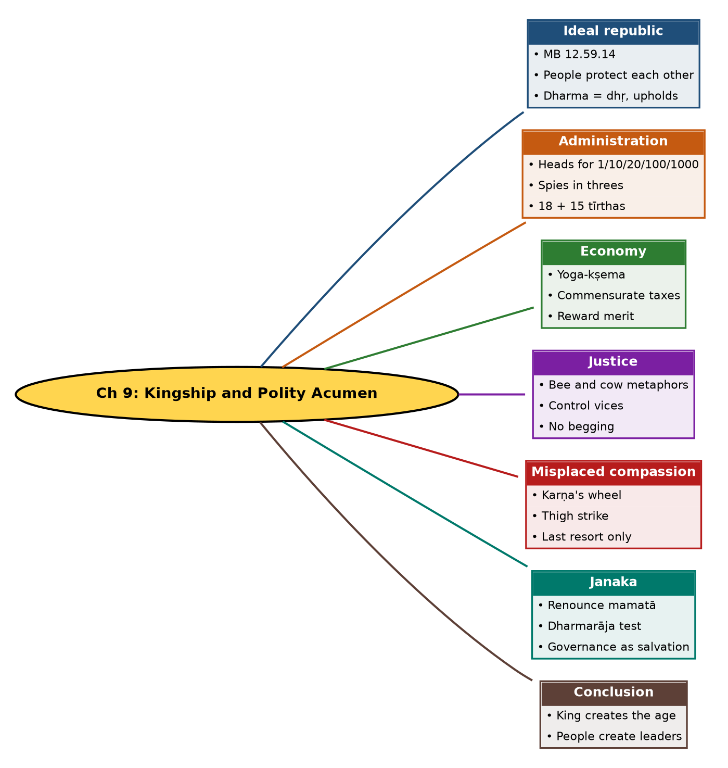

Tree view (text version for quick revision)
Ch 9: Kingship and Polity Acumen
- Ideal republic
  - MB 12.59.14
  - People protect each other
  - Dharma = dhṛ, upholds
- Administration
  - Heads for 1/10/20/100/1000
  - Spies in threes
  - 18 + 15 tīrthas
- Economy
  - Yoga-kṣema
  - Commensurate taxes
  - Reward merit
- Justice
  - Bee and cow metaphors
  - Control vices
  - No begging
- Misplaced compassion
  - Karṇa's wheel
  - Thigh strike
  - Last resort only
- Janaka
  - Renounce mamatā
  - Dharmarāja test
  - Governance as salvation
- Conclusion
  - King creates the age
  - People create leaders

10. Quick Revision: Memory Aids
- Hierarchy numbers: 1-10-20-100-1000.
- 18 + 15 = 33 tīrthas; spies in 3s.
- Bee and Cow = take without harming.
- Verse trio: 12.59.14 (republic), 12.110.11 (dharma), 12.70.06 (king and time).
- Janaka verse: 14.32.25; Dharmarāja tests him.
- Bhīṣma and Nārada are the two teachers of polity.

11. Exam Practice: Questions and Model Answers
Q1. Explain the ideal republic described by Bhīṣma (MB 12.59.14).
Ans: A state with no king, kingdom, lawbreaker or magistrate where people protect each other by Dharma; it stresses holding to Dharma.
Q2. How is Dharma defined and what does it imply for society?
Ans: From dhṛ, 'to uphold'; actions that hold society together. If all follow Dharma, society is stable and healthy.
Q3. Outline Bhīṣma's administrative structure and use of spies.
Ans: Heads for every village, ten, twenty, hundred and thousand villages reporting upward; spies roam the land to test policy and reputation and report to the head. Nārada adds groups of three mutually unknown spies for 18 tīrthas on the opposite side and 15 on one's own.
Q4. What economic principles are given?
Ans: A town supervisor checks sales, purchases, expenses, routes, taxes traders and ensures their yoga-kṣema; artisans must live well; taxes commensurate; wealth spent properly, soldiers paid in advance, spoils shared by merit, good work praised.
Q5. Explain the metaphors of the bee and the cow.
Ans: The king should take revenue without harming subjects: as a bee takes honey without damaging the flower, and a cow is milked mindful of the calf.
Q6. What does Bhīṣma say about vices and begging?
Ans: Control taverns, prostitutes, pimps, gamblers; no begging except in disaster, when compassionate people may give.
Q7. What is 'misplaced compassion' as argued in the chapter?
Ans: The author's view that leniency toward adharmic forces, where firm action is needed, harms national security; Kṛṣṇa's last-resort use of adharma against adharmic enemies (Karṇa's wheel, Duryodhana's thigh) is cited.
Q8. Narrate the Janaka-Brāhmaṇa saṃvāda.
Ans: Janaka exiled a Brāhmaṇa, who asked which land was Janaka's to rule. Janaka realised the land was not his, that he had conquered senses and mind and renounced mamatā, and acted for others. The Brāhmaṇa was Dharmarāja, who said such a king can turn the dharma-cakra and attain Brahma Pada.
Q9. What does MB 12.70.06 teach?
Ans: Do not doubt that the king creates the age (Time); leaders shape a nation's destiny, and in a democracy the people create them.
Q10. Which sages are listed as advisers of rulers in India?
Ans: Cāṇakya, Rāmakṛṣṇa Paramahaṃsa, Samartha Rāmadāsa, Thathachariar, Vidyāraṇya and Amma.

Self-test: one-line recall
- Teachers of polity = ? Bhīṣma and Nārada.
- Spy groups = ? 3, unknown to each other.
- Janaka's tester = ? Dharmarāja.
- Verse for king and Time = ? 12.70.06.

