CHAPTER 10
Mahābhārata in Adages
Strategic Lessons from Mahābhārata | Exam-Ready Revision Notes | Book pages 123 to 134
Chapter at a glance
- Core idea: Everyday sayings that come from Mahābhārata: Yato dharmas tato jayaḥ, ati sarvatra varjayet, mahājano yena gataḥ sa panthāḥ, vayaṃ pañcādhikaṃ śatam, plus the Nyāyas (Kūrmāṅga, Sundopasunda) and idioms like 'Vyāsa Ghaṭ'.
- Yato dharmas tato jayaḥ ('where there is Dharma, there is victory') is the refrain/central message, on the Supreme Court of India emblem.
- Atidānād hataḥ Karṇaḥ, atilobhāt Suyodhanaḥ... ati sarvatra varjayet: avoid excess.
- Mahājano yena gataḥ sa panthāḥ: dharma's tattva is hidden in a cave; follow great souls (Yakṣa Praśna).
- Vayaṃ pañcādhikaṃ śatam = 105: unity before outsiders (Yudhiṣṭhira).
- Nyāyas (maxims; G. A. Jacob): Kūrmāṅga and Sundopasunda; idioms: Urvaśī Śāpa Upakāram, Vyāsa Ghaṭ, Dātā Karṇa.

1. Complete Summary
Adages enrich every language; their sources are often unknown, born of community experience, conversation or literature. Some are sūktas with deep philosophy, others simple proverbs. Mahābhārata has supplied many. A child who sees a giant says 'as big as Bhīma', not Kumbhakarṇa (although Kumbhakarṇa is bigger), because Kumbhakarṇa is used for sleepers. The word 'Mahābhārata' itself means a terrible fight, even verbal.
Yato dharmas tato jayaḥ: the refrain of the Itihāsa, whose first name was Jaya, so its message is 'Victory to Dharma'. When the war was announced, Gāndhārī blessed Duryodhana with exactly these words, perhaps trying again to invoke dharma in her son. The phrase appears in four situations linked to Gāndhārī, though Karṇa first used it, and is recited by Bhīṣma, Vyāsa, Arjuna and Kṛṣṇa. It is inscribed on the Supreme Court of India's emblem, and Narendra Kohli titled his analysis of Mahābhārata 'Yato Dharmas Tato Jayaḥ'. It is known from the Himalayas to Kanyakumari.
Ati sarvatra varjayet ('excess of anything should be avoided'): part of a subhāṣita, not the text itself: 'atidānād hataḥ Karṇaḥ atilobhāt Suyodhanaḥ, atikāmād Daśagrīvaḥ, ati sarvatra varjayet'. Karṇa donated his natural armour (ati-dāna) and died; Duryodhana's excessive greed (ati-lobha) ruined himself and tens of thousands, whereas half the kingdom would have let him live content. Generosity must not be self-destructive or ignore the subtleties of Dharma; emperors fell through misplaced compassion. The verse also names Rāvaṇa (Daśagrīva) for excessive desire. The last quarter generalises: excess of anything leads to destruction.
Mahājano yena gataḥ sa panthāḥ: from the śloka 'tarko 'pratiṣṭhaḥ śrutayo vibhinnā nāsāv ṛṣir yasya mataṃ na bhinnam, dharmasya tattvaṃ nihitaṃ guhāyāṃ mahājano yena gataḥ sa panthāḥ'. Logic alone cannot fix dharma's subtle principle (one would just follow the cleverest); the śrutis differ and are contextual; following a single ācārya gives only some theories universal acceptance; dharma's principle is like a treasure hidden in a cave; so follow the path of the great. In the Yakṣa Praśna (Vana Parva, Dvaita forest) Yudhiṣṭhira's brothers died after drinking the lake's water without answering a crane-voiced Yakṣa's questions; Yudhiṣṭhira answered all, including 'kaḥ panthāḥ?' (what is the way?) with this adage. The Yakṣa revived his brothers and revealed himself as Dharma Deva.
Vayaṃ pañcādhikaṃ śatam ('we are 105'): the adage of unity, with similar ones such as 'saṃhatiḥ kārya-sādhikā'. Mahābhārata shows both the triumph of dharma and the tragic downfall of the disunited. When the Gandharvas captured Duryodhana during exile, Yudhiṣṭhira told Bhīma and Arjuna to free him; asked whether it would be easier if the Gandharvas killed him, he said: when an outsider attacks the Kuru family, 'we are 105'; when we fight each other, we are 5 and 100 (Vana Parva). Apply it in nation, community and family.
Nyāyas: short phrases from stories that carry a principle, like idioms; translated by Colonel G. A. Jacob as 'Popular Maxims' (A Handful of Popular Maxims, 3 volumes), though he preferred keeping 'Nyāya'. Asidhārā ('razor's edge') is a Sanskrit example. Kūrmāṅga Nyāya (limbs of a tortoise): the Gītā (2.58) says a devotee withdraws the senses from objects as a tortoise withdraws its limbs; used for things that can be withdrawn and re-manifested, and by Madhavācārya (Sarvadarśana Saṅgraha, Sāṃkhya) and Vācaspati Miśra (Sāṃkhyatattvakaumudī). Sundopasunda Nyāya: mutual destruction; source is Ādi Parva chapters 209-212: the invincible asura brothers Sunda and Upasunda conquered three worlds; Brahmā had Viśvakarmā create the apsaras Tilottamā; the brothers fought over her and killed each other. Other idioms: Urvaśī Śāpa Upakāram (a curse that turned out to be a timely boon), Vyāsa Ghaṭ (hard to comprehend), Dātā Karṇa/'Karṇa-sama dāna' (very generous donation). These show how deeply Mahābhārata has entered Indian life.

2. Section-wise Detailed Notes

A. About adages
- Found in every language; sources often unknown (community experience, conversation, literature).
- Range: sūktas with deep philosophy to proverbs.
- 'Big as Bhīma' (giant) vs 'Kumbhakarṇa' (sleeper); 'Mahābhārata' = great fight.

B. Yato dharmas tato jayaḥ
- Refrain of MB; first name Jaya: 'Victory to Dharma'.
- Gāndhārī blessed Duryodhana with it before the war.
- Four situations linked to Gāndhārī; Karṇa used it first; also Bhīṣma, Vyāsa, Arjuna, Kṛṣṇa.
- On Supreme Court of India emblem; Narendra Kohli's book title.

C. Ati sarvatra varjayet
- From a subhāṣita, not the MB text.
- Ati-dāna → Karṇa (gave away armour); ati-lobha → Duryodhana (refused half the kingdom); ati-kāma → Rāvaṇa (Daśagrīva).
- Generosity must not be self-destructive; misplaced compassion toppled emperors.
- Moral: avoid excess in everything.

D. Mahājano yena gataḥ sa panthāḥ
- Verse: tarko 'pratiṣṭhaḥ... dharmasya tattvaṃ nihitaṃ guhāyām.
- Logic fails; śrutis differ; single ācārya limited; dharma like a treasure in a cave.
- Yakṣa Praśna, Vana Parva, Dvaita forest: question 'kaḥ panthāḥ?'.
- Yudhiṣṭhira's brothers revived; Yakṣa = Dharma Deva.

E. Vayaṃ pañcādhikaṃ śatam
- Means 105 together; 'saṃhatiḥ kārya-sādhikā'.
- Gandharvas captured Duryodhana; Yudhiṣṭhira sent Bhīma and Arjuna to free him.
- 'Against outsiders we are 105; among ourselves 5 and 100.'
- Apply to nation, community, family.

F. Nyāyas and idioms
- Nyāya = popular maxim; Colonel G. A. Jacob, 'A Handful of Popular Maxims' (3 vols).
- Asidhārā = razor's edge.
- Kūrmāṅga Nyāya: tortoise limbs; Gītā 2.58; Madhavācārya, Vācaspati Miśra.
- Sundopasunda Nyāya: mutual destruction; Ādi Parva ch. 209-212; Tilottamā.
- Idioms: Urvaśī Śāpa Upakāram, Vyāsa Ghaṭ, Dātā/Karṇa-sama dāna.

3. Key Terms and Keywords
Term | Meaning / Why it matters
Adage | Traditional saying; may be a sūkta with philosophy or a proverb.
Sūkta / Subhāṣita | Well-spoken verse with wisdom.
Jaya | Original name of MB; also 'victory'.
Yato dharmas tato jayaḥ | Where there is Dharma there is victory.
Ati sarvatra varjayet | Avoid excess in all things.
Mahājano yena gataḥ sa panthāḥ | The way is the path trodden by great souls.
Yakṣa Praśna | Yakṣa's questions to Yudhiṣṭhira in Vana Parva.
Vayaṃ pañcādhikaṃ śatam | 'We are 105': unity against outsiders.
Nyāya | Short phrase condensing a principle from a story; 'popular maxim'.
Kūrmāṅga Nyāya | Maxim of the tortoise's limbs: withdrawal and manifestation.
Sundopasunda Nyāya | Maxim for mutual destruction, from Sunda and Upasunda.
Urvaśī Śāpa Upakāram | A curse that turned into a timely boon.
Vyāsa Ghaṭ | Something very hard to comprehend.

4. Numbers, Facts and Figures
Fact | Detail
Total of Kauravas + Pāṇḍavas in the adage | 105 (100 + 5)
Ādi Parva chapters for Sunda-Upasunda | 209 to 212
Gītā verse for tortoise | 2.58
Jacob's work | A Handful of Popular Maxims, 3 volumes
People who recite Yato dharmas tato jayaḥ | Karṇa (first), Gāndhārī, Bhīṣma, Vyāsa, Arjuna, Kṛṣṇa
Excess examples in subhāṣita | Dāna (Karṇa), Lobha (Duryodhana), Kāma (Rāvaṇa)

5. People, Places and Texts
Name | Role / Significance in this chapter
Gāndhārī | Blessed Duryodhana: 'Yato dharmas tato jayaḥ'.
Karṇa | First to use the phrase; example of ati-dāna.
Duryodhana | Example of ati-lobha; captured by Gandharvas.
Yudhiṣṭhira | Answered the Yakṣa; 'we are 105'.
Dharma Deva (Yakṣa) | Questioner at the lake.
Narendra Kohli | Author of 'Yato Dharmas Tato Jayaḥ' study.
Colonel G. A. Jacob | Translator/compiler of Nyāyas.
Sunda, Upasunda, Tilottamā, Viśvakarmā, Brahmā | Cast of the mutual-destruction story.

6. Ślokas, Sayings and Sources
Śloka / Source | Meaning and use
yato dharmas tato jayaḥ | Where Dharma, there victory; on the Supreme Court emblem.
atidānād hataḥ karṇaḥ, atilobhāt suyodhanaḥ; atikāmād daśagrīvaḥ, ati sarvatra varjayet | Excess in charity, greed or desire ruins; avoid excess everywhere.
tarko 'pratiṣṭhaḥ śrutayo vibhinnā nāsāv ṛṣir yasya mataṃ na bhinnam; dharmasya tattvaṃ nihitaṃ guhāyāṃ mahājano yena gataḥ sa panthāḥ | Logic and scriptures differ; follow the path of the great.
parāḥ paribhave prāpte vayaṃ pañcottaraṃ śatam; parasparavirodhe tu vayaṃ pañcaiva te śatam | Against outsiders we are 105; among ourselves 5 and 100.

7. Comparisons and Frameworks

Adages and their stories
Adage | Story / source | Message
Yato dharmas tato jayaḥ | Gāndhārī's blessing to Duryodhana; whole Itihāsa | Dharma leads to victory
Ati sarvatra varjayet | Karṇa's donation, Duryodhana's greed, Rāvaṇa's desire | Avoid excess
Mahājano yena gataḥ sa panthāḥ | Yakṣa Praśna, Vana Parva | Follow the great souls' path
Vayaṃ pañcādhikaṃ śatam | Gandharvas capture Duryodhana, Vana Parva | Unity against outsiders
Sundopasunda Nyāya | Ādi Parva ch. 209-212 | Mutual destruction
Kūrmāṅga Nyāya | Gītā 2.58 | Withdraw senses like tortoise limbs

Three excesses
Excess | Person | Result
Ati-dāna | Karṇa | Gave away natural armour, paving the way to his death
Ati-lobha | Duryodhana | Refused half a kingdom; destroyed himself and thousands
Ati-kāma | Rāvaṇa (Daśagrīva) | Ruined by excessive desire (as in the subhāṣita)

8. Mind Map
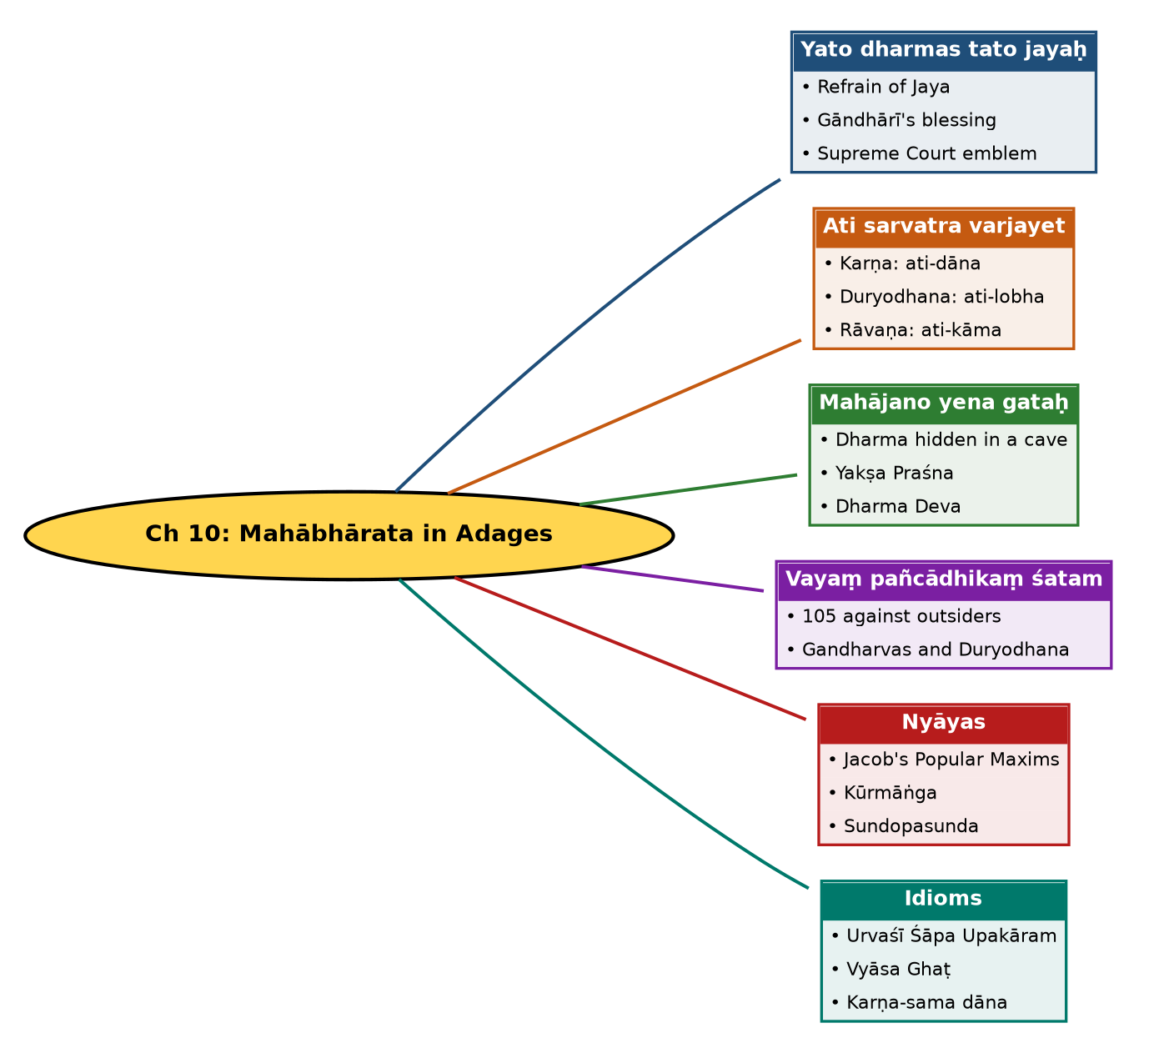

Tree view (text version for quick revision)
Ch 10: Mahābhārata in Adages
- Yato dharmas tato jayaḥ
  - Refrain of Jaya
  - Gāndhārī's blessing
  - Supreme Court emblem
- Ati sarvatra varjayet
  - Karṇa: ati-dāna
  - Duryodhana: ati-lobha
  - Rāvaṇa: ati-kāma
- Mahājano yena gataḥ
  - Dharma hidden in a cave
  - Yakṣa Praśna
  - Dharma Deva
- Vayaṃ pañcādhikaṃ śatam
  - 105 against outsiders
  - Gandharvas and Duryodhana
- Nyāyas
  - Jacob's Popular Maxims
  - Kūrmāṅga
  - Sundopasunda
- Idioms
  - Urvaśī Śāpa Upakāram
  - Vyāsa Ghaṭ
  - Karṇa-sama dāna

10. Quick Revision: Memory Aids
- Three excesses: Karṇa (Dāna), Duryodhana (Lobha), Rāvaṇa (Kāma): D-L-K.
- 105 = 100 + 5; apart, '5 and 100'.
- Cave treasure = dharma-tattva; follow mahājana.
- Gāndhārī blessed; Karṇa first used the phrase.
- Sunda + Upasunda + Tilottamā = mutual destruction.
- Gītā 2.58 = tortoise; ch. 209-212 = Sundopasunda.

11. Exam Practice: Questions and Model Answers
Q1. Why is 'Yato dharmas tato jayaḥ' called the refrain of Mahābhārata?
Ans: The original name is Jaya, and its central message is the victory of Dharma. The phrase recurs through the Itihāsa, spoken by Karṇa, Gāndhārī, Bhīṣma, Vyāsa, Arjuna and Kṛṣṇa, and appears on the Supreme Court emblem.
Q2. Explain the context of Gāndhārī's use of the phrase.
Ans: When war was announced, Duryodhana sought her blessing and she said 'Yato dharmas tato jayaḥ', trying to invoke dharma in her son.
Q3. Explain 'ati sarvatra varjayet' with the examples in the subhāṣita.
Ans: Karṇa died from excess charity (giving his armour), Duryodhana from excess greed (refusing half the kingdom), Rāvaṇa from excess desire; excess of anything leads to destruction.
Q4. What does 'mahājano yena gataḥ sa panthāḥ' teach and where was it used?
Ans: Dharma's subtle principle is hidden in a cave and cannot be settled by logic or conflicting scriptures; follow the path of great souls. Yudhiṣṭhira used it to answer the Yakṣa's question 'what is the way?'.
Q5. Narrate the Yakṣa Praśna context.
Ans: In the Dvaita forest, Yudhiṣṭhira's brothers died drinking water without answering the Yakṣa. Yudhiṣṭhira answered all questions; the Yakṣa, Dharma Deva, revived them.
Q6. What is the meaning of 'vayaṃ pañcādhikaṃ śatam'?
Ans: When outsiders attack the Kuru family, the Pāṇḍavas and Kauravas are 105 together; when fighting among themselves, they are 5 and 100. It teaches unity.
Q7. Define Nyāya and mention Jacob's contribution.
Ans: A short phrase from a story representing a principle, like an idiom. G. A. Jacob compiled 'A Handful of Popular Maxims' (3 vols), though he preferred the word Nyāya to 'maxim'.
Q8. Explain Sundopasunda Nyāya.
Ans: It denotes mutual destruction. The invincible asura brothers Sunda and Upasunda were destroyed when they fought over the apsaras Tilottamā created by Viśvakarmā at Brahmā's request (Ādi Parva ch. 209-212).
Q9. What is Kūrmāṅga Nyāya?
Ans: The maxim of the tortoise's limbs: just as a tortoise withdraws its limbs, the devotee withdraws the senses from objects (Gītā 2.58); also used for things that can be withdrawn and re-manifested.
Q10. Give three idioms from Mahābhārata used in everyday language.
Ans: Urvaśī Śāpa Upakāram (a curse that proves a timely boon), Vyāsa Ghaṭ (hard to comprehend), Karṇa-sama dāna (great generosity).

Self-test: one-line recall
- Adage on Supreme Court emblem = ? Yato dharmas tato jayaḥ.
- 'We are 105' by whom? Yudhiṣṭhira.
- Who is the Yakṣa? Dharma Deva.
- Nyāya compiler = ? Col. G. A. Jacob.

