CHAPTER 11
Popular Regional Tales
Strategic Lessons from Mahābhārata | Exam-Ready Revision Notes | Book pages 137 to 147
Chapter at a glance
- Core idea: Four tales that live outside Vyāsa's text or differ from it: Aravan and the Kūvāgam festival, Duṣyanta and Śakuntalā (Kālidāsa vs Vyāsa), the Malanada Duryodhana temple, and Barbarīka/Khāṭū Śyām.
- Aravan (Iravān/Irāvat): son of Arjuna and Ulūpī; in Parata Veṇpā (Peruntevanār, 9th c.) he gives kaḷappali; Kūvāgam: 18-day festival, Aravānis.
- Śakuntalā: Kālidāsa adds Durvāsā's curse and the ring in the fish; Vyāsa has Duṣyanta feign forgetfulness until a voice from the sky speaks.
- Malanada Duryodhana Temple (Poruvazhi, Kerala): only South Indian Duryodhana temple; no idol, platform with Nandis; Malakkuda festival; pays property tax.
- Barbarīka / Khāṭū Śyām: grandson of Bhīma; 3 infallible arrows; head offered to Kṛṣṇa before war; source Skanda Purāṇa.
- These tales show living oral traditions; variations from Vyāsa Mahābhārata are part of culture.

1. Complete Summary
Mahābhārata has spread across Greater India like a giant tree with spreading roots; each region has its own flavour outside Vyāsa's text, found in regional writings, oral tradition, art and rituals. This chapter narrates four popular tales that are not in Vyāsa Mahābhārata (or differ from it).
Aravan and the Kūvāgam festival: Arjuna broke the Pāṇḍavas' agreement (no entry while Draupadī was with one brother; the penalty was twelve years in the forest, an agreement Nārada recommended) and went into exile. While bathing in the Gaṅgā he met the Nāga princess Ulūpī, who wished to marry him; their son was Iravān (Irāvat/Aravan), a Nāga warrior who fought at Kurukṣetra. In Vyāsa's text he dies a hero's death fighting the rākṣasa Alambuṣa. In the earliest surviving Tamil Mahābhārata, Parata Veṇpā by Peruntevanār (9th century), Aravan offers himself in the kaḷappali ritual ('sacrifice to the battlefield'), to Goddess Kālī, to ensure Pāṇḍava victory. Before it he asks for a boon: to be married before death. Kṛṣṇa becomes the beautiful Mohinī and marries him; Aravan is sacrificed next day. His severed head is the presiding deity of the Kattāntavar Kovil at Kūvāgam, Tamil Nadu.
The 18-day festival, held in Caitra (April/May), draws lakhs of devotees and is worshipped especially by transgender people called Aravānis. Three rituals: the marriage of Aravānis with Aravan, his sacrifice the next day, and their mourning as widows. On the 14th day Aravānis dressed as Mohinī in bridal finery (sarees, bangles, garlands, gold) gather at the temple with puja items, a kalaśa (pot) and tāli (mangalasūtra); priests, representing Aravan, tie the tāli and apply sindūra. On the 16th day the image is carried in procession to the mourning ground (Aḻukaḷam), where the garlands and decorations are removed from the effigy (symbolising the removal of his flesh at sacrifice); the Aravānis remove their mangalasūtras, smash their bangles and weep. The widowhood is symbolic and temporary; the ritual is repeated yearly, with the climax on the full-moon day.
Duṣyanta and Śakuntalā: in Kālidāsa's Abhijñānaśākuntalam, King Duṣyanta met Śakuntalā (living in sage Kaṇva's hermitage) while hunting and married her, giving a gold ring with his name and promising to return. Absorbed in thoughts of him, she failed to attend Durvāsā, who cursed that the person she dreamt of would forget her; he softened it: if shown something of theirs the king would remember. Years later, with her son, she set out; her ring fell into a river and a fish swallowed it. The king did not recognise her; she returned to the forest, where her son Bharata grew up among animals. A fisherman later presented the ring found in a fish; Duṣyanta remembered, found the boy playing with a lion cub, and the family was united; Bharata became a great king. In Vyāsa's Mahābhārata (Sambhava Parva) there is no curse or ring: Duṣyanta, to avoid public embarrassment, pretends not to know her and rejects her and the boy; she protests the injustice. Then a voice from the sky says she spoke the truth and he should accept her and support his son. Duṣyanta, delighted, said he knew it but that accepting them on her word alone would have raised suspicion and the son would never be accepted as true; he accepted her according to Dharma and named the heir Bharata.
Malanada Duryodhana Temple (Poruvazhi, Kerala), the only temple in South India dedicated to Duryodhana. Legend: during the Pāṇḍavas' exile, Duryodhana, wishing to track them, reached Malanada hill, very thirsty, and asked at a house of the Kuruva (forest-dwelling) community for water; an elderly woman offered toddy as a customary mark of respect. He sensed divinity and extraordinary healing knowledge there and noticed her 'kurathali' ornament. Touched by their hospitality, he sat on the hill and worshipped Śiva for the people's welfare; the villagers built the temple on that spot. There is no sanctum or deity, only a raised platform where he is considered absorbed in Śiva Caitanya, with Nandis symbolising Śiva. The annual festival Malakkuda is held when the season's agricultural work ends and before the next paddy cultivation: Kodiyēṭṭu (flag hoisting) on the first Friday of Malayalam month Mīnam and Malakkuda on the second Friday, making eight days. Legend: before the war Duryodhana told the community head he would return victorious in a week, or else to consider him dead and perform his last rites as his 'father'; so the priest (arāli) is a prati-puruṣa, a representative of Duryodhana's son. Ancestor worship is followed; there are thirteen sub-shrines including one for his sister Duḥśalā; the temple pays property tax in Duryodhana's name.
Barbarīka (Khāṭū Śyām), told in Gujarat and Rajasthan folktales. After the wax palace, the Pāṇḍavas hid in the forest and met the rākṣasa siblings Hiḍimbā and Hiḍimba; Bhīma killed Hiḍimba and married Hiḍimbā; their son was Ghaṭotkaca, who married Morvī (Maurvī), daughter of the rākṣasa Mura of Prāgjyotiṣapura. Their son Barbarīka was taken to Dvārakā; Kṛṣṇa advised him to worship Durgā, who granted three infallible arrows making him victorious in all three worlds. Back home the war had been declared; he told his mother he would watch first, then fight for the losing side. Kṛṣṇa, disguised as a Brāhmaṇa under a peepal tree, asked how he could fight with three arrows: the first marks those to protect, the second those to kill, the third kills them. Kṛṣṇa saw that if he joined the losing Kaurava side, Dharma would be destroyed, so he revealed his form and asked for the head of a brave Kṣatriya as sacrifice before the war. Barbarīka agreed instantly, asking only to see the war to the end. Kṛṣṇa placed his head on a hilltop. After the war he said he saw only the Sudarśana cakra cutting down the Kaurava army and Draupadī in the fierce form of Mahākālī drinking blood. Kṛṣṇa blessed him to be worshipped as 'Śyām' in Kali Yuga; his head was buried in Khāṭū, hence Khāṭū Śyām (Khatushyam) temple. Barbarīka is not in Vyāsa Mahābhārata; the account is in the Skanda Purāṇa. The chapter closes: countless such tales show oral tradition's power and living Mahābhārata traditions, even where they vary from Vyāsa.

2. Section-wise Detailed Notes

A. Aravan and the Kūvāgam festival
- Arjuna broke the privacy agreement (12 years in forest); Nārada had advised the agreement.
- Met Ulūpī (Nāga princess) at the Gaṅgā; son Iravān/Irāvat/Aravan.
- Vyāsa MB: killed by Alambuṣa. Parata Veṇpā (Peruntevanār, 9th c.): kaḷappali to Kālī for Pāṇḍava victory.
- Boon: marry before death; Kṛṣṇa = Mohinī.
- Festival: Kūvāgam, Kattāntavar Kovil, 18 days, Caitra (Apr/May), Aravānis.
- Rituals: marriage (14th day), procession/Aḻukaḷam (16th), mourning; tāli and sindūra, bangles smashed; symbolic temporary widowhood; climax full moon.

B. Duṣyanta and Śakuntalā
- Kālidāsa: hunting, Kaṇva's hermitage, gold ring; Durvāsā's curse; ring swallowed by fish in river; fisherman returns it; Bharata with lion cub.
- Vyāsa (Sambhava Parva): no curse/ring; Duṣyanta feigns forgetfulness to avoid embarrassment; voice from sky; he accepts per Dharma (public proof); son named Bharata.
- Lesson: same core, different treatment.

C. Malanada Duryodhana Temple
- Poruvazhi, Kerala; only South Indian Duryodhana temple; Malanada = 'temple on the hill'.
- Legend: thirsty Duryodhana; Kuruva woman offers toddy; he worships Śiva for the people.
- No sanctum; raised platform, Nandis; Śiva Caitanya.
- Malakkuda: Kodiyēṭṭu first Friday of Mīnam; second Friday Malakkuda; 8 days; end of farming season.
- Promise: return in a week or perform last rites; prati-puruṣa (priest); 13 sub-shrines incl. Duḥśalā; pays property tax.

D. Barbarīka / Khāṭū Śyām
- Family: Bhīma + Hiḍimbā → Ghaṭotkaca + Morvī (daughter of Mura) → Barbarīka.
- Durgā's boon: three infallible arrows (protect, mark to kill, kill).
- Vow: fight for the losing side; Kṛṣṇa fears dharma's destruction.
- Asked for head as Kṣatriya sacrifice; wish: watch the war; head on hilltop.
- Witnessed Sudarśana cakra and Draupadī as Mahākālī.
- Boon: worshipped as Śyām in Kali Yuga; head buried in Khāṭū; source Skanda Purāṇa, not Vyāsa MB.

E. Message
- Oral traditions keep Mahābhārata alive.
- Variations (subtle or gross) are still living traditions and relevant culture.

3. Key Terms and Keywords
Term | Meaning / Why it matters
Kaḷappali | 'Sacrifice to the battlefield' performed before battle for victory.
Aravānis | Transgender devotees who 'marry' Aravan at Kūvāgam.
Mohinī | Kṛṣṇa's female form who marries Aravan.
Aḻukaḷam | 'Mourning ground' where the Aravānis grieve.
Tāli / mangalasūtra | Sacred marriage thread tied by priests representing Aravan.
Parata Veṇpā | Earliest surviving Tamil Mahābhārata, by Peruntevanār (9th c.).
Abhijñānaśākuntalam | Kālidāsa's play on Śakuntalā.
Malakkuda | Annual festival of the Malanada temple.
Kodiyēṭṭu | Flag hoisting that begins a temple festival.
Prati-puruṣa | Representative; the priest stands for Duryodhana's son.
Khatushyam / Khāṭū Śyām | Barbarīka worshipped in Khāṭū (Rajasthan).
Śiva Caitanya | Presence of Śiva in which Duryodhana is absorbed at Malanada.

4. Numbers, Facts and Figures
Fact | Detail
Exile for breaking agreement | 12 years
Kūvāgam festival | 18 days; Caitra (April/May); marriage on 14th day, procession on 16th
Parata Veṇpā | 9th century, Peruntevanār
Malakkuda festival | 8 days (Kodiyēṭṭu to Malakkuda); Mīnam, first and second Fridays
Sub-shrines at Malanada | 13
Barbarīka's arrows | 3 infallible arrows
Duryodhana's promised return | Within 1 week
Sources | Skanda Purāṇa (Barbarīka); Sambhava Parva (Duṣyanta-Śakuntalā)

5. People, Places and Texts
Name | Role / Significance in this chapter
Iravān / Aravan | Son of Arjuna and Ulūpī; self-sacrifice; deity at Kūvāgam.
Ulūpī | Nāga princess; Arjuna's wife.
Alambuṣa | Rākṣasa who kills Iravān in Vyāsa's text.
Peruntevanār | Author of Parata Veṇpā.
Duṣyanta, Śakuntalā, Bharata, Kaṇva, Durvāsā | Characters of the Śakuntalā story.
Malanada Appappan / Kuruva woman | Priest-ruler and host of Duryodhana.
Ghaṭotkaca, Morvī, Mura, Barbarīka | Family of Barbarīka.
Kṛṣṇa | Mohinī for Aravan; tests Barbarīka and takes his head.

6. Ślokas, Sayings and Sources
Śloka / Source | Meaning and use
Barbarīka's arrows | First protects, second marks those to kill, third kills.
Barbarīka's report | He saw only Sudarśana cakra and Draupadī as Mahākālī drinking blood.
Duryodhana's promise | 'I will return victorious within a week; else perform my last rites as your son.'

7. Comparisons and Frameworks

Śakuntalā: Kālidāsa vs Vyāsa
Element | Kālidāsa's play | Vyāsa Mahābhārata
Why Duṣyanta forgets | Durvāsā's curse | He pretends, avoiding public embarrassment
Ring | Lost in river; fish; fisherman returns it | Not part of the story
Recognition | Ring restores memory | Voice from the sky confirms truth
Outcome | Family reunited | Accepts per Dharma; son named Bharata heir

Aravan: Vyāsa vs Tamil tradition
 | Vyāsa MB | Tamil/Regional tradition
Death | Heroic death fighting Alambuṣa | Self-sacrifice (kaḷappali) to Kālī for victory
Special feature | None of marriage | Marries Mohinī (Kṛṣṇa) before death
Legacy | Nāga warrior | Deity at Kattāntavar Kovil; Kūvāgam festival

Tales at a glance
Tale | Place | Key element
Aravan | Kūvāgam, Tamil Nadu | Marriage to Mohinī; Aravānis
Śakuntalā | Kanva's hermitage / Hastināpura | Curse, ring, recognition
Duryodhana temple | Poruvazhi, Kerala | No idol; Śiva worship; Malakkuda
Barbarīka | Khāṭū, Rajasthan | Three arrows; head sacrificed

8. Mind Map
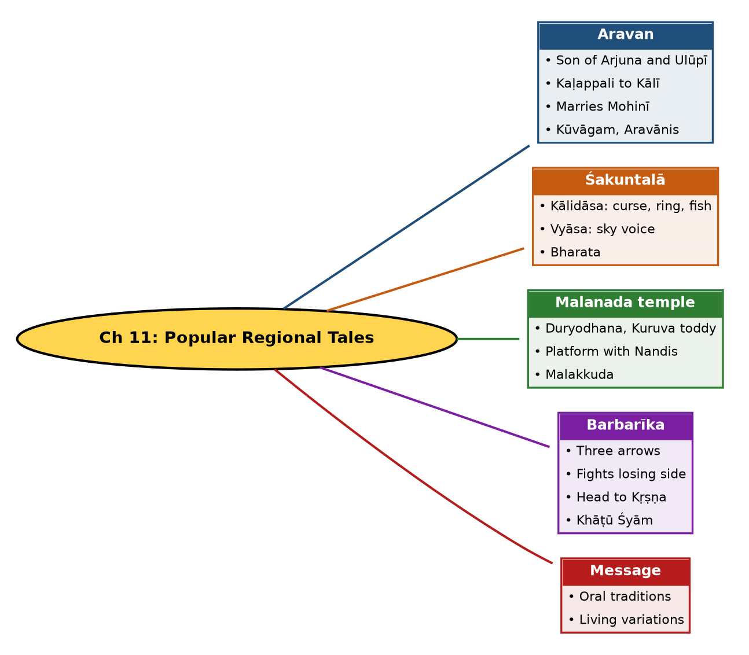

Tree view (text version for quick revision)
Ch 11: Popular Regional Tales
- Aravan
  - Son of Arjuna and Ulūpī
  - Kaḷappali to Kālī
  - Marries Mohinī
  - Kūvāgam, Aravānis
- Śakuntalā
  - Kālidāsa: curse, ring, fish
  - Vyāsa: sky voice
  - Bharata
- Malanada temple
  - Duryodhana, Kuruva toddy
  - Platform with Nandis
  - Malakkuda
- Barbarīka
  - Three arrows
  - Fights losing side
  - Head to Kṛṣṇa
  - Khāṭū Śyām
- Message
  - Oral traditions
  - Living variations

10. Quick Revision: Memory Aids
- Four tales: A-S-M-B = Aravan, Śakuntalā, Malanada, Barbarīka.
- Kālidāsa extras: curse, ring, fish. Vyāsa: sky voice.
- 3 arrows: protect, mark, kill.
- 14th day marriage, 16th day mourning.
- Boon chain (Barbarīka): Durgā's arrows, Kṛṣṇa's head-boon, Śyām in Kali Yuga.
- Source check: Barbarīka = Skanda Purāṇa, not Vyāsa MB; Aravan's marriage = Tamil tradition.

11. Exam Practice: Questions and Model Answers
Q1. Narrate the story of Aravan and the Kūvāgam festival.
Ans: Arjuna's son by Ulūpī, Aravan, offers himself in kaḷappali to Kālī for Pāṇḍava victory (Parata Veṇpā). He asks to marry first; Kṛṣṇa becomes Mohinī and marries him; he is sacrificed next day. At Kūvāgam, Aravānis marry Aravan on the 14th day and mourn on the 16th.
Q2. How does Aravan's death differ in Vyāsa's text and the Tamil tradition?
Ans: Vyāsa: he dies fighting Alambuṣa. Tamil version: he sacrifices himself in the kaḷappali ritual to Kālī.
Q3. Describe the rituals of the Kūvāgam festival.
Ans: Marriage of Aravānis to Aravan with tāli and sindūra; procession to Aḻukaḷam where decorations are removed from the effigy; Aravānis remove mangalasūtras, break bangles and mourn; symbolic widowhood repeats yearly.
Q4. Compare Kālidāsa's and Vyāsa's versions of Duṣyanta and Śakuntalā.
Ans: Kālidāsa has Durvāsā's curse and the ring in the fish; Vyāsa has Duṣyanta feign forgetfulness, a voice from the sky, and acceptance by Dharma with the son named Bharata.
Q5. Why did Duṣyanta accept Śakuntalā only after the voice, per Vyāsa?
Ans: He said accepting on her word alone would raise public suspicion and the son would never be considered rightful.
Q6. What makes the Malanada Duryodhana Temple unique?
Ans: It is the only Duryodhana temple in South India; no idol or sanctum, a platform with Nandis representing Śiva Caitanya; it follows ancestor worship and pays property tax in his name.
Q7. Explain the legend of Duryodhana's visit to Malanada.
Ans: Thirsty during the Pāṇḍavas' exile, he was given toddy by a Kuruva woman as a mark of respect; touched by hospitality, he worshipped Śiva for the people's welfare on the hill.
Q8. What is Malakkuda?
Ans: The annual festival of the Malanada temple, starting with Kodiyēṭṭu on the first Friday of Mīnam and Malakkuda on the second Friday, an eight-day festival at the end of the agricultural season.
Q9. Narrate the story of Barbarīka.
Ans: Son of Ghaṭotkaca and Morvī, he got three infallible arrows from Durgā and planned to join the losing side. Kṛṣṇa, fearing dharma's defeat, asked for his head; Barbarīka agreed and watched the war from a hilltop; he was blessed to be worshipped as Śyām.
Q10. What did Barbarīka report about the war?
Ans: He saw only the Sudarśana cakra cutting down the Kaurava army and Draupadī as Mahākālī drinking blood.
Q11. What do these tales demonstrate?
Ans: The power of oral traditions and how regional retellings, even when differing from Vyāsa, are part of Mahābhārata's living culture.

Self-test: one-line recall
- Aravan's mother = ? Ulūpī.
- Boon asked by Aravan = ? Marriage before death.
- Barbarīka's source text = ? Skanda Purāṇa.
- Malanada: how many days? 8.

