CHAPTER 12
Strategical Silhouette of an Extraordinary Peace Mission
Strategic Lessons from Mahābhārata | Exam-Ready Revision Notes | Book pages 151 to 162
Chapter at a glance
- Core idea: Kṛṣṇa's peace mission to Hastināpura in Udyoga Parva: he knows it will probably fail but 'spares no effort' for peace, takes precautions (ten Mahārathis, 1,000 soldiers, Sātyaki), shows his Viśvarūpa, and states that the individual, family and village may be sacrificed for the larger good.
- Udyoga = effort/active preparation: peace attempts + war preparations side by side.
- Pāṇḍavas raised 7 akṣauhiṇīs; Duryodhana 11 (total 18).
- Kṛṣṇa stayed at Vidura's house, rejecting Duryodhana's hospitality; knew the mission would probably fail but tried 'so that everyone knows who is responsible'.
- Duryodhana: not even a needle's point of land; plot to capture Kṛṣṇa → Viśvarūpa; Sātyaki alerted.
- MB 5.126.48: *tyajet kulārthe puruṣaṃ...*: sacrifice smaller for larger; ātmārthe pṛthivīṃ tyajet.

1. Complete Summary
The chapter begins with a modern observation: Indian naval ships dock at strategic locations when national leaders hold diplomatic talks with an unfriendly country, and promises to link it to the epic. After the thirteen years (twelve in forest plus one incognito at Virāṭa's kingdom) the Pāṇḍavas could claim their kingdom, and Udyoga Parva begins. 'Udyoga' means effort or preparation; the Parva shows serious effort for peace and preparation for war.
First, a learned priest of King Drupada was sent as delegate to Hastināpura to ask for half the kingdom. Expecting Duryodhana's refusal, the Pāṇḍavas raised an army of seven akṣauhiṇīs (a battle unit with chariots, horses, elephants, cavalry and infantry in fixed ratios). Duryodhana, informed by spies, raised eleven. The priest politely demanded half; Bhīṣma supported; Karṇa ridiculed, saying not even a quarter would be returned. Unable to decide, Dhṛtarāṣṭra sent Saṃjaya, who said Dhṛtarāṣṭra wanted peace. Yudhiṣṭhira replied they also preferred peace and would forgive all past suffering if Indraprastha were returned. Saṃjaya instead preached the evils of war ('can happiness come from possessions won by war? even without the kingdom, do not abandon Dharma'). Kṛṣṇa intervened, recounted the Kauravas' misconduct including Draupadī's disrobing, and said he still desired peace and would visit the Kauravas before disaster.
Kṛṣṇa consulted all five brothers and Draupadī. Yudhiṣṭhira said the mission would be futile and Duryodhana might harm Kṛṣṇa. Kṛṣṇa agreed it would likely fail but that peace must be attempted in every way before massive destruction, and warned that if Duryodhana tried to capture him he would burn everything down. He went with a weapon-equipped chariot, ten Mahārathis and a thousand soldiers. Dhṛtarāṣṭra arranged lavish welcomes and rest-stops as a pretense to win him over; Kṛṣṇa ignored them and went to Hastināpura. He refused Duryodhana's splendid arrangements and stayed with Vidura, who was overwhelmed. Vidura also said the mission would fail because Duryodhana trusted Bhīṣma, Droṇa, Kṛpa and Karṇa. Kṛṣṇa answered that he knew the effect of his words but wanted to save them from imminent death; he would win eternal fame if he succeeded and the consolation of doing his best if not; he also wanted everyone in the court to know the injustice done: war is inevitable but let all know who is responsible.
In the court, Kṛṣṇa told Dhṛtarāṣṭra he wished to stop a war that would kill eighteen akṣauhiṇīs, Mahārathas and heroes; if Kauravas and Pāṇḍavas lived peacefully they would have no rival; only Dhṛtarāṣṭra could save the world. Dhṛtarāṣṭra whined that he was powerless; Kṛṣṇa praised Duryodhana's family and gifts and urged him toward truth and righteousness. Bhīṣma, Droṇa and Vidura agreed, but Duryodhana accused Kṛṣṇa of partiality and said he would not give half the kingdom, five villages, or even land held by the point of a sharp needle. Kṛṣṇa, angry, again listed the wrongs (wax palace, gambling, disrobing, Duḥśāsana's and Karṇa's insults) and held the assembly responsible for pampering Duryodhana. He recited that a person may be abandoned for a family, a family for a village, a village for a nation, and the world for the soul, and told them to sacrifice Duryodhana to save the race. Duryodhana left in rage with Duḥśāsana; Gāndhārī was called, but he ignored her too.
Outside, Duryodhana, Duḥśāsana, Karṇa and Śakuni conspired to capture Kṛṣṇa. Sātyaki, alert, readied soldiers at the gate, hinted Kṛṣṇa and told Dhṛtarāṣṭra and Vidura. Vidura brought Duryodhana back; they again praised Kṛṣṇa's greatness. Kṛṣṇa mocked Duryodhana for thinking him a single person when he is everything in the universe; he laughed, and gods, suns and everything emerged from him in the Viśvarūpa, a radiant form with many arms and weapons. Except Droṇa, Bhīṣma, Vidura, Saṃjaya and the Ṛṣis, everyone closed their eyes. Kṛṣṇa then left to meet his paternal aunt Kuntī.
Analysis (three insights). (1) 'Spare no effort' for peace: Kṛṣṇa knew Duryodhana would not return land, yet said it was right to try before a war with colossal damage, leaving a message for future generations that peace was attempted. This refutes the misrepresentation of Kṛṣṇa as war-instigator: he cared for both sides. (2) Strategy: Yudhiṣṭhira warned of harm to the messenger; Kṛṣṇa's escort of ten Mahārathis (a Mahāratha being a warrior who can fight seven lakh warriors, e.g. Karṇa, Bhīṣma, Rāvaṇa, Abhimanyu, Droṇa, Kumbhakarṇa), including chief general Sātyaki who later defeated Karṇa, and a weapon-laden chariot show political precaution, like naval ships docked at strategic locations today. (3) MB 5.126.48: individual for family, family for village, village for nation, earth for the soul. Family prevails over individual, village over family, nation over village; when worldly pleasures are seen as empty one may give them up. The verse is repeated more than twice in the Itihāsa, suggesting a bedrock philosophy; the dharmic view of a greater good lets one give up lesser things and the spiritual view of renunciation leads to Divinity.

2. Section-wise Detailed Notes

A. Background
- 13 years done (12 forest + 1 incognito at Virāṭa); claim share of kingdom.
- Udyoga Parva: 'udyoga' = effort/preparation: peace + war prep.
- Priest of Drupada sent first; asks half kingdom; Bhīṣma supports; Karṇa ridicules (not even quarter).

B. Armies
- Pāṇḍavas 7 akṣauhiṇīs; Duryodhana 11 (spies informed him).
- Akṣauhiṇī = unit of chariots, horses, elephants, cavalry, infantry in fixed ratios.
- Total 18 akṣauhiṇīs.

C. Saṃjaya's mission
- Dhṛtarāṣṭra sends Saṃjaya: wants peace, but gives nothing.
- Yudhiṣṭhira: return Indraprastha and past is forgiven.
- Saṃjaya lectures on evils of war; Kṛṣṇa lists Kauravas' wrongs, decides to go.

D. Before and on the journey
- Consults five Pāṇḍavas + Draupadī.
- Yudhiṣṭhira: futile, may harm Kṛṣṇa; Kṛṣṇa: still must try; if captured, will burn everything.
- Escort: ten Mahārathis + 1000 soldiers, armed chariot.
- Rejected Dhṛtarāṣṭra's lavish arrangements (pretense) and Duryodhana's hospitality; stayed with Vidura.
- Goal: save them; win fame or at least 'done my best'; let everyone know who is responsible.

E. In the court
- Warns of 18 akṣauhiṇīs' destruction; unity would leave no rival.
- Dhṛtarāṣṭra: helpless; asks Kṛṣṇa to persuade Duryodhana.
- Duryodhana: no half, no five villages, no needle's point; accuses Kṛṣṇa of partiality.
- Kṛṣṇa lists wrongs; blames assembly; MB 5.126.48; says sacrifice Duryodhana.
- Duryodhana walks out; Gāndhārī also ignored.

F. Plot and Viśvarūpa
- Duryodhana, Duḥśāsana, Karṇa, Śakuni plot to capture Kṛṣṇa.
- Sātyaki alerts soldiers and Kṛṣṇa, Dhṛtarāṣṭra, Vidura.
- Kṛṣṇa shows Viśvarūpa; only Droṇa, Bhīṣma, Vidura, Saṃjaya, Ṛṣis unafraid; then meets Kuntī.

G. Insights
- 1. Spare no effort for peace: refutes view that Kṛṣṇa instigated war.
- 2. Strategy: Mahāratha = fights 7 lakh warriors; Sātyaki (who later defeated Karṇa); parallel with naval ships at diplomatic meetings.
- 3. MB 5.126.48: individual < family < village < nation; ātmārthe pṛthivīṃ tyajet; verse repeated in MB.

3. Key Terms and Keywords
Term | Meaning / Why it matters
Udyoga Parva | Parva of effort and preparation: peace efforts and war preparation.
Akṣauhiṇī | Large battle formation of chariots, horses, elephants, cavalry and infantry in fixed ratios.
Mahāratha | Warrior who can fight seven lakh warriors at once.
Viśvarūpa | Kṛṣṇa's universal form revealed in the Kaurava court.
Aparājita/needle's point | Duryodhana's refusal: not even land the point of a sharp needle can hold.
Dūta | Messenger/envoy; Kṛṣṇa as peace messenger.
Spare no effort | Kṛṣṇa's principle of exhausting peaceful options before war.
Greater good (Dharmic view) | Renouncing smaller attachments for larger welfare, ending in spiritual renunciation.

4. Numbers, Facts and Figures
Fact | Detail
Pāṇḍava army | 7 akṣauhiṇīs
Kaurava army | 11 akṣauhiṇīs
Kṛṣṇa's escort | 10 Mahārathis + 1,000 soldiers
A Mahāratha fights | 7 lakh warriors
Exile completed | 13 years (12 + 1)
Verse reference | MB 5.126.48
Duryodhana's refusal | Not half, not five villages, not a needle's point
Persons who stayed unafraid at Viśvarūpa | Droṇa, Bhīṣma, Vidura, Saṃjaya, Ṛṣis

5. People, Places and Texts
Name | Role / Significance in this chapter
Kṛṣṇa | Peace envoy; Viśvarūpa.
Dhṛtarāṣṭra | Powerless father; false hospitality.
Duryodhana, Duḥśāsana, Karṇa, Śakuni | Plot to capture Kṛṣṇa.
Vidura | Host of Kṛṣṇa; brings Duryodhana back.
Bhīṣma, Droṇa | Agree with Kṛṣṇa's counsel.
Saṃjaya | Dhṛtarāṣṭra's envoy to the Pāṇḍavas.
Sātyaki | Chief general in escort; detects plot; later defeats Karṇa.
Drupada's priest | First delegate seeking half kingdom.
Kuntī | Aunt whom Kṛṣṇa visits after the court.
Gāndhārī | Called to persuade Duryodhana; ignored.

6. Ślokas, Sayings and Sources
Śloka / Source | Meaning and use
tyajet kulārthe puruṣaṃ grāmasyārthe kulaṃ tyajet; grāmaṃ janapadasyārthe ātmārthe pṛthivīṃ tyajet (MB 5.126.48) | Give up the individual for the family, family for the village, village for the nation, world for the soul.
'War is inevitable, but let everyone know who is responsible' (Kṛṣṇa to Vidura) | Purpose of the mission beyond success.
'Not even land the point of a sharp needle can hold' (Duryodhana) | His uncompromising refusal.

7. Comparisons and Frameworks

Stages of negotiation
Step | Envoy | Outcome
1 | Drupada's priest to Hastināpura | Demand for half kingdom; Bhīṣma supports, Karṇa mocks
2 | Saṃjaya to Pāṇḍavas | Peace claimed but no land; Kṛṣṇa decides to go
3 | Kṛṣṇa to Hastināpura | Stays with Vidura; court speech; Duryodhana refuses; plot; Viśvarūpa

Three lessons from Kṛṣṇa's mission
Lesson | Evidence
Spare no effort for peace | Goes despite knowing it will likely fail; refutes 'war instigator' claim
Prepare strategically | Ten Mahārathis, armed chariot, Sātyaki alert; naval-ship analogy
Greater good | MB 5.126.48: sacrifice the lesser for the larger; renounce world for the soul

8. Mind Map
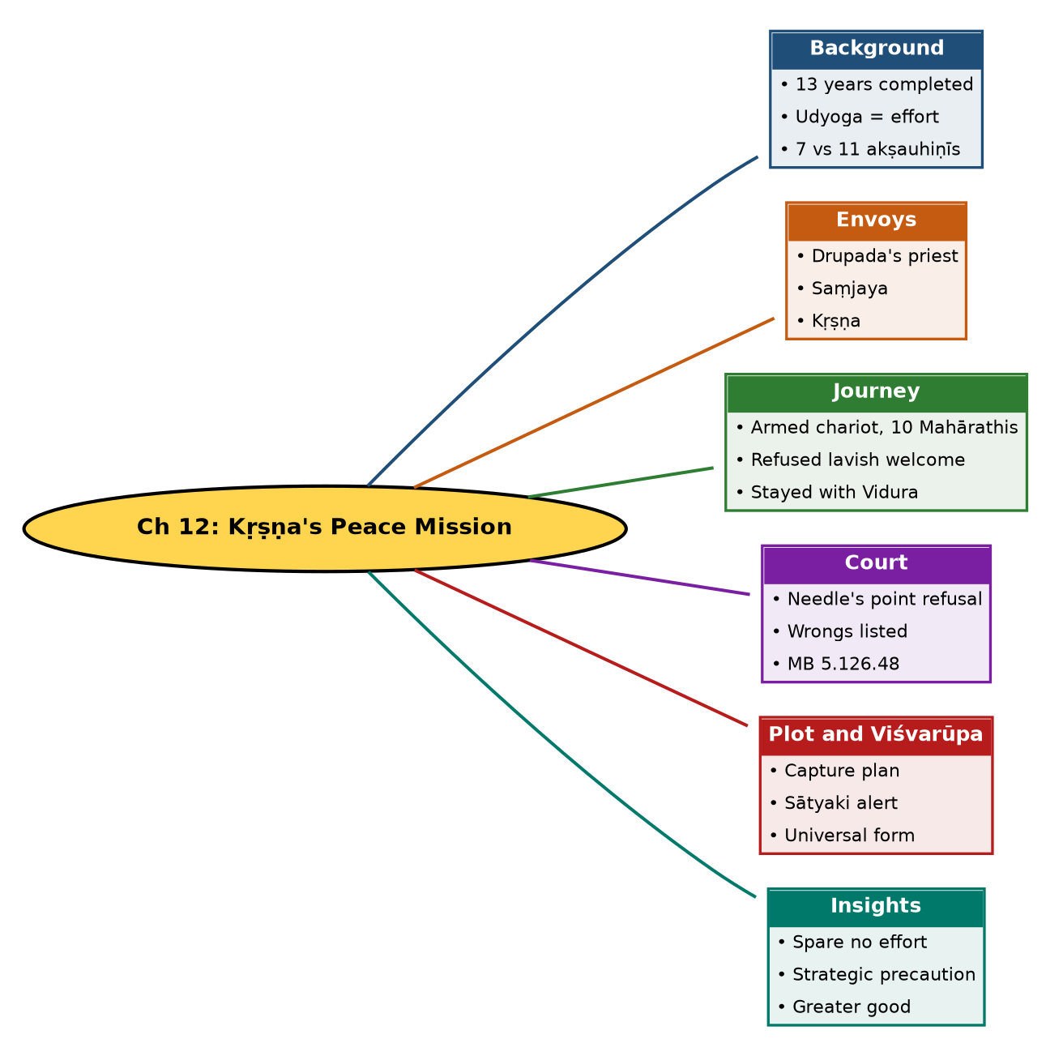

Tree view (text version for quick revision)
Ch 12: Kṛṣṇa's Peace Mission
- Background
  - 13 years completed
  - Udyoga = effort
  - 7 vs 11 akṣauhiṇīs
- Envoys
  - Drupada's priest
  - Saṃjaya
  - Kṛṣṇa
- Journey
  - Armed chariot, 10 Mahārathis
  - Refused lavish welcome
  - Stayed with Vidura
- Court
  - Needle's point refusal
  - Wrongs listed
  - MB 5.126.48
- Plot and Viśvarūpa
  - Capture plan
  - Sātyaki alert
  - Universal form
- Insights
  - Spare no effort
  - Strategic precaution
  - Greater good

10. Quick Revision: Memory Aids
- 7 vs 11 akṣauhiṇīs (Pāṇḍava vs Kaurava) = 18.
- 10 + 1000: Mahārathis and soldiers in Kṛṣṇa's escort.
- Three envoys: Priest, Saṃjaya, Kṛṣṇa.
- Needle point = Duryodhana's refusal.
- Hierarchy of sacrifice: Individual, Family, Village, Nation, Self (Ātman).
- Only 5 unafraid at Viśvarūpa: Droṇa, Bhīṣma, Vidura, Saṃjaya, Ṛṣis.

11. Exam Practice: Questions and Model Answers
Q1. What is the meaning of 'Udyoga Parva' and why is the name apt?
Ans: Udyoga is effort or preparation. The Parva shows efforts for peace alongside war preparations.
Q2. How many akṣauhiṇīs did each side raise?
Ans: Pāṇḍavas seven, Duryodhana eleven, totalling eighteen.
Q3. List the envoys sent before Kṛṣṇa and their results.
Ans: Drupada's priest demanded half the kingdom (Bhīṣma supported, Karṇa mocked); Saṃjaya conveyed Dhṛtarāṣṭra's desire for peace without offering land and lectured on war's evils.
Q4. Why did Kṛṣṇa go on the peace mission despite expecting failure?
Ans: To try every peaceful means before colossal destruction, to leave a message for posterity, to save the Kauravas if possible, and to show everyone who is responsible for the war.
Q5. How did Kṛṣṇa behave on arrival in Hastināpura?
Ans: He ignored Dhṛtarāṣṭra's lavish arrangements and Duryodhana's hospitality and stayed with Vidura.
Q6. What was Duryodhana's response in the court?
Ans: He accused Kṛṣṇa of partiality and refused half the kingdom, five villages or even the point of a needle of land.
Q7. Explain MB 5.126.48 and its context.
Ans: Kṛṣṇa said abandon a person for the family, a family for the village, a village for the nation, and the world for the soul; he urged sacrificing Duryodhana to save the race.
Q8. Describe the plot to capture Kṛṣṇa and how it was foiled.
Ans: Duryodhana, Duḥśāsana, Karṇa and Śakuni conspired; Sātyaki alerted soldiers and informed Kṛṣṇa, Dhṛtarāṣṭra and Vidura. Kṛṣṇa showed the Viśvarūpa.
Q9. What strategic precautions did Kṛṣṇa take, and what modern parallel is given?
Ans: A weapon-equipped chariot, ten Mahārathis and a thousand soldiers, with Sātyaki alert. Parallel: Indian naval ships docked at strategic locations during diplomatic talks.
Q10. How does the chapter counter the claim that Kṛṣṇa instigated war?
Ans: Kṛṣṇa tried every way for peace even knowing it would probably fail, caring for both sides.

Self-test: one-line recall
- Kṛṣṇa's host in Hastināpura = ? Vidura.
- Kaurava army = ? 11 akṣauhiṇīs.
- Who alerted Kṛṣṇa? Sātyaki.
- Verse = ? MB 5.126.48.

