CHAPTER 13
Yājñasenī: A Woman from Fire
Strategic Lessons from Mahābhārata | Exam-Ready Revision Notes | Book pages 165 to 172
Chapter at a glance
- Core idea: Draupadī as an inspiration (pratah-smaraṇīyā): an able manager of home and state, steady in her pativratyam, courageous in crisis (vipatti-dhairya), devoted to Kṛṣṇa and learned in Dharma and Artha; Amma's message on women's potential.
- Pañca-kanyā verse: Ahalyā, Draupadī, Kuntī, Tārā, Mandodarī; remembering them each morning destroys great sins.
- Managerial skill (Āraṇya Parva, to Satyabhāmā): knew thousands of servants and the king's revenue and expenditure.
- Pativratyam under Nārada's advice; five husbands = niyoga/divine will (boon asked five times from Parameśvara), not choice.
- Vipatti-dhairya: Jayadratha's abduction, Kīcaka, dice-game humiliation; prayer to Kṛṣṇa.
- Vidura: 'dharmārtha-kuśalā dharmacāriṇī'; lessons for men too; Amma's eagle and chicken story.

1. Complete Summary
The chapter says that without external opportunity and security, self-confidence is the key that lets women excel in politics, arts, business, law, order and defence. Amma says that, though outlooks and activities differ by time, place and culture, courageous women have lived in every age and broken out of imposed cages; she names Rani Padmini, Hathi Rani, Mirabai and Jhansi Rani as icons of valour and purity, to be remembered constantly so that the infinite potential in women sinks into minds.
The tradition of remembering heroines is expressed in the verse 'ahalyā draupadī kuntī tārā mandodarī tathā, pañca-kanyā smared nityaṃ mahā-pātaka-nāśanam': remembering these five women every morning before dawn removes great sins. Draupadī is pratah-smaraṇīyā. In Āraṇya Parva, Satyabhāmā asks how she keeps the mighty Pāṇḍavas in check; Draupadī describes her routine, household work, responsibilities and virtues: she manages thousands of servants and knows each one's name, work and clothing, and every detail of the king's revenue and expenditure. She served each Pāṇḍava as Nārada advised: at Khāṇḍavaprastha Nārada had told them that Draupadī should live with one husband per fixed period, and when she is with one, she dedicates herself fully to him without even thinking of others. Thus she treated all equally and upheld pativratyam (chaste devotion to husband).
The chapter addresses the misconception about her polyandry. Karṇa insulted her in the dice game, calling her a vesyā unworthy of a queen's dharma because she had five husbands. The book replies that Draupadī upheld pativratyam as per Nārada's advice; that Karṇa overlooked that she did not choose five husbands; it was niyoga, destiny and divine will. In a previous birth she had no husband, meditated on Parameśvara, and when offered a boon asked for a husband with all qualities; she repeated it five times out of overflowing desire, so she received five worthy husbands. If Karṇa were right, she would have left the Pāṇḍavas after they lost her and joined Duryodhana; instead she held to a devoted wife's Dharma, did not abandon them for their deeds, and saved them.
Management and work-life balance: today people chasing success mismanage home life; Draupadī, amid queenly duties, never failed her responsibilities as a life partner to five husbands. Vipatti-dhairya (courage in crisis) is a hard but essential life skill: after trauma (abuse, theft, robbery, life-threatening events) we are often dejected, fearful, unable to think. Draupadī faced such things repeatedly and neither fell into depression nor held grudges against God or life. When Jayadratha abducted her from the Kāmyaka forest, she warned him of her husbands' strength and told him to release her and beg forgiveness. With Kīcaka in Virāṭa's palace she faced him alone; even Queen Sudeṣṇā, whom she served, sided with Kīcaka and sent her to his quarters; when he tried force, she escaped, found no protection, and persuaded Bhīma to kill him. In the dice game she lamented in the court when none answered but kept composure, addressed the court, and finally rescued her husbands.
Amma: 'Women are not weak. Natural compassion and sympathy have often been misinterpreted as weakness.' Her story of the eagle that thought it was a chicken: a baby eagle raised among chicks foraged for worms until another eagle showed it its reflection in a lake and said it was an eagle; then it soared. Amma: the sky is the eagle's birthright; women have the potential to soar, but must prepare through steady effort and eliminate the thought that they are powerless. Draupadī is a role model of self-growth: at her most desperate in the Kaurava court she closed her eyes and prayed to Kṛṣṇa, and he rescued her. She also had vast knowledge of Dharma and the Śāstras: when the Pāṇḍavas left for the forest, Vidura (Dharmadeva born) said to Yudhiṣṭhira, 'Draupadī is dharmārtha-kuśalā dharmacāriṇī', skilled in Dharma and Artha.
Her life teaches men too: how men should and should not be, the shamelessness and lack of morals of those who misbehave with women and their end. A progressive society is one where women are safe, free and flourishing, and all of us have a role. Hence let us invoke her memory every morning and through her embrace Mahābhārata to fulfil life's purpose.

2. Section-wise Detailed Notes

A. Women's potential and the pañca-kanyā verse
- Self-confidence is the key; Amma names Padmini, Hathi Rani, Mirabai, Jhansi Rani.
- 'ahalyā draupadī kuntī tārā mandodarī tathā': remembering them daily destroys great sins.
- Draupadī = pratah-smaraṇīyā (to be remembered in the morning).

B. Draupadī the manager
- Āraṇya Parva: Satyabhāmā asks how she controls the Pāṇḍavas.
- Manages thousands of servants (knows names, work, clothes); knows revenue and expenditure.
- Balances home and career; important lesson today.

C. Pativratyam and polyandry
- Nārada's advice at Khāṇḍavaprastha: one husband at a time; full dedication.
- Karṇa's insult (calling her a vesyā) refuted: she did not choose; niyoga / divine will.
- Previous birth: asked Parameśvara for a husband with all qualities five times → five husbands.
- After the dice game she did not leave; saved the Pāṇḍavas.

D. Vipatti-dhairya (courage in crisis)
- Jayadratha's abduction: warned him, urged him to beg forgiveness.
- Kīcaka: Sudeṣṇā sided with him; Draupadī persuaded Bhīma to kill him.
- Dice-game court: spoke even when none answered; saved the day.
- No depression, no grudge against God or life.

E. Amma's teaching
- 'Women are not weak; compassion misread as weakness.'
- Eagle and chicken: realise your nature; sky is birthright.
- Prepare through steady effort; remove 'I am powerless' thinking.

F. Faith, wisdom and lessons
- Prayed to Kṛṣṇa; he rescued her.
- Vidura (Dharmadeva): dharmārtha-kuśalā dharmacāriṇī.
- Lessons for men: respect and morals; society must make women safe, free, flourishing.
- Invoke her every morning.

3. Key Terms and Keywords
Term | Meaning / Why it matters
Yājñasenī | Draupadī, born from Drupada's yajña fire.
Pañca-kanyā | Five women remembered each morning: Ahalyā, Draupadī, Kuntī, Tārā, Mandodarī.
Pratah-smaraṇīyā | One to be remembered in the morning.
Pativratyam | Chaste devotion to one's husband.
Niyoga (here) | Destiny/divine will; her five husbands were not her choice.
Vipatti-dhairya | Courage in crisis.
Dharmārtha-kuśalā | Skilled in Dharma and Artha (Vidura's words).
Vesyā | Courtesan; insult used by Karṇa.
Parameśvara | Śiva, from whom she asked a boon in her previous birth.

4. Numbers, Facts and Figures
Fact | Detail
Pañca-kanyās | 5 (Ahalyā, Draupadī, Kuntī, Tārā, Mandodarī)
Times she asked for a husband (boon) | 5
Husbands | 5 Pāṇḍavas, one at a time per Nārada's rule
Servants she managed | Thousands
Crises mentioned | 3: Jayadratha, Kīcaka, dice-game court
Icons named by Amma | Padmini, Hathi Rani, Mirabai, Jhansi Rani

5. People, Places and Texts
Name | Role / Significance in this chapter
Draupadī (Yājñasenī) | Heroine; manager, devoted wife, courageous.
Satyabhāmā | Asks Draupadī how she controls the Pāṇḍavas.
Nārada | Advised the marriage arrangement.
Karṇa | Insulted her in the dice game.
Jayadratha | Abducted her from the forest.
Kīcaka and Sudeṣṇā | Harasser and the queen who aided him.
Bhīma | Killed Kīcaka at her urging.
Vidura | Praised her as dharmārtha-kuśalā.
Amma | Eagle story; 'women are not weak'.

6. Ślokas, Sayings and Sources
Śloka / Source | Meaning and use
ahalyā draupadī kuntī tārā mandodarī tathā; pañca-kanyā smared nityaṃ mahā-pātaka-nāśanam | Remember these five women every morning to remove great sins.
'dharmārtha-kuśalā dharmacāriṇī' (Vidura on Draupadī) | She follows Dharma and is skilled in Dharma and Artha.
Amma: 'Women are not weak...' | Compassion and sympathy are strengths often misread as weakness.

7. Comparisons and Frameworks

Draupadī's crises and responses
Crisis | Draupadī's response
Jayadratha's abduction (forest) | Warned him of her husbands' strength; urged him to release her and beg forgiveness
Kīcaka (Virāṭa's palace) | Faced him alone despite Sudeṣṇā's support; escaped; urged Bhīma to kill him
Dice game (Kaurava court) | Questioned the court, kept composure, prayed to Kṛṣṇa; saved her husbands

Karṇa's charge vs the book's reply
Charge | Reply
She is a vesyā because she has five husbands | She followed Nārada's one-at-a-time rule and pativratyam
She chose five husbands | It was niyoga/divine will from a boon she asked five times
She would be disloyal | After the dice game she did not leave the Pāṇḍavas; she saved them

8. Mind Map
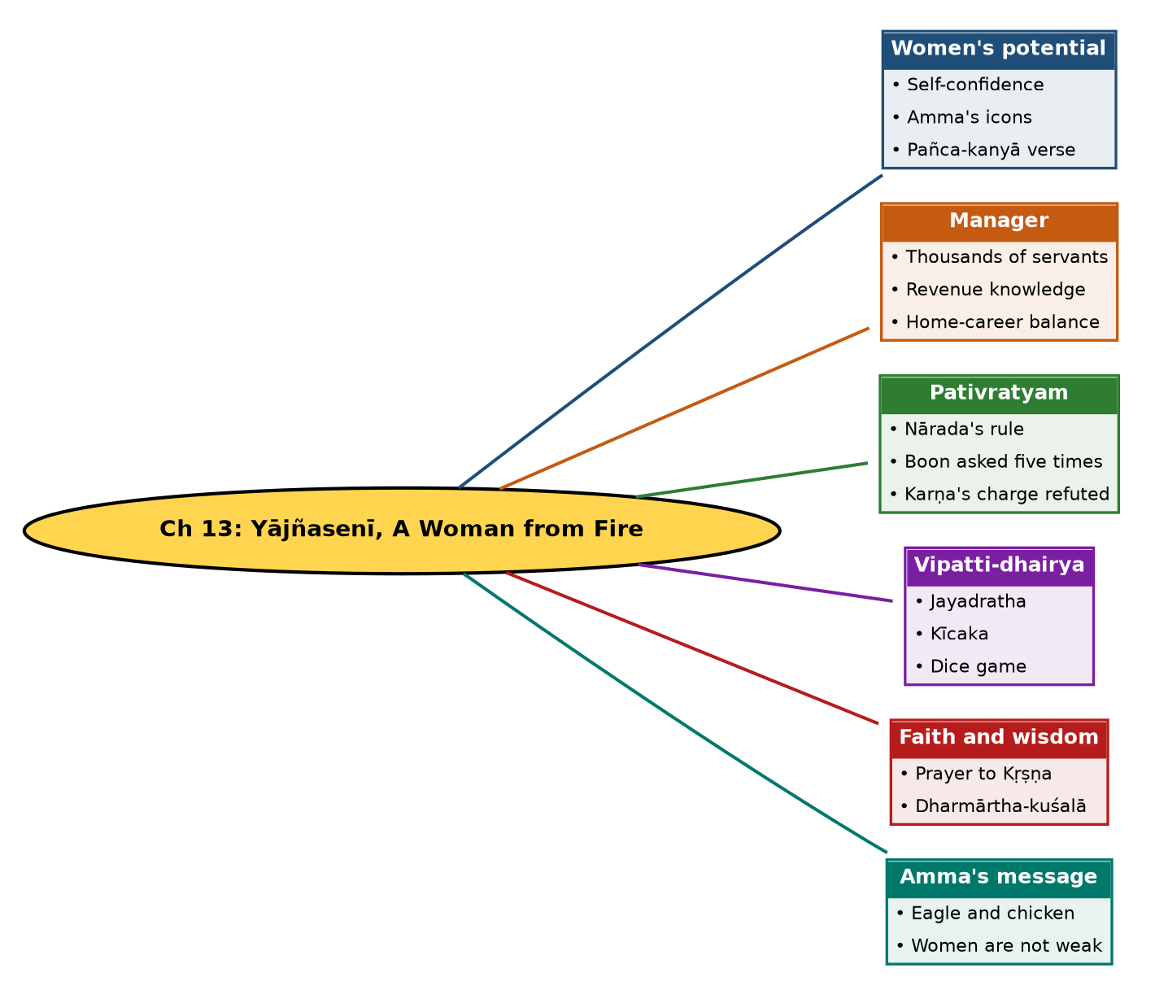

Tree view (text version for quick revision)
Ch 13: Yājñasenī, A Woman from Fire
- Women's potential
  - Self-confidence
  - Amma's icons
  - Pañca-kanyā verse
- Manager
  - Thousands of servants
  - Revenue knowledge
  - Home-career balance
- Pativratyam
  - Nārada's rule
  - Boon asked five times
  - Karṇa's charge refuted
- Vipatti-dhairya
  - Jayadratha
  - Kīcaka
  - Dice game
- Faith and wisdom
  - Prayer to Kṛṣṇa
  - Dharmārtha-kuśalā
- Amma's message
  - Eagle and chicken
  - Women are not weak

10. Quick Revision: Memory Aids
- Pañca-kanyā: A-D-K-T-M = Ahalyā, Draupadī, Kuntī, Tārā, Mandodarī.
- Three crises: Jayadratha, Kīcaka, dice court (J-K-D).
- Boon 5 times → 5 husbands.
- Vidura's words: dharmārtha-kuśalā dharmacāriṇī.
- Amma's story: eagle raised among chicks; reflection in lake.
- Satyabhāmā asks; Nārada advises.

11. Exam Practice: Questions and Model Answers
Q1. Who are the pañca-kanyās and why are they remembered?
Ans: Ahalyā, Draupadī, Kuntī, Tārā and Mandodarī; remembering them each morning before dawn removes great sins.
Q2. How does Draupadī's reply to Satyabhāmā show her managerial skills?
Ans: She managed thousands of servants, knowing their names, work and garments, and knew the king's revenue and expenditure, serving each Pāṇḍava as Nārada advised.
Q3. How does the chapter answer Karṇa's accusation about Draupadī?
Ans: She upheld pativratyam under Nārada's rule; she did not choose five husbands but received them through divine will from a boon she asked five times; and she stayed with the Pāṇḍavas after the dice game.
Q4. Define vipatti-dhairya and give three examples from Draupadī's life.
Ans: Courage in crisis: facing Jayadratha's abduction, Kīcaka's assault, and the dice-game humiliation without despair.
Q5. Narrate Draupadī and Kīcaka.
Ans: In Virāṭa's palace Kīcaka harassed her; Queen Sudeṣṇā sided with him and sent her to his quarters; she escaped his force and persuaded Bhīma to kill him.
Q6. What is Amma's eagle story and its moral?
Ans: A baby eagle raised with chicks believed it was a chicken until another eagle showed it its reflection; then it soared. Women must realise their potential and discard the thought that they are powerless.
Q7. What did Vidura say about Draupadī?
Ans: That she is dharmārtha-kuśalā dharmacāriṇī, skilled in Dharma and Artha and always following Dharma.
Q8. Why is Draupadī relevant to men as well?
Ans: Her story shows how men should and should not behave toward women and the fate of the immoral.
Q9. What does the chapter say about work-life balance?
Ans: Draupadī managed state and household duties and her role as partner of five husbands, a model in an age when people neglect home for career.
Q10. What does a progressive society need, according to the chapter?
Ans: Women who are safe, free and flourishing, with everyone playing a role.

Self-test: one-line recall
- Born from? Drupada's yajña fire (Yājñasenī).
- Who asked Draupadī about managing husbands? Satyabhāmā.
- Who killed Kīcaka? Bhīma.
- Who calls her dharmārtha-kuśalā? Vidura.

