CHAPTER 14
Death and Deathlessness
Strategic Lessons from Mahābhārata | Exam-Ready Revision Notes | Book pages 175 to 184
Chapter at a glance
- Core idea: Death is the result of 'I and mine' (ego); deathlessness comes from selflessness. The Pāṇḍavas' last journey (Mahāprasthānika Parva) shows how ego-flaws made five fall while compassionate Yudhiṣṭhira, who refused to abandon a dog, entered heaven bodily.
- Asato mā sad gamaya (Bṛhadāraṇyaka Upaniṣad 1.3.28): from asat to sat, darkness to light, death to immortality: a prayer for self-knowledge, not for worldly things.
- Pāṇḍavas' last journey: order Yudhiṣṭhira, Bhīma, Arjuna, Nakula, Sahadeva, Draupadī, plus a dog (seventh).
- Fall order: Draupadī → Sahadeva → Nakula → Arjuna → Bhīma, each due to an ego flaw.
- MB 14.13.03: 'mama' (two letters) = death; 'na mama' (three letters) = eternal Brahman.
- Stories: sculptor and Death (Rāma Tīrtha), Amma's dirt clod and dry leaf (lotus and tulasi).

1. Complete Summary
The chapter opens with the Bṛhadāraṇyaka Upaniṣad prayer 'asato mā sad gamaya, tamaso mā jyotir gamaya, mṛtyor mā amṛtaṃ gamaya': lead me from the unreal to the real, from darkness to light, from death to immortality. It is not a plea for food, health, fame or heaven, but an admission of limitedness and a heartfelt cry for help to transcend it. The third line is a prayer to realise 'I am deathless since I was never born; I am not the body, mind or intellect, but eternal blissful consciousness, the substratum of creation': a journey of knowledge from misidentification to what one truly is.
Mahābhārata presents this journey in the penultimate Parva, Mahāprasthānika Parva ('great departure'). After ruling many years following the Kurukṣetra war, the Pāṇḍavas decided on the great departure, installed Parīkṣit as king of the Kurus, instructed that funeral rites be done after their departure, gave away jewels, horses, cattle and garments, and wearing only tree-bark, the five Pāṇḍavas and Draupadī left, as they had earlier left after the dice game. Yudhiṣṭhira walked first, then Bhīma, Arjuna, the twins in order, Draupadī at the back; a dog joined as the seventh. Absorbed in yoga and renunciation, they saw Dvārakā flooded by the ocean when going southwest, then fasted and headed north to the Himalayas.
One by one they fell, and to Bhīma's questions Yudhiṣṭhira gave reasons without looking back. Draupadī fell first: she had partiality for Arjuna. Sahadeva: he thought no one equalled him in wisdom. Nakula: he held that no one equalled his beauty ('anything ordained for a person is bound to happen'). Arjuna: he had said he would burn the enemies in a single day but did not, was proud of his valour and disrespected other warriors. Bhīma: he ate too much, boasted of his strength and disrespected others. Yudhiṣṭhira walked on with the dog alone.
Indra arrived on a divine chariot and asked Yudhiṣṭhira to ascend. Yudhiṣṭhira, grieving, asked that his brothers and delicate Draupadī be taken too; Indra said they had cast off human bodies and reached heaven, but he could ascend in this body. Then Yudhiṣṭhira asked that the faithful dog come along, out of compassion. Indra objected (immortality, prosperity, fame, Svarga's happiness; abandoning a dog is no lack of compassion), but Yudhiṣṭhira said he did not want prosperity gained by abandoning the devoted, and was ready to forsake heaven for the dog. The dog then became Dharma Deva himself: this was a test of his dharmaniṣṭhā (steadfastness in Dharma). Having passed, he ascended.
Two lessons: Yudhiṣṭhira's boundless compassion and clarity of Dharma earned immortal stature; and the weaknesses that felled the others are shown too. Vyāsa marks the difference between death and deathlessness: the others died because of a three-letter word, 'ego' (ahaṃkāra): ego of beauty, of strength, favouritism, boasting. Though the Pāṇḍavas are shown in the light of Dharma, their subtle identifications are exposed. 'Mine' and 'my' lead to death; selflessness leads to deathlessness. Rāma Tīrtha's story ('In Woods of God-Realization'): a sculptor who made twelve perfect replicas of himself to fool Death's messenger was told, 'You erred in one thing' and when he asked 'In what?', the messenger seized him: 'Just this was your error'; the little imp of the doer-self is claimed by death.
MB confirms it (Aśvamedha Parva 14.13.03): 'dvyakṣaras tu bhaven mṛtyus tryakṣaraṃ brahma śāśvatam; mameti dvyakṣaro mṛtyur na mameti ca śāśvatam': the two-letter 'mama' (mine) is death; the three-letter 'na mama' (not mine) is eternal Brahman. As long as we think 'I' and 'mine', we tread toward death; when they fade, there is nothing to die. We shrink into a peanut of likes and dislikes, like a horse with blinkers.
Amma's story: on a spring full-moon night as Kṛṣṇa danced with the gopīs, one asked why he loved the lotus and tulasi; he said they are flowers of self-sacrifice. A dirt clod and a dry leaf, sweeping aside from Kṛṣṇa's path by gopīs, felt useless; the clod wished to die, but the leaf said suicide's bad karma might prevent hearing the Lord's word again, so better to be useful before dying. Hearing a lotus seed dying in the noon heat, the clod rolled it into the pond and dissolved; the dry leaf covered a tiny tulasi seed, protected it from sun, wind, snow and rain, and was powdered to nothing. Kṛṣṇa: 'When I see tulasi and lotus, I remember the sacrifice of the dirt clod and dry leaf.' Amma: we all have I-and-mine like the clod and leaf, which is why we are rejected and cannot feel God's presence; killing ego and attachment to remove another's sorrow makes us God's beloved. The clod is a hard mass of vāsanās (negative tendencies) that dissolves in the water of love and devotion; the dry leaf is the fallen leaf of the past that becomes fertiliser for the fruits of the present. Resolve to shed ego and attachment, at least to listen to another's concern if we cannot rise to Yudhiṣṭhira who would forsake heaven for a dog.

2. Section-wise Detailed Notes

A. The prayer: Asato mā sad gamaya
- Bṛhadāraṇyaka Upaniṣad 1.3.28.
- Asat → sat; tamas → jyoti; mṛtyu → amṛta.
- Not a prayer for food, health, fame or heaven; admits limitedness.
- Third line: realise 'I am deathless, never born; not body, mind or intellect'.

B. Mahāprasthānika Parva: the great departure
- Parīkṣit crowned; funeral rites to be done after departure; wealth given away.
- Wore tree-bark, as when leaving after the dice game.
- Order: Yudhiṣṭhira, Bhīma, Arjuna, Nakula, Sahadeva, Draupadī; dog = 7th.
- Saw Dvārakā flooded (southwest); fasted; went north to Himālayas.

C. Why they fell
- Draupadī: partiality to Arjuna.
- Sahadeva: pride in wisdom.
- Nakula: pride in beauty; 'what is ordained happens'.
- Arjuna: boasted he would burn enemies in one day; disrespected warriors.
- Bhīma: ate too much, boasted of strength, disrespected others.
- Yudhiṣṭhira did not look back.

D. Yudhiṣṭhira and the dog
- Indra on a divine chariot; Yudhiṣṭhira asks to take brothers and Draupadī; they have already reached heaven; he alone ascends in his body.
- Refuses to leave the dog: 'How can a noble person do an ignoble act?'
- Dog = Dharma Deva; test of dharmaniṣṭhā; passes.

E. The teaching: ego and selflessness
- Three-letter word 'ego' felled the others (ego of beauty, strength, favouritism, boasting).
- 'Mine'/'my' → death; selflessness → deathlessness.
- Sculptor and Death (Rāma Tīrtha): the doer-self is the flaw.
- MB 14.13.03: mama (2 letters) = death; na mama (3 letters) = Brahman.
- 'Peanut' of likes/dislikes; horse with blinkers.

F. Amma's story and resolve
- Dirt clod and dry leaf → lotus and tulasi (flowers of self-sacrifice).
- Dry leaf: suicide's bad karma; be useful before dying.
- Clod = vāsanās dissolving in love and devotion; leaf = past becoming fertiliser for the present.
- Resolve: shed ego and attachment; listen to others.

3. Key Terms and Keywords
Term | Meaning / Why it matters
Asat / Sat | Unreal / Real.
Mṛtyu / Amṛta | Death / Immortality.
Mahāprasthāna | 'Great departure' of the Pāṇḍavas to the Himālayas.
Mahāprasthānika Parva | Penultimate Parva of the Itihāsa as described in this chapter.
Dharmaniṣṭhā / dharmaniratattvam | Steadfastness in Dharma.
Ahaṃkāra / ego | The 'three-letter' flaw that causes death in the chapter's teaching.
Mama / Na mama | 'Mine' (death) / 'not mine' (immortality).
Vāsanā | Negative tendencies, represented by the dirt clod.
Dharma Deva | God of Dharma who appeared as the dog.
Svarga | Heaven reached by Yudhiṣṭhira in his body.

4. Numbers, Facts and Figures
Fact | Detail
Travellers | 7: five Pāṇḍavas, Draupadī, and the dog (seventh)
Order of fall | Draupadī, Sahadeva, Nakula, Arjuna, Bhīma
Verse references | Bṛhadāraṇyaka 1.3.28; MB 14.13.03
Letters in the verse | 'mama' = 2; 'na mama' = 3
Sculptor's replicas | 12 (a dozen)
Directions | Southwest (Dvārakā flooded), then north (Himālayas)

5. People, Places and Texts
Name | Role / Significance in this chapter
Yudhiṣṭhira | Survives; compassion for the dog; enters heaven bodily.
Bhīma | Questions each fall; falls last.
Draupadī, Sahadeva, Nakula, Arjuna | Fell for partiality, pride of wisdom, beauty, valour.
Indra | Offers the chariot; urges leaving the dog.
Dharma Deva | The dog; tests Yudhiṣṭhira.
Parīkṣit | Installed as king before the departure.
Rāma Tīrtha | Source of the sculptor story.
Amma | Dirt clod and dry leaf story.

6. Ślokas, Sayings and Sources
Śloka / Source | Meaning and use
asato mā sad gamaya; tamaso mā jyotir gamaya; mṛtyor mā amṛtaṃ gamaya (Bṛhadāraṇyaka 1.3.28) | Lead me from the unreal to the real, darkness to light, death to immortality.
dvyakṣaras tu bhaven mṛtyus tryakṣaraṃ brahma śāśvatam; mameti dvyakṣaro mṛtyur na mameti ca śāśvatam (MB 14.13.03) | 'Mine' is death; 'not mine' is eternal Brahman.
'How can a noble person perform an ignoble act?' (Yudhiṣṭhira) | His refusal to abandon the dog even at the cost of heaven.

7. Comparisons and Frameworks

Why each Pāṇḍava fell
Fallen | Reason (Yudhiṣṭhira's words)
Draupadī | Great partiality for Arjuna
Sahadeva | Thought no one equalled him in wisdom
Nakula | Thought no one equalled his beauty
Arjuna | Boasted he would burn enemies in a day, failed; disrespected other warriors
Bhīma | Ate too much, boasted of strength, disrespected others
Yudhiṣṭhira | Did not fall: compassion and steadfast Dharma; refused to abandon the dog

Death vs Deathlessness
Aspect | Death | Deathlessness
Root | 'Mama', I and mine, ego | 'Na mama', selflessness
Pāṇḍava example | Draupadī, Sahadeva, Nakula, Arjuna, Bhīma | Yudhiṣṭhira
Amma's story | Hard dirt clod, dry leaf unwilling to serve | Clod and leaf sacrifice themselves for the lotus and tulasi seeds

8. Mind Map
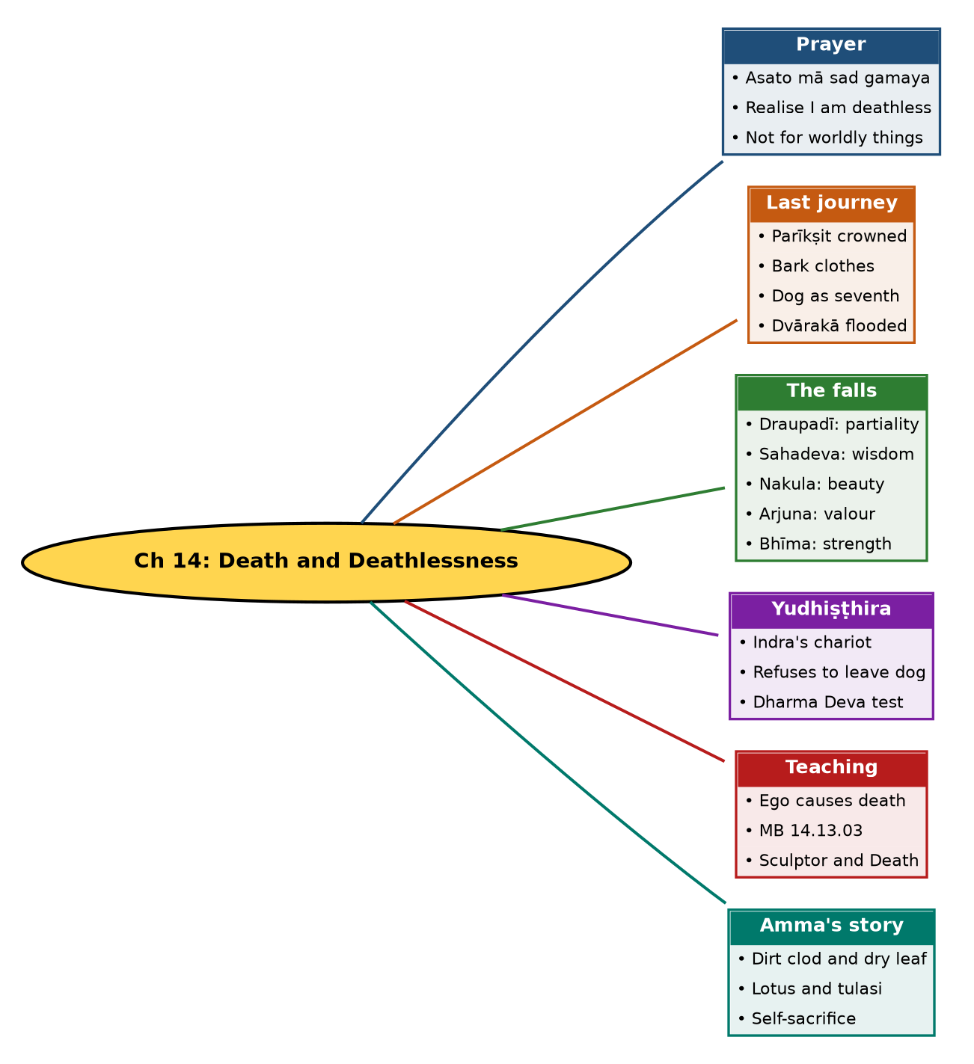

Tree view (text version for quick revision)
Ch 14: Death and Deathlessness
- Prayer
  - Asato mā sad gamaya
  - Realise I am deathless
  - Not for worldly things
- Last journey
  - Parīkṣit crowned
  - Bark clothes
  - Dog as seventh
  - Dvārakā flooded
- The falls
  - Draupadī: partiality
  - Sahadeva: wisdom
  - Nakula: beauty
  - Arjuna: valour
  - Bhīma: strength
- Yudhiṣṭhira
  - Indra's chariot
  - Refuses to leave dog
  - Dharma Deva test
- Teaching
  - Ego causes death
  - MB 14.13.03
  - Sculptor and Death
- Amma's story
  - Dirt clod and dry leaf
  - Lotus and tulasi
  - Self-sacrifice

10. Quick Revision: Memory Aids
- Fall order: D-S-N-A-B = Draupadī, Sahadeva, Nakula, Arjuna, Bhīma.
- Flaws: Partiality, Wisdom-pride, Beauty-pride, Valour-pride, Strength-pride.
- 'Ego' = the 3-letter word (as the chapter puts it); mama (2) vs na mama (3).
- Dog = 7th traveller = Dharma Deva.
- Clod → lotus seed; leaf → tulasi seed.
- Verse refs: 1.3.28 (Upaniṣad), 14.13.03 (MB).

11. Exam Practice: Questions and Model Answers
Q1. Explain 'asato mā sad gamaya' and why it is not a worldly prayer.
Ans: It asks to be led from unreal to real, darkness to light, death to immortality; it is an admission of limitedness and a cry to transcend it, and the last line is a prayer to realise the deathless Self.
Q2. Describe the order of the Pāṇḍavas' last journey.
Ans: Yudhiṣṭhira first, then Bhīma, Arjuna, the twins and Draupadī last, with a dog joining as seventh.
Q3. Why did each of the Pāṇḍavas and Draupadī fall?
Ans: Draupadī: partiality to Arjuna; Sahadeva: pride in wisdom; Nakula: pride in beauty; Arjuna: boasting and disrespect of other warriors; Bhīma: overeating, boasting of strength and disrespect to others.
Q4. How did Yudhiṣṭhira respond to Indra's offer?
Ans: He asked that his brothers and Draupadī be taken too and refused to abandon the faithful dog even at the cost of heaven.
Q5. Who was the dog and what was the test?
Ans: Dharma Deva himself, testing Yudhiṣṭhira's steadfastness in Dharma; he passed and ascended in his body.
Q6. What two lessons does the episode give?
Ans: Yudhiṣṭhira's boundless compassion and clarity of Dharma earn deathlessness, while ego (pride, partiality) caused the others to fall.
Q7. Interpret MB 14.13.03.
Ans: 'Mama' (mine), two letters, is death; 'na mama' (not mine), three letters, is eternal Brahman. As I-and-mine fade, there is nothing left to die.
Q8. Narrate the sculptor story of Rāma Tīrtha.
Ans: A sculptor made a dozen perfect replicas to fool Death's messenger, who returned and said he had erred in one thing; when the sculptor asked what, he was seized: the doer-self was the error.
Q9. Summarise Amma's dirt clod and dry leaf story.
Ans: A clod and a leaf, swept aside from Kṛṣṇa's path, gave themselves to help a lotus seed and a tulasi seed; Kṛṣṇa loves lotus and tulasi as flowers of self-sacrifice. It teaches shedding ego and serving others.
Q10. What does the clod and the leaf symbolise, according to Amma?
Ans: The clod is a hard mass of vāsanās that dissolves in love and devotion; the leaf is the fallen past that becomes fertiliser for the present.

Self-test: one-line recall
- First to fall = ? Draupadī.
- Last to fall = ? Bhīma.
- Who is the dog? Dharma Deva.
- Two-letter word = ? Mama.

